**Exercise 3: Stored Procedures**

**Scenario 1: The bank needs to process monthly interest for all savings accounts.**

**Question: Write a stored procedure ProcessMonthlyInterest that calculates and updates the balance of all savings accounts by applying an interest rate of 1% to the current balance.**

**Step 1: Create Accounts Table**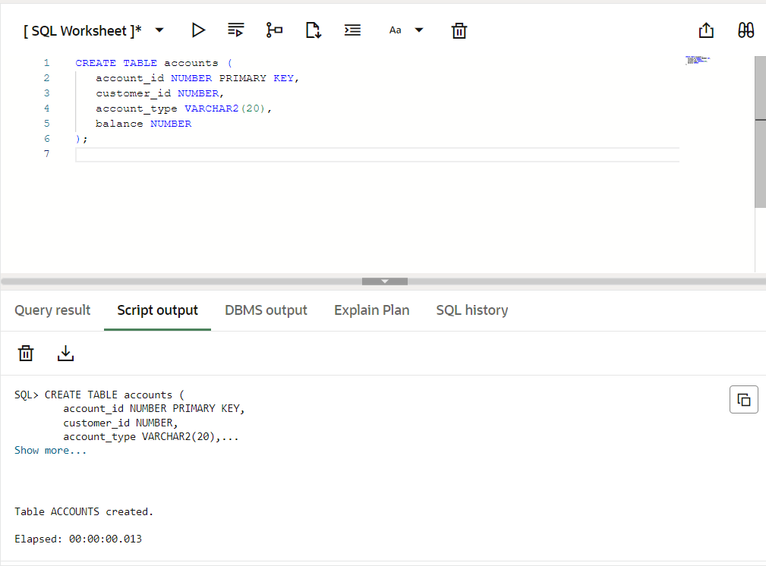

**Step 2: Insert Sample Data**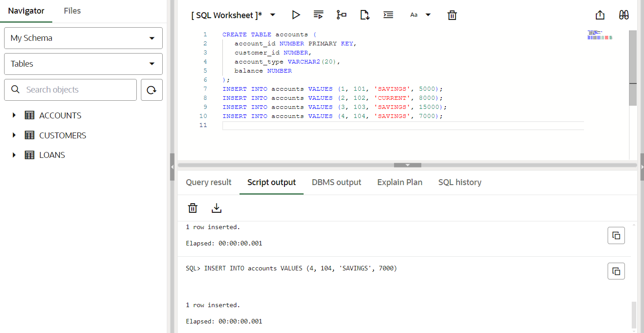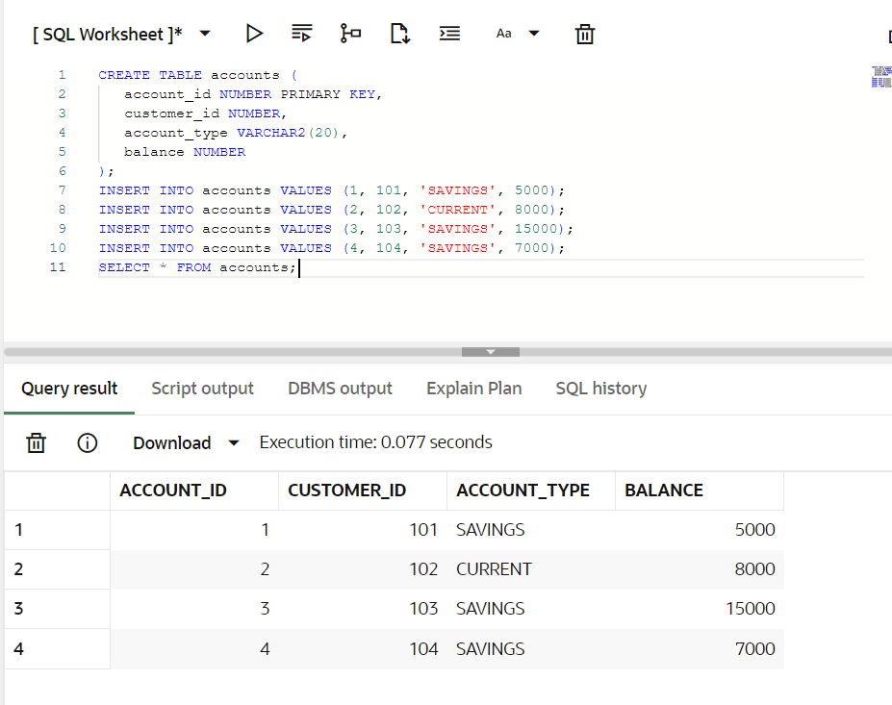

**Step 3: Create the Procedure**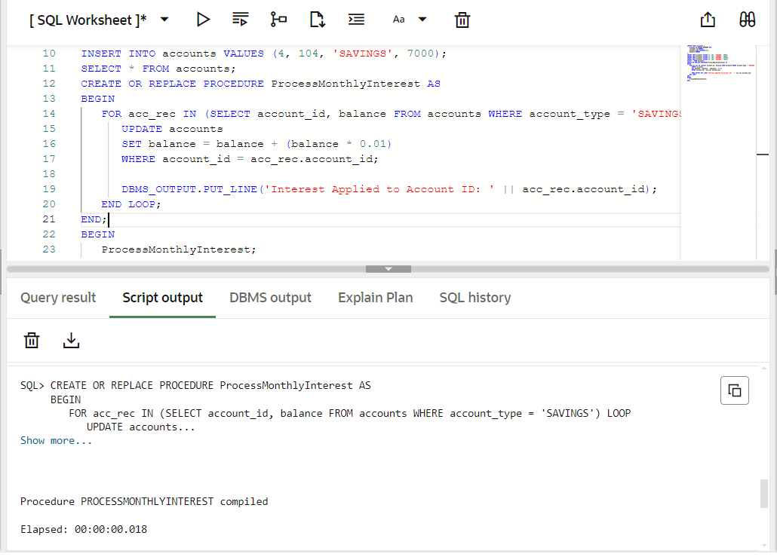

**Step 4: Run the Procedure**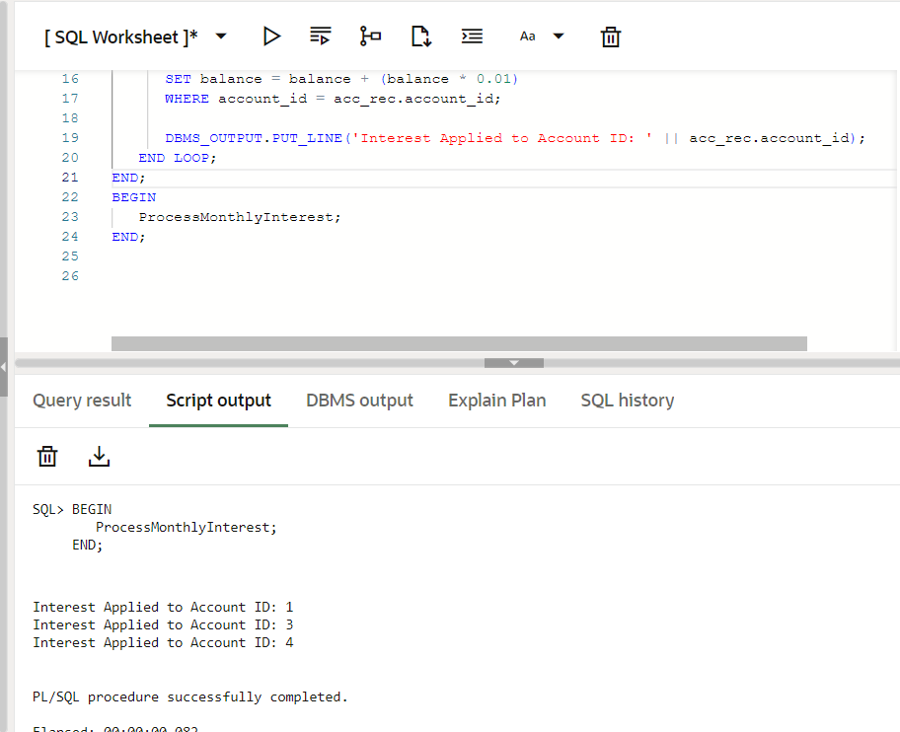

**Step 5: Verify Updated Balances**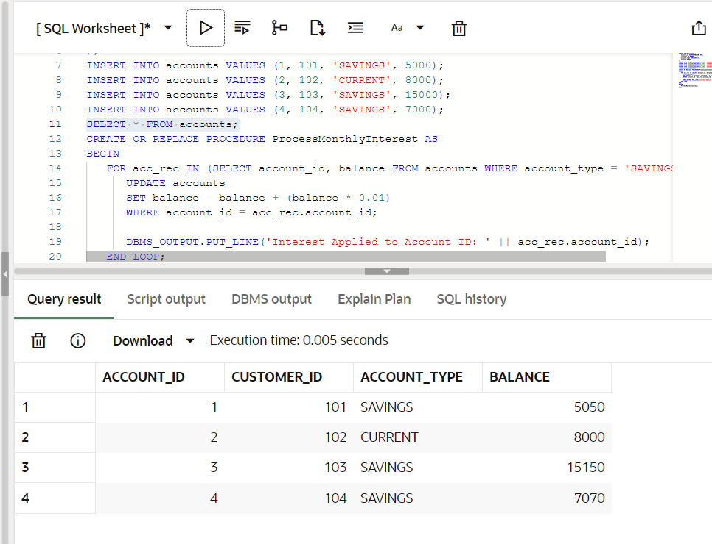

**Scenario 2: The bank wants to implement a bonus scheme for employees based on their performance.**

**Question: Write a stored procedure UpdateEmployeeBonus that updates the salary of employees in a given department by adding a bonus percentage passed as a parameter.**

**Step 1: Create the Employees Table**

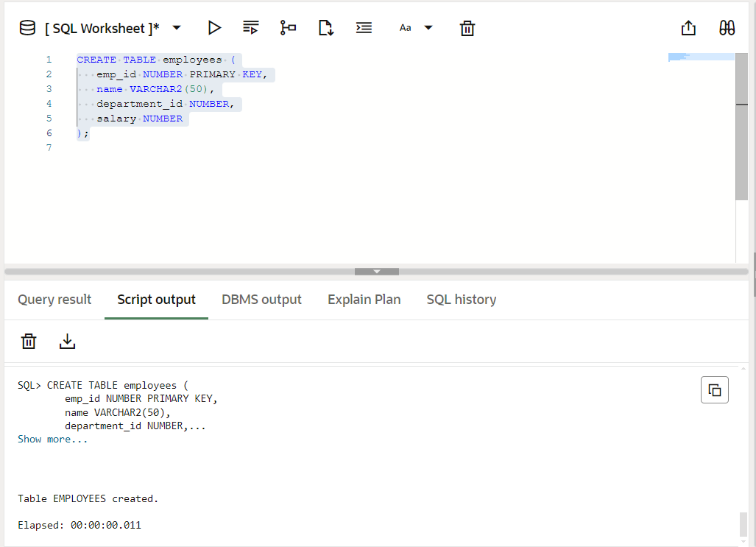

**Step 2: Insert Sample Data**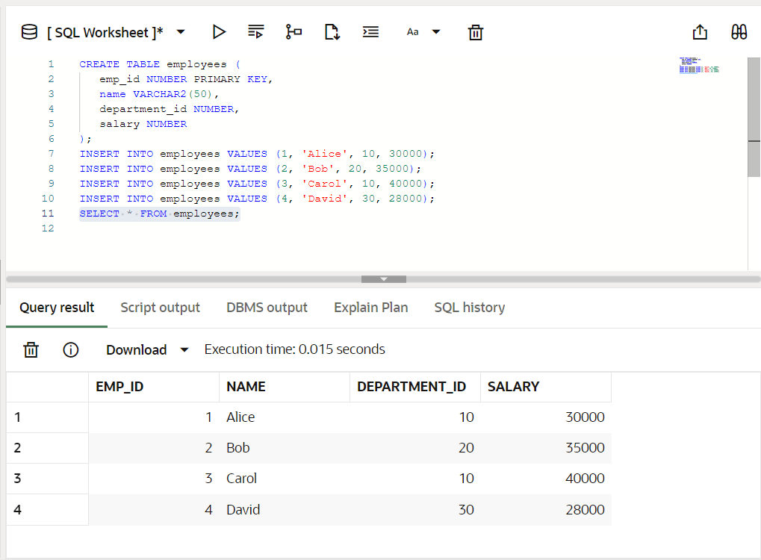

**Step 3: Create the Procedure**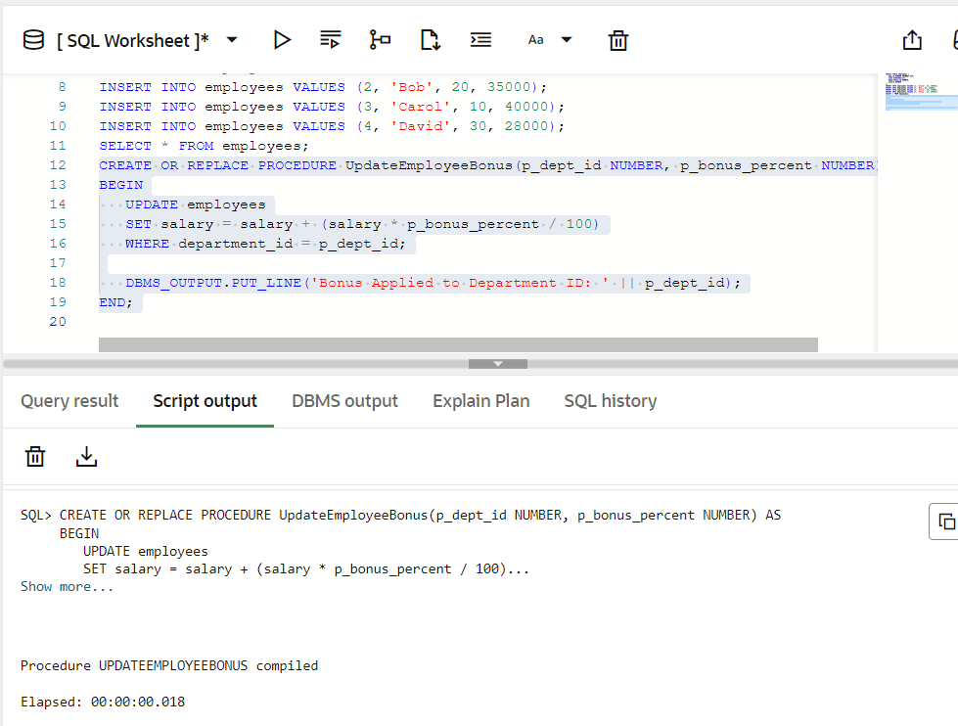

**Step 4: Run the Procedure**

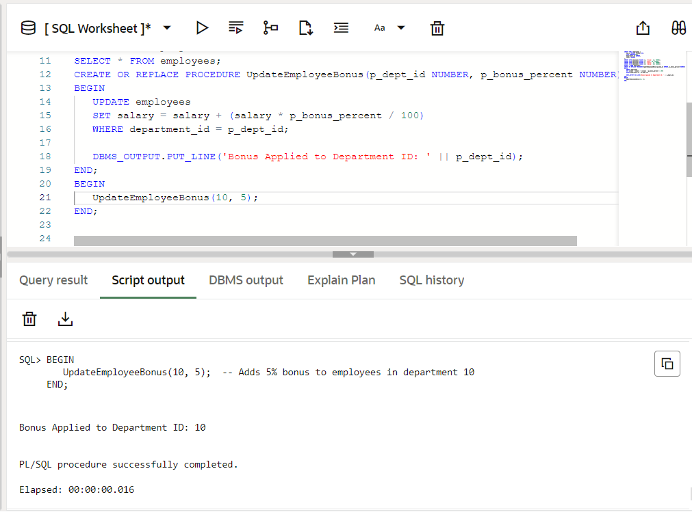

**RESULT**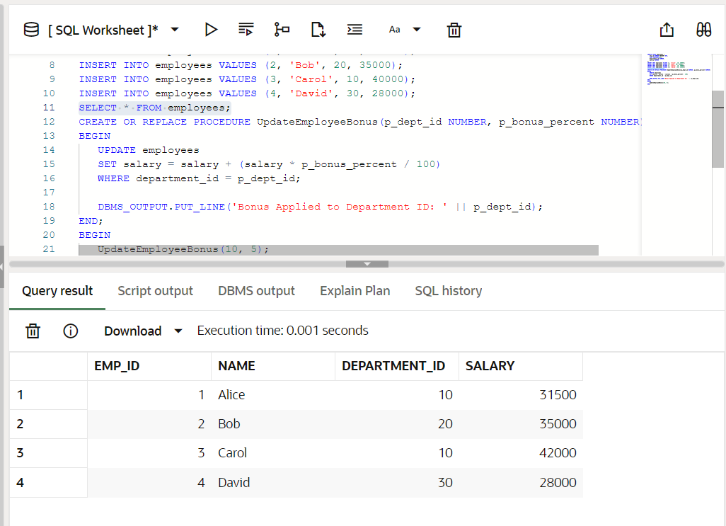

**Scenario 3: Customers should be able to transfer funds between their accounts.**

**Question: Write a stored procedure TransferFunds that transfers a specified amount from one account to another, checking that the source account has sufficient balance before making the transfer.**

**BEFORE TRANSACTION DONE:[table accounts already available from scenario 1]**

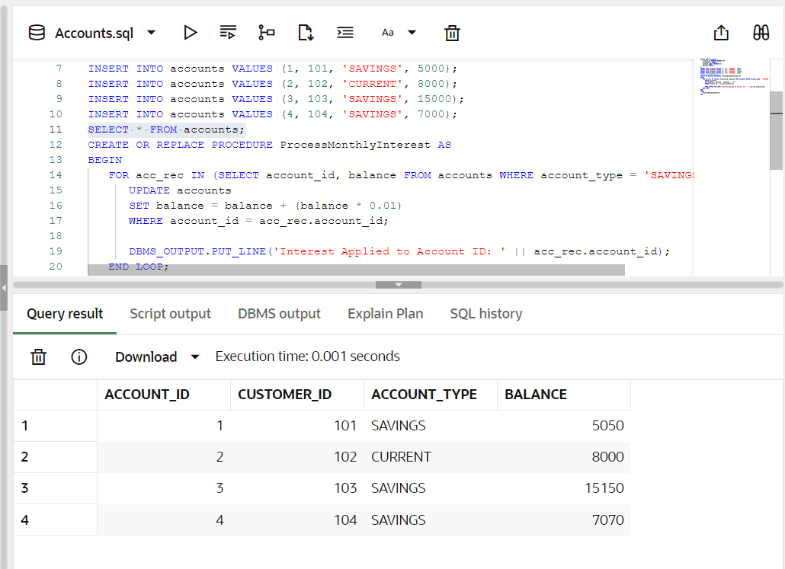

**PROCEDURED CREATED:**

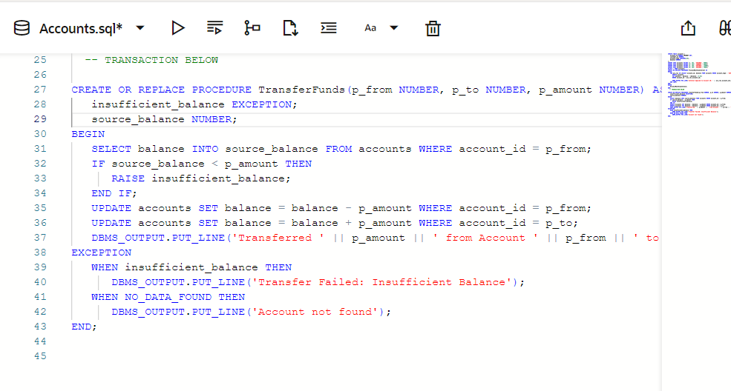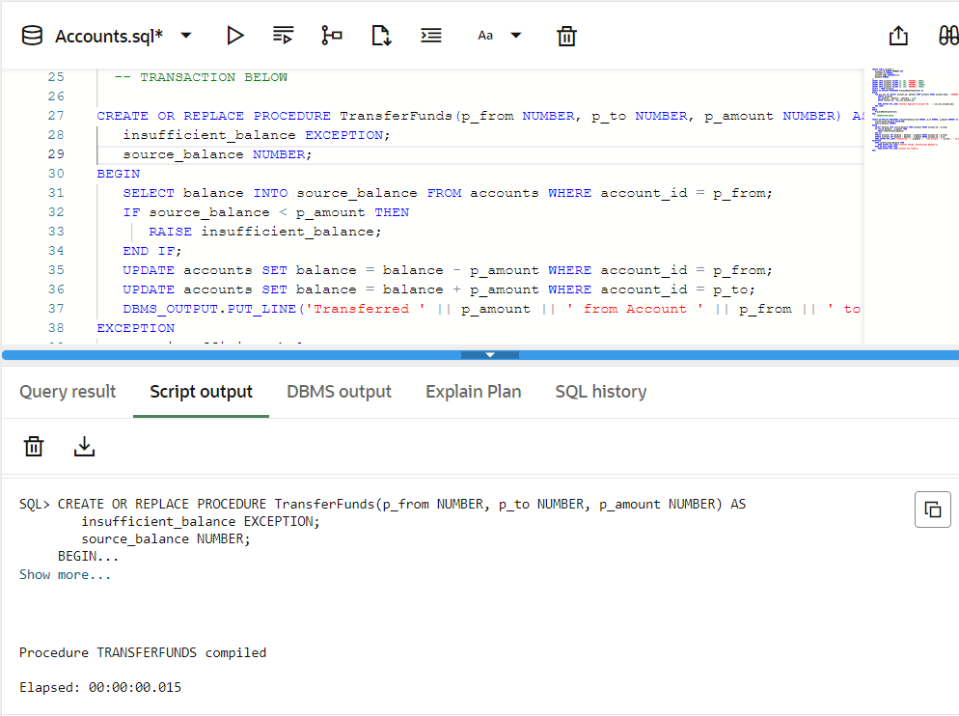

**RUN THE PROCEDURE:**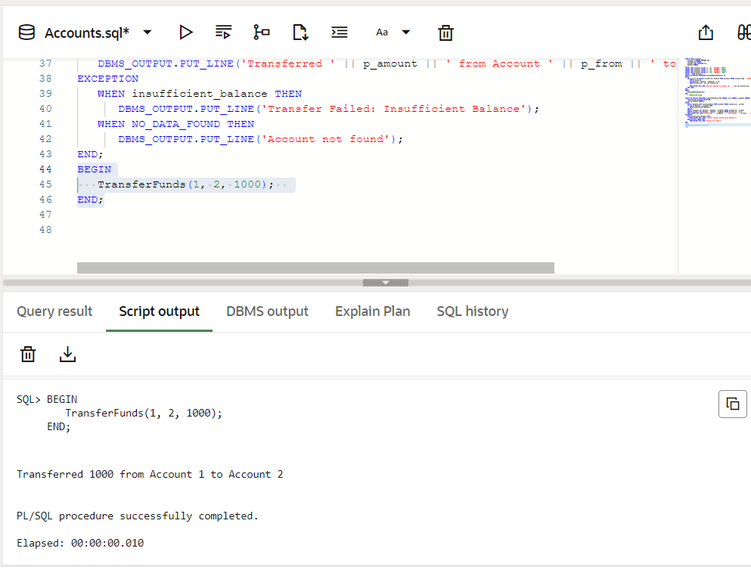

**RESULT: [TRANSACTION DONE FROM ACCOUNT 1 TO ACCOUNT 2]**