**Exercise 1: Control Structures**

**Scenario 1:** The bank wants to apply a discount to loan interest rates for customers above 60 years old.

* + **Question:** Write a PL/SQL block that loops through all customers, checks their age, and if they are above 60, apply a 1% discount to their current loan interest rates.

**Scenario 2:** A customer can be promoted to VIP status based on their balance.

* + **Question:** Write a PL/SQL block that iterates through all customers and sets a flag IsVIP to TRUE for those with a balance over $10,000.

**Scenario 3:** The bank wants to send reminders to customers whose loans are due within the next 30 days.

* + **Question:** Write a PL/SQL block that fetches all loans due in the next 30 days and prints a reminder message for each customer.

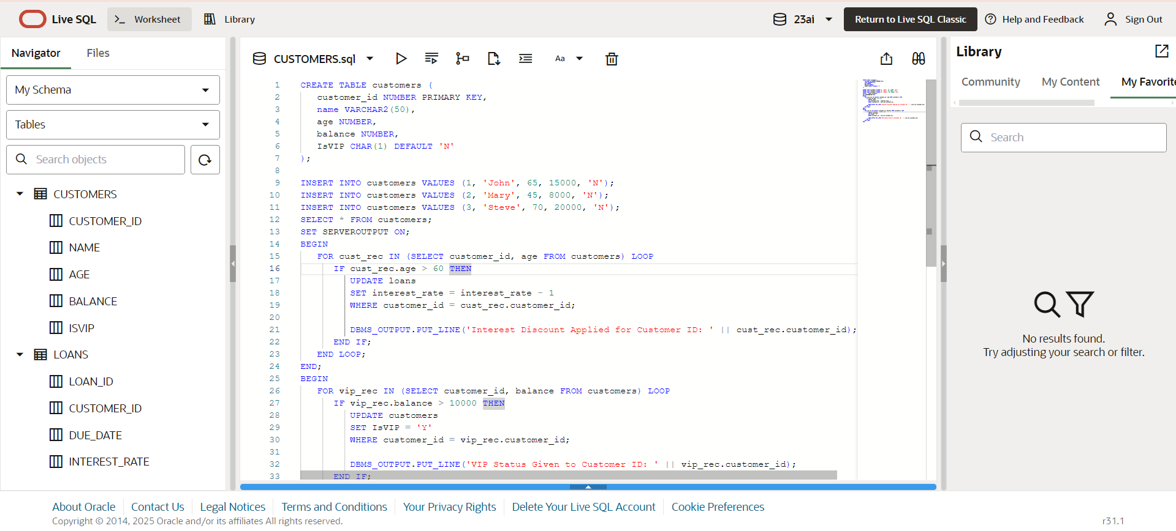

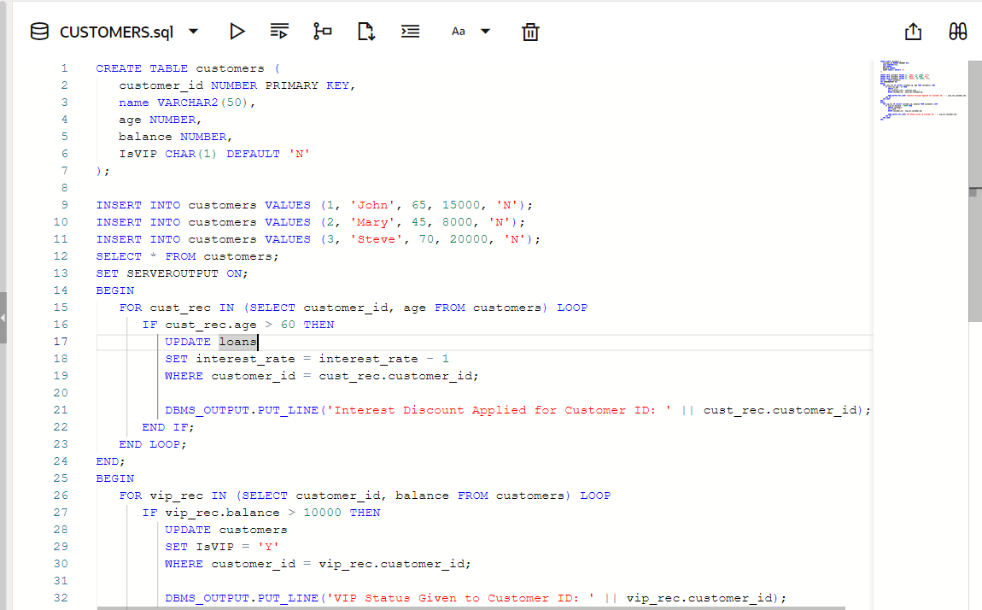 **CUSTOMERS.SQL** 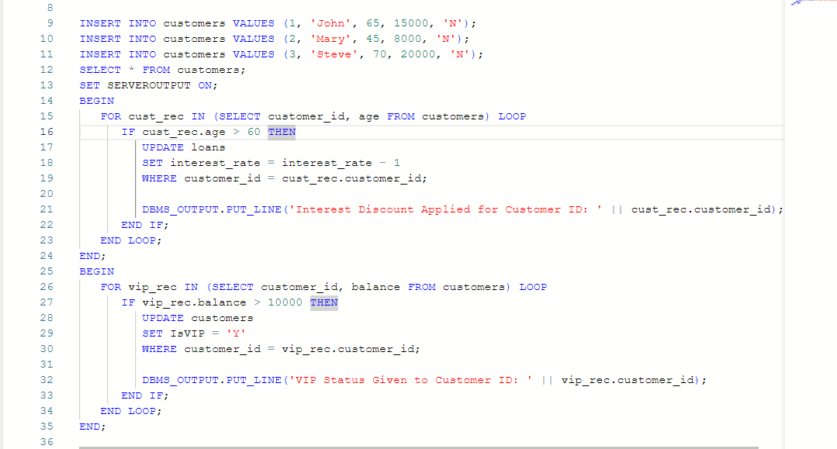

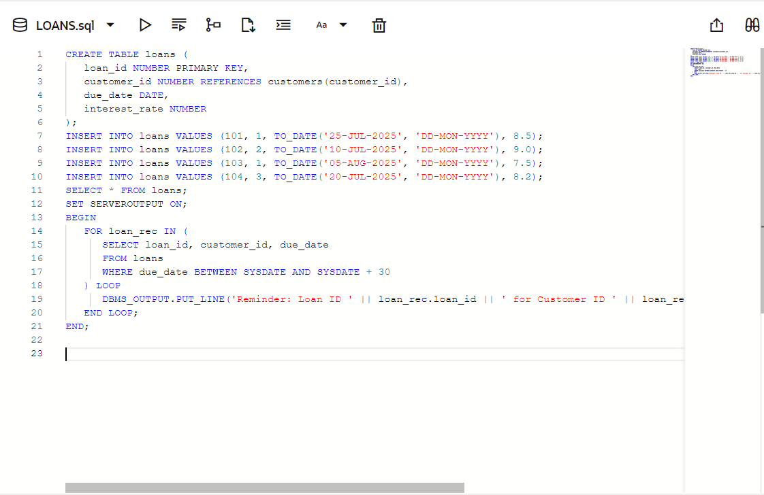

**TABLES CREATION:**

**We created two tables:**

**customers , stores customer details like customer_id, name, age, balance, IsVIP  
 loans, stores loan details like loan_id, customer_id, due_date, interest_rate**

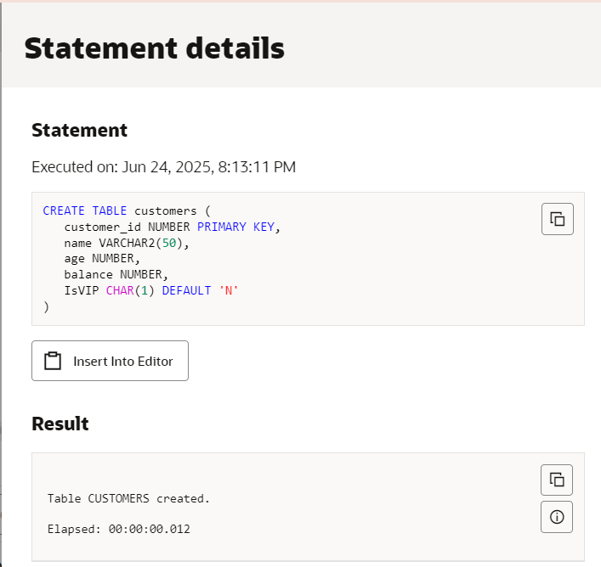 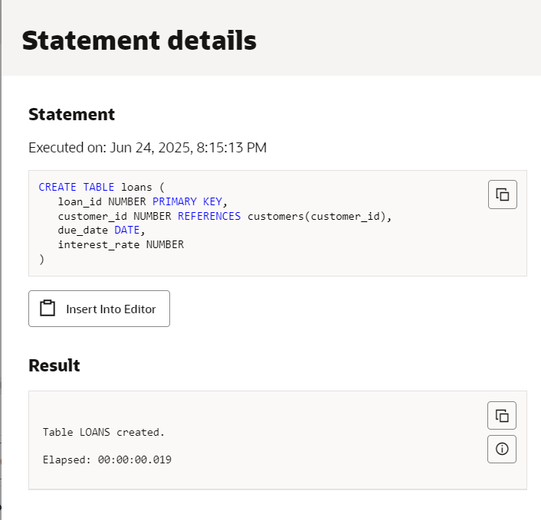

**VALUES INSERTED:**

**Added 3 customers:**

* **John (Age 65, Balance 15,000)**
* **Mary (Age 45, Balance 8,000)**
* **Steve (Age 70, Balance 20,000)**

**Added 4 loans linked to customers with different due dates and interest rates**

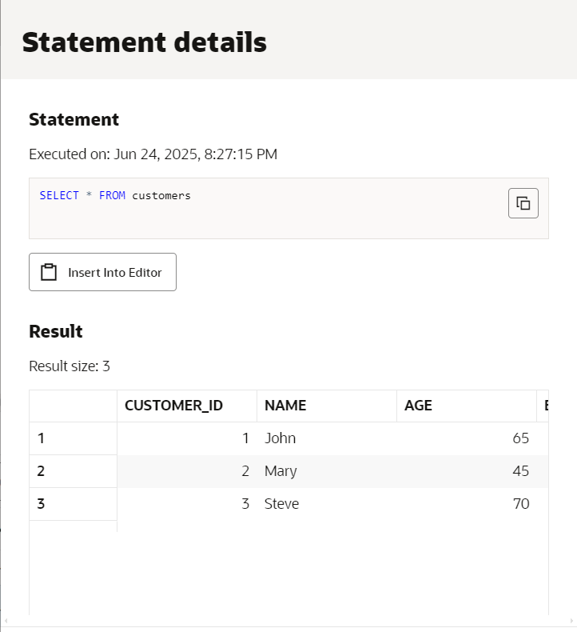

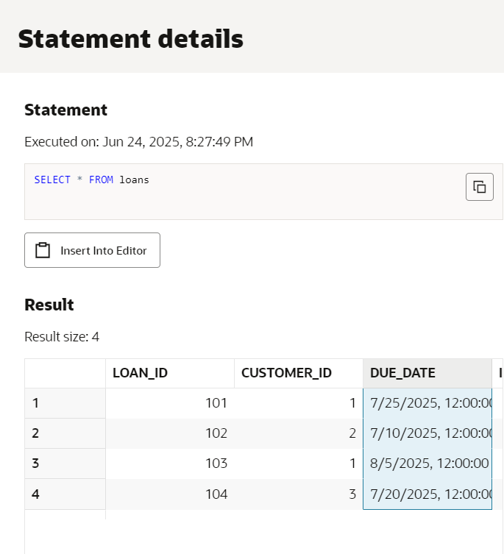 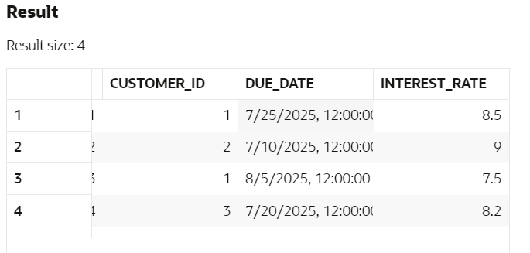

**SCENARIO 1:**

**Loop through all customers.  
 If customer age > 60 → reduce their loan interest rate by 1%.  
 Print confirmation for each updated customer.**

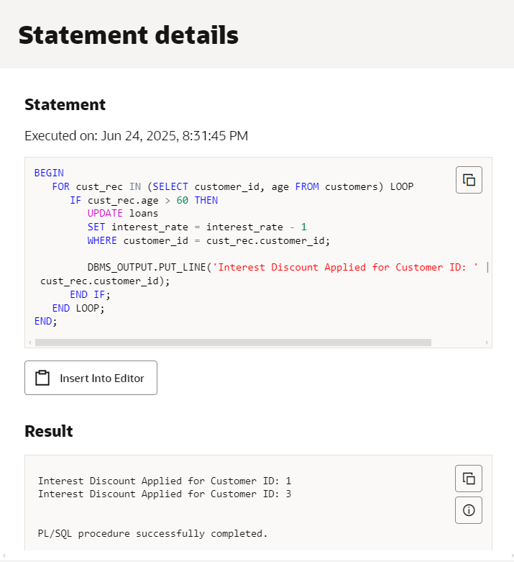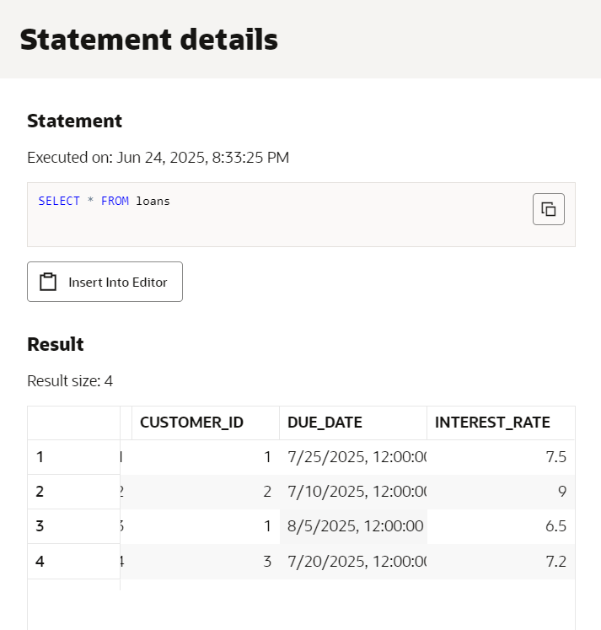

**SCENARIO 2:**

**✔ Loop through all customers  
✔ If balance > 10,000 → set IsVIP = 'Y'  
✔ Print which customers got VIP status**

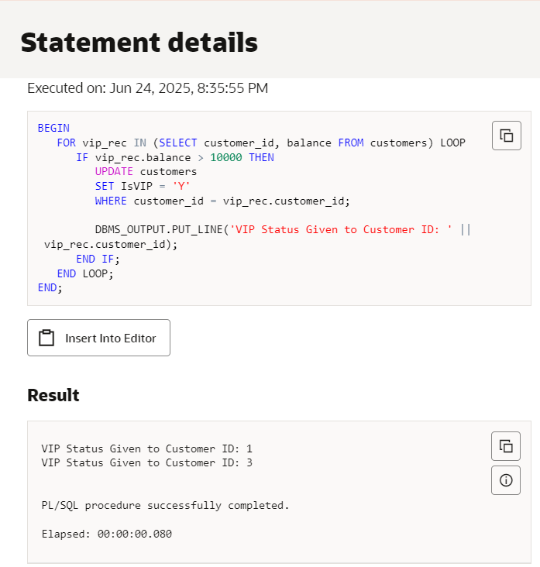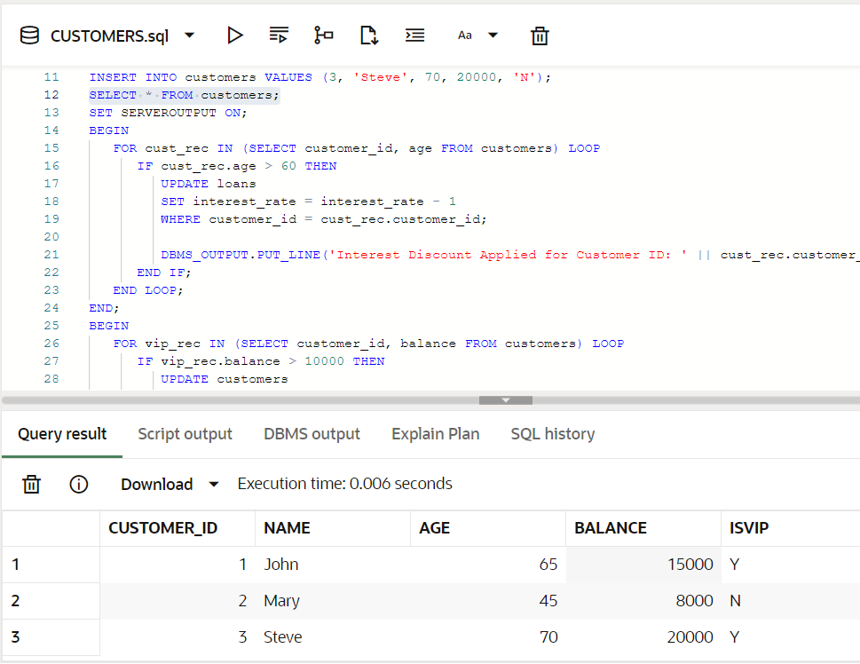

**SCENARIO 3:**

**✔ Check loans due within next 30 days  
✔ Print reminder message for each customer**

