**1)spring-data-jpa-handson**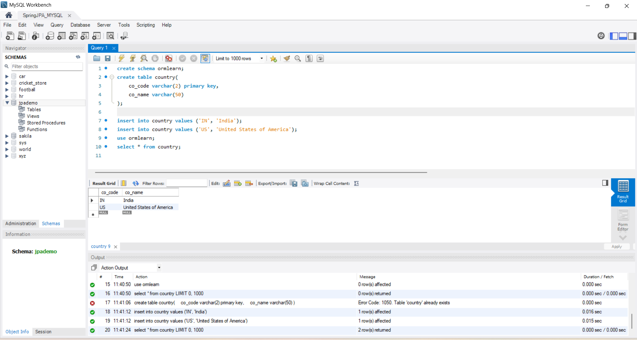 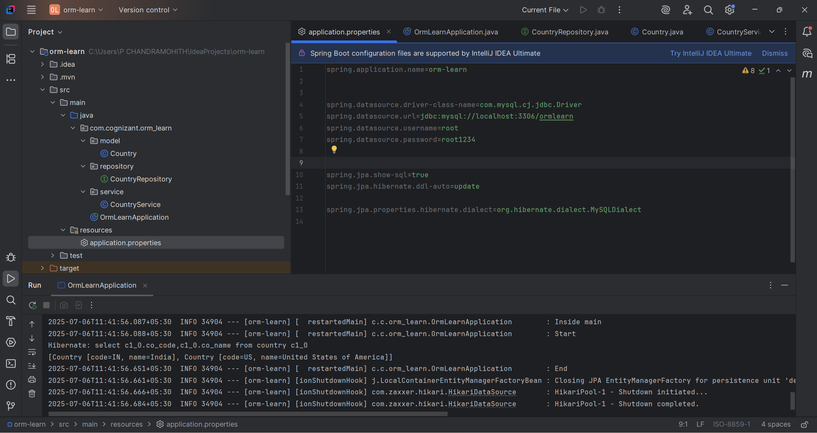 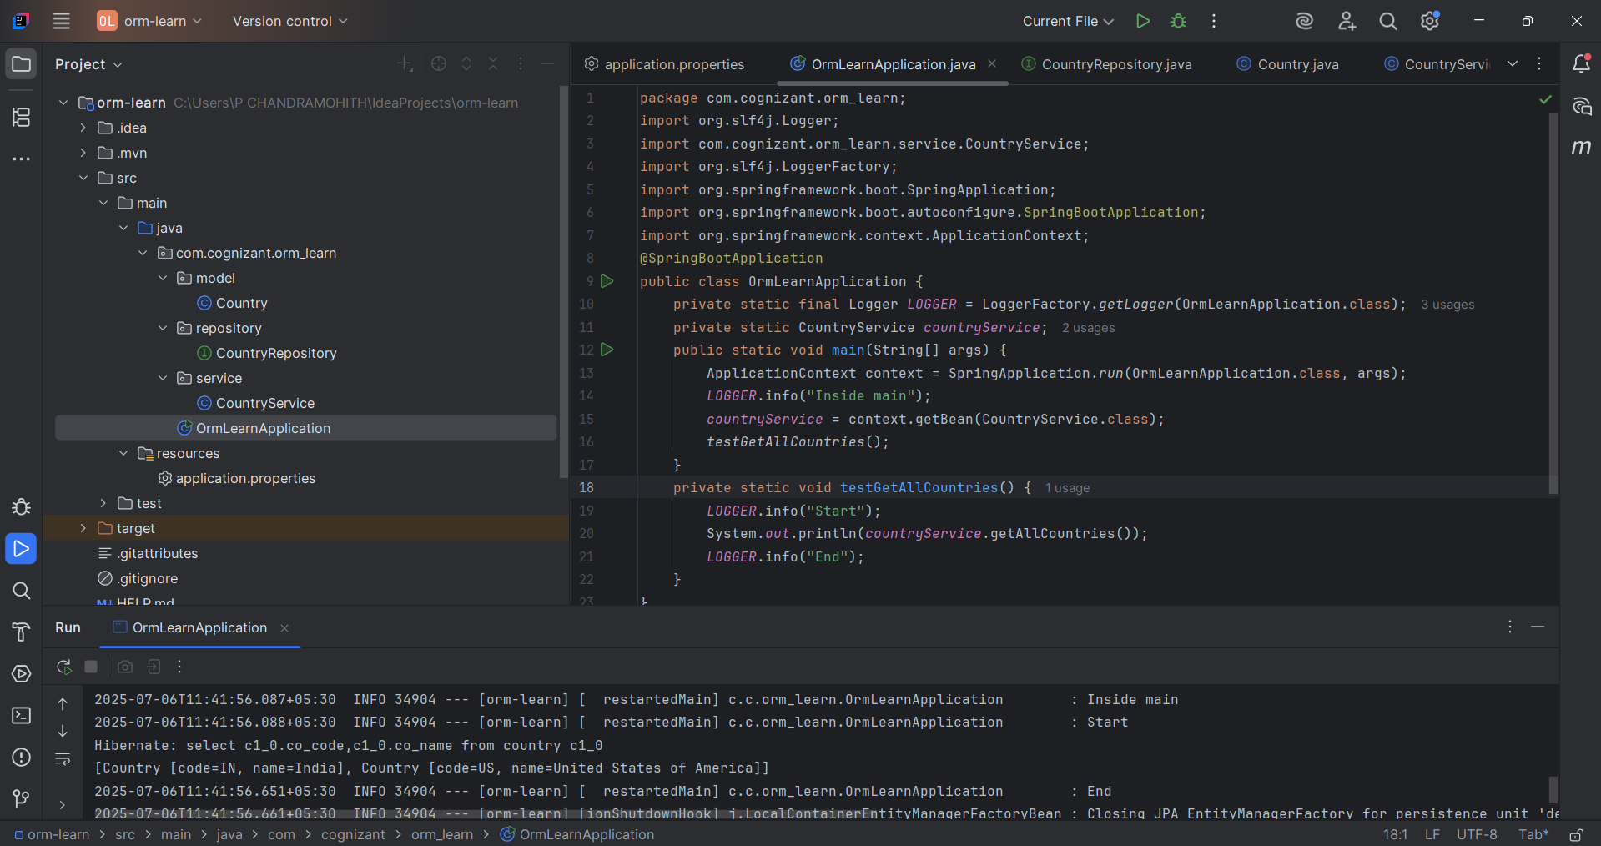

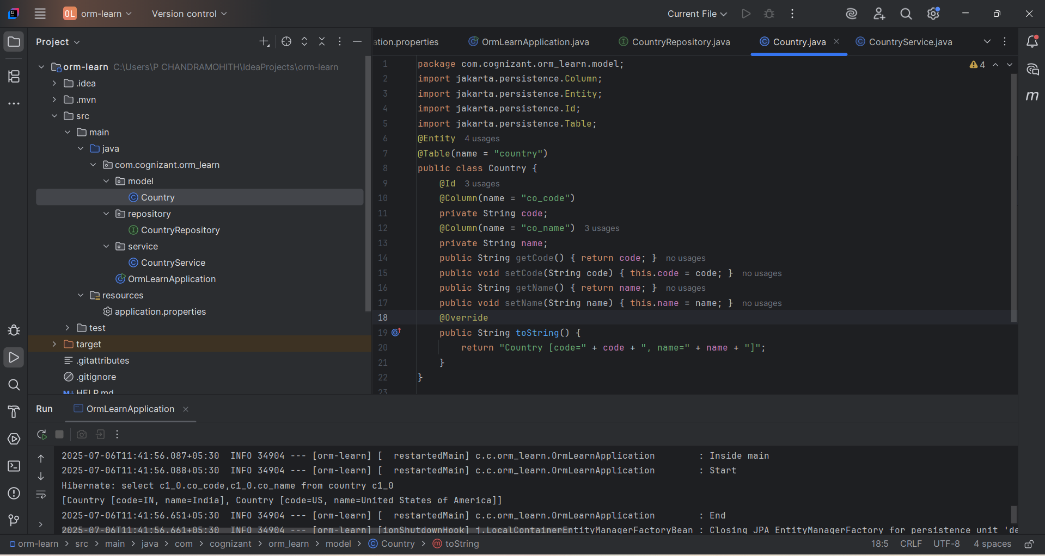 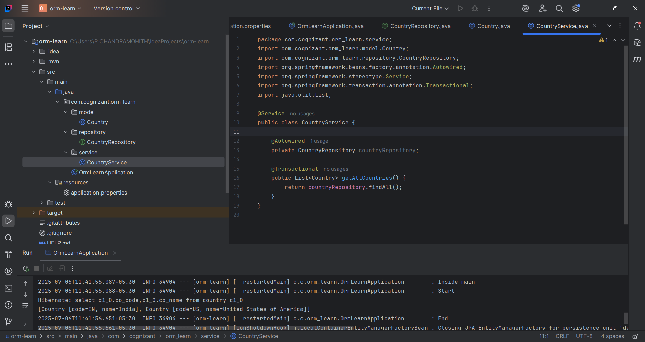 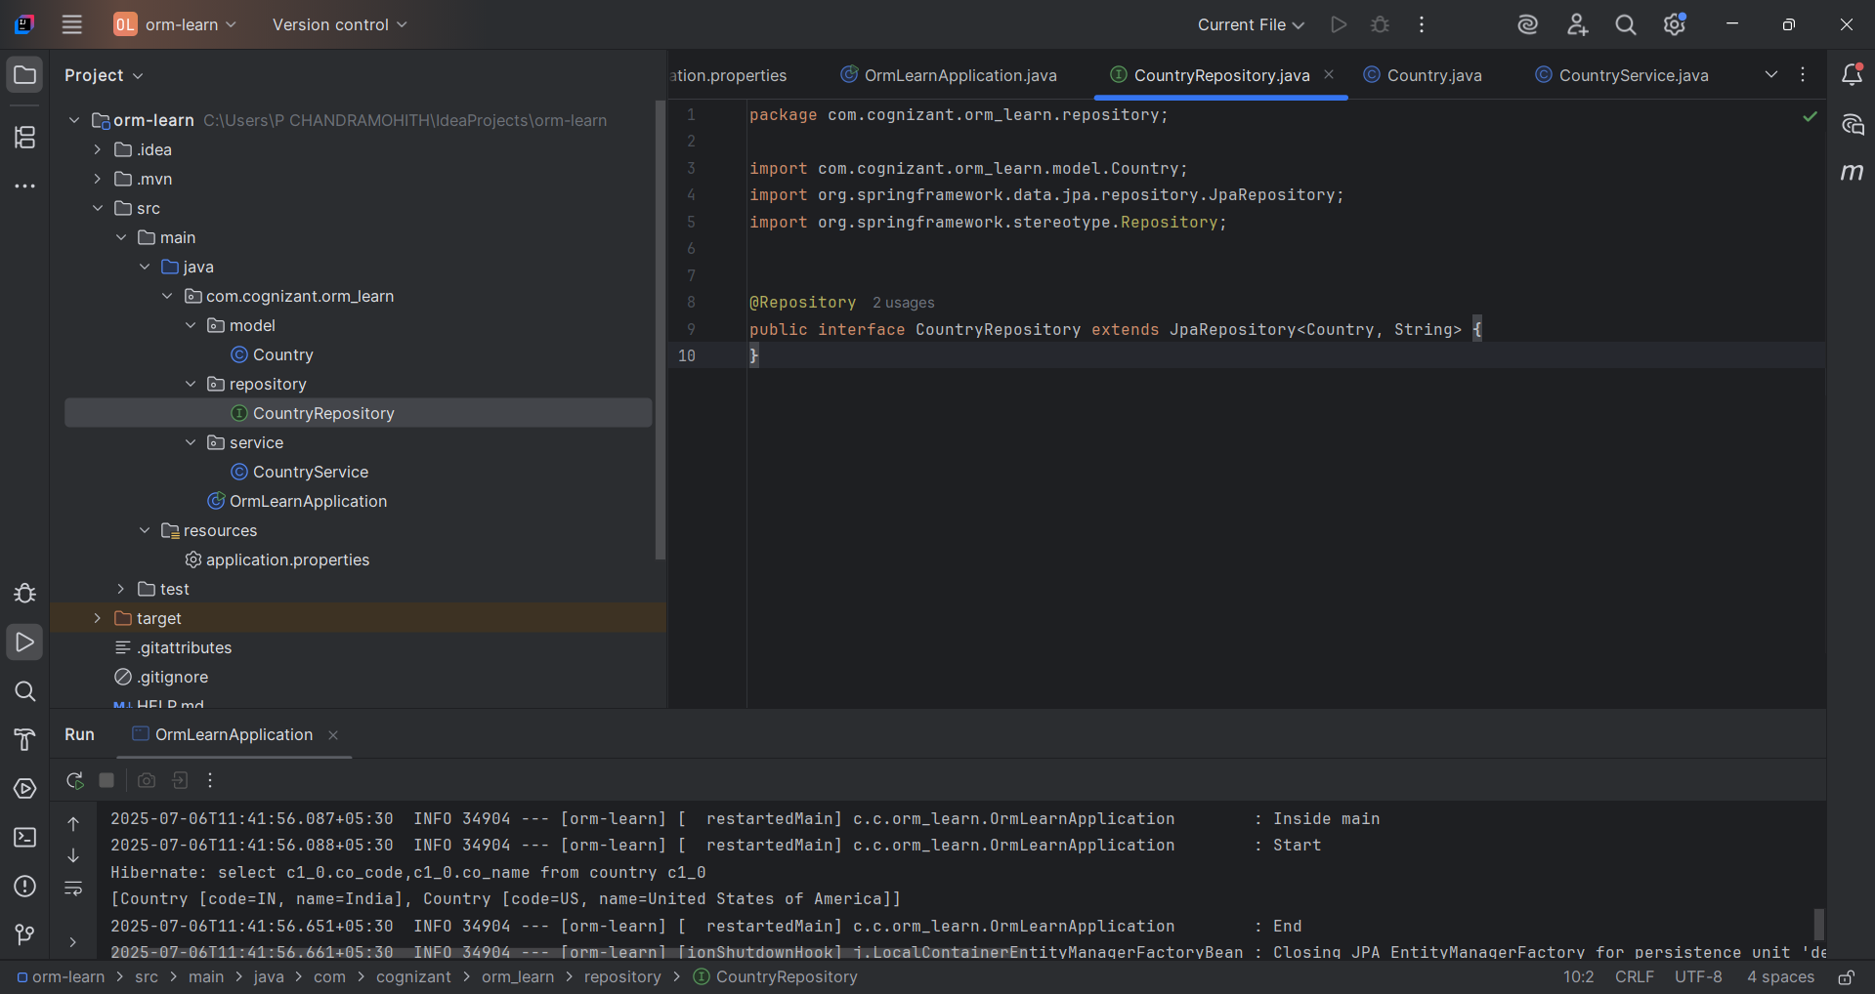

**Project Title: ORM-Learn (Spring Boot JPA Project)**

**Explanation:**  
In this project, we built a simple Spring Boot application that connects to a MySQL database using JPA (Java Persistence API) and Hibernate. The project mainly focuses on fetching data from the database and displaying it.

**Flow of the Project:**  
✅ Spring Boot starts the application (OrmLearnApplication).  
✅ Database connection is established using MySQL Driver (com.mysql.cj.jdbc.Driver).  
✅ Hibernate handles communication with the database.  
✅ It fetches records from the country table.  
✅ The list of countries is printed on the console.  
✅ Application shuts down gracefully after execution.

**Technologies Used:**  
✔ Spring Boot  
✔ Spring Data JPA  
✔ Hibernate ORM  
✔ MySQL Database

**Key Features:**

* Database configuration is managed in application.properties.
* Hibernate auto-generates SQL queries.
* Clean object-oriented access to database tables (using Entity classes).