**Exercise 9: Creating a Spring Boot Application**

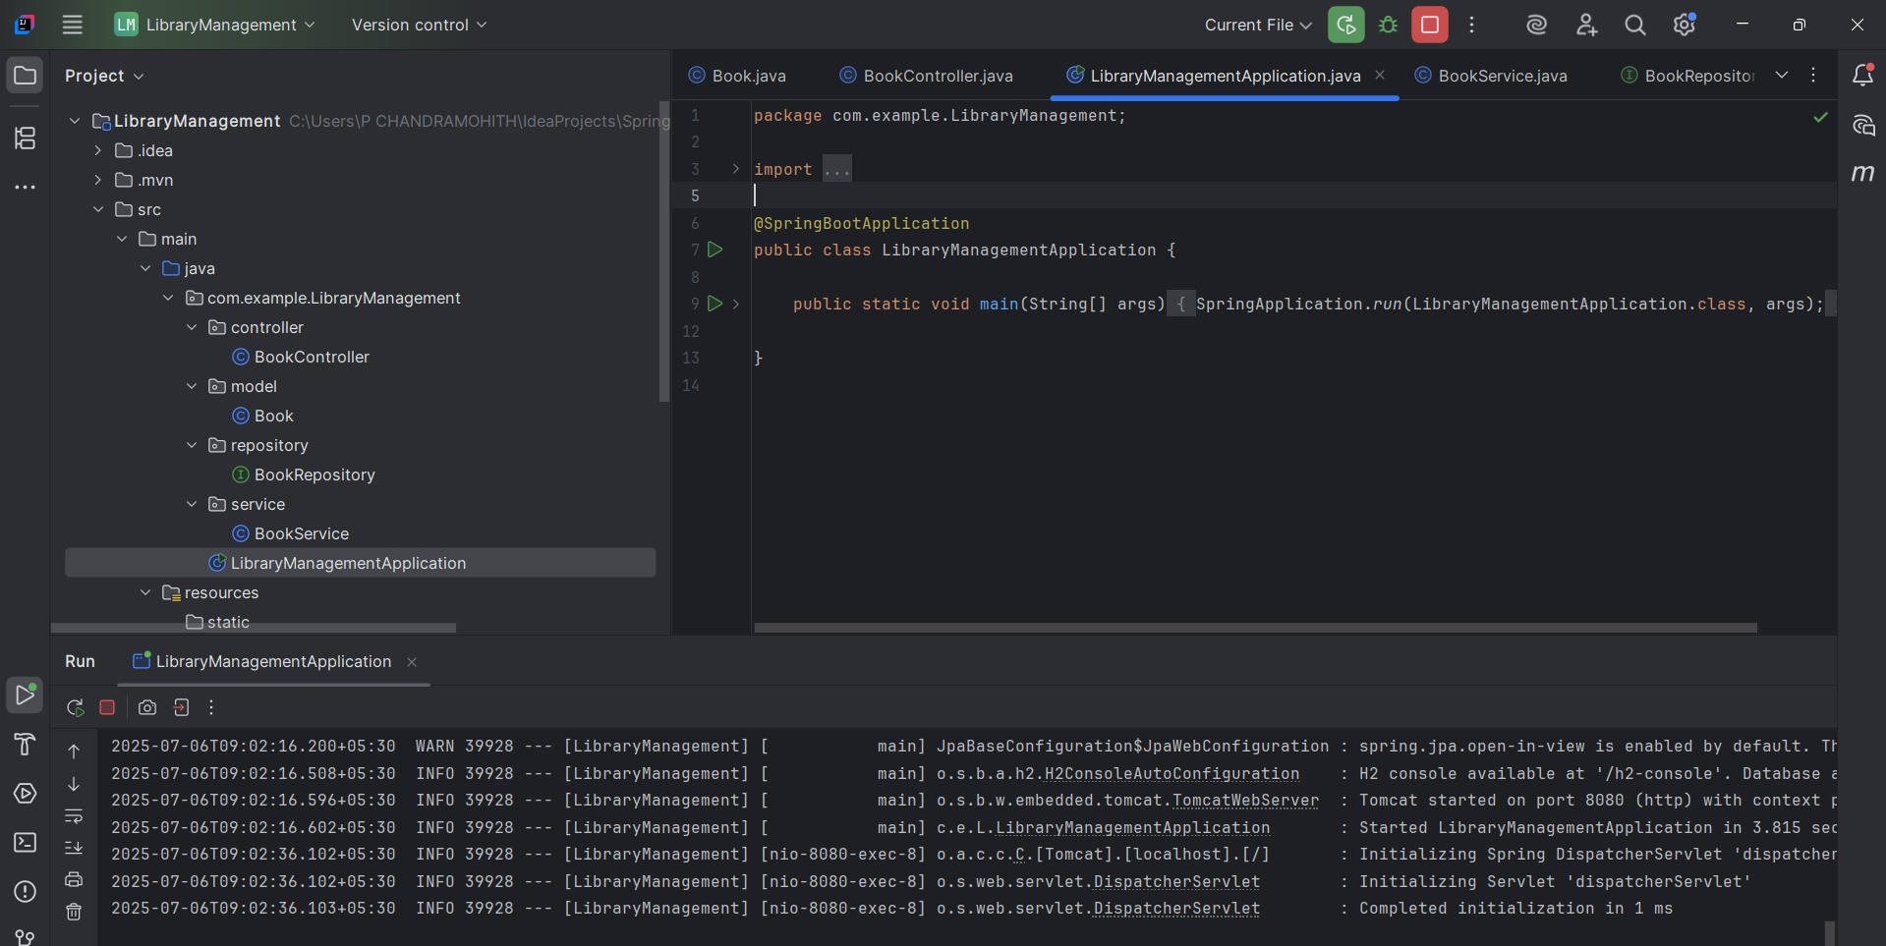

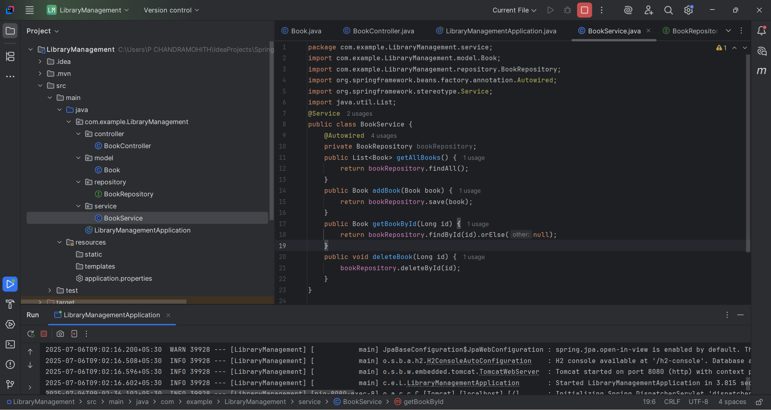

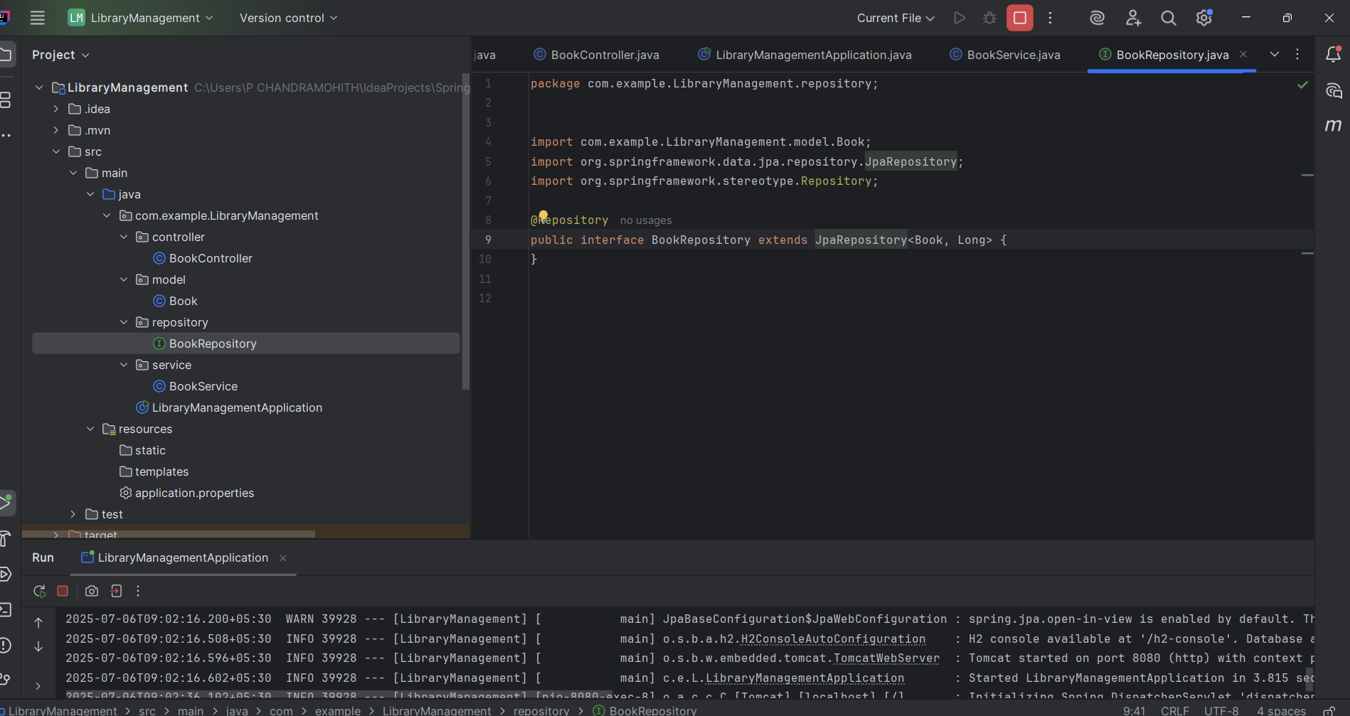

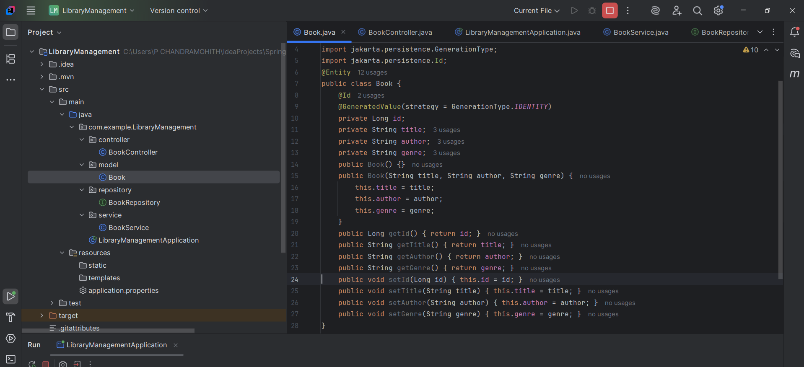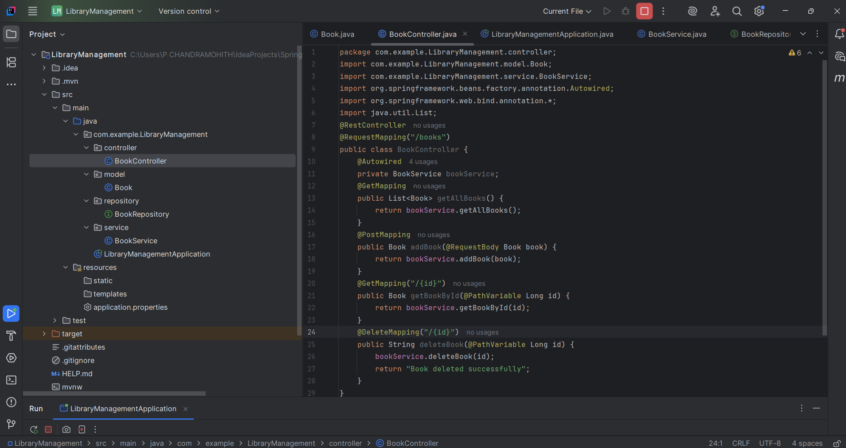 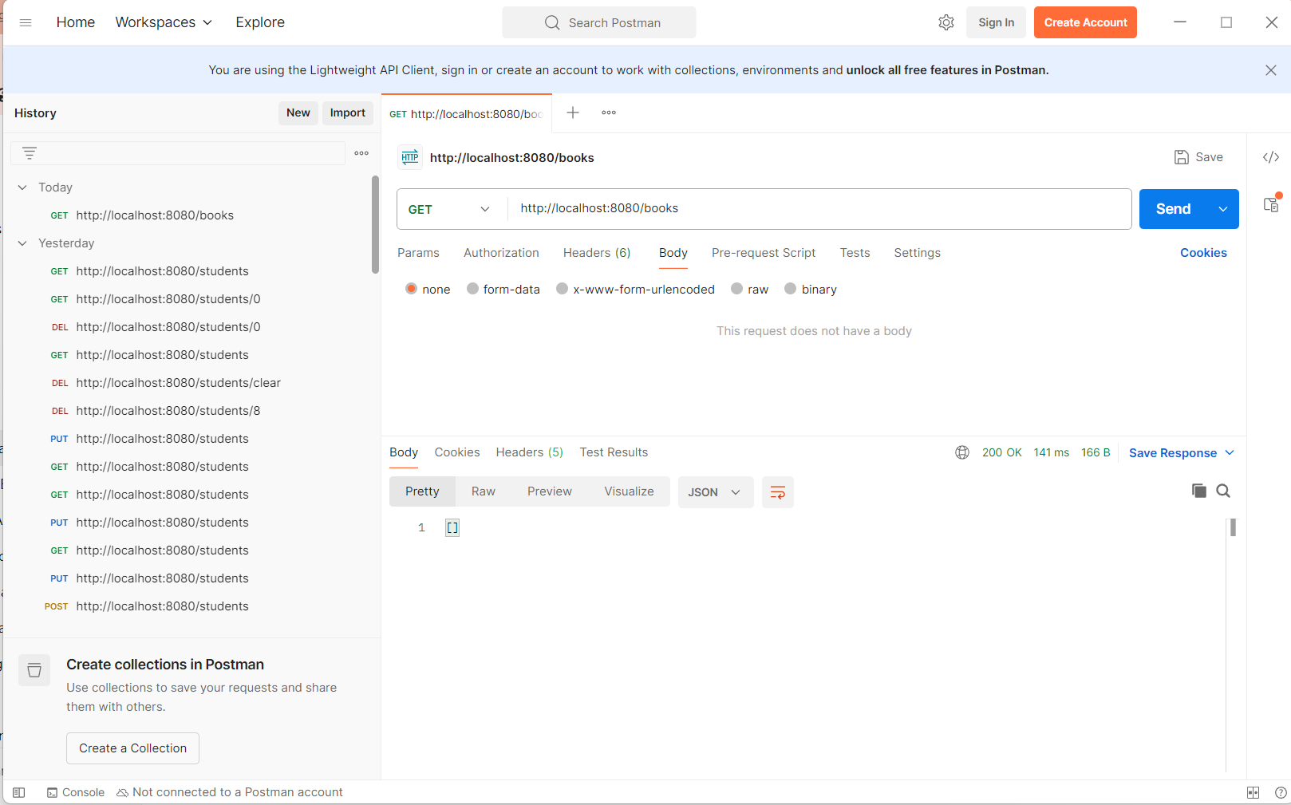 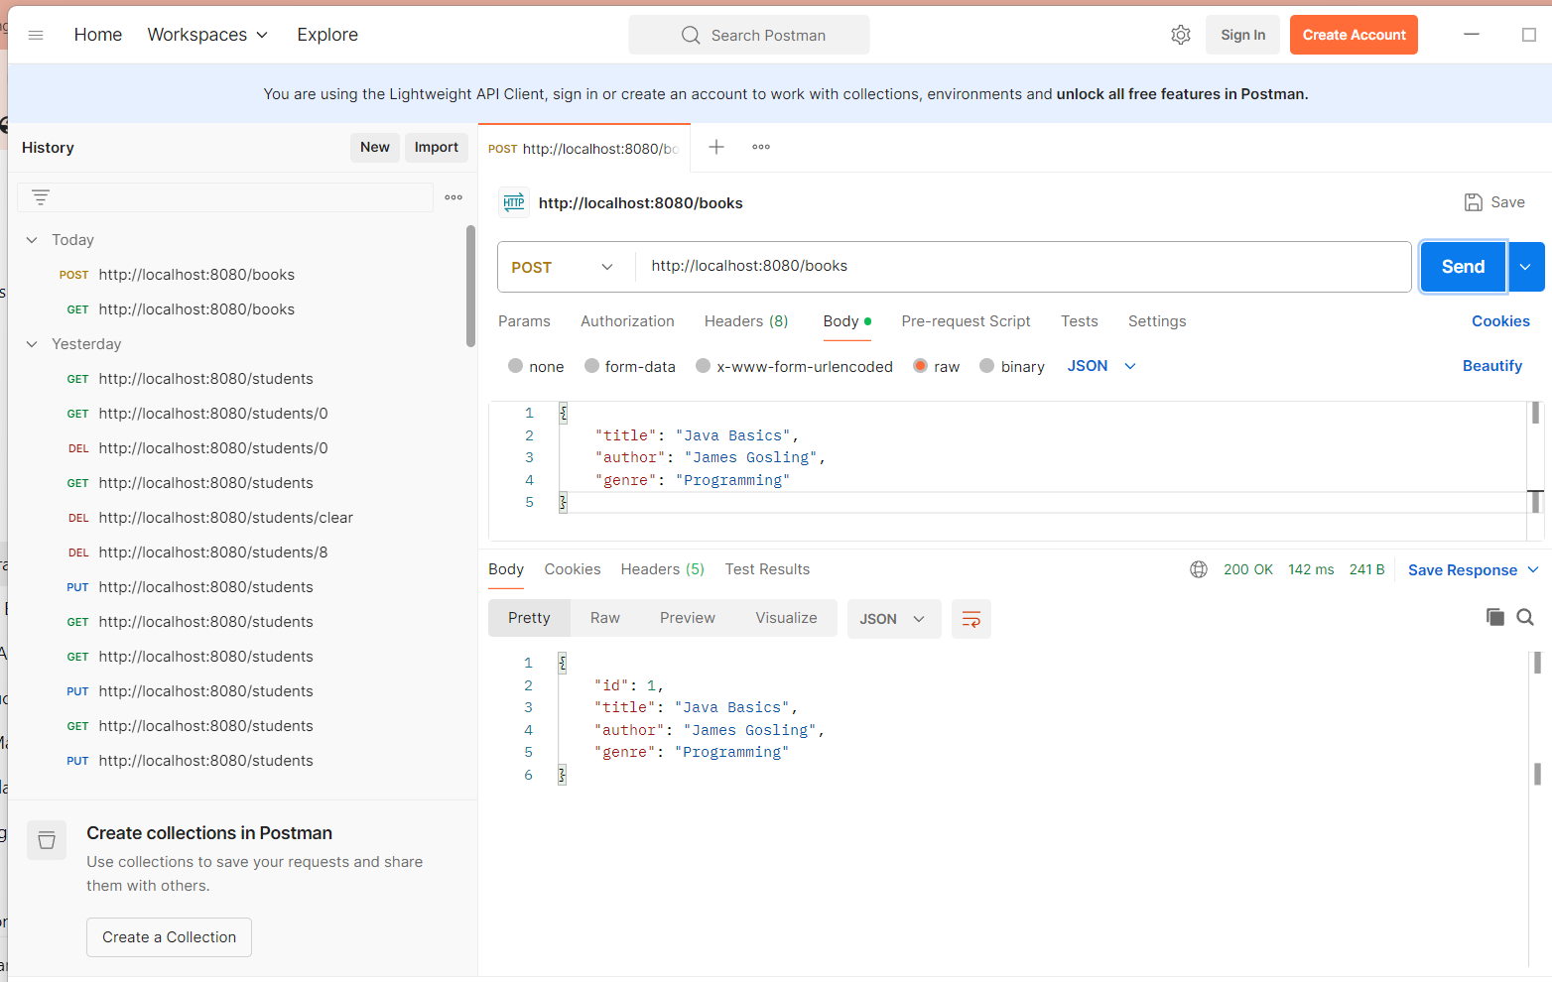 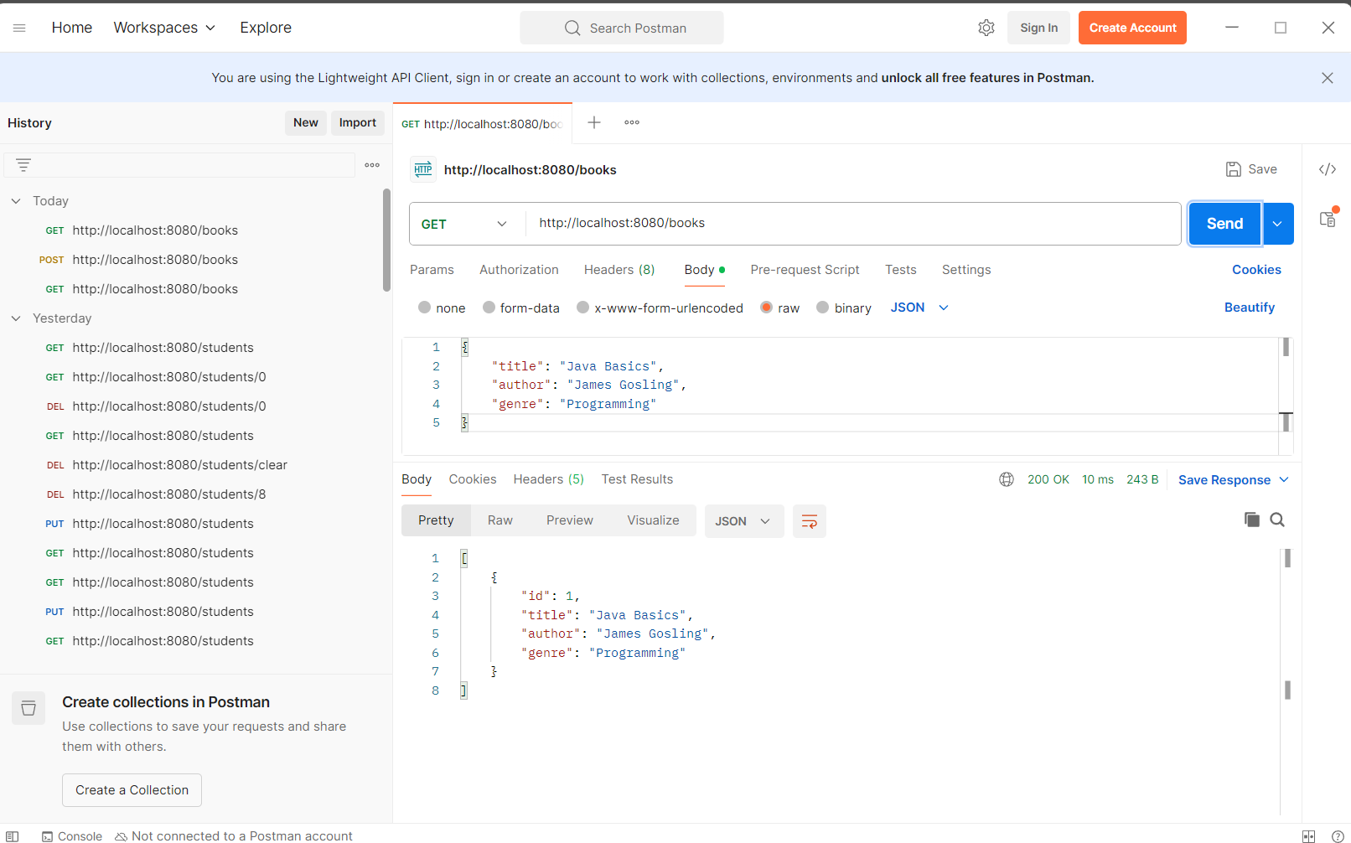 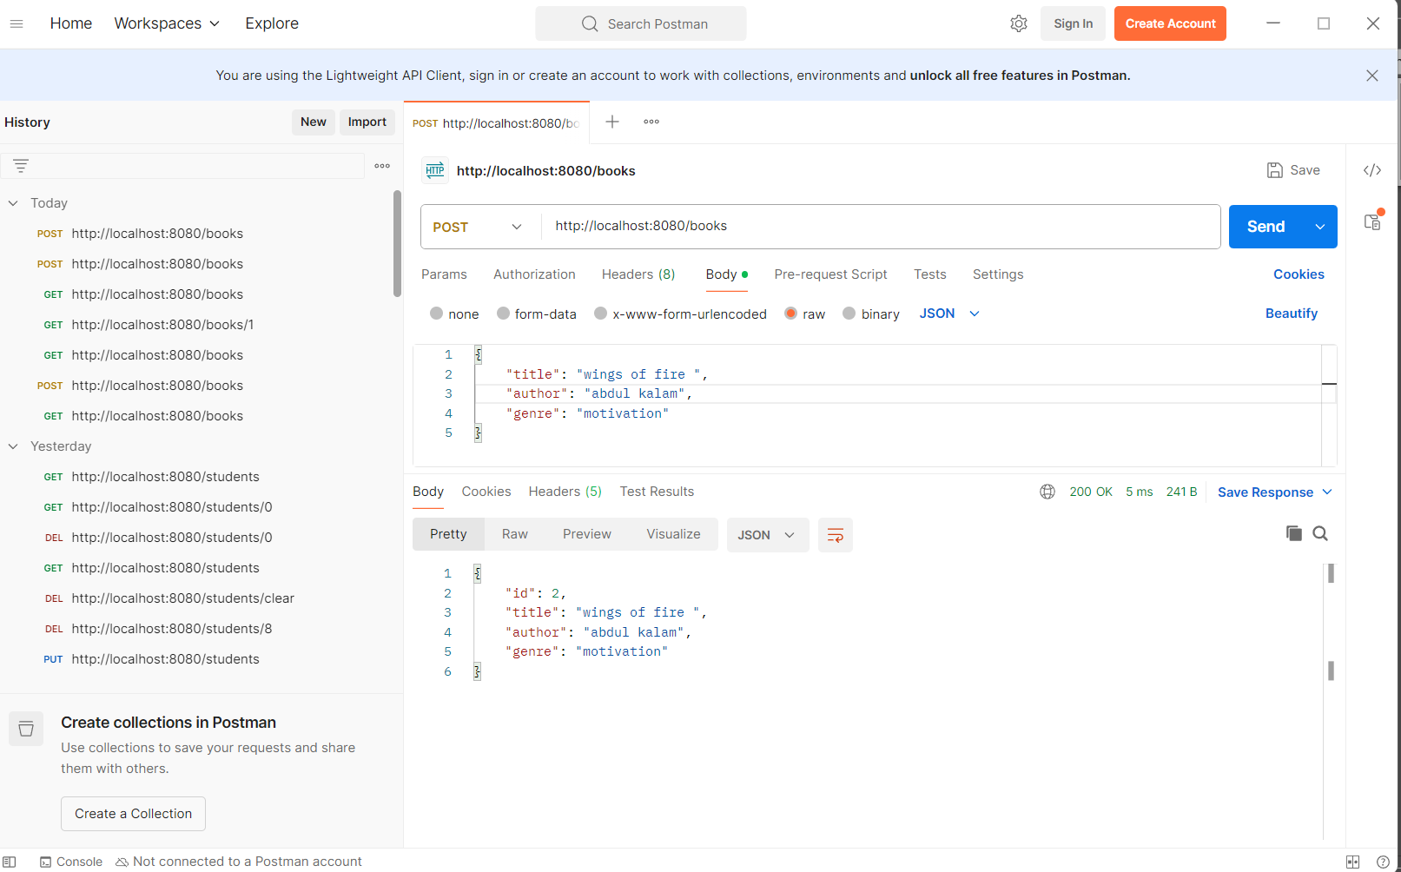 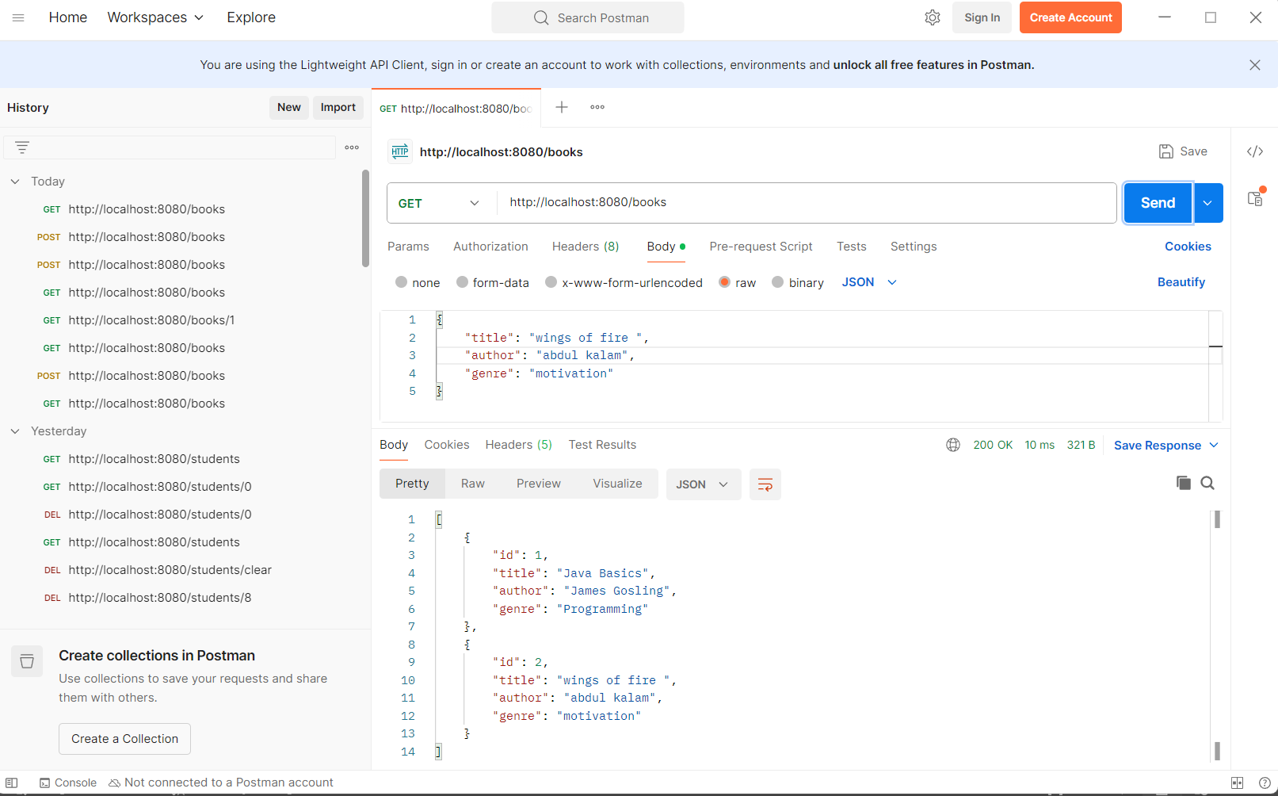 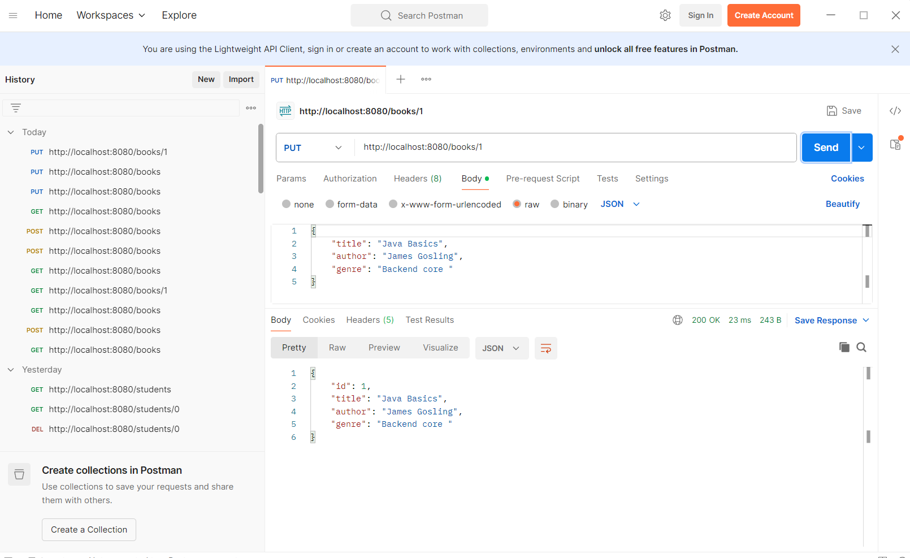 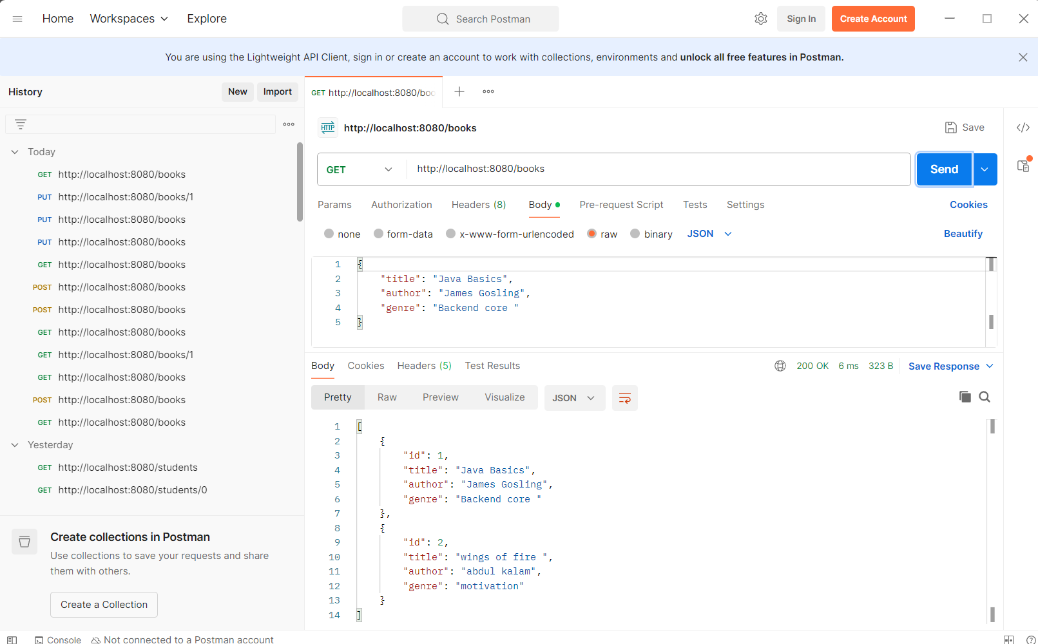 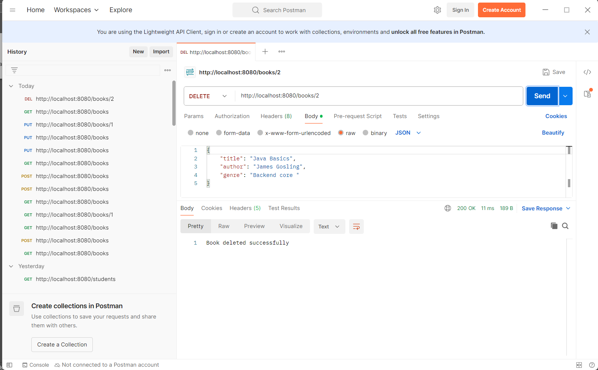 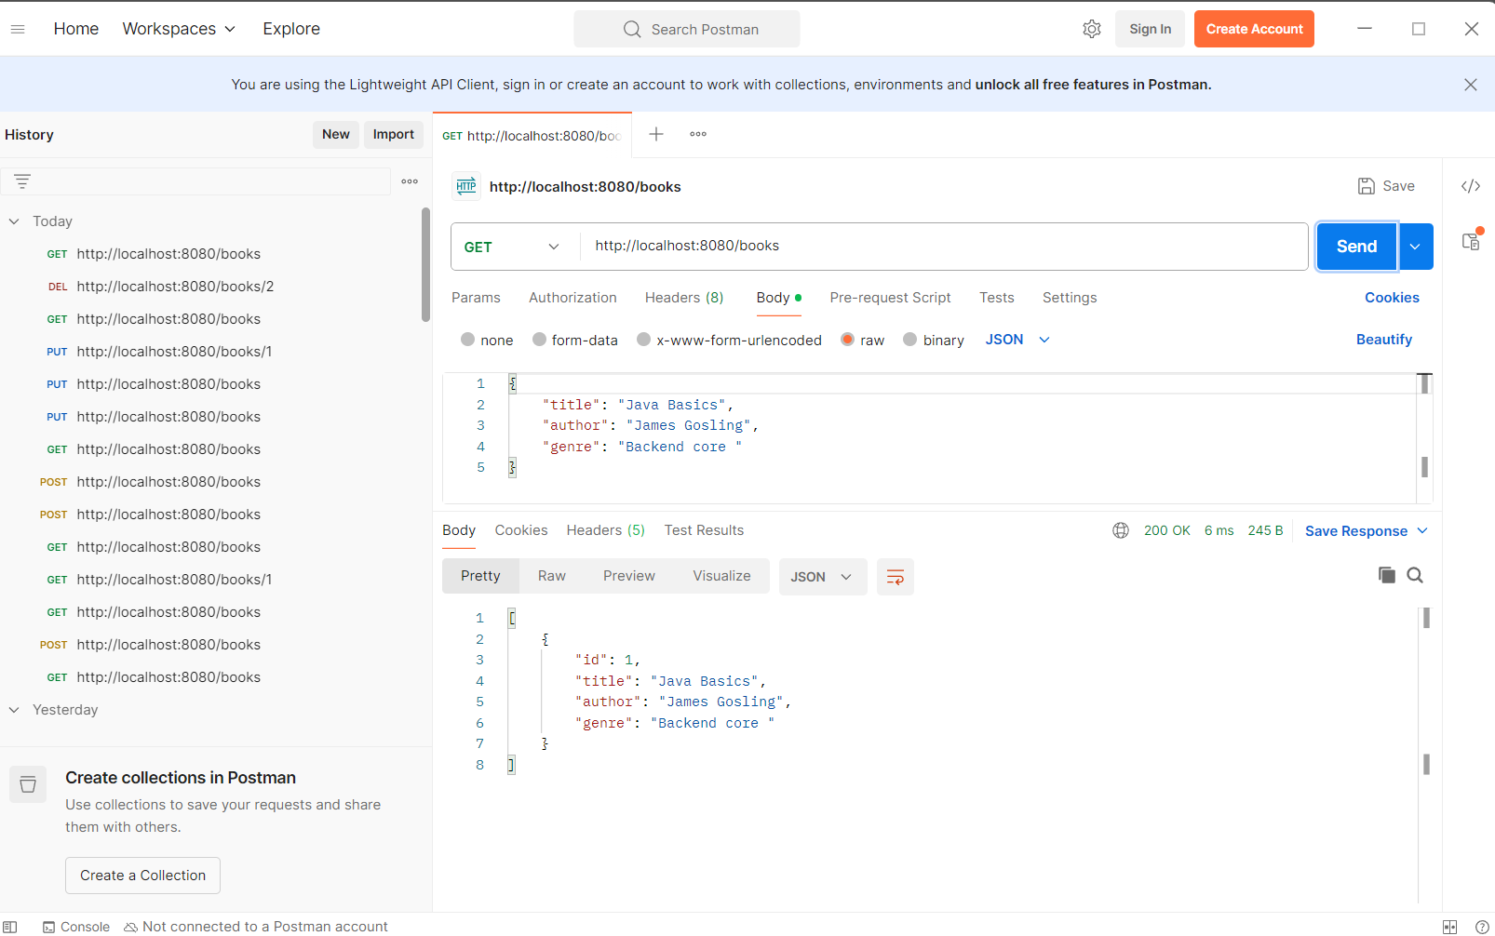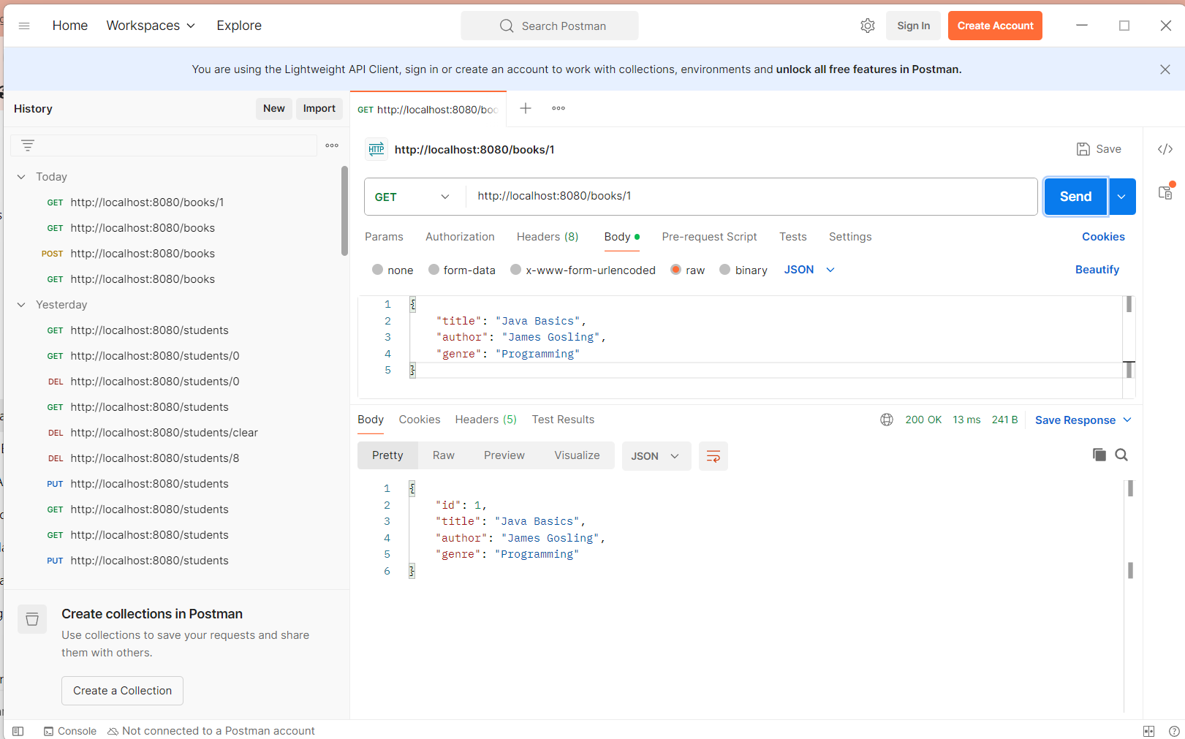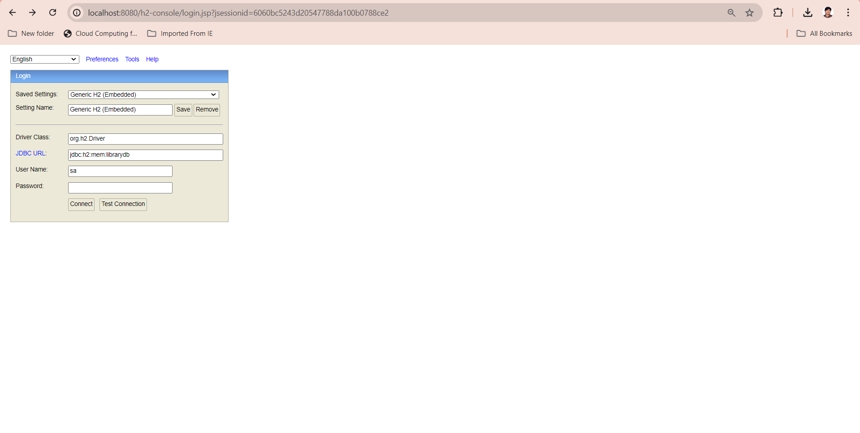 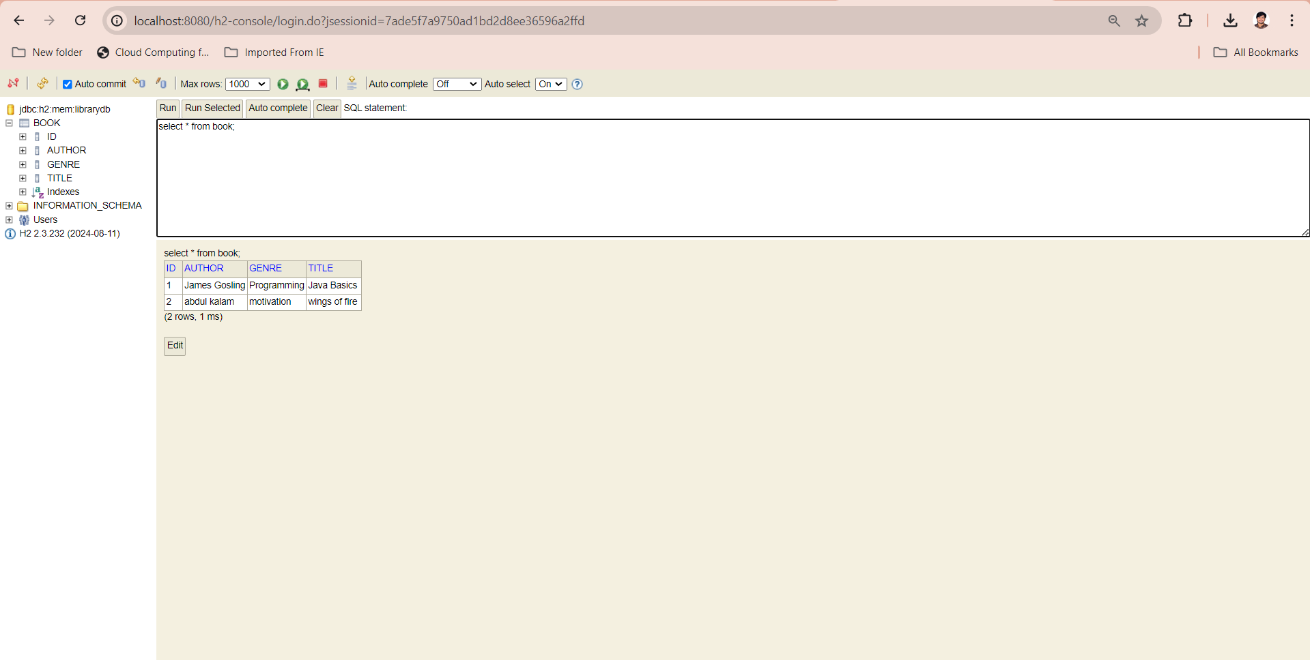

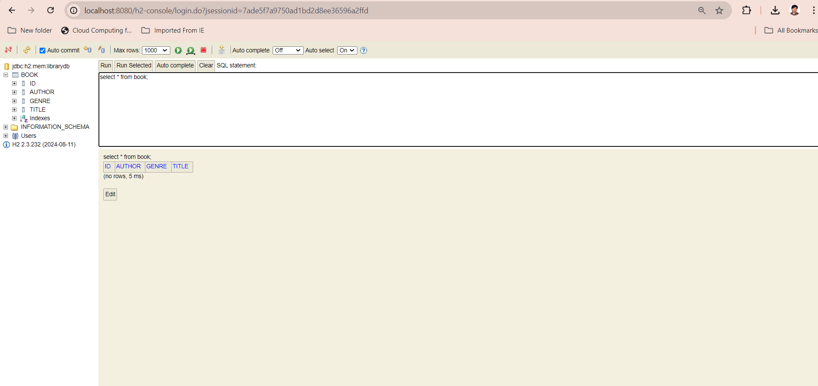 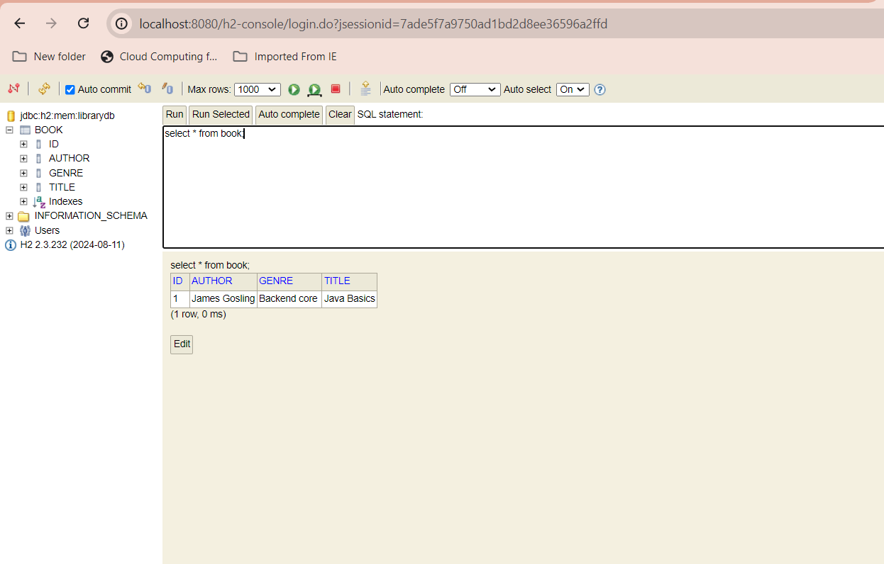

**Project Notes - Library Management System (Spring Boot)**

* **This project is a simple Library Management system built using Spring Boot.**
* **It uses Spring Web for building REST APIs.**
* **Spring Data JPA is used to handle database operations without writing SQL manually.**
* **We used an in-memory H2 Database, so no external setup is needed.**
* **Created a Book entity to store book details like title, author, and genre.**
* **BookRepository connects the entity to the database.**
* **BookService handles the logic between controller and repository.**
* **BookController provides REST endpoints to:**
  + **Add new books**
  + **View all books**
  + **View a book by ID**
  + **Update existing books**
  + **Delete books**
* **H2 Console is enabled to view and test the database directly at:**

**http://localhost:8080/h2-console**

* **REST APIs can be tested using Postman or browser.**
* **This project simplifies book management with minimal configuration and easy deployment.**