COACH METRICS
Mentor Activity Management System

Functional Requirements Document (FRD)

Document Version | 1.0
Date | April 2026
Document Type | Functional Requirements Document
Status | Draft
Classification | Internal Use Only

1. Document Information

1.1 Document Purpose
This Functional Requirements Document (FRD) describes the complete functional specifications, system behavior, user interface requirements, and user workflows for the Coach Metrics web-based application. It includes annotated wireframe screens for all primary pages and serves as the reference for development, QA, and stakeholder review.

1.2 Project Overview
Coach Metrics is a web-based application designed to streamline the management and monitoring of mentor activities within an organization. It provides an efficient platform to track mentor engagement, manage records, and generate analytical reports for informed decision-making.

1.3 Scope
The application covers the following functional areas:
- Admin module: Full control over mentor and coach profiles, performance reporting, and data export.
- Coach module: Operational management of mentor records, schedules, and cohort assignments.
- Shared functionality: Advanced search, filtering, and secure role-based access control.

1.4 Document Control

Version | Date | Author | Change Description | Approved By
1.0 | Apr 2026 | Project Team | Initial Draft | Pending

2. Introduction

2.1 Background
Organizations that conduct structured mentoring programs face challenges in tracking mentor-mentee interactions, measuring engagement, and reporting on outcomes. Manual tracking is error-prone and lacks real-time analysis capability. Coach Metrics was conceived to digitize and centralize all mentoring activity data within a secure, role-based web application.

2.2 Objectives
- Centralized platform for managing mentor profiles and activities.
- Enable administrators to monitor performance across departments and time periods.
- Allow coaches to manage mentor records, schedules, and cohort assignments.
- Support report generation and export in Excel and CSV formats.
- Implement advanced search and filter capabilities.

2.3 Definitions and Acronyms

Term / Acronym | Definition
FRD | Functional Requirements Document
Admin | Administrator user with full system access
Coach | User responsible for managing mentor operational records
Mentor | Subject being tracked; provides guidance to mentees
Cohort | A group of mentees assigned to a specific mentor in a period
SDET | Software Development Engineer in Test; a tracked department
.NET/C# | A development platform department tracked within the system
RBAC | Role-Based Access Control — security model restricting access by role
CSV | Comma-Separated Values; data export format

3. System Overview

3.1 User Roles

Role | Primary Responsibilities | Access Level
Admin | Full system control; manage profiles, view reports, export data | Full Access — all modules, reports, and settings
Coach | Manage mentor records, update schedules, assign cohorts | Restricted — operational module and assigned data only

3.2 Key Features

Feature | Admin | Coach
Manage Coach Profiles | Yes (Add / Edit / Delete) | No
Manage Mentor Records | Yes | Yes (Add / Edit / Delete)
View Performance Reports | Yes (all departments) | No
Time-Based Filters | Yes (Daily / Weekly / Monthly) | No
Export Data (Excel / CSV) | Yes | No
Manage Mentoring Schedules | Yes | Yes
Advanced Search & Filter | Yes | Yes

4. Functional Requirements

4.1 Authentication and Authorization

4.1.1 Requirements
Req. ID | Feature | Description | Priority
FR-AUTH-01 | User Login | Login screen with Username and Password fields. Users authenticate using valid credentials. | High
FR-AUTH-02 | Role Detection | System detects role (Admin/Coach) on login and redirects to correct dashboard. | High
FR-AUTH-03 | Invalid Credentials | Clear error message shown for incorrect credentials without revealing system details. | High
FR-AUTH-04 | Session Timeout | Session auto-expires after 30 minutes of inactivity; user redirected to login. | Medium
FR-AUTH-05 | Logout | Logout option terminates session and redirects to login page. | High
FR-AUTH-06 | RBAC | Users can only access modules and data permitted by their assigned role. | High

4.1.2 Screen: Login Page — Wireframe
The Login Screen is the secure entry point for all users. It presents a branded, minimal interface with credential inputs and primary authentication action.

Login Screen — UI Elements
① Username Field — Text input for entering username or email address.
② Password Field — Masked input with Show / Hide toggle for password visibility.
③ Remember Me checkbox and Forgot Password hyperlink.
④ Login Button — Primary CTA; full-width, submits credentials for authentication.
⑤ Error Message Area — Inline validation block shown below form on failed login attempts.
Top bar shows the application URL in the browser chrome for context.

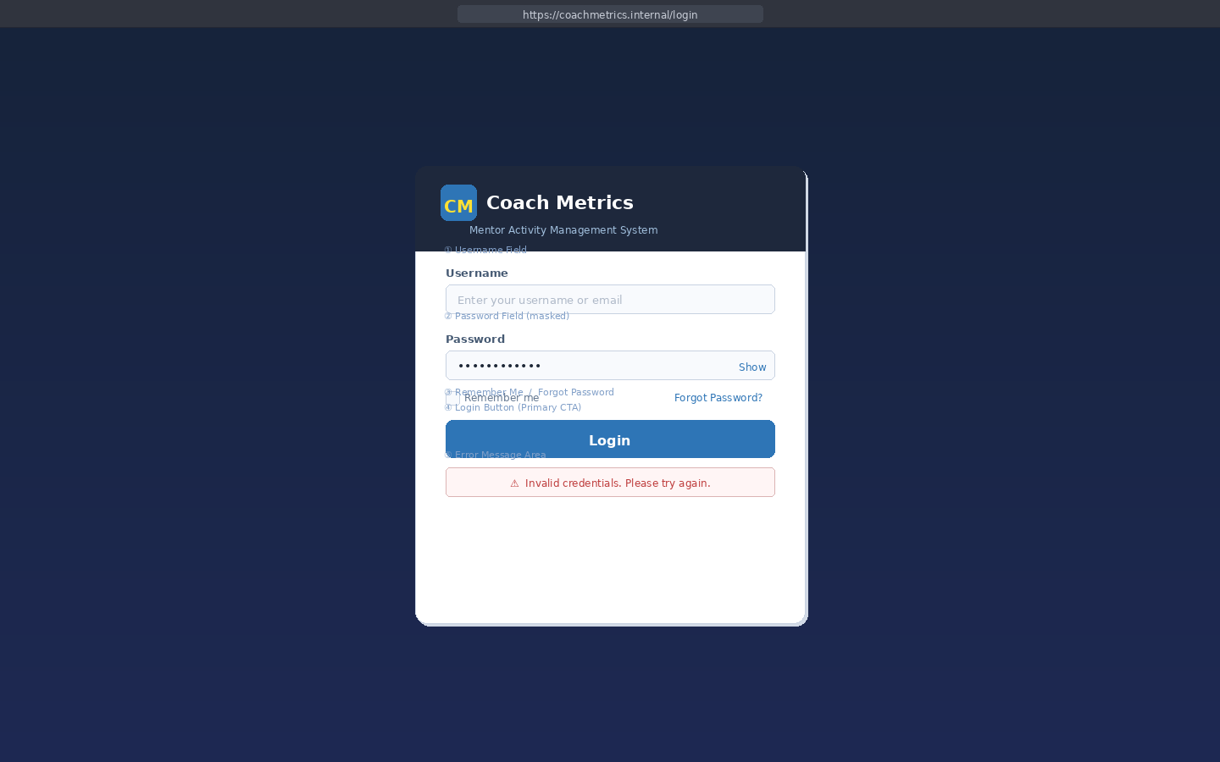
Figure 1 — Coach Metrics: Login Page Wireframe

4.2 Admin Module

4.2.1 Admin Dashboard — Requirements
Req. ID | Feature | Description | Priority
FR-ADM-01 | KPI Cards | Dashboard displays 4 summary cards: Total Mentors, Active Coaches, SDET Count, .NET/C# Count. | High
FR-ADM-02 | Navigation | Sidebar links: Dashboard, Coach Mgmt, Mentor Mgmt, Reports, Settings. | High
FR-ADM-03 | Quick Actions | Buttons for Add Coach, View Reports, Add Mentor. | Medium
FR-ADM-04 | Recent Activity | Live feed of latest CUD events with user and timestamp. | Medium
FR-ADM-05 | Dept. Summary | Bar chart showing mentor distribution across SDET and .NET/C#. | Medium
FR-ADM-06 | Upcoming Sessions | Mini list of next 3 upcoming mentoring sessions. | Low

4.2.2 Screen: Admin Dashboard — Wireframe
The Admin Dashboard is the operational hub. It presents KPI summary cards, quick-action buttons, a recent activity feed, a department distribution chart, and upcoming sessions — all accessible from a single view.

Admin Dashboard — UI Elements
Top Bar — 'CM' logo, 'Coach Metrics' title, ADMIN role badge, username, Logout button.
Left Sidebar — Navigation: Dashboard (active), Coach Mgmt, Mentor Mgmt, Reports, Settings.
KPI Cards (row of 4) — Total Mentors, Active Coaches, SDET Dept., .NET/C# Dept. with color indicators.
Quick Actions — Buttons: '+ Add Coach', 'View Reports', '+ Add Mentor'.
Recent Activity Panel — Tabular event log: Activity description, User, Date & Time, color-coded dots.
Department Summary Panel — Named bar indicators showing mentor count and percentage per dept.
Upcoming Sessions Panel — Compact list of next sessions with mentor name, date, time slot, View button.

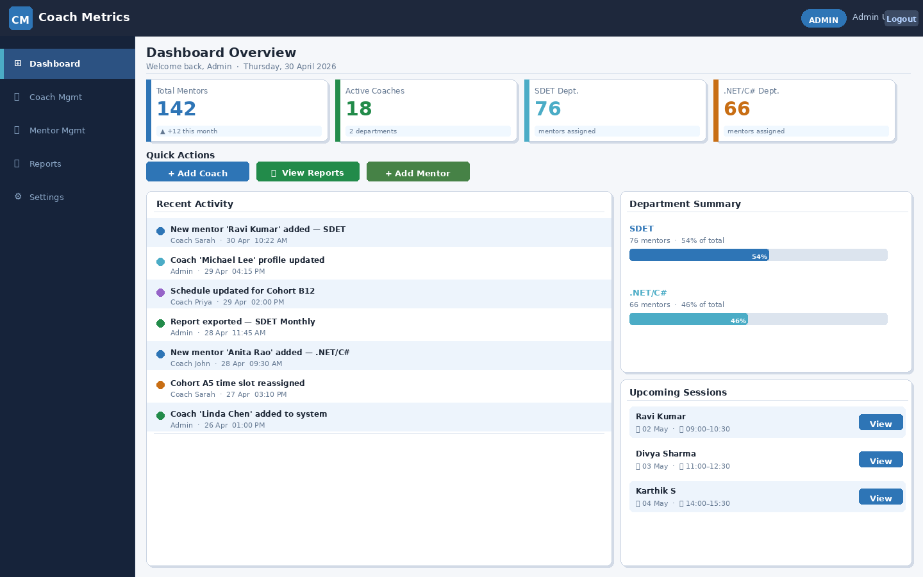
Figure 2 — Coach Metrics: Admin Dashboard Wireframe

4.2.3 Coach Profile Management — Requirements
Req. ID | Feature | Description | Priority
FR-ADM-07 | View Coach List | Paginated list with: #, Name, Email, Department, Contact, Status, Actions. | High
FR-ADM-08 | Search & Filter | Real-time name search; Department and Status dropdown filters. | High
FR-ADM-09 | Stats Bar | Summary row: Total, Active, Inactive, Departments. | Medium
FR-ADM-10 | Add Coach | Modal form: Full Name, Email, Department, Contact, Status. Email uniqueness validated. | High
FR-ADM-11 | Edit Coach | All fields editable via pre-filled modal. Saved on confirmation. | High
FR-ADM-12 | Delete Coach | Confirmation dialog before deletion. Deleted coaches lose login access. | High

4.2.4 Screen: Coach Management Page — Wireframe
The Coach Management page gives Admins a complete view of all registered coaches with inline search, filters, and per-row action buttons for editing and deletion.

Coach Management — UI Elements
Search Bar — Real-time text input filtering coaches by name or email.
Department Dropdown — Filters list to SDET or .NET/C#.
Status Dropdown — Filters by Active / Inactive.
Stats Bar — 4 KPI mini-cards: Total Coaches, Active, Inactive, Departments.
'+ Add Coach' Button — Opens modal form to create a new coach profile.
Data Table — Columns: #, Full Name, Email Address, Department (badge), Contact, Status (badge), Actions.
Department Badge — Color coded: SDET (dark blue), .NET/C# (light blue).
Status Badge — Color coded: Active (green), Inactive (red).
Action Buttons — 'Edit' (blue) and 'Delete' (red) per row.
Pagination — Page controls showing record range and total count.

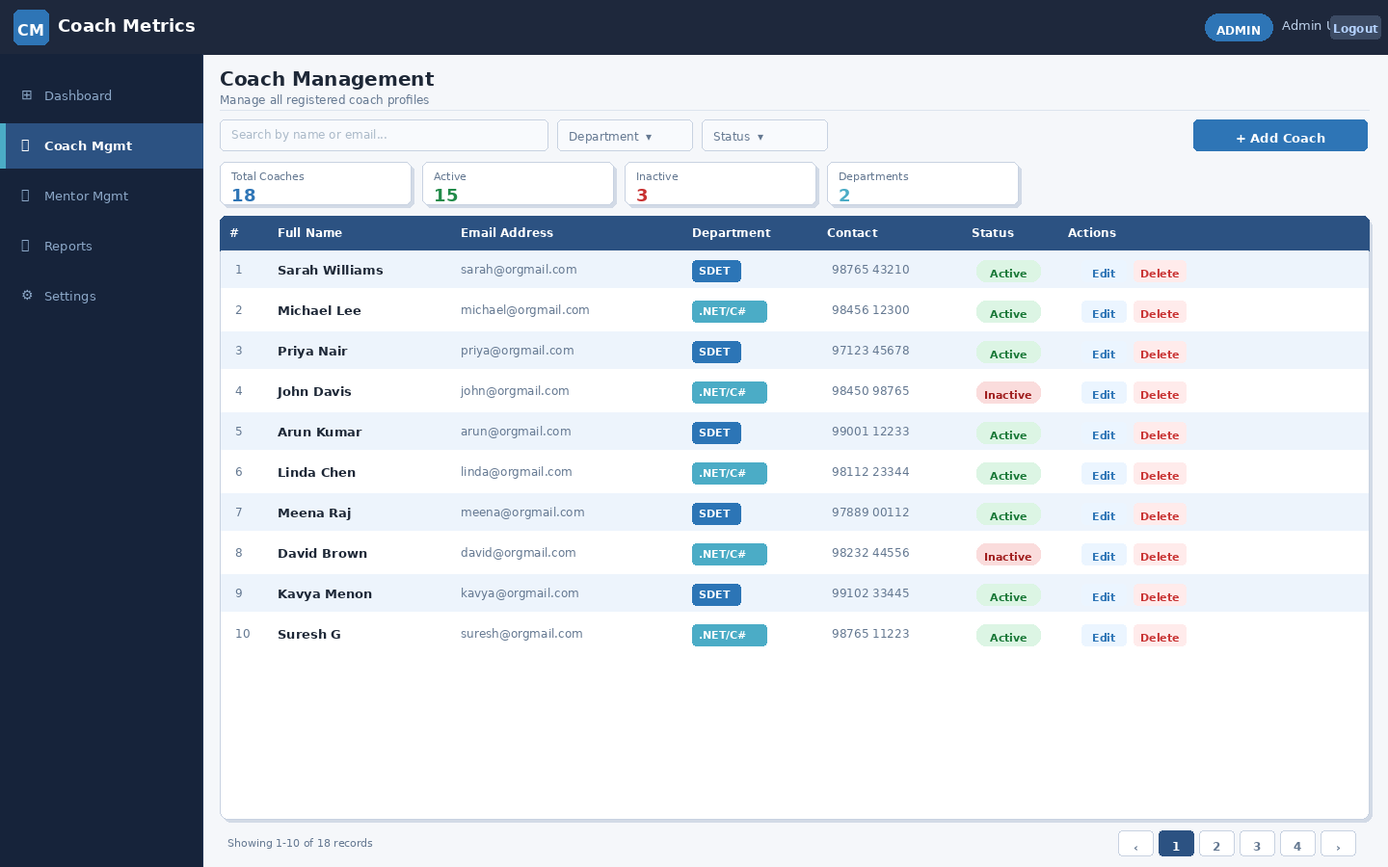
Figure 3 — Coach Metrics: Coach Management Page Wireframe (Admin)

4.2.5 Performance Reports — Requirements
Req. ID | Feature | Description | Priority
FR-ADM-13 | Filter Panel | Inline filter bar: Department dropdown, Time Period tabs, Date Range picker. | High
FR-ADM-14 | Time Period Tabs | Tab selector: Daily / Weekly / Monthly (one active at a time). | High
FR-ADM-15 | KPI Summary Row | 4 KPI cards: Total Sessions, Total Hours, Mentors Tracked, Avg Hrs/Session. | Medium
FR-ADM-16 | Report Table | Columns: Mentor Name, Department, Cohort, Sessions, Hours, Avg Duration, Coach. | High
FR-ADM-17 | Totals Row | Bold aggregate row at table bottom showing session and hour totals. | Medium
FR-ADM-18 | Export Excel | Exports filtered data as .xlsx file with all visible columns. | High
FR-ADM-19 | Export CSV | Exports filtered data as .csv file. | High

4.2.6 Screen: Performance Reports Page — Wireframe
The Reports page provides analytical insights into mentoring engagement. Admins select filters and export data directly from this screen.

Reports Screen — UI Elements
Filter Panel (top bar) — Department dropdown, Time Period tabs (Daily/Weekly/Monthly), Date Range picker.
Export Buttons — 'Export Excel' (green) and 'Export CSV' (orange) at top-right corner.
KPI Summary Row — 4 cards: Total Sessions, Total Hours, Mentors Tracked, Avg. Hrs/Session.
Report Table — Columns: Mentor Name, Department (badge), Cohort, Total Sessions (badge), Total Hours (green), Avg. Duration, Coach.
Alternating Row Colors — Blue-tinted alternating rows for readability.
Totals Row — Bold aggregate summary row with blue top border, bottom of table.
Pagination — Page controls; record range and total displayed bottom-left.

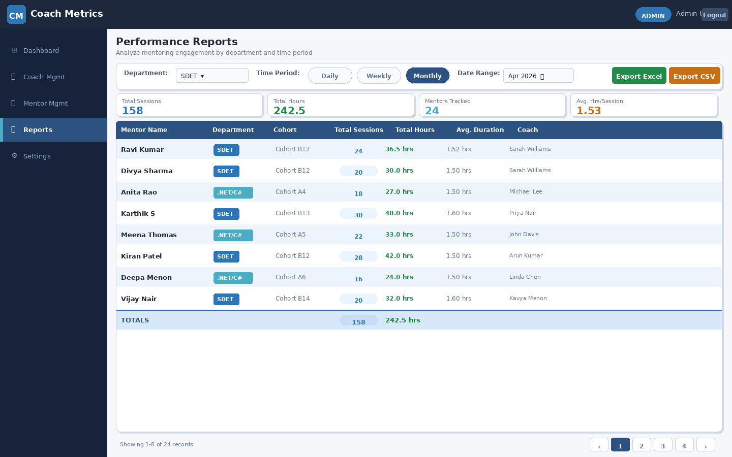
Figure 4 — Coach Metrics: Performance Reports Page Wireframe (Admin)

4.3 Coach Module

4.3.1 Mentor Management — Requirements
Req. ID | Feature | Description | Priority
FR-COA-01 | KPI Cards | 4 summary cards: My Mentors, Sessions This Month, Upcoming Sessions, Cohorts Assigned. | High
FR-COA-02 | View Mentor List | Paginated list of mentors assigned to logged-in coach. | High
FR-COA-03 | Search & Filter | Name search, Department filter, Cohort filter; Clear button to reset. | High
FR-COA-04 | Add Mentor | Form: Name, Dept, Cohort, Email, Contact, Session Date, Time Slot, Notes. | High
FR-COA-05 | Edit Mentor | All fields editable. System re-validates on save. | High
FR-COA-06 | Delete Mentor | Confirmation prompt before permanent deletion. | High
FR-COA-07 | Data Isolation | Coach can only see and manage records assigned to their account. | High
FR-COA-08 | Conflict Detection | Alert shown if new time slot conflicts with existing slot for same mentor. | High
FR-COA-09 | Time Slot Badge | Each row shows assigned time slot as a styled badge for visual clarity. | Medium

4.3.2 Screen: Mentor Management Page — Wireframe
The Mentor Management page is the coach's primary operational screen. It features full CRUD controls for mentor records, schedule date/time assignment, cohort selection, and advanced filtering — all within one dedicated page.

Mentor Management — UI Elements
Top Bar — 'CM' logo, 'Sarah Williams' (Coach name), COACH role badge, Logout.
Left Sidebar — Restricted 3-item menu: Dashboard, Mentor Mgmt (active), Schedule.
KPI Cards (row of 4) — My Mentors, Sessions This Month, Upcoming Sessions, Cohorts Assigned.
Search Bar — Real-time mentor name search input.
Filter Dropdowns — Department filter, Cohort filter; 'Clear' reset button.
'+ Add Mentor' Button — Opens the Add Mentor form (top-right).
Data Table — Columns: #, Mentor Name (bold), Department (badge), Cohort, Session Date, Time Slot (styled badge), Notes, Actions.
Time Slot Badge — Light blue pill badge showing scheduled time window per row.
Action Buttons — 'Edit' (blue) and 'Delete' (red) inline per row.
Pagination — Page controls; showing record range and total at bottom.

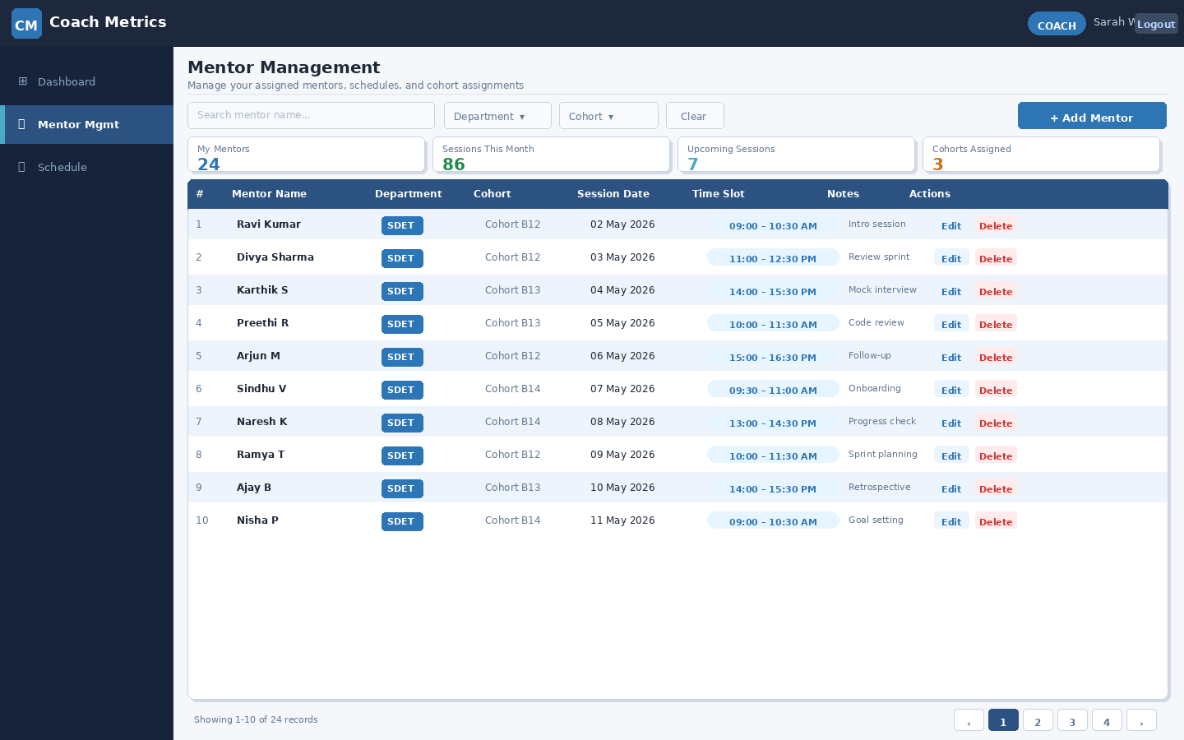
Figure 5 — Coach Metrics: Mentor Management Page Wireframe (Coach)

5. Search and Filter Functionality

Req. ID | Feature | Description | Priority
FR-SRF-01 | Search by Name | Real-time name search; results update as user types. | High
FR-SRF-02 | Filter by Department | Dropdown filter: SDET or .NET/C#. | High
FR-SRF-03 | Filter by Cohort | Filter by cohort name or number. | High
FR-SRF-04 | Combined Filters | Multiple filters can be applied simultaneously. | Medium
FR-SRF-05 | Clear Filters | 'Clear' button resets all active filters. | Medium
FR-SRF-06 | No Results State | 'No results found' shown when no records match. | Low
FR-SRF-07 | Pagination | Default 10 records per page with navigation controls. | Medium
FR-SRF-08 | Column Sorting | Click column headers to sort ascending / descending. | Medium

6. Data Export

Req. ID | Feature | Description | Priority
FR-EXP-01 | Export to Excel | Export active filtered report as .xlsx. | High
FR-EXP-02 | Export to CSV | Export active filtered report as .csv. | High
FR-EXP-03 | File Naming | CoachMetrics_Report_[Filter]_[Date].xlsx/csv | Medium
FR-EXP-04 | Filter Scope | Only data visible with active filters is exported. | High
FR-EXP-05 | Instant Download | File downloaded to browser immediately on click. | High

7. Non-Functional Requirements

7.1 Performance
- Pages load within 3 seconds under normal conditions.
- Search/filter results return within 1 second for up to 10,000 records.
- Report generation completes within 5 seconds for up to 12 months of data.

7.2 Security
- All data transmissions use HTTPS/TLS encryption.
- Passwords stored using strong hashing (bcrypt or equivalent).
- RBAC enforced — users cannot access unauthorized modules.
- Session tokens expire after 30 minutes of inactivity.
- All CUD operations logged with user ID and timestamp.

7.3 Usability
- Any primary feature reachable within 2 clicks from the dashboard.
- Responsive for desktop and tablet viewports.
- Form validation feedback displays in real-time.

7.4 Reliability
- System targets 99.5% uptime during business hours.
- Supports minimum 100 concurrent users without degradation.
- Daily backups with RPO of 24 hours.

8. Key Workflows

8.1 Admin: Add Coach
- Admin logs in → navigates to Coach Management.
- Clicks '+ Add Coach'.
- Fills form fields (Name, Email, Department, Status) → clicks Save.
- System validates fields. Shows inline errors if invalid.
- On success: coach saved, list refreshed, success notification shown.

8.2 Admin: Generate & Export Report
- Admin navigates to Reports page.
- Selects Department and Time Period (e.g., Monthly) → clicks Apply Filters.
- System renders filtered report table with KPI summary.
- Admin clicks 'Export Excel' or 'Export CSV'.
- File generated and downloaded immediately.

8.3 Coach: Add and Schedule a Mentor
- Coach logs in → navigates to Mentor Management.
- Clicks '+ Add Mentor'.
- Fills: Name, Department, Cohort, Session Date, Time Slot, Notes.
- System validates and checks for time slot conflicts.
- If conflict: alert displayed with conflicting slot highlighted.
- On success: mentor record saved, list refreshed.

9. Assumptions and Constraints

9.1 Assumptions
- Modern browser required (Chrome, Firefox, Edge, Safari — latest 2 versions).
- User accounts created by Admin; self-registration not supported.
- Departments limited to SDET and .NET/C# at v1.0.
- Sessions tracked manually; calendar integration is out of scope for v1.0.

9.2 Out of Scope for v1.0
- Email/SMS notifications for upcoming sessions.
- Mobile application (iOS/Android).
- Mentee-facing self-service portal.
- Integration with external HR or LMS platforms.
- AI-powered analytics or recommendations.

10. Acceptance Criteria

10.1 Authentication
- Valid credentials log in and redirect users to correct role dashboard.
- Invalid credentials show clear error without revealing system details.
- Sessions expire on inactivity and redirect to login.

10.2 Admin Module
- Admin adds, edits, deletes coach profiles with full field validation.
- Reports filter correctly by Department and Time Period.
- Exports produce correct .xlsx and .csv files reflecting active filters.

10.3 Coach Module
- Coach adds, edits, deletes mentor records on the Mentor Management page.
- Schedules include date, time slot, cohort — with conflict detection active.
- Coaches see and modify only their own records.

10.4 Search & Filter
- Name search returns accurate real-time results.
- Department and cohort filters work independently and combined.
- 'No results found' state displays when no records match.

11. Revision History

Version | Date | Author | Changes | Reviewed By
1.0 | Apr 2026 | Project Team | Initial Document Creation | Pending

End of Document

