Date Time
Import java.time.*

Creating object:
LocalDate ld=LocalDate.now()
LocalDateTime ldt=LocalDateTime.now()
LocalDate ld=LocalDate.of(2006,08,18)
LocalDateTime ldt=LocalDateTime.of(2004,05,12,11,30,30)
Methods:
1)Boolean methods:
ld.isLeapYear() -> return t/f for leap year
ld.isBefore(ld2), ld.isAfter(ld2) -> return t/f
ld.isEqual(ld2)-> compare 2 ld
2)Altering value:
.plusDays(long days) → Adds days.
.plusWeeks(long weeks) → Adds weeks.
.plusMonths(long months) → Adds months.
.plusYears(long years) → Adds years.
.minusDays(long days) → Subtracts days.
.minusWeeks(long weeks) → Subtracts weeks.
.minusMonths(long months) → Subtracts months.
.minusYears(long years) → Subtracts years.
.minusYears(long years)
.plusHours(long hours) → Adds hours.
.plusMinutes(long minutes) → Adds minutes.
.plusSeconds(long seconds) → Adds seconds.
.minusHours(long hours)-> Substract hours
.minusMinutes(long minutes) -> Substract minutes
.minusSeconds(long seconds) -> Substract seconds
3) Getters:
.getYear() → Returns the year (e.g., 2026).
.getMonth() → Returns the Month enum (e.g., APRIL).
.getMonthValue() → Returns the month as an int (1–12).
.getDayOfMonth() → Returns the day of the month (1–31).
.getDayOfWeek() → Returns the DayOfWeek enum (e.g., MONDAY).
.getDayOfYear() → Returns the day number in the year (1–365/366).

4)Parsing String:
Import java.time.format.*
1) LocalDate ld=LocalDate.parse(“2004-08-18”) -> direct parsing only in format yyyy-mm-dd
2) using DateTimeFormatter: (MM because mm means minutes)
DateTimeFormatter formatter=DateTimeFormatter.ofPattern(“MM-dd-yyyy”)
LocalDate ld=LocalDate.parse(“08-18-2004”,formatter);

Formets-> dd-MM-yyyy, yyyy-MM-dd, MM/dd/yyyy, yyyy/dd/MM

Questions

1️⃣ Check if years are leap years
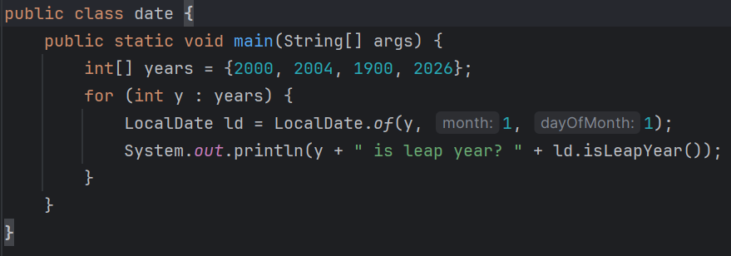
2️⃣ Compare two LocalDate object
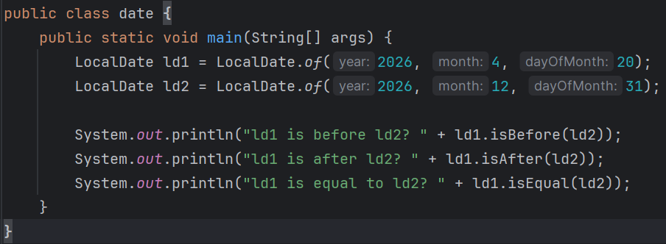
3️⃣ Compare today’s date with your birthday
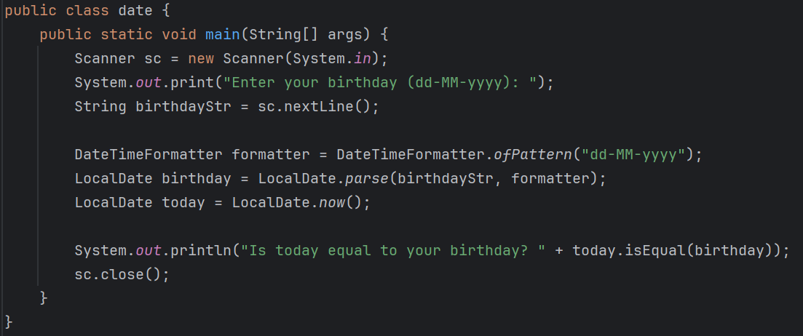

4️⃣ Date after 1000 days
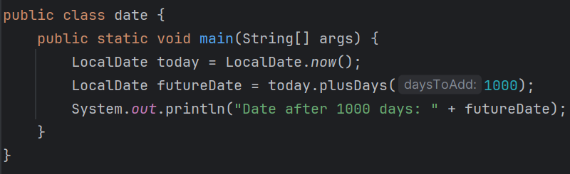
5️⃣ Birthday day of week for next 10 years
