

IMAGE SCRAPING AND CLASSIFICATION PROJECT

Submitted by:

Gurdhati .Chandramouli

# ACKNOWLEDGMENT

I would like to express my special thanks of gratitude to “FlipRobo

Technologies” that made this project possible. I would like thank my SME

Mr.Swethank Mishra for his guidance in building this project. I would also like to thank Data Trained Institution to making me capable of making

proper decisions in the field of damascene and Machine learning. Lastly, I would like to thank my parents to make all of this happen.

# INTRODUCTION

## • Business Problem Framing

Classification is a systematic arrangement in groups and categories based on its features. Image classification came into existence for decreasing the gap between the computer vision and human vision by training the computer with the data. The image classification is achieved by differentiating the image into the prescribed category based on the content of the vision. We use Deep Learning to accomplish the task of image Classification.

In this project we have to classify whether is image is of a jeans , a trouser or a saree. We could we such model either for automatic segmentation of items using IOT and techniques for Industry 4.0

## Conceptual Background of the Domain Problem

Deep learning (DL) is a sub field to the machine learning, capable of learning through its own method of computing. A deep learning model is introduced to persistently break down information with a homogeneous structure like how a human would make determinations. To accomplish this, deep learning utilizes a layered structure of several algorithms expressed as an artificial neural system (ANN). The architecture of an ANN is simulated with the help of the biological neural network of the human brain. This makes the deep learning most capable than the standard machine learning models.

In deep neural networks every node decides its basic inputs by itself and sends it to the next tier on behalf of the previous tier. We train the data in the networks by giving an input image and conveying the network about its output. Neural networks are expressed in terms of number of layers involved for producing the inputs and outputs and the depth of the neural network.

## • Review of Literature

Recently, image classification is growing and becoming a trend among technology developers especially with the growth of data in different parts of industry such as e-commerce, automotive, healthcare, and gaming. The most obvious example of this technology is applied to Facebook. Facebook now can detect up to 98% accuracy in order to identify your face with only a few tagged images and classified it into your Facebook’s album. The technology itself almost beats the ability of human in image classification or recognition.

One of the dominant approaches for this technology is deep learning. Deep learning falls under the category of Artificial Intelligence where it can act or think like a human. Normally, the system itself will be set with hundreds or maybe thousands of input data in order to make the ‘training’ session to be more efficient and fast. It starts by giving some sort of ‘training’ with all the input data (Faux & Luthon, 2012).

Image classification has become a major challenge in machine vision and has a long history with it. The challenge includes a broad intra-class range of images caused by color, size, environmental conditions and shape. It is required big data of labelled training images and to prepare this big data, it consumes a lot of time and cost as for the training purpose only

In this project we will be using a transfer learning state of the art model for getting the best results that is VGG 16. Which was a winner in the ImageNet competition.

## • Motivation for the Problem Undertaken

The problem was undertaken in order to classify images efficiently using best deep learning algorithms and data augmentation techniques.

# Analytical Problem Framing

## • Mathematical/ Analytical Modelling of the Problem

We have scraped images of all 3 classes that is men jeans, men trouser and saree from the internet and we have built our model by training it on this data.

We have used transfer learning to get state of the art results for our model.

## • Data Sources and their formats

Data has been scraped from amazon.com using a python script which with selenium. All the data is in the .jpg image format.

We have over 250 images per class.

## • Data Pre-processing Done

We have first labelled the image data.

We have manually removed irrelevant images that were downloading via the script

We have removed the duplicate images using a script.

We have also performed multiple data augmentation techniques in order to train the model better or multiple angles and orientation of the same image.

## • Data Inputs- Logic- Output Relationships

We have given raw yet cleaned images to the machine learning model and the output produced is a label of the image on which the model is predicted

• State the set of assumptions (if any) related to the problem under consideration

NO relevant assumptions

## • Hardware and Software Requirements and Tools Used • Hardware and Software Requirements and Tools Used

Hardware Required:

* A computer with a processor i3 or above.
* More than 4 GB of Ram.
* GPU preferred.
* Around 100 Mib of Storage Space.

Software Required:

* Python 3.6 or above
* Jupyter Notebook.
* Google Collab.

Tools/Libraries Used:

1. Computing Tools:

* Numpy
* Pandas
* Tensorflow

2. Visualizing Tools:

• Matplotlib

3. Saving Tools:

• keras.savemodel

# Model/s Development and Evaluation

## • Identification of possible problem-solving approaches (methods)

We will be first scraping the data from amazon and then cleaning the data to be further used for training the model.

Then splitting the data into train and test set to model evaluation.

We would use VGG16, A transfer learning SOTA model for training our data on.

We would perform multiple data augmentation techniques on the images for better generalization of our model.

We could check and identity an optimal batch size and number of epoch to Train the model using trial and error method also keeping the epoch loss for both training set and validation in mind.

• Testing of Identified Approaches (Algorithms)

Listing down all the algorithms used for the training and testing.

## • Run and Evaluate selected models

Model summary:

Model: "model_4"

_________________________________________________________________

Layer (type) Output Shape Param # ================================================================= input_5 (InputLayer) [(None, 256, 256, 3)] 0 _________________________________________________________________ block1_conv1 (Conv2D) (None, 256, 256, 64) 1792 _________________________________________________________________ block1_conv2 (Conv2D) (None, 256, 256, 64) 36928 _________________________________________________________________ block1_pool (MaxPooling2D) (None, 128, 128, 64) 0 _________________________________________________________________ block2_conv1 (Conv2D) (None, 128, 128, 128) 73856 _________________________________________________________________ block2_conv2 (Conv2D) (None, 128, 128, 128) 147584 _________________________________________________________________ block2_pool (MaxPooling2D) (None, 64, 64, 128) 0 _________________________________________________________________ block3_conv1 (Conv2D) (None, 64, 64, 256) 295168 _________________________________________________________________ block3_conv2 (Conv2D) (None, 64, 64, 256) 590080 _________________________________________________________________ block3_conv3 (Conv2D) (None, 64, 64, 256) 590080 _________________________________________________________________ block3_pool (MaxPooling2D) (None, 32, 32, 256) 0 _________________________________________________________________ block4_conv1 (Conv2D) (None, 32, 32, 512) 1180160 _________________________________________________________________ block4_conv2 (Conv2D) (None, 32, 32, 512) 2359808 _________________________________________________________________ block4_conv3 (Conv2D) (None, 32, 32, 512) 2359808 _________________________________________________________________ block4_pool (MaxPooling2D) (None, 16, 16, 512) 0 _________________________________________________________________ block5_conv1 (Conv2D) (None, 16, 16, 512) 2359808 _________________________________________________________________ block5_conv2 (Conv2D) (None, 16, 16, 512) 2359808 _________________________________________________________________ block5_conv3 (Conv2D) (None, 16, 16, 512) 2359808 _________________________________________________________________ block5_pool (MaxPooling2D) (None, 8, 8, 512) 0 _________________________________________________________________ flatten_4 (Flatten) (None, 32768) 0 _________________________________________________________________ dense_4 (Dense) (None, 3) 98307 =================================================================

Total params: 14,812,995

Trainable params: 98,307

Non-trainable params: 14,714,688

_________________________________________________________________

# compile the model model.compile(optimizer='adam',

loss='categorical_crossentropy', metrics = ['accuracy'])

## • Key Metrics for success in solving problem under consideration

We have considered the model accuracy and loss for both the training and validation data.

## • Visualizations

A Random image for a training set:

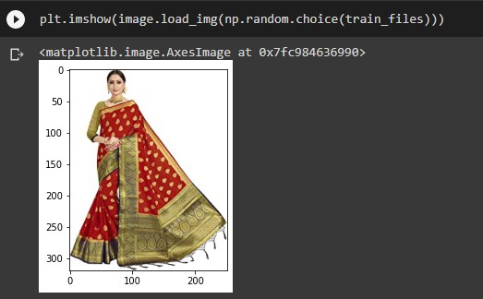

Model Accuracy:

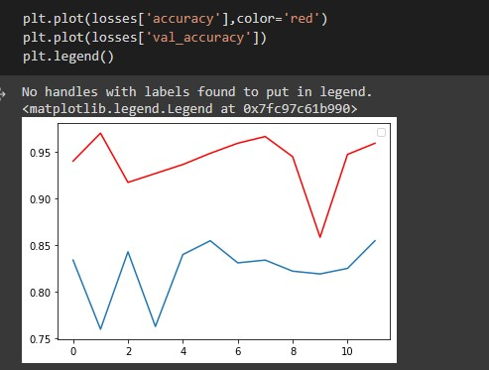

Model Loss:

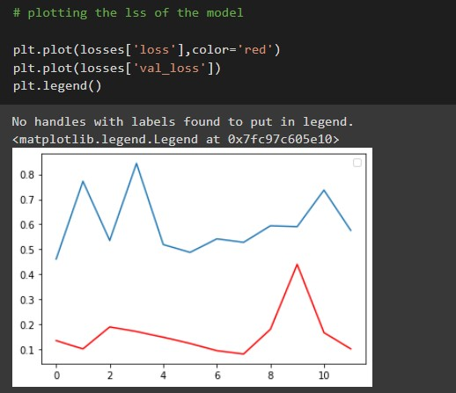

Evalutions metrics per Epoch:

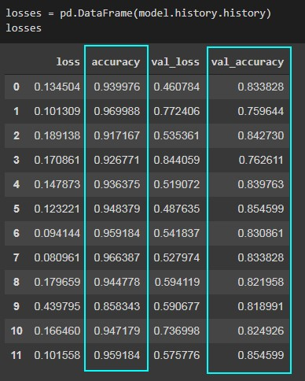

## • Interpretation of the Results

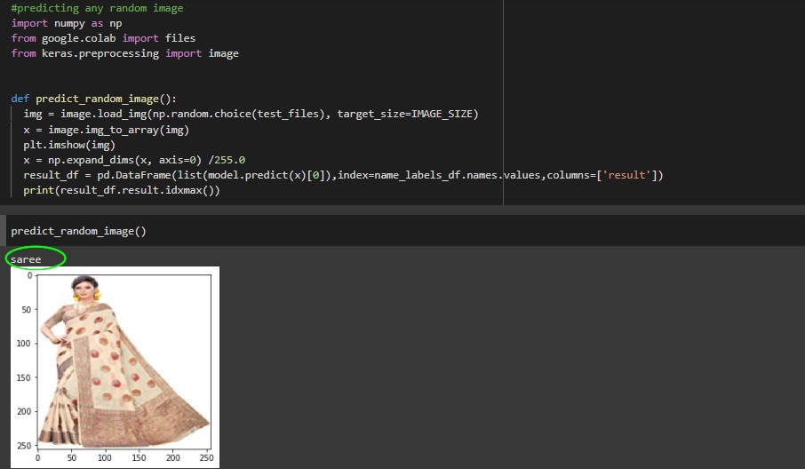

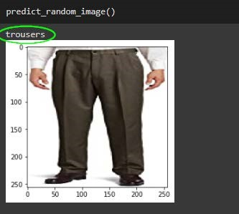

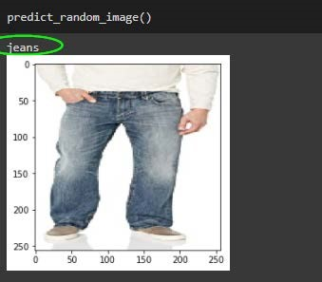

# CONCLUSION

## • Key Findings and Conclusions of the Study

Our model was successfully to classify the images with an accuracy of 85 Percent on a validation set of around 70 images

## • Learning Outcomes of the Study in respect of Data Science

The larger the data the better the model could predict. Multi class prediction are somewhat relatively harder to train in comparison to a Binary class prediction.

Data Augmentation is necessary where we have small datasets of images.

## • Limitations of this work and Scope for Future Work

One could always provide more data for training the model in order to get better results.

We could use to model for apparel segmentation at Supermarkets and shopping stores.