**STEP 1 :** Fork the repository https://github.com/shanoorahmed/osoc_jr_induction.git Clone it to your local machine.

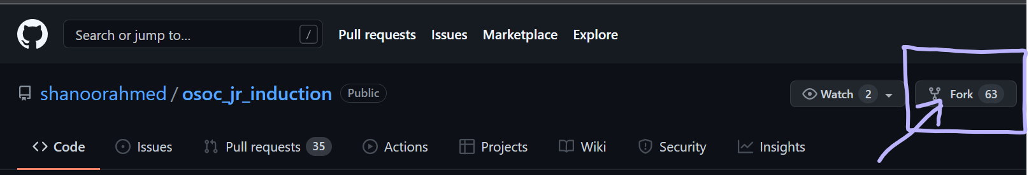

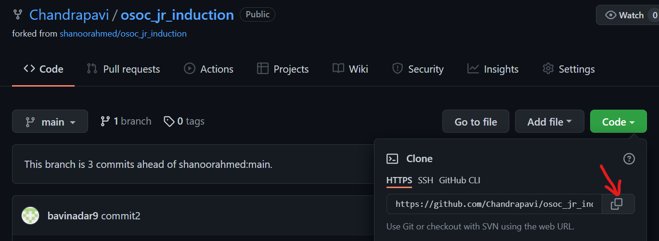

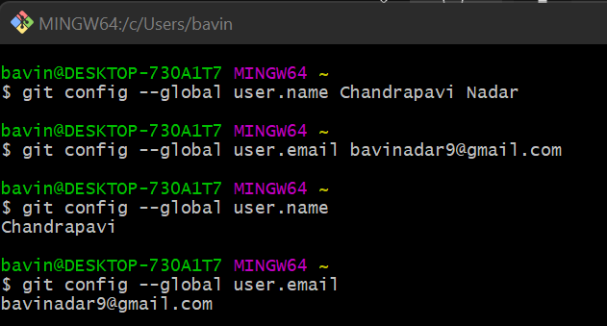

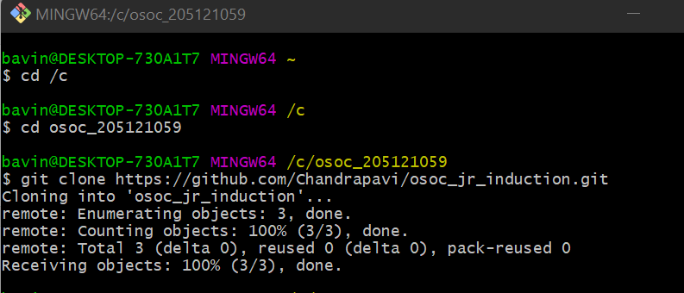

**STEP 2 :** Create a new branch.



**STEP 3 :** Make a text file with 10 git commands and their description which you have not used in the task.

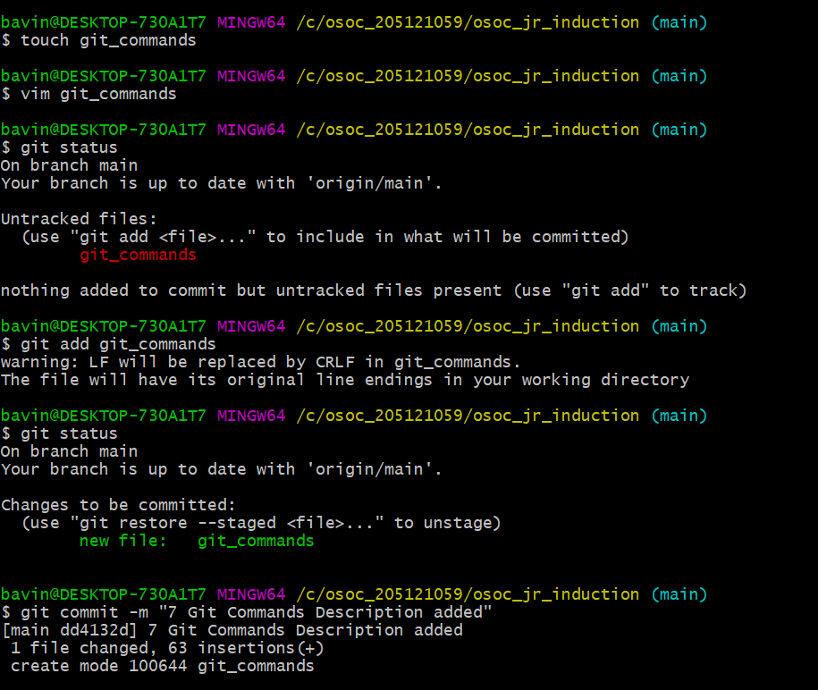

STEP 4 : Create a merge conflict (look it up in Google) while merging the new branch with your main/master branch and then resolve it.

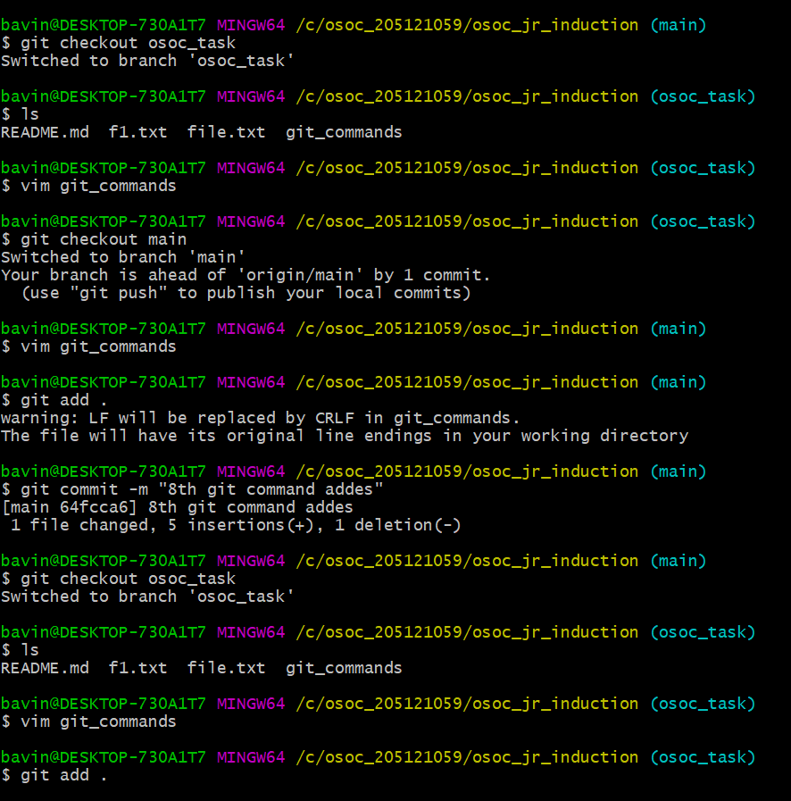

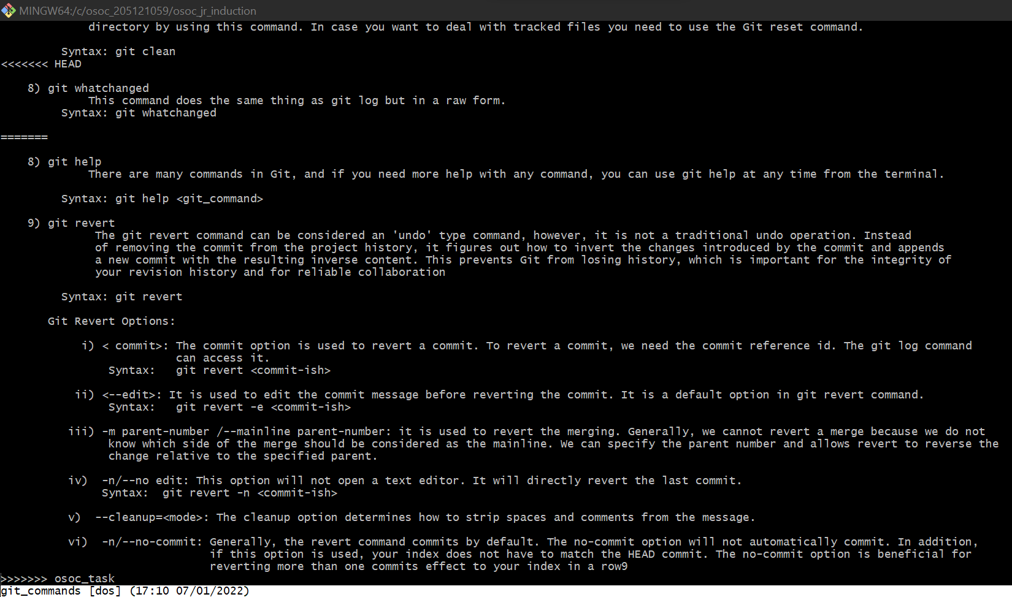

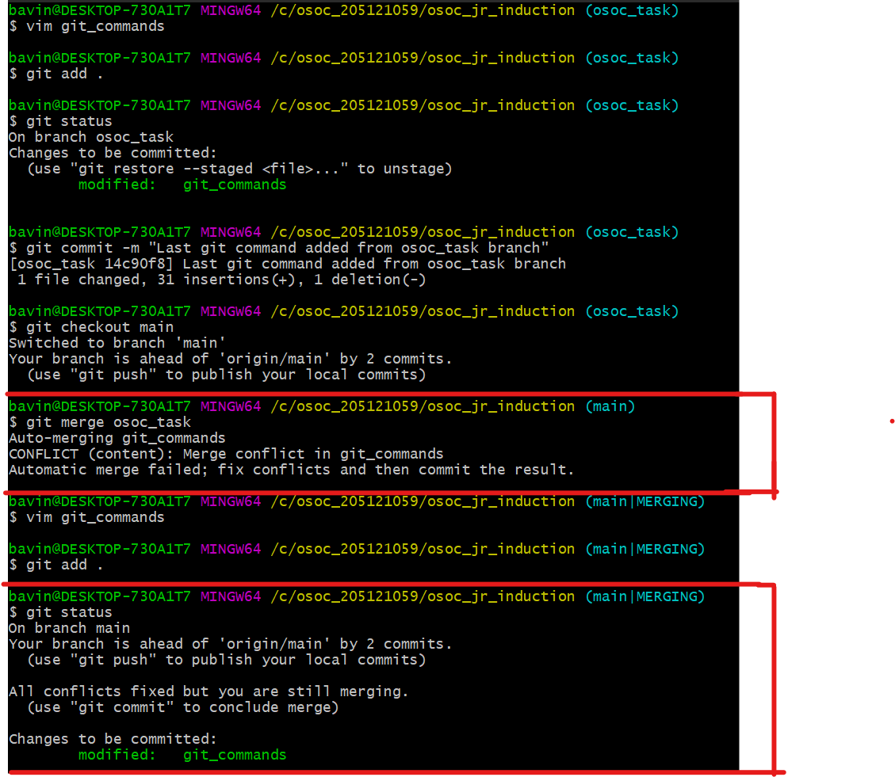

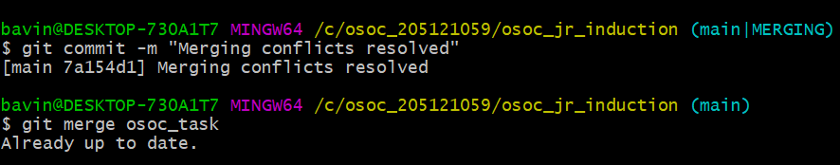

**STEP 5 :** Once resolved, create another text file about the merge conflict and how you resolved it.

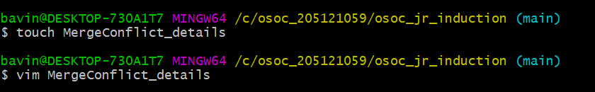

**STEP 6 :** Copy all the git commits to a file using a git command.



**STEP 7 :** Make a folder of all the screenshots up until this point.

**STEP 8 :** Add all the files and folders and push it to GitHub.

Command- git push origin

