Create the component for book detail in the components section.

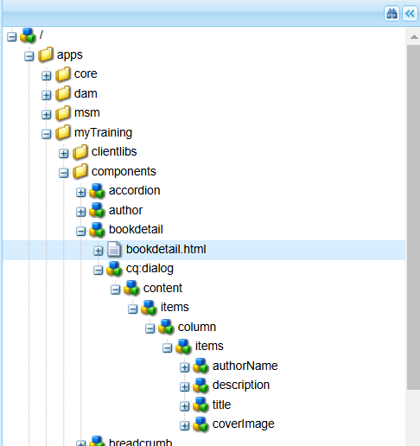

Create the html file which is used to display the book’s detail. 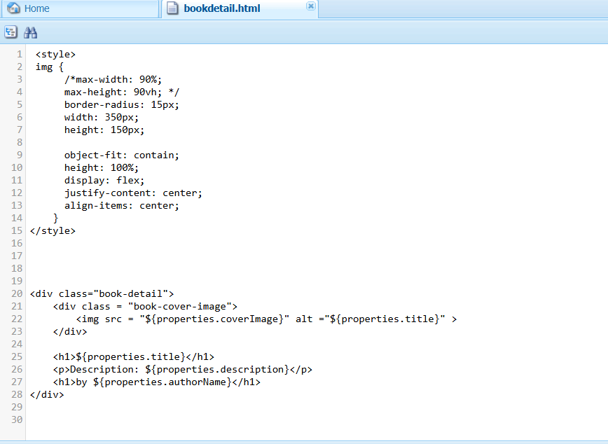

Create a template for the books in AEM with custom header and footer.

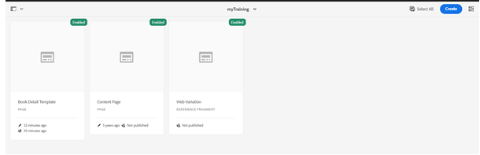

List of pages .create as many as required.

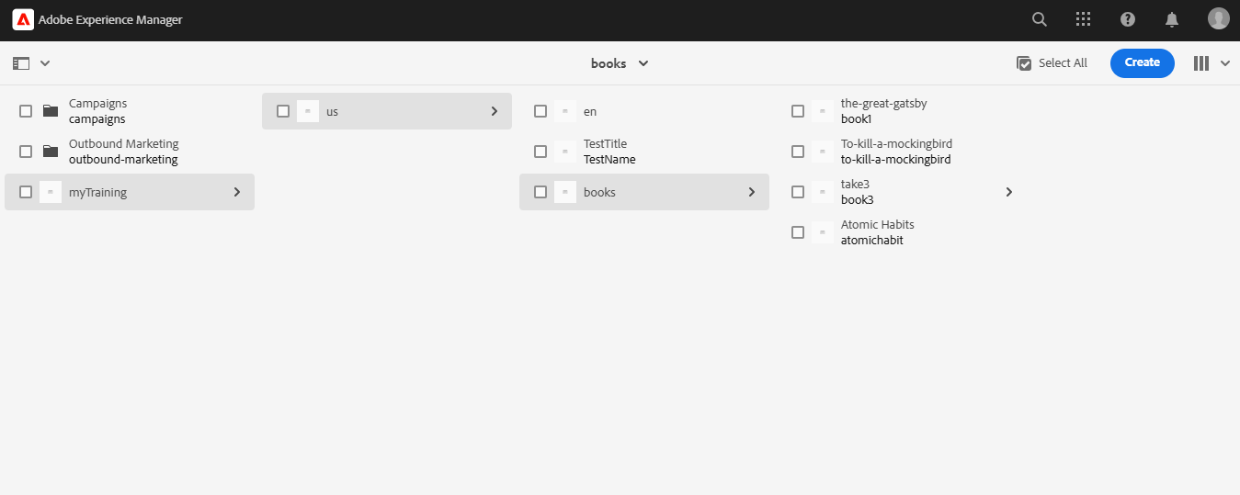

Header



Book page creation:

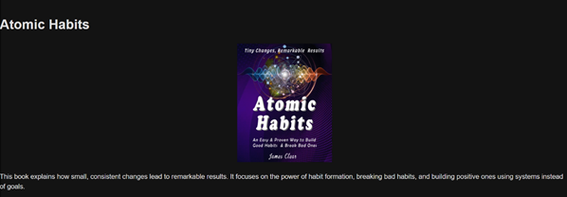

Now in each page of the template, give the details of the book, author name and description with image path to complete the book detail component.

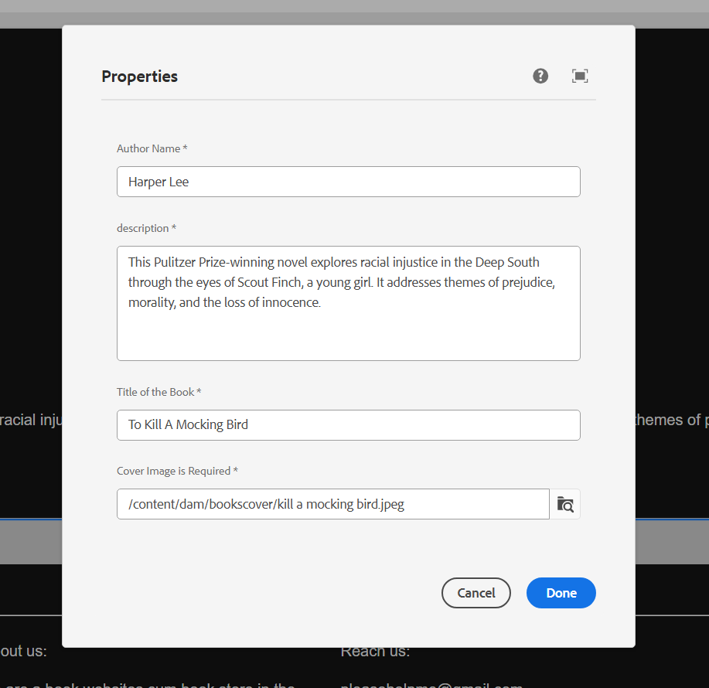

Now create as many pages as required with the book template and book component.

Footer

