Lesson 9: Device tree USB (Assignment 9)

Command – lsusb

Command - sudo lsusb –verbose

Command - sudo apt install libusb-1.0-0-dev

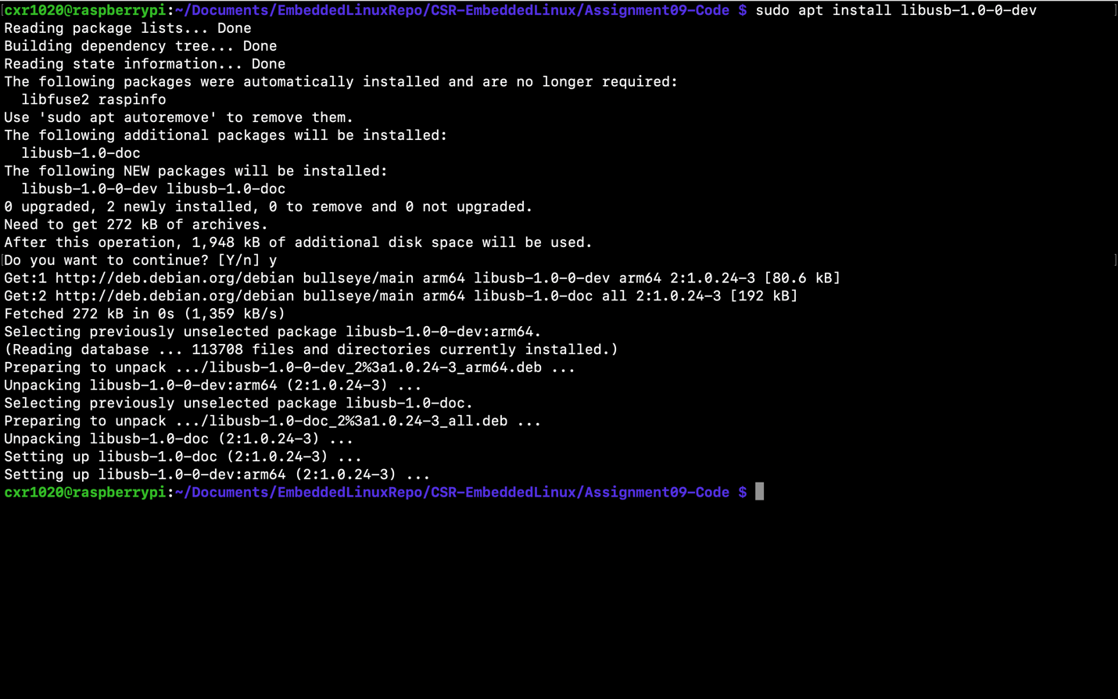

SourceCode – usb-demo.c

Output - usb-demo

