19BCS092 || R CHANDRA VARDHAN

DBMS ASSIGNMENT

# *SHOw how to create and delete a data base*

# *2 .SHOW all data bases in the system*

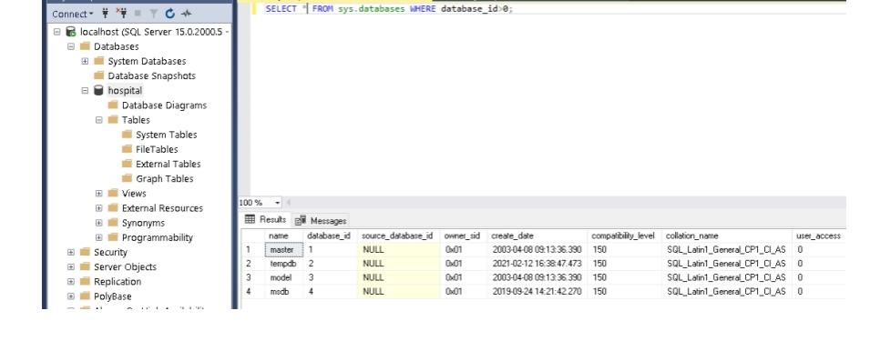

# **3 . Create table for your database**

# **4 . Drop table**

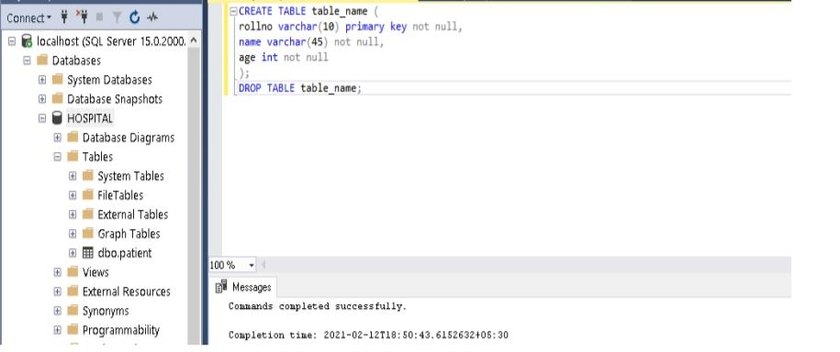

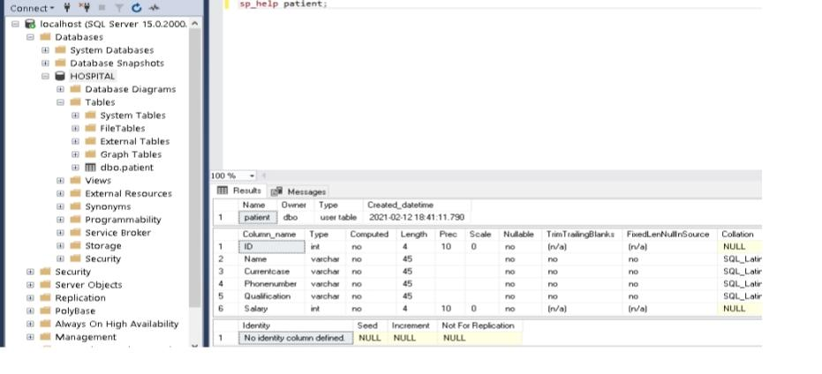**5 . Show how to check the schema of the tables**

**6 . Show all the tables from the database**

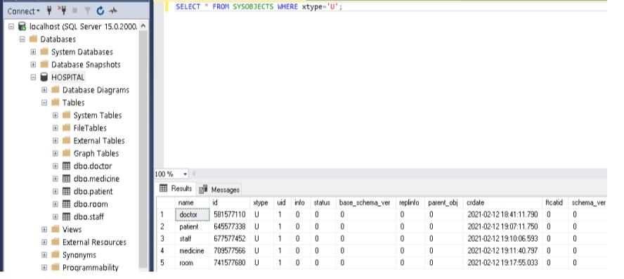

**7 . Create table using select Statement**

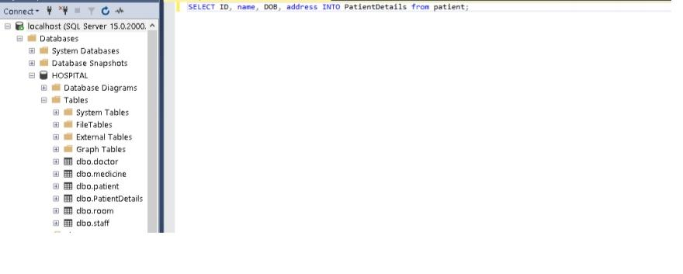

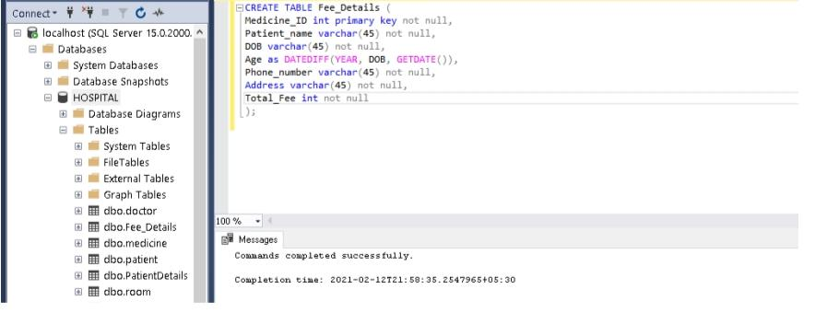**8 . Create a table that has derived attributes**