**SRKR ENGINEERING COLLEGE::BHIMAVARAM**

**Department of Computer Science and Engineering**

**Name of the Course**: Design and Analysis of Algorithms

Program: B. Tech (AIML)

**UNIT-1**

1) Define an Algorithm? What are the different criteria that satisfy the algorithm(algorithm specification)

2)Explain how algorithms performance is analyzed? Describe asymptotic notations.

3) Draw the tree calls of merge sort for the following set.

(35,25,15,10,45,75,85,65,55,5,20,18)

4) Analyze best & Worst-case time complexities for Quick Sort with examples

5) Apply Divide and Conquer Paradigm to explain Merge Sort Algorithm with Example.

6) Analyze the time complexity of Strassen's matrix multiplication with an example.

7) What is Convex hull Problem? Discuss about QuickHull Algorithm

**UNIT-2**

1) Discuss Union and Find Operations in Disjoint Sets

2) What is a Spanning tree? Describe Algorithms for minimum spanning-tree.

3) Demonstrate Huffman coding with examples.

4) Solve the given job sequencing with deadlines problem using Greedy Method?

N=4 (p1,p2,p3,p4)=(100,10,15,27) (d1,d2,d3,d4)=(2,1,2,1)

5) Find an optimal solution to the knapsack instance n=3, m=20, (p1, p2,p3) = (25,24,15) and (w1, w2, w3) = (18,15,10).

6) Construct optimal Binary merge tree for the following files:

2, 5, 7, 26, 11 ,16, 21, 17, 35, 42

7) Single source shortest path problem using greedy method.

**UNIT-3**

1) What is the principle of optimality and discuss the general method of Dynamic programming.

2) Discuss all pair’s shortest paths Algorithm.

3) Design an algorithm to find the minimum cost path from s to t in the multistage graph given below.

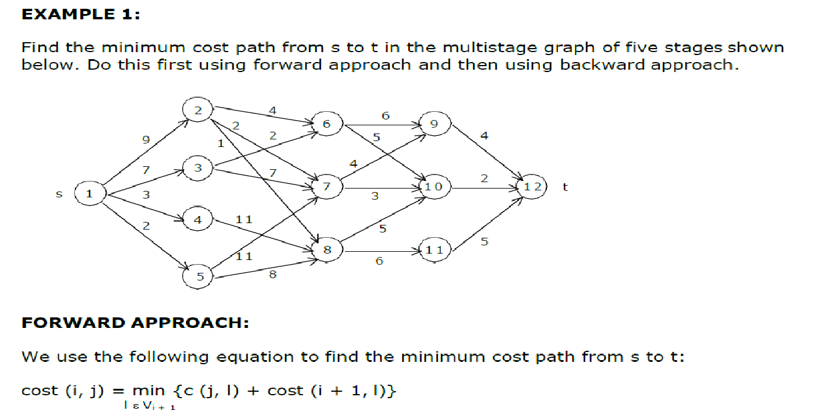

4) Describe solution for traveling salesman problem using Dynamic programming

5)Describe optimal binary search tree and Determine optimal search tree for the following data n=4, (a1,a2,a3,a4)=(do,if,int,while),P(1:4)=(3,3,1,1),Q(0:4)=(2,3,1,1,1).

6) Solve 0/1 knapsack problem for the following data using Dynamic programming n=6 (p1, p2, p3, p4, p5, p6) = (w1, w2, w3, w4, w5, w6) = (100, 50, 20, 10,7, 3) m=165.

**UNIT-4**

1. Illustrate Graph coloring problem. CO4 K3
2. Find the solution for the 0/1 knapsack problem using LCBB given N=4, profits= (10,10,12,18), weights= (2,4,6,9) and m=15. CO4 K3
3. Describe Sum of Subsets problem. Draw the portion of the state space tree that is the generated solution for given data W= {5,7,10,12,15,18,20} and M=35. CO4 K3
4. Classify methods in Branch and Bound Technique CO4 K2
5. Discuss about 8-Queens problem CO4 K2
6. Discuss about Hamiltonian cycle problem CO4 K2

**UNIT-5**

1. Give the importance of Lower Bound Theory. CO5 K2
2. Demonstrate Classes of NP-hard and NP-Complete. CO5 K3
3. Discuss about Comparison Trees. CO5 K2
4. Illustrate Non-Deterministic Algorithms. CO5 K3
5. Explain about Fast Fourier Transform CO5 K2