**z-index**

The z-index property in CSS is used to control the **stacking order** of overlapping elements.

It determines which elements appear in front of or behind others when they overlap.

**Key Points About z-index:**

1. **Applies to Positioned Elements**: The z-index property only applies to elements that have a position value of **relative**, **absolute**, **fixed**, or **sticky**. It does not work on elements with the default position value of **static**.
2. **Stacking Context**: Elements with a z-index property create a stacking context. This context is used to determine the stack level of the element and its children.
3. **Integer Values**: The z-index property accepts integer values, including negative, zero, and positive numbers. Higher values place an element in front of elements with lower values.
4. **Default Value**: The default value of z-index is auto, which means the element follows the stacking order of its parent.

**Example of z-index**

Let's create a simple example that demonstrates the use of z-index by layering different elements on top of each other.

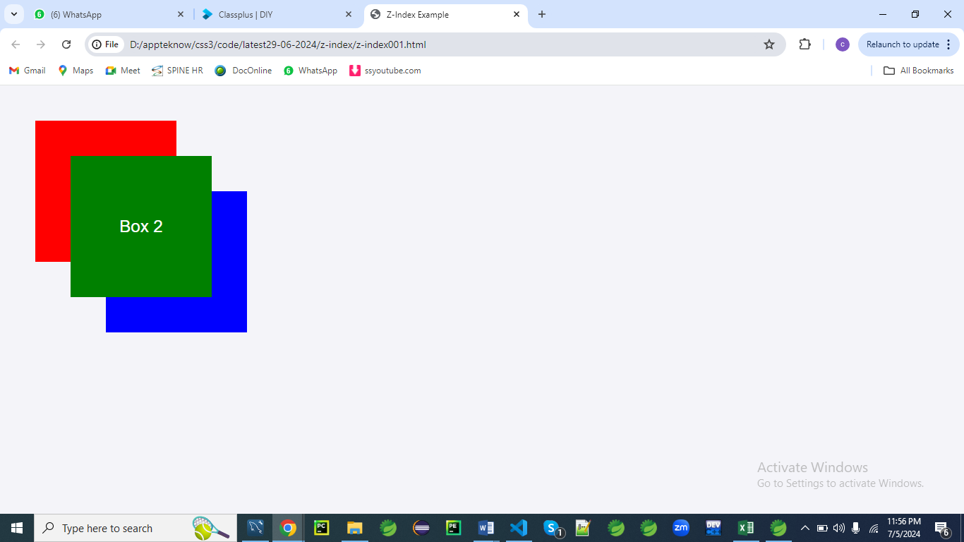

**HTML**

<!DOCTYPE html>

<html lang="en">

<head>

<meta charset="UTF-8">

<meta name="viewport" content="width=device-width, initial-scale=1.0">

<title>Z-Index Example</title>

<link rel="stylesheet" href="styles.css">

</head>

<body>

<div class="box box1">Box 1</div>

<div class="box box2">Box 2</div>

<div class="box box3">Box 3</div>

</body>

</html>

**CSS (styles.css)**

body {

margin: 0;

font-family: Arial, sans-serif;

display: flex;

justify-content: center;

align-items: center;

height: 100vh;

background-color: #f4f4f9;

}

.box {

position: absolute;

width: 200px;

height: 200px;

display: flex;

justify-content: center;

align-items: center;

color: white;

font-size: 24px;

}

.box1 {

background-color: red;

top: 50px;

left: 50px;

z-index: 1; /* Layer 1 */

}

.box2 {

background-color: green;

top: 100px;

left: 100px;

z-index: 3; /* Layer 3 */

}

.box3 {

background-color: blue;

top: 150px;

left: 150px;

z-index: 2; /* Layer 2 */

}

**CSS Rules Explanation**

**body:**

**body {**

**margin: 0;**

**font-family: Arial, sans-serif;**

**display: flex;**

**justify-content: center;**

**align-items: center;**

**height: 100vh;**

**background-color: #f4f4f9;**

**}**

1. **margin: 0;**
   * Removes any default margin around the body element.
   * Ensures there is no extra space outside the body content.
   * Provides a clean edge for the body content and sets a consistent starting point for layout adjustments.
2. **font-family: Arial, sans-serif;**
   * Sets the font family for the entire body of the document.
   * Uses Arial as the primary font choice, with a fallback to a generic sans-serif font if Arial is not available.
   * Ensures a consistent text appearance across different devices and browsers.
   * Affects all text content within the body, providing a clean and readable typeface.
3. **display: flex;**
   * Activates the Flexbox layout for the body element.
   * Allows for flexible and responsive layout arrangements of child elements.
   * Enables alignment and distribution of child elements within the body.
4. **justify-content: center;**
   * Centers child elements horizontally within the body.
   * Aligns the content in the center of the available space along the main axis.
   * Useful for centering content like the .box elements within the viewport.
5. **align-items: center;**
   * Centers child elements vertically within the body.
   * Aligns the content in the center of the available space along the cross axis.
   * Ensures that the content is centrally aligned both horizontally and vertically.
6. **height: 100vh;**
   * Sets the height of the body to 100% of the viewport height.
   * Ensures that the body element covers the full height of the browser window.
   * Useful for vertical centering of content.
7. **background-color: #f4f4f9;**
   * Sets the background color of the body to #f4f4f9.
   * #f4f4f9 is a light grayish-blue color.
   * Provides a neutral and subtle background color for the entire page.

**.box:**

**.box {**

**position: absolute;**

**width: 200px;**

**height: 200px;**

**display: flex;**

**justify-content: center;**

**align-items: center;**

**color: white;**

**font-size: 24px;**

**}**

1. **position: absolute;**
   * Positions the .box element absolutely within its nearest positioned ancestor.
   * Allows precise placement of the .box element using top, left, right, and bottom properties.
   * Takes the element out of the normal document flow.
2. **width: 200px;**
   * Sets the width of the .box element to 200 pixels.
   * Defines the horizontal size of the .box element.
3. **height: 200px;**
   * Sets the height of the .box element to 200 pixels.
   * Defines the vertical size of the .box element.
4. **display: flex;**
   * Activates the Flexbox layout for the .box element.
   * Enables flexible and responsive layout arrangements of child elements within .box.
5. **justify-content: center;**
   * Centers child elements horizontally within the .box.
   * Aligns the content in the center of the available space along the main axis.
6. **align-items: center;**
   * Centers child elements vertically within the .box.
   * Aligns the content in the center of the available space along the cross axis.
7. **color: white;**
   * Sets the text color inside the .box element to white.
   * Ensures that text inside .box is visible against the colored background.
8. **font-size: 24px;**
   * Sets the font size of the text inside the .box to 24 pixels.
   * Defines the size of the text displayed within the .box element.

**.box1, .box2, .box3:**

**.box1 {**

**background-color: red;**

**top: 50px;**

**left: 50px;**

**z-index: 1; /* Layer 1 */**

**}**

**.box2 {**

**background-color: green;**

**top: 100px;**

**left: 100px;**

**z-index: 3; /* Layer 3 */**

**}**

**.box3 {**

**background-color: blue;**

**top: 150px;**

**left: 150px;**

**z-index: 2; /* Layer 2 */**

**}**

1. **background-color: red;** (for .box1), **background-color: green;** (for .box2), **background-color: blue;** (for .box3)
   * Sets the background color of each .box element to red, green, or blue respectively.
   * Provides a visual distinction between the different .box elements.
2. **top: 50px;** (for .box1), **top: 100px;** (for .box2), **top: 150px;** (for .box3)
   * Positions each .box element vertically from the top of its containing block.
   * Moves the .box elements down from the top edge by the specified pixel value.
3. **left: 50px;** (for .box1), **left: 100px;** (for .box2), **left: 150px;** (for .box3)
   * Positions each .box element horizontally from the left edge of its containing block.
   * Moves the .box elements right from the left edge by the specified pixel value.
4. **z-index: 1;** (for .box1), **z-index: 3;** (for .box2), **z-index: 2;** (for .box3)
   * Specifies the stack order of the .box elements.
   * **Elements with a higher z-index value are placed in front of elements with a lower value.**
   * Ensures proper layering and visibility of overlapping .box elements.

This explanation breaks down how each CSS rule contributes to the layout and appearance of the page, including positioning, styling, and layering of elements

**Explanation**

* **HTML**: The HTML contains three div elements, each with the class box and additional classes box1, box2, and box3 for specific styling.
* **CSS**:
  + **General Box Styling**: All boxes are styled with position: absolute, a set width and height, centered text, and a flex layout for centering content.
  + **Box Specific Styling**:
    - .box1 is positioned at the top-left corner with a red background and a z-index of 1.
    - .box2 is positioned slightly lower and to the right with a green background and a z-index of 3.
    - .box3 is positioned even lower and to the right with a blue background and a z-index of 2.

By using different z-index values, the boxes are layered on top of each other, with .box2 (green) on top of .box3 (blue), which is on top of .box1 (red).

This demonstrates how z-index affects the stacking order of elements.

**position**

The position property in CSS is used to specify the positioning method for an element.

It determines how an element is positioned in the document.

The position property can take the following values:

1. **static**: This is the default value. The element is positioned according to the normal flow of the document. Top, right, bottom, and left properties have no effect.

.static {

position: static;

}

1. **relative**: The element is positioned relative to its normal position. Setting the top, right, bottom, and left properties will cause it to be adjusted from its normal position.

.relative {

position: relative;

top: 10px;

left: 20px;

}

1. **absolute**: The element is positioned relative to its nearest positioned ancestor (an ancestor that has a position value other than static). If there is no such ancestor, it is positioned relative to the initial containing block (usually the viewport).

.absolute {

position: absolute;

top: 50px;

right: 30px;

}

1. **fixed**: The element is positioned relative to the browser window (viewport). It will not move when the window is scrolled.

.fixed {

position: fixed;

bottom: 10px;

right: 10px;

}

1. **sticky**: The element is treated as relative positioned until it crosses a specified point, then it is treated as fixed positioned. This allows for elements that "stick" to a specific position as the user scrolls.

.sticky {

position: sticky;

top: 0; /* Stick to the top of the container */

}

**Examples:**

Here's a demonstration of how different position values affect elements:

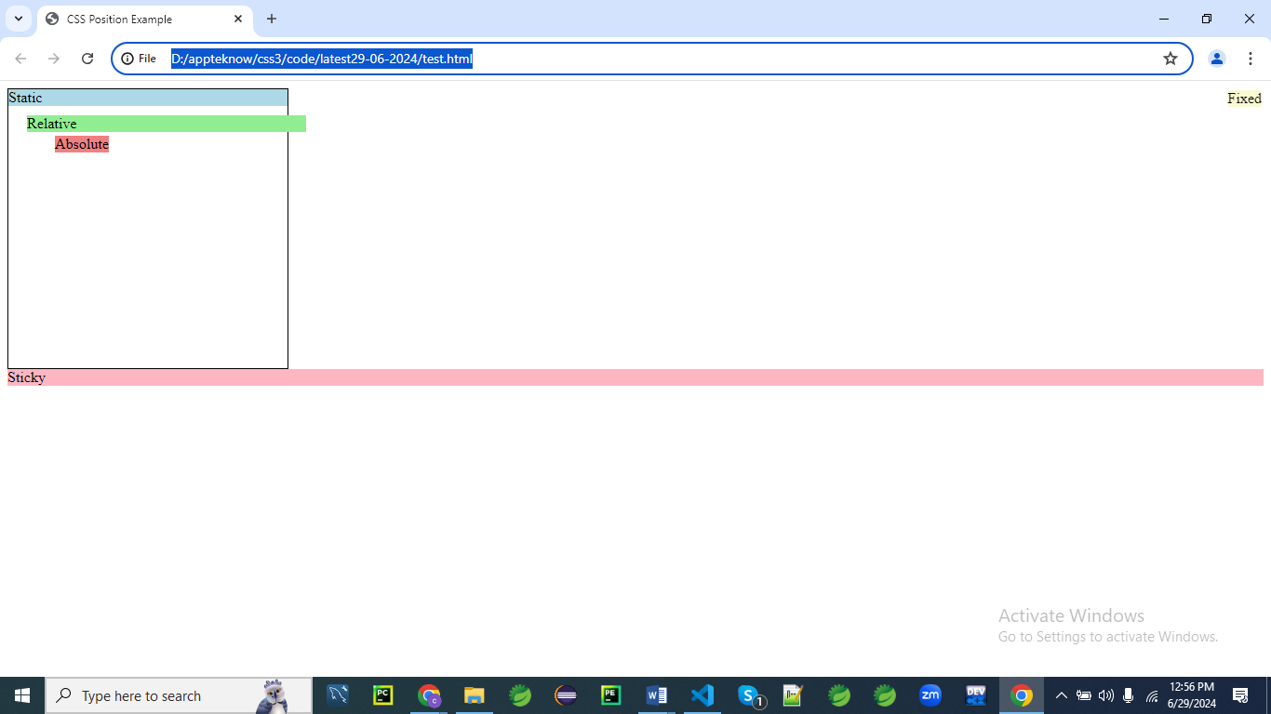

<!DOCTYPE html>

<html lang="en">

<head>

<meta charset="UTF-8">

<meta name="viewport" content="width=device-width, initial-scale=1.0">

<title>CSS Position Example</title>

<style>

.container {

position: relative;

width: 300px;

height: 300px;

border: 1px solid black;

}

.static {

position: static;

background-color: lightblue;

}

.relative {

position: relative;

top: 10px;

left: 20px;

background-color: lightgreen;

}

.absolute {

position: absolute;

top: 50px;

left: 50px;

background-color: lightcoral;

}

.fixed {

position: fixed;

top: 10px;

right: 10px;

background-color: lightgoldenrodyellow;

}

.sticky {

position: sticky;

top: 0;

background-color: lightpink;

}

</style>

</head>

<body>

<body>

  <div class="container">

    <div class="static">Static</div>

    <div class="relative">Relative</div>

    <div class="absolute">Absolute</div>

  </div>

  <div class="fixed">Fixed</div>

  <div class="sticky">Sticky (sticks to top while page scrolls)</div>

  <!-- Filler to enable scrolling -->

  <div style="height:1500px; background: #f5f5f5;">Scroll down…</div>

  <div>testing....</div>

</body>

</html>

**CSS Rules Explanation**

**.container**

**.container {**

**position: relative;**

**width: 300px;**

**height: 300px;**

**border: 1px solid black;**

**}**

1. **position: relative;**
   * Establishes a new positioning context for the .container element.
   * Child elements with position: absolute will be positioned relative to this container.
   * The element remains in the normal document flow but can be offset using top, bottom, left, and right properties.
   * Does not affect the layout of other elements, but creates a reference point for absolutely positioned elements.
   * Essential for creating complex layouts where child elements need to be positioned relative to a specific parent.
2. **width: 300px;**
   * Defines the width of the .container element as 300 pixels.
   * Sets a fixed horizontal size for the container, impacting its overall layout.
   * Ensures that the container maintains a consistent width regardless of its content.
   * Helps in creating predictable layouts where exact dimensions are needed.
   * Affects the space available for child elements within the container.
3. **height: 300px;**
   * Sets the height of the .container element to 300 pixels.
   * Defines a fixed vertical size, similar to width, impacting layout consistency.
   * Ensures that the container maintains a fixed height, regardless of its content.
   * Provides a specific area for child elements, which is useful for layout design.
   * Helps in controlling the vertical spacing and layout of child elements.
4. **border: 1px solid black;**
   * Adds a 1-pixel wide solid black border around the .container.
   * Creates a visual boundary, helping to define the edges of the container.
   * The border visually separates the container from surrounding content.
   * Provides a clear outline, making the container's dimensions and position more apparent.
   * Useful for debugging layout issues and for visual emphasis.
5. **This container serves as a reference point for absolutely positioned child elements.**
   * It defines the area where child elements with position: absolute will be positioned.
   * Ensures that child elements are placed relative to this container, not to the viewport or other elements.
   * Provides a controlled environment for positioning and layering elements.
   * Essential for complex layouts where specific positioning is required.
   * Acts as a layout framework for organizing and positioning child elements.

**.static**

**.static {**

**position: static;**

**background-color: lightblue;**

**}**

1. **position: static;**
   * Applies the default positioning behavior where the element is placed in the normal document flow.
   * The element will not be affected by top, bottom, left, or right properties.
   * Ensures that the element does not overlap or shift other elements.
   * Maintains its position relative to the flow of other content.
   * Useful for elements that should stay in their natural position without additional adjustments.
2. **background-color: lightblue;**
   * Sets the background color of the .static element to light blue.
   * Provides a visual distinction and helps differentiate it from other elements.
   * Enhances the element’s visibility and aesthetic appeal.
   * Useful for improving readability and visual hierarchy.
   * Helps in creating a pleasing and organized design layout.
3. **The .static element will flow naturally with the content.**
   * It will be positioned based on the standard document flow.
   * It will not affect or be affected by other positioned elements.
   * Maintains its place in the layout as determined by surrounding content.
   * Does not overlap other elements or create layout shifts.
   * Essential for maintaining a consistent and predictable layout.

**.relative {**

**position: relative;**

**top: 10px;**

**left: 20px;**

**background-color: lightgreen;**

**}**

1. **position: relative;**
   * Positions the .relative element relative to its normal position.
   * Allows adjustments using top, bottom, left, and right properties.
   * Does not remove the element from the document flow; other elements will still be positioned as if it were in its original place.
   * Provides flexibility to adjust positioning without affecting the overall layout.
   * Useful for fine-tuning the placement of elements.
2. **top: 10px;**
   * Moves the .relative element 10 pixels down from its original position.
   * Adjusts the vertical placement without affecting the layout of other elements.
   * Allows for precise positioning adjustments within the normal document flow.
   * Useful for creating specific visual effects or aligning elements.
   * Ensures that the element remains in the flow while being slightly repositioned.
3. **left: 20px;**
   * Moves the .relative element 20 pixels to the right from its original position.
   * Adjusts the horizontal placement while maintaining the document flow.
   * Allows for fine-tuning the positioning within its parent container or layout.
   * Useful for aligning or spacing elements precisely.
   * Ensures consistent layout adjustments without affecting other elements.
4. **background-color: lightgreen;**
   * Sets the background color of the .relative element to light green.
   * Provides visual distinction and enhances the element’s appearance.
   * Useful for differentiating elements and improving readability.
   * Enhances the overall design and visual hierarchy.
   * Helps in creating a cohesive and appealing layout.
5. **The .relative element will retain its place in the document flow, but its position will be adjusted.**
   * Maintains its space within the layout, ensuring that other elements are positioned correctly.
   * The adjusted position will only affect the visual appearance without altering the document flow.
   * Provides flexibility in positioning while keeping the element's original space.
   * Useful for precise layout adjustments and visual effects.
   * Ensures that the element's position can be adjusted without disrupting the surrounding content.

**.absolute {**

**position: absolute;**

**top: 50px;**

**left: 50px;**

**background-color: lightcoral;**

**}**

1. **position: absolute;**
   * Positions the .absolute element relative to the nearest positioned ancestor (i.e., .container).
   * Removes the element from the normal document flow, so it does not affect the layout of other elements.
   * Allows for precise positioning using top, bottom, left, and right properties.
   * The element will overlap other elements if they are in the same stacking context.
   * Useful for creating layered or floating elements within a container.
2. **top: 50px;**
   * Moves the .absolute element 50 pixels down from the top edge of its containing block (i.e., .container).
   * Allows for vertical placement control within the container.
   * Useful for creating specific layout effects or positioning elements precisely.
   * Does not affect the placement of other elements in the document flow.
   * Ensures that the element is positioned at a specific vertical distance from the top.
3. **left: 50px;**
   * Moves the .absolute element 50 pixels to the right from the left edge of its containing block.
   * Allows for horizontal placement control within the container.
   * Useful for aligning elements or creating specific visual effects.
   * Does not affect the layout of other elements in the document flow.
   * Ensures that the element is positioned at a specific horizontal distance from the left.
4. **background-color: lightcoral;**
   * Sets the background color of the .absolute element to light coral.
   * Provides a visual distinction and enhances the element’s appearance.
   * Useful for differentiating the element and improving visibility.
   * Helps create a visually appealing and organized design.
   * Enhances the overall design and visual hierarchy of the page.
5. **The .absolute element will overlap other content and be positioned precisely within its container.**
   * Positioned relative to the nearest positioned ancestor, ensuring precise placement.
   * Removed from the document flow, allowing it to float above other elements.
   * Useful for creating complex layouts where specific positioning is required.
   * Can overlap other elements if they are within the same stacking context.
   * Provides flexibility for positioning elements exactly where needed.

**.fixed {**

**position: fixed;**

**top: 10px;**

**right: 10px;**

**background-color: lightgoldenrodyellow;**

**}**

1. **position: fixed;**
   * Positions the .fixed element relative to the viewport, not to any parent or ancestor.
   * Remains fixed in its position regardless of scrolling, always visible in the same spot on the screen.
   * Does not affect the layout of other elements on the page.
   * Useful for elements that need to stay visible at all times, such as navigation bars or action buttons.
   * Can overlap other content if not managed correctly.
2. **top: 10px;**
   * Moves the .fixed element 10 pixels down from the top edge of the viewport.
   * Controls the vertical position of the element relative to the viewport.
   * Ensures that the element is placed a fixed distance from the top edge of the screen.
   * Useful for precise placement in fixed positioning scenarios.
   * Remains constant even when the page is scrolled.
3. **right: 10px;**
   * Moves the .fixed element 10 pixels from the right edge of the viewport.
   * Controls the horizontal position of the element relative to the viewport.
   * Ensures that the element is placed a fixed distance from the right edge of the screen.
   * Useful for positioning elements in a consistent location regardless of scrolling.
   * Remains in place even when the page is scrolled.
4. **background-color: lightgoldenrodyellow;**
   * Sets the background color of the .fixed element to light goldenrod yellow.
   * Provides a visual distinction and enhances the element’s appearance.
   * Useful for differentiating the element and improving visibility.
   * Helps create a cohesive and organized design.
   * Enhances the overall aesthetic of the page.
5. **The .fixed element remains in a constant position relative to the viewport, regardless of scrolling.**
   * Ensures that the element stays in view at all times, regardless of how much the page is scrolled.
   * Useful for creating elements that need to be persistently visible, such as floating action buttons or navigation menus.
   * Can overlap other content, so careful consideration is needed for placement.
   * Provides a consistent user experience by keeping essential elements accessible.
   * Ensures that the element is always in the same position on the screen.

**.sticky**

**.sticky {**

**position: sticky;**

**top: 0;**

**background-color: lightpink;**

**}**

1. **position: sticky;**
   * Positions the .sticky element based on the user's scroll position.
   * Toggles between relative and fixed positioning depending on the scroll position relative to its containing block.
   * The element will scroll with the page until it reaches a defined position, then sticks in place.
   * Useful for creating headers or menus that need to stay visible only when scrolling past their initial position.
   * Requires a defined top, bottom, left, or right property to determine the sticking point.
2. **top: 0;**
   * Sets the top offset for the .sticky element to 0 pixels.
   * Ensures that the element sticks to the top of its containing block when scrolling.
   * Determines the point where the element will switch from relative to fixed positioning.
   * Useful for creating sticky headers that stick to the top of the viewport as the page scrolls.
   * Ensures that the element remains in view at the top of the viewport when the user scrolls.
3. **background-color: lightpink;**
   * Sets the background color of the .sticky element to light pink.
   * Provides visual distinction and enhances the element’s appearance.
   * Useful for differentiating the element and making it more noticeable.
   * Enhances readability and design consistency.
   * Helps in creating a visually appealing layout.
4. **The .sticky element will stick to the top of its containing block during scrolling.**
   * Remains in place within its container when scrolling past its initial position.
   * Provides a dynamic layout experience where elements stay visible based on scroll position.
   * Useful for maintaining accessibility and visibility of key elements like navigation bars.
   * Ensures that the element remains in view only when needed.
   * Enhances user experience by keeping important content accessible.
5. **Sticky positioning combines the behaviors of relative and fixed positioning.**
   * The element behaves like a relatively positioned element until it reaches the scroll position.
   * Once at the specified offset, it behaves like a fixed-position element, staying in view.
   * Provides a flexible approach to positioning elements that need to remain visible during scrolling.
   * Ensures that the element does not overlap content when not in the sticky state.
   * Useful for creating interactive and responsive layouts.

Each CSS property and value is designed to control different aspects of element positioning and layout, enabling you to create complex and responsive designs.

**In this example:**

* The .static element follows the normal document flow.
* The .relative element is offset by 10px down and 20px to the right from its original position.
* The .absolute element is positioned 50px from the top and left of the .container.
* The .fixed element stays fixed at the top right corner of the viewport.
* The .sticky element sticks to the top of the container as you scroll.

Understanding these positioning methods is crucial for creating complex and responsive web layouts.

**Example 01**

Let's create an example that demonstrates how different values of the position property work together to create a complex layout. This example will showcase static, relative, absolute, fixed, and sticky positioning in a real-world scenario, such as a webpage layout with a header, a sidebar, a content area, and a footer.

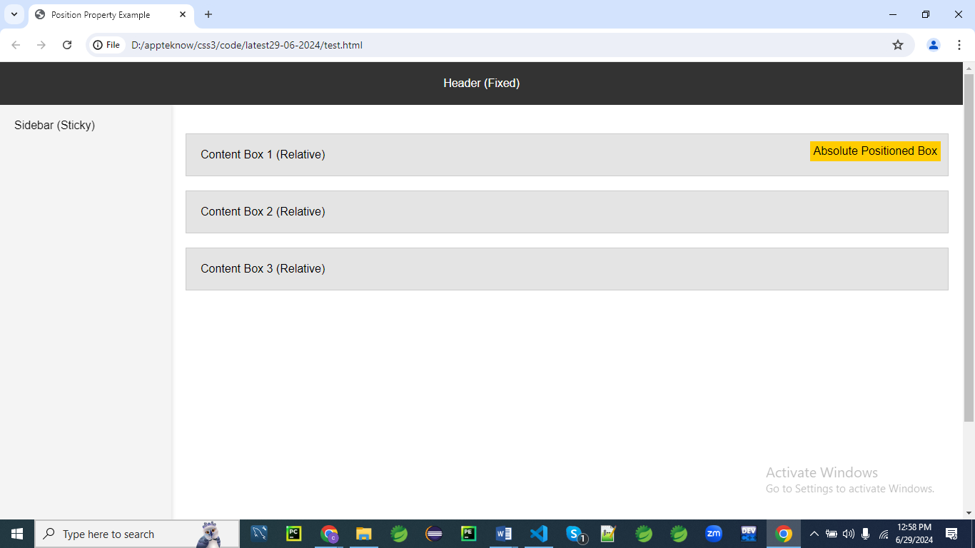

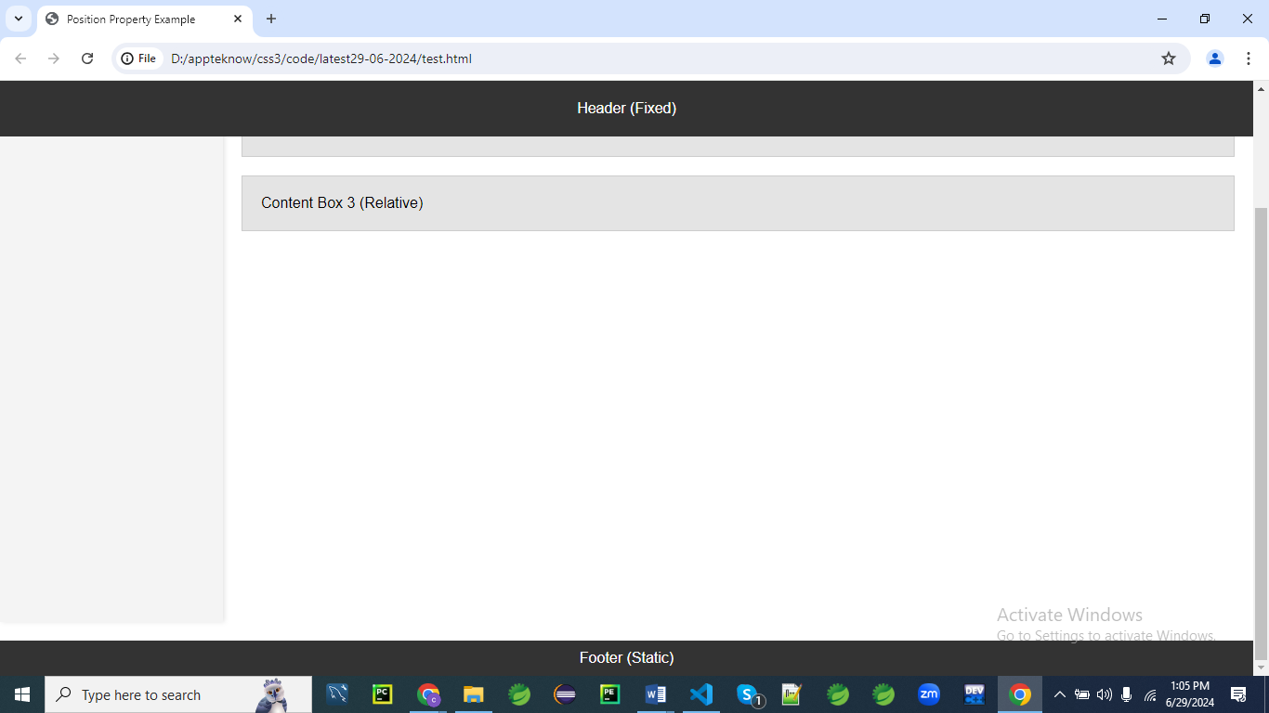

**Webpage Layout**

Here's the HTML and CSS code for the example:

<!DOCTYPE html>

<html lang="en">

<head>

<meta charset="UTF-8">

<meta name="viewport" content="width=device-width, initial-scale=1.0">

<title>Position Property Example</title>

<style>

body {

margin: 0;

font-family: Arial, sans-serif;

}

.header {

position: fixed;

top: 0;

width: 100%;

height: 60px;

background-color: #333;

color: white;

display: flex;

align-items: center;

justify-content: center;

z-index: 1000;

}

.container {

display: flex;

margin-top: 60px; /* Offset the height of the fixed header */

}

.sidebar {

position: sticky;

top: 60px; /* Stick to the bottom of the header */

width: 200px;

height: 100vh;

background-color: #f4f4f4;

padding: 20px;

box-shadow: 2px 0 5px rgba(0,0,0,0.1);

}

.content {

flex: 1;

padding: 20px;

}

.box {

position: relative;

margin: 20px 0;

padding: 20px;

background-color: #e4e4e4;

border: 1px solid #ccc;

}

.box .absolute {

position: absolute;

top: 10px;

right: 10px;

background-color: #ffcc00;

padding: 5px;

}

.footer {

position: static;

width: 100%;

background-color: #333;

color: white;

text-align: center;

padding: 10px 0;

margin-top: 20px;

}

</style>

</head>

<body>

<div class="header">Header (Fixed)</div>

<div class="container">

<div class="sidebar">Sidebar (Sticky)</div>

<div class="content">

<div class="box">

Content Box 1 (Relative)

<div class="absolute">Absolute Positioned Box</div>

</div>

<div class="box">Content Box 2 (Relative)</div>

<div class="box">Content Box 3 (Relative)</div>

</div>

</div>

<div class="footer">Footer (Static)</div>

</body>

</html>

**Explanation:**

1. **Fixed Header**:
   * The header is positioned at the top of the viewport and stays fixed when the page is scrolled.
   * It has position: fixed; and top: 0;.
2. **Sticky Sidebar**:
   * The sidebar is positioned relative to the viewport and remains in view when scrolling within the content area.
   * It has position: sticky; and top: 60px; to stick below the fixed header.
3. **Relative Content Boxes**:
   * Each content box is positioned relative to its normal position.
   * It has position: relative; to allow for absolutely positioned elements inside.
4. **Absolute Positioned Element**:
   * The yellow box inside the first content box is positioned absolutely relative to its nearest positioned ancestor (the content box).
   * It has position: absolute;, top: 10px;, and right: 10px;.
5. **Static Footer**:
   * The footer follows the normal flow of the document and stays at the bottom of the page.
   * It has position: static;.

This example demonstrates how various position values can be used together to create a functional and visually appealing webpage layout.

**Explanation to CSS:**

This CSS stylesheet defines the styles for a web page layout, including a fixed header, sticky sidebar, content area, boxes within the content, and a footer.

Here's a line-by-line explanation:

**body {**

**margin: 0;**

**font-family: Arial, sans-serif;**

**}**

* Sets the body's margin to 0, removing default margin.
* Uses the Arial font family, or a generic sans-serif if Arial is unavailable.

**.header {**

**position: fixed;**

**top: 0;**

**width: 100%;**

**height: 60px;**

**background-color: #333;**

**color: white;**

**display: flex;**

**align-items: center;**

**justify-content: center;**

**z-index: 1000;**

**}**

* .header is fixed at the top of the viewport.
* It spans the full width of the page and has a height of 60px.
* The background color is dark gray (#333) and text color is white.
* Uses flexbox to center its content both vertically and horizontally.
* z-index: 1000 ensures the header stays above other elements.

The z-index: 1000 property in the .header CSS rule is important for controlling the stacking order of the header element relative to other elements on the page.

Here's why it is significant:

1. **Stacking Context**: z-index defines the order in which elements are layered on top of one another. Elements with a higher z-index value are displayed above elements with a lower z-index value.
2. **Fixed Positioning**: The .header element is positioned using position: fixed;, which means it stays fixed in place relative to the viewport, even when scrolling. Without a proper z-index, it could be covered by other elements that also use positioning or have a higher stacking context.
3. **Ensuring Visibility**: Setting z-index: 1000 ensures that the header is highly likely to stay on top of other elements, making it always visible and accessible. This is particularly important for elements like headers or navigation bars that need to be consistently accessible to the user.
4. **Conflict Prevention**: By assigning a high value like 1000, you minimize the chances of other elements unintentionally overlapping the header. It serves as a safe guard against unexpected layout issues that might arise from elements introduced later in the design process.

In summary, z-index: 1000 ensures the header remains on top of other page elements, providing consistent visibility and preventing conflicts with other content.Top of Form

**.container {**

**display: flex;**

**margin-top: 60px; /* Offset the height of the fixed header */**

**}**

* .container is a flex container.
* margin-top: 60px offsets the fixed header's height, preventing content from being hidden behind it.

**.sidebar {**

**position: sticky;**

**top: 60px; /* Stick to the bottom of the header */**

**width: 200px;**

**height: 100vh;**

**background-color: #f4f4f4;**

**padding: 20px;**

**box-shadow: 2px 0 5px rgba(0,0,0,0.1);**

**}**

* .sidebar is sticky and stays 60px from the top (right below the header).
* It's 200px wide and extends the full viewport height (100vh).
* Has a light gray background (#f4f4f4) and 20px padding.
* Adds a shadow to the right side for a 3D effect.

**.content {**

**flex: 1;**

**padding: 20px;**

**}**

* .content takes up the remaining space in the flex container.
* Includes 20px padding for spacing inside the content area.

**.box {**

**position: relative;**

**margin: 20px 0;**

**padding: 20px;**

**background-color: #e4e4e4;**

**border: 1px solid #ccc;**

**}**

* .box has a relative position for child elements to position absolutely inside it.
* Includes 20px margin vertically and padding inside.
* Has a light gray background (#e4e4e4) and a light gray border (#ccc).

**.box .absolute {**

**position: absolute;**

**top: 10px;**

**right: 10px;**

**background-color: #ffcc00;**

**padding: 5px;**

**}**

* .box .absolute positions absolutely within its parent .box.
* It is positioned 10px from the top and right.
* Has a yellow background (#ffcc00) and 5px padding.

**.footer {**

**position: static;**

**width: 100%;**

**background-color: #333;**

**color: white;**

**text-align: center;**

**padding: 10px 0;**

**margin-top: 20px;**

**}**

* .footer has a static position (default).
* Spans the full width of the page and has a dark gray background (#333) with white text.
* Centers its text horizontally and includes 10px vertical padding.
* margin-top: 20px adds space above the footer.

This CSS sets up a structured and responsive page layout with distinct areas for a header, sidebar, main content, individual boxes within the content, and a footer.

Bottom of Form

**Example 02**

Let's create a real-like example for a webpage layout that incorporates the use of the position property to achieve a header, a sidebar, a content area with multiple sections, and a footer. This example will demonstrate how fixed, relative, absolute, and sticky positioning work together to create a cohesive and interactive layout.

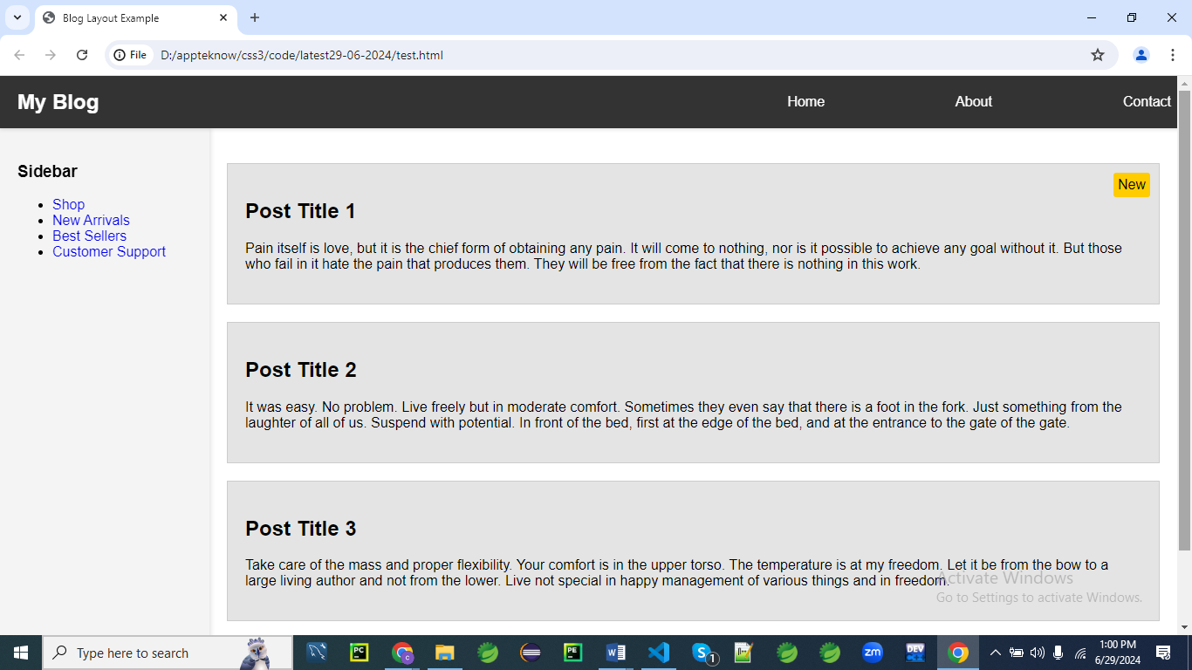

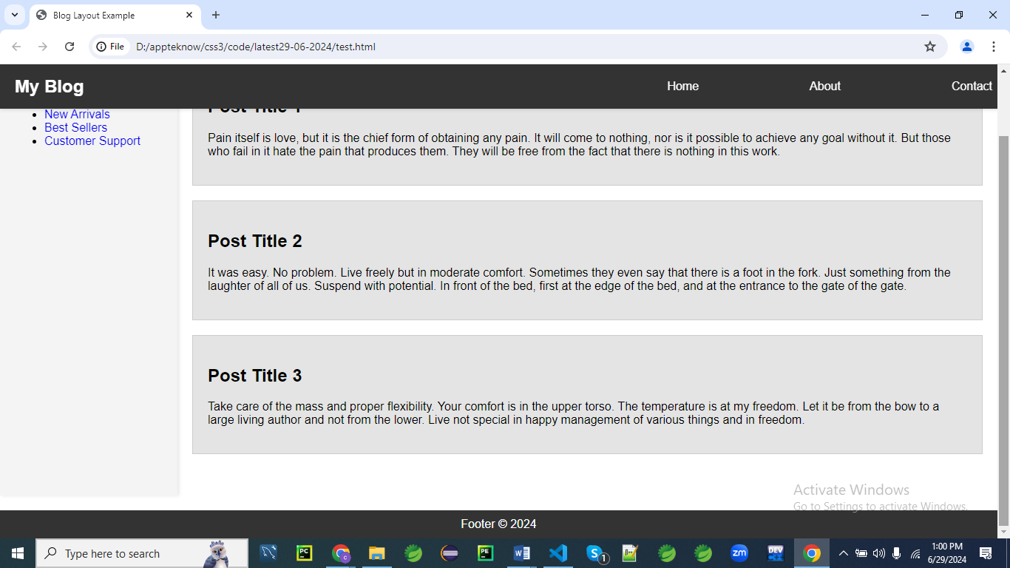

**Blog Layout**

Here's the complete HTML and CSS for a blog-like layout:

<!DOCTYPE html>

<html lang="en">

<head>

    <meta charset="UTF-8">

    <meta name="viewport" content="width=device-width, initial-scale=1.0">

    <title>Blog Layout Example</title>

    <style>

        body {

            margin: 0;

            font-family: Arial, sans-serif;

        }

        .header {

            position: fixed;

            top: 0;

            left: 0;

            width: 98%;

            height: 60px;

            background-color: #333;

            color: white;

            display: flex;

            align-items: center;

            justify-content: space-between;

            padding: 0 20px;

            z-index: 1000;

            box-shadow: 0 2px 4px rgba(0,0,0,0.1);

        }

        .header .logo {

            font-size: 1.5em;

            font-weight: bold;

        }

        .header .nav {

            display: flex;

            gap: 150px;

        }

        .container {

            display: flex;

            margin-top: 60px; /* Offset the height of the fixed header */

        }

        .sidebar {

            position: sticky;

            top: 60px; /* Stick to the bottom of the header */

            width: 200px;

            height: calc(100vh - 60px);

            background-color: #f4f4f4;

            padding: 20px;

            box-shadow: 2px 0 5px rgba(0,0,0,0.1);

        }

        .content {

            flex: 1;

            padding: 20px;

        }

        .post {

            position: relative;

            margin: 20px 0;

            padding: 20px;

            background-color: #e4e4e4;

            border: 1px solid #ccc;

        }

        .post .absolute {

            position: absolute;

            top: 10px;

            right: 10px;

            background-color: #ffcc00;

            padding: 5px;

            border-radius: 3px;

        }

        .footer {

            position: static;

            width: 100%;

            background-color: #333;

            color: white;

            text-align: center;

            padding: 10px 0;

            margin-top: 20px;

        }

    </style>

</head>

<body>

    <div class="header">

        <div class="logo">My Blog</div>

        <div class="nav">

            <a href="#" style="color: white; text-decoration: none;">Home</a>

            <a href="#" style="color: white; text-decoration: none;">About</a>

            <a href="#" style="color: white; text-decoration: none;">Contact</a>

        </div>

    </div>

    <div class="container">

        <div class="sidebar">

            <h3>Sidebar</h3>

            <ul>

                <li><a href="#" style="text-decoration: none;">Shop</a></li>

                <li><a href="#" style="text-decoration: none;">New Arrivals</a></li>

                <li><a href="#" style="text-decoration: none;">Best Sellers</a></li>

                <li><a href="#" style="text-decoration: none;">Customer Support</a></li>

            </ul>

        </div>

        <div class="content">

            <div class="post">

                <h2>Post Title 1</h2>

                <p>Pain itself is love, but it is the chief form of obtaining any pain. It will come to nothing, nor is it possible to achieve any goal without it. But those who fail in it hate the pain that produces them. They will be free from the fact that there is nothing in this work.</p>

                <div class="absolute">New</div>

            </div>

            <div class="post">

                <h2>Post Title 2</h2>

                <p>It was easy. No problem. Live freely but in moderate comfort. Sometimes they even say that there is a foot in the fork. Just something from the laughter of all of us. Suspend with potential. In front of the bed, first at the edge of the bed, and at the entrance to the gate of the gate.</p>

            </div>

            <div class="post">

                <h2>Post Title 3</h2>

                <p>Take care of the mass and proper flexibility. Your comfort is in the upper torso. The temperature is at my freedom. Let it be from the bow to a large living author and not from the lower. Live not special in happy management of various things and in freedom.</p>

            </div>

        </div>

    </div>

    <div class="footer">Footer © 2024</div>

</body>

</html>

**Explanation:**

1. **Header**:
   * The header is fixed at the top of the viewport, with a logo and navigation links.
   * It has position: fixed;, top: 0;, and left: 0;.
2. **Sidebar**:
   * The sidebar sticks to the top of the viewport, just below the header.
   * It has position: sticky; and top: 60px; to account for the height of the header.
3. **Content Area**:
   * The content area contains multiple posts.
   * Each post has position: relative; to allow for absolutely positioned elements inside.
4. **Absolute Positioned Element**:
   * A "New" label in the first post is positioned absolutely relative to the post container.
   * It has position: absolute;, top: 10px;, and right: 10px;.
5. **Footer**:
   * The footer follows the normal document flow and is positioned at the bottom of the page.
   * It has position: static;.

This example creates a practical and visually appealing blog layout, showcasing the effective use of different CSS position properties.

**Explanation:**

Let's go through each line of the CSS code in the provided example to understand how it works.

**Global Styles**

**body {**

**margin: 0;**

**font-family: Arial, sans-serif;**

**}**

* margin: 0;: Removes the default margin from the body element to prevent any unwanted spacing around the edges of the page.
* font-family: Arial, sans-serif;: Sets the default font for the entire webpage to Arial, and if Arial is not available, it falls back to a generic sans-serif font.

**Header Styles**

**.header {**

**position: fixed;**

**top: 0;**

**left: 0;**

**width: 100%;**

**height: 60px;**

**background-color: #333;**

**color: white;**

**display: flex;**

**align-items: center;**

**justify-content: space-between;**

**padding: 0 20px;**

**z-index: 1000;**

**box-shadow: 0 2px 4px rgba(0,0,0,0.1);**

**}**

* position: fixed;: Fixes the header at the top of the viewport, so it remains in place even when the page is scrolled.
* top: 0; left: 0;: Positions the header at the top-left corner of the viewport.
* width: 100%;: Makes the header span the entire width of the viewport.
* height: 60px;: Sets the height of the header to 60 pixels.
* background-color: #333;: Sets the background color of the header to a dark gray color.
* color: white;: Sets the text color of the header to white.
* display: flex;: Uses flexbox layout for the header's content.
* align-items: center;: Vertically centers the items within the header.
* justify-content: space-between;: Horizontally spaces out the items within the header, placing space between them.
* padding: 0 20px;: Adds padding of 20 pixels on the left and right sides of the header.
* z-index: 1000;: Ensures the header stays on top of other content with a high stacking order.
* box-shadow: 0 2px 4px rgba(0,0,0,0.1);: Adds a subtle shadow below the header for a slight 3D effect.

**Header Logo and Navigation Styles**

**.header .logo {**

**font-size: 1.5em;**

**font-weight: bold;**

**}**

**.header .nav {**

**display: flex;**

**gap: 15px;**

**}**

* .header .logo: Targets the logo within the header.
  + font-size: 1.5em;: Sets the font size of the logo text to 1.5 times the base font size.
  + font-weight: bold;: Makes the logo text bold.
* .header .nav: Targets the navigation container within the header.
  + display: flex;: Uses flexbox layout for the navigation links.
  + gap: 15px;: Adds 15 pixels of space between each navigation link.

**Container Styles**

**.container {**

**display: flex;**

**margin-top: 60px; /* Offset the height of the fixed header */**

**}**

* display: flex;: Uses flexbox layout for the container, allowing the sidebar and content to be positioned side by side.
* margin-top: 60px;: Adds a top margin to the container to offset the fixed header's height, preventing the header from overlapping the content.

**Sidebar Styles**

**.sidebar {**

**position: sticky;**

**top: 60px; /* Stick to the bottom of the header */**

**width: 200px;**

**height: calc(100vh - 60px);**

**background-color: #f4f4f4;**

**padding: 20px;**

**box-shadow: 2px 0 5px rgba(0,0,0,0.1);**

**}**

* position: sticky;: Makes the sidebar sticky, so it remains visible within the viewport when scrolling past a certain point.
* top: 60px;: Keeps the sidebar 60 pixels below the top of the viewport, aligning it with the bottom of the fixed header.
* width: 200px;: Sets the width of the sidebar to 200 pixels.
* height: calc(100vh - 60px);: Makes the sidebar's height equal to the full height of the viewport minus the height of the header.
* background-color: #f4f4f4;: Sets the background color of the sidebar to a light gray color.
* padding: 20px;: Adds 20 pixels of padding inside the sidebar for spacing.
* box-shadow: 2px 0 5px rgba(0,0,0,0.1);: Adds a shadow on the right side of the sidebar for a slight 3D effect.

**Content Styles**

**.content {**

**flex: 1;**

**padding: 20px;**

**}**

* flex: 1;: Allows the content area to grow and fill the remaining space within the flex container.
* padding: 20px;: Adds 20 pixels of padding inside the content area for spacing.

**Post Styles**

**.post {**

**position: relative;**

**margin: 20px 0;**

**padding: 20px;**

**background-color: #e4e4e4;**

**border: 1px solid #ccc;**

**}**

* position: relative;: Makes the post container a reference point for absolutely positioned elements inside it.
* margin: 20px 0;: Adds 20 pixels of margin above and below each post for spacing.
* padding: 20px;: Adds 20 pixels of padding inside each post for spacing.
* background-color: #e4e4e4;: Sets the background color of each post to a light gray color.
* border: 1px solid #ccc;: Adds a light gray border around each post.

**Absolute Positioned Element Inside Post**

**.post .absolute {**

**position: absolute;**

**top: 10px;**

**right: 10px;**

**background-color: #ffcc00;**

**padding: 5px;**

**border-radius: 3px;**

**}**

* position: absolute;: Positions the element absolutely relative to its nearest positioned ancestor (.post).
* top: 10px;: Positions the element 10 pixels from the top of the post.
* right: 10px;: Positions the element 10 pixels from the right of the post.
* background-color: #ffcc00;: Sets the background color of the element to a yellow color.
* padding: 5px;: Adds 5 pixels of padding inside the element for spacing.
* border-radius: 3px;: Rounds the corners of the element slightly.

**Footer Styles**

**.footer {**

**position: static;**

**width: 100%;**

**background-color: #333;**

**color: white;**

**text-align: center;**

**padding: 10px 0;**

**margin-top: 20px;**

**}**

* position: static;: Keeps the footer in its normal document flow position.
* width: 100%;: Makes the footer span the entire width of the viewport.
* background-color: #333;: Sets the background color of the footer to a dark gray color.
* color: white;: Sets the text color of the footer to white.
* text-align: center;: Centers the text within the footer.
* padding: 10px 0;: Adds 10 pixels of padding above and below the footer text.
* margin-top: 20px;: Adds a top margin of 20 pixels to create space above the footer.

This explanation covers the purpose and effect of each line of CSS in the provided example, helping to understand how different CSS properties and values are used to create a functional and visually appealing webpage layout.

**Example 03**

Let's create another example code for a webpage layout with a different structure. This example will feature a navigation bar at the top, a sidebar, a main content area, and a footer. We'll use the position property to achieve this layout.

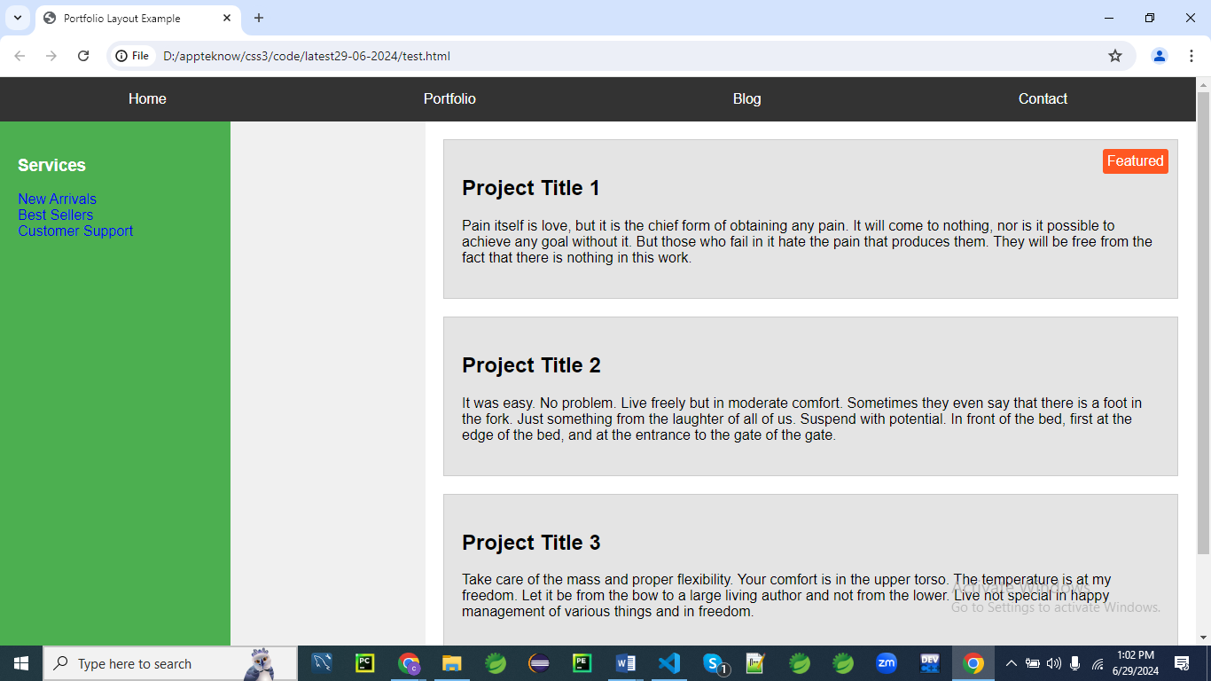

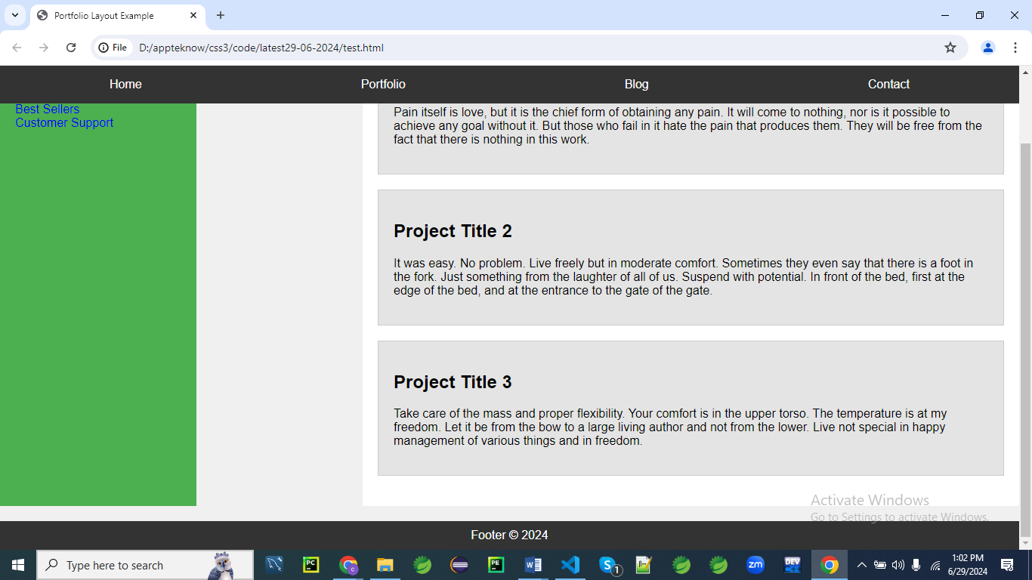

**Portfolio Layout**

Here's the complete HTML and CSS for a portfolio-style layout:

<!DOCTYPE html>

<html lang="en">

<head>

    <meta charset="UTF-8">

    <meta name="viewport" content="width=device-width, initial-scale=1.0">

    <title>Portfolio Layout Example</title>

    <style>

        body {

            margin: 0;

            font-family: Arial, sans-serif;

            background-color: #f0f0f0;

        }

        .navbar {

            position: fixed;

            top: 0;

            left: 0;

            width: 100%;

            height: 50px;

            background-color: #333;

            color: white;

            display: flex;

            align-items: center;

            justify-content: space-around;

            z-index: 1000;

        }

        .container {

            display: flex;

            margin-top: 50px; /* Offset the height of the fixed navbar */

        }

        .sidebar {

            position: sticky;

            top: 50px; /* Stick to the bottom of the navbar */

            width: 220px;

            height: calc(100vh - 50px);

            background-color: #4CAF50;

            padding: 20px;

            color: white;

        }

        .main-content {

            flex: 1;

            padding: 20px;

            background-color: #fff;

            margin-left: 220px; /* Offset the width of the sidebar */

        }

        .project {

            position: relative;

            margin-bottom: 20px;

            padding: 20px;

            background-color: #e4e4e4;

            border: 1px solid #ccc;

        }

        .project .absolute {

            position: absolute;

            top: 10px;

            right: 10px;

            background-color: #ff5722;

            color: white;

            padding: 5px;

            border-radius: 3px;

        }

        .footer {

            position: static;

            width: 100%;

            background-color: #333;

            color: white;

            text-align: center;

            padding: 10px 0;

            margin-top: 20px;

        }

    </style>

</head>

<body>

    <div class="navbar">

        <a href="#" style="color: white; text-decoration: none;">Home</a>

        <a href="#" style="color: white; text-decoration: none;">Portfolio</a>

        <a href="#" style="color: white; text-decoration: none;">Blog</a>

        <a href="#" style="color: white; text-decoration: none;">Contact</a>

    </div>

    <div class="container">

        <div class="sidebar">

            <h3>Services</h3>

            <ul style="list-style: none; padding: 0;">

                <li><a href="#" style="text-decoration: none;">New Arrivals</a></li>

                <li><a href="#" style="text-decoration: none;">Best Sellers</a></li>

                <li><a href="#" style="text-decoration: none;">Customer Support</a></li>

            </ul>

        </div>

        <div class="main-content">

            <div class="project">

                <h2>Project Title 1</h2>

                <p>Pain itself is love, but it is the chief form of obtaining any pain. It will come to nothing, nor is it possible to achieve any goal without it. But those who fail in it hate the pain that produces them. They will be free from the fact that there is nothing in this work.</p>

                <div class="absolute">Featured</div>

            </div>

            <div class="project">

                <h2>Project Title 2</h2>

                <p>It was easy. No problem. Live freely but in moderate comfort. Sometimes they even say that there is a foot in the fork. Just something from the laughter of all of us. Suspend with potential. In front of the bed, first at the edge of the bed, and at the entrance to the gate of the gate.</p>

            </div>

            <div class="project">

                <h2>Project Title 3</h2>

                <p>Take care of the mass and proper flexibility. Your comfort is in the upper torso. The temperature is at my freedom. Let it be from the bow to a large living author and not from the lower. Live not special in happy management of various things and in freedom.</p>

            </div>

        </div>

    </div>

    <div class="footer">Footer © 2024</div>

</body>

</html>

**Explanation:**

1. **Navbar**:
   * The navbar is fixed at the top of the viewport.
   * It uses flexbox to evenly space the navigation links.
   * position: fixed;, top: 0;, left: 0;, width: 100%;, height: 50px;, background-color: #333;, color: white;, display: flex;, align-items: center;, justify-content: space-around;, z-index: 1000;.
2. **Container**:
   * The container uses flexbox to position the sidebar and main content side by side.
   * It has a top margin to offset the height of the fixed navbar.
   * display: flex;, margin-top: 50px;.
3. **Sidebar**:
   * The sidebar is sticky and sticks below the navbar.
   * It has a fixed width and height to fit the viewport minus the navbar's height.
   * position: sticky;, top: 50px;, width: 220px;, height: calc(100vh - 50px);, background-color: #4CAF50;, padding: 20px;, color: white;.
4. **Main Content**:
   * The main content area grows to fill the remaining space and has padding for spacing.
   * It has a background color of white and a margin-left to account for the sidebar's width.
   * flex: 1;, padding: 20px;, background-color: #fff;, margin-left: 220px;.
5. **Project**:
   * Each project has a relative position to allow for absolute positioning of child elements.
   * It has margins, padding, background color, and a border.
   * position: relative;, margin-bottom: 20px;, padding: 20px;, background-color: #e4e4e4;, border: 1px solid #ccc;.
6. **Absolute Positioned Element in Project**:
   * The "Featured" label is positioned absolutely within the project container.
   * It has a background color, padding, and rounded corners.
   * position: absolute;, top: 10px;, right: 10px;, background-color: #ff5722;, color: white;, padding: 5px;, border-radius: 3px;.
7. **Footer**:
   * The footer follows the normal document flow and spans the entire width of the viewport.
   * It has a background color, text color, text alignment, padding, and top margin.
   * position: static;, width: 100%;, background-color: #333;, color: white;, text-align: center;, padding: 10px 0;, margin-top: 20px;.

This example creates a practical portfolio layout, showcasing the effective use of different CSS position properties to create a functional and visually appealing webpage.

**Explanation:**

Let's go through the CSS in the provided portfolio layout example and explain each part:

**Global Styles**

**body {**

**margin: 0;**

**font-family: Arial, sans-serif;**

**background-color: #f0f0f0;**

**}**

* margin: 0;: Removes the default margin from the body element to prevent any unwanted spacing around the edges of the page.
* font-family: Arial, sans-serif;: Sets the default font for the entire webpage to Arial, and if Arial is not available, it falls back to a generic sans-serif font.
* background-color: #f0f0f0;: Sets a light gray background color for the entire page.

**Navbar Styles**

**.navbar {**

**position: fixed;**

**top: 0;**

**left: 0;**

**width: 100%;**

**height: 50px;**

**background-color: #333;**

**color: white;**

**display: flex;**

**align-items: center;**

**justify-content: space-around;**

**z-index: 1000;**

**}**

* position: fixed;: Fixes the navbar at the top of the viewport, so it remains in place even when the page is scrolled.
* top: 0;, left: 0;: Positions the navbar at the top-left corner of the viewport.
* width: 100%;: Makes the navbar span the entire width of the viewport.
* height: 50px;: Sets the height of the navbar to 50 pixels.
* background-color: #333;: Sets the background color of the navbar to a dark gray color.
* color: white;: Sets the text color of the navbar to white.
* display: flex;: Uses flexbox layout for the navbar's content.
* align-items: center;: Vertically centers the items within the navbar.
* justify-content: space-around;: Horizontally spaces out the items within the navbar, placing space around them.
* z-index: 1000;: Ensures the navbar stays on top of other content with a high stacking order.

**Container Styles**

**.container {**

**display: flex;**

**margin-top: 50px; /* Offset the height of the fixed navbar */**

**}**

* display: flex;: Uses flexbox layout for the container, allowing the sidebar and content to be positioned side by side.
* margin-top: 50px;: Adds a top margin to the container to offset the fixed navbar's height, preventing the navbar from overlapping the content.

**Sidebar Styles**

**.sidebar {**

**position: sticky;**

**top: 50px; /* Stick to the bottom of the navbar */**

**width: 220px;**

**height: calc(100vh - 50px);**

**background-color: #4CAF50;**

**padding: 20px;**

**color: white;**

**}**

* position: sticky;: Makes the sidebar sticky, so it remains visible within the viewport when scrolling past a certain point.
* top: 50px;: Keeps the sidebar 50 pixels below the top of the viewport, aligning it with the bottom of the fixed navbar.
* width: 220px;: Sets the width of the sidebar to 220 pixels.
* height: calc(100vh - 50px);: Makes the sidebar's height equal to the full height of the viewport minus the height of the navbar.
* background-color: #4CAF50;: Sets the background color of the sidebar to a green color.
* padding: 20px;: Adds 20 pixels of padding inside the sidebar for spacing.
* color: white;: Sets the text color of the sidebar to white.

**Main Content Styles**

**.main-content {**

**flex: 1;**

**padding: 20px;**

**background-color: #fff;**

**margin-left: 220px; /* Offset the width of the sidebar */**

**}**

* flex: 1;: Allows the main content area to grow and fill the remaining space within the flex container.
* padding: 20px;: Adds 20 pixels of padding inside the main content area for spacing.
* background-color: #fff;: Sets the background color of the main content area to white.
* margin-left: 220px;: Adds a left margin to the main content area to offset the width of the sidebar, preventing overlap.

**Project Styles**

**.project {**

**position: relative;**

**margin-bottom: 20px;**

**padding: 20px;**

**background-color: #e4e4e4;**

**border: 1px solid #ccc;**

**}**

* position: relative;: Makes the project container a reference point for absolutely positioned elements inside it.
* margin-bottom: 20px;: Adds 20 pixels of margin below each project for spacing.
* padding: 20px;: Adds 20 pixels of padding inside each project for spacing.
* background-color: #e4e4e4;: Sets the background color of each project to a light gray color.
* border: 1px solid #ccc;: Adds a light gray border around each project.

**Absolute Positioned Element Inside Project**

**.project .absolute {**

**position: absolute;**

**top: 10px;**

**right: 10px;**

**background-color: #ff5722;**

**color: white;**

**padding: 5px;**

**border-radius: 3px;**

**}**

* position: absolute;: Positions the element absolutely relative to its nearest positioned ancestor (.project).
* top: 10px;: Positions the element 10 pixels from the top of the project.
* right: 10px;: Positions the element 10 pixels from the right of the project.
* background-color: #ff5722;: Sets the background color of the element to a reddish-orange color.
* color: white;: Sets the text color of the element to white.
* padding: 5px;: Adds 5 pixels of padding inside the element for spacing.
* border-radius: 3px;: Rounds the corners of the element slightly.

**Footer Styles**

.**footer {**

**position: static;**

**width: 100%;**

**background-color: #333;**

**color: white;**

**text-align: center;**

**padding: 10px 0;**

**margin-top: 20px;**

**}**

* position: static;: Keeps the footer in its normal document flow position.
* width: 100%;: Makes the footer span the entire width of the viewport.
* background-color: #333;: Sets the background color of the footer to a dark gray color.
* color: white;: Sets the text color of the footer to white.
* text-align: center;: Centers the text within the footer.
* padding: 10px 0;: Adds 10 pixels of padding above and below the footer text.
* margin-top: 20px;: Adds a top margin of 20 pixels to create space above the footer.

This explanation covers the purpose and effect of each line of CSS in the provided example, helping to understand how different CSS properties and values are used to create a functional and visually appealing webpage layout.