**Exercise 01: Simple Event Page Layout**

**Objective**: Create a basic event page layout with a header, navigation bar, main content area featuring event details, and a footer using the same CSS styles as in your provided example.

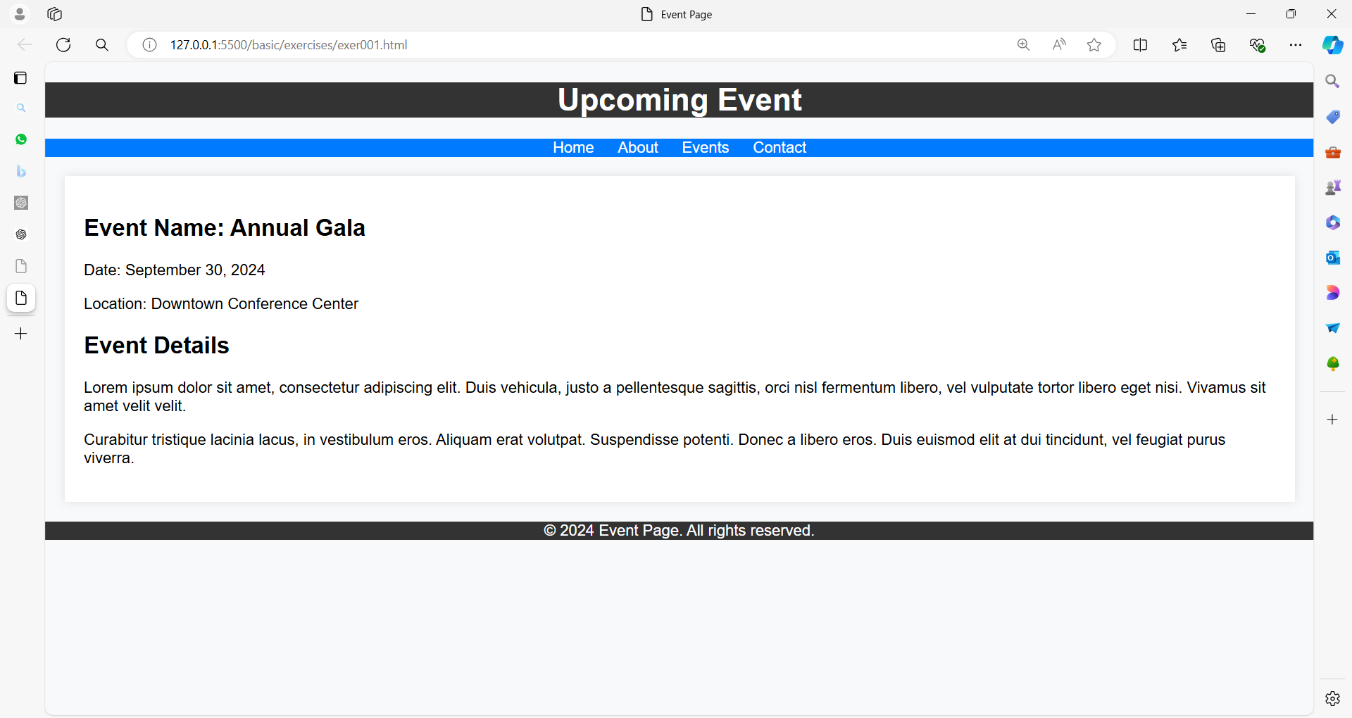

**Solution**:

<!DOCTYPE html>

<html lang="en">

<head>

<meta charset="UTF-8">

<meta name="viewport" content="width=device-width, initial-scale=1.0">

<title>Event Page</title>

<style>

body {

font-family: Arial, sans-serif;

margin: 0;

background-color: #f8f9fa;

}

header {

background-color: #333;

color: white;

text-align: center;

}

nav {

background-color: #007bff;

color: white;

text-align: center;

}

nav a {

color: white;

text-decoration: none;

margin: 0 10px;

}

footer {

background-color: #333;

color: white;

text-align: center;

bottom: 0;

width: 100%;

}

main {

padding: 20px;

background-color: white;

margin: 20px;

box-shadow: 0 0 10px rgba(0, 0, 0, 0.1);

}

.event-details {

margin-top: 20px;

}

.event-details h2 {

margin-top: 0;

}

</style>

</head>

<body>

<header>

<h1>Upcoming Event</h1>

</header>

<nav>

<a href="#">Home</a>

<a href="#">About</a>

<a href="#">Events</a>

<a href="#">Contact</a>

</nav>

<main>

<h2>Event Name: Annual Gala</h2>

<p>Date: September 30, 2024</p>

<p>Location: Downtown Conference Center</p>

<div class="event-details">

<h2>Event Details</h2>

<p>Lorem ipsum dolor sit amet, consectetur adipiscing elit. Duis vehicula, justo a pellentesque sagittis, orci nisl fermentum libero, vel vulputate tortor libero eget nisi. Vivamus sit amet velit velit.</p>

<p>Curabitur tristique lacinia lacus, in vestibulum eros. Aliquam erat volutpat. Suspendisse potenti. Donec a libero eros. Duis euismod elit at dui tincidunt, vel feugiat purus viverra.</p>

</div>

</main>

<footer>

&copy; 2024 Event Page. All rights reserved.

</footer>

</body>

</html>

**Exercise 02: Simple Contact Page Layout**

**Objective**: Create a contact page layout with a header, a navigation bar, a main content area with a contact form, and a footer using the same CSS styles as in your provided example.

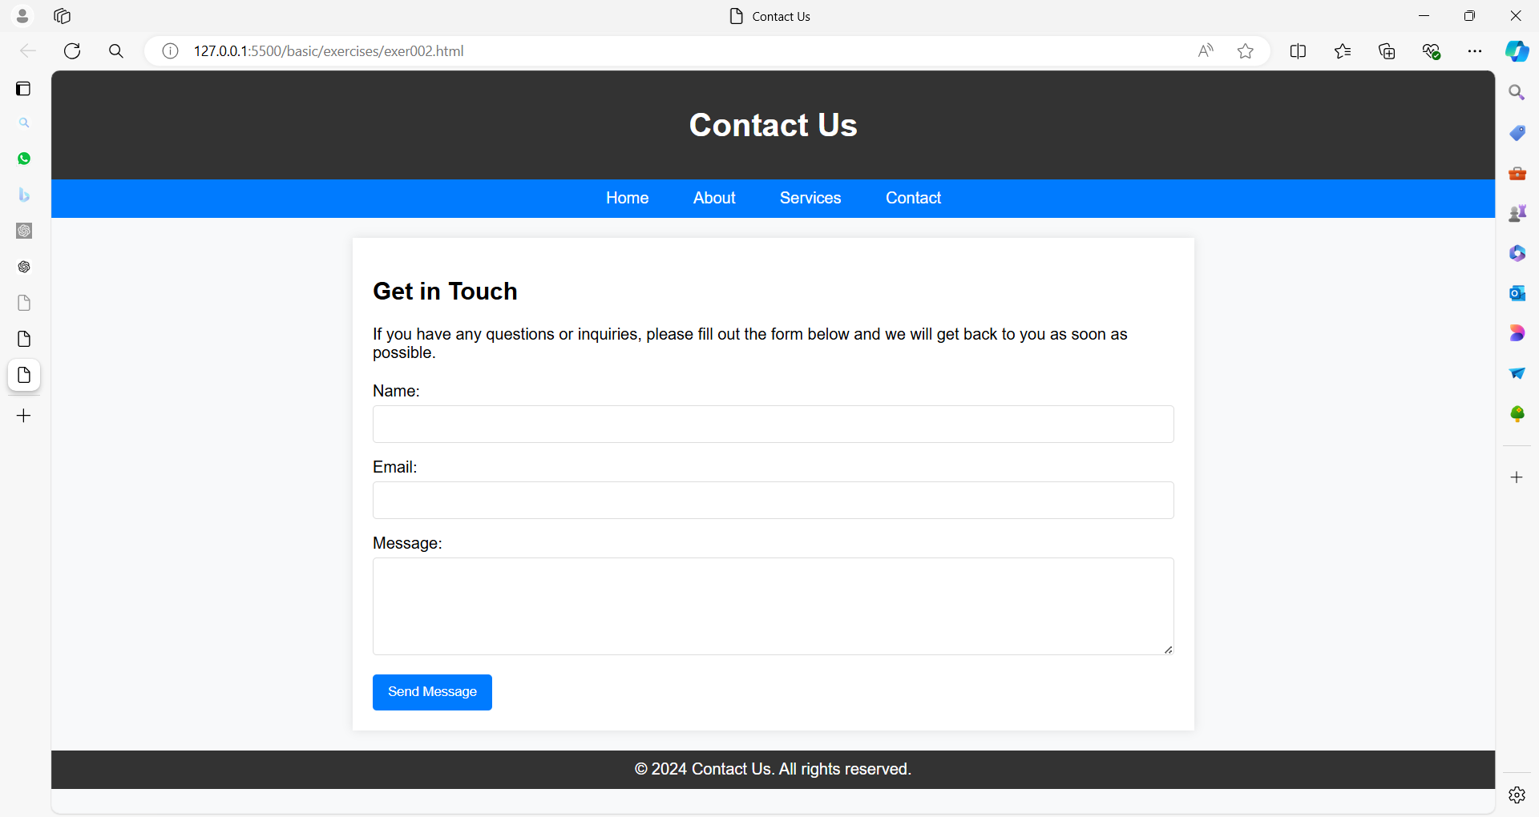

**Solution**:

<!DOCTYPE html>

<html lang="en">

<head>

<meta charset="UTF-8">

<meta name="viewport" content="width=device-width, initial-scale=1.0">

<title>Contact Us</title>

<style>

body {

font-family: Arial, sans-serif;

margin: 0;

padding: 0;

background-color: #f8f9fa;

}

header {

background-color: #333;

color: white;

text-align: center;

padding: 15px 0;

}

nav {

background-color: #007bff;

color: white;

text-align: center;

padding: 10px 0;

}

nav a {

color: white;

text-decoration: none;

margin: 0 10px;

padding: 5px 10px;

border-radius: 4px;

transition: background-color 0.3s;

}

nav a:hover {

background-color: #0056b3;

}

main {

padding: 20px;

background-color: white;

margin: 20px auto;

max-width: 800px;

box-shadow: 0 0 10px rgba(0, 0, 0, 0.1);

}

footer {

background-color: #333;

color: white;

text-align: center;

padding: 10px 0;

margin-top: 20px;

width: 100%;

}

form {

margin-top: 20px;

}

label {

margin-bottom: 5px;

float: left; /* Aligns labels to the left */

width: 100%; /* Ensures labels take up the full width */

}

input[type="text"],

input[type="email"],

textarea {

width: 100%;

padding: 10px;

border: 1px solid #ddd;

border-radius: 4px;

margin-bottom: 15px;

box-sizing: border-box; /* Includes padding and border in width */

}

button {

background-color: #007bff;

color: white;

border: none;

padding: 10px 15px;

border-radius: 4px;

cursor: pointer;

}

button:hover {

background-color: #0056b3;

}

</style>

</head>

<body>

<header>

<h1>Contact Us</h1>

</header>

<nav>

<a href="#">Home</a>

<a href="#">About</a>

<a href="#">Services</a>

<a href="#">Contact</a>

</nav>

<main>

<h2>Get in Touch</h2>

<p>If you have any questions or inquiries, please fill out the form below and we will get back to you as soon as possible.</p>

<form action="#" method="post">

<label for="name">Name:</label>

<input type="text" id="name" name="name" required>

<label for="email">Email:</label>

<input type="email" id="email" name="email" required>

<label for="message">Message:</label>

<textarea id="message" name="message" rows="5" required></textarea>

<button type="submit">Send Message</button>

</form>

</main>

<footer>

&copy; 2024 Contact Us. All rights reserved.

</footer>

</body>

</html>

**Exercise 03: Simple Contact Page Layout**

**Objective**: Create a contact page layout that includes a header, navigation bar, main content area with a contact form, and a footer.

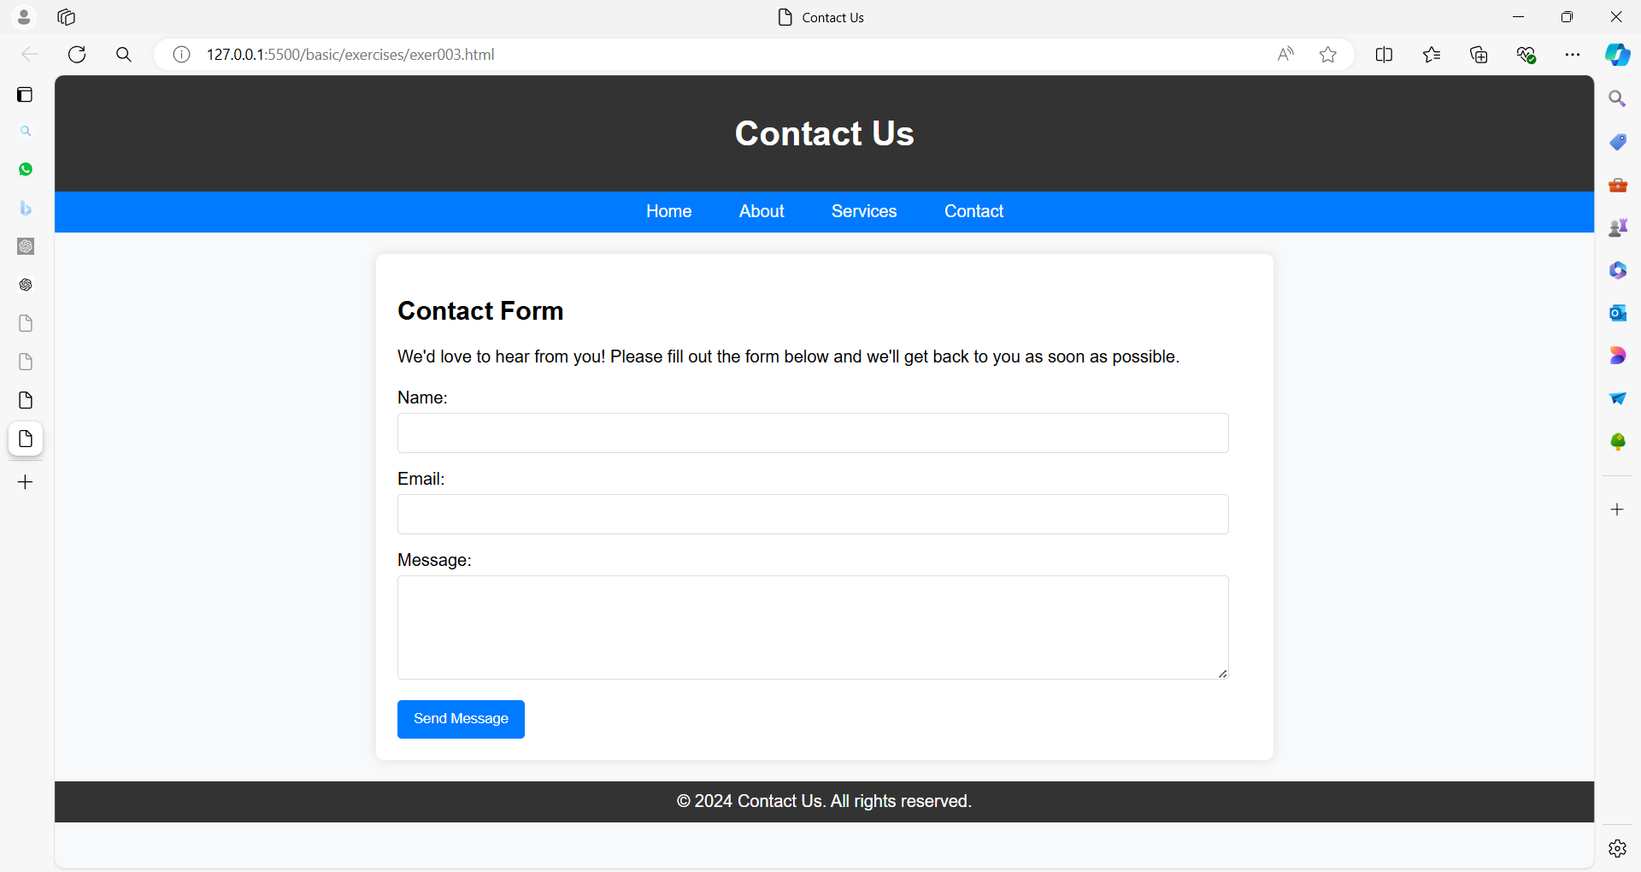

**Solution**:

<!DOCTYPE html>

<html lang="en">

<head>

<meta charset="UTF-8">

<meta name="viewport" content="width=device-width, initial-scale=1.0">

<title>Contact Us</title>

<style>

body {

font-family: Arial, sans-serif;

margin: 0;

padding: 0;

background-color: #f8f9fa;

}

header {

background-color: #333;

color: white;

text-align: center;

padding: 15px 0;

}

nav {

background-color: #007bff;

color: white;

text-align: center;

padding: 10px 0;

}

nav a {

color: white;

text-decoration: none;

margin: 0 10px;

padding: 5px 10px;

border-radius: 4px;

transition: background-color 0.3s;

}

nav a:hover {

background-color: #0056b3;

}

main {

padding: 20px;

background-color: white;

margin: 20px auto;

max-width: 800px;

box-shadow: 0 0 10px rgba(0, 0, 0, 0.1);

border-radius: 8px; /* Rounded corners */

}

footer {

background-color: #333;

color: white;

text-align: center;

padding: 10px 0;

margin-top: 20px;

width: 100%;

clear: both; /* Ensures footer stays below content */

}

form {

margin-top: 20px;

}

label {

margin-bottom: 5px;

float: left; /* Align labels to the left */

width: 100%; /* Ensure labels take full width */

}

input[type="text"],

input[type="email"],

textarea {

width: calc(100% - 22px); /* Full width minus padding and border */

padding: 10px;

border: 1px solid #ddd;

border-radius: 4px;

margin-bottom: 15px;

box-sizing: border-box; /* Includes padding and border in width */

}

button {

background-color: #007bff;

color: white;

border: none;

padding: 10px 15px;

border-radius: 4px;

cursor: pointer;

}

button:hover {

background-color: #0056b3;

}

</style>

</head>

<body>

<header>

<h1>Contact Us</h1>

</header>

<nav>

<a href="#">Home</a>

<a href="#">About</a>

<a href="#">Services</a>

<a href="#">Contact</a>

</nav>

<main>

<h2>Contact Form</h2>

<p>We'd love to hear from you! Please fill out the form below and we'll get back to you as soon as possible.</p>

<form action="#" method="post">

<label for="name">Name:</label>

<input type="text" id="name" name="name" required>

<label for="email">Email:</label>

<input type="email" id="email" name="email" required>

<label for="message">Message:</label>

<textarea id="message" name="message" rows="5" required></textarea>

<button type="submit">Send Message</button>

</form>

</main>

<footer>

&copy; 2024 Contact Us. All rights reserved.

</footer>

</body>

</html>

**Exercise 04: Contact Page Layout**

**Objective**: Create a contact page layout with a header, navigation bar, main content area containing a contact form with various fields, and a footer, using different colors.

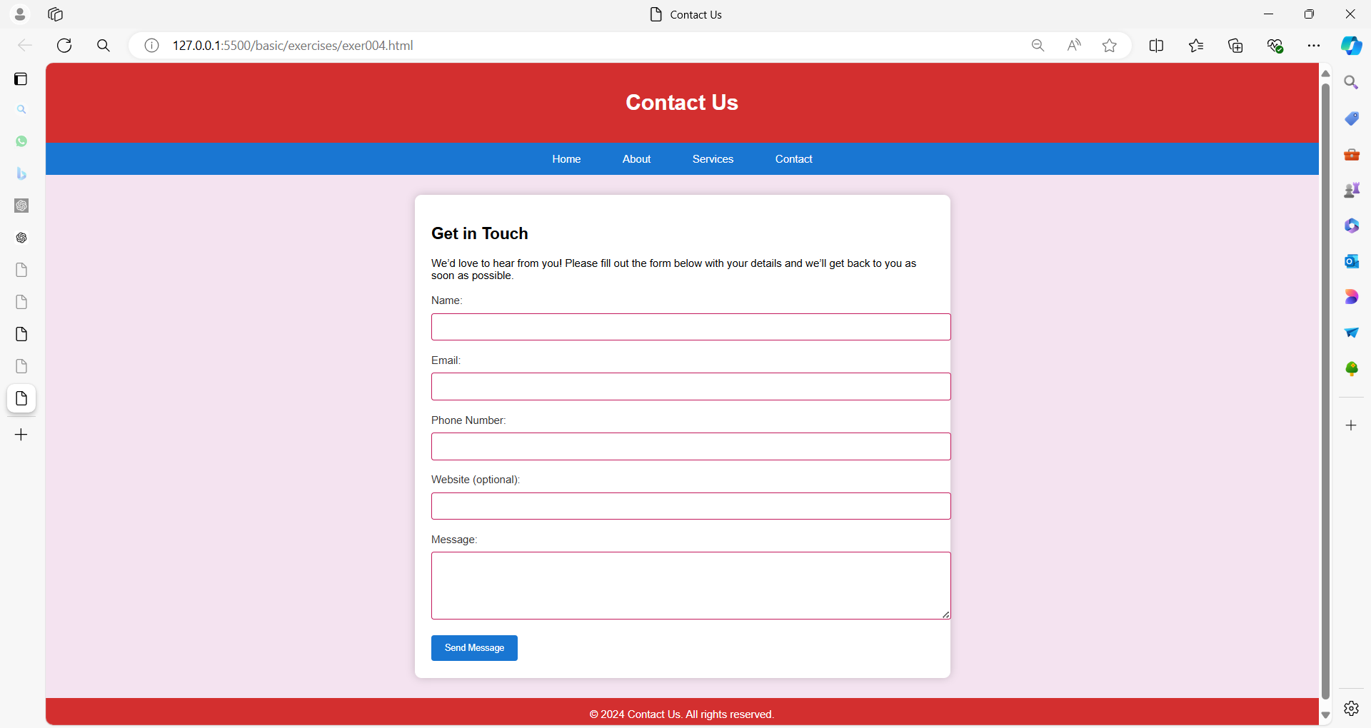

**Solution**:

<!DOCTYPE html>

<html lang="en">

<head>

<meta charset="UTF-8">

<meta name="viewport" content="width=device-width, initial-scale=1.0">

<title>Contact Us</title>

<style>

body {

font-family: Arial, sans-serif;

margin: 0;

padding: 0;

background-color: #f4e3f0; /* Light pink background */

}

header {

background-color: #d32f2f; /* Bright red background */

color: white;

text-align: center;

padding: 20px 0;

}

nav {

background-color: #1976d2; /* Blue background */

color: white;

text-align: center;

padding: 15px 0;

}

nav a {

color: white;

text-decoration: none;

margin: 0 15px;

padding: 8px 14px;

border-radius: 5px;

transition: background-color 0.3s;

}

nav a:hover {

background-color: #0d47a1; /* Dark blue on hover */

}

main {

padding: 25px;

background-color: #ffffff; /* White background */

margin: 30px auto;

max-width: 750px;

box-shadow: 0 0 12px rgba(0, 0, 0, 0.2);

border-radius: 10px; /* Rounded corners */

}

footer {

background-color: #d32f2f; /* Bright red background */

color: white;

text-align: center;

padding: 15px 0;

margin-top: 30px;

width: 100%;

}

form {

margin-top: 20px;

}

label {

display: block; /* Ensures labels take up full width */

margin-bottom: 10px;

color: #333; /* Dark gray color */

}

input[type="text"],

input[type="email"],

input[type="tel"],

input[type="url"],

textarea {

width: 100%; /* Full width */

padding: 12px;

border: 1px solid #c2185b; /* Dark pink border */

border-radius: 4px;

margin-bottom: 20px;

margin-right: -2px; /* Compensate for border width */

}

button {

background-color: #1976d2; /* Blue background */

color: white;

border: none;

padding: 12px 20px;

border-radius: 4px;

cursor: pointer;

}

button:hover {

background-color: #0d47a1; /* Dark blue on hover */

}

</style>

</head>

<body>

<header>

<h1>Contact Us</h1>

</header>

<nav>

<a href="#">Home</a>

<a href="#">About</a>

<a href="#">Services</a>

<a href="#">Contact</a>

</nav>

<main>

<h2>Get in Touch</h2>

<p>We’d love to hear from you! Please fill out the form below with your details and we’ll get back to you as soon as possible.</p>

<form action="#" method="post">

<label for="name">Name:</label>

<input type="text" id="name" name="name" required>

<label for="email">Email:</label>

<input type="email" id="email" name="email" required>

<label for="phone">Phone Number:</label>

<input type="tel" id="phone" name="phone">

<label for="website">Website (optional):</label>

<input type="url" id="website" name="website">

<label for="message">Message:</label>

<textarea id="message" name="message" rows="5" required></textarea>

<button type="submit">Send Message</button>

</form>

</main>

<footer>

&copy; 2024 Contact Us. All rights reserved.

</footer>

</body>

</html>