**Exercise 01: Simple Event Page Layout**

**Objective**: Create a basic event page layout with a header, navigation bar, main content area featuring event details, and a footer using the same CSS styles as in your provided example.

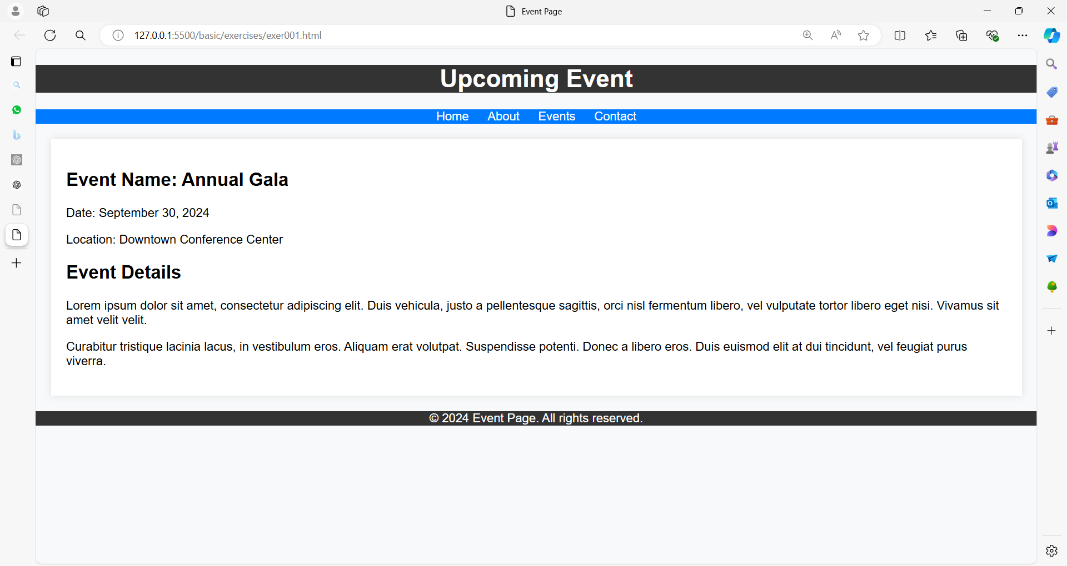

**Exercise 02: Simple Contact Page Layout**

**Objective**: Create a contact page layout with a header, a navigation bar, a main content area with a contact form, and a footer using the same CSS styles as in your provided example.

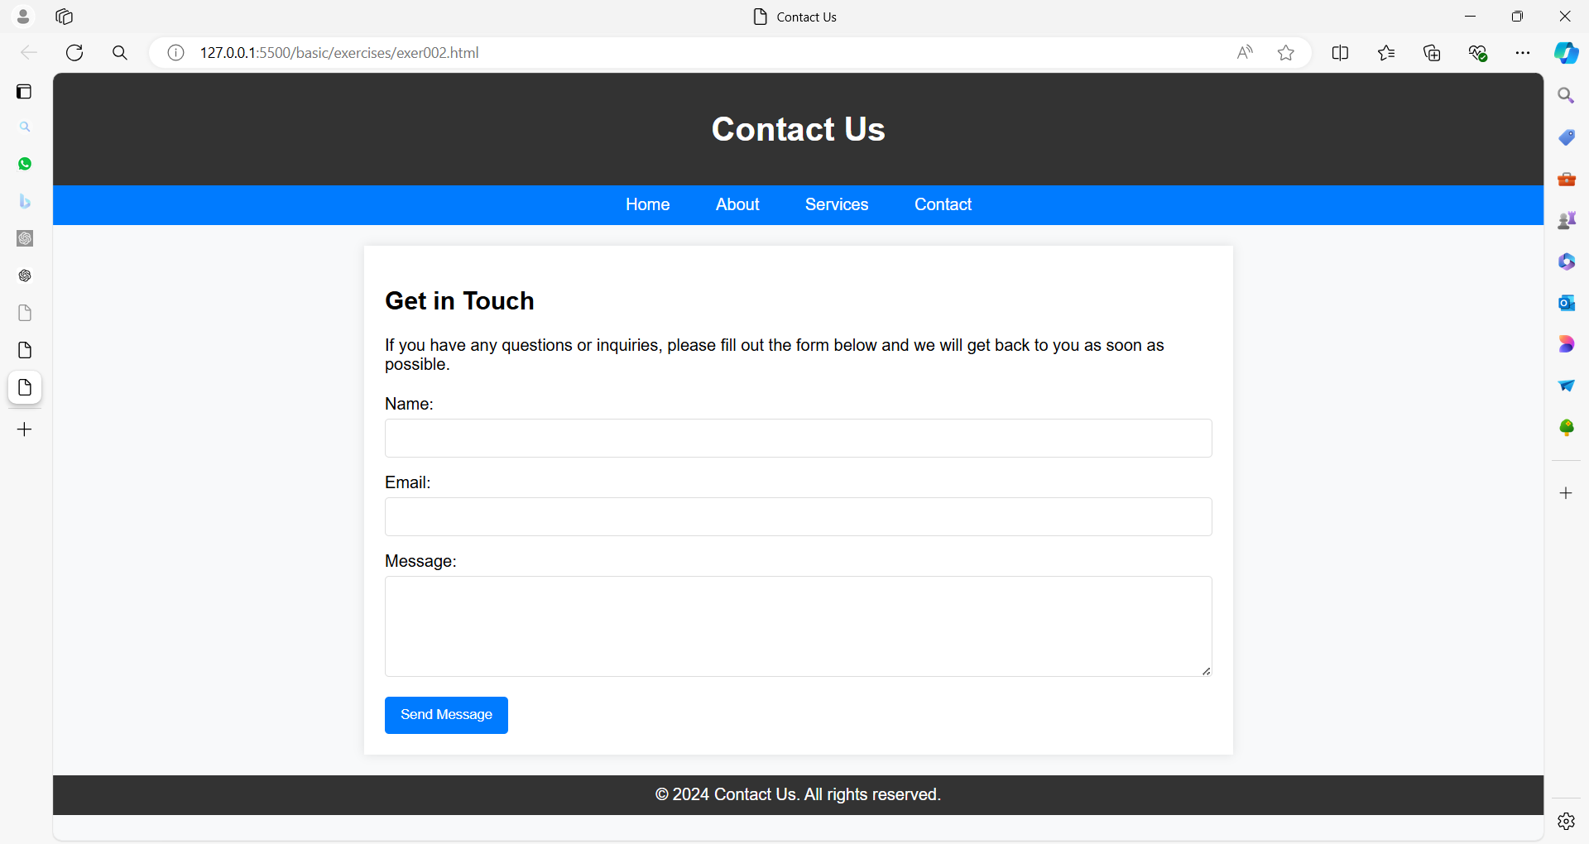

**Exercise 03: Simple Contact Page Layout**

**Objective**: Create a contact page layout that includes a header, navigation bar, main content area with a contact form, and a footer.

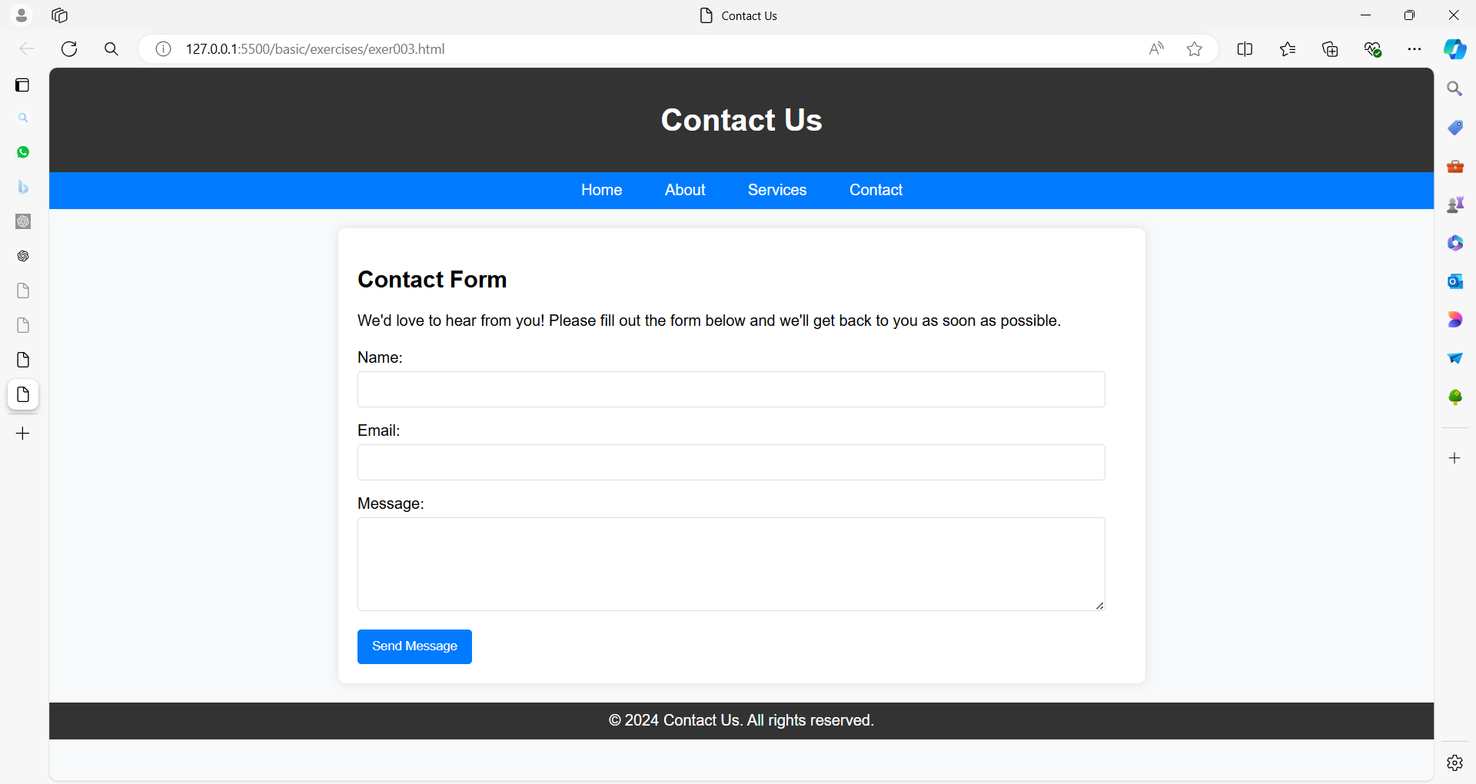

**Exercise 04: Contact Page Layout**

**Objective**: Create a contact page layout with a header, navigation bar, main content area containing a contact form with various fields, and a footer, using different colors.

