**Exercises on Flexbox Layout**

**Exercise 1: Basic Flexbox Layout**

**Objective**: Create a simple layout with a header, main content area, and footer using Flexbox.

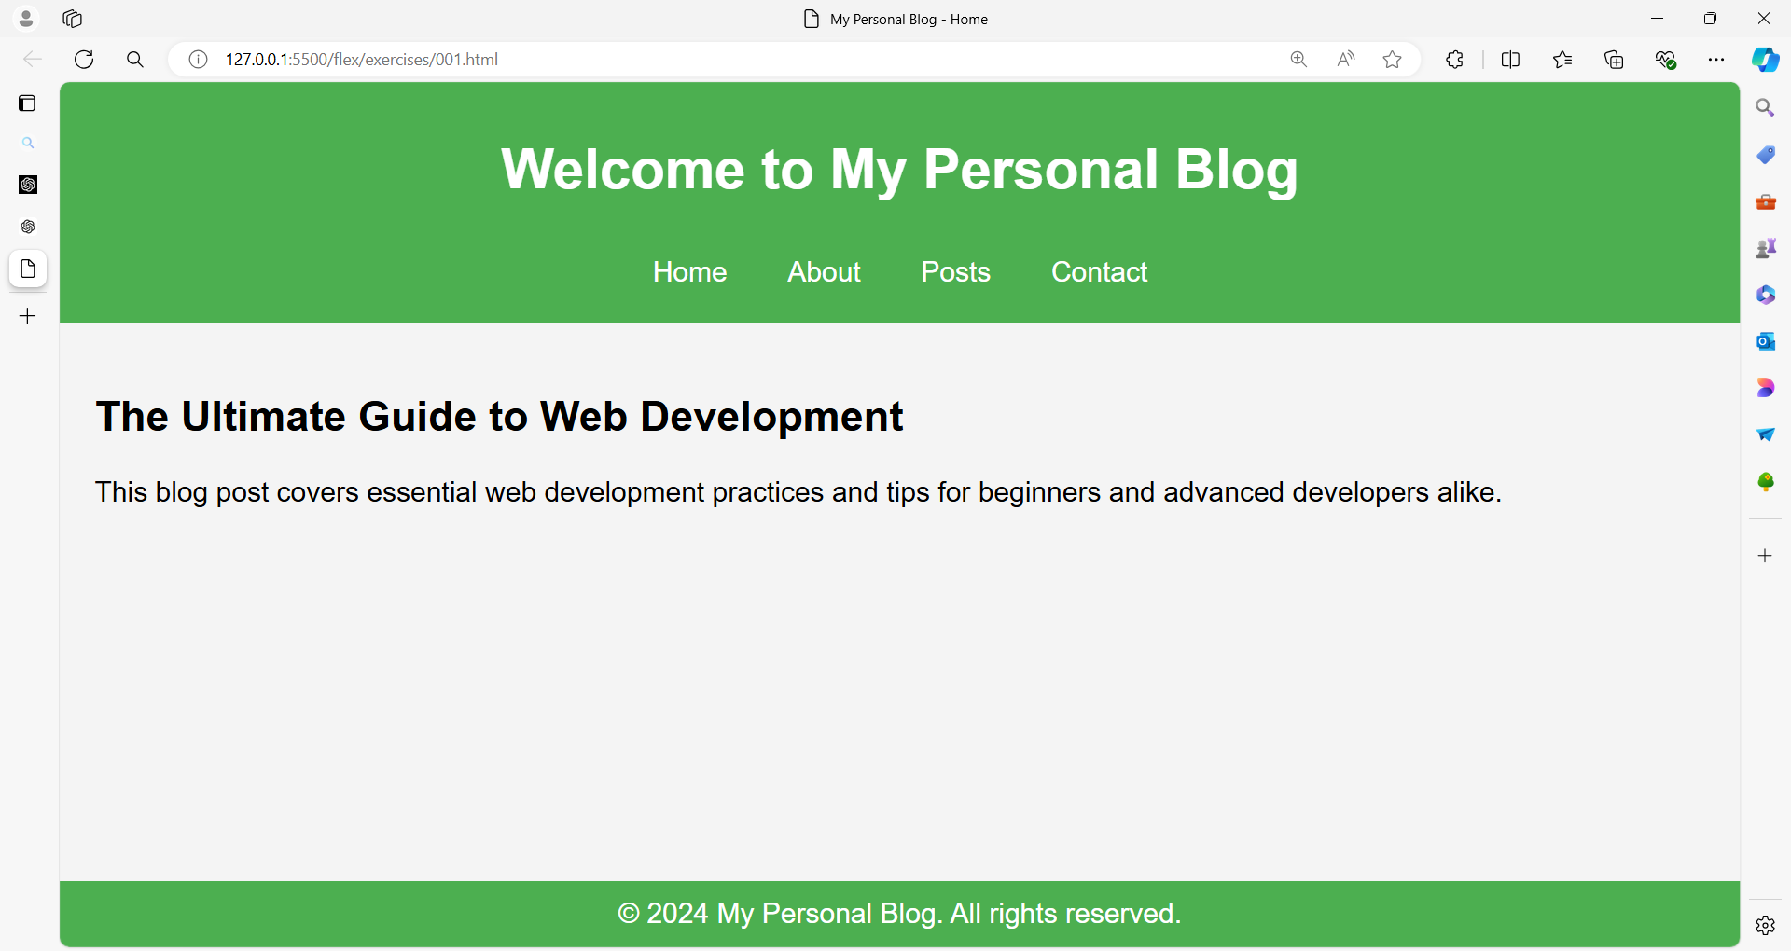

**Exercise 2: Centering Content**

**Objective**: Center a child element both horizontally and vertically within a container.

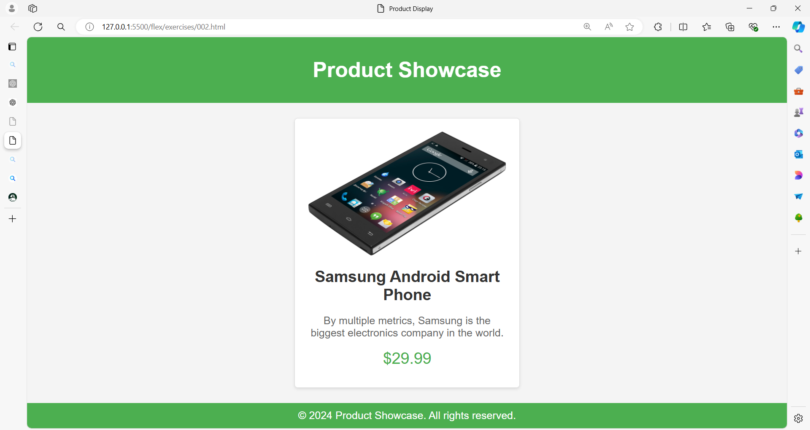

**Exercise 3: Flexbox Columns Layout**

**Objective**: Create a three-column layout where columns have equal width.

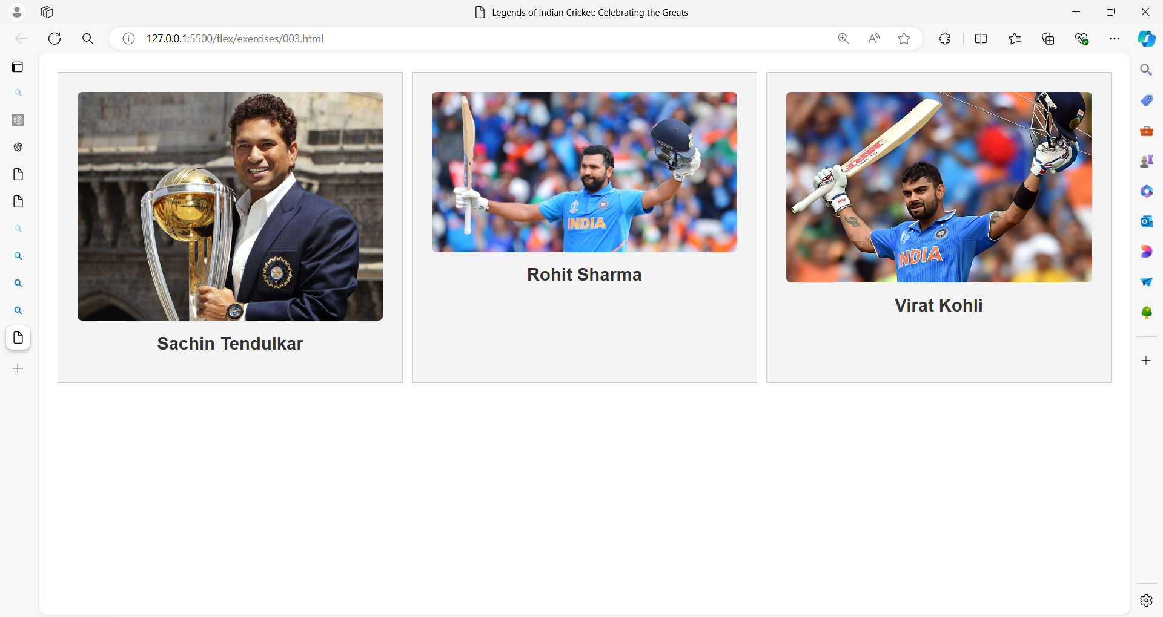

**Code:**

**Exercise 4: Responsive Flexbox Layout**

**Objective**: Create a responsive layout where columns stack on top of each other on smaller screens.

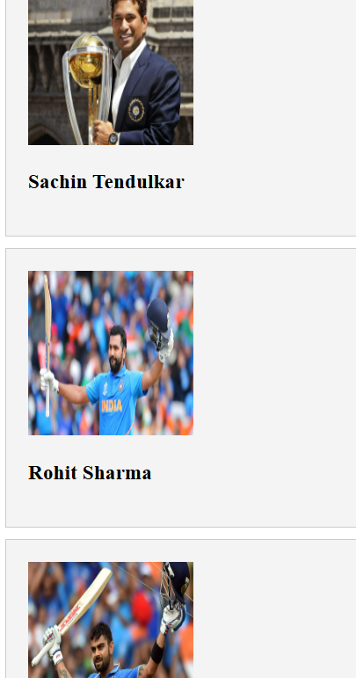

**Exercise 5: Flexbox Alignment**

**Objective**: Align items within a container with space between them and centered vertically.

