**Exercises on float**

**Exercise 1: Basic Float Layout**

**Objective**: Create a simple page layout with a header, a sidebar, a main content area, and a footer using the float property.

**Instructions**:

1. Create a header that spans the full width of the page.
2. Float a sidebar to the left of the main content.
3. Ensure the main content takes up the remaining space.
4. Create a footer that spans the full width of the page.

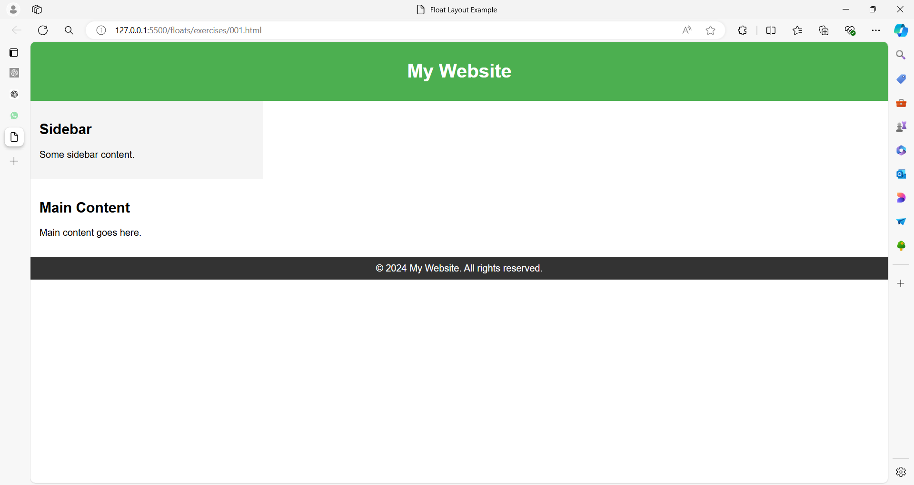

**Solution**:

<!DOCTYPE html>

<html lang="en">

<head>

<meta charset="UTF-8">

<meta name="viewport" content="width=device-width, initial-scale=1.0">

<title>Float Layout Example</title>

<style>

body {

margin: 0;

font-family: Arial, sans-serif;

}

header {

background-color: #4CAF50;

color: white;

text-align: center;

padding: 10px 0;

}

.container {

width: 100%;

overflow: hidden; /* Clearfix */

}

.sidebar {

float: left;

width: 25%;

background-color: #f4f4f4;

padding: 15px;

}

.main-content {

float: left;

width: 75%;

padding: 15px;

}

footer {

background-color: #333;

color: white;

text-align: center;

padding: 10px 0;

clear: both; /* Ensures the footer is below floated elements */

}

</style>

</head>

<body>

<header>

<h1>My Website</h1>

</header>

<div class="container">

<div class="sidebar">

<h2>Sidebar</h2>

<p>Some sidebar content.</p>

</div>

<div class="main-content">

<h2>Main Content</h2>

<p>Main content goes here.</p>

</div>

</div>

<footer>

&copy; 2024 My Website. All rights reserved.

</footer>

</body>

</html>

**Exercise 2: Floating Images with Text**

**Objective**: Create a layout where an image floats to the left of some text, and the text wraps around the image.

**Instructions**:

1. Float an image to the left.
2. Allow text to wrap around the image.

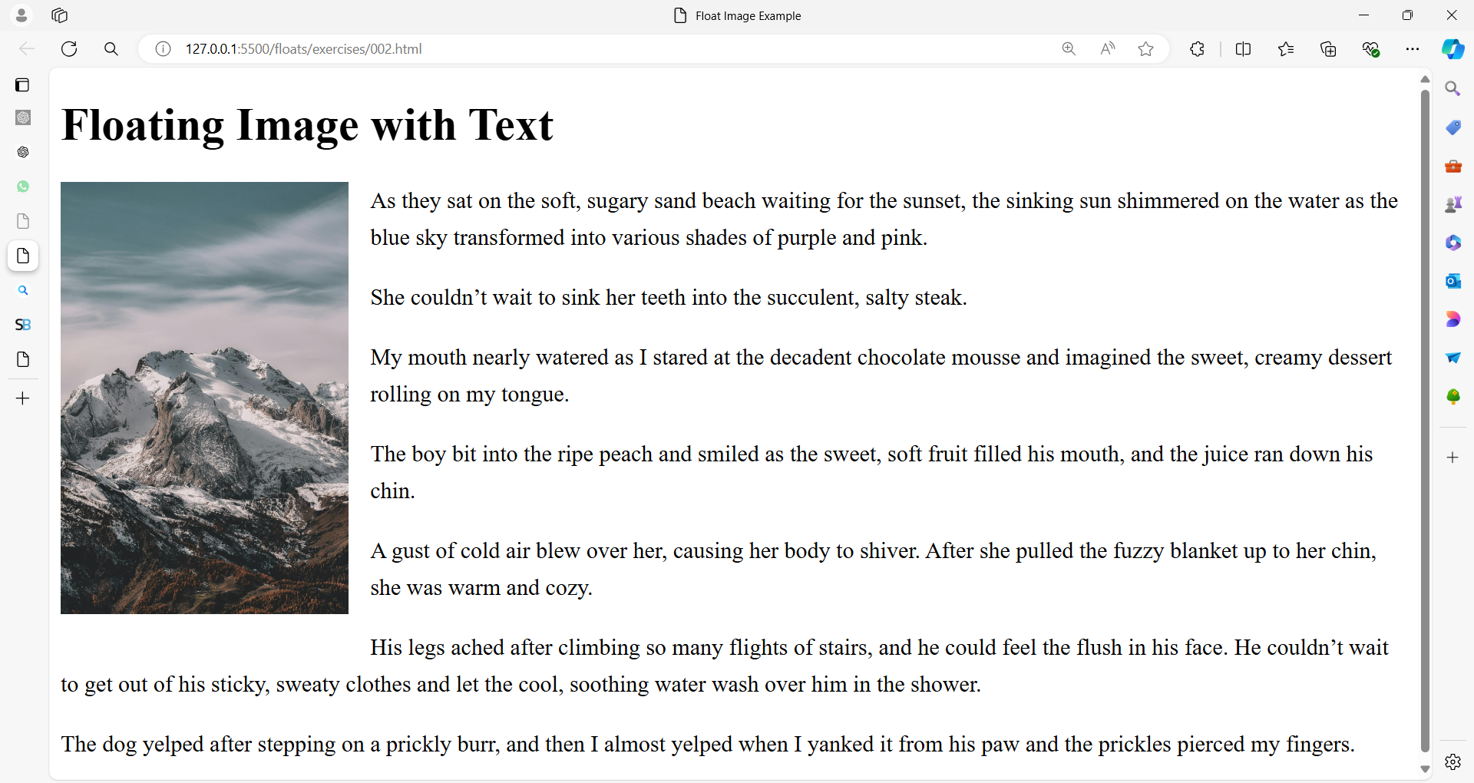

**Solution**:

<!DOCTYPE html>

<html lang="en">

<head>

    <meta charset="UTF-8">

    <meta name="viewport" content="width=device-width, initial-scale=1.0">

    <title>Float Image Example</title>

    <style>

        img {

            float: left;

            margin-right: 15px;

            margin-bottom: 15px;

            width: 200px;

        }

        p {

            line-height: 1.6;

        }

    </style>

</head>

<body>

    <h1>Floating Image with Text</h1>

    <img src="image01.jpg" alt="Placeholder Image">

    <p>As they sat on the soft, sugary sand beach waiting for the sunset, the sinking sun shimmered on the water as the blue sky transformed into various shades of purple and pink.</p>

    <p>She couldn’t wait to sink her teeth into the succulent, salty steak.

    <p>My mouth nearly watered as I stared at the decadent chocolate mousse and imagined the sweet, creamy dessert rolling on my tongue.</p>

    <p>The boy bit into the ripe peach and smiled as the sweet, soft fruit filled his mouth, and the juice ran down his chin.</p>

    <p>A gust of cold air blew over her, causing her body to shiver. After she pulled the fuzzy blanket up to her chin, she was warm and cozy.</p>

    <p>His legs ached after climbing so many flights of stairs, and he could feel the flush in his face. He couldn’t wait to get out of his sticky, sweaty clothes and let the cool, soothing water wash over him in the shower.</p>

    <p>The dog yelped after stepping on a prickly burr, and then I almost yelped when I yanked it from his paw and the prickles pierced my fingers.</p>

    </body>

</html>

**Exercise 3: Multiple Column Layout**

**Objective**: Create a three-column layout with a header and a footer.

**Instructions**:

1. Create a header that spans the full width of the page.
2. Create three columns: a left column, a center column, and a right column.
3. Ensure that the columns are floated side by side and span the full width of the page.
4. Create a footer that spans the full width of the page.

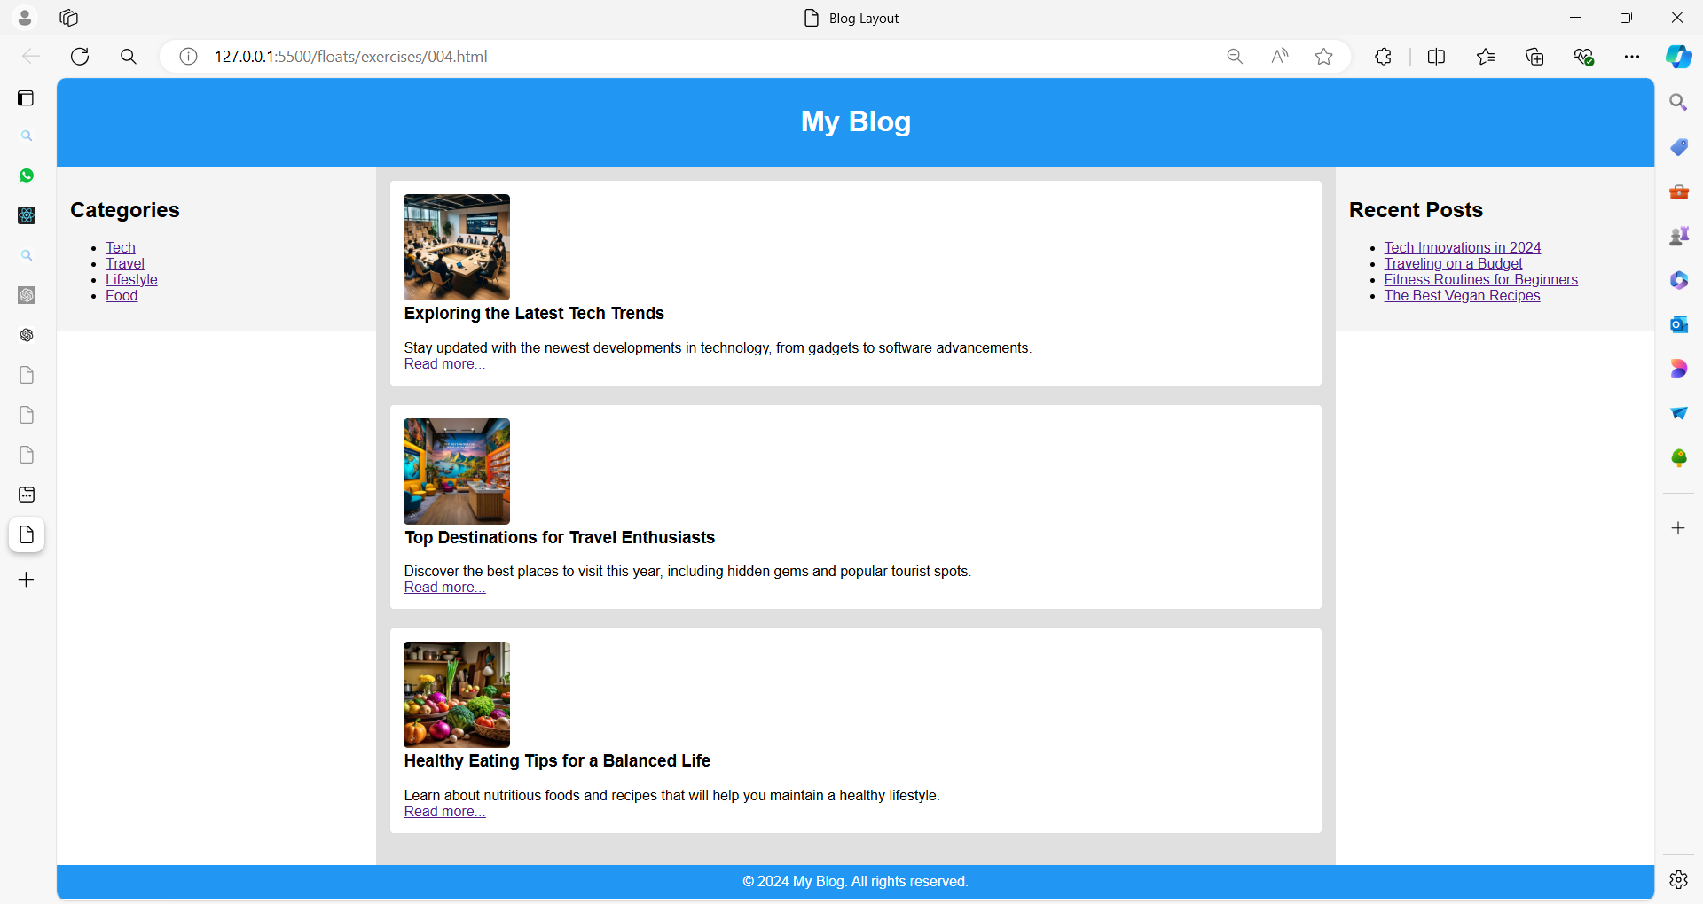

**Solution**:

<!DOCTYPE html>

<html lang="en">

<head>

    <meta charset="UTF-8">

    <meta name="viewport" content="width=device-width, initial-scale=1.0">

    <title>Blog Layout</title>

    <style>

        body {

            margin: 0;

            font-family: Arial, sans-serif;

        }

        header {

            background-color: #2196F3;

            color: white;

            text-align: center;

            padding: 10px 0;

        }

        .container {

            width: 100%;

            overflow: hidden; /* Clearfix */

        }

        .column {

            float: left;

            padding: 15px;

            box-sizing: border-box; /* Include padding in width calculations */

        }

        .left {

            width: 20%;

            background-color: #f4f4f4;

        }

        .center {

            width: 60%;

            background-color: #e0e0e0;

        }

        .right {

            width: 20%;

            background-color: #f4f4f4;

        }

        footer {

            background-color: #2196F3;

            color: white;

            text-align: center;

            padding: 10px 0;

            clear: both; /* Ensures the footer is below floated elements */

        }

        .post {

            margin-bottom: 20px;

            background-color: #fff;

            border: 1px solid #ddd;

            border-radius: 5px;

            padding: 15px;

        }

        .post img {

            max-width: 100%; /* Maintain width */

            height: 120px; /* Fixed height for the image */

            object-fit: cover; /* Ensure the image covers the specified height while maintaining aspect ratio */

            border-radius: 5px;

        }

        .post h3 {

            margin-top: 0;

        }

        .post p {

            margin-bottom: 0;

        }

    </style>

</head>

<body>

    <header>

        <h1>My Blog</h1>

    </header>

    <div class="container">

        <div class="column left">

            <h2>Categories</h2>

            <ul>

                <li><a href="#">Tech</a></li>

                <li><a href="#">Travel</a></li>

                <li><a href="#">Lifestyle</a></li>

                <li><a href="#">Food</a></li>

            </ul>

        </div>

        <div class="column center">

            <div class="post">

                <img src="tech001.jpg" alt="Blog Post 1">

                <h3>Exploring the Latest Tech Trends</h3>

                <p>Stay updated with the newest developments in technology, from gadgets to software advancements.</p>

                <a href="#">Read more...</a>

            </div>

            <div class="post">

                <img src="travel001.jpg" alt="Blog Post 2">

                <h3>Top Destinations for Travel Enthusiasts</h3>

                <p>Discover the best places to visit this year, including hidden gems and popular tourist spots.</p>

                <a href="#">Read more...</a>

            </div>

            <div class="post">

                <img src="health001.jpg" alt="Blog Post 3">

                <h3>Healthy Eating Tips for a Balanced Life</h3>

                <p>Learn about nutritious foods and recipes that will help you maintain a healthy lifestyle.</p>

                <a href="#">Read more...</a>

            </div>

        </div>

        <div class="column right">

            <h2>Recent Posts</h2>

            <ul>

                <li><a href="#">Tech Innovations in 2024</a></li>

                <li><a href="#">Traveling on a Budget</a></li>

                <li><a href="#">Fitness Routines for Beginners</a></li>

                <li><a href="#">The Best Vegan Recipes</a></li>

            </ul>

        </div>

    </div>

    <footer>

        &copy; 2024 My Blog. All rights reserved.

    </footer>

</body>

</html>

**Explanation**

1. **Basic Float Layout**: Demonstrates how to create a simple page layout with a header, sidebar, main content area, and footer using floating elements.
2. **Floating Images with Text**: Shows how to float an image to the left and have text wrap around it.
3. **Multiple Column Layout**: Creates a three-column layout where columns are floated side by side.

These exercises provide a practical understanding of using the float property for layout purposes.