**Exercises on float**

**Exercise 1: Basic Float Layout**

**Objective**: Create a simple page layout with a header, a sidebar, a main content area, and a footer using the float property.

**Instructions**:

1. Create a header that spans the full width of the page.
2. Float a sidebar to the left of the main content.
3. Ensure the main content takes up the remaining space.
4. Create a footer that spans the full width of the page.

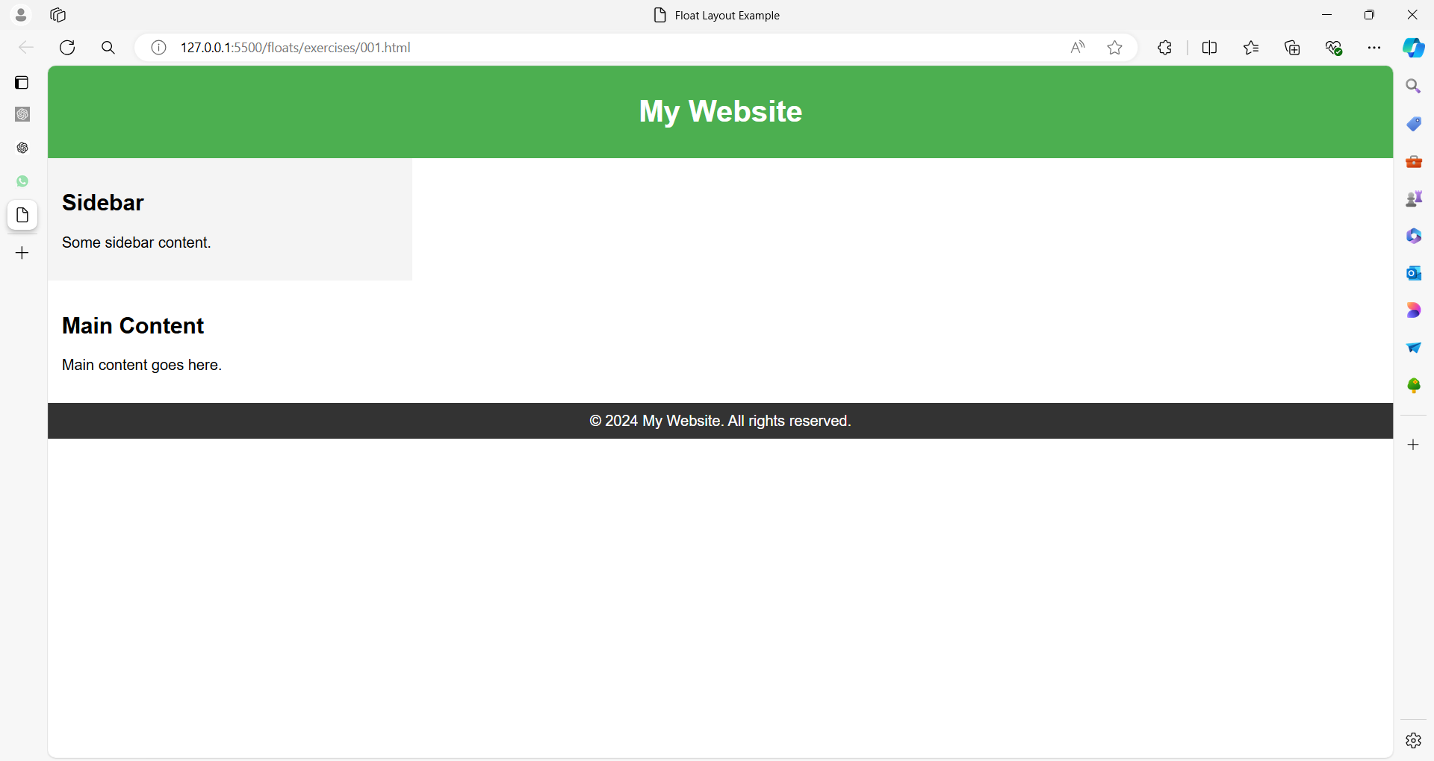

**Exercise 2: Floating Images with Text**

**Objective**: Create a layout where an image floats to the left of some text, and the text wraps around the image.

**Instructions**:

1. Float an image to the left.
2. Allow text to wrap around the image.

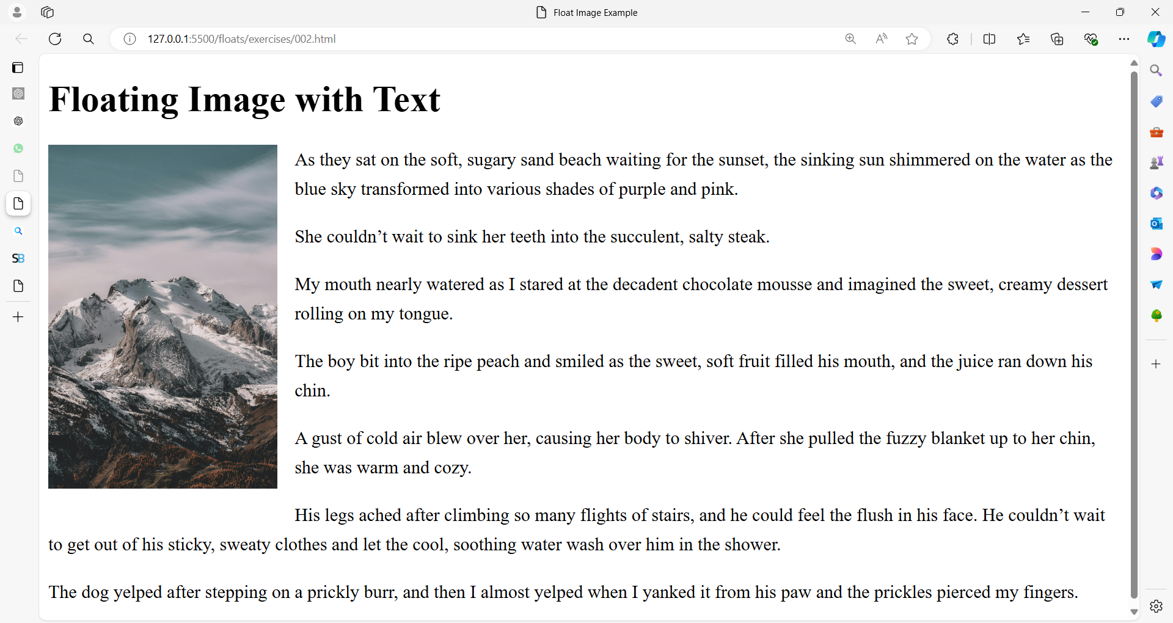

**Exercise 3: Multiple Column Layout**

**Objective**: Create a three-column layout with a header and a footer.

**Instructions**:

1. Create a header that spans the full width of the page.
2. Create three columns: a left column, a center column, and a right column.
3. Ensure that the columns are floated side by side and span the full width of the page.
4. Create a footer that spans the full width of the page.

