1. **Abstract Superclass Shape and Its Concrete Subclasses**

Write the superclass Shape and its subclasses Circle, Rectangle and Square, as shown in the class diagram.

Shape is an abstract class containing 2 abstract methods: getArea() and getPerimeter(), where its concrete subclasses must provide its implementation.

All instance variables shall have protected access, i.e., accessible by its subclasses and classes in the same package.

Mark all the overridden methods with annotation @Override.

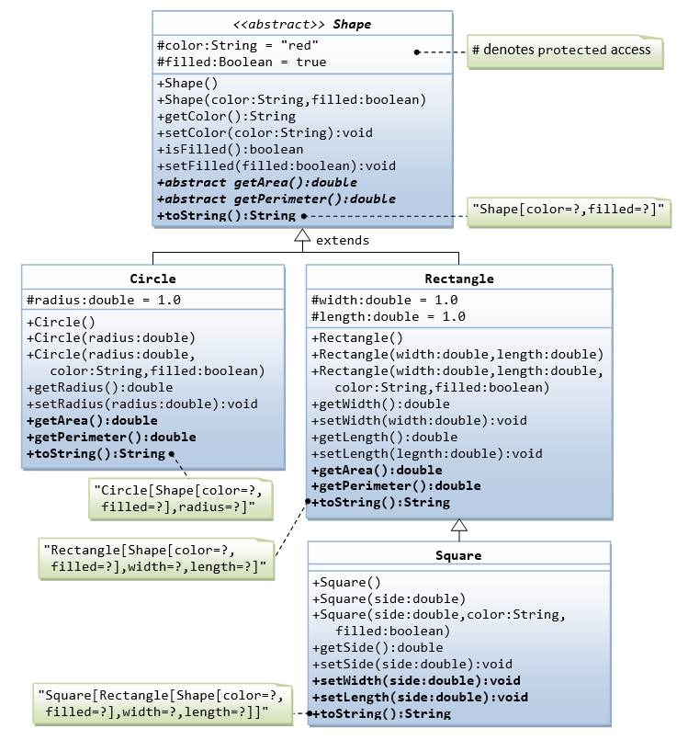

In this exercise, Shape shall be defined as an abstract class, which contains:

* Two protected instance variables color(String) and filled(boolean). The protected variables can be accessed by its subclasses and classes in the same package. They are denoted with a '#' sign in the class diagram.
* Getter and setter for all the instance variables, and toString().
* Two abstract methods getArea() and getPerimeter() (shown in italics in the class diagram).

The subclasses Circle and Rectangle shall *override* the abstract methods  getArea() and

getPerimeter() and provide the proper implementation. They also *override* the toString().

Write a test class to test these statements involving polymorphism and explain the outputs. Some statements may trigger compilation errors. Explain the errors, if any.

Shape s1 = new Circle(5.5, "red", false); // Upcast Circle to Shape

System.out.println(s1); // which version?

System.out.println(s1.getArea()); // which version?

System.out.println(s1.getPerimeter()); // which version?

System.out.println(s1.getColor());

System.out.println(s1.isFilled());

System.out.println(s1.getRadius());

Circle c1 = (Circle)s1; // Downcast back to Circle

System.out.println(c1);

System.out.println(c1.getArea());

System.out.println(c1.getPerimeter());

System.out.println(c1.getColor());

System.out.println(c1.isFilled());

System.out.println(c1.getRadius());

Shape s2 = new Shape();

Shape s3 = new Rectangle(1.0, 2.0, "red", false); // Upcast

System.out.println(s3);

System.out.println(s3.getArea());

System.out.println(s3.getPerimeter());

System.out.println(s3.getColor());

System.out.println(s3.getLength());

Rectangle r1 = (Rectangle)s3; // downcast

System.out.println(r1);

System.out.println(r1.getArea());

System.out.println(r1.getColor());

System.out.println(r1.getLength());

Shape s4 = new Square(6.6); // Upcast

System.out.println(s4);

System.out.println(s4.getArea());

System.out.println(s4.getColor());

System.out.println(s4.getSide());

// Take note that we downcast Shape s4 to Rectangle,

// which is a superclass of Square, instead of Square

Rectangle r2 = (Rectangle)s4;

System.out.println(r2);

System.out.println(r2.getArea());

System.out.println(r2.getColor());

System.out.println(r2.getSide());

System.out.println(r2.getLength());

// Downcast Rectangle r2 to Square

Square sq1 = (Square)r2;

System.out.println(sq1);

System.out.println(sq1.getArea());

System.out.println(sq1.getColor());

System.out.println(sq1.getSide());

System.out.println(sq1.getLength());

1. **Abstract Superclass Animal and its Implementation Subclasses**

Write the codes for all the classes shown in the class diagram. Mark all the overridden methods with annotation @Override.

