**Exercises on Angular**

1. Design a form as shown in the picture below

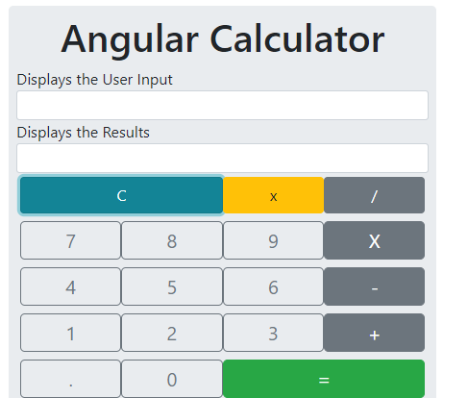

* + Create an Angular application named “calculator-app”
  + You have to create a folder ‘calculator’ in app folder under src folder. And you need to write all the programs in this folder.
  + Include bootstrap library in this application

1. You need to get an output shown in the below picture

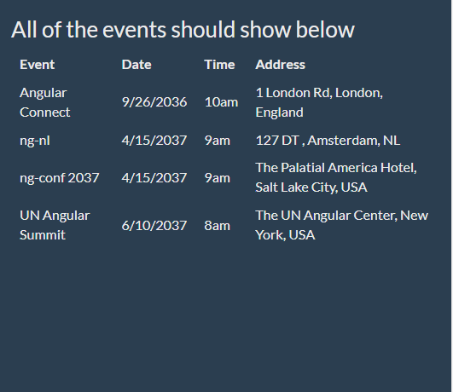

* + Create an Angular application named “event-app”
  + You have to create a folder ‘event’ in app folder under src folder. And you need to write all the programs in this folder.
  + Include bootstrap library in this application
  + Create set of events in the class as class variable as shown below

 const events = [

    {name:'Angular Connect', date: '9/26/2036', time: '10am', location: {address: '1 London Rd', city: 'London', country: 'England'}},

    {name:'ng-nl', date: '4/15/2037', time: '9am', location: {address: '127 DT ', city: 'Amsterdam', country: 'NL'}},

    {name:'ng-conf 2037', date: '4/15/2037', time: '9am', location: {address: 'The Palatial America Hotel', city: 'Salt Lake City', country: 'USA'}},

    {name:'UN Angular Summit', date: '6/10/2037', time: '8am', location: {address: 'The UN Angular Center', city: 'New York', country: 'USA'}},

  ]