**Exercise on Angular Services**

1. Create a ProductService with the help of the following output.

You need to create product.service.ts

You need to create create-product.component.ts

You need to create create-product.component.html

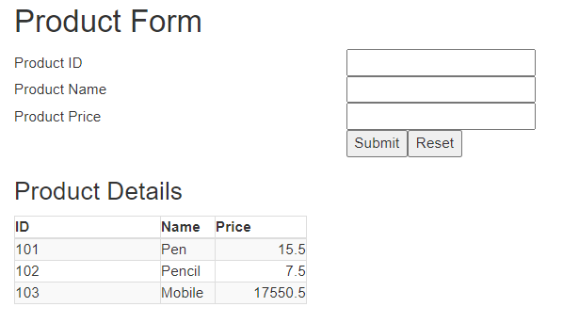

1. Whenever you activate this form first time your output should display like in the following output

It should display one product information as shown in the below output.

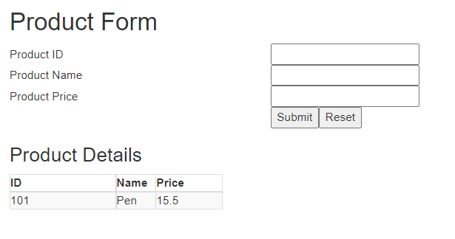

1. If you have not given any input in the fields you should validate as shown in the following output.

You should validate all the fields

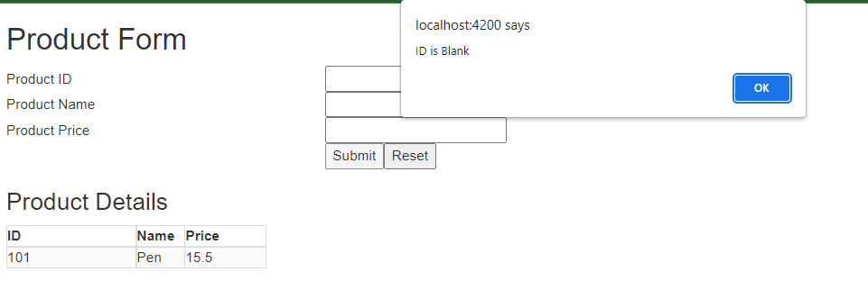

1. After adding all the inputs and before clicking on the Submit button, the following output should display

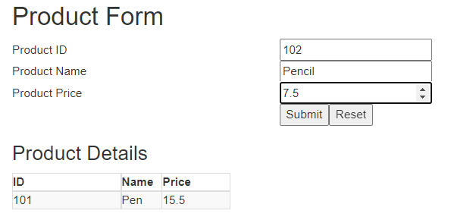

1. Create another service CustomerService as shown in the above example. Try to use bootstrap to show your output with different colors.
2. After clicking on Submit button, the following output should display.

All textboxes should be cleared as shown in the below output.

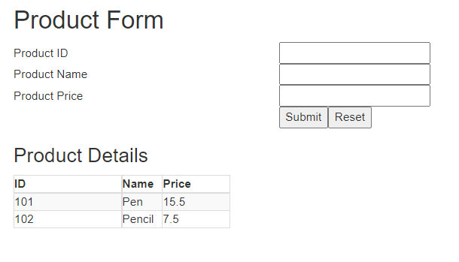

1. Fff
2. Fff
3. Ffff
4. Ffff
5. Ffff
6. Fff
7. Ffff
8. Ffff
9. Ffff
10. Fff