Exercise on HttpClient

1. Finish the Application as given below

1. In this exercise you have to make a simple application using Http, Observable.
2. Create a new project - F1SimpleHttpService - in your favorite Angular folder
3. We want to use Bootstrap 4, so update the index.html file
4. **In this project will we use a webservice from Ergast.com to retrieve information about this sesons F1 Drivers.**
5. **If you open your Browser and insert:**

**http://ergast.com/api/f1/2019/drivers.json - will you get the following information:**

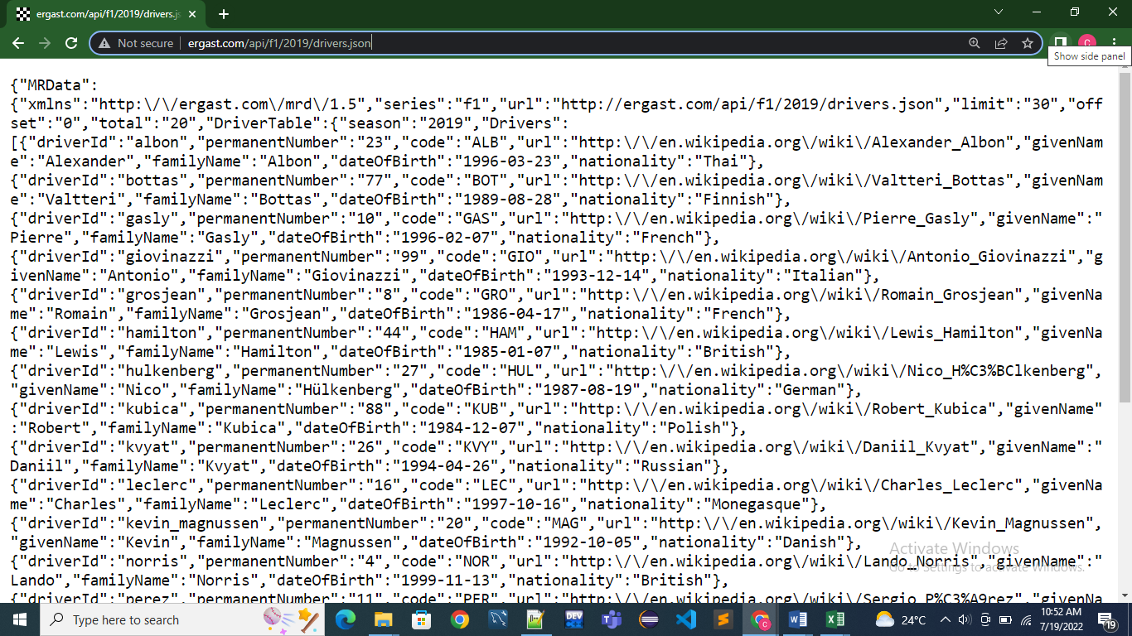

1. **Our first task is to create a class Driver with properties given by the json-file from Ergast.**

**Driver-object with information about "Fernando Alonso":**

{"driverId":"alonso","permanentNumber":"14","code":"ALO","url":"http:\/\/en.wikipedia.org\/wiki\/Fernando_Alonso","givenName":"Fernando","familyName":"Alonso","dateOfBirth":"1981-07-29","nationality":"Spanish"}

1. Create a new class Driver, with properties given by the sample above. { ***driverId: string; permanentNumber: string; code; string; givenName: string***; ... }).
2. **Import HttpClientModule in AppModule**
3. Create a new Service: F1SimpleService.
4. Create a method getDrivers( ), the return-type of the method must be Observable<Driver[ ]>
5. Create a new Component: SimpleHttpService
6. Inject the F1SimpleService in the constructor to the class and call the service-metod getDrivers( ) to get the Observable object with all the Drivers.
7. **Template**

Use the directive: *ngFor in the template to list information about all the drivers.

1. And test your application