**Hibernate Exercises**

1. Create the following tables by using Hibernate JPA. (Don’t create tables by your own, let hibernate to do it.)

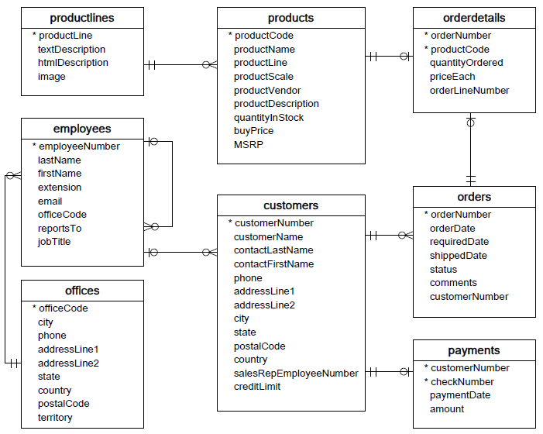

1. Create entity classes like Product, ProductLine, OrderDetail, Order, Customer, Employee, Office and Payment.
2. The identifier for each class should be automatically generated.
3. Implement @OneToMany between entities
4. Implememt @ManyToMany between the entities
5. Implememt @ManyToOne between entities
6. Saving objects of type all entities (Product, ProductLine, OrderDetail, Order, Customer, Employee, Office and Payment) to the database
7. look for objects in the database of type (Product, ProductLine, OrderDetail, Order, Customer, Employee, Office and Payment)  by id
8. removing (Product, ProductLine, OrderDetail, Order, Customer, Employee, Office and Payment)   records from the database
9. searching a product records by title
10. searching for customer records by id
11. returning all employee records
12. returning all office records

You can do lot of other possibilities. Please include the questions and answers here.