1. **Write a servlet application to print the current date and time.**  
     
     
   The most important advantage of using Servlet is that we can use all the methods available in core java. The Date class is available in java.util package.  
     
   Below program shows how to print the current date and time. We can use simple Date object with toString() to print current date and time.
2. **Write a servlet application to establish communication between html and servlet page using hyperlink.**

**3. Write an application to auto refresh a page in servlet.**

**Output:**  
  
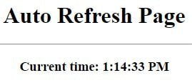  
  
It refreshes the browser every second and current time will be changed automatically.

**4. Write an application to demonstrate the session tracking in Servlet.**

**Output:**  
  
**i. When we run the application first time**  
  
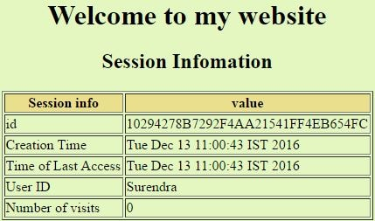  
  
**ii. After refreshing the application**  
  
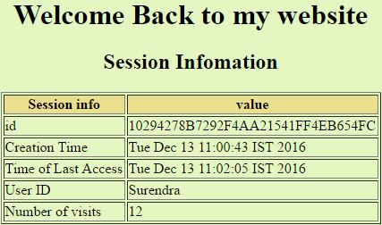

**5. Write a servlet program to select the record from the database.**

**Output:**  
  
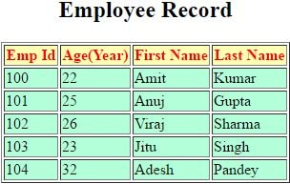

**6. Write a Servlet application for login page, which is check the username and password. If username and password are matched, display welcome message.**

**Output:**  
  
**i. Enter username or password**  
  
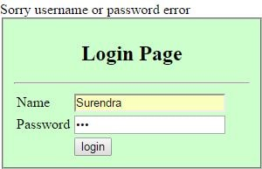  
  
**ii. Correct username and password**  
  
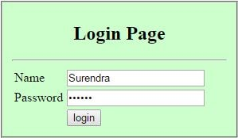  
  
welcome message

**7. Develop a registration page in servlet with proper validation and store all records in the database.**  
  
  
  
**Create a "Registration" table**  
  
SQL> create table registration (Name varchar2(20), password varchar2(10), email varchar2(20), mobile number, dob varchar2(20), gender varchar2(6), country varchar2 (10));

**Output:**  
  
This page doesn’t allow to submit the record without filling the textbox.    
  
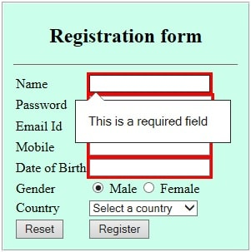  
  
After filling all textbox, it allows to submit the record.  
  
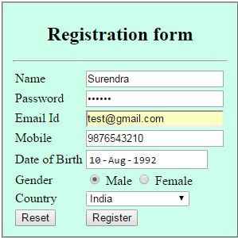  
  
Click on Register button.  
  
message

**8 . Write a Servlet application to count the total number of visits on your website.**

**Output:**  
  
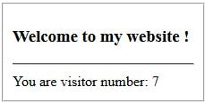

**9. Write a java program to accept the details of Teacher (TId, Name, Address) from the user and insert it into the Database.**  
  
**Create a table in a database to store the record.**  
  
Create table teacherdetails (tid number, name varchar2(20), address varchar2(40);

**Output:**  
  
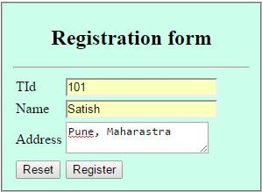  
  
teacher registration

**10 . Write a Servlet program that accepts the age and name and displays if the user is eligible for voting or not.**   

**Output:**  
  
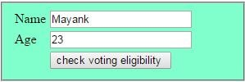  
  
voter check  
  
  
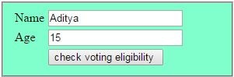  
  
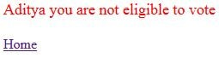

**11 . Write a servlet program that accepts the Mobile phone details from user and displays the details on the next page.**

**Output:**  
  
**i. Insert record**  
  
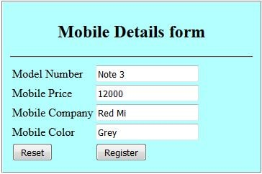  
  
**ii. Display the record**  
  
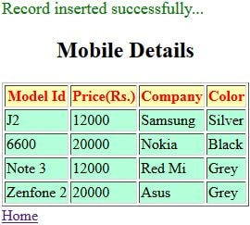

**12 . Create an Html page that contains 4 option buttons Java, UNIX, DDBMS, OOSE and 2 buttons Submit and Reset. When the user clicks on Submit button the server responds by adding cookie containing the selected Subject and sends the html page to the client. Program should not allow duplicate cookie to be written.**  
                    

**Output:**  
  
Select Java and click on submit. It adds the cookies with value Java.  
  
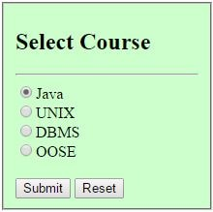  
  
cookies