**Props and State**:

In React, **props** and **state** are two fundamental concepts used to manage data and control the behaviour of components.

Here’s an overview of each:

**Props**

**Props** (short for "properties") are a mechanism for passing data from a parent component to a child component.

Props are read-only, meaning that a child component cannot modify the props it receives.

They are used to configure or customize a component.

**Key Characteristics:**

* **Immutable**: Props are immutable. The child component receives the props but cannot change them.
* **Passed Down**: Props are passed from parent components to child components.
* **Read-Only**: Components that receive props can only read them; they cannot modify them.

**Example**

Here’s an example of using props in React:

**Parent Component:**

import React from 'react';

import Greeting from './Greeting';

function App() {

return (

<div>

<Greeting name="Alice" />

<Greeting name="Bob" />

</div>

);

}

export default App;

**Child Component (Greeting.js):**

import React from 'react';

function Greeting(props) {

return <h1>Hello, {props.name}!</h1>;

}

export default Greeting;

**In this example:**

* The **App** component is passing different names as props to the **Greeting** component.
* The **Greeting** component receives the name prop and uses it to render a personalized message.

**State**

**State** is a mechanism for managing data that can change over time within a component.

Unlike props, state is managed within the component and can be modified by the component itself, typically through user interactions or other events.

**Key Characteristics:**

* **Mutable**: State is mutable. Components can modify their own state.
* **Local**: State is specific to a component. Changes to state in one component do not affect other components unless explicitly shared.
* **Managed Internally**: State is managed internally within a component and can change based on user interactions or lifecycle events.

**Example**

Here’s an example of using state in a React function component:

**Counter Component:**

import React, { useState } from 'react';

function Counter() {

const [count, setCount] = useState(0);

const increment = () => {

setCount(count + 1);

};

const decrement = () => {

setCount(count - 1);

};

return (

<div>

<h1>Count: {count}</h1>

<button onClick={increment}>Increment</button>

<button onClick={decrement}>Decrement</button>

</div>

);

}

export default Counter;

In this example:

* The **Counter** component uses the **useState** hook to manage the **count state**.
* The **increment** and **decrement** functions modify the **count state.**
* The component re-renders whenever the state changes, reflecting the updated count in the UI.

**Summary**

* **Props**: Used to pass data from parent to child components. They are read-only and immutable.
* **State**: Used to manage data that can change over time within a component. It is mutable and managed internally by the component.

By understanding and leveraging both props and state, you can effectively manage data and interactions within your React applications.

**Example 01**

Let's create a larger example of a React application that includes a form.

This example will demonstrate both **props** and **state**:

**Overview**

The application will include:

1. **Parent Component**:
   * Manages the form data and passes props to child components.
2. **Child Components**:
   * **Form Component**: A large form that takes user input.
   * **FormField Component**: Represents individual input fields within the form.
   * **Summary Component**: Displays the submitted form data.

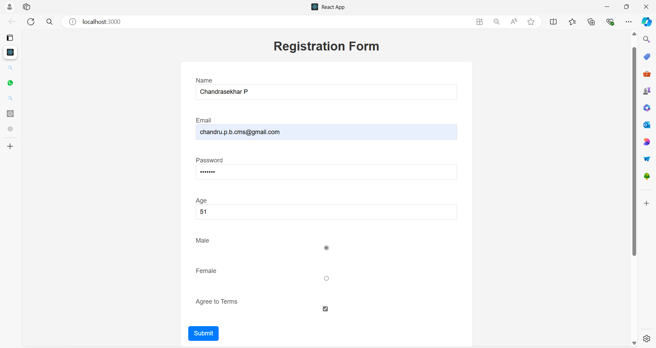

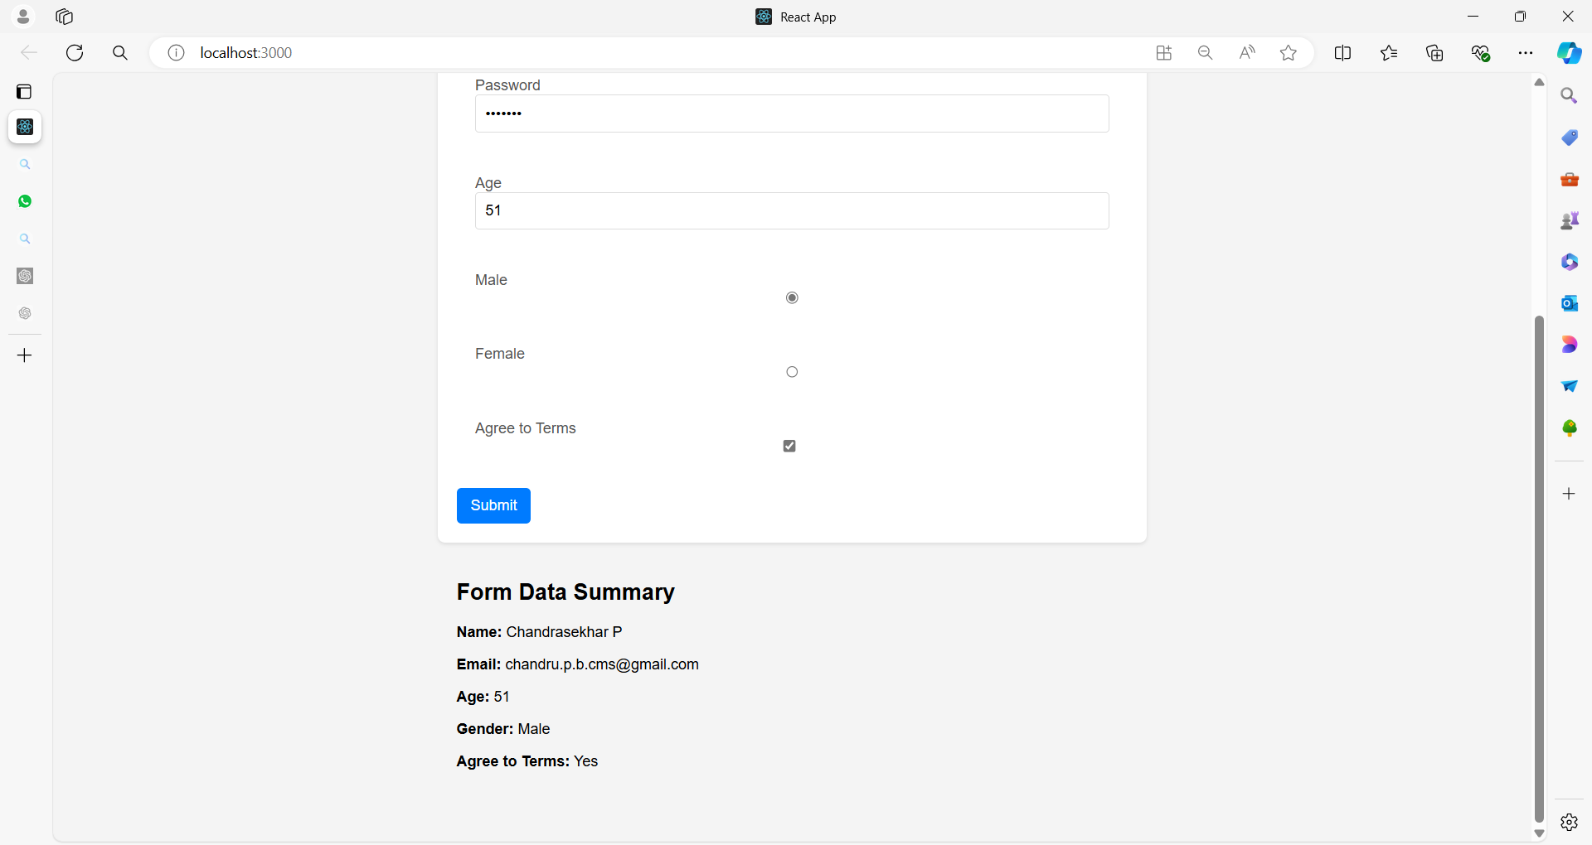

**Full Example**

**1. App Component (Parent)**

The App component will manage the form state and handle the form submission.

**App.js**

import React, { useState } from 'react';

import Form from './Form';

import Summary from './Summary';

import './App.css'

function App() {

const [formData, setFormData] = useState({

name: '',

email: '',

password: '',

age: '',

gender: '',

agreeToTerms: false,

});

const handleInputChange = (event) => {

const { name, value, type, checked } = event.target;

setFormData({

...formData,

[name]: type === 'checkbox' ? checked : value,

});

};

const handleSubmit = (event) => {

event.preventDefault();

// Handle form submission, e.g., send data to a server

console.log('Form submitted:', formData);

};

return (

<div>

<h1>Registration Form</h1>

<Form formData={formData} onInputChange={handleInputChange} onSubmit={handleSubmit} />

<Summary data={formData} />

</div>

);

}

export default App;

**Explanation**

Here's a line-by-line explanation of the App component code:

**1. Importing React and useState Hook**

**import React, { useState } from 'react';**

* **Purpose:** This line imports React and the useState hook from the react library.
* **React:** Required to create React components and manage the component lifecycle.
* **useState:** A hook that allows functional components to have state.

**2. Importing Other Components**

**import Form from './Form';**

**import Summary from './Summary';**

* **Purpose:** This line imports two custom components, Form and Summary, from their respective files.
* **Form Component:** Likely handles rendering and managing the input fields of the form.
* **Summary Component:** Displays a summary of the form data or any other relevant information.

**3. Defining the App Component**

**function App() {**

* **Purpose:** This line defines a functional component named App.
* **Functional Component:** This is a basic React component that returns JSX to render UI elements.

**4. Setting Up State with useState**

**const [formData, setFormData] = useState({**

**name: '',**

**email: '',**

**password: '',**

**age: '',**

**gender: '',**

**agreeToTerms: false,**

**});**

* **Purpose:** This line initializes the state of the component with an object formData.
* **useState:** Returns an array with two elements: the current state (formData) and a function to update it (setFormData).
* **Initial State:** The state object has properties for various form fields with default values (empty strings or false).

**{**

**name: '',**

**email: '',**

**password: '',**

**age: '',**

**gender: '',**

**agreeToTerms: false,**

**}**

**Purpose:** This is a JavaScript object that represents the initial state of the form data.

**Fields and Their Initial Values**

* **name: ''**
  + **Field:** Represents the name of the user.
  + **Initial Value:** An empty string (''). Indicates that the name field starts empty.
* **email: ''**
  + **Field:** Represents the email address of the user.
  + **Initial Value:** An empty string (''). Indicates that the email field starts empty.
* **password: ''**
  + **Field:** Represents the password of the user.
  + **Initial Value:** An empty string (''). Indicates that the password field starts empty.
* **age: ''**
  + **Field:** Represents the age of the user.
  + **Initial Value:** An empty string (''). Indicates that the age field starts empty.
* **gender: ''**
  + **Field:** Represents the gender of the user.
  + **Initial Value:** An empty string (''). Indicates that the gender field starts empty.
* **agreeToTerms: false**
  + **Field:** Represents whether the user agrees to the terms and conditions.
  + **Initial Value:** false. Indicates that the checkbox for agreeing to terms is initially unchecked.

**Usage in State Management**

* **Purpose:** This object serves as the initial state for a form in a React component.
* **State Management:** The useState hook initializes the state with this object. As users interact with the form, the values in this object will be updated accordingly.

**Updating State**

* **Dynamic Updates:** When a user inputs data into the form fields, the state object will be updated. For instance, when a user types their name into the name field, the name property in the state object will be updated with the new value.

**5. Form Handling**

* **Data Handling:** This initial state structure helps to manage form data in a centralized manner, making it easier to handle form submissions, validations, and other interactions.

**5. Handling Input Changes**

**const handleInputChange = (event) => {**

**const { name, value, type, checked } = event.target;**

**setFormData({**

**...formData,**

**[name]: type === 'checkbox' ? checked : value,**

**});**

**};**

* **Purpose:** This function updates the state whenever an input field changes.
* **Destructuring:** Extracts name, value, type, and checked from the event target.
* **Conditional Update:** **If the input type is 'checkbox', it updates the state with checked; otherwise, it uses value.**

**setFormData({**

**...formData,**

**[name]: type === 'checkbox' ? checked : value,**

**});**

**1. Function Call**

**setFormData({**

**// State update logic here**

**});**

* **Purpose:** Calls the setFormData function to update the formData state with a new value.
* **setFormData:** A state updater function provided by the useState hook.

**2. Spread Operator (...formData)**

**...formData**

* **Purpose:** This is the JavaScript spread operator.
* **Function:** It copies all the existing properties and values from the formData object into the new object being created.
* **Benefit:** Ensures that all existing form data is preserved while updating only the specific field that changed.

**3. Dynamic Property Name**

**[name]: type === 'checkbox' ? checked : value**

* **Purpose:** Updates a specific property in the formData object.
* **Dynamic Property:** [name] uses the value of the name variable as the key for the property to be updated.
* **Conditional Value:**
  + **type === 'checkbox' ? checked : value:** A ternary operator that determines the new value for the property based on the input type.
  + **checked:** The value for checkbox inputs. It’s either true or false, reflecting whether the checkbox is checked or not.
  + **value:** The value for other input types (text, email, etc.). It reflects the current value of the input field.

**4. Overall Function**

Combining the above elements, the line does the following:

* **Preserve Existing Data:** The spread operator (...formData) copies the existing state into the new object.
* **Update Specific Field:** The property identified by name is updated with a new value, which is determined based on the input type.
* **Handle Different Input Types:** For checkboxes, it uses the checked property. For other input types, it uses the value property.

**6. Handling Form Submission**

**const handleSubmit = (event) => {**

**event.preventDefault();**

**// Handle form submission, e.g., send data to a server**

**console.log('Form submitted:', formData);**

**};**

* **Purpose:** This function handles the form submission event.
* **event.preventDefault():** Prevents the default form submission behavior (page reload).
* **Logging Data:** Prints the form data to the console (could be replaced with actual submission logic).

**7. Rendering the Component**

**return (**

**<div>**

**<h1>Registration Form</h1>**

**<Form**

**formData={formData}**

**onInputChange={handleInputChange}**

**onSubmit={handleSubmit} />**

**<Summary data={formData} />**

**</div>**

**);**

* **Purpose:** This section defines what the component will render.
* **<h1>:** Displays a heading for the form.
* **<Form />:** Renders the Form component, passing formData, handleInputChange, and handleSubmit as props.
* **<Summary />:** Renders the Summary component, passing formData as a prop.

**8. Exporting the Component**

**export default App;**

* **Purpose:** This line exports the App component as the default export of the file.
* **Export:** Allows other files to import and use the App component.

**Summary**

1. **Imports:** Bring in React, hooks, and other components.
2. **State Setup:** Initializes form data state and its updater function.
3. **Input Handling:** Updates state based on user input, handling different input types.
4. **Form Submission:** Prevents default submission and logs form data.
5. **Rendering:** Renders the UI with Form and Summary components, passing necessary props.

**2. Form Component (Child)**

The Form component renders the form and individual fields, and it receives form data and change handlers as props.

**Form.js**

import React from 'react';

import FormField from './FormField';

function Form({ formData, onInputChange, onSubmit }) {

return (

<form onSubmit={onSubmit}>

<FormField

label="Name"

name="name"

value={formData.name}

onChange={onInputChange}

/>

<FormField

label="Email"

name="email"

value={formData.email}

onChange={onInputChange}

/>

<FormField

label="Password"

name="password"

type="password"

value={formData.password}

onChange={onInputChange}

/>

<FormField

label="Age"

name="age"

type="number"

value={formData.age}

onChange={onInputChange}

/>

<FormField

label="Male"

name="gender"

type="radio"

value="Male"

checked={formData.gender === 'Male'}

onChange={onInputChange}

/>

<FormField

label="Female"

name="gender"

type="radio"

value="Female"

checked={formData.gender === 'Female'}

onChange={onInputChange}

/>

<FormField

label="Agree to Terms"

name="agreeToTerms"

type="checkbox"

checked={formData.agreeToTerms}

onChange={onInputChange}

/>

<button type="submit">Submit</button>

</form>

);

}

export default Form;

Let's explain each line in detail.

**1. Importing React**

**import React from 'react';**

1. **import React**: Imports the React object from the react library.
2. **from 'react'**: Specifies the source module, which is react.
3. **React**: The default export from the react library, required to use JSX and create React components.
4. **Required for JSX**: JSX (JavaScript XML) syntax is used to describe what the UI should look like. React must be in scope to transform this syntax into JavaScript.
5. **No JSX Without It**: Even if you don’t directly use React in your code, it’s needed for JSX compilation.

**2. Importing FormField**

**import FormField from './FormField';**

1. **import FormField**: Imports the FormField component.
2. **from './FormField'**: Specifies the local file from which to import FormField, assumed to be FormField.js.
3. **Component Reusability**: Allows the Form component to use FormField, promoting code reuse.
4. **Local Import**: The ./ indicates that FormField is in the same directory as the current file.
5. **File Resolution**: The imported file should export FormField as default or named export.

**3. Function Declaration**

**function Form({ formData, onInputChange, onSubmit }) {**

1. **function Form**: Declares a functional component named Form.
2. **Destructuring Props**: { formData, onInputChange, onSubmit } destructures props directly in the function parameters for easier access.
3. **Component Purpose**: Form is a React component used to render a form.
4. **Props**: This component expects three props: formData, onInputChange, and onSubmit.
5. **Function Scope**: The component function defines the scope where local logic and rendering logic reside.

**4. Form Element**

**return (**

**<form onSubmit={onSubmit}>**

1. **return**: Specifies what the Form component should render.
2. **<form>**: HTML element that defines the form.
3. **onSubmit={onSubmit}**: Sets the form's onSubmit event handler to the onSubmit function passed as a prop.
4. **Event Handling**: The onSubmit handler will be triggered when the form is submitted.
5. **Form Behavior**: This setup allows custom behavior for form submission through the handler.

**5. Name Field**

**<FormField**

**label="Name"**

**name="name"**

**value={formData.name}**

**onChange={onInputChange}**

**/>**

1. **<FormField>**: Uses the FormField component to render a form field.
2. **label="Name"**: Sets the label for the input field.
3. **name="name"**: Defines the name attribute for the input element, identifying it in the form data.
4. **value={formData.name}**: Binds the input’s value to formData.name from the parent component's state.
5. **onChange={onInputChange}**: Passes the onInputChange handler to manage updates to this field's value.

**6. Email Field**

**<FormField**

**label="Email"**

**name="email"**

**value={formData.email}**

**onChange={onInputChange}**

**/>**

1. **<FormField>**: Another instance of the FormField component.
2. **label="Email"**: Sets the label for this input field to "Email".
3. **name="email"**: Sets the name attribute for this input element.
4. **value={formData.email}**: Binds the input’s value to formData.email.
5. **onChange={onInputChange}**: Uses the same onInputChange handler for this field.

**7. Password Field**

**<FormField**

**label="Password"**

**name="password"**

**type="password"**

**value={formData.password}**

**onChange={onInputChange}**

**/>**

1. **<FormField>**: Another FormField instance, this time for a password input.
2. **label="Password"**: Sets the label for the field to "Password".
3. **name="password"**: Defines the name attribute for the password field.
4. **type="password"**: Sets the input type to "password" to obscure the input characters.
5. **value={formData.password}**: Binds the input value to formData.password.

**8. Age Field**

**<FormField**

**label="Age"**

**name="age"**

**type="number"**

**value={formData.age}**

**onChange={onInputChange}**

**/>**

1. **<FormField>**: Used to render an input field for age.
2. **label="Age"**: Sets the label to "Age".
3. **name="age"**: Defines the name attribute.
4. **type="number"**: Sets the input type to "number" to restrict input to numeric values.
5. **value={formData.age}**: Binds the value to formData.age.

**9. Male Radio Button**

**<FormField**

**label="Male"**

**name="gender"**

**type="radio"**

**value="Male"**

**checked={formData.gender === 'Male'}**

**onChange={onInputChange}**

**/>**

1. **<FormField>**: Renders a radio button for "Male".
2. **label="Male"**: Sets the label for this radio button.
3. **name="gender"**: Defines the name attribute to group radio buttons.
4. **type="radio"**: Specifies that this input is a radio button.
5. **checked={formData.gender === 'Male'}**: Conditionally checks this radio button if formData.gender is "Male".

**10. Female Radio Button**

**<FormField**

**label="Female"**

**name="gender"**

**type="radio"**

**value="Female"**

**checked={formData.gender === 'Female'}**

**onChange={onInputChange}**

**/>**

1. **<FormField>**: Renders a radio button for "Female".
2. **label="Female"**: Sets the label for this radio button.
3. **name="gender"**: Uses the same name as the "Male" radio button to group them.
4. **type="radio"**: Indicates that this is a radio button.
5. **checked={formData.gender === 'Female'}**: Checks this radio button if formData.gender is "Female".

**11. Agree to Terms Checkbox**

**<FormField**

**label="Agree to Terms"**

**name="agreeToTerms"**

**type="checkbox"**

**checked={formData.agreeToTerms}**

**onChange={onInputChange}**

**/>**

1. **<FormField>**: Renders a checkbox input.
2. **label="Agree to Terms"**: Sets the label for this checkbox.
3. **name="agreeToTerms"**: Defines the name attribute for this input.
4. **type="checkbox"**: Specifies that this input is a checkbox.
5. **checked={formData.agreeToTerms}**: Binds the checked state to formData.agreeToTerms.

**12. Submit Button**

**<button type="submit">Submit</button>**

1. **<button>**: Defines a button element.
2. **type="submit"**: Sets the button type to "submit", which triggers form submission when clicked.
3. **Submit**: The text displayed on the button.
4. **button Element**: Represents a clickable button in the form.
5. **Form Submission**: Clicking this button will trigger the onSubmit event handler specified in the form.

**13. Closing Form Tag**

**</form>**

**);**

1. **</form>**: Closes the form element.
2. **</form>**: Ensures the form is properly closed after all fields and the submit button.
3. **Form Scope**: Defines the end of the form section.
4. **return Statement Ends**: Completes the return statement of the Form component.
5. **Form Layout**: Properly closing tags ensures correct rendering of form elements.

**14. Exporting Form Component**

**export default Form;**

1. **export default Form;**: Exports the Form component as the default export from this module.
2. **Default Export**: Allows importing this component in other files without curly braces.
3. **Component Availability**: Makes Form available for use in other parts of the application.
4. **Module System**: Part of ES6 module system for managing imports and exports.
5. **Usage**: Simplifies importing Form elsewhere in your codebase.

Each line is designed to define, configure, and manage different aspects of a form within a React component.

**3. FormField Component (Child)**

The FormField component is a reusable component for rendering individual form fields.

**FormField.js**

import React from 'react';

function FormField({ label, name, type = 'text', value, checked, onChange }) {

return (

<div>

<label>

{label}

{type === 'checkbox' ? (

<input

type={type}

name={name}

checked={checked}

onChange={onChange}

/>

) : (

<input

type={type}

name={name}

value={value}

onChange={onChange}

/>

)}

</label>

</div>

);

}

export default FormField;

Let's break down this FormField component line by line, providing five points for each section:

**1. Importing React**

**import React from 'react';**

1. **import React**: Imports the React object from the react library.
2. **from 'react'**: Specifies the source module for the import.
3. **React**: The default export from react, needed to use JSX syntax.
4. **JSX Compilation**: React must be in scope to compile JSX into JavaScript.
5. **React Dependency**: Essential for defining and rendering React components.

**2. Function Declaration**

**function FormField({ label, name, type = 'text', value, checked, onChange }) {**

1. **function FormField**: Declares a functional React component named FormField.
2. **Destructuring Props**: { label, name, type = 'text', value, checked, onChange } destructures the props directly in the function parameters.
3. **Default Prop Value**: type = 'text' sets a default value for the type prop if it is not provided.
4. **Component Purpose**: FormField is used to render various types of form inputs with a label.
5. **Function Scope**: This function will define the rendering and behavior of the FormField component.

**3. Returning JSX**

**return (**

**<div>**

1. **return**: Specifies the JSX to be rendered by the FormField component.
2. **<div>**: Starts a div element to contain the form field and label.
3. **Container Element**: div serves as a container for the label and input.
4. **Wrapper**: Provides a wrapper for styling and layout purposes.
5. **Enclosing JSX**: All JSX elements within the return statement must be enclosed in a single parent element.

**4. Label Element**

**<label>**

**{label}**

1. **<label>**: HTML element used to label form controls.
2. **{label}**: Inserts the value of the label prop into the label element.
3. **Text Content**: The label text is displayed to the user.
4. **Accessibility**: Labels are important for accessibility, linking form inputs with their descriptions.
5. **Dynamic Content**: The label text can be dynamically set based on the label prop.

**5. Conditional Rendering for Checkbox**

**{type === 'checkbox' ? (**

**<input**

**type={type}**

**name={name}**

**checked={checked}**

**onChange={onChange}**

**/>**

**) : (**

1. **{type === 'checkbox' ? ( ... )**: Uses a ternary operator to conditionally render different input types based on the type prop.
2. **Checkbox Input**: If type is 'checkbox', an input element of type checkbox is rendered.
3. **type={type}**: Sets the type attribute to 'checkbox'.
4. **name={name}**: Sets the name attribute for form submission.
5. **checked={checked}**: Binds the checked state to the checked prop.

**6. Conditional Rendering for Other Inputs**

**<input**

**type={type}**

**name={name}**

**value={value}**

**onChange={onChange}**

**/>**

**)}**

1. **<input>**: Renders an input element for non-checkbox types.
2. **type={type}**: Sets the type attribute (e.g., text, password, number).
3. **name={name}**: Sets the name attribute for the input.
4. **value={value}**: Binds the value of the input to the value prop.
5. **onChange={onChange}**: Passes the onChange handler to manage input changes.

**7. Closing Tags**

**</label>**

**</div>**

**);**

**}**

1. **</label>**: Closes the label element.
2. **</div>**: Closes the div element.
3. **);**: Ends the return statement of the FormField component.
4. **Component Layout**: Properly closes all opened HTML elements.
5. **Render Completion**: Completes the JSX structure for the component.

**8. Exporting Component**

**export default FormField;**

1. **export default FormField;**: Exports the FormField component as the default export from this module.
2. **Default Export**: Allows importing FormField without curly braces.
3. **Component Availability**: Makes the FormField component available for use in other parts of the application.
4. **Module System**: Utilizes ES6 module syntax for exporting components.
5. **Ease of Use**: Simplifies importing and using the FormField component in other files.

This FormField component is a versatile component used for rendering form fields with labels, handling various input types (e.g., text, checkbox), and managing state changes.

**4. Summary Component (Child)**

The Summary component displays the submitted form data.

**Summary.js**

import React from 'react';

function Summary({ data }) {

return (

<div>

<h2>Form Data Summary</h2>

<p><strong>Name:</strong> {data.name}</p>

<p><strong>Email:</strong> {data.email}</p>

<p><strong>Age:</strong> {data.age}</p>

<p><strong>Gender:</strong> {data.gender}</p>

<p><strong>Agree to Terms:</strong> {data.agreeToTerms ? 'Yes' : 'No'}</p>

</div>

);

}

export default Summary;

Let's break down this Summary component line by line, providing five points for each section:

**1. Importing React**

**import React from 'react';**

1. **import React**: Imports the React object from the react library.
2. **from 'react'**: Specifies the module from which to import React.
3. **React**: Required for JSX syntax and to define React components.
4. **JSX Compilation**: React must be in scope to transform JSX into JavaScript.
5. **Essential for Components**: Necessary for any React component that uses JSX.

**2. Function Declaration**

**function Summary({ data }) {**

1. **function Summary**: Declares a functional React component named Summary.
2. **Destructuring Props**: { data } destructures the data prop directly in the function parameters.
3. **Component Purpose**: Summary is used to display a summary of form data.
4. **Prop Handling**: Expects a single prop named data, which contains the form data.
5. **Functional Component**: Defines a component using a function, making it stateless.

**3. Returning JSX**

**return (**

**<div>**

1. **return**: Specifies what the Summary component should render.
2. **<div>**: Starts a div element to contain the summary information.
3. **Container Element**: div is used as a container for the summary content.
4. **Wrapper**: Provides a structural wrapper for styling and layout.
5. **Enclosing JSX**: All JSX elements within the return statement are enclosed in a single parent element.

**4. Title Element**

**<h2>Form Data Summary</h2>**

1. **<h2>**: HTML heading element for the title of the summary.
2. **Title Text**: The text "Form Data Summary" provides a clear heading for the summary section.
3. **Semantic HTML**: <h2> helps with document structure and SEO.
4. **Visual Hierarchy**: Displays the title prominently on the page.
5. **Content Separation**: Distinguishes the summary section from other content.

**5. Name Display**

**<p><strong>Name:</strong> {data.name}</p>**

1. **<p>**: HTML paragraph element to display a piece of information.
2. **<strong>**: HTML element to bold the label "Name:".
3. **{data.name}**: Inserts the value of data.name from the data prop.
4. **Dynamic Content**: Displays the name dynamically based on the data prop.
5. **Text Formatting**: Provides clear and readable formatting for the summary data.

**6. Email Display**

**<p><strong>Email:</strong> {data.email}</p>**

1. **<p>**: HTML paragraph element for displaying email information.
2. **<strong>**: Bolds the label "Email:" for emphasis.
3. **{data.email}**: Inserts the value of data.email from the data prop.
4. **Dynamic Content**: Displays the email address dynamically.
5. **Consistent Formatting**: Maintains the same formatting style as other data points.

**7. Age Display**

**<p><strong>Age:</strong> {data.age}</p>**

1. **<p>**: HTML paragraph element for displaying the age.
2. **<strong>**: Bolds the label "Age:".
3. **{data.age}**: Inserts the value of data.age from the data prop.
4. **Dynamic Content**: Shows the age based on the provided data.
5. **Uniform Style**: Follows the same formatting as the other pieces of information.

**8. Gender Display**

**<p><strong>Gender:</strong> {data.gender}</p>**

1. **<p>**: HTML paragraph element for displaying gender information.
2. **<strong>**: Bolds the label "Gender:".
3. **{data.gender}**: Inserts the value of data.gender from the data prop.
4. **Dynamic Content**: Displays the gender dynamically.
5. **Consistent Formatting**: Maintains formatting consistency with other data points.

**9. Agree to Terms Display**

**<p><strong>Agree to Terms:</strong> {data.agreeToTerms ? 'Yes' : 'No'}</p>**

1. **<p>**: HTML paragraph element for displaying the agreement status.
2. **<strong>**: Bolds the label "Agree to Terms:".
3. **Conditional Rendering**: Uses a ternary operator to display 'Yes' if data.agreeToTerms is true, otherwise 'No'.
4. **Dynamic Content**: Shows the agreement status based on the data prop.
5. **Readability**: Provides a clear and readable summary of whether the terms were agreed to.

**10. Closing Tags**

**</div>**

**);**

**}**

1. **</div>**: Closes the div element.
2. **Component Closure**: Ends the container element for the summary content.
3. **);**: Ends the return statement of the Summary component.
4. **Component Layout**: Properly closes all opened HTML elements.
5. **Completion**: Marks the end of the JSX structure and component function.

**11. Exporting Component**

**export default Summary;**

1. **export default Summary;**: Exports the Summary component as the default export from this module.
2. **Default Export**: Allows importing Summary without curly braces.
3. **Component Availability**: Makes the Summary component available for use in other parts of the application.
4. **Module System**: Uses ES6 module syntax for exporting components.
5. **Simplified Import**: Simplifies the import process in other files.

The Summary component is designed to present a summary of the form data in a readable and organized manner, leveraging dynamic content insertion and conditional rendering for clear and effective display

**CSS**

Here’s a set of CSS styles for each component in your React application. The styles aim to make the form and summary components look clean and user-friendly.

**1. App.css**

/* App.css */

body {

font-family: Arial, sans-serif;

margin: 0;

padding: 0;

background-color: #f4f4f4;

}

div {

padding: 20px;

max-width: 800px;

margin: 0 auto;

}

h1 {

text-align: center;

color: #333;

}

**2. Form.css**

/* Form.css */

form {

background-color: #fff;

padding: 20px;

border-radius: 8px;

box-shadow: 0 2px 4px rgba(0, 0, 0, 0.1);

}

button {

background-color: #007bff;

color: #fff;

border: none;

padding: 10px 15px;

font-size: 16px;

border-radius: 5px;

cursor: pointer;

margin-top: 10px;

}

button:hover {

background-color: #0056b3;

}

**3. FormField.css**

/* FormField.css */

div {

margin-bottom: 15px;

}

label {

display: flex;

flex-direction: column;

margin-bottom: 5px;

color: #555;

}

input {

padding: 10px;

font-size: 16px;

border: 1px solid #ddd;

border-radius: 4px;

}

input[type="checkbox"] {

width: auto;

margin-right: 10px;

}

input[type="radio"] {

margin-right: 5px;

}

**4. Summary.css**

/* Summary.css */

div {

background-color: #fff;

padding: 20px;

border-radius: 8px;

box-shadow: 0 2px 4px rgba(0, 0, 0, 0.1);

margin-top: 20px;

}

h2 {

text-align: center;

color: #333;

}

p {

margin: 5px 0;

font-size: 16px;

}

strong {

color: #333;

}

**Component Imports in Each File**

Make sure to import the corresponding CSS file in each React component file:

**App.js**

import './App.css';

**Form.js**

import './Form.css';

**FormField.js**

import './FormField.css';

**Summary.js**

import './Summary.css';

**Summary of CSS Styles**

1. **App.css:**
   * Sets global styles including font, margin, and background color.
   * Centers the content and applies padding.
2. **Form.css:**
   * Styles the form with padding, background color, and a box shadow.
   * Styles the submit button with a blue background and hover effect.
3. **FormField.css:**
   * Provides styling for individual form fields.
   * Ensures consistent margin, padding, and border styling.
   * Adjusts styling for checkboxes and radio buttons.
4. **Summary.css:**
   * Styles the summary section with padding, background color, and box shadow.
   * Centers the title and adjusts spacing for summary items.

These styles should make your form and summary components visually appealing and user-friendly. Adjust the colors, fonts, and spacing as needed to match your design preferences.

**Explanation**

1. **App Component**:
   * Manages the formData state and handles changes to form inputs and form submission.
   * Passes the formData and handleInputChange function as props to the Form component.
   * Passes the formData to the Summary component for displaying the submitted data.
2. **Form Component**:
   * Receives formData, onInputChange, and onSubmit as props.
   * Renders individual FormField components for different types of input fields.
3. **FormField Component**:
   * A reusable component for rendering different types of form fields.
   * Handles different input types like text, password, number, radio, and checkbox.
4. **Summary Component**:
   * Receives the form data and displays it in a summary format.

**Running the Example**

1. **Setup**:
   * Ensure you have create-react-app installed. Create a new React application if you haven’t already:

**npx create-react-app large-form**

**cd large-form**

1. **Add Components**:
   * Create new files Form.js, FormField.js, Summary.js, and App.js in the src directory with the code provided.
2. **Start the Application**:
   * Run the application using:

**npm start**

* + This will open the application in your default web browser.

This example demonstrates how to use props and state effectively in a React application with a complex form. It shows how to manage form data, pass props to child components, and handle user input and form submission.

**Example 02**

**Example Overview**

1. **Parent Component (MainFormApp)**: Manages the form state and handles form submission.
2. **Child Components**:
   * **UserForm**: Represents the large form with user input fields.
   * **InputField**: Represents individual input fields within the form.
   * **FormSummary**: Displays the submitted form data.

**Project Structure**

src/

|-- App.js

|-- MainFormApp.js

|-- UserForm.js

|-- InputField.js

|-- FormSummary.js

|-- App.css

|-- MainFormApp.css

|-- UserForm.css

|-- FormSummary.css

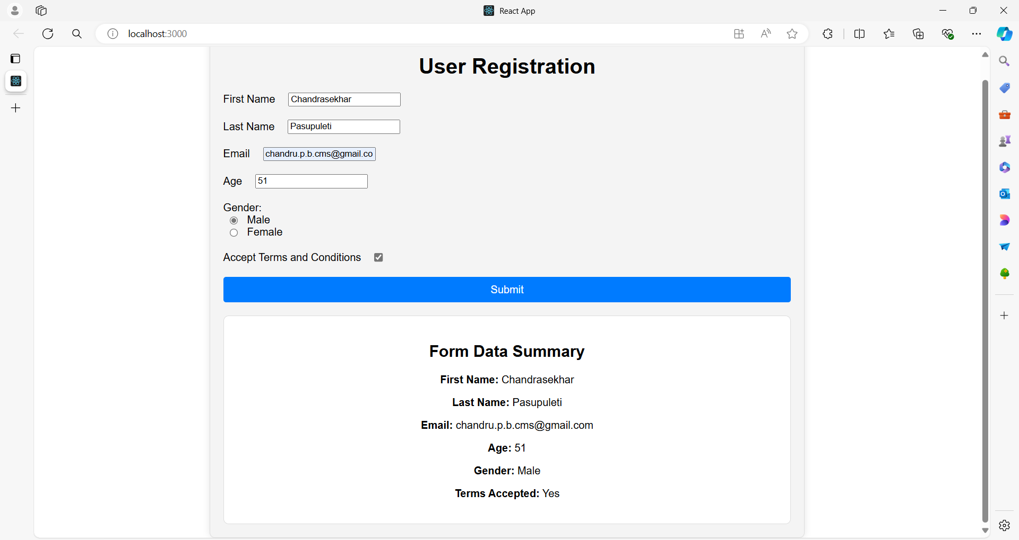

**1. App.js**

You will import the MainFormApp component and render it inside the App component.

**App.js**

import React from 'react';

import './App.css';

import MainFormApp from './MainFormApp';

function App() {

return (

<div className="App">

<MainFormApp />

</div>

);

}

export default App;

Ensure the CSS files are correctly placed and referenced:

**App.css**

.App {

font-family: Arial, sans-serif;

text-align: center;

}

**2. MainFormApp Component**

Ensure the MainFormApp component is defined.

**MainFormApp.js**

import React, { useState } from 'react';

import './MainFormApp.css';

import UserForm from './UserForm';

import FormSummary from './FormSummary';

function MainFormApp() {

const [userData, setUserData] = useState({

firstName: '',

lastName: '',

email: '',

age: '',

gender: '',

termsAccepted: false,

});

const handleInputChange = (event) => {

const { name, value, type, checked } = event.target;

setUserData({

...userData,

[name]: type === 'checkbox' ? checked : value,

});

};

const handleSubmit = (event) => {

event.preventDefault();

console.log('Form submitted:', userData);

};

return (

<div className="container">

<h1>User Registration</h1>

<UserForm userData={userData} onInputChange={handleInputChange} onSubmit={handleSubmit} />

<FormSummary data={userData} />

</div>

);

}

export default MainFormApp;

**MainFormApp.css**

.container {

width: 60%;

margin: 0 auto;

padding: 20px;

border: 1px solid #ddd;

border-radius: 8px;

box-shadow: 0 0 10px rgba(0, 0, 0, 0.1);

background-color: #f4f4f4;

}

h1 {

text-align: center;

}

**3. Ensure Child Components are Properly Defined**

**UserForm.js**

import React from 'react';

import InputField from './InputField';

import './UserForm.css';

function UserForm({ userData, onInputChange, onSubmit }) {

return (

<form className="form" onSubmit={onSubmit}>

<InputField

label="First Name"

name="firstName"

value={userData.firstName}

onChange={onInputChange}

/>

<InputField

label="Last Name"

name="lastName"

value={userData.lastName}

onChange={onInputChange}

/>

<InputField

label="Email"

name="email"

type="email"

value={userData.email}

onChange={onInputChange}

/>

<InputField

label="Age"

name="age"

type="number"

value={userData.age}

onChange={onInputChange}

/>

<div className="form-group">

<label>Gender:</label>

<InputField

name="gender"

type="radio"

value="Male"

checked={userData.gender === 'Male'}

onChange={onInputChange}

labelText="Male"

/>

<InputField

name="gender"

type="radio"

value="Female"

checked={userData.gender === 'Female'}

onChange={onInputChange}

labelText="Female"

/>

</div>

<InputField

label="Accept Terms and Conditions"

name="termsAccepted"

type="checkbox"

checked={userData.termsAccepted}

onChange={onInputChange}

/>

<button type="submit">Submit</button>

</form>

);

}

export default UserForm;

**UserForm.css**

.form {

display: grid;

gap: 20px;

}

.form-group {

display: flex;

flex-direction: column;

}

label {

display: flex;

align-items: center;

gap: 10px;

}

input {

margin-left: 10px;

}

button {

width: 100%;

padding: 10px;

border: none;

border-radius: 4px;

background-color: #007bff;

color: white;

font-size: 16px;

cursor: pointer;

transition: background-color 0.3s;

}

button:hover {

background-color: #0056b3;

}

**InputField.js**

import React from 'react';

function InputField({ label, name, type = 'text', value, checked, onChange, labelText }) {

return (

<div className="form-group">

<label>

{label}

{type === 'checkbox' || type === 'radio' ? (

<input

type={type}

name={name}

value={value}

checked={checked}

onChange={onChange}

/>

) : (

<input

type={type}

name={name}

value={value}

onChange={onChange}

/>

)}

{type === 'radio' && labelText && <span>{labelText}</span>}

</label>

</div>

);

}

export default InputField;

**FormSummary.js**

import React from 'react';

import './FormSummary.css';

function FormSummary({ data }) {

return (

<div className="summary">

<h2>Form Data Summary</h2>

<p><strong>First Name:</strong> {data.firstName}</p>

<p><strong>Last Name:</strong> {data.lastName}</p>

<p><strong>Email:</strong> {data.email}</p>

<p><strong>Age:</strong> {data.age}</p>

<p><strong>Gender:</strong> {data.gender}</p>

<p><strong>Terms Accepted:</strong> {data.termsAccepted ? 'Yes' : 'No'}</p>

</div>

);

}

export default FormSummary;

**4. CSS Files**

Ensure the CSS files are correctly placed and referenced:

**App.css**

.App {

font-family: Arial, sans-serif;

text-align: center;

}

**MainFormApp.css**

.container {

width: 60%;

margin: 0 auto;

padding: 20px;

border: 1px solid #ddd;

border-radius: 8px;

box-shadow: 0 0 10px rgba(0, 0, 0, 0.1);

background-color: #f4f4f4;

}

h1 {

text-align: center;

}

**UserForm.css**

.form {

display: grid;

gap: 20px;

}

.form-group {

display: flex;

flex-direction: column;

}

label {

display: flex;

align-items: center;

gap: 10px;

}

input {

margin-left: 10px;

}

button {

width: 100%;

padding: 10px;

border: none;

border-radius: 4px;

background-color: #007bff;

color: white;

font-size: 16px;

cursor: pointer;

transition: background-color 0.3s;

}

button:hover {

background-color: #0056b3;

}

**FormSummary.css**

.summary {

margin-top: 20px;

padding: 20px;

border: 1px solid #ddd;

border-radius: 8px;

background-color: #fff;

}

h2 {

margin-bottom: 20px;

}

**Running the Example**

1. **Setup**:
   * Create a new React application if you haven’t already:

**npx create-react-app user-form-example**

**cd user-form-example**

1. **Add Components**:
   * Replace the contents of src/App.js with the updated App.js code.
   * Create new files MainFormApp.js, UserForm.js, InputField.js, FormSummary.js in the src directory with the provided code.
   * Add the corresponding CSS files to the src directory.
2. **Start the Application**:
   * Run the application using:

**npm start**

* + This will open the application in your default web browser.

This setup ensures that the MainFormApp component is used as the main component within the App.js, making it easy to manage and understand the structure of your application.

**Example 03**

Creating a more complex example for an e-commerce website will involve multiple components and interactions.

Here’s a basic but comprehensive example of an e-commerce application with the following features:

1. **Product List**: Displays a list of products.
2. **Product Item**: Represents individual product cards.
3. **Cart**: Displays items added to the cart.
4. **Cart Item**: Represents individual items in the cart.
5. **Checkout**: A form to handle the checkout process.

**Overview**

1. **App Component**: The main component that integrates the ProductList and Cart components.
2. **ProductList Component**: Manages the list of products.
3. **ProductItem Component**: Represents each product.
4. **Cart Component**: Manages the cart state and displays cart items.
5. **CartItem Component**: Represents each item in the cart.
6. **Checkout Component**: Handles the checkout process.

**ecommerce-app/**

|-- public/

| |-- index.html

|-- src/

| |-- App.js

| |-- ProductList.js

| |-- ProductItem.js

| |-- Cart.js

| |-- CartItem.js

| |-- Checkout.js

| |-- App.css

| |-- ProductList.css

| |-- ProductItem.css

| |-- Cart.css

| |-- CartItem.css

| |-- Checkout.css

|-- package.json

|-- README.md

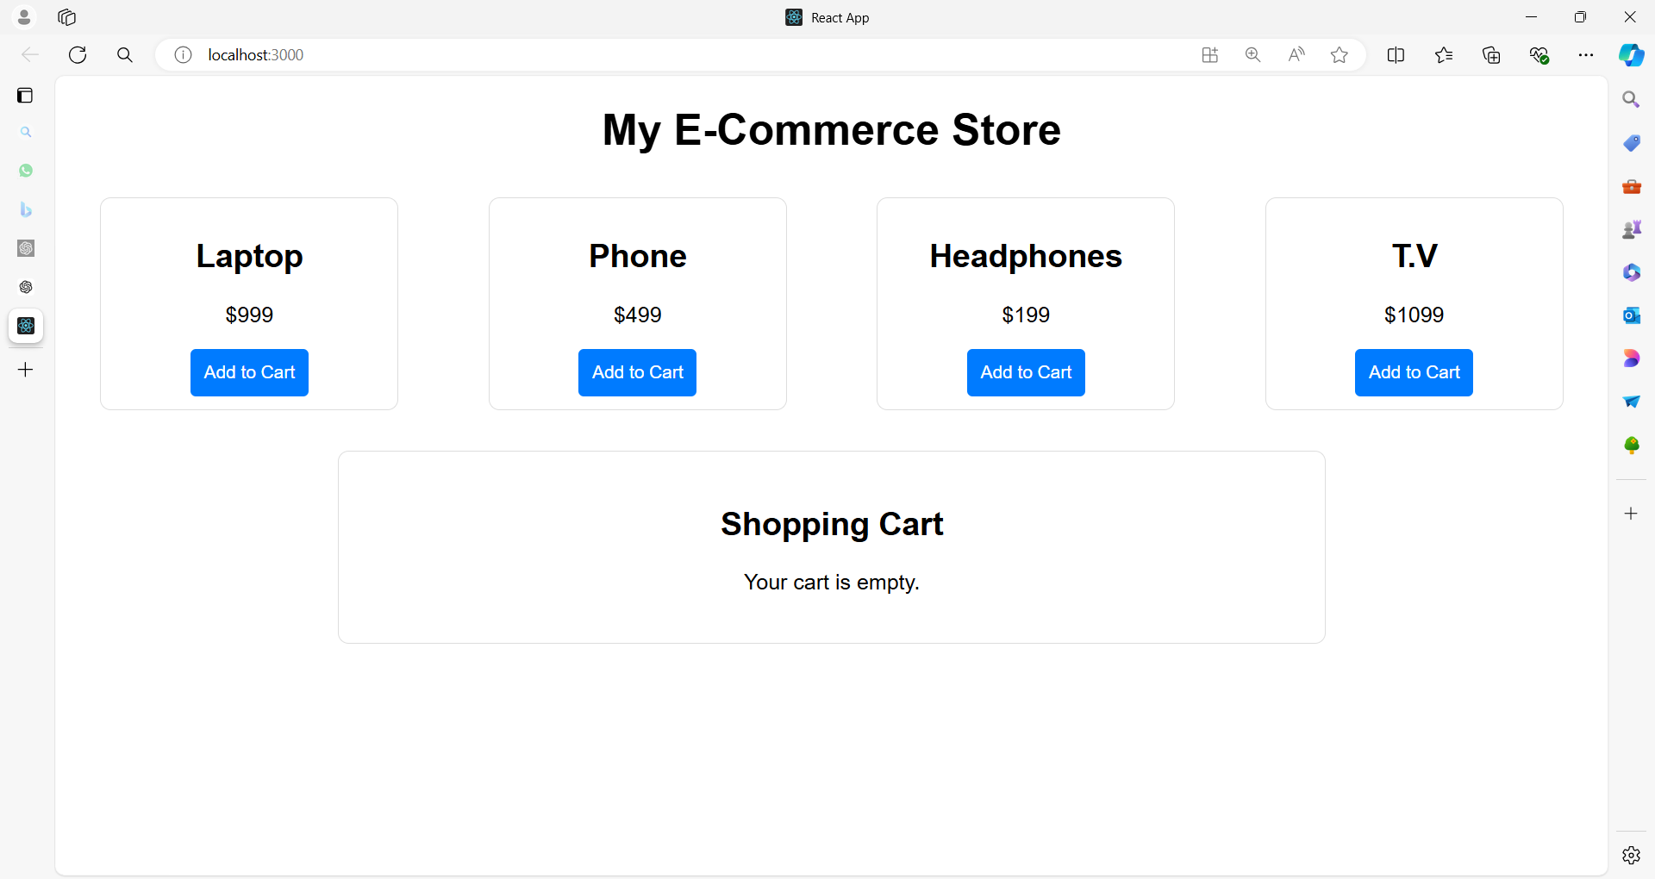

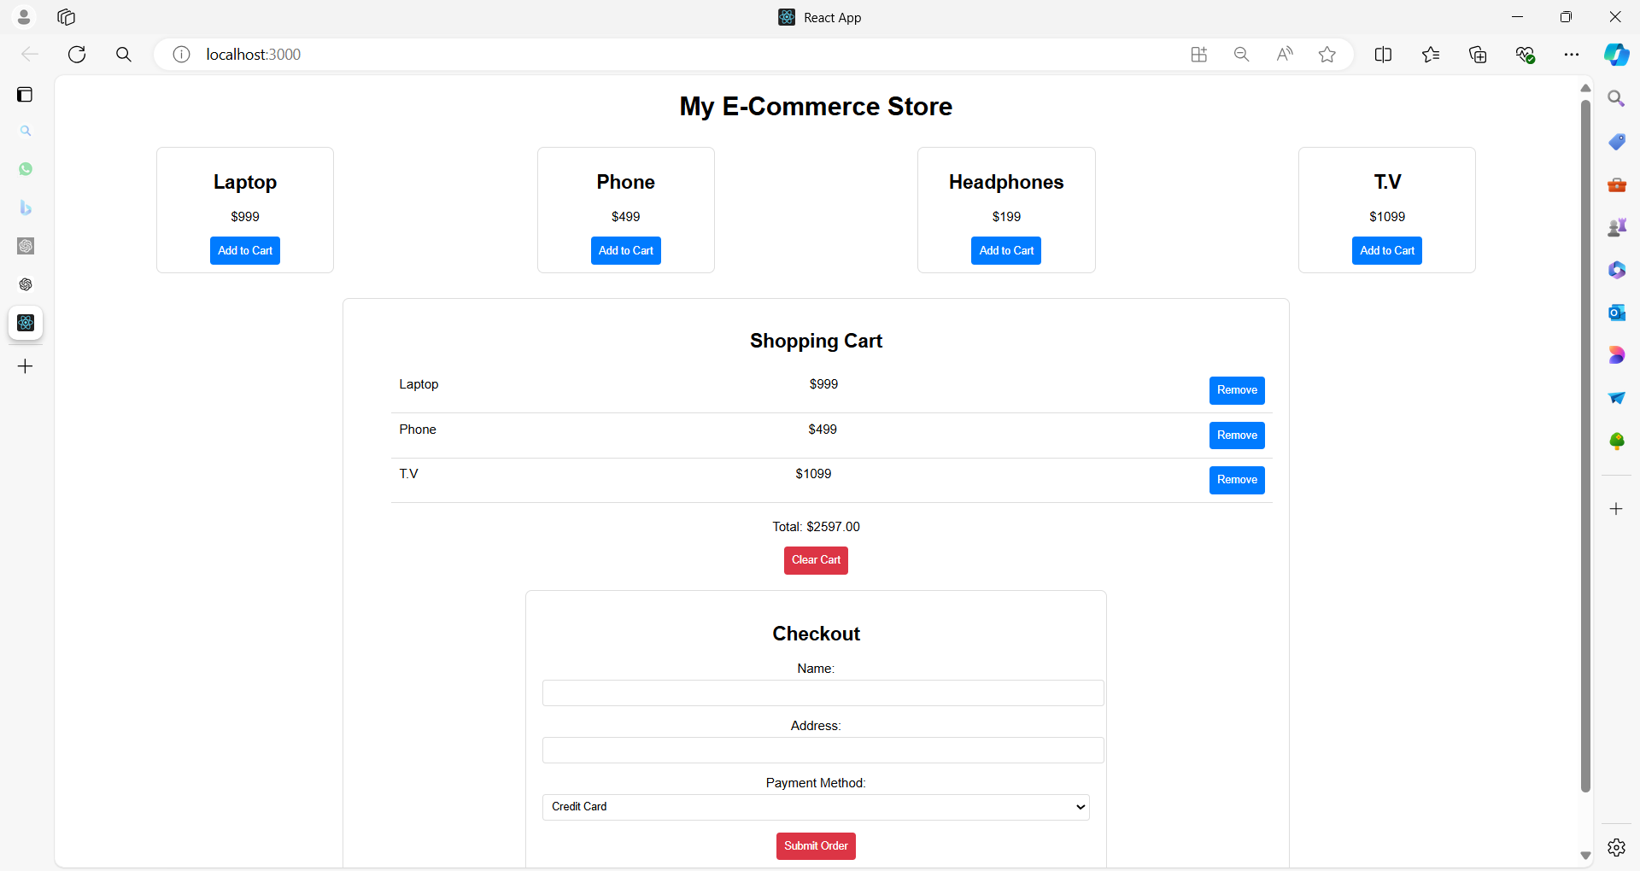

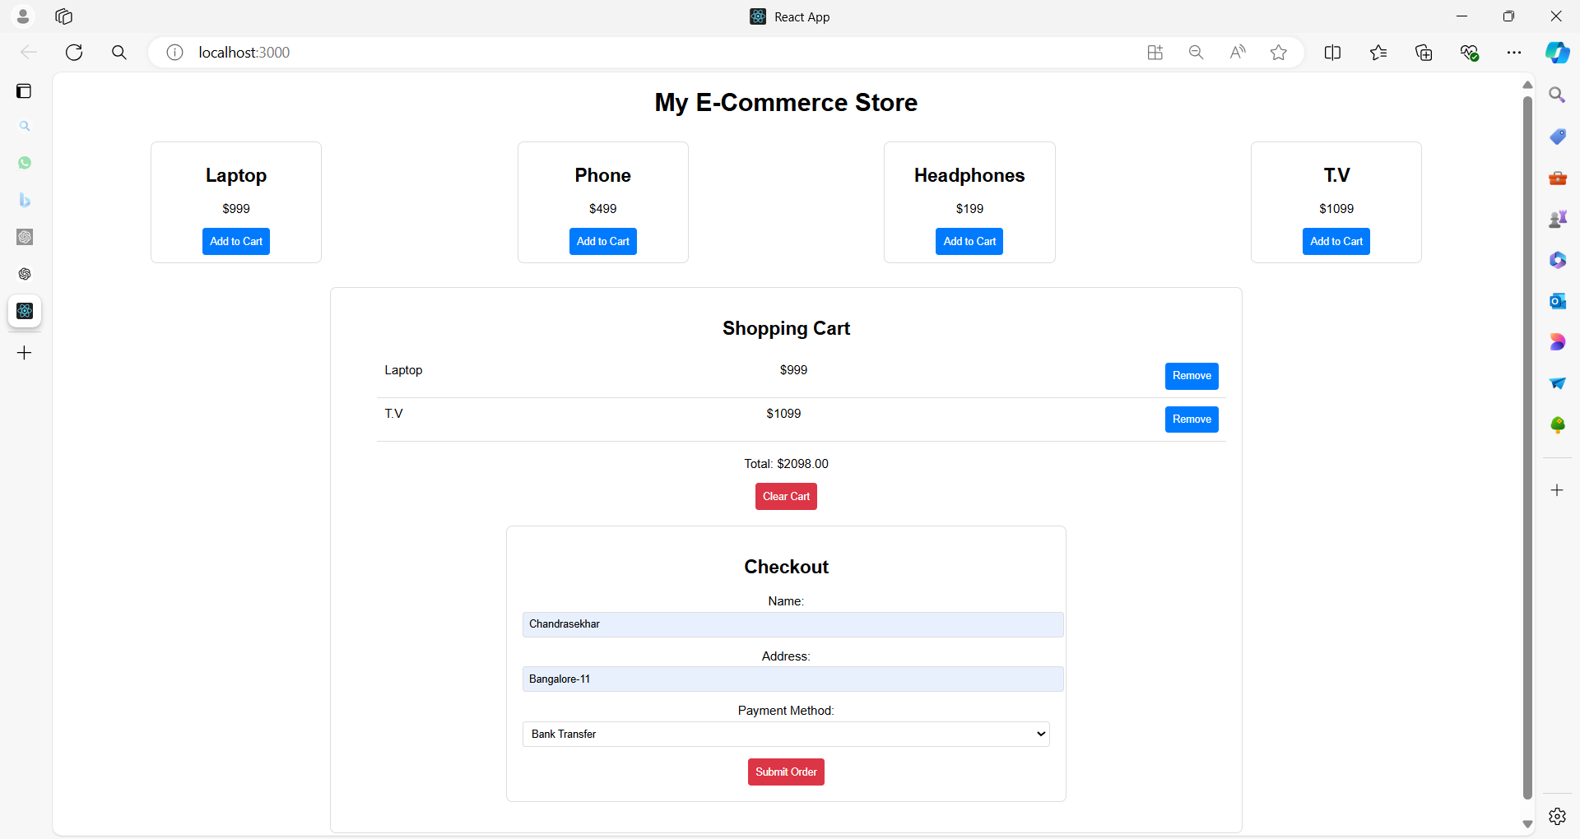

**Full Example**

**1. App Component**

**App.js**

import React, { useState } from 'react';

import './App.css';

import ProductList from './ProductList';

import Cart from './Cart';

function App() {

const [cartItems, setCartItems] = useState([]);

const addToCart = (product) => {

setCartItems((prevItems) => [...prevItems, product]);

};

const removeFromCart = (productId) => {

setCartItems((prevItems) => prevItems.filter(item => item.id !== productId));

};

const clearCart = () => {

setCartItems([]);

};

return (

<div className="App">

<h1>My E-Commerce Store</h1>

<ProductList addToCart={addToCart} />

<Cart items={cartItems} removeFromCart={removeFromCart} clearCart={clearCart} />

</div>

);

}

export default App;

**2. ProductList Component**

**ProductList.js**

import React from 'react';

import ProductItem from './ProductItem';

import './ProductList.css';

const products = [

{ id: 1, name: 'Laptop', price: 999 },

{ id: 2, name: 'Phone', price: 499 },

{ id: 3, name: 'Headphones', price: 199 },

];

function ProductList({ addToCart }) {

return (

<div className="product-list">

{products.map(product => (

<ProductItem key={product.id} product={product} addToCart={addToCart} />

))}

</div>

);

}

export default ProductList;

**3. ProductItem Component**

**ProductItem.js**

import React from 'react';

import './ProductItem.css';

function ProductItem({ product, addToCart }) {

return (

<div className="product-item">

<h2>{product.name}</h2>

<p>${product.price}</p>

<button onClick={() => addToCart(product)}>Add to Cart</button>

</div>

);

}

export default ProductItem;

**4. Cart Component**

**Cart.js**

import React from 'react';

import CartItem from './CartItem';

import Checkout from './Checkout';

import './Cart.css';

function Cart({ items, removeFromCart, clearCart }) {

const total = items.reduce((sum, item) => sum + item.price, 0);

return (

<div className="cart">

<h2>Shopping Cart</h2>

{items.length === 0 ? (

<p>Your cart is empty.</p>

) : (

<>

<ul>

{items.map(item => (

<CartItem key={item.id} item={item} removeFromCart={removeFromCart} />

))}

</ul>

<div className="cart-summary">

<p>Total: ${total.toFixed(2)}</p>

<button onClick={clearCart}>Clear Cart</button>

<Checkout />

</div>

</>

)}

</div>

);

}

export default Cart;

**5. CartItem Component**

**CartItem.js**

import React from 'react';

import './CartItem.css';

function CartItem({ item, removeFromCart }) {

return (

<li className="cart-item">

<span>{item.name}</span>

<span>${item.price}</span>

<button onClick={() => removeFromCart(item.id)}>Remove</button>

</li>

);

}

export default CartItem;

**6. Checkout Component**

**Checkout.js**

import React, { useState } from 'react';

import './Checkout.css';

function Checkout() {

const [formData, setFormData] = useState({

name: '',

address: '',

paymentMethod: 'Credit Card'

});

const handleChange = (e) => {

const { name, value } = e.target;

setFormData({ ...formData, [name]: value });

};

const handleSubmit = (e) => {

e.preventDefault();

console.log('Checkout form submitted:', formData);

};

return (

<div className="checkout">

<h2>Checkout</h2>

<form onSubmit={handleSubmit}>

<div className="form-group">

<label>Name:</label>

<input

type="text"

name="name"

value={formData.name}

onChange={handleChange}

required

/>

</div>

<div className="form-group">

<label>Address:</label>

<input

type="text"

name="address"

value={formData.address}

onChange={handleChange}

required

/>

</div>

<div className="form-group">

<label>Payment Method:</label>

<select

name="paymentMethod"

value={formData.paymentMethod}

onChange={handleChange}

>

<option value="Credit Card">Credit Card</option>

<option value="PayPal">PayPal</option>

<option value="Bank Transfer">Bank Transfer</option>

</select>

</div>

<button type="submit">Submit Order</button>

</form>

</div>

);

}

export default Checkout;

**CSS Files**

**App.css**

.App {

font-family: Arial, sans-serif;

text-align: center;

}

**ProductList.css**

.product-list {

display: flex;

justify-content: space-around;

flex-wrap: wrap;

}

**ProductItem.css**

.product-item {

border: 1px solid #ddd;

border-radius: 8px;

padding: 10px;

width: 200px;

margin: 10px;

text-align: center;

}

.product-item button {

background-color: #007bff;

color: white;

border: none;

padding: 10px;

border-radius: 4px;

cursor: pointer;

}

.product-item button:hover {

background-color: #0056b3;

}

**Cart.css**

.cart {

border: 1px solid #ddd;

border-radius: 8px;

padding: 20px;

margin: 20px auto;

width: 60%;

}

.cart-summary {

margin-top: 20px;

}

.cart-summary button {

background-color: #dc3545;

color: white;

border: none;

padding: 10px;

border-radius: 4px;

cursor: pointer;

}

.cart-summary button:hover {

background-color: #c82333;

}

**CartItem.css**

.cart-item {

display: flex;

justify-content: space-between;

padding: 10px;

border-bottom: 1px solid #ddd;

}

**Checkout.css**

.checkout {

border: 1px solid #ddd;

border-radius: 8px;

padding: 20px;

margin: 20px auto;

width: 60%;

}

.form-group {

margin-bottom: 15px;

}

form input,

form select {

width: 100%;

padding: 8px;

margin-top: 5px;

border-radius: 4px;

border: 1px solid #ddd;

}

button {

background-color: #007bff;

color: white;

border: none;

padding: 10px;

border-radius: 4px;

cursor: pointer;

}

button:hover {

background-color: #0056b3;

}

**Explanation**

1. **App Component**:
   * Manages the cart state and handles adding/removing items and clearing the cart.
   * Integrates ProductList and Cart components.
2. **ProductList Component**:
   * Displays a list of products by mapping over a predefined array.
   * Passes addToCart function to ProductItem components.
3. **ProductItem Component**:
   * Displays individual product information and a button to add the product to the cart.
4. **Cart Component**:
   * Displays items in the cart and provides options to clear the cart and view the checkout form.
5. **CartItem Component**:
   * Represents individual items in the cart with an option to remove them.
6. **Checkout Component**:
   * A form to handle user input for completing the purchase.

This example provides a complete basic structure for an e-commerce website with meaningful components, demonstrating the use of props and state in React.

**Spread Operator**

The spread operator (...) allows you to unpack elements from an array or properties from an object.

In the context of arrays, it can be used to create a new array by copying the elements of an existing array and optionally adding new elements.

**Explanation of [...prevItems, product]**

1. **prevItems**: This is the current array of items in the cart. It’s the previous state of the cart before the new item is added.
2. **...prevItems**: The spread operator takes each element from the prevItems array and includes it in the new array. It essentially creates a **shallow copy** of the prevItems array.
3. **product**: This is the new item that you want to add to the cart. It is placed at the end of the new array.
4. **[...prevItems, product]**: This creates a new array that contains all the elements of prevItems, followed by the new product. This approach is used to add an item to the existing list while maintaining immutability.

**Example**

Suppose prevItems is [ { id: 1, name: 'Laptop', price: 999 } ], and product is { id: 2, name: 'Phone', price: 499 }.

Using [...prevItems, product] will result in a new array:

const prevItems = [{ id: 1, name: 'Laptop', price: 999 }];

const product = { id: 2, name: 'Phone', price: 499 };

const newItems = [...prevItems, product];

console.log(newItems);

// Output: [{ id: 1, name: 'Laptop', price: 999 }, { id: 2, name: 'Phone', price: 499 }]

**Why Use It?**

1. **Immutability**: This approach helps in maintaining immutability. Instead of modifying the existing prevItems array, it creates a new array with the added item. This is crucial in React because it allows the framework to detect changes and re-render components effectively.
2. **Conciseness**: Using the spread operator makes it easy to copy and append elements in a concise and readable way.

This pattern is commonly used in React state updates when you need to add or remove items from an array without mutating the existing state.

**Reduce method**

The line const total = items.reduce((sum, item) => sum + item.price, 0); uses the reduce method to compute the total price of items in an array.

Here’s a detailed explanation:

**reduce Method**

The reduce method in JavaScript is used to apply a function against an accumulator and each element in an array (from left to right) to reduce it to a single value.

It’s a powerful and versatile method often used to perform calculations or transformations on arrays.

**Syntax**

array.reduce((accumulator, currentValue) => {

// return updated accumulator

}, initialValue);

* **accumulator**: The accumulated value returned by the last execution of the callback function. It is initialized to initialValue on the first call.
* **currentValue**: The current element being processed in the array.
* **initialValue**: A value to start the accumulation with. If not provided, the first element in the array is used as the initial value, and the iteration starts from the second element.

**Explanation of const total = items.reduce((sum, item) => sum + item.price, 0);**

1. **items**: This is the array of objects where each object represents an item in the cart. Each object has a price property.
2. **.reduce((sum, item) => sum + item.price, 0)**:
   * **(sum, item) => sum + item.price**: This is the callback function that reduce uses to accumulate values.
     + **sum**: This is the accumulator, which starts with the value of 0 (provided by initialValue). In each iteration, it holds the cumulative total of prices.
     + **item**: This represents the current item being processed in the array.
     + **sum + item.price**: In each iteration, the price of the current item is added to the sum, updating the accumulator.
   * **0**: This is the initialValue for the accumulator. It initializes sum to 0 before any iteration starts.
3. **const total**: This stores the final result after all iterations. It will be the total sum of all price values from the items array.

**Example**

Consider the following array of items:

const items = [

{ id: 1, name: 'Laptop', price: 999 },

{ id: 2, name: 'Phone', price: 499 },

{ id: 3, name: 'Headphones', price: 199 }

];

Using the reduce method:

const total = items.reduce((sum, item) => sum + item.price, 0);

console.log(total); // Output: 1697

* **Initial State**: sum starts at 0.
* **First Iteration**: sum = 0 + 999 (price of the first item), so sum becomes 999.
* **Second Iteration**: sum = 999 + 499 (price of the second item), so sum becomes 1498.
* **Third Iteration**: sum = 1498 + 199 (price of the third item), so sum becomes 1697.

The final value of total is 1697, which is the sum of all item prices.

**Summary**

The reduce method iterates over each element in the array and applies the provided function to accumulate a result.

In this case, it calculates the total sum of item prices, starting from 0 and adding each item's price to the cumulative total.