**SMART WASTE SEGREGATION**

Nirosha.K 1,a) ,Sowmya. S 2,b),Vaishnavi. S 3,c), Seshu Kumar.K 4,d),Chandra Shekar.K 5,e) ,Ram Teja.M 6,f).

*Assistant Professor 1,2, Student 3,4,5,6.*

*Department of AI, Vidya Jyothi Institute of Technology, Aziznagar Gate, Chilkur Balaji Road, Himayat Sagar Rd, Hyderabad, Telangana 500075*

*a)*[*nirosha.kunduru@gmail.com*](mailto:nirosha.kunduru@gmail.com) *,b)* [*sowmyasai@vjit.ac.in*](mailto:sowmyasai@vjit.ac.in) *, c)* [*vaishnavisamkula@gmail.com*](mailto:vaishnavisamkula@gmail.com)*, d)*[*seshu478@gmail.com*](mailto:seshu478@gmail.com) *,e)* [*chandrashekar63707@gmail.com*](mailto:chandrashekar63707@gmail.com) *,f)* [*ramteja@gmail.com*](mailto:ramteja@gmail.com).

**Abstract:**

In India, inefficient waste management results in 40% of waste going to landfills and only 30% being recycled, leading to pollution and health risks for workers. A Smart Waste Segregation system is needed to enhance recycling, reduce landfill waste, and improve worker safety. We propose a Smart Waste Segregation system using IoT to automate waste sorting, enhance recycling, reduce landfill waste, and improve worker safety. The methodology involves integrating sensors and motors with an Arduino for automated waste sorting, programming the system for operation, testing components, and deploying the system in urban areas. The system relies on sensor data to automate sorting and monitor operations in real-time. By providing timely alerts to municipal authorities, the system helps ensure efficient waste collection. It aims for over 90% accuracy in sorting wet and dry waste, contributing to a cleaner and more sustainable environment.

**Keywords:** Waste Management, Recycling, Smart Segregation, IoT, Sensors, Arduino, Real-time Monitoring

**I.INTRODUCTION**

Efficient waste management is a critical challenge in India, where rapid urbanization and population growth exacerbate existing issues. Currently, approximately 40% of waste ends up in landfills, while only 30% is recycled, leading to significant environmental pollution and health risks for waste workers[1]. The accumulation of unsegregated waste in landfills results in the generation of leachate and greenhouse gases, further contributing to environmental degradation. Additionally, manual waste sorting exposes workers to hazardous conditions, increasing their health risks[2].

To address these challenges, this project proposes the development of a Smart Waste Segregation system that utilizes Internet of Things (IoT) technology.[4] The system aims to automate the segregation of waste into distinct categories, such as wet and dry, to improve recycling rates and reduce the volume of waste sent to landfills. By integrating various sensors with an Arduino microcontroller, the system provides real-time monitoring and precise sorting of waste materials.

The methodology involves the deployment of ultrasonic sensors for distance measurement, soil moisture sensors for detecting wet waste, and servo motors for sorting. The Arduino serves as the central processing unit, controlling the operation of the sensors and motors based on the input data[2]. The system is designed to send timely alerts to municipal authorities when bins are full, ensuring prompt waste collection and minimizing overflow.This innovative approach aims to enhance the efficiency of waste management processes, improve environmental sustainability, and safeguard the health of waste workers[5]. By leveraging advanced technology for waste segregation, the proposed system represents a significant step toward creating cleaner and more sustainable urban environments.

**II.RELATED WORKS**

While working on our system, it's essential to have knowledge about the existing work or published papers related to our system's design. These resources serve as valuable references for study, helping us analyse productive ways to build and incorporate components that we might not be familiar with. Automated smart waste segregation system using IoT technology byMR Chitale, S J Chitpur , A B Chivate, P D Chopade , S M Deshmukh and A Marathe published a paper in Journal of Physics: Conference Series & September 2023: Says One of the major challenges faced not just by India but globally as well is waste management. any-a-times it is observed that despite providing separate bins for dry and wet trash, the convention is carelessly ignored. With the traditional methods of periodic garbage collection and manual segregation of wet, metallic, non-recyclable, and recyclable waste proving to be inefficient, there is a need for a better solution[2]. To make use of proper disposal and waste management techniques, the segregation of wastes is essential. In the existing systems, drones are used for identifying waste using image processing, and deep learning and use GPS, and GSM methods to identify and send locations to the authorities[1].

Smart Waste Management: Waste Segregation using Machine Learning by Gayathri Rajakumaran, Shola Usharani, Christie Vincent, Sujatha M had published another paper in Recent Advances in Wireless Communications & Emerging Technologies (RAWCET 2022) & April 2023 which says in the digitized era, the role of smart mechanisms plays a vital role and one among them is the segregation of waste[1]. The enhancement achieved is to analyze and implement waste segregation with the help of image classification and multi-object detection. Waste management may therefore be done more efficiently with an accuracy of 95% with a mean average of 87.4% which in turn helps significantly to reduce labor costs[7].

Waste-Seg-Net: A Deep Learning Approach for Smart Waste Segregation in Urban Environments by Aatmaj Amol Salunke in the Department of Computer Science & Engineering Manipal University Jaipur & July 2023:Efficient waste segregation is paramount for sustainable urban waste management. In this study, we present Waste-Seg-Net, a custom-designed Convolutional Neural Network (CNN) for automated waste segregation into Organic and Recyclable categories. Trained on 22,564 waste images with a test set of 2,513 samples, Waste-Seg-Net achieves an impressive accuracy of 87.5% on the test dataset[4]. Comparative analysis with traditional methods highlights the superior performance of Waste-Seg-Net in accurate waste item classification. The model’s strength lies in its ability to discern intricate visual patterns, enabling effective segregation. By harnessing deep learning techniques, Waste-Seg-Net offers a promising solution to optimize waste sorting processes, reduce landfill waste, combat environmental pollution, and foster sustainable waste management practices in smart cities[6]. The proposed system uses smart garbage tracking, segregation, and collection systems, interfaced with ultrasonic sensors, rainfall/moisture sensors, inductive proximity sensors, and servo motors, along with the necessary hardware, with Arduino as the main controlling unit[2].

**III. PROPOSED METHODOLOGY**

Creating a Smart waste segregation using IOT involves several steps, including the design of both hardware and software components. Here is a detailed methodology for such a system:

**III.1 HARDWARE COMPONENTS AND SOFTWARE COMPONENTS**

**1. SERVO SG90 HARDWARE:**

SG90 is a popular micro servo motor can rotate 180 degrees with a maximum torque of 1.8 kg-cm. It operates at 4.8-6V and has a weight of approximately 9 grams, making it ideal for small-scale robotics and model control applications. Take the servo SG90 and insert it into the model so that it can be flip easily

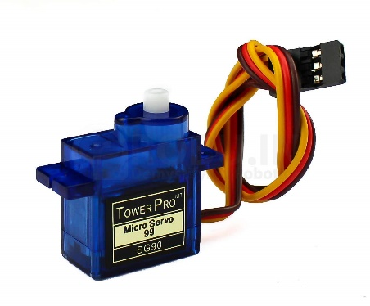

**FIG 1: SERVO SG90**

**2.ULTRASONIC SENSOR HARDWARE:**

This sensor is used to detect the object distance without any physical contact with the object. Ultrasonic sensors can measure distance and detect the presence of an object without making physical contact. They do so by producing and monitoring an ultrasonic echo. Depending on the sensor and object properties, the effective range in air is between a few centimeters up to several meters.

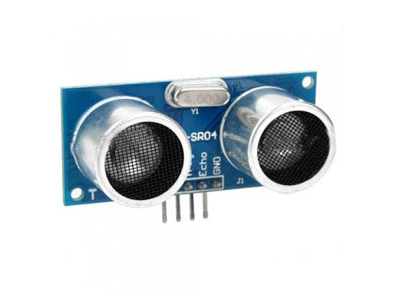

**FIG 2: ULTRASONIC SENSOR**

**3.ARDUINO UNO OPEN-SOURCE HARDWARE:**

Arduino UNO is a low-cost, flexible, and easy-to-use programmable open-source microcontroller board that can be integrated into a variety of electronic projects. This board can be interfaced with other Arduino boards, Arduino shields, Raspberry Pi boards and can control relays, LEDs, servos, and motors as an output.

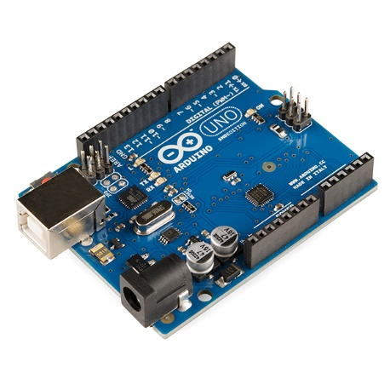

**FIG 3 : ARDUINO UNO**

**4. SOIL MOISTURE SENSOR HARDWARE:**

When electric current passes through these electrodes, they form an electromagnetic field in the soil. The probe measures the permittivity of a soil medium by measuring the charge time of a capacitor made with that medium and thus the soil water content.

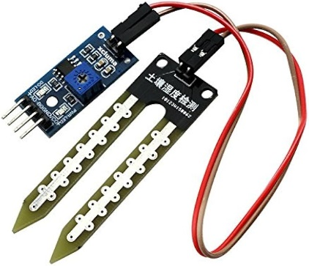

**FIG 4 :SOIL MOISTURE SENSOR**

**III.2 OTHER COMPONENTS**

**1. NUT BOLTS:**

Their principal function is to create a clamping force across the joint which can sustain the operating conditions without loosening. Correctly tightened bolts make use of their elastic properties; to work well they must behave like springs.

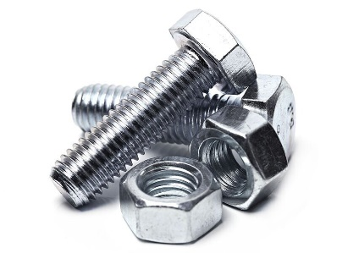

**FIG 5: NUT BOLTS**

**2. LCD DEVICE:**

LCD (Liquid Crystal Display) is a type of flat panel display which uses liquid crystals in its primary form of operation. LEDs have a large and varying set of use cases for consumers and businesses, as they can be commonly found in smartphones, televisions, computer monitors and instrument panels.

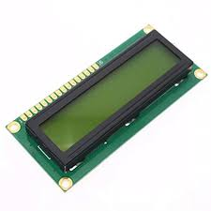

**FIG 6: LCD**

**3. BUZZER DEVICE:**

Buzzer meaning electronic component that generates sound through the transmission of electrical signals. Its primary function is to provide an audible alert or notification and typically operates within a voltage range of 5V to 12V.

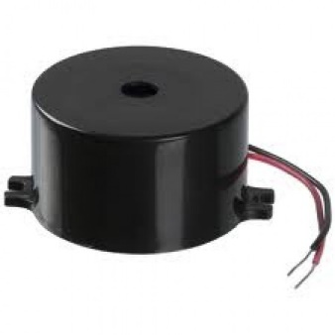

**FIG 7: BUZZER**

**4. LED DEVICE:**

LED stands for light emitting diode. LED lighting products produce light up to 90% more efficiently than incandescent light bulbs. An electrical current passes through a microchip, which illuminates the tiny light sources we call LEDs, and the result is visible light.

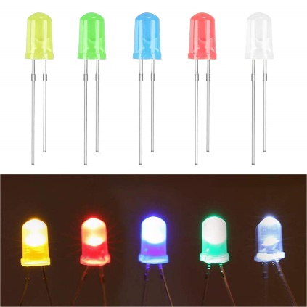

**FIG 8: LED**

**III.3 BLOCK DIAGRAM:**

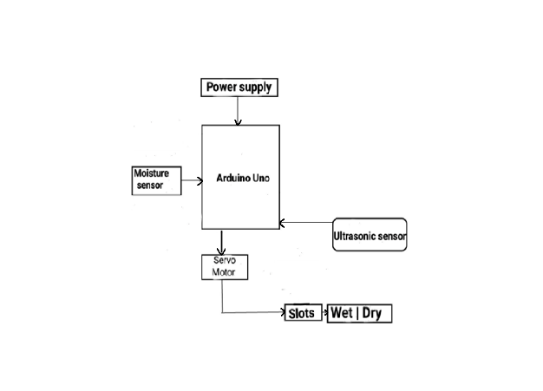

**FIG 9: BLOCK DIAGRAM FOR THE SMART WASTE SEGREGATION**

Moisture sensor is fixed on to upper part of segregator such that when is waste is put it directly lands on sensor. There is also a touch sensor besides it to detect dry waste. Arduino UNO is a low-cost, flexible, and easy-to-use programmable open-source microcontroller board that can be integrated into a variety of electronic projects. This board can be interfaced with other Arduino boards, Arduino shields, Raspberry Pi boards and can control relays, LEDs, servos, and motors as an output. Servo motor is used as an actuator which will rotate depending on the type of waste (dry or wet). Ultra sonic sensor as the distance to an object is determined by measuring the time of flight and not by the intensity of the sound, ultrasonic sensors are excellent at suppressing background interference. Virtually, all materials which reflect sound can be detected, regardless of their colour.

* Firstly, we take the Arduino Uno and connect the Ultrasonic Sensor, Soil Moisture Sensor to it.
* Now we take the GSM device, insert a sim into it, and give the connection with Arduino Uno which used to give the message to the municipal offices that bins are full.

Now by using the servo motor we will be able to rotate the plate which is used to segregate the waste.

* And then connect an LCD display to check out the readings.
* After adding all the required components and related code to run the model we start giving the supply to the model.
* Now we place different items on to the plate and test our model

**III.4 PC INTERFACE DEVELOPMENT**

**USER INTERFACE:** Design a user-friendly interface to display the bin level to municipal office.

**COMMUNICATION:** These models send a message immediately when the bin gets filled and ask them to empty it (i.e., to the municipal offices).

**INTEGRATION AND TESTING:**

Hardware Testing: Test individual components (Sensors) to ensure they are working correctly. Assemble the complete system and test all connections.

**FIRMWARE TESTING**: Test communication between the Arduino Uno and PC Test relay control and sensor data acquisition.

**SYSTEM TESTING:** Test the integrated system to ensure all components work together seamlessly. Conduct tests to measure the system’s performance and reliability.

**III.5 DEPLOYMENT AND MAINTENANCE**

**INSTALLATION:** Install the system in the desired location. Ensure proper insulation and safety measures for electrical connections.

**USER TRAINING:** Provide instructions on how to use the system. Offer a guide for troubleshooting common issues.

**IV. RESULTS AND DISCUSSIONS**

As we have given and checked all the connections properly, we will start giving the power supply to the model.

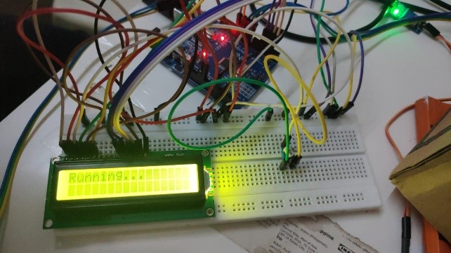

**FIG 10: CONNECTION ON BREAD BOARD**

Then we will start testing of our model by placing various materials. Objects detected using ultrasonic sensor, then sorted into categories (wet waste, dry waste). Wet waste includes items like banana peels, moist tissue paper, and wet cloth. Dry waste includes items such as dry cloth, cardboard, paper, and plastic.

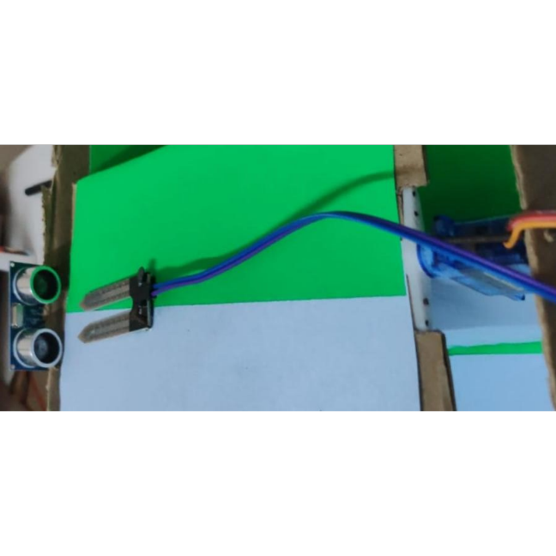

**FIG 11: POSITION FOR PLACING THE WASTE OBJECTS**

Moisture sensor used to determine wet waste based on minimum 5% moisture content threshold. Model’s base rotates to direct items to respective waste bins after classification. Suitable for deployment in public places or transportation hubs to manage trash effectively and maintain cleanliness.

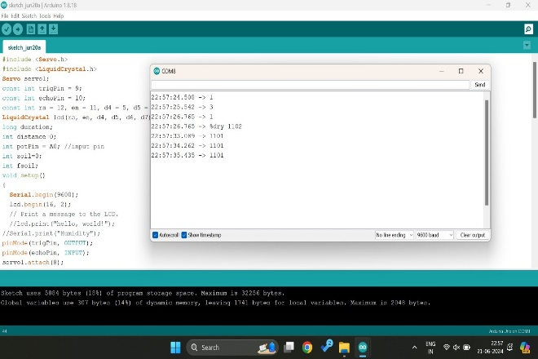

**FIG 12: INITIALIZING READINGS**

While we are testing the model we write the readings simultaneously.As we keep on adding the materials to the bin, the bin gets filled. As the bin fills the GSM modules sends a message to the municipal office to collect the trash.

Finally, we can prepare the model:

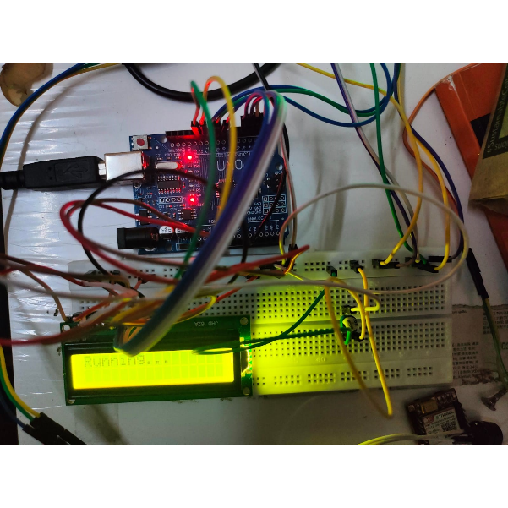

**FIG 13: OVER ALL CONNECTIONS**

If we kept dry waste on IR Sensor (battery):

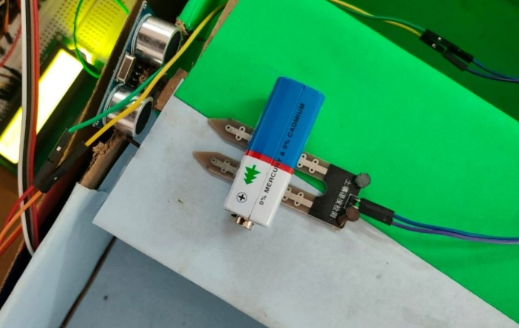

**FIG 14: TESTING OF DRY WASTE**

It will fall towards left in where all dry wastes are collected there.

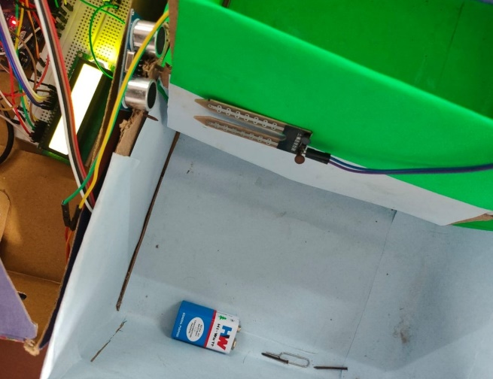

**FIG 15: DETECTING THE DRY WASTE**

The LCD will display the like text like below

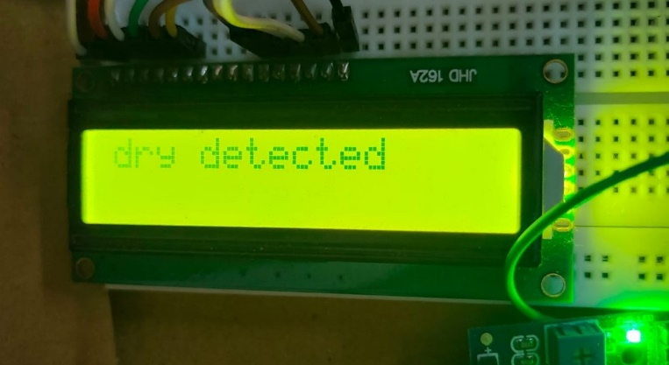

**FIG 16: READINGS OF DRY WASTE**

Likewise, the same thing will happen for wet waste, If we place wet waste like potato on Sensor.

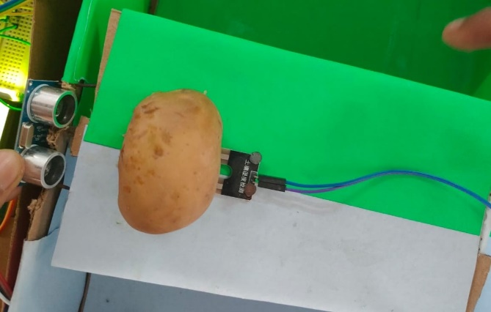

**FIG 17: TESTING THE WET WASTE**

It will fall towards right , in that all wet wastes are collected.

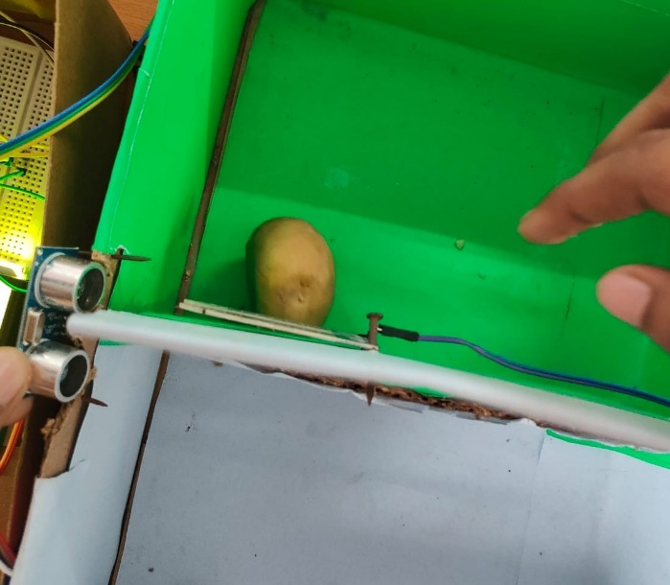

**FIG 18: DETECTING THE WET WASTE**

The LCD displays the text like below.

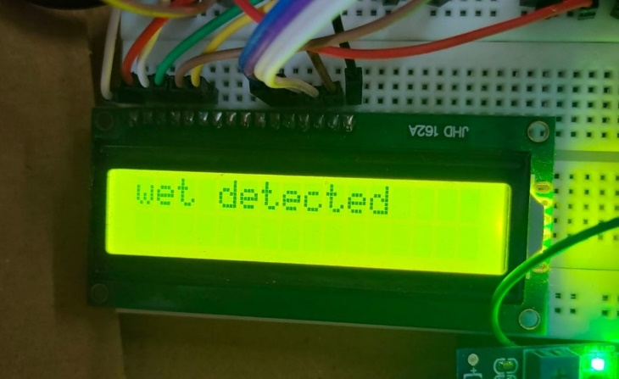

**FIG 19: READINGS OF WET WASTE**

The overall project looks like below.

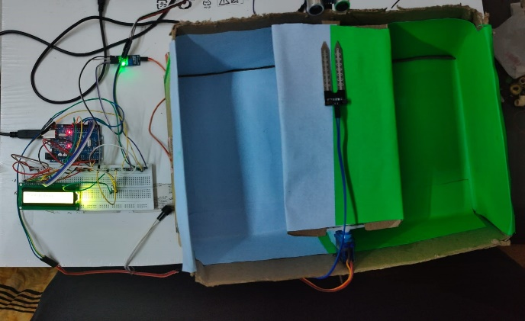

**FIG 20: THE OVER ALL PROJECT SET UP**

**V.CONCLUSION**

With growing urbanization and increasing population, effective waste disposal is a major concern. Manual waste segregation is extremely expensive, time consuming and inefficient.

Waste management is an extremely crucial consideration for reducing environmental pollution. The dustbins in public places get filled with huge piles of unsorted garbage. The system built in this project will ensure that the garbage is disposed of in a conventional manner and that no garbage will be chunked out. The project will ensure that no human involvement will be required for the categorization process. This will hence safeguard the health of the municipal workers who are involved in the practice of collection and scrapping of garbage. The human settings will then be clean, and no litter or rubbish will be there. This innovative solution not only improves the efficiency of waste management processes but also contributes to environmental sustainability and worker safety. By adopting this system, urban areas can achieve more effective waste management, leading to cleaner, healthier, and more sustainable cities.

However, the system does have potential disadvantages, including the initial cost of installation and maintenance, as well as the need for regular calibration and potential technical failures of sensors. To prevent these issues, it is crucial to implement a comprehensive maintenance plan and provide training for operators to handle and troubleshoot the system effectively. Additionally, regular system updates and component checks can help ensure long-term reliability and performance.

**VI.REFERENCES**

[1] Gayathri Rajakumaran1[0000-0001-8995-1221]1, Shola Usharani[0000-00027480-7777]1, Christie Vincent1, Sujatha M2 1School of Computer Science and Engineering, Vellore Institute of Technology, Chennai, Tamilnadu 2Department of Eletronics and Communication Engineering, Koneru Lakshmaiah Education Foundation, Vijayawada, Andhrapradesh, India gayathri.r@vit.ac.in1,sholausha.rani@vit.ac.in2, [chrisite.vincent2021@vitstudent.ac.in3](mailto:chrisite.vincent2021@vitstudent.ac.in3)

[2] M R Chitale1, S J Chitpur1, A B Chivate1*, P D Chopade1, S M Deshmukh1 and A Marathe2 1Department of Computer Engineering 2Department of Electronics and Telecommunication 1,2Vishwakarma Institute of Technology, Pune, 411037, Maharashtra, India *Corresponding Author: A B Chivate. Email: [chivateatharva@gmail.com](mailto:chivateatharva@gmail.com)

[3] ManishaJayson(2018),Lakshmi H R ,”SmartBin-automatic waste segregation and collection”. Second International Conference on Advances in Electronics, Computer and Communication(ICAE CC-2018).

[4] Aatmaj Amol Salunke BACHELOR OF TECHNOLOGY In Computer Science & Engineering Department of Computer Science & Engineering Manipal University Jaipur [aatmajsalunke@yahoo.com](mailto:aatmajsalunke@yahoo.com)

[5] Jayshree Ghorpade- Anagha Wadkar,Janhairkamble ,Vijajendrapagare,”Smart Dustbin An Efficient Garbage Management Approach for a Healthy Society”,IEEE 2018.

[6] SaurabhDugdhe,PoojaShelar, SajuliJire and AnujaApte,”Efficient Waste Collection System”,IEEE 2016..

[7] V.Sowndharya1*, P.Savitha1 , S.Hebziba Jeba Rani 2 1UG Scholar, Dept of Computer Science and Engineering, Sri Ramakrishna Institute of Technology, Coimbatore, TN, India 2Assistant Professor, Department of Computer Science and Engineering, Sri Ramakrishna Institute of Technology, Coimbatore, TN, India *Corresponding author E-Mail ID: sowndharya.15cs@srit.org, Mobile: +91 8110000979 DOI: <https://doi.org/10.34256/irjmt1921>

[8] 500 W. Peace St. Raleigh, NC 27603. United States.[info@bridgera.com](mailto:info@bridgera.com) [+1 919-230-9951 [Raleigh]](tel:+1-919-230-9951)