**Name : Madhavi Suratkar**

**Topic : Kubernetes**

**Date : 26-04-2023**

**Installation of Kubernetes & Minikube**

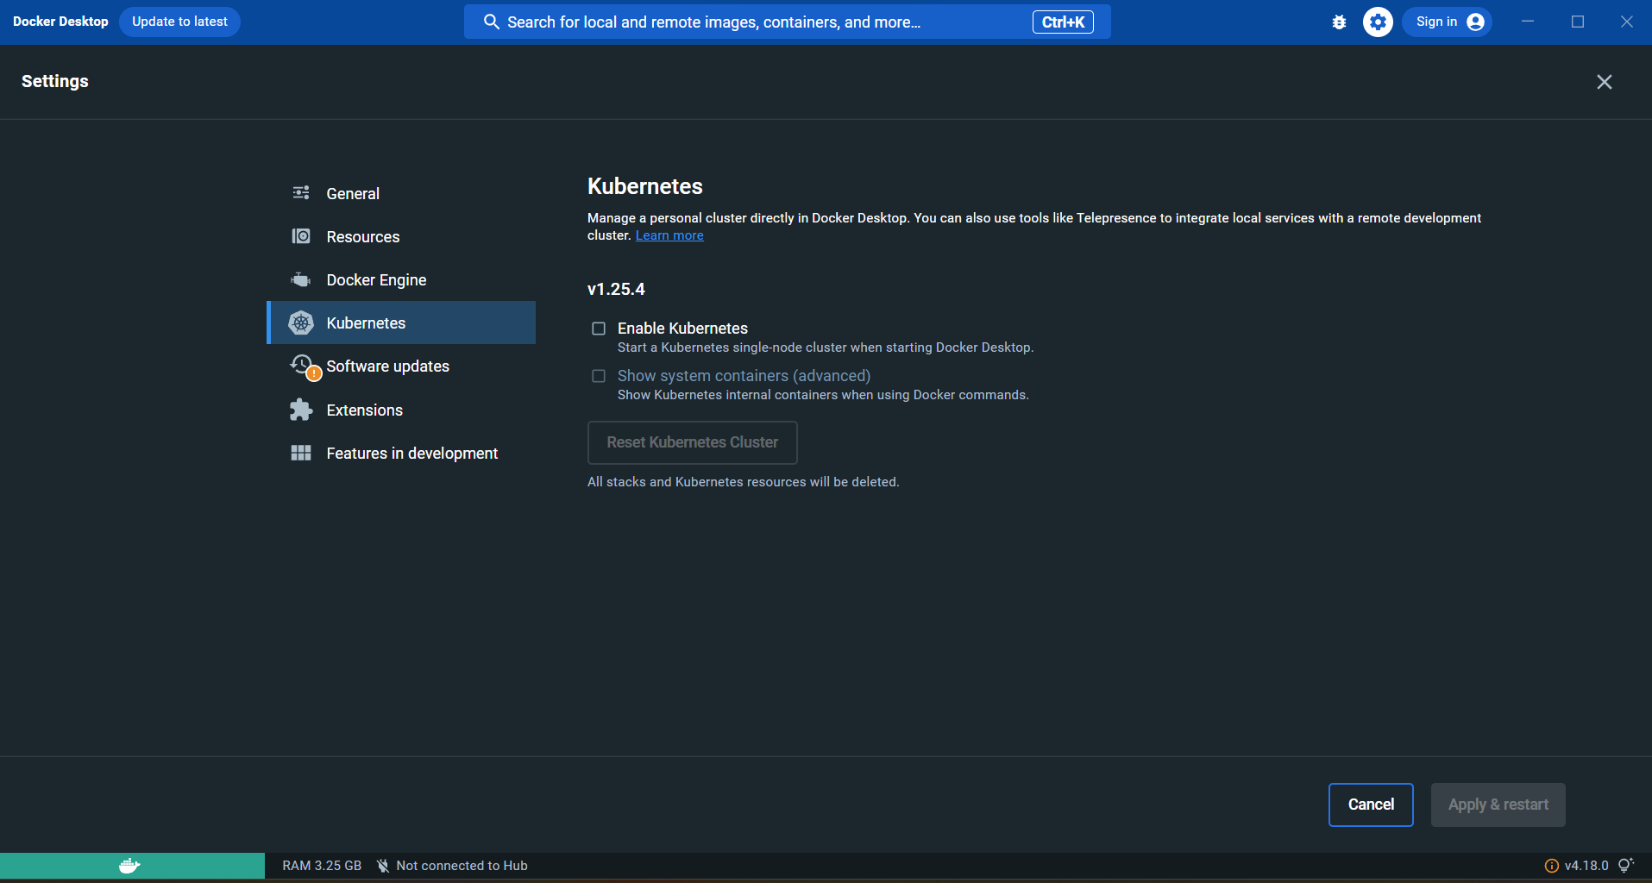

Enable kubernetes

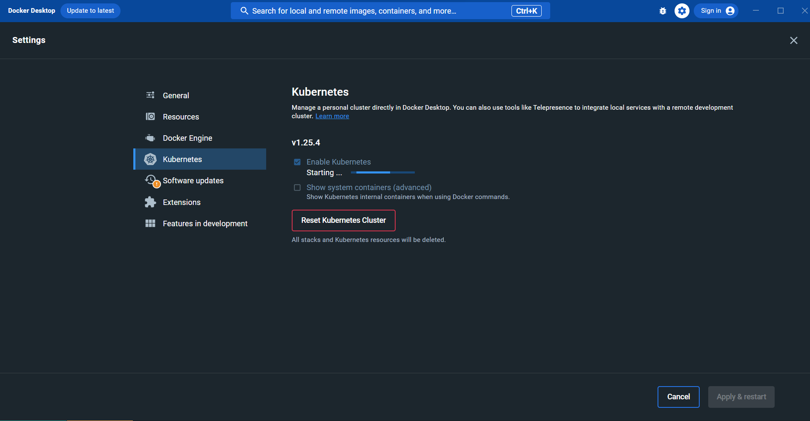

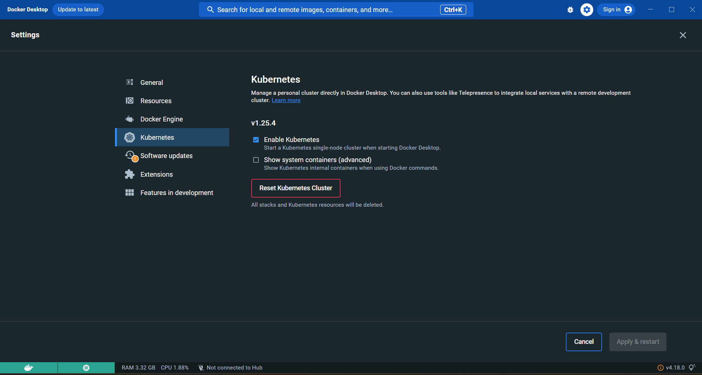

The command "**minikube version**" is used to check the version of the Minikube tool installed on your local machine.



**minikube start** is a command used to start a single-node Kubernetes cluster locally on your machine using Minikube.

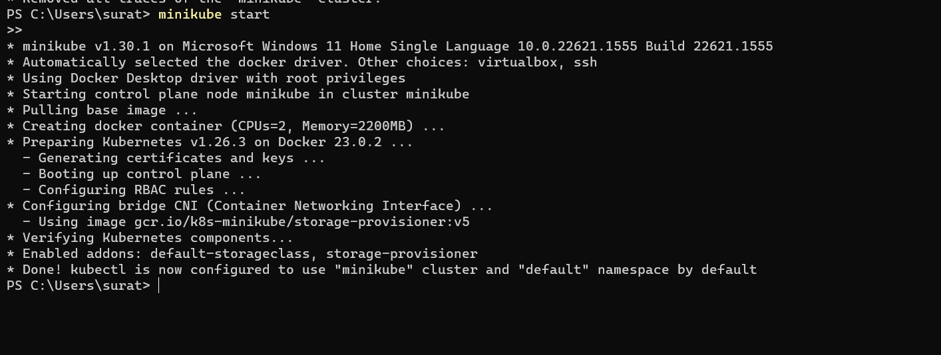

The command "**kubectl get nodes**" is used to retrieve information about the nodes in a Kubernetes cluster. It lists the names, status, roles, age, version, and any labels assigned to each node.

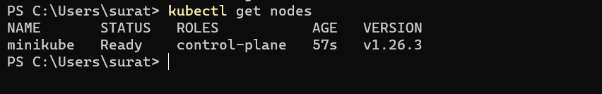

The "**kubectl get services**" command is used to list all the services in the currently active Kubernetes context



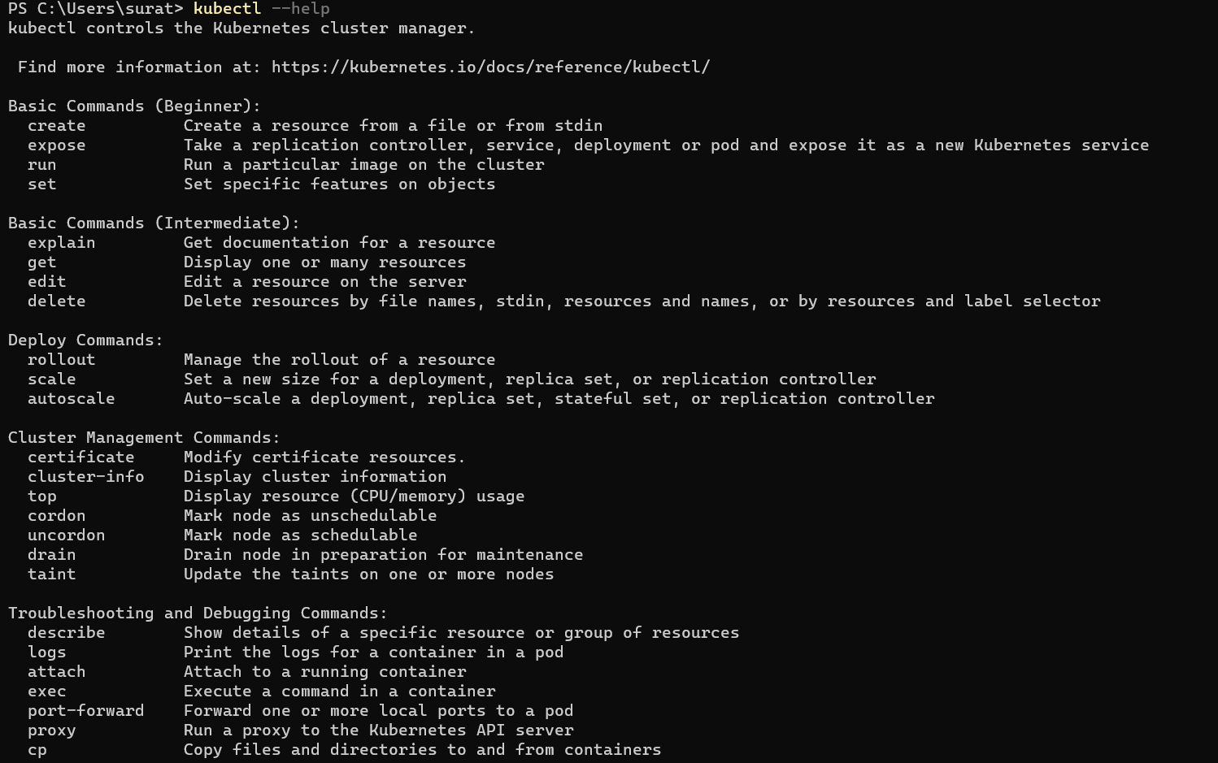

The **'ls'** command is used to list files and directories.

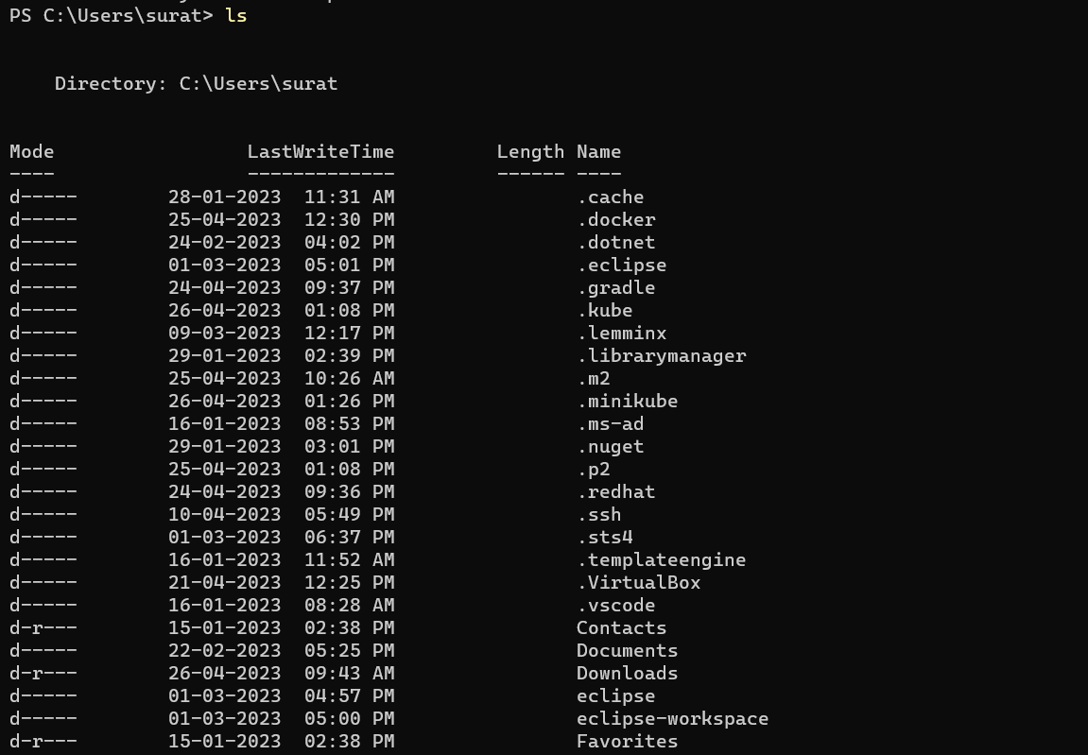

The **kubectl get pods --all-namespaces** command is used to list all the pods in all the namespaces of a Kubernetes cluster. This command can be useful for getting an overview of all the pods running in a cluster

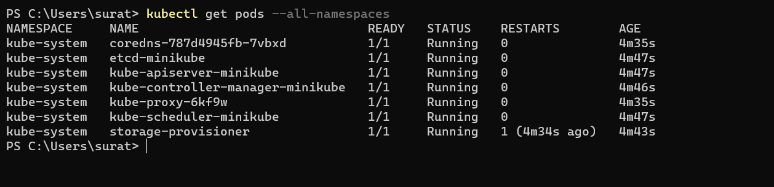

The **kubectl get svc** command will list all the services in the default namespace.



The command "**kubectl get all**" is used to retrieve information about all resources of all types in a Kubernetes cluster. This includes information about pods, services, deployments, replicasets



The command "**kubectl get pod -o wide**" is used to list all the pods in the current Kubernetes namespace, along with additional information about each pod's status, such as the pod's IP address, node name, and the node's internal IP address.



The "**kubectl cluster-info**" command is used to retrieve information about the Kubernetes cluster that the current context points to. This command provides the cluster endpoint, namespace, and authentication information.



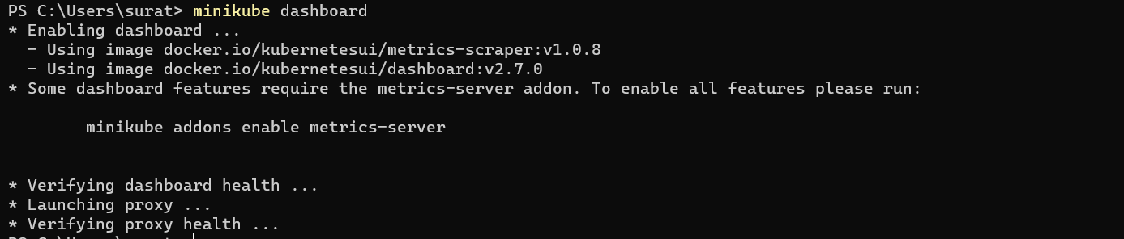

The command "**kubectl create deployment nginx -depl --image=nginx**" creates a deployment named "nginx" with the image "nginx" using the Kubernetes command-line tool "kubectl".

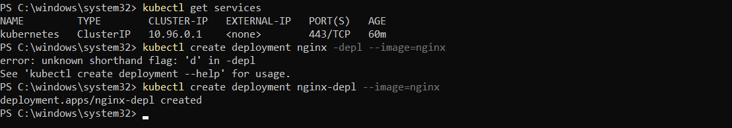

The **kubectl get deployment** command is used in Kubernetes to retrieve information about the deployments that are currently running in the cluster.





The "**kubectl get replicaset**" command is used to retrieve information about the ReplicaSets in a Kubernetes cluster



The **kubectl create deployment** command is used to create a new deployment in a Kubernetes cluster. The command creates a new deployment with the specified name and container image.





The command "**kubectl exec -it mongo-depl-5ccf565747-wm4w5 -- bin/bash**" is used to launch an interactive shell session in a container running in a Kubernetes cluster.

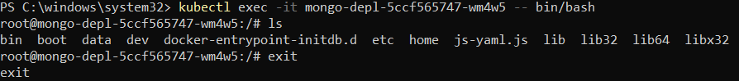

The command "**kubectl logs mongo-depl-5ccf565747-wm4w5**" is used to view the logs of a container running in a Kubernetes cluster.

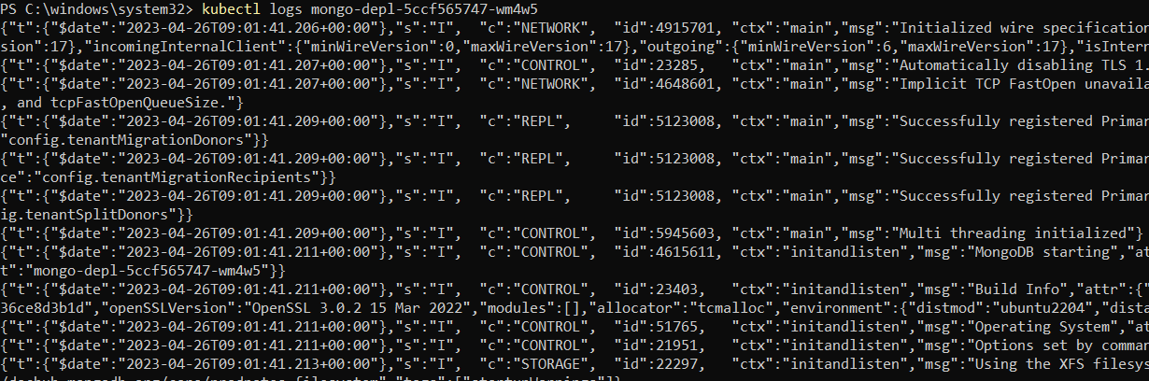

**To Delete the deployment**

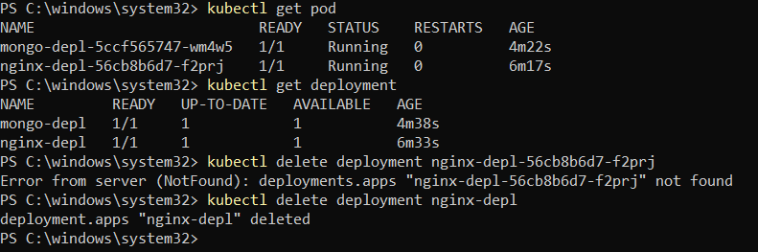

**minikube dashboard** is a web-based user interface that provides a graphical representation of your local Kubernetes cluster.



**Minikube dashboard**

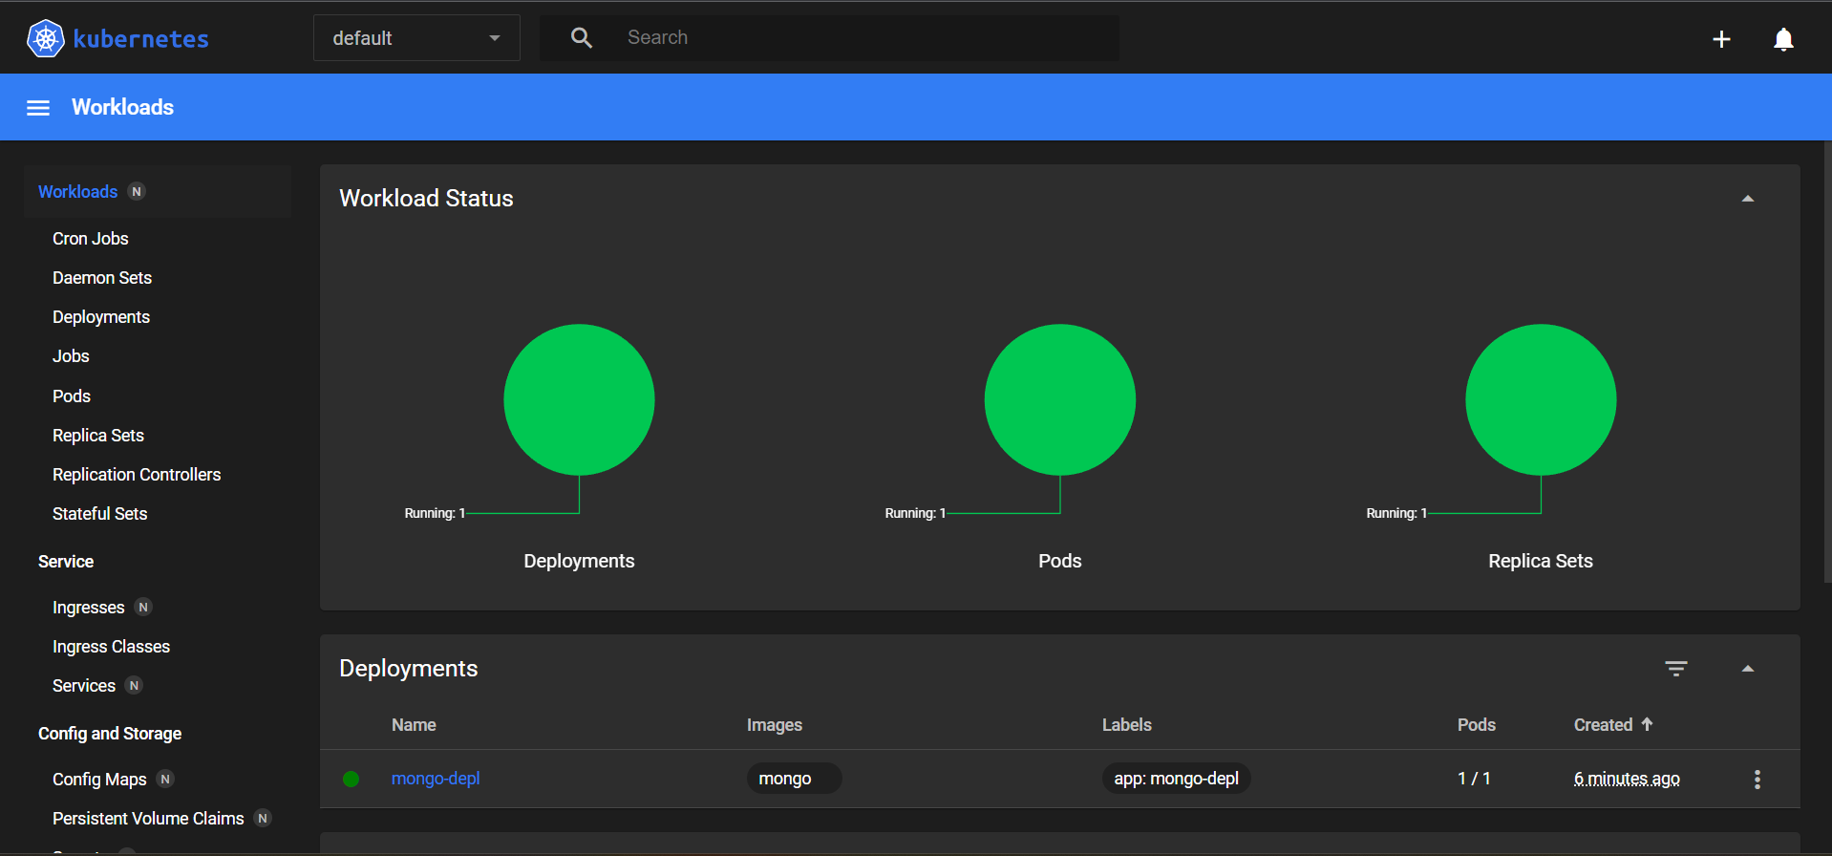

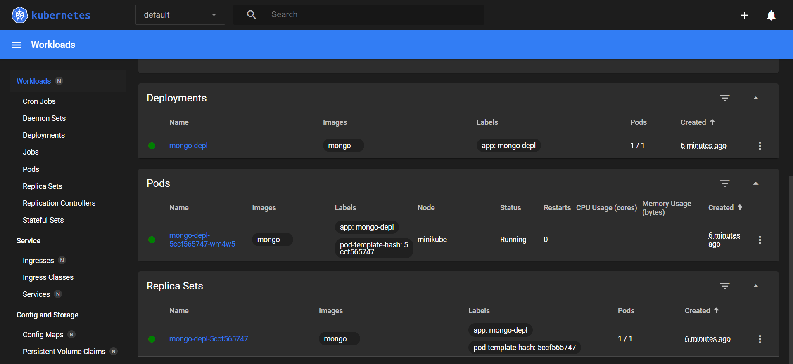

**Docker Desktop**

