1. **Create a "repository" (project) with a git hosting tool (like Github)**

Steps Perform:

1. Created a repository named as Infobell_Project on github
2. Then added a txt file to it named as NewFile

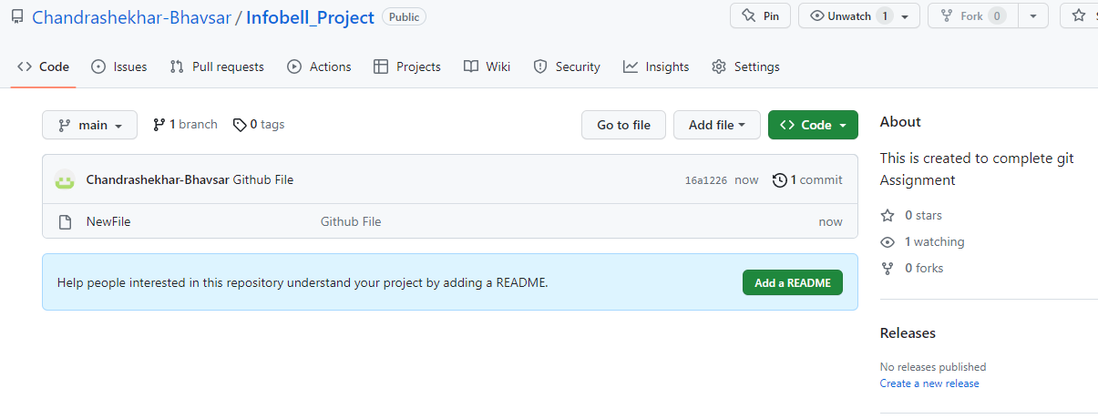

1. **Copy (or clone) the repository to your local machine**

Steps Perform:

1. Configured username and user email id using git config
2. Then initiated repository using remote repository
3. Cloned remote reporsitory to local using git clone command

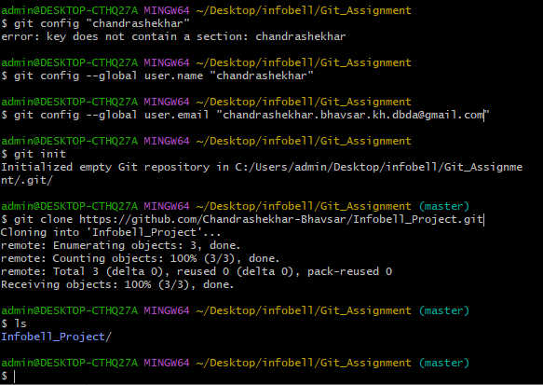

1. Add a file to your local repo and "commit" (save) the changes

Steps Perform:

1. Added a file in local repository
2. Then committed this file using git commit command

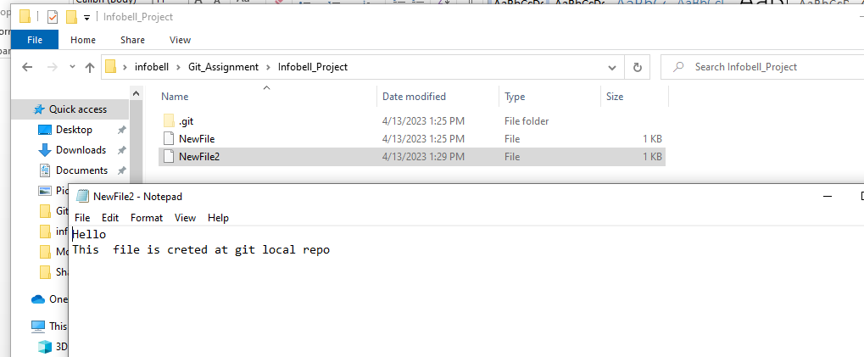

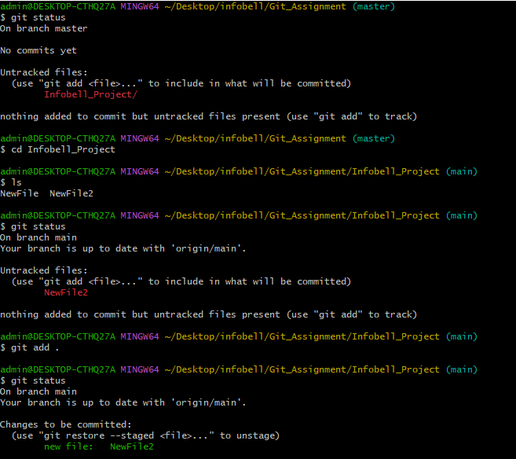

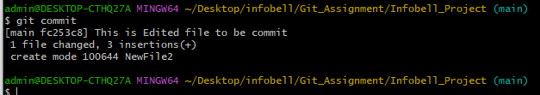

1. "Push" your changes to your main branch

Steps Perform:

1. Pushed this file to remote repository using git push command

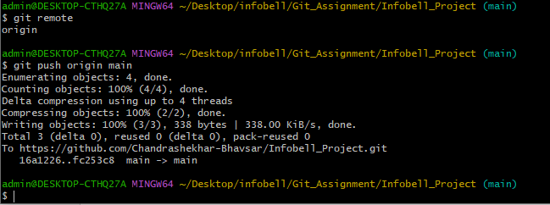

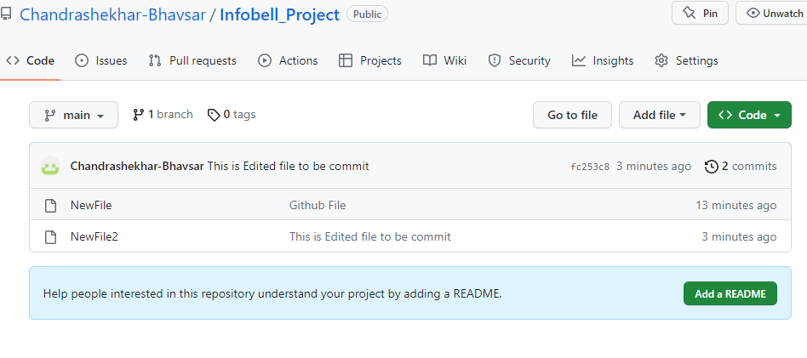

1. Make a change to your file with a git hosting tool and commit

Steps Perform:

1. Edited file in github and made changes committed

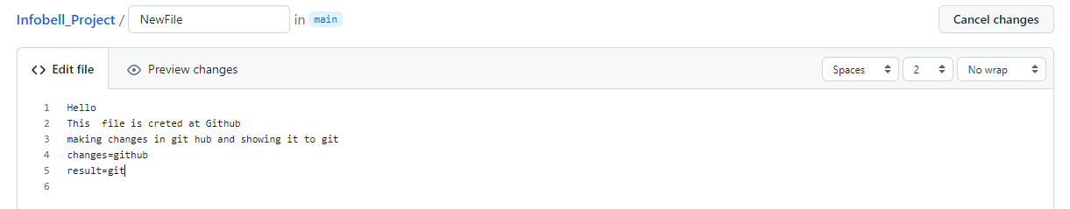

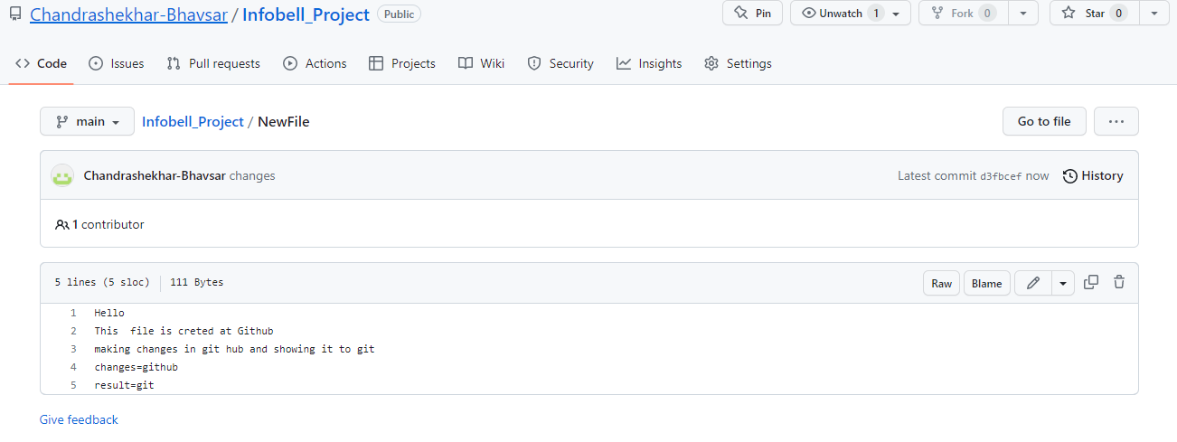

1. "Pull" the changes to your local machine

Steps Perform:

1. now to see edited file is pulled from remote repository to local using git pull command
2. To see changes I used cat command which is displaying inside file content

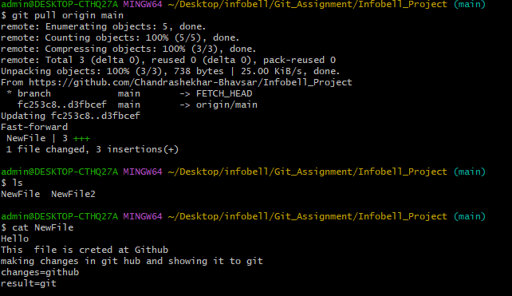

1. Create a "branch" (version), make a change, commit the change

Steps Perform:

1. Created a new branch named as New Branch
2. To see changes I used cat command which is displaying inside file content

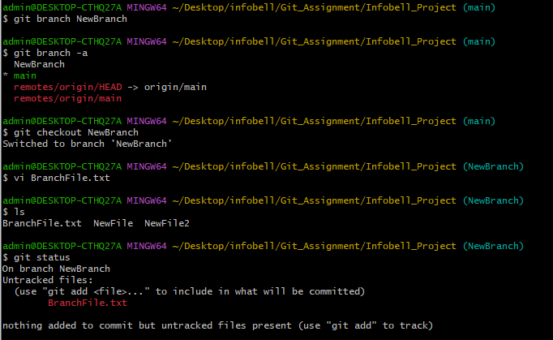

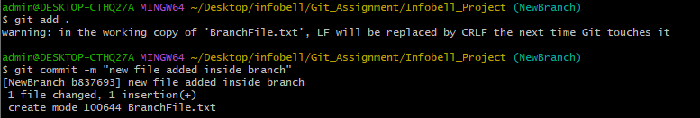

1. Open a "pull request" (propose changes to the main branch)

Steps Perform:

1. To create pull request branch is pushed to remote repository
2. To push branch I have used command git push

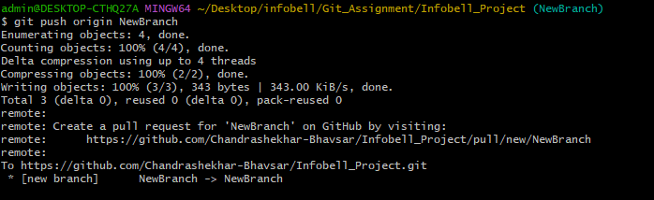

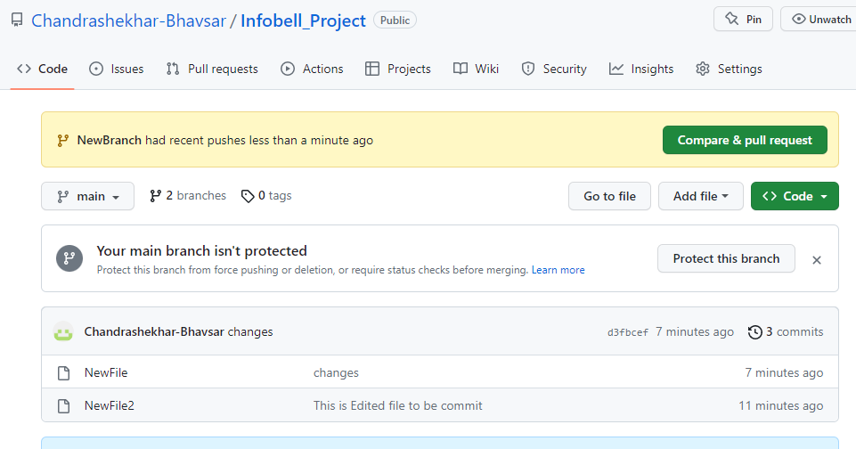

1. Resolve review comments

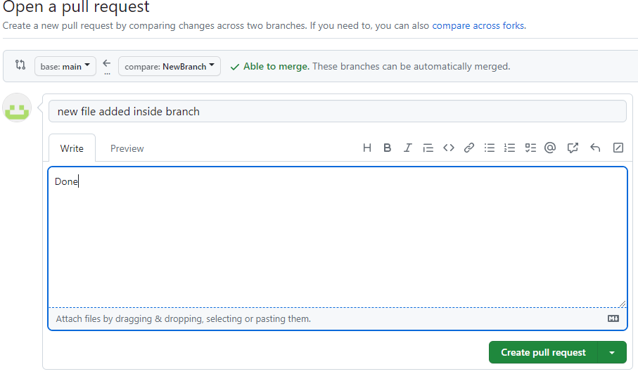

1. "Merge" your branch to the main branch & Resolve conflicts.

