### A PROJECT REPORT

**ON**

***IoT Based Safety, Monitoring and Alerting system for Mines***

Submitted by

**Sonar Pranav Mahendra (GL)**

**Thakur Pooja Ajay**

**Yemul Chandrashekhar Raju**

Under the guidance of

## Mr. K. R. Biradar

## 

**ELECTRONICS AND TELECOMMUNICATION ENGINEERING,**

**WALCHAND INSTITUTE OF TECHNOLOGY,**

**SOLAPUR**

**2022-23**

# CERTIFICATE

This is to certify that project report entitled

***IoT Based Safety, Monitoring and Alerting system for Mines***

Submitted by

|  |  |  |
| --- | --- | --- |
| **Sr. No.**  1 | **Name**  Sonar Pranav Mahendra | **Exam Seat No.**  194091 |
| 2 | Thakur Pooja Ajay | 194156 |
| 3 | Yemul Chandrashekhar Raju | 194394 |

has been approved as the partial fulfillment for the award of ‘Bachelor of Electronics and Telecommunication Engineering’ by **Punyashlok Ahilyadevi Holkar Solapur University, Solapur** in the academic **year 2022-23**.

### Mr. K. R. Biradar Dr. Ms. A. V. Thalange

### Project Guide Head, E&TC Engg.

**Dr V. A. Athavale PRINCIPAL**

**ELECTRONICS AND TELECOMMUNICATION ENGINEERING WALCHAND INSTITUTE OF TECHNOLOGY,**

**SOLAPUR 2022-23**

# ACKNOWLEDGEMENT

The project has certainly enlightened us with the modern era of technologies & it has boosted our confidence. The project work has certainly rendered us tremendous learning as well as practical experience.

We are thankful to **Dr V. A. Athavale**, Principal of Walchand Institute of Technology, Solapur, **Dr. Ms. A. V. Thalange**, Head of Electronics and Telecommunication Engineering for granting permission to undertake this project.

We are very grateful to **Mr. K. R. Biradar** for her valuable guidance about Software implementation and Programming.

At last, but not least we are thankful to the staff of the Electronics and Telecommunication Engineering of Walchand Institute of Technology, Solapur.

# INDEX

|  |  |  |  |
| --- | --- | --- | --- |
| **Chapter No.** | **Sub No.** | **Name of Chapter** | **Page No.** |
|  |  | Abstract | 5 |
| Chapter 1 |  | Introduction | 6 |
|  | 1.1 | Introduction | 6 |
|  | 1.2 | Purpose of the project | 7 |
| Chapter 2 |  | Literature Survey | 8 |
|  | 2.1 | Literature Survey | 8 |
|  | 2.2 | Problem Statement | 9 |
|  | 2.3 | Objectives | 10 |
|  | 2.4 | Scope of the project | 10 |
| Chapter 3 |  | System Description | 11 |
|  | 3.1 | System Description | 11 |
|  | 3.2 | Conversion Flow Diagram | 13 |
|  | 3.3 | Details of methodology | 15 |
| Chapter 4 |  | Software and Hardware Components | 17 |
|  | 4.1 | Software Components | 17 |
|  | 4.2 | Hardware Components | 18 |
|  | 4.3 | Circuit Layout | 23 |
| Chapter 5 |  | Advantages, Disadvantages and Applications | 25 |
| Chapter 6 |  | Result and Conclusion | 27 |
|  | 6.1 | Result | 27 |
|  | 6.2 | Conclusion and Future Scope | 28 |
| Chapter 7 |  | Budget Details | 30 |
| Chapter 8 |  | Bibliography | 31 |

**List of figures**

|  |  |  |
| --- | --- | --- |
| **Figure**  **No.** | **Title Of Figure** | **Page No.** |
| 3.1 | Block Diagram | 11 |
| 3.2 | Flow Diagram | 13, 14 |
| 3.3 | Circuit Layout | 22,23 |

**ABSTRACT**

IoT-based coal mine monitoring and alerting system using Arduino as a tool to enhance the safety and efficiency of mining operations. The methods employed involve installing sensors on a wearable device to capture crucial parameters such as temperature, humidity, gas levels, and flame. These sensors are connected to Arduino boards, enabling data collection and transmission via ZigBee technology to a central hub or gateway. The data is then analyzed and monitored in real-time. The results of the study demonstrate that the wearable device is configured to send alerts to the control unit when any of the parameters exceed pre-set thresholds. A piezoelectric buzzer is employed to promptly alert the control unit, enabling swift response and necessary actions to safeguard the workers. The significance of this study lies in the remote monitoring and management capabilities offered by the IoT-based system. It enables continuous monitoring of the mine environment and workers' safety, while also generating real-time alerts on potential hazards or issues. This aids mining companies in accident identification and prevention, ultimately enhancing the overall safety and efficiency of mining operations.

**Keywords**: IoT-based system, coal mine monitoring, Arduino, safety, efficiency, wearable device, real-time alerts, remote monitoring.

## CHAPTER 1: INTRODUCTION

### Introduction:

The mines are the world's most dangerous mining operation, with thousands of workers dying each year as a result of massive explosions. According to a recent study, in such mining incidents, an estimated 12,000 people have died on average. Coal is a non-human resource that can be converted; there are a few problems in the mines; and workers risked their lives by working in coal mines; and, unfortunately, some miners end up losing their lives in coal mines. Often, such problems arise as a result of outdated technology, the final result being the mismanagement and spillage of toxic gases in coal mines poses a serious threat to archaeologists, underground operation. The eight deadliest mines in history have occurred in China. Liaoning eruption kills 210 people, Guangdong floods kill 123 people, Xinjiang eruption kills 83 people, Shanxi eruption kills 72 people in 2015. A coal explosion at the Honkeiko Colliery in China killed 1,549 miners, making it one of the most dangerous mining disasters in history. As a result, the importance of safety for mine workers in recent days, monitoring mine employees in underground mines has become extremely challenging. Internet of Things (IOT) is a set of gadgets(objects) connected to the net. IOT implementation varies substantially on a massive scale. Internet of Things Europe group has most essential IOT gadgets. Clever apps, clever power, enterprise, fitness, and clever cities as a whole encompass smart housing, smart transportation, and clever housing to call a few nets of things (IOT) is a sport-changing invention in which all sensory records are stored within the cloud and accessed fast.

#### Purpose of Project:

Safety is the most important aspect of any industry. Safety and security are extremely important in the mining business. To avoid mishaps, the mining sector takes several fundamental safeguards. Temperature rises, water levels rise, and methane gas leaks continue to cause accidents in underground mines. It ensures worker safety here. When a worker is in danger, it can use the panic button to alert security. To improve underground mine safety, a reliable communication system between subterranean mine workers and the fixed ground mining system must be built. The verbal exchange community cannot be disrupted at any time or under any occasions. This suggestion proposes a low-free Zigbee-based totally wireless mine surveillance device with early-caution intelligence. The reputation of employees may be tracked via IOT.

## CHAPTER 2: LITERATURE SURVEY

### Literature Survey:

* Yongping Wu and Guo Feng use the Bluetooth wireless transmission system to track coal mines. Bluetooth technology would develop a popular power efficient, cheaper wireless air interface and controlling software opening framework as a single global short-range wireless communication standard. This paper discusses the context of Bluetooth technology’s growth, as well as the technological features and layout of the protocol stack, and proposes solutions for the wireless communication of Bluetooth host controller interface (HCI) in development convolution. Simultaneously, the device employs mature CAN bus technology and has realized the integration of wired and wireless data. device of transmission the biggest challenge with this device is that Bluetooth is a short-range wireless technology that makes cabling difficult. The cabling is broken while a catastrophe or a roof disintegrate occurs. As a result, traditional communication systems are unreliable and have a short lifespan. The construction and maintenance of the equipment became difficult due to the rasping climate in the mine.
* Tanmoy Maity and Partha Sarathi Das use Zigbee to build a wireless monitoring and safety device for workers in the mine. This device aims to provide a cost-effective and adaptable solution for the safety of underground mine workers. A microcontroller is used to collect data and make decisions, after which mine workers are notified via alarm and voice system. The voice-based notification system including a speaker and a microphone transforms the collected information into a digital signal and communicates wirelessly with the ground control station. For the short-distance communication between the miner's equipment and the ground control station, a ZigBee based short-range wireless network, is used to notify relevant departments.

### Problem Statement:

In the mining industry, safety and security is a fundamental aspect of everything. To avoid any types of accidents, the mining industry follows some basic precautions. Accidents such as rise in temperature, increased water level, and methane gas leakage. The mining industry involves many dangerous activities and processes that require careful attention to safety and security. This is because mining operations can involve working with heavy machinery, drilling and blasting, and handling hazardous materials, all of which can pose significant risks to workers if proper precautions are not taken. One of the key safety concerns in the mining industry is the risk of accidents such as fires and explosions. These types of incidents can be caused by a number of factors, including a rise in temperature, increased water levels, and methane gas leaks. Overall, safety and security are fundamental aspects of the mining industry.

### Objectives:

Mining environment often has hidden dangers within such as toxic gases, which may present severe health exposures to the people working within mining. These gases need to be detected at times and informed the dangerous situation in right time for the safety of miners. Wired network monitoring systems have assisted the mine safety significantly, but it is not idea for all types of mining environment. A real-time monitoring system may assist in monitoring and control over the mining environment. Zigbee technology offers its most of the advantages ideal for the real-time monitoring system. Thus, the primary objective of this project is decided to design an efficient real-time monitoring system so that various leaked mine gases could be identified at times and preventive measures could be devised accordingly. Our objective in designing this system is as follows:

* Detection of different toxic gases and other factors within mining environment
* Communication establishment between sensors and Zigbee
* Establishment of Wireless Sensor Network
* Design of a real-time monitoring system

### Scope of Project:

With the development of this model, future work of this experimentation may incorporate, greater improvement of the framework by utilizing other progressed sensors for checking the underground dangers. Likewise, every one of the underground tasks can be monitored from the beginning. New creating correspondence advancements can be utilized for fast information move in a mix with keen sensors for detecting the mine conditions. Additionally, more IOT-empowered frameworks can be created for further developed uses.

## CHAPTER 3: SYSTEM DESCRIPTION

### System Description:

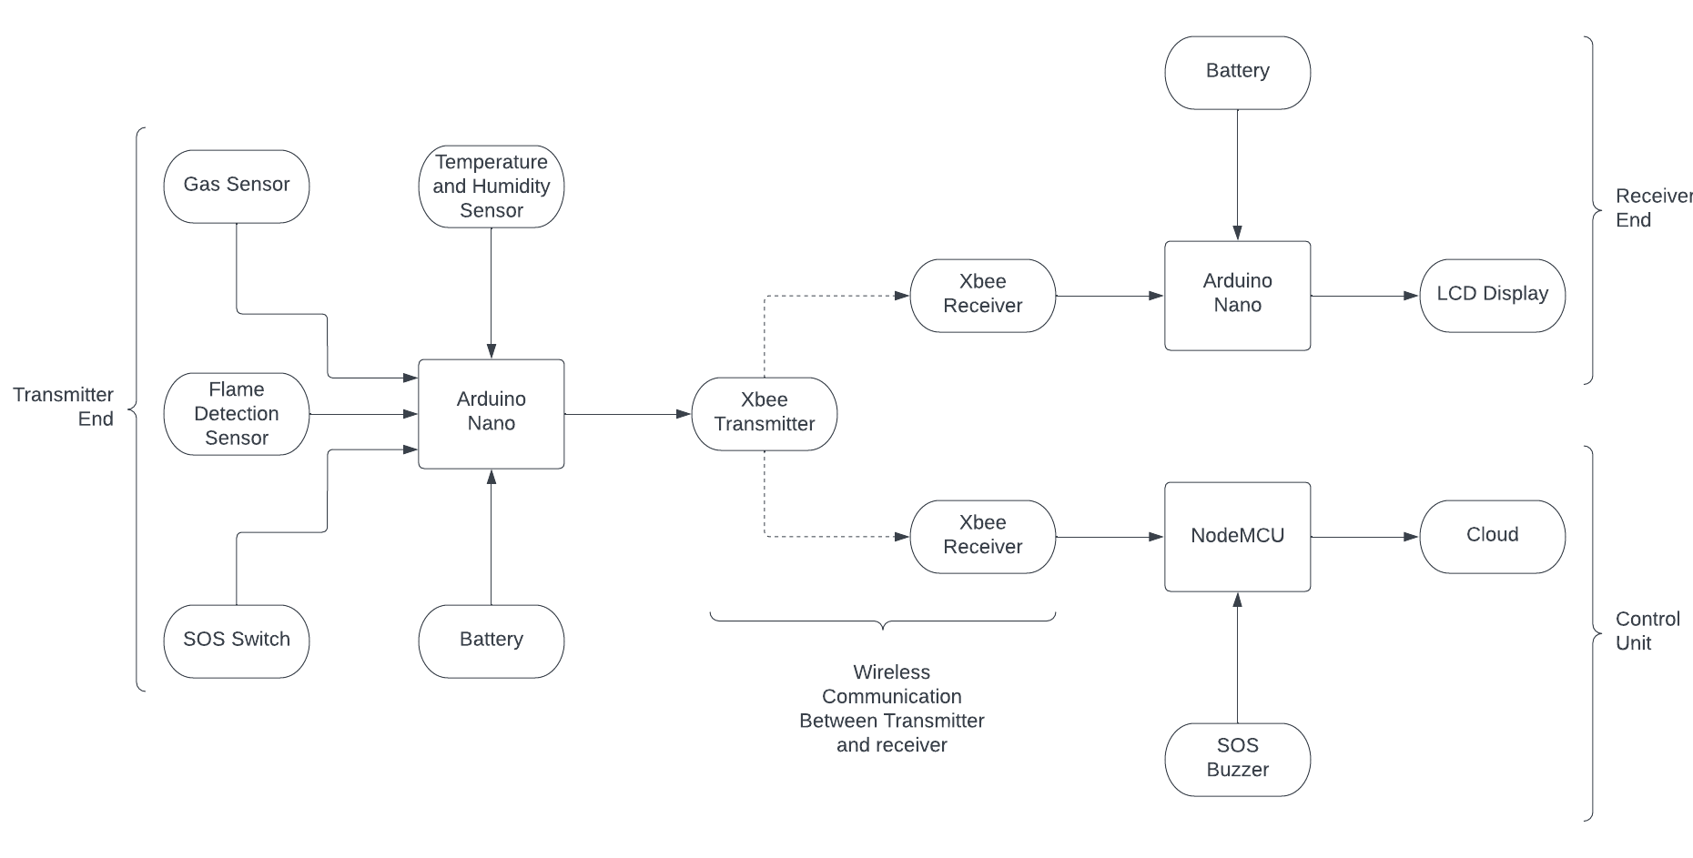

Fig 1. Block Diagrammatic Representation

An IoT-based coal mine monitoring and alerting system using Arduino can be a useful tool for improving the safety and efficiency of mining operations. Such a system can be designed to monitor various parameters, such as temperature, humidity, gas levels and then send alerts if any of these parameters exceed pre-set thresholds.

1. Sensors are installed on a wearable device to capture various parameters, including temperature, humidity, gas levels, and flame. These sensors can be linked to Arduino boards, which facilitate data collection and transmission to a central hub or gateway using ZigBee technology.
2. The data from the sensors is transmitted to the central hub or gateway, which is connected to the network. This allows the data to be analyzed and monitored in real-time.
3. The wearable device is configured to send alerts if any of the parameters exceed pre-set thresholds. For example, if the temperature exceeds a certain level, or if there is a sudden increase in gas levels, an alert can be sent to the control unit
4. Furthermore, we have used a piezoelectric buzzer to alert the control unit. This enables them to quickly respond to any potential hazards and take the appropriate action to protect the workers.
5. The data can also be used to generate reports, analyze trends, and help optimize mining operations. It can be used to identify patterns that may indicate maintenance needs or areas of the mine that require increased safety precautions.
6. The advantage of using an IoT based system is that it allows for remote monitoring and management of the mine operations, enabling the monitoring of mine environment, workers' safety, and to generate real-time alerts on any potential hazards or issues. This can help mining companies to identify accidents and prevents casualties ultimately improve the overall safety and efficiency of mining operation.

### 3.2 Conversion Flow Diagram:

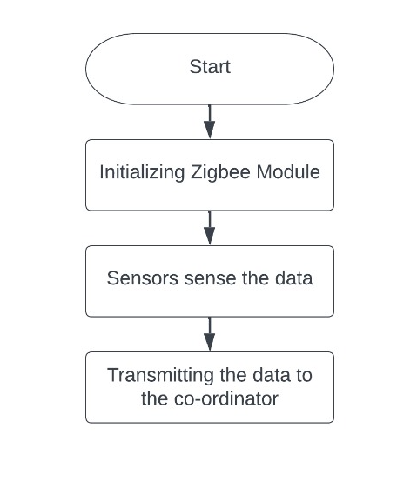

Flow Chart for Transmission End

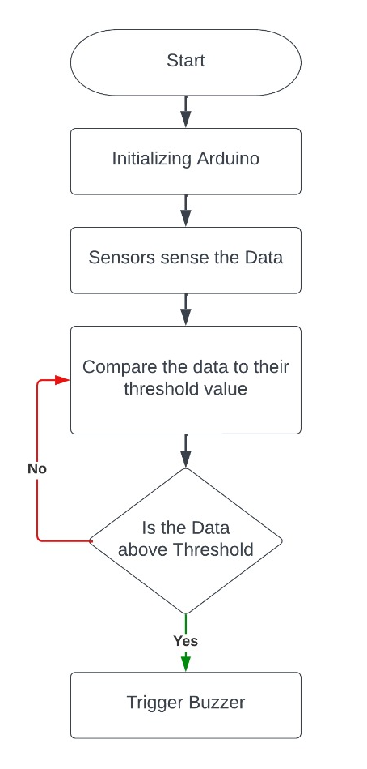

Flow Chart of Monitoring system for Sensor unit

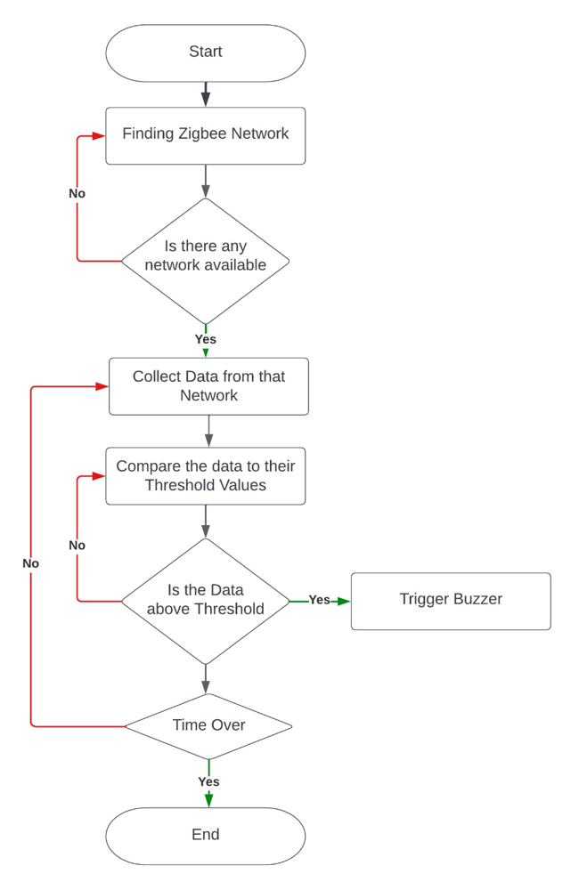

Flow Chart for Alerting system

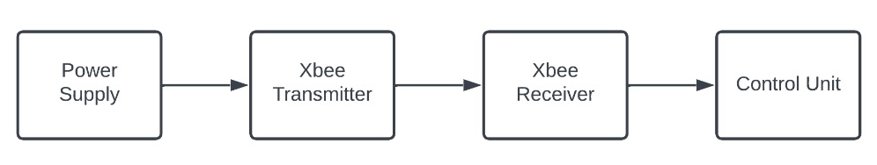

Flow Chart for Control Unit

## Details of Methodology:

* One of the major challenges faced by workers in underground mines is ensuring their safety in a hazardous environment. To address this issue, we have developed a wireless wearable working unit that is specifically designed to enhance the safety of workers within the mining industry. This unit consists of three main components: the transmitter, receiver, and main control unit. The transmitter is equipped with various sensors that monitor the working environment. The receiver is installed at multiple locations throughout the mining site to receive and transmit the data from the transmitter. The main control unit, which is located outside the mine, analyzes the data and alerts the workers and supervisors in case of any emergency. Figure 1 shows the block diagram of our wireless wearable working unit, which illustrates how the sensors and the transmitter Xbee are integrated.
* The Arduino NANO microcontroller serves as the central hub for receiving and processing the sensed values from the various sensors. These values are then transmitted to the designated receiver for further analysis and action. If the mining parameters surpass predetermined threshold levels, an immediate alert message is dispatched to the control room, enabling swift response and intervention. Furthermore, in the event of detecting any presence of flames, an audible alarm in the form of a buzzer is activated, promptly notifying and safeguarding the workers within the mining unit.
* The safety system is fortified with essential sensors, including the DHT11 Temperature and Humidity sensor, the Flame sensor, and a Gas sensor. These sensors play a vital role in monitoring the physical parameters of the mining unit, parameters that are inherently challenging for human beings to predict accurately. By continuously monitoring these parameters, our system provides early warnings and critical information to mitigate potential risks and hazards.
* The Arduino-based mine safety system integrates multiple sensors, each connected to dedicated controllers. The sensed values obtained from these sensors are seamlessly transmitted to a mobile application via the Node MCU platform, utilizing the efficient Xbee communication protocol. This comprehensive approach empowers workers to leverage a range of monitoring and control systems, significantly enhancing overall working conditions. Through the automation of environmental parameters such as temperature, humidity, and the presence of hazardous gases, the system proactively safeguards the lives and well-being of workers safety of the coal mine workers.
* The design of our system incorporates cutting-edge IoT (Internet of Things) technology, leveraging an Android device, a main controlling unit (MCU), a suite of sensors for measuring various parameters, and an alert system. This intelligent integration ensures the utmost security for workers operating within the mining industry, providing a reliable and comprehensive solution to address their safety needs.

## CHAPTER 4: SOFTWARE AND HARDWARE COMPONENTS

## 

* 1. **SOFTWARE COMPONENTS:**
* **C Language:**

Arduino is an open-source hardware and software platform that is commonly used for building electronics projects. The Arduino Integrated Development Environment (IDE) is a software application that is used to write and upload code to the Arduino board. The Arduino language is based on C/C++, and it includes a set of libraries that provide functions for interacting with the hardware of the board. To write a program for the Arduino board, you will need to use the Arduino language, which is a variant of C++. You can write code in the Arduino IDE using the Arduino language, or you can write code in a separate text editor and then use the Arduino IDE to compile and upload it to the board. In the Arduino language, you can use C/C++ language constructs such as variables, loops, and functions to write code that interacts with the hardware of the board. You can also use the Arduino libraries to access the board's peripherals, such as its input/output pins, serial communication ports, and analog-to-digital converters.

* **Open source IoT platform Blynk Software:**

Blynk Cloud is open-source. Blynk is an Internet of things (IoT) company that provides a platform for building mobile (IOS and Android) applications that can connect electronic devices to the Internet and remotely monitor and control these devices. Blynk platform is used by engineers to connect MCUs and prototyping development boards like Arduino, ESP8266, or SBCs like Raspberry Pi over Wi-Fi, Ethernet, or the cellular to the Internet and build custom mobile applications to remotely monitor and control.



Fig 2. Blynk Software

## HARDWARE COMPONENTS:

* **Zigbee:**

Zigbee is a wireless communication technology that is used for connecting low-power devices over short distances. It is a popular choice for building networks of connected devices, also known as IoT (Internet of Things) networks. Zigbee is often used in a variety of applications, including home automation, smart energy management, and industrial automation. Some examples of devices that might use Zigbee include smart thermostats, smart light bulbs, smart outlets, and sensors for monitoring temperature, humidity, and other environmental conditions. One of the main advantages of Zigbee is its low power consumption, which makes it well-suited for use in battery-powered devices. It is also relatively low-cost, easy to use, and has a robust set of features that support networking and security. Zigbee operates in the 2.4 GHz frequency band, which is the same band used by other wireless technologies such as Wi-Fi and Bluetooth. However, Zigbee uses a different set of protocols and has a different set of characteristics that make it well-suited for IoT applications.

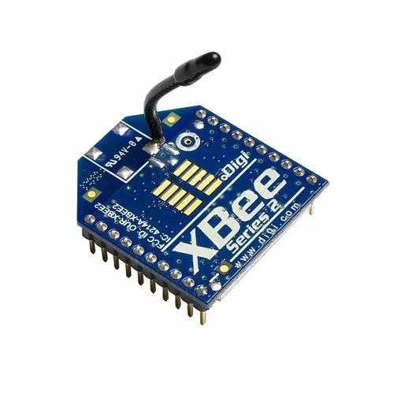

Fig 3. Xbee S2C

* **Arduino nano:**

Arduino nano is an open-source electronics platform based on easy-to-use hardware and software. It is intended for artists, designers, hobbyists, and anyone interested in creating interactive objects or environments. The Arduino platform consists of a series of microcontroller boards and a software development environment (IDE) that runs on your computer. The microcontroller boards are programmed using the Arduino programming language, which is based on C++. The Arduino boards have a variety of inputs and outputs (I/O) that allow you to connect sensors, actuators, and other devices to them. They can be used to control motors, lights, and other devices, or to read data from sensors like temperature, humidity, and pressure. To get started with Arduino, you'll need to purchase a microcontroller board and install the Arduino IDE on your computer. You can then connect the board to your computer using a USB cable, and use the IDE to write and upload code to the board. There are many different types of Arduino boards available, including the Arduino Uno, Arduino Mega, and Arduino Nano. Each board has its own set of features and capabilities, so you'll want to choose the one that best meets your needs. Once you have your board and the IDE installed, you can start exploring the many projects and tutorials available online to help you get started with Arduino.

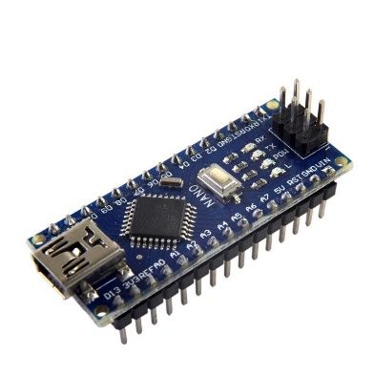

Fig 4. Arduino Nano

* **Sensors:**
* **Temperature and humidity sensor:**

The DHT11 is a basic, low-cost digital temperature and humidity sensor. It uses a capacitive humidity sensor and a thermistor to measure the surrounding air, and spits out a digital signal on the data pin (no analog input pins needed).

### ****Specifications****

* Operating Voltage: 3.5V to 5.5V
* Operating current: 0.3mA (measuring) 60uA (standby)
* Output: Serial data
* Temperature Range: 0°C to 50°C
* Humidity Range: 20% to 90%
* Resolution: Temperature and Humidity both are 16-bit
* Accuracy: ±1°C and ±1%

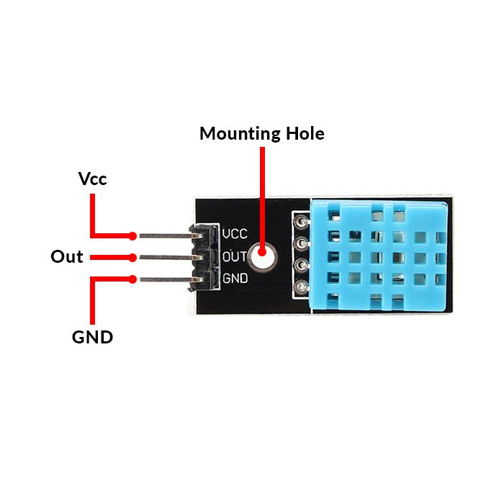

Fig 5. DHT11

* **Gas Sensors (MQ5):**

MQ5 gas sensors are widely employed in gas leakage detection systems, industrial safety monitoring, and gas concentration measurement in residential and commercial settings. They are compatible with microcontrollers like Arduino and can be integrated into IoT systems for real-time monitoring and alerting in case of gas leaks or hazardous gas levels.

### ****Specifications****

* Power: 2.5V ~ 5.0V
* Dimension: 40.0mm * 21.0mm
* Mounting holes size: 2.0mm

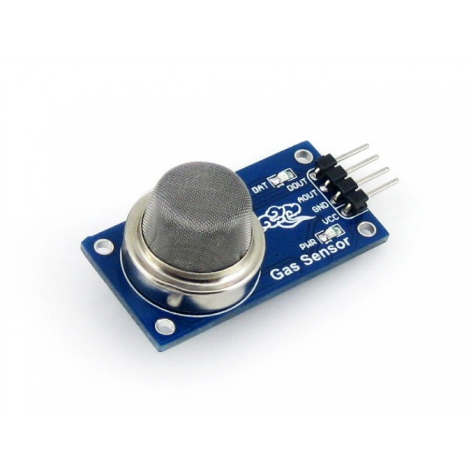

Fig 6. MQ5

* **Flame sensor:**

A flame sensor is a device that detects the presence of a flame or fire. It is commonly used in fire alarm systems, industrial boilers, and other applications where the detection of a flame is important for safety or process control.

### ****Specifications****

* Spectrum range: 760nm ~ 1100nm
* Detection angle: 0 - 60 degree
* Power: 3.3V ~ 5.3V
* Operating temperature: -25℃ ~ 85℃
* Dimension: 27.3mm * 15.4mm
* Mounting holes size: 2.0mm

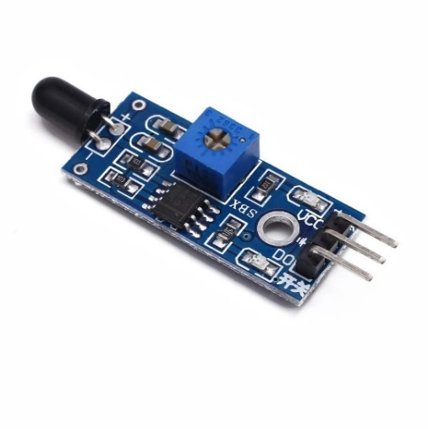

Fig 7. Flame Sensor

* **Buzzer:**

A piezoelectric buzzer is a type of electromechanical device that converts electrical energy into mechanical motion and sound. It consists of a piezoelectric element, which is a material that generates an electric charge in response to applied mechanical stress, and a thin metal diaphragm that vibrates to produce sound.

### ****Specifications****

* Rated Voltage: 6V DC
* Operating Voltage: 4-8V DC
* Rated current: <30mA
* Sound Type: Continuous Beep
* Resonant Frequency: ~2300 Hz

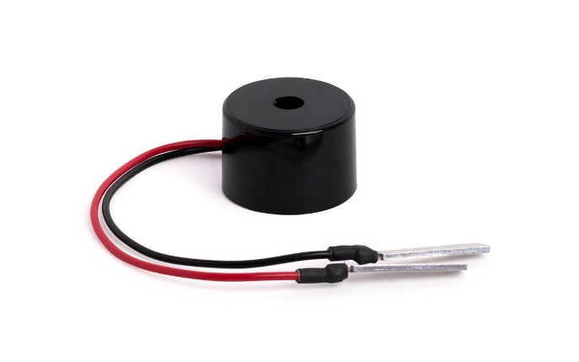

Fig 8. Buzzer

* **PCB:**

Zero PCB is basically a general-purpose printed circuit board (PCB), also known as perfboard or DOT PCB. It is a thin rigid copper sheet with holes pre-drilled at standard intervals across a grid with 2.54mm (0.1-inch) spacing between holes. Each hole is encircled by a round or square copper pad so that component lead can be inserted into the hole and soldered around the pad without short-circuiting the nearby pads and other leads. For connecting the lead of component with another lead, solder these together or join these using a suitable conducting wire.

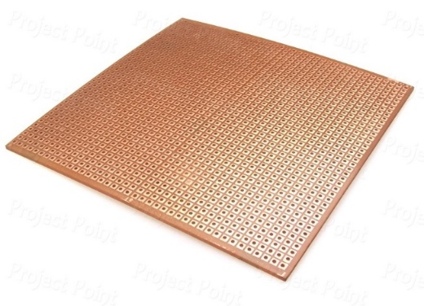

Fig 9. PCB

**4.3 Circuit Layout:**

### 

### 

### Transmission End

### 

### 

### Reception End

### 

### Control Unit

## CHAPTER 5: ADVANTAGES, DISADVANTAGES & APPLICATIONS

## 

### Advantages:

* It is crucial for the health and safety of mine workers in the coal mining industry.
* Using the remote IOT platform, supervisors and managers can monitor critical parameters from inside the mine from anywhere in the world.
* “The price is modest, and upkeep is simple” is indicating that the cost of the product or service is relatively low and the maintenance required is straightforward, which makes it an economical and low-maintenance option.

#### Disadvantages:

* “Requires stable internet connection” when it comes to IoT based monitoring and alerting, means that in order for the monitoring and alerting system to function properly and efficiently, a stable and reliable internet connection is necessary. This is because IoT devices rely on the internet to transmit and receive data, without a stable connection, there will be an interruption in the data transmission which can lead to delays in alerting, lack of accurate monitoring and ultimately, it can put safety and security at risk.

#### Applications:

An IoT-based coal mine monitoring and alerting system has several potential applications in enhancing safety and efficiency within the mining industry. Here are some different applications:

1. Worker Safety: The system can monitor various environmental parameters such as temperature, humidity, and presence of hazardous gases to ensure a safe working environment for miners. It can provide real-time alerts to workers and supervisors in case of dangerous conditions, allowing for immediate evacuation or intervention.
2. Emergency Response: The system can help improve emergency response by automatically detecting incidents such as fires, gas leaks, or collapses. It can promptly alert the control room and emergency services, enabling faster and more effective rescue operations.
3. Environmental Monitoring: The project can include sensors for monitoring air quality, noise levels, and water conditions within the mining area. This data can be used to assess and mitigate the environmental impact of mining activities.
4. Remote Monitoring and Control: The system can allow remote monitoring and control of various processes and equipment within the mine. This enables mine managers and supervisors to access real-time data, make informed decisions, and optimize operations from a centralized location.
5. Compliance and Reporting: The system can automatically collect and analyze data related to safety and environmental regulations. This simplifies compliance monitoring and reporting, ensuring that the mine operates in accordance with legal requirements.
6. Data Analytics and Predictive Maintenance: The collected data from the system can be used for advanced analytics, enabling predictive maintenance of equipment, identifying patterns or anomalies, and optimizing mining processes for increased productivity and safety.

## CHAPTER 6: RESULTS & CONCLUSIONS

### Results:

IoT based coal mine monitoring and alerting system that can improve the safety and efficiency of coal mining operations. The system consists of a network of sensors that collect various environmental parameters such as temperature, humidity, gas concentration, and vibration. The data is transmitted to a cloud server via wireless communication modules. The cloud server performs data analysis and generates alerts in case of any abnormal or hazardous situations. The alerts are sent to the miners and the supervisors through a mobile app and a web dashboard. The system also provides real-time visualization and historical analysis of the sensor data.

### Blynk Website:

### 

### Blynk Application:

### 

### Conclusion & Future Scope:

### Conclusion:

* The Arduino microcontroller is used to create a prototype for a mine safety system in this proposed method. This device is made from each hardware and software program factors. The hardware is made from several sensors, while the software program is made of an Android software that connects to the Arduino board and other hardware additives via the internet of things.
* The android-based totally programmed consists of signals and a database in which readings from sensors are presented and inserted the usage of hardware.
* The use of the wireless community to growth mine safety is a solution for reaching each protection and development in mining initiatives. This looks at objectives to automate the method of mining unit monitoring and handing over updates via cell networks.
* This gadget hardware components talk with all the sensors. This project is used to optimize the utilization of the mining subject without the intervention of human beings with the aid of using sensors that screen the environment and a microcontroller that switches on/off the buzzer routinely in the event of unstable condition maintaining mining operation these days necessitates ensuring the protection and well-being of employees and property.
* The employment of Arduino, gasoline sensors, Temperature sensors, and humidity sensors inside sensors inside the improvement of coal mine security for employees maintains to screen mining protection and replace data at the IOT websites.

### Future Scope:

* The crucial parameters from inside the mine can be monitored from anywhere in the world by the supervisors and manager. Using the remote IoT platform. This can result in better management and improvement of production standards.
* This is a safety-critical project. Therefore, this system can be improved by making it fail-safe. We can implement the fail-safe operation using redundancy in the system. If one module fails then the parallel module will take over the operation.
* With the upcoming developments future work of this experimentation may incorporate, greater improvement of the framework by utilizing other progressed sensors for checking the underground dangers.
* Using additional sensors all possible safety issues could be monitored such as gases, dust, vibrations, fire, etc.
* Zigbee can also be used for the surveillance of mining operations such as subsidence, water leakage, etc.
* The other important data can be communicated through these systems making it feasible where wired communication is a hindrance.

## CHAPTER 7: BUDGET DETAILS OF PROJECT

The entire cost of project is rupees 6,777 only.

|  |  |  |  |
| --- | --- | --- | --- |
| Sr.no. | Components | Specifications | Quantity |
| 1. | Arduino | Arduino nano | 2 |
| 2. | Temperature and Humidity Sensor | DHT11 | 1 |
| 3. | Zigbee | Zigbee S2C | 3 |
| 4. | Gas Sensor | MQ5 | 1 |
| 5. | Buzzer | Piezoelectric Buzzer | 1 |
| 6. | Node MCU | ESP 8266 | 1 |
| 7. | Flame sensor | Flame sensor | 1 |
| 8. | Zero PCB | PCB | 3 |
| 9. | Jumper Wires | Wires | 15 |

**Budget Details of the Project:**

## CHAPTER 8: BIBLIOGRAPHY

1] Bin, G., Huizong, L. (2011), “The research on ZigBee-based Mine Safety Monitoring System”

2] Borkar, C., “Development of wireless sensor network system for indoor air quality monitoring”

3] Fu, H., Wang, T., Yuang, C. (2009), “Intelligent Fuzzy Sensing System in Coal Mine Safety Monitoring”

4] Liu, T., Wei, Y., Song, G., Li, Y. (2013), “Advances of optical fiber sensors for coal mine safety monitoring applications”.

5] Xiaodong, Z., Yuegang, T., Yan, H. (2014), “Research and Application of Embedded Technology in Remote Network Monitoring System of Coal Mine”

6] Wei, S, Li, L.L. (2009), “Multi-parameter Monitoring System for Coal Mine based on Wireless Sensor Network Technology”

7] Sun, Z., Zhang, X., Li, H., Li, A. (2008), “The Application of TinyOS Beaconing WSN Routing Protocol in Mine Safety Monitoring”

8] Osunmakinde, I.O. (2013), “Towards Safety from Toxic Gases in Underground Mines Using Wireless Sensor Networks and Ambient Intelligence”

9] Liu, T., Wei, Y., Song, G., Li, Y. (2013), “Advances of optical fiber sensors for coal mine safety monitoring applications”

31