**WALCHAND INSTITUTE OF TECHNOLOGY, SOLAPUR**

DEPARTMENT OF ELECTRONICS AND TELECOMMUNICATION ENGINEERING

**Year 2022-2023**

Project Synopsis

1. **Name of the course:** Electronics and Telecommunication Engineering

|  |  |  |
| --- | --- | --- |
| 2. **Name of Students:**  Name | Sr. No. | Signature |
| 1. Pranav Mahendra Sonar (Group Leader) | 19 |  |
| 2. Pooja Ajay Thakur | 20 |  |
| 3. Chandrashekhar Raju Yemul | 21 |  |

1. **Name of the Guide:** Mr. K. R. Biradar
2. **Name of the Project:** IoT Based Safety, Monitoring and Alerting system for Mines.
3. **Whether Project is Sponsored:** No
4. **Introduction** **and Purpose of the project:**

Mines are the world’s most dangerous place to work because of explosion such mishaps happen as a direct result of the old equipment and wired devices, mishandling, spillage of the noxious gases in the coal mines, pose tremendous hazards to the excavators inside the coal mines. In the project, we have tackled the issues by checking the information gathered by the sensors. Where information is utilized and the observed with the help of open source IoT platform. Control is possible by both automatically and manually.

1. **Problem Statement:**

In the mining industry, safety and security is a fundamental aspect of everything. To avoid any types of accidents, the mining industry follows some basic precautions. Accidents such as rise in temperature, increased water level, and methane gas leakage.

1. **Objectives of the Project:**

Safety is an important aspect of any industry. Safety and security are extremely important in the mining business. We want to create a wearable device that will be used for the safety of workers. The sensors monitor the data and send it to the control unit where it will be analysed. If a worker is in danger, they can use the panic button (i.e. buzzer) to alert security.

1. **Scope of the Project:**

With the development of this model, future work of this experimentation may incorporate, greater improvement of the framework by utilizing other progressed sensors for checking the underground dangers. Likewise, every one of the underground tasks can be monitored from the beginning. New creating correspondence advancements can be utilized for fast information move in a mix with keen sensors for detecting the mine conditions. Additionally, more IOT-empowered frameworks can be created for further developed uses.

1. **Literature Survey:**

* Yongping Wu and Guo Feng use the Bluetooth wireless transmission system to track coal mines. Bluetooth technology would develop a popular power efficient, cheaper wireless air interface and controlling software opening framework as a single global short-range wireless communication standard. This paper discusses the context of Bluetooth technology’s growth, as well as the technological features and layout of the protocol stack, and proposes solutions for the wireless communication of Bluetooth host controller interface (HCI) in development convolution. Simultaneously, the device employs mature CAN bus technology and has realized the integration of wired and wireless data. device of transmission the biggest challenge with this device is that Bluetooth is a short-range wireless technology that makes cabling difficult. The cabling is broken while a catastrophe or a roof disintegrate occurs. As a result, traditional communication systems are unreliable and have a short lifespan. The construction and maintenance of the equipment became difficult due to the rasping climate in the mine.
* Tanmoy Maity and Partha Sarathi Das use Zigbee to build a wireless monitoring and safety device for workers in the mine. This device aims to provide a cost-effective and adaptable solution for the safety of underground mine workers. A microcontroller is used to collect data and make decisions, after which mine workers are notified via alarm and voice system. The voice-based notification system including a speaker and a microphone transforms the collected information into a digital signal and communicates wirelessly with the ground control station. For the short-distance communication between the miner's equipment and the ground control station, a ZigBee based short-range wireless network, is used to notify relevant departments.

1. **Brief Description of the Project:**

An IoT-based coal mine monitoring and alerting system using Arduino can be a useful tool for improving the safety and efficiency of mining operations. Such a system can be designed to monitor various parameters, such as temperature, humidity, gas levels and then send alerts if any of these parameters exceed pre-set thresholds

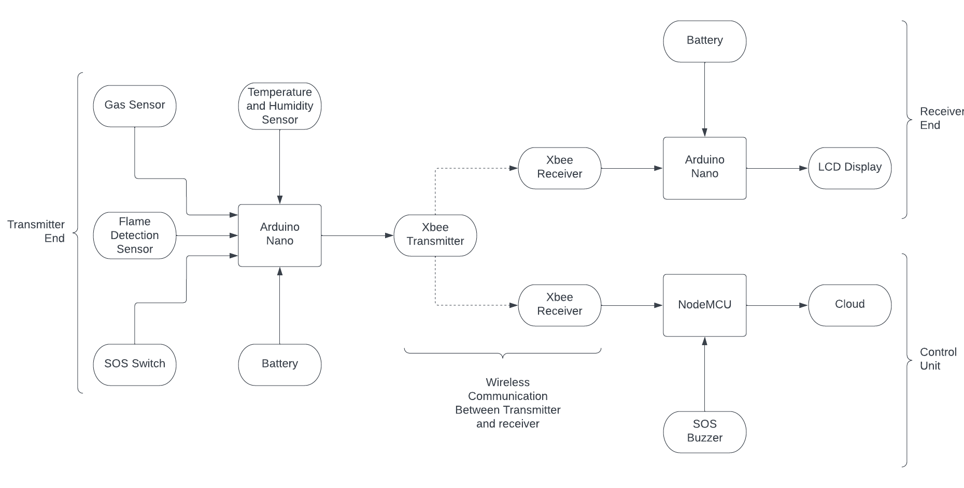

1. Sensors are installed on a wearable device to capture various parameters, including temperature, humidity, gas levels, and flame. These sensors can be linked to Arduino boards, which facilitate data collection and transmission to a central hub or gateway using ZigBee technology.
2. The data from the sensors is transmitted to the central hub or gateway, which is connected to the network. This allows the data to be analyzed and monitored in real-time.
3. The wearable device is configured to send alerts if any of the parameters exceed pre-set thresholds. For example, if the temperature exceeds a certain level, or if there is a sudden increase in gas levels, an alert can be sent to the control unit.
4. Furthermore, we have used a piezoelectric buzzer to alert the control unit. This enables them to quickly respond to any potential hazards and take the appropriate action to protect the workers.
5. The data can also be used to generate reports, analyze trends, and help optimize mining operations. It can be used to identify patterns that may indicate maintenance needs or areas of the mine that require increased safety precautions.
6. The advantage of using an IoT based system is that it allows for remote monitoring and management of the mine operations, enabling the monitoring of mine environment, workers' safety, and to generate real-time alerts on any potential hazards or issues. This can help mining companies to identify accidents and prevents casualties ultimately improve the overall safety and efficiency of mining operation.

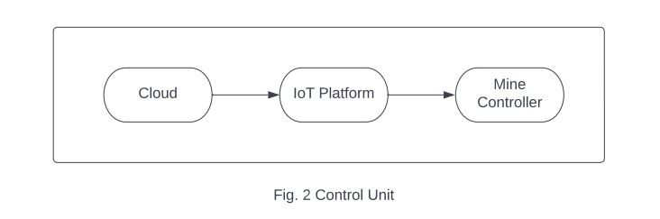

1. **Software and Hardware Components:**

|  |  |  |  |
| --- | --- | --- | --- |
| Sr.no. | Components | Specifications | Quantity |
| 1. | Arduino | Arduino nano | 2 |
| 2. | Temperature and Humidity Sensor | DHT11 | 1 |
| 3. | Zigbee | Zigbee S2C | 3 |
| 4. | Gas Sensor | MQ5 | 1 |
| 5. | Buzzer | Piezoelectric Buzzer | 1 |
| 6. | Node MCU | ESP 8266 | 1 |
| 7. | Flame sensor | Flame sensor | 1 |
| 8. | Zero PCB | PCB | 3 |
| 9. | Jumper Wires | Wires | 15 |

1. **Total Cost of Project:**

The entire cost of the Project is Rupees 6,777 only.

**Dr. Ms. A. V. Thalange**

**Head, E&TC Engg.**

**Mr. K. R. Biradar**

**Project Guide**