***IoT Based Safety, Monitoring and Alerting System for Mines***

## Mr. K. R. Biradar1, Pranav Sonar2, Pooja Thakur3, Chandrashekhar Yemul4

1Assistant Professor, Department of Electronics & Telecommunication Engineering

Walchand Institute of Technology, Solapur.

2,3,4UG Scholar, Department of Electronics & Telecommunication Engineering

Walchand Institute of Technology, Solapur.

**ABSTRACT**

IoT-based coal mine monitoring and alerting system using Arduino as a tool to enhance the safety and efficiency of mining operations. The methods employed involve installing sensors on a wearable device to capture crucial parameters such as temperature, humidity, gas levels, and flame. These sensors are connected to Arduino boards, enabling data collection and transmission via ZigBee technology to a central hub or gateway. The data is then analyzed and monitored in real-time. The significance of this study lies in the remote monitoring and management capabilities offered by the IoT-based system. It enables continuous monitoring of the mine environment and workers' safety, while also generating real-time alerts on potential hazards or issues. This aids mining companies in accident identification and prevention, ultimately enhancing the overall safety and efficiency of mining operations.

## **Keywords: -** IoT-based system, Arduino, safety, wearable device, real-time alerts, remote monitoring, Xbee.

# 1. INTRODUCTION

The mines are the world's most dangerous mining operation, with thousands of workers dying each year as a result of massive explosions. According to a recent study, in such mining incidents, an estimated 12,000 people have died on average. Coal is a non-human resource that can be converted; there are a few problems in the mines; and workers risked their lives by working in coal mines; and, unfortunately, some miners end up losing their lives in coal mines. Often, such problems arise as a result of outdated technology, the final result being the mismanagement and spillage of toxic gases in coal mines poses a serious threat to archaeologists, underground operation. The eight deadliest mines in history have occurred in China. Liaoning eruption kills 210 people, Guangdong floods kill 123 people, Xinjiang eruption kills 83 people, Shanxi eruption kills 72 people in 2015. A coal explosion at the Honkeiko Colliery in China killed 1,549 miners, making it one of the most dangerous mining disasters in history. As a result, the importance of safety for mine workers in recent days, monitoring mine employees in underground mines has become extremely challenging. Internet of Things (IOT) is a set of gadgets(objects) connected to the net. IOT implementation varies substantially on a massive scale. Internet of Things Europe group has most essential IOT gadgets. Clever apps, clever power, enterprise, fitness, and clever cities as a whole encompass smart housing, smart transportation, and clever housing to call a few nets of things (IOT) is a sport-changing invention in which all sensory records are stored within the cloud and accessed fast.

# 2. LITERATURE SURVEY

* Yongping Wu and Guo Feng use the Bluetooth wireless transmission system to track coal mines. Bluetooth technology would develop a popular power efficient, cheaper wireless air interface and controlling software opening framework as a single global short-range wireless communication standard. This paper discusses the context of Bluetooth technology’s growth, as well as the technological features and layout of the protocol stack, and proposes solutions for the wireless communication of Bluetooth host controller interface (HCI) in development convolution. Simultaneously, the device employs mature CAN bus technology and has realized the integration of wired and wireless data. device of transmission the biggest challenge with this device is that Bluetooth is a short-range wireless technology that makes cabling difficult. The cabling is broken while a catastrophe or a roof disintegrate occurs. As a result, traditional communication systems are unreliable and have a short lifespan. The construction and maintenance of the equipment became difficult due to the rasping climate in the mine.
* Tanmoy Maity and Partha Sarathi Das use Zigbee to build a wireless monitoring and safety device for workers in the mine. This device aims to provide a cost-effective and adaptable solution for the safety of underground mine workers. A microcontroller is used to collect data and make decisions, after which mine workers are notified via alarm and voice system. The voice-based notification system including a speaker and a microphone transforms the collected information into a digital signal and communicates wirelessly with the ground control station. For the short-distance communication between the miner's equipment and the ground control station, a ZigBee based short-range wireless network, is used to notify relevant departments.

# 3. BLOCK DIAGRAM & SETUP

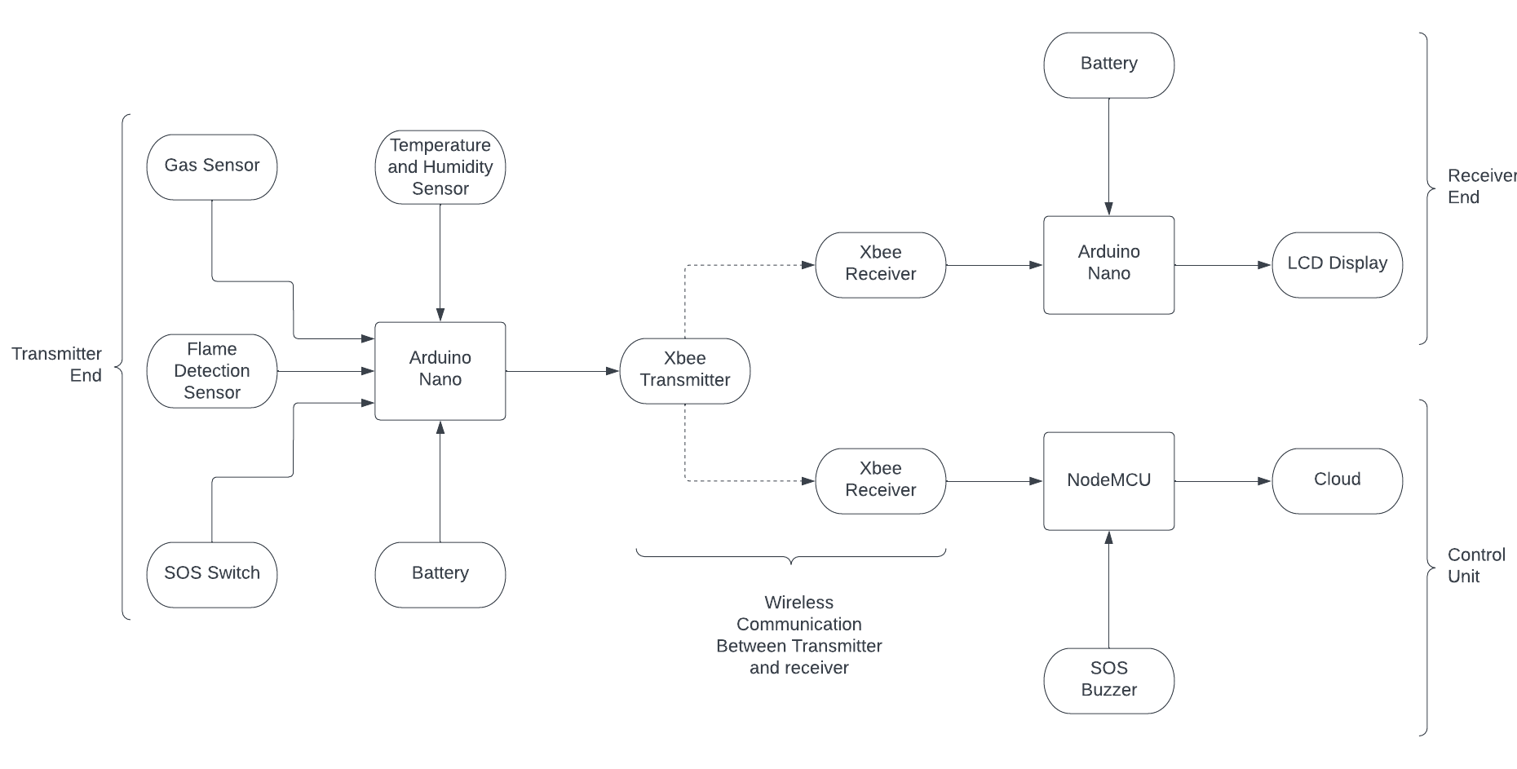

* One of the major challenges faced by workers in underground mines is ensuring their safety in a hazardous environment. To address this issue, we have developed a wireless wearable working unit that is specifically designed to enhance the safety of workers within the mining industry. This unit consists of three main components: the transmitter, receiver, and main control unit. The transmitter is equipped with various sensors that monitor the working environment. The receiver is installed at multiple locations throughout the mining site to receive and transmit the data from the transmitter. The main control unit, which is located outside the mine, analyses the data and alerts the workers and supervisors in case of any emergency. Figure 1 shows the block diagram of our wireless wearable working unit, which illustrates how the sensors and the transmitter Xbee are integrated.
* The Arduino NANO microcontroller serves as the central hub for receiving and processing the sensed values from the various sensors. These values are then transmitted to the designated receiver for further analysis and action. If the mining parameters surpass predetermined threshold levels, an immediate alert message is dispatched to the control room, enabling swift response and intervention. Furthermore, in the event of detecting any presence of flames, an audible alarm in the form of a buzzer is activated, promptly notifying and safeguarding the workers within the mining unit.
* The safety system is fortified with essential sensors, including the DHT11 Temperature and Humidity sensor, the Flame sensor, and a Gas sensor. These sensors play a vital role in monitoring the physical parameters of the mining unit, parameters that are inherently challenging for human beings to predict accurately. By continuously monitoring these parameters, our system provides early warnings and critical information to mitigate potential risks and hazards.
* The Arduino-based mine safety system integrates multiple sensors, each connected to dedicated controllers. The sensed values obtained from these sensors are seamlessly transmitted to a mobile application via the Node MCU platform, utilizing the efficient Xbee communication protocol. This comprehensive approach empowers workers to leverage a range of monitoring and control systems, significantly enhancing overall working conditions. Through the automation of environmental parameters such as temperature, humidity, and the presence of hazardous gases, the system proactively safeguards the lives and well-being of workers safety of the coal mine workers.
* The design of our system incorporates cutting-edge IoT (Internet of Things) technology, leveraging an Android device, a main controlling unit (MCU), a suite of sensors for measuring various parameters, and an alert system. This intelligent integration ensures the utmost security for workers operating within the mining industry, providing a reliable and comprehensive solution to address their safety needs.

# 4. ADVANTAGES

* It is crucial for the health and safety of mine workers in the coal mining industry.
* Using the remote IOT platform, supervisors and managers can monitor critical parameters from inside the mine from anywhere in the world.
* “The price is modest, and upkeep is simple” is indicating that the cost of the product or service is relatively low and the maintenance required is straightforward, which makes it an economical and low-maintenance option.

# 5. DISADVANTAGES

* “Requires stable internet connection” when it comes to IoT based monitoring and alerting, means that in order for the monitoring and alerting system to function properly and efficiently, a stable and reliable internet connection is necessary. This is because IoT devices rely on the internet to transmit and receive data, without a stable connection, there will be an interruption in the data transmission which can lead to delays in alerting, lack of accurate monitoring and ultimately, it can put safety and security at risk.

# 6. APPLICATIONS

* **Worker Safety:** The system can monitor various environmental parameters such as temperature, humidity, and presence of hazardous gases to ensure a safe working environment for miners. It can provide real-time alerts to workers and supervisors in case of dangerous conditions, allowing for immediate evacuation or intervention.
* **Emergency Response:** The system can help improve emergency response by automatically detecting incidents such as fires, gas leaks, or collapses. It can promptly alert the control room and emergency services, enabling faster and more effective rescue operations.
* **Environmental Monitoring:** The project can include sensors for monitoring air quality, noise levels, and water conditions within the mining area. This data can be used to assess and mitigate the environmental impact of mining activities.
* **Remote Monitoring and Control:** The system can allow remote monitoring and control of various processes and equipment within the mine. This enables mine managers and supervisors to access real-time data, make informed decisions, and optimize operations from a centralized location.
* **Data Analytics and Predictive Maintenance:** The collected data from the system can be used for advanced analytics, enabling predictive maintenance of equipment, identifying patterns or anomalies, and optimizing mining processes for increased productivity and safety.

**7. RESULTS**

An IoT-based coal mine monitoring system collects environmental data through sensors, sends it to a cloud server, and analyzes it. Alerts are generated for abnormal or hazardous situations and sent to miners and supervisors via a mobile app and web dashboard. Real-time visualization and historical analysis of sensor data are provided. This system improves safety and efficiency in coal mining operations.

* **Blynk Website:**

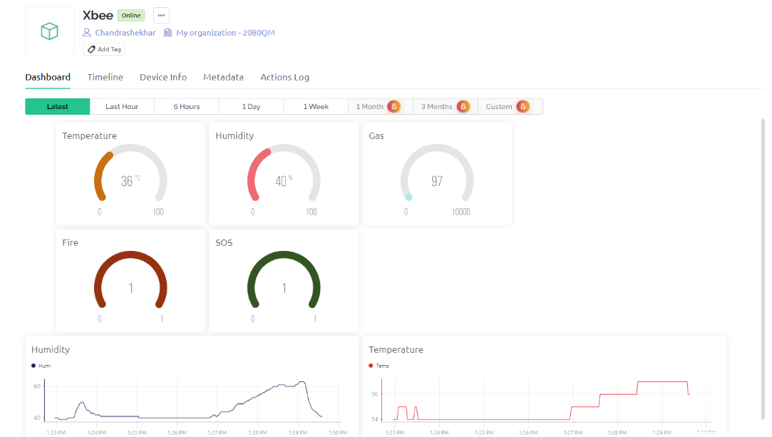

# 8. CONCLUSION

* The Arduino microcontroller is used to create a prototype for a mine safety system in this proposed method. This device is made from each hardware and software program factors. The hardware is made from several sensors, while the software program is made of an Android software that connects to the Arduino board and other hardware additives via the internet of things.
* The android-based totally programmed consists of signals and a database in which readings from sensors are presented and inserted the usage of hardware.
* The use of the wireless community to growth mine safety is a solution for reaching each protection and development in mining initiatives. This looks at objectives to automate the method of mining unit monitoring and handing over updates via cell networks.
* This gadget hardware components talk with all the sensors. This project is used to optimize the utilization of the mining subject without the intervention of human beings with the aid of using sensors that screen the environment and a microcontroller that switches on/off the buzzer routinely in the event of unstable condition maintaining mining operation these days necessitates ensuring the protection and well-being of employees and property.
* The employment of Arduino, gasoline sensors, Temperature sensors, and humidity sensors inside sensors inside the improvement of coal mine security for employees maintains to screen mining protection and replace data at the IOT websites.

**9. REFERENCES**

1] Bin, G., Huizong, L. (2011), “The research on ZigBee-based Mine Safety Monitoring System”

2] Borkar, C., “Development of wireless sensor network system for indoor air quality monitoring”

3] Fu, H., Wang, T., Yuang, C. (2009), “Intelligent Fuzzy Sensing System in Coal Mine Safety Monitoring”

4] Liu, T., Wei, Y., Song, G., Li, Y. (2013), “Advances of optical fiber sensors for coal mine safety monitoring applications”.

5] Xiaodong, Z., Yuegang, T., Yan, H. (2014), “Research and Application of Embedded Technology in Remote Network Monitoring System of Coal Mine”

6] Wei, S, Li, L.L. (2009), “Multi-parameter Monitoring System for Coal Mine based on Wireless Sensor Network Technology”

7] Sun, Z., Zhang, X., Li, H., Li, A. (2008), “The Application of TinyOS Beaconing WSN Routing Protocol in Mine Safety Monitoring”

8] Osunmakinde, I.O. (2013), “Towards Safety from Toxic Gases in Underground Mines Using Wireless Sensor Networks and Ambient Intelligence”

9] Liu, T., Wei, Y., Song, G., Li, Y. (2013), “Advances of optical fiber sensors for coal mine safety monitoring applications”