**Useful reports with business insights**

**Report 1:** Looking for good right winger and age below 28-- List of players with right-winger position

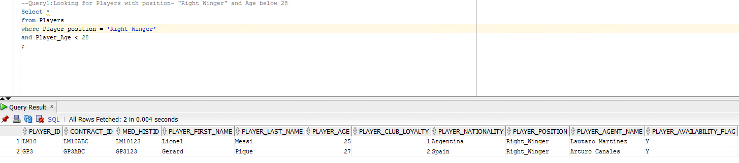

**Business benefits:** Scouts has the privilege of getting information about multiple players at a time. Also, scouts can now run a report on basis of various criterions like Age, position of players etc.

**Query1: Looking for Players with position- "Right Winger" and Age below 28**

Select *

from Players

where Player_position = 'Right_Winger'

and Player_Age < 28

;

**Report 2:** Players having buy-out clause below 50 million Euros (threshold) and remaining time of existing contract should be less than a year.

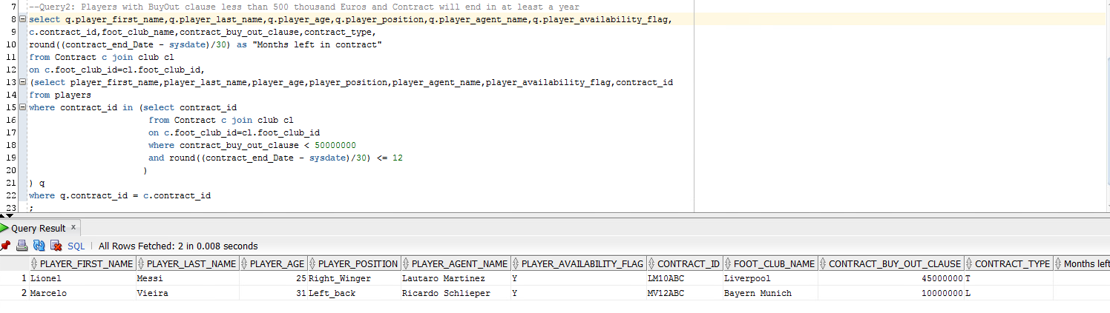

**Business benefits:** Using this report scouts can get players whose contracts will end soon and will be available for bidding. This will help them to focus on specific players rather than looking for all players or one player at a time.

**Query2: Players with BuyOut clause less than 500 thousand Euros and Contract will end in at least a year**

select q.player_first_name,q.player_last_name,q.player_age,q.player_position,q.player_agent_name,q.player_availability_flag,

c.contract_id,foot_club_name,contract_buy_out_clause,contract_type,

round((contract_end_Date - sysdate)/30) as "Months left in contract"

from Contract c join club cl

on c.foot_club_id=cl.foot_club_id,

(select player_first_name,player_last_name,player_age,player_position,player_agent_name,player_availability_flag,contract_id

from players

where contract_id in (select contract_id

from Contract c join club cl

on c.foot_club_id=cl.foot_club_id

where contract_buy_out_clause < 50000000

and round((contract_end_Date - sysdate)/30) <= 12

)

) q

where q.contract_id = c.contract_id

;

**Report 3:** Players who are available for bidding

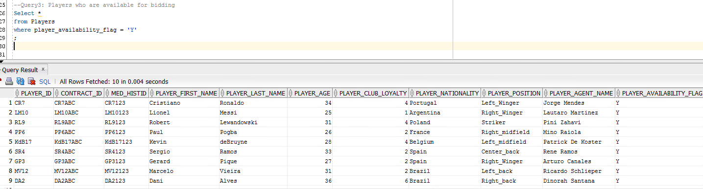

**Business benefits:** This report provides details on players who are currently available for bidding window. This is vey important criterion for scouts as this helps them to get to the players who are available for any immediate requirement.

**Query3: Players who are available for bidding**

Select *

from Players

where player_availability_flag = 'Y'

;

**Report 4:** Players’ discipline – position= defender, number of cards

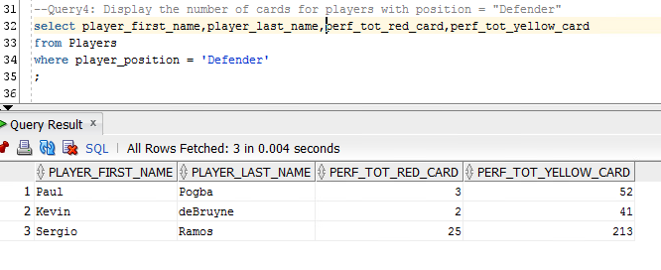

**Business benefits:** Scouts always prefer to look for players with good performance stats. This report provides number of red cards and yellow cards a Defender (player position) has.

**Query4: Display the number of cards for players with position = "Defender"**

select player_first_name,player_last_name,perf_tot_red_card,perf_tot_yellow_card

from Players

where player_position = 'Defender'

;

**Report 5:** Optimize travel plan (for assessment of players) for scouts according to league location. In other words, scout can sort the results in terms of league nation say Players with same league nation

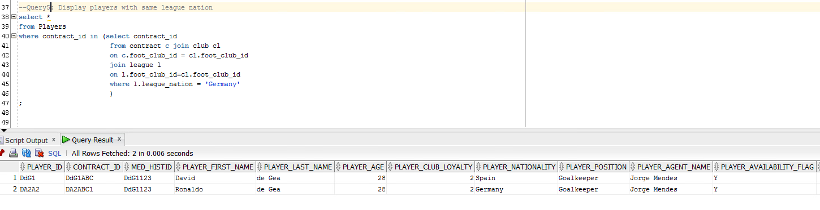

**Business benefits:** Using this report and combining with more criterions (as required by Scouts) Scout can plan the player assessment travel plan in an optimized way. This can be done by sorting the list of players on basis of same League location or Players who play for same club. This would also help Scouts to do faster negotiations.

**Query5: Display players with same league nation**

select *

from Players

where contract_id in (select contract_id

from contract c join club cl

on c.foot_club_id = cl.foot_club_id

join league l

on l.foot_club_id=cl.foot_club_id

where l.league_nation = 'Germany'

)

;