**Hands on 1**

**Create a Spring Web Project using Maven**

**SpringLearnApplication.java**

package com.cognizant.spring_learn;  
  
import org.springframework.boot.SpringApplication;  
import org.springframework.boot.autoconfigure.SpringBootApplication;  
  
@SpringBootApplication  
public class SpringLearnApplication {  
  
 public static void main(String[] args) {  
 SpringApplication.*run*(SpringLearnApplication.class, args);  
 System.*out*.println("Application started successfully");  
 }  
}

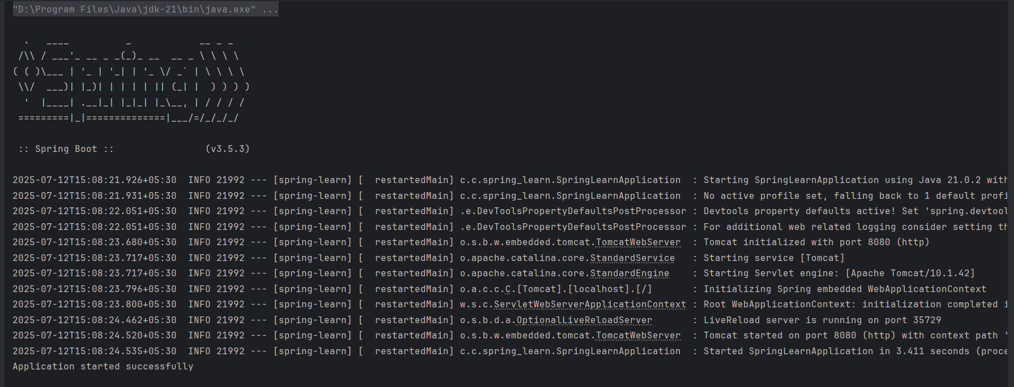

**Hands on 4**

**Spring Core – Load Country from Spring Configuration XML**

**SpringLearnApplication.java**

package com.cognizant.spring_learn;  
  
import org.slf4j.Logger;  
import org.slf4j.LoggerFactory;  
import org.springframework.context.ApplicationContext;  
import org.springframework.context.support.ClassPathXmlApplicationContext;  
  
public class SpringLearnApplication {  
 private static final Logger *LOGGER* = LoggerFactory.*getLogger*(SpringLearnApplication.class);  
  
 public static void main(String[] args) {  
 *displayCountry*();  
 }  
  
 public static void displayCountry() {  
 ApplicationContext context = new ClassPathXmlApplicationContext("country.xml");  
 Country country = context.getBean("country", Country.class);  
 *LOGGER*.debug("Country : {}", country.toString());  
 System.*out*.println("Country: " + country); // Visible in console  
 }  
}

**country.xml**

<?xml version="1.0" encoding="UTF-8"?>  
<beans xmlns="http://www.springframework.org/schema/beans"  
 xmlns:xsi="http://www.w3.org/2001/XMLSchema-instance"  
 xsi:schemaLocation="http://www.springframework.org/schema/beans  
 http://www.springframework.org/schema/beans/spring-beans.xsd">  
  
 <bean id="country" class="com.cognizant.spring_learn.Country">  
 <property name="code" value="IN"/>  
 <property name="name" value="India"/>  
 </bean>  
</beans>

**Country.java**

package com.cognizant.spring_learn;  
  
import org.slf4j.Logger;  
import org.slf4j.LoggerFactory;  
  
public class Country {  
 private static final Logger *LOGGER* = LoggerFactory.*getLogger*(Country.class);  
  
 private String code;  
 private String name;  
  
 public Country() {  
 *LOGGER*.debug("Inside Country Constructor.");  
 }  
  
 public String getCode() {  
 *LOGGER*.debug("Inside getCode()");  
 return code;  
 }  
  
 public void setCode(String code) {  
 *LOGGER*.debug("Inside setCode()");  
 this.code = code;  
 }  
  
 public String getName() {  
 *LOGGER*.debug("Inside getName()");  
 return name;  
 }  
  
 public void setName(String name) {  
 *LOGGER*.debug("Inside setName()");  
 this.name = name;  
 }  
  
 @Override  
 public String toString() {  
 return "Country{code='" + code + "', name='" + name + "'}";  
 }  
}

**application.properties**

spring.application.name=spring-learn  
logging.level.com.cognizant.spring_learn=DEBUG

**pom.xml**

<?xml version="1.0" encoding="UTF-8"?>  
<project xmlns="http://maven.apache.org/POM/4.0.0"  
 xmlns:xsi="http://www.w3.org/2001/XMLSchema-instance"  
 xsi:schemaLocation="http://maven.apache.org/POM/4.0.0 https://maven.apache.org/xsd/maven-4.0.0.xsd">  
  
 <modelVersion>4.0.0</modelVersion>  
  
 <parent>  
 <groupId>org.springframework.boot</groupId>  
 <artifactId>spring-boot-starter-parent</artifactId>  
 <version>3.5.3</version>  
 <relativePath/> </parent>  
  
 <groupId>com.cognizant</groupId>  
 <artifactId>spring-learn</artifactId>  
 <version>0.0.1-SNAPSHOT</version>  
 <name>spring-learn</name>  
 <description>Demo project for Spring Boot</description>  
  
 <properties>  
 <java.version>17</java.version>  
 </properties>  
  
 <dependencies>  
 <dependency>  
 <groupId>org.springframework.boot</groupId>  
 <artifactId>spring-boot-starter-web</artifactId>  
 </dependency>  
  
 <dependency>  
 <groupId>org.springframework.boot</groupId>  
 <artifactId>spring-boot-devtools</artifactId>  
 <scope>runtime</scope>  
 <optional>true</optional>  
 </dependency>  
  
 <dependency>  
 <groupId>org.springframework.boot</groupId>  
 <artifactId>spring-boot-starter-test</artifactId>  
 <scope>test</scope>  
 </dependency>  
  
 <!-- SLF4J Logging Support -->  
 <dependency>  
 <groupId>org.slf4j</groupId>  
 <artifactId>slf4j-api</artifactId>  
 <version>1.7.36</version>  
 </dependency>   
 </dependencies>  
  
 <build>  
 <plugins>  
 <plugin>  
 <groupId>org.springframework.boot</groupId>  
 <artifactId>spring-boot-maven-plugin</artifactId>  
 </plugin>  
 </plugins>  
 </build>  
  
</project>

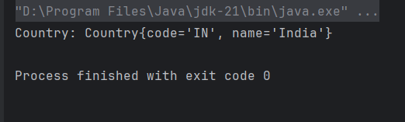

**Hello World RESTful Web Service**

**SpringLearnApplication.java**

package com.cognizant.spring_learn;  
  
import org.springframework.boot.SpringApplication;  
import org.springframework.boot.autoconfigure.SpringBootApplication;  
  
@SpringBootApplication  
public class SpringLearnApplication {  
 public static void main(String[] args) {  
 SpringApplication.*run*(SpringLearnApplication.class, args);  
 }  
}

**HelloController.java**

ackage com.cognizant.spring_learn.controller;  
  
import org.slf4j.Logger;  
import org.slf4j.LoggerFactory;  
import org.springframework.web.bind.annotation.GetMapping;  
import org.springframework.web.bind.annotation.RestController;  
  
@RestController  
public class HelloController {  
  
 private static final Logger *LOGGER* = LoggerFactory.*getLogger*(HelloController.class);  
  
 @GetMapping("/hello")  
 public String sayHello() {  
 *LOGGER*.info("START - sayHello()");  
 String message = "Hello World!!";  
 *LOGGER*.info("END - sayHello()");  
 return message;  
 }  
}

**application.properties**

server.port=8083

**pom.xml**

<?xml version="1.0" encoding="UTF-8"?>  
<project xmlns="http://maven.apache.org/POM/4.0.0"  
 xmlns:xsi="http://www.w3.org/2001/XMLSchema-instance"  
 xsi:schemaLocation="http://maven.apache.org/POM/4.0.0 https://maven.apache.org/xsd/maven-4.0.0.xsd">  
  
 <modelVersion>4.0.0</modelVersion>  
  
 <parent>  
 <groupId>org.springframework.boot</groupId>  
 <artifactId>spring-boot-starter-parent</artifactId>  
 <version>3.2.4</version>  
 <relativePath/>  
 </parent>  
  
 <groupId>com.cognizant</groupId>  
 <artifactId>spring-learn</artifactId>  
 <version>0.0.1-SNAPSHOT</version>  
 <name>spring-learn</name>  
 <description>Spring Boot Learning Project</description>  
  
 <properties>  
 <java.version>17</java.version>  
 </properties>  
  
 <dependencies>  
 <dependency>  
 <groupId>org.springframework.boot</groupId>  
 <artifactId>spring-boot-starter-web</artifactId>  
 </dependency>  
  
 <dependency>  
 <groupId>org.springframework.boot</groupId>  
 <artifactId>spring-boot-devtools</artifactId>  
 <scope>runtime</scope>  
 <optional>true</optional>  
 </dependency>  
  
 <dependency>  
 <groupId>org.springframework.boot</groupId>  
 <artifactId>spring-boot-starter-test</artifactId>  
 <scope>test</scope>  
 </dependency>  
 </dependencies>  
  
 <build>  
 <plugins>  
 <plugin>  
 <groupId>org.springframework.boot</groupId>  
 <artifactId>spring-boot-maven-plugin</artifactId>  
 </plugin>  
 </plugins>  
 </build>  
  
</project>

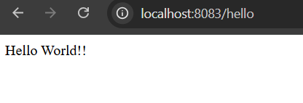

**REST - Country Web Service**

**SpringLearnApplication.java**

package com.cognizant.spring_learn;  
  
import org.springframework.boot.SpringApplication;  
import org.springframework.boot.autoconfigure.SpringBootApplication;  
  
@SpringBootApplication  
public class SpringLearnApplication {  
 public static void main(String[] args) {  
 SpringApplication.*run*(SpringLearnApplication.class, args);  
 }  
}

**application.properties**

server.port=8083

**country.xml**

<?xml version="1.0" encoding="UTF-8"?>  
<beans xmlns="http://www.springframework.org/schema/beans"  
 xmlns:xsi="http://www.w3.org/2001/XMLSchema-instance"  
 xsi:schemaLocation="http://www.springframework.org/schema/beans  
 https://www.springframework.org/schema/beans/spring-beans.xsd">  
  
 <bean id="country" class="com.cognizant.spring_learn.model.Country">  
 <property name="code" value="IN" />  
 <property name="name" value="India" />  
 </bean>  
  
</beans>

**CountryController.java**

package com.cognizant.spring_learn.controller;  
  
import com.cognizant.spring_learn.model.Country;  
import org.slf4j.Logger;  
import org.slf4j.LoggerFactory;  
import org.springframework.context.ApplicationContext;  
import org.springframework.context.support.ClassPathXmlApplicationContext;  
import org.springframework.web.bind.annotation.RequestMapping;  
import org.springframework.web.bind.annotation.RestController;  
  
@RestController  
public class CountryController {  
  
 private static final Logger *LOGGER* = LoggerFactory.*getLogger*(CountryController.class);  
  
 @RequestMapping("/country")  
 public Country getCountryIndia() {  
 *LOGGER*.info("START - getCountryIndia()");  
 ApplicationContext context = new ClassPathXmlApplicationContext("country.xml");  
 Country country = context.getBean("country", Country.class);  
 *LOGGER*.info("END - getCountryIndia()");  
 return country;  
 }  
}

**Country.java**

package com.cognizant.spring_learn.model;  
  
import org.slf4j.Logger;  
import org.slf4j.LoggerFactory;  
  
public class Country {  
 private static final Logger *LOGGER* = LoggerFactory.*getLogger*(Country.class);  
  
 private String code;  
 private String name;  
  
 public Country() {  
 *LOGGER*.debug("Inside Country Constructor.");  
 }  
  
 public String getCode() {  
 *LOGGER*.debug("Inside getCode()");  
 return code;  
 }  
  
 public void setCode(String code) {  
 *LOGGER*.debug("Inside setCode()");  
 this.code = code;  
 }  
  
 public String getName() {  
 *LOGGER*.debug("Inside getName()");  
 return name;  
 }  
  
 public void setName(String name) {  
 *LOGGER*.debug("Inside setName()");  
 this.name = name;  
 }  
  
 @Override  
 public String toString() {  
 return "Country{" +  
 "code='" + code + '\'' +  
 ", name='" + name + '\'' +  
 '}';  
 }  
}

**pom.xml**

<?xml version="1.0" encoding="UTF-8"?>  
<project xmlns="http://maven.apache.org/POM/4.0.0"  
 xmlns:xsi="http://www.w3.org/2001/XMLSchema-instance"  
 xsi:schemaLocation="http://maven.apache.org/POM/4.0.0 https://maven.apache.org/xsd/maven-4.0.0.xsd">  
  
 <modelVersion>4.0.0</modelVersion>  
  
 <parent>  
 <groupId>org.springframework.boot</groupId>  
 <artifactId>spring-boot-starter-parent</artifactId>  
 <version>3.2.4</version>  
 <relativePath/>  
 </parent>  
  
 <groupId>com.cognizant</groupId>  
 <artifactId>spring-learn</artifactId>  
 <version>0.0.1-SNAPSHOT</version>  
 <name>spring-learn</name>  
 <description>Spring Boot REST API for country details</description>  
  
 <properties>  
 <java.version>17</java.version>  
 </properties>  
  
 <dependencies>  
 <dependency>  
 <groupId>org.springframework.boot</groupId>  
 <artifactId>spring-boot-starter-web</artifactId>  
 </dependency>  
  
 <dependency>  
 <groupId>org.springframework.boot</groupId>  
 <artifactId>spring-boot-devtools</artifactId>  
 <scope>runtime</scope>  
 <optional>true</optional>  
 </dependency>  
  
 <dependency>  
 <groupId>org.springframework.boot</groupId>  
 <artifactId>spring-boot-starter</artifactId>  
 </dependency>  
  
 <dependency>  
 <groupId>org.springframework.boot</groupId>  
 <artifactId>spring-boot-starter-test</artifactId>  
 <scope>test</scope>  
 </dependency>  
 </dependencies>  
  
 <build>  
 <plugins>  
 <plugin>  
 <groupId>org.springframework.boot</groupId>  
 <artifactId>spring-boot-maven-plugin</artifactId>  
 </plugin>  
 </plugins>  
 </build>  
</project>

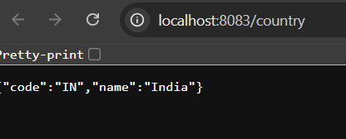

**REST - Get country based on country code**

**SpringLearnApplication.java**

package com.cognizant.spring_learn;  
  
import org.springframework.boot.SpringApplication;  
import org.springframework.boot.autoconfigure.SpringBootApplication;  
import org.springframework.context.annotation.ImportResource;  
  
@SpringBootApplication  
@ImportResource("classpath:country.xml")  
public class SpringLearnApplication {  
 public static void main(String[] args) {  
 SpringApplication.*run*(SpringLearnApplication.class, args);  
 }  
}

**application.properties**

server.port=8083

**country.xml**

<?xml version="1.0" encoding="UTF-8"?>  
<beans xmlns="http://www.springframework.org/schema/beans"  
 xmlns:xsi="http://www.w3.org/2001/XMLSchema-instance"  
 xsi:schemaLocation="  
 http://www.springframework.org/schema/beans  
 https://www.springframework.org/schema/beans/spring-beans.xsd">  
  
 <bean id="countryList" class="java.util.ArrayList">  
 <constructor-arg>  
 <list>  
 <bean class="com.cognizant.spring_learn.model.Country">  
 <property name="code" value="in"/>  
 <property name="name" value="India"/>  
 </bean>  
 <bean class="com.cognizant.spring_learn.model.Country">  
 <property name="code" value="us"/>  
 <property name="name" value="United States"/>  
 </bean>  
 <bean class="com.cognizant.spring_learn.model.Country">  
 <property name="code" value="cn"/>  
 <property name="name" value="China"/>  
 </bean>  
 </list>  
 </constructor-arg>  
 </bean>  
</beans>

**CountryController.java**

package com.cognizant.spring_learn.controller;  
  
import com.cognizant.spring_learn.model.Country;  
import com.cognizant.spring_learn.service.CountryService;  
import org.springframework.beans.factory.annotation.Autowired;  
import org.springframework.context.ApplicationContext;  
import org.springframework.web.bind.annotation.*;  
  
import java.util.List;  
  
@RestController  
public class CountryController {  
  
 @Autowired  
 private CountryService countryService;  
  
 @Autowired  
 private ApplicationContext context;  
  
 @RequestMapping("/country")  
 public Country getCountryIndia() {  
 @SuppressWarnings("unchecked")  
 List<Country> countryList = (List<Country>) context.getBean("countryList");  
 return countryList.get(0); // Return India (first element)  
 }  
  
 @GetMapping("/countries/{code}")  
 public Country getCountry(@PathVariable String code) {  
 return countryService.getCountry(code);  
 }  
}

**CountryService.java**

package com.cognizant.spring_learn.service;  
  
import com.cognizant.spring_learn.model.Country;  
import org.springframework.beans.factory.annotation.Autowired;  
import org.springframework.context.ApplicationContext;  
import org.springframework.stereotype.Service;  
  
import java.util.List;  
  
@Service  
public class CountryService {  
  
 @Autowired  
 private ApplicationContext context;  
  
 public Country getCountry(String code) {  
 @SuppressWarnings("unchecked")  
 List<Country> countryList = (List<Country>) context.getBean("countryList");  
  
 return countryList.stream()  
 .filter(country -> country.getCode().equalsIgnoreCase(code))  
 .findFirst()  
 .orElse(null); // Or throw custom CountryNotFoundException  
 }  
}

**Country.java**

package com.cognizant.spring_learn.model;  
  
public class Country {  
 private String code;  
 private String name;  
  
 public String getCode() {  
 return code;  
 }  
  
 public void setCode(String code) {  
 this.code = code;  
 }  
  
 public String getName() {  
 return name;  
 }  
  
 public void setName(String name) {  
 this.name = name;  
 }  
}

**pom.xml**

<?xml version="1.0" encoding="UTF-8"?>  
<project xmlns="http://maven.apache.org/POM/4.0.0"  
 xmlns:xsi="http://www.w3.org/2001/XMLSchema-instance"  
 xsi:schemaLocation="http://maven.apache.org/POM/4.0.0 https://maven.apache.org/xsd/maven-4.0.0.xsd">  
  
 <modelVersion>4.0.0</modelVersion>  
  
 <parent>  
 <groupId>org.springframework.boot</groupId>  
 <artifactId>spring-boot-starter-parent</artifactId>  
 <version>3.2.4</version>  
 <relativePath/>  
 </parent>  
  
 <groupId>com.cognizant</groupId>  
 <artifactId>spring-learn</artifactId>  
 <version>0.0.1-SNAPSHOT</version>  
 <name>spring-learn</name>  
 <description>Spring Boot REST API for country details</description>  
  
 <properties>  
 <java.version>17</java.version>  
 </properties>  
  
 <dependencies>  
 <dependency>  
 <groupId>org.springframework.boot</groupId>  
 <artifactId>spring-boot-starter-web</artifactId>  
 </dependency>  
  
 <dependency>  
 <groupId>org.springframework.boot</groupId>  
 <artifactId>spring-boot-devtools</artifactId>  
 <scope>runtime</scope>  
 <optional>true</optional>  
 </dependency>  
  
 <dependency>  
 <groupId>org.springframework.boot</groupId>  
 <artifactId>spring-boot-starter</artifactId>  
 </dependency>  
  
 <dependency>  
 <groupId>org.springframework.boot</groupId>  
 <artifactId>spring-boot-starter-test</artifactId>  
 <scope>test</scope>  
 </dependency>  
 </dependencies>  
  
 <build>  
 <plugins>  
 <plugin>  
 <groupId>org.springframework.boot</groupId>  
 <artifactId>spring-boot-maven-plugin</artifactId>  
 </plugin>  
 </plugins>  
 </build>  
  
</project>

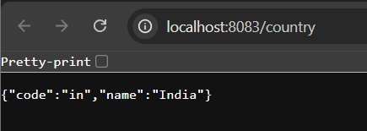

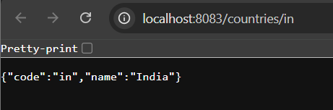

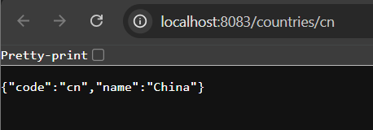

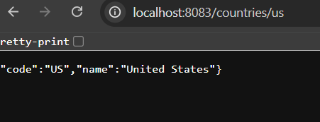

**Create authentication service that returns JWT**

**JwtAuthServerApplication.java**

package com.example.jwt_auth_service;  
  
import org.springframework.boot.SpringApplication;  
import org.springframework.boot.autoconfigure.SpringBootApplication;  
  
@SpringBootApplication  
public class JwtAuthServiceApplication {  
 public static void main(String[] args) {  
 SpringApplication.*run*(JwtAuthServiceApplication.class, args);  
 }  
}

**JwtUtil.java**

package com.example.jwt_auth_service.util;  
  
import io.jsonwebtoken.Jwts;  
import io.jsonwebtoken.SignatureAlgorithm;  
import org.springframework.stereotype.Component;  
  
import java.util.Date;  
  
@Component  
public class JwtUtil {  
 private final String SECRET_KEY = "mySecretKey";  
  
 public String generateToken(String username) {  
 return Jwts.*builder*()  
 .setSubject(username)  
 .setIssuedAt(new Date(System.*currentTimeMillis*()))  
 .setExpiration(new Date(System.*currentTimeMillis*() + 1000 * 60 * 60)) // 1 hour  
 .signWith(SignatureAlgorithm.*HS256*, SECRET_KEY)  
 .compact();  
 }  
}

**SecurityConfig.java**

package com.example.jwt_auth_service.config;  
  
import org.springframework.context.annotation.Bean;  
import org.springframework.context.annotation.Configuration;  
import org.springframework.security.web.SecurityFilterChain;  
import org.springframework.security.config.annotation.web.configuration.EnableWebSecurity;  
import org.springframework.security.config.annotation.web.builders.HttpSecurity;  
  
@Configuration  
@EnableWebSecurity  
public class SecurityConfig {  
  
 @Bean  
 public SecurityFilterChain filterChain(HttpSecurity http) throws Exception {  
 http.csrf().disable()  
 .authorizeHttpRequests()  
 .requestMatchers("/authenticate").permitAll()  
 .anyRequest().authenticated()  
 .and()  
 .httpBasic();  
  
 return http.build();  
 }  
}

**application.properties**

server.port=8090

**AuthController.java**

package com.example.jwt_auth_service.controller;  
  
import com.example.jwt_auth_service.util.JwtUtil;  
import jakarta.servlet.http.HttpServletRequest;  
import org.springframework.beans.factory.annotation.Autowired;  
import org.springframework.http.ResponseEntity;  
import org.springframework.web.bind.annotation.*;  
  
import java.util.Base64;  
  
@RestController  
public class AuthController {  
  
 @Autowired  
 private JwtUtil jwtUtil;  
  
 @GetMapping("/authenticate")  
 public ResponseEntity<?> authenticate(HttpServletRequest request) {  
 String authHeader = request.getHeader("Authorization");  
 System.*out*.println("Authorization Header = " + authHeader);   
  
 if (authHeader != null && authHeader.startsWith("Basic ")) {  
 String base64Credentials = authHeader.substring("Basic ".length());  
 byte[] decoded = Base64.*getDecoder*().decode(base64Credentials);  
 String credentials = new String(decoded);  
 String[] values = credentials.split(":", 2);  
  
 String username = values[0];  
 String password = values[1];  
  
 System.*out*.println("username: " + username);   
 System.*out*.println("password: " + password);   
  
 if ("user".equals(username) && "pwd".equals(password)) {  
 String token = jwtUtil.generateToken(username);  
 return ResponseEntity.*ok*("{\"token\":\"" + token + "\"}");  
 }  
 }  
  
 return ResponseEntity.*status*(401).body("Invalid credentials");  
 }  
  
}

**HelloController.java**

package com.example.jwt_auth_service.controller;  
  
import org.springframework.web.bind.annotation.GetMapping;  
import org.springframework.web.bind.annotation.RestController;  
  
@RestController  
public class HelloController {  
 @GetMapping("/")  
 public String hello() {  
 return "✅ Server is running!";  
 }  
}

**pom.xml**

<?xml version="1.0" encoding="UTF-8"?>  
<project xmlns="http://maven.apache.org/POM/4.0.0"  
 xmlns:xsi="http://www.w3.org/2001/XMLSchema-instance"  
 xsi:schemaLocation="http://maven.apache.org/POM/4.0.0  
 http://maven.apache.org/xsd/maven-4.0.0.xsd">  
 <modelVersion>4.0.0</modelVersion>  
 <groupId>com.example</groupId>  
 <artifactId>jwt-auth-service</artifactId>  
 <version>0.0.1-SNAPSHOT</version>  
 <packaging>jar</packaging>  
  
 <name>jwt-auth-service</name>  
 <description>JWT Auth Service</description>  
  
 <parent>  
 <groupId>org.springframework.boot</groupId>  
 <artifactId>spring-boot-starter-parent</artifactId>  
 <version>3.1.0</version> <!-- or 2.7.9 if you're using Java 8 -->  
 <relativePath/> <!-- lookup parent from repository -->  
 </parent>  
  
 <properties>  
 <java.version>17</java.version>  
 </properties>  
  
 <dependencies>  
 <!-- Spring Web -->  
 <dependency>  
 <groupId>org.springframework.boot</groupId>  
 <artifactId>spring-boot-starter-web</artifactId>  
 </dependency>  
  
 <!-- Spring Security -->  
 <dependency>  
 <groupId>org.springframework.boot</groupId>  
 <artifactId>spring-boot-starter-security</artifactId>  
 </dependency>  
  
 <!-- JWT -->  
 <dependency>  
 <groupId>io.jsonwebtoken</groupId>  
 <artifactId>jjwt</artifactId>  
 <version>0.9.1</version>  
 </dependency>  
  
 <!-- Optional Devtools -->  
 <dependency>  
 <groupId>org.springframework.boot</groupId>  
 <artifactId>spring-boot-devtools</artifactId>  
 <scope>runtime</scope>  
 </dependency>  
  
 </dependencies>  
  
 <build>  
 <plugins>  
 <plugin>  
 <groupId>org.springframework.boot</groupId>  
 <artifactId>spring-boot-maven-plugin</artifactId>  
 </plugin>  
 </plugins>  
 </build>  
</project>

