## **HANDS-ON:01**

## **Objectives**

Familiar with Git commands like git init, git status, git add, git commit, git push, and git pull.

In this hands-on lab, you will learn how to

* Setup your machine with Git Configuration
* Integrate notepad++.exe to Git and make it a default editor
* Add a file to source code repository

## **Prerequisites**

* Installed Git Bash client in your machine

**Step 1: Setup machine with Git Configuration**

1. To check if Git client is installed properly: Open Git bash shell and execute

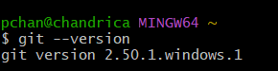

1. To configure user level configuration of user ID and email ID execute

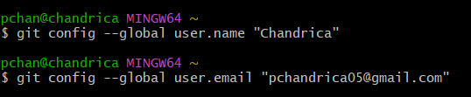

1. To check if the configuration is properly set, execute the following command.

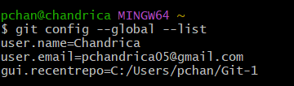

**Step 2: Integrate notepad++.exe to Git and make it a default editor**

1. To check, if notepad++.exe execute from Git bash



1. Exit Git bash shell, open bash shell and execute



Now, notepad++ will open from Git bash shell

1. To create an alias command for notepad++.exe, execute



1. To configure the editor, execute the command



1. To verify if notepad++ is the default editor, execute the command



**Step 3: Add a file to source code repository**

1. Open Git bash shell and create a new project “**GitDemo**” by executing the command

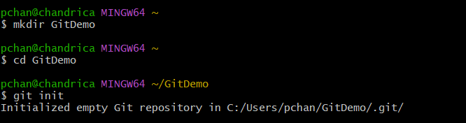

1. Git bash initializes the “**GitDemo**” repository.
2. To create a file **“welcome.txt”** and add content to the file, execute the command



1. To verify if the file “welcome.txt” is created and execute
2. To verify the content, execute the command



1. Check the status by executing

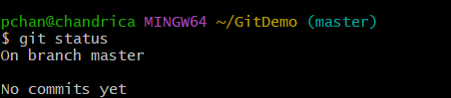

Now the file **“welcome.txt”** is available in Git “working directory”

1. To make the file to be tracked by Git repository, execute the command



1. To add multi line comments, we are opening default editor to comment. Execute the command



1. To check if local and “Working Directory” git repository are same, execute git status

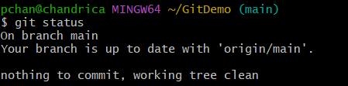

**welcome.txt** is added to the local repository.

1. Signup with GitHub and create a remote repository **“GitDemo”**
2. To pull the remote repository, execute

git pull

1. To push the local to remote repository, execute

git push

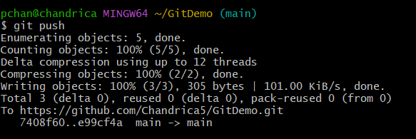

**HANDS-ON:02**

## **Objectives**

* Explain git ignore
* Explain how to ignore unwanted files using git ignore

In this hands-on lab, you will learn how to:

* Implement git ignore command to ignore unwanted files and folders

## **Prerequisites**

The following are the pre-requisites to complete this hands-on lab:

* Setting up Git environment
* Integrate notepad++ as a default editor
* A Git repository in the local system and a remote repository in GitLab

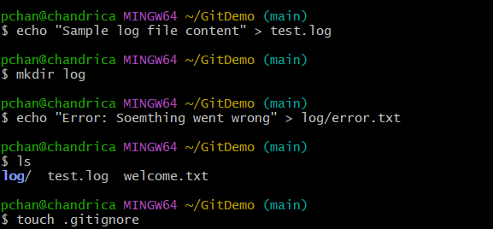 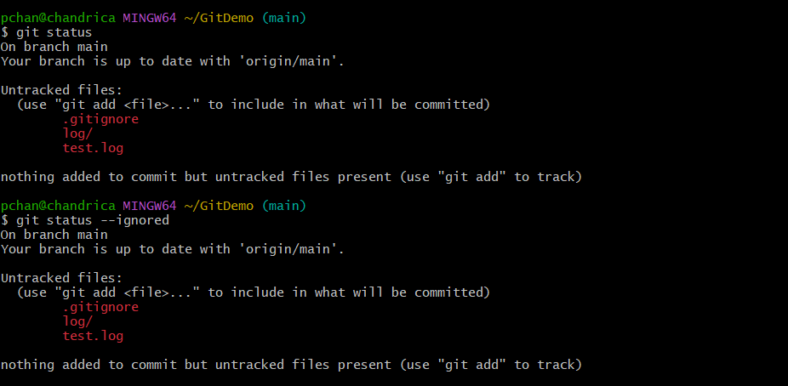

**HANDS-ON:03**

## **Objectives**

* Explain branching and merging
* Explain about creating a branch request in GitLab
* Explain about creating a merge request in GitLab

In this hands-on lab, you will learn how to:

* Construct a branch, do some changes in the branch, and merge it with master (or trunk)

## **Prerequisites**

The following are the pre-requisites to complete this hands-on lab:

* Setting up Git environment with P4Merge tool for Windows

**BRANCHING:**

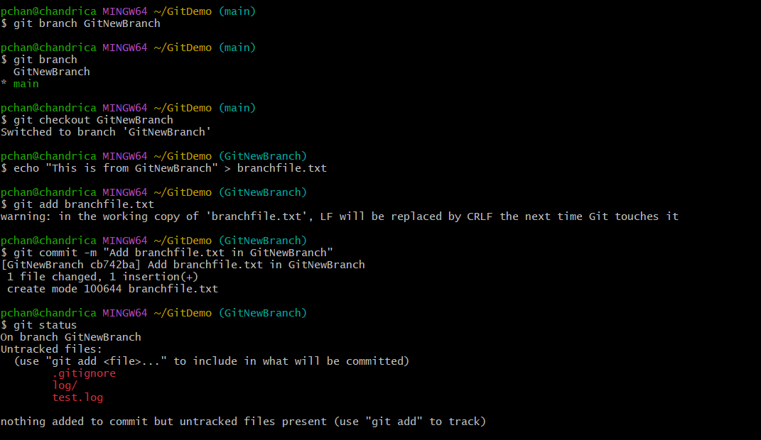

**MERGING:**

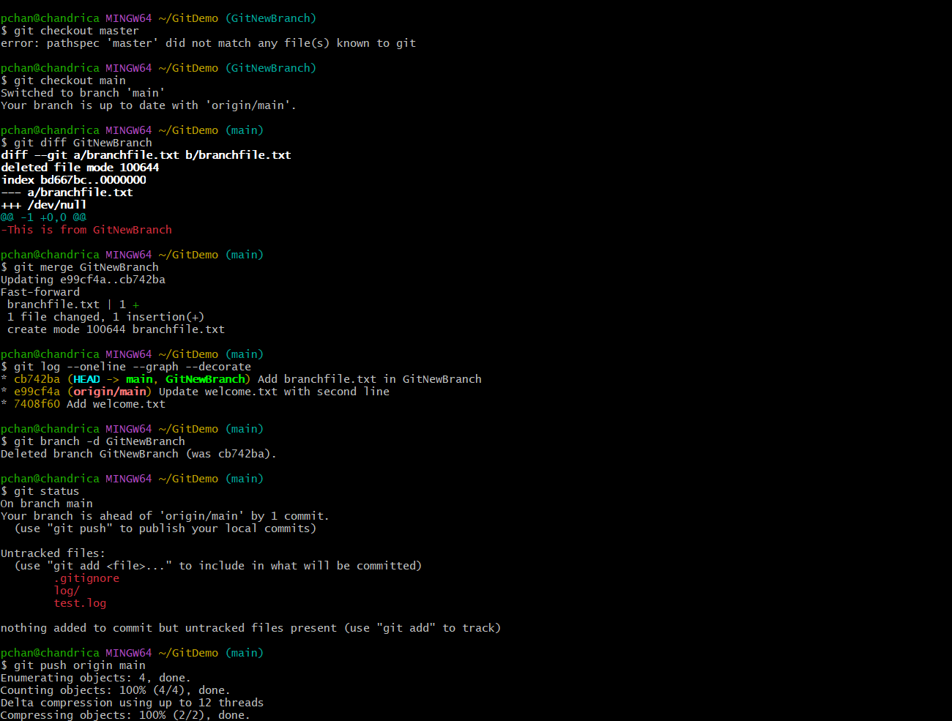

**HANDS-ON:04**

## **Objectives**

* Explain how to resolve the conflict during merge.

In this hands-on lab, you will learn how to:

* Implement conflict resolution when multiple users are updating the trunk (or master) in such a way that it results into a conflict with the branch’s modification.

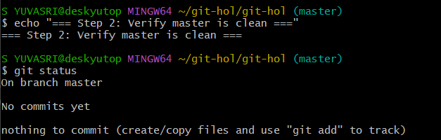

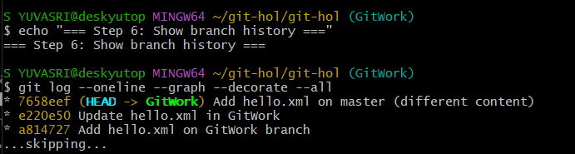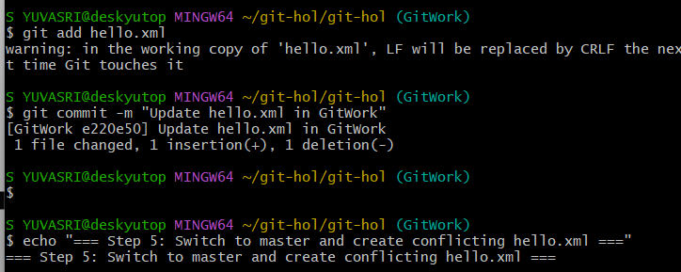

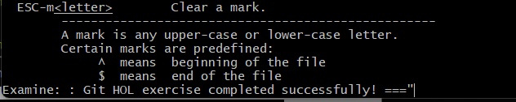

**HANDS-ON:05**

**Git commands to clean, update master, and push 'Git-T03-HOL_002' to remote.**

