POWER BI PROJECT
Retail Sales Analytics Dashboard

Project Overview
In this project, you will act as a Business Intelligence (BI) Analyst for a fictional retail company called NovaMart. You have been given one year of sales transaction data, customer information, product details, and salesperson records. Your job is to load this data into Power BI, transform it, build a data model, create meaningful measures, and design an interactive dashboard for NovaMart's management team.

Learning Objectives
By completing this project, you will be able to:
• Import and transform data using Power Query
• Create relationships between tables (data model)
• Write DAX measures and calculated columns
• Build interactive visualizations and slicers
• Design a professional, multi-page Power BI report

Dataset Files
You will be given one Excel file:
RetailSalesData.xlsx
It contains four sheets: Sales, Customers, Products, Salespersons

Grading Summary
Part 1 — Data Import & Transformation: 20 pts
Part 2 — Data Model & Relationships: 15 pts
Part 3 — DAX Measures: 25 pts
Part 4 — Visualizations & Report: 30 pts
Part 5 — Analysis Questions: 10 pts
Total: 100 pts

Dataset Description
The dataset contains 300 sales transactions from January 1, 2023 through December 31, 2023 across four related tables:

Table 1: Sales (300 rows)
Column | Type | Description
OrderID | Text | Unique identifier for each order (e.g. ORD0001)
Date | Date | Date the order was placed
CustomerID | Text | Links to the Customers table
SalespersonID | Text | Links to the Salespersons table
ProductID | Text | Links to the Products table
Category | Text | Product category (Electronics, Furniture, etc.)
Region | Text | Sales region (North, South, East, West, Central)
Units | Number | Number of units sold
UnitPrice | Currency | Selling price per unit
Discount | Decimal | Discount applied (0 = no discount, 0.10 = 10% off)
TotalRevenue | Currency | Final revenue after discount

Table 2: Customers (50 rows)
Column | Type | Description
CustomerID | Text | Unique customer identifier (e.g. C001)
CustomerName | Text | Customer name
Segment | Text | Customer type: Retail, Wholesale, Online, Corporate
City | Text | Customer city
Country | Text | Customer country
JoinDate | Date | Date customer first joined NovaMart
LoyaltyPoints | Number | Accumulated loyalty points

Table 3: Products (16 rows)
Column | Type | Description
ProductID | Text | Unique product identifier (e.g. P001)
ProductName | Text | Name of the product
Category | Text | Product category
CostPrice | Currency | What NovaMart pays the supplier
SellingPrice | Currency | Standard retail price
StockLevel | Number | Current units in stock
Supplier | Text | Supplier name

Table 4: Salespersons (5 rows)
Column | Type | Description
SalespersonID | Text | Unique salesperson ID (e.g. SP01)
Name | Text | Salesperson full name
Department | Text | B2B Sales, Retail Sales, or Online Sales
Region | Text | Assigned sales region
HireDate | Date | Date salesperson was hired
BaseSalary | Currency | Annual base salary

Part 1: Data Import & Transformation (20 pts)
In this section, you will load all four tables into Power BI and clean the data using Power Query Editor.

Step 1: Import the Data
- Open Power BI Desktop. Click Home > Get Data > Excel Workbook.
- Navigate to RetailSalesData.xlsx and click Open.
- In the Navigator, check all four sheets: Sales, Customers, Products, Salespersons.
- Click Transform Data to open Power Query Editor.

Step 2: Transform the Sales Table
Perform the following transformations in Power Query on the Sales table:

# | Task | Description | Points
1 | Rename Table | Rename the query from 'Sales' to 'FactSales' using the Query Properties panel. | 2 pts
2 | Set Date Type | Ensure the 'Date' column is set to the Date data type (not text). | 2 pts
3 | Discount % | Create a new column called 'DiscountPercent' by multiplying the Discount column by 100. Set type to Decimal Number. | 3 pts
4 | Month Column | Add a custom column called 'Month' using: Date.MonthName([Date]). Set type to Text. | 3 pts

Step 3: Transform the Customers Table
# | Task | Description | Points
1 | Rename Table | Rename the query to 'DimCustomers'. | 1 pt
2 | Capitalize City | Ensure the City column uses Proper Case (Transform > Format > Capitalize Each Word). | 1 pt
3 | Filter Country | Confirm all rows have 'USA' in the Country column. Remove any blank rows if found. | 1 pt

Step 4: Transform the Products Table
# | Task | Description | Points
1 | Rename Table | Rename the query to 'DimProducts'. | 1 pt
2 | Profit Margin | Add a custom column called 'GrossMargin' using formula: [SellingPrice] - [CostPrice] | 2 pts
3 | Margin % | Add another column 'MarginPct': [GrossMargin] / [SellingPrice]. Set to Percentage type. | 2 pts

Step 5: Transform the Salespersons Table
# | Task | Description | Points
1 | Rename Table | Rename the query to 'DimSalespersons'. | 1 pt

Click Close & Apply to load the transformed data into Power BI.

Part 2: Data Model & Relationships (15 pts)
Switch to the Model view in Power BI (click the Model icon on the left sidebar). You will define the relationships between your tables.

Required Relationships
Create the following relationships in the Model view. For each, drag the key column from the fact table to the dimension table (or use Manage Relationships).

From Table | Column | To Table | Column | Cardinality | Points
FactSales | CustomerID | DimCustomers | CustomerID | Many-to-One (*:1) | 3 pts
FactSales | ProductID | DimProducts | ProductID | Many-to-One (*:1) | 3 pts
FactSales | SalespersonID | DimSalespersons | SalespersonID | Many-to-One (*:1) | 3 pts

Note on Cross-filter Direction
Set all relationships to Single cross-filter direction (the arrow points from the dimension table to the fact table). This is best practice for a star schema model.

Verify Your Model (6 pts)
After creating all relationships, take a screenshot of your Model view and paste it below (or attach it to your submission). Your diagram should resemble a Star Schema with FactSales in the center.

Part 3: DAX Measures (25 pts)
Create a dedicated Measures Table to keep your work organized. In the Home tab, click Enter Data, create a blank table named '_Measures', and click Load. Then use this table to house all your DAX measures.

Write the following DAX measures. Each measure should be created in the FactSales table or the _Measures table. Pay attention to the instructions carefully.

Basic Measures
# | Task | Description | Points
1 | Total Revenue | Sum all values in the TotalRevenue column. Formula: Total Revenue = SUM(FactSales[TotalRevenue]) | 3 pts
2 | Total Units Sold | Count the total number of units sold across all orders. Formula: Total Units Sold = SUM(FactSales[Units]) | 2 pts
3 | Total Orders | Count the number of unique orders. Formula: Total Orders = DISTINCTCOUNT(FactSales[OrderID]) | 2 pts
4 | Average Order Value | Calculate average revenue per order. Formula: Avg Order Value = DIVIDE([Total Revenue], [Total Orders]) | 3 pts

Intermediate Measures
# | Task | Description | Points
1 | Gross Profit | Calculate profit by subtracting total cost from total revenue. Hint: Total Cost = SUMX(FactSales, FactSales[Units] * RELATED(DimProducts[CostPrice])) | 4 pts
2 | Gross Profit Margin % | Express gross profit as a percentage of total revenue. Formula: Gross Profit Margin % = DIVIDE([Gross Profit], [Total Revenue]) | 3 pts
3 | Discounted Orders | Count orders where a discount was applied (Discount > 0). Hint: Use CALCULATE with a filter. | 4 pts

Advanced Measures
# | Task | Description | Points
1 | Top Category Revenue | Return the revenue of the highest-selling category. Hint: Use MAXX + SUMMARIZE or TOPN. | 4 pts

Part 4: Visualizations & Report Design (30 pts)
Design a multi-page Power BI report. The report should be clean, professional, and easy for NovaMart management to use. Use a consistent color theme and include proper titles on all visuals.

Page 1: Executive Summary
This page gives management a high-level overview of annual performance. It should fit on one screen without scrolling.

# | Task | Description | Points
1 | KPI Cards | Add 4 KPI Card visuals showing: Total Revenue, Total Orders, Average Order Value, Gross Profit Margin %. | 4 pts
2 | Revenue by Month | Add a Line Chart showing Total Revenue (Y-axis) by Month (X-axis). Sort months chronologically. | 4 pts
3 | Revenue by Category | Add a Bar Chart or Donut Chart showing Total Revenue broken down by Category. | 4 pts
4 | Region Slicer | Add a Slicer for Region so that all visuals on this page can be filtered by region. | 2 pts

Page 2: Sales Performance
This page focuses on salesperson and customer performance.

# | Task | Description | Points
1 | Salesperson Table | Add a Table visual showing each salesperson's Name, Total Revenue, Total Orders, and Avg Order Value. Sort by Total Revenue descending. | 4 pts
2 | Revenue by Segment | Add a stacked bar or pie chart showing Revenue by Customer Segment (Retail, Wholesale, etc.). | 3 pts
3 | Top 10 Customers | Add a bar chart showing the Top 10 customers by Total Revenue. Apply a Top N filter. | 3 pts

Page 3: Product Insights
This page helps the purchasing team understand product performance and margins.

# | Task | Description | Points
1 | Product Revenue Table | Add a Table or Matrix showing ProductName, Category, Total Revenue, Total Units Sold, Gross Profit. | 3 pts
2 | Margin Chart | Add a Scatter Chart with Total Revenue on X-axis and Gross Profit Margin % on Y-axis. Use Category as the legend. | 3 pts

Part 5: Analysis Questions (10 pts)
Answer the following questions based on your completed Power BI report. Use your visuals and measures to find the answers. Write 2–3 sentences for each answer.

Question 1 (2 pts)
Which product category generated the most revenue in 2023, and what percentage of total revenue does it represent?

Your Answer:
The Electronics category generated most of the revenue among all the categories and the generated revenue percentage is 52% which is most highest generated revenue percentage and the second highest most generated
category is the Furniuture which is the 34% of the revenue.

Question 2 (2 pts)
Which region had the lowest total revenue? What recommendation would you give to NovaMart management to improve performance in that region?

Your Answer:
The lowest total revenue generated region is the North region. NovaMart management should focus on improving marketing campaigns, promotions, or expanding product availability in this region. Increasing local sales efforts or targeted discounts could help boost performance there.

Question 3 (2 pts)
Look at your Gross Profit Margin % by category. Which category is the most profitable in terms of margin percentage, and why do you think that might be?

Your Answer:
Electronics Categories has the most profitable Gross Profit Margin%.This may occur because the products in this category have lower cost prices compared to selling prices. Higher margins indicate that NovaMart earns more profit per sale in this category.

Question 4 (2 pts)
How many orders received a discount? What was the total revenue lost due to discounts (hint: compare discounted orders to full-price orders)?

Your Answer:
A total of 152 orders received a discount, while 148 orders were sold at full price. Based on the applied discount levels (5%, 10%, and 15%), the estimated revenue reduction due to discounts is approximately $40,000 out of the total $413,000 revenue. While discounts reduce potential revenue, they likely helped increase sales volume and attract more customers

Question 5 (2 pts)
Based on your Executive Summary page, in which month did NovaMart achieve its peak revenue? What business factors might explain a seasonal spike in sales?

Your Answer:
NovaMart achieved its highest revenue in June based on the revenue by month chart on the Executive Summary page. This spike may be due to seasonal demand, promotional campaigns, holiday shopping periods, or sales events that increase customer purchases

Submission Instructions
When you are finished, submit the following files:

- RetailSalesData_YourName.pbix — Your completed Power BI file
- This document with your written answers filled in (Part 5)
- A screenshot of your Model View (can be pasted in this document or submitted as a separate image)

Submission Format
Save your .pbix file as: PowerBI_YourFirstName_YourLastName.pbix

Grading Rubric Summary
Section | Max Points | Key Criteria
Part 1: Data Import & Transform | 20 pts | Correct table names, data types, new columns
Part 2: Data Model | 15 pts | 3 correct relationships, proper cardinality, screenshot submitted
Part 3: DAX Measures | 25 pts | Correct formulas, no errors, proper use of RELATED/CALCULATE
Part 4: Visualizations | 30 pts | Correct chart types, slicers work, professional design
Part 5: Analysis Questions | 10 pts | Accurate answers with insight and reasoning
TOTAL | 100 pts

Good luck! Remember — the goal is not just to complete the tasks,
but to tell a clear data story that helps NovaMart make better decisions.

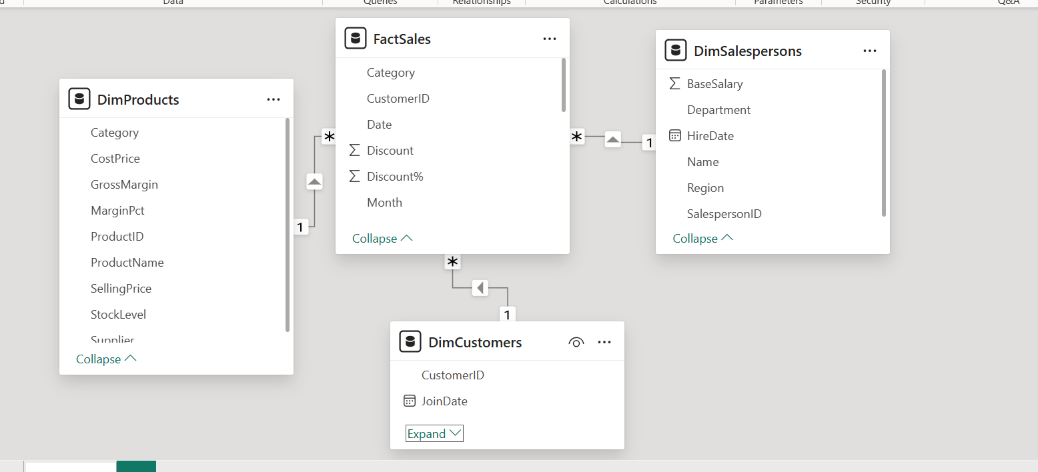

The Model View of the Retail Sales Analytics.

