Name - B.V.S. Chandrika
Date Of Submission - 27-10-2025
No. of programs solved - 30/50
Link to Folder - https://docs.google.com/document/d/1Xn2T-vgIeQATPjuZtrCRaXjFYIGKKtIcsWQpf2G0i-Q/edit?usp=drive_link

Q1] Develop a Java program to take user input for name and age and display a welcome message.

Input -
import java.util.Scanner; // We need this to get input from you!

public class SimpleWelcome {

public static void main(String[] args) {

// This helps us read what you type
Scanner keyboard = new Scanner(System.in);

// Ask for your name
System.out.println("What is your name?");
String yourName = keyboard.nextLine(); // We store your name here

// Ask for your age
System.out.println("How old are you?");
int yourAge = keyboard.nextInt(); // We store your age here

// Now, we say hello!
System.out.println("Hello there, " + yourName + "! You are " + yourAge + " years old. Nice to meet you!");

// Very important: close the keyboard reader when done!
keyboard.close();
}
}

Output -
What is your name?
Chandrika
How old are you?
20
Hello there, Chandrika! You are 20 years old. Nice to meet you!
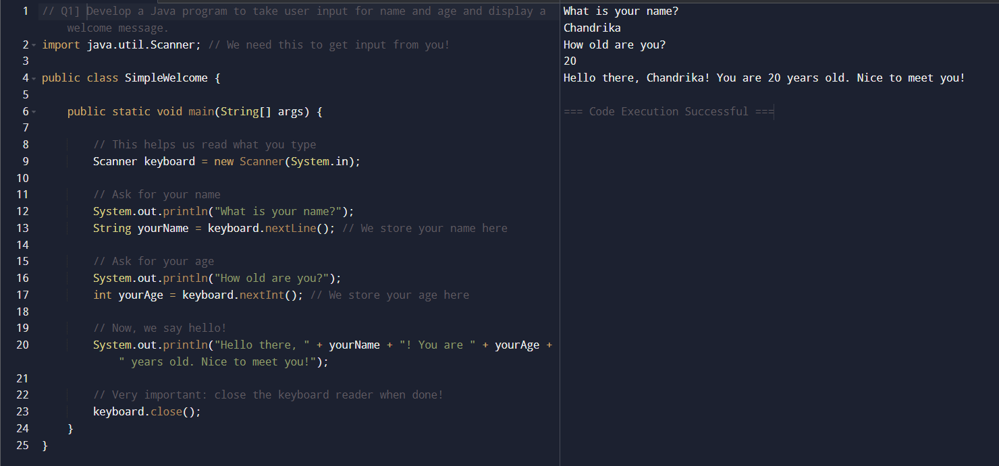

Q2] Write a Java program that takes two numbers and performs basic arithmetic operations (+, –, , /).

Input -
import java.util.Scanner; // We need this to get input from the user

public class BasicCalculator {

public static void main(String[] args) {

// Create a Scanner object to read input from the console
Scanner inputReader = new Scanner(System.in);

// --- Get the first number ---
System.out.println("Please enter the first number:");
double number1 = inputReader.nextDouble(); // Read the first number (can be decimal)

// --- Get the second number ---
System.out.println("Please enter the second number:");
double number2 = inputReader.nextDouble(); // Read the second number (can be decimal)

// --- Perform the arithmetic operations ---

// Addition
double sum = number1 + number2;
System.out.println("\nResults:"); // Add a newline for better formatting
System.out.println(number1 + " + " + number2 + " = " + sum);

// Subtraction
double difference = number1 - number2;
System.out.println(number1 + " - " + number2 + " = " + difference);

// Multiplication
double product = number1 * number2;
System.out.println(number1 + " * " + number2 + " = " + product);

// Division
// We need to be careful if the second number is zero!
if (number2 != 0) {
double quotient = number1 / number2;
System.out.println(number1 + " / " + number2 + " = " + quotient);
} else {
System.out.println("Cannot divide by zero!"); // Tell the user if they tried to divide by zero
}

// --- Close the scanner ---
// It's good practice to close the scanner when you're done with it
inputReader.close();
System.out.println("\nCalculation complete!");
}
}

Output -
Please enter the first number:
23
Please enter the second number:
45

Results:
23.0 + 45.0 = 68.0
23.0 - 45.0 = -22.0
23.0 * 45.0 = 1035.0
23.0 / 45.0 = 0.5111111111111111

Calculation complete!

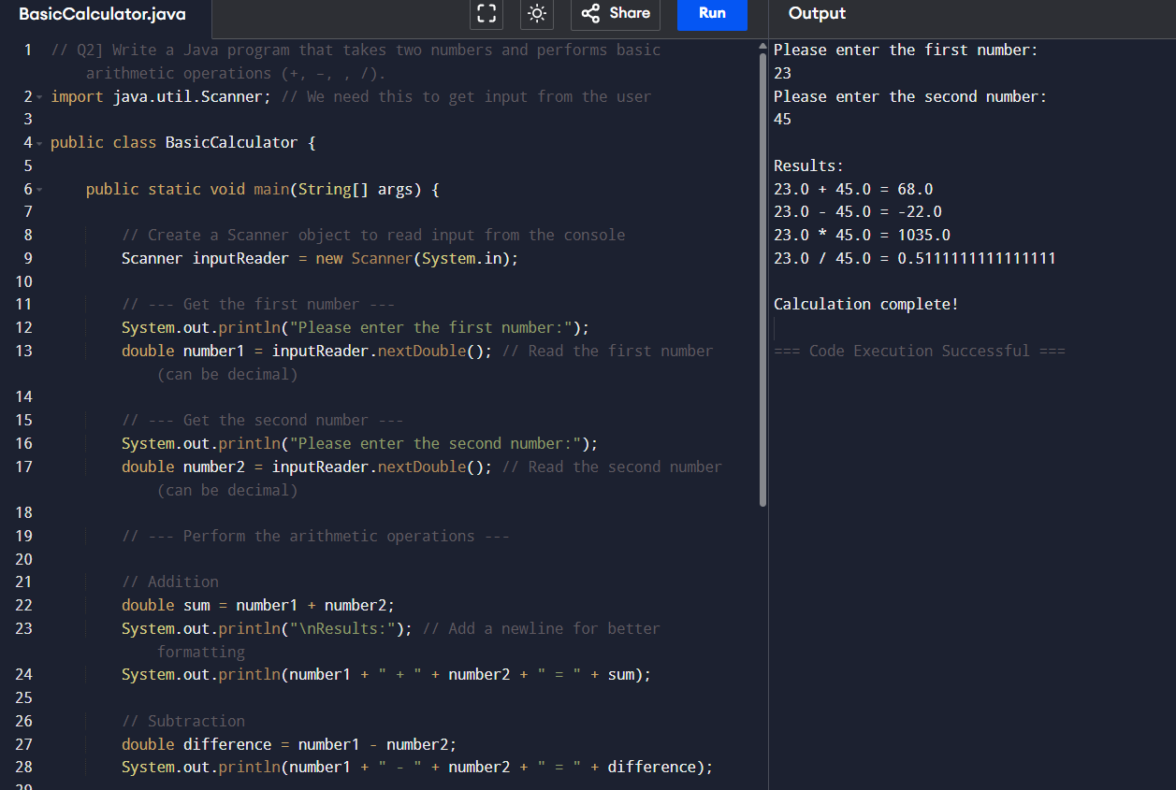

Q3] Create a program to convert temperature from Fahrenheit to Celsius.

Input -
import java.util.Scanner; // We need this to get input from the user

public class TemperatureConverter {

public static void main(String[] args) {

// Create a Scanner object to read input from the console
Scanner inputReader = new Scanner(System.in);

// --- Get temperature in Fahrenheit ---
System.out.println("Please enter the temperature in Fahrenheit:");
double fahrenheit = inputReader.nextDouble(); // Read the Fahrenheit temperature

// --- Perform the conversion to Celsius ---
// The formula for Fahrenheit to Celsius is: C = (F - 32) * 5/9
double celsius = (fahrenheit - 32) * 5.0 / 9.0; // Use 5.0 or 9.0 to ensure floating-point division

// --- Display the result ---
System.out.println("\n" + fahrenheit + " Fahrenheit is equal to " + celsius + " Celsius.");

// --- Close the scanner ---
// It's good practice to close the scanner when you're done with it
inputReader.close();
System.out.println("\nConversion complete!");
}
}

Output -
Please enter the temperature in Fahrenheit:
78

78.0 Fahrenheit is equal to 25.555555555555557 Celsius.

Conversion complete!

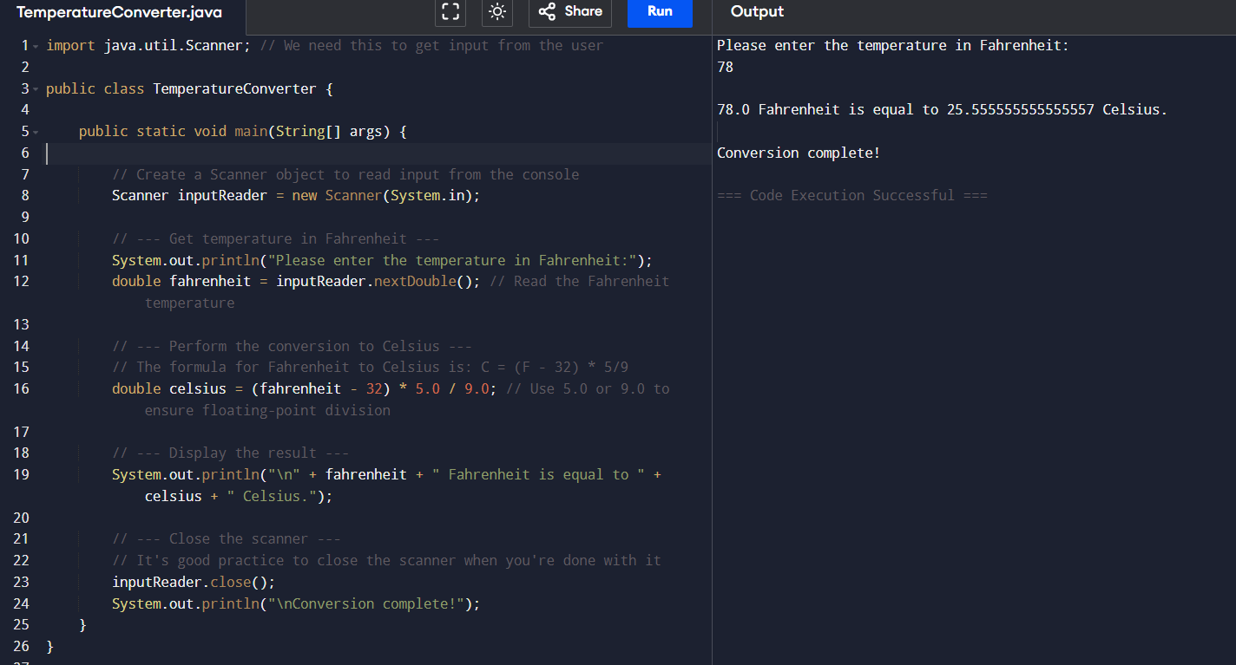

Q4] Design a Java application to calculate simple interest using the formula: SI = (P × R × T) / 100.

Input -
import java.util.Scanner; // Needed to get input from the user

public class SimpleInterestCalculator {

public static void main(String[] args) {

// Create a Scanner object to read input from the console
Scanner inputReader = new Scanner(System.in);

// --- Get the Principal amount (P) ---
System.out.println("Enter the Principal amount (P):");
double principal = inputReader.nextDouble(); // Read the principal amount

// --- Get the Annual Interest Rate (R) ---
System.out.println("Enter the Annual Interest Rate (R) in percentage (e.g., for 5%, enter 5):");
double rate = inputReader.nextDouble(); // Read the interest rate

// --- Get the Time period (T) ---
System.out.println("Enter the Time period (T) in years:");
double time = inputReader.nextDouble(); // Read the time period

// --- Calculate Simple Interest (SI) ---
// Formula: SI = (P * R * T) / 100
double simpleInterest = (principal * rate * time) / 100.0; // Use 100.0 for floating-point division

// --- Display the result ---
System.out.println("\n--- Simple Interest Calculation ---");
System.out.println("Principal Amount: $" + String.format("%.2f", principal));
System.out.println("Annual Interest Rate: " + String.format("%.2f", rate) + "%");
System.out.println("Time Period: " + String.format("%.2f", time) + " years");
System.out.println("---------------------------------");
System.out.println("Simple Interest (SI): $" + String.format("%.2f", simpleInterest));
System.out.println("---------------------------------");

// --- Close the scanner ---
// It's good practice to close the scanner to free up system resources
inputReader.close();
System.out.println("\nCalculation complete!");
}
}

Output -
Enter the Principal amount (P):
6790
Enter the Annual Interest Rate (R) in percentage (e.g., for 5%, enter 5):
89
Enter the Time period (T) in years:
2

--- Simple Interest Calculation ---
Principal Amount: $6790.00
Annual Interest Rate: 89.00%
Time Period: 2.00 years
---------------------------------
Simple Interest (SI): $12086.20
---------------------------------

Calculation complete!

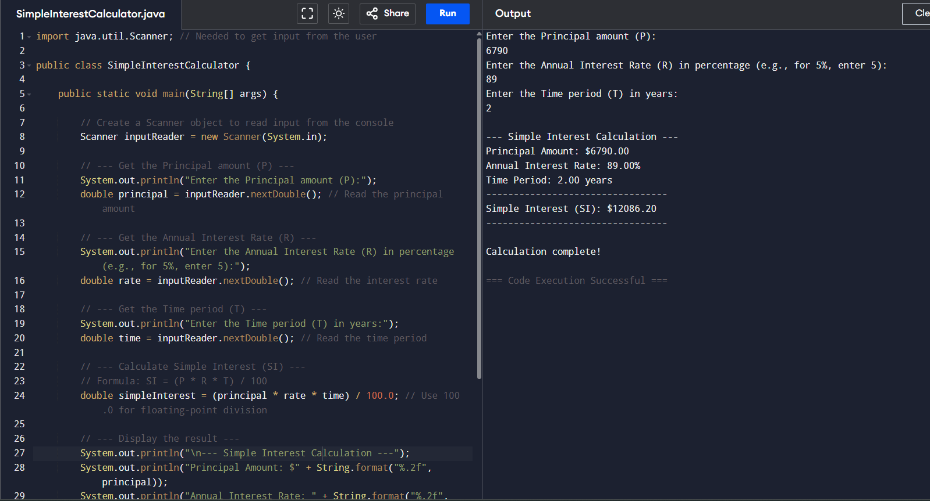

Q5] Write a Java program to determine whether a given year is a leap year.

Input -
import java.util.Scanner; // Needed to get input from the user

public class LeapYearChecker {

public static void main(String[] args) {

// Create a Scanner object to read input from the console
Scanner inputReader = new Scanner(System.in);

// --- Get the year from the user ---
System.out.println("Enter a year to check if it's a leap year:");
int year = inputReader.nextInt(); // Read the year as an integer

// --- Determine if it's a leap year using the rules ---
boolean isLeapYear;

// Rule 1: A year is a leap year if it is divisible by 4
// Rule 2: EXCEPT if it is divisible by 100
// Rule 3: BUT it IS a leap year if it is divisible by 400
if ((year % 4 == 0 && year % 100 != 0) || (year % 400 == 0)) {
isLeapYear = true;
} else {
isLeapYear = false;
}

// --- Display the result ---
if (isLeapYear) {
System.out.println(year + " is a leap year.");
} else {
System.out.println(year + " is NOT a leap year.");
}

// --- Close the scanner ---
// It's good practice to close the scanner to free up system resources
inputReader.close();
System.out.println("\nCheck complete!");
}
}

Output -
Enter a year to check if it's a leap year:
2023
2023 is NOT a leap year.

Check complete!

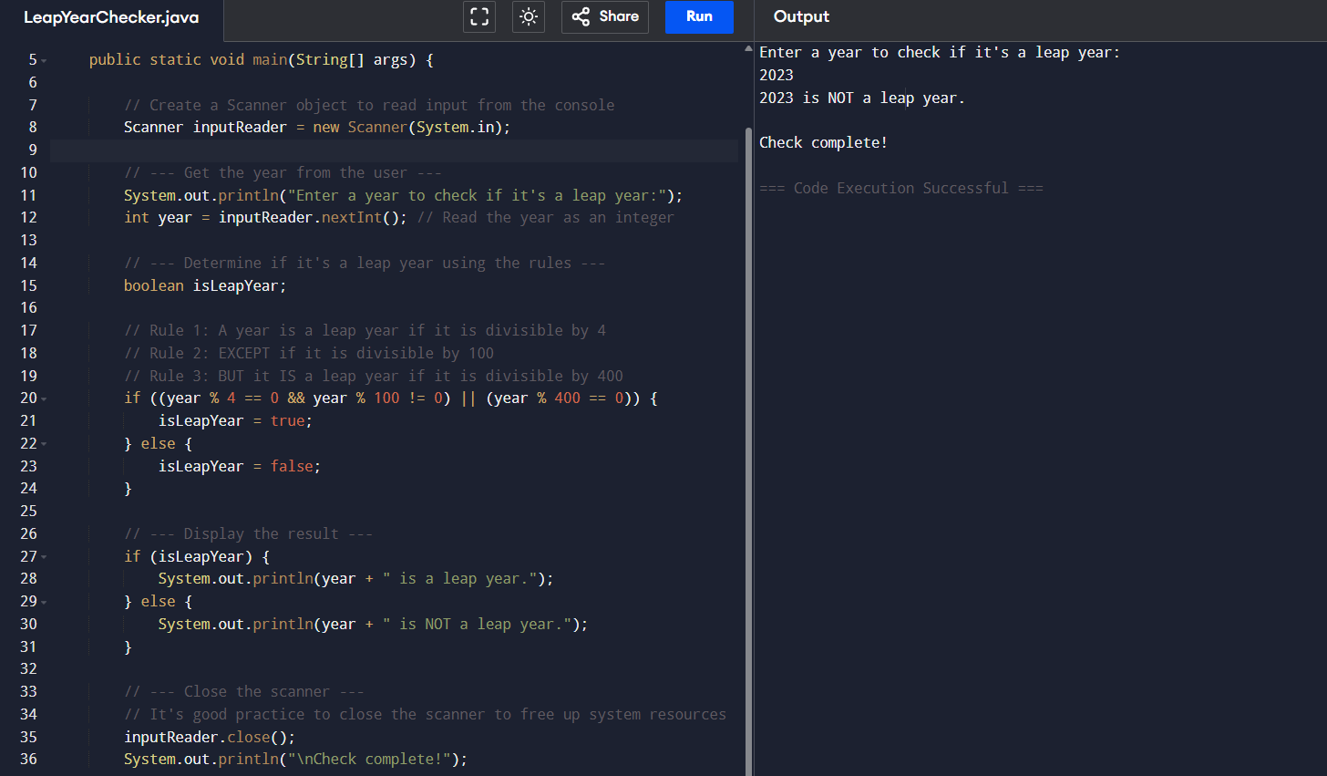

Q6] Develop a program to check whether an input number is prime or not using for loop..
Input -
import java.util.Scanner; // Needed to get input from the user

public class PrimeNumberChecker {

public static void main(String[] args) {

// Create a Scanner object to read input from the console
Scanner inputReader = new Scanner(System.in);

// --- Get the number from the user ---
System.out.println("Enter a positive integer to check if it's a prime number:");
int number = inputReader.nextInt(); // Read the integer from the user

// --- Determine if the number is prime ---
boolean isPrime = true; // Assume the number is prime initially

// Prime numbers are natural numbers greater than 1 that have no positive
// divisors other than 1 and themselves.

if (number <= 1) {
// Numbers less than or equal to 1 are not prime by definition
isPrime = false;
} else {
// We only need to check for divisors from 2 up to the square root of the number.
// If a number 'n' has a divisor 'd' greater than its square root,
// then it must also have a divisor 'n/d' which is less than its square root.
// So, checking up to sqrt(n) is sufficient.
for (int i = 2; i * i <= number; i++) {
if (number % i == 0) {
// If the number is divisible by 'i', it's not prime
isPrime = false;
break; // No need to check further, we found a divisor
}
}
}

// --- Display the result ---
if (isPrime) {
System.out.println(number + " is a prime number.");
} else {
System.out.println(number + " is NOT a prime number.");
}

// --- Close the scanner ---
// It's important to close the scanner to release system resources
inputReader.close();
System.out.println("\nCheck complete!");
}
}

Output -
Enter a positive integer to check if it's a prime number:
3

3 is a prime number.

Check complete!

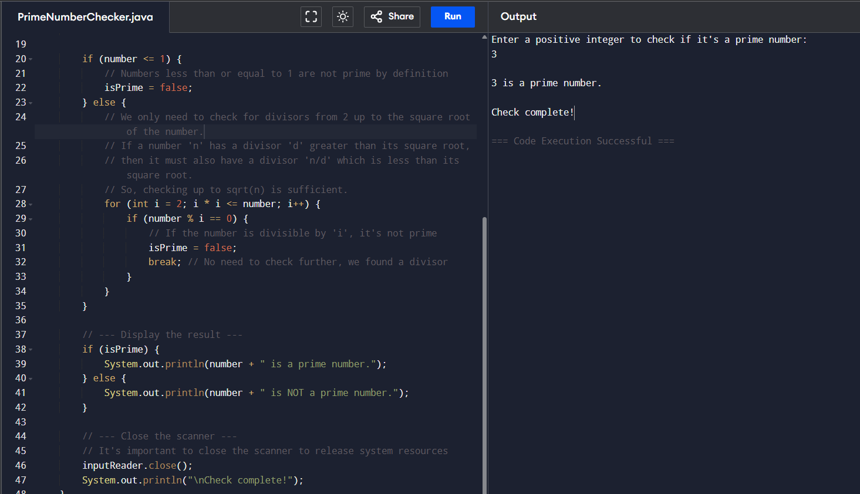

Q7] Write a program to reverse a number using a while loop.

Input -
class Main {
public static void main(String[] args) {

int num = 1234567, reversed = 0;

for(;num != 0; num /= 10) {
int digit = num % 10;
reversed = reversed * 10 + digit;
}

System.out.println("Reversed Number: " + reversed);
}
}

Output -

Reversed Number: 7654321

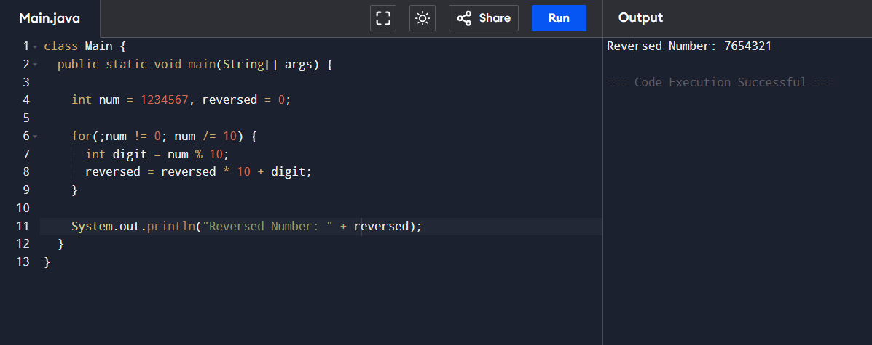

Q8] Create a Java application to generate Fibonacci series up to a given number using a do-while loop..
Input -
class Main {
public static void main(String[] args) {

int i = 1, n = 10, firstTerm = 0, secondTerm = 1;
System.out.println("Fibonacci Series till " + n + " terms:");

while (i <= n) {
System.out.print(firstTerm + ", ");

int nextTerm = firstTerm + secondTerm;
firstTerm = secondTerm;
secondTerm = nextTerm;

i++;
}
}
}

Output -
Fibonacci Series till 10 terms:
0, 1, 1, 2, 3, 5, 8, 13, 21, 34,

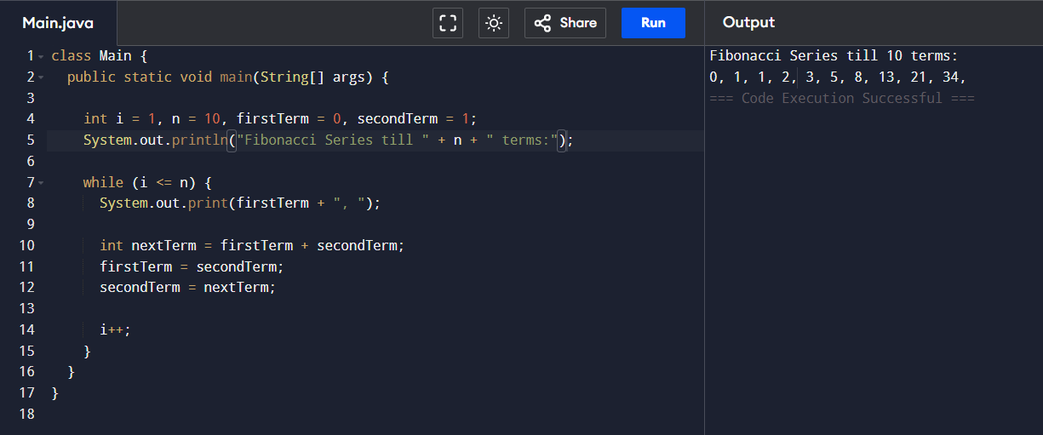

Q9] Design a recursive program to compute the factorial of a number using function.
Input -
import java.util.Scanner;

public class FactorialRecursive {

// Recursive function to compute factorial
static long factorial(int n) {
if (n == 0 || n == 1) { // Base case
return 1;
} else {
return n * factorial(n - 1); // Recursive call
}
}

public static void main(String[] args) {
Scanner sc = new Scanner(System.in);

System.out.print("Enter a number: ");
int num = sc.nextInt();

long result = factorial(num);
System.out.println("Factorial of " + num + " is: " + result);

sc.close();
}
}

Output -
Enter a number: 234
Factorial of 234 is: 0
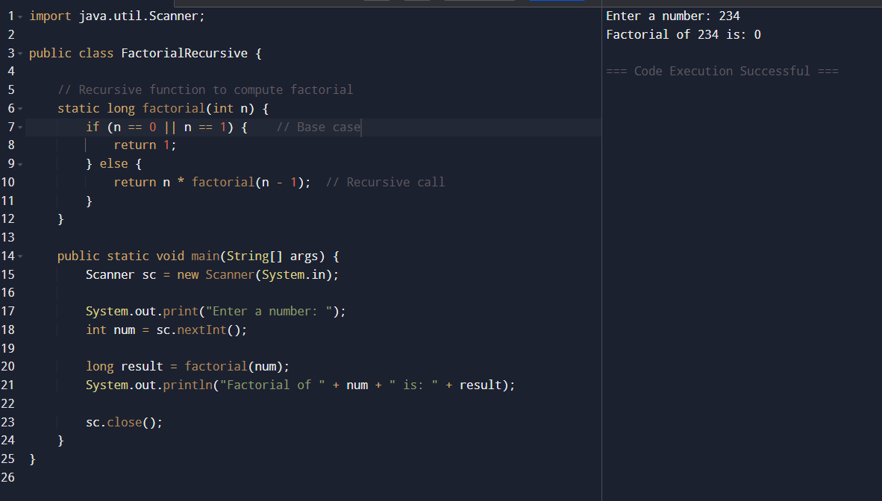

Q10] Implement a program to check whether a given number is an Armstrong number.

Input -

import java.util.Scanner;

public class ArmstrongNumber {

public static void main(String[] args) {
Scanner sc = new Scanner(System.in);

System.out.print("Enter a number: ");
int num = sc.nextInt();

if (isArmstrong(num)) {
System.out.println(num + " is an Armstrong number.");
} else {
System.out.println(num + " is not an Armstrong number.");
}

sc.close();
}

// Function to check Armstrong number
static boolean isArmstrong(int num) {
int original = num;
int digits = 0;

// Count digits
int temp = num;
while (temp != 0) {
digits++;
temp /= 10;
}

// Calculate sum of digits raised to 'digits'
int sum = 0;
temp = num;
while (temp != 0) {
int digit = temp % 10;
sum += Math.pow(digit, digits);
temp /= 10;
}

return sum == original;
}
}

Output -

Enter a number: 34567
34567 is not an Armstrong number.

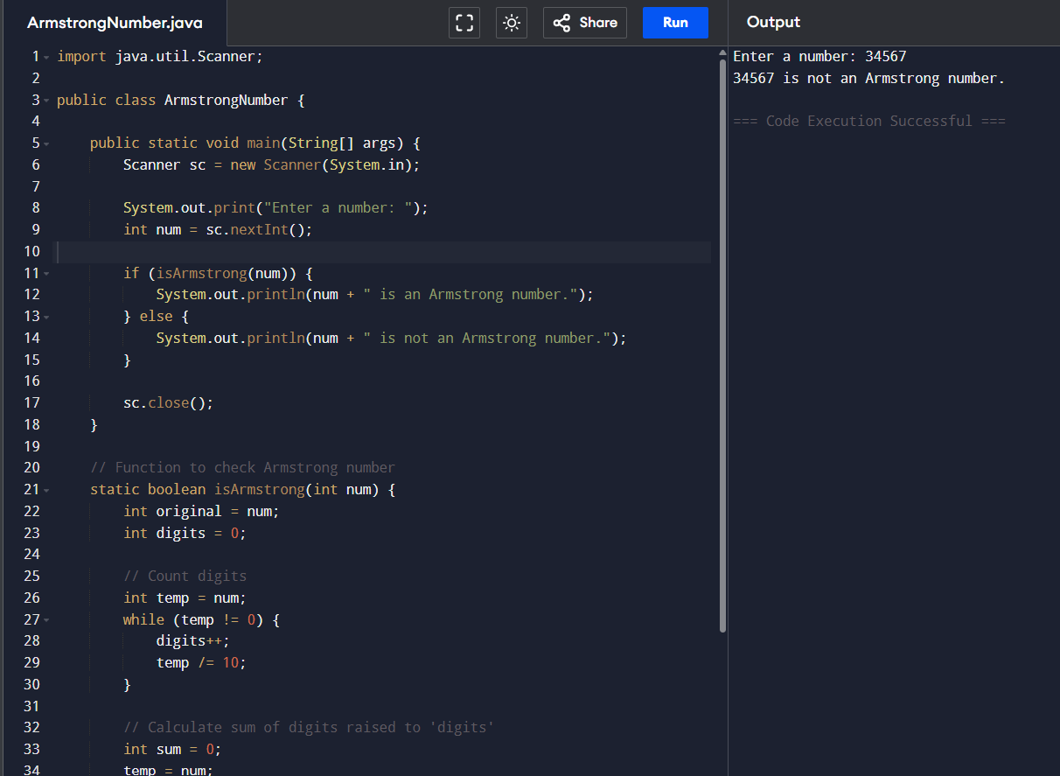
Q11] Write a Java program to find the largest and smallest number in an array.
Input -
import java.util.Scanner;

public class LargestSmallestInArray {
public static void main(String[] args) {
Scanner sc = new Scanner(System.in);

System.out.print("Enter number of elements: ");
int n = sc.nextInt();
int[] arr = new int[n];

System.out.println("Enter " + n + " numbers:");
for (int i = 0; i < n; i++) {
arr[i] = sc.nextInt();
}

// Initialize both to the first element
int largest = arr[0];
int smallest = arr[0];

// Loop through the array
for (int i = 1; i < n; i++) {
if (arr[i] > largest) {
largest = arr[i];
}
if (arr[i] < smallest) {
smallest = arr[i];
}
}

System.out.println("Largest number = " + largest);
System.out.println("Smallest number = " + smallest);

sc.close();
}
}

Output -
Enter number of elements: 3
Enter 3 numbers:
34 67 89
Largest number = 89
Smallest number = 34

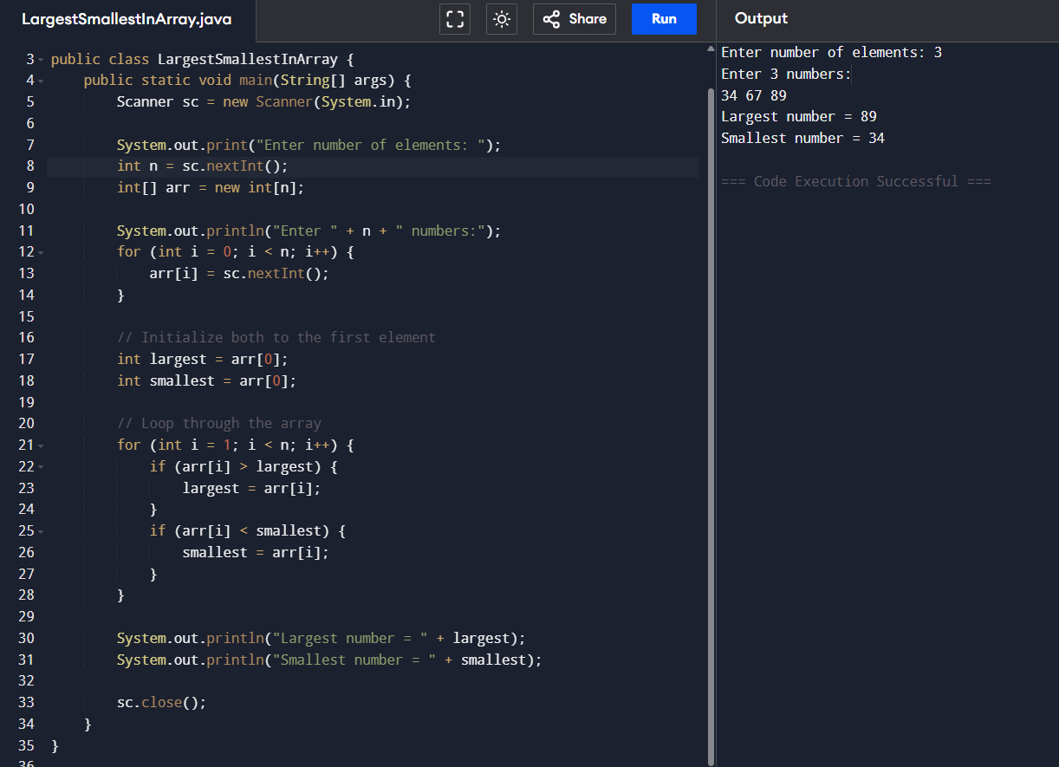

Q12] Develop a program to sort an array using bubble sort algorithm.
Input -
import java.util.Scanner;

public class BubbleSortExample {
public static void main(String[] args) {
Scanner sc = new Scanner(System.in);

System.out.print("Enter number of elements: ");
int n = sc.nextInt();
int[] arr = new int[n];

System.out.println("Enter " + n + " numbers:");
for (int i = 0; i < n; i++) {
arr[i] = sc.nextInt();
}

// Bubble Sort
for (int i = 0; i < n - 1; i++) {
for (int j = 0; j < n - i - 1; j++) {
if (arr[j] > arr[j + 1]) {
// Swap arr[j] and arr[j+1]
int temp = arr[j];
arr[j] = arr[j + 1];
arr[j + 1] = temp;
}
}
}

System.out.println("Sorted array (ascending order):");
for (int num : arr) {
System.out.print(num + " ");
}

sc.close();
}
}

Output -
Enter number of elements: 3
Enter 3 numbers:
34 12 24
Sorted array (ascending order):
12 24 34

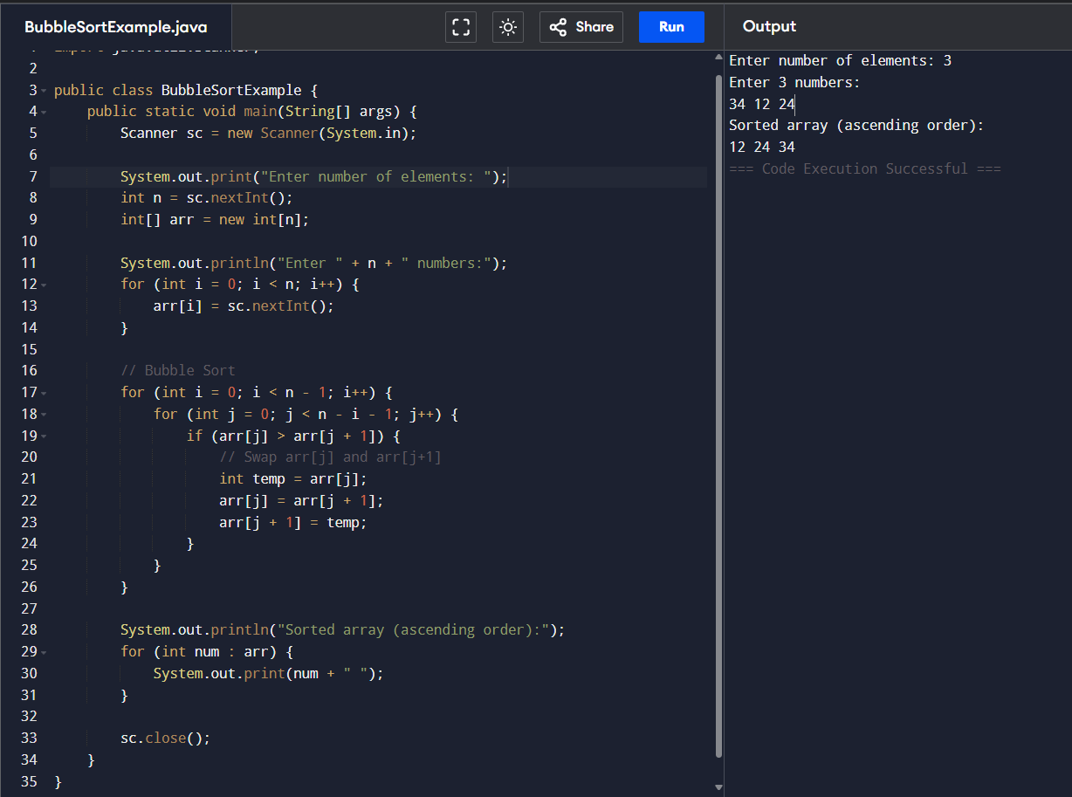

Q13] Implement linear search to find an element in an array.
Input -
import java.util.Scanner;

public class LinearSearchExample {
public static void main(String[] args) {
Scanner sc = new Scanner(System.in);

System.out.print("Enter number of elements: ");
int n = sc.nextInt();
int[] arr = new int[n];

System.out.println("Enter " + n + " numbers:");
for (int i = 0; i < n; i++) {
arr[i] = sc.nextInt();
}

System.out.print("Enter element to search: ");
int key = sc.nextInt();

int index = -1; // to store position if found
for (int i = 0; i < n; i++) {
if (arr[i] == key) {
index = i; // store index
break; // stop searching after found
}
}

if (index != -1) {
System.out.println("Element " + key + " found at position " + (index + 1));
} else {
System.out.println("Element " + key + " not found in the array.");
}

sc.close();
}
}

Output -
Enter number of elements: 3
Enter 3 numbers:
45 23 78
Enter element to search: 78
Element 78 found at position 3

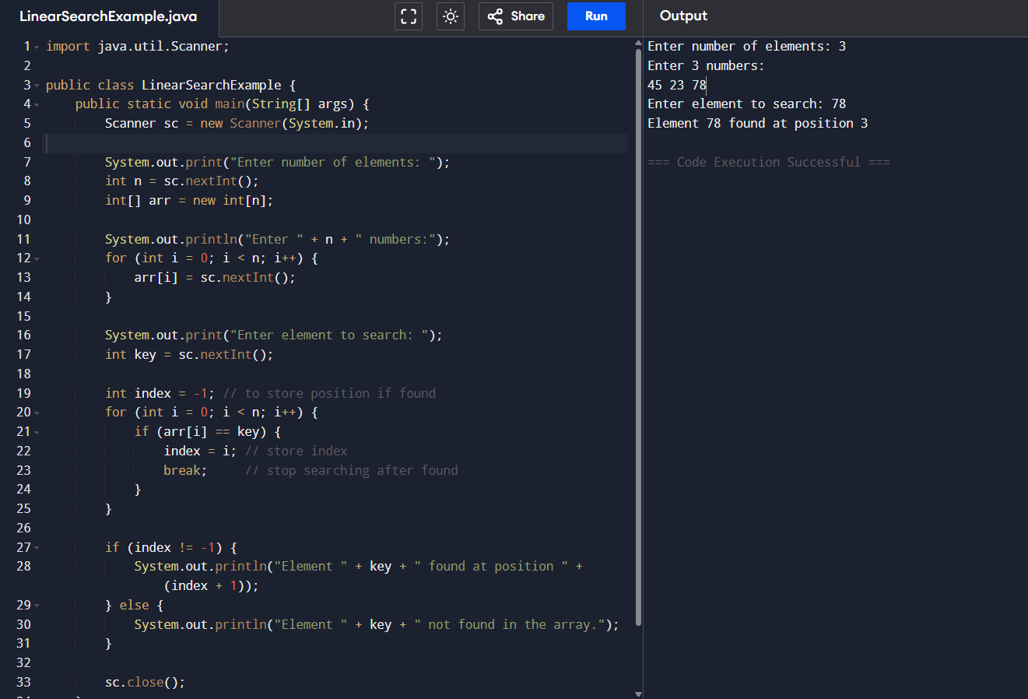

Q14] Implement binary search to find an element in an array.
Input -
import java.util.Arrays;
import java.util.Scanner;

public class BinarySearchExample {
public static void main(String[] args) {
Scanner sc = new Scanner(System.in);

System.out.print("Enter number of elements: ");
int n = sc.nextInt();
int[] arr = new int[n];

System.out.println("Enter " + n + " numbers:");
for (int i = 0; i < n; i++) {
arr[i] = sc.nextInt();
}

// Ensure array is sorted before binary search
Arrays.sort(arr);

System.out.print("Enter element to search: ");
int key = sc.nextInt();

int index = binarySearch(arr, key);

if (index != -1) {
System.out.println("Element " + key + " found at position " + (index + 1));
} else {
System.out.println("Element " + key + " not found in the array.");
}

sc.close();
}

// Iterative Binary Search
static int binarySearch(int[] arr, int key) {
int low = 0, high = arr.length - 1;

while (low <= high) {
int mid = (low + high) / 2; // middle index

if (arr[mid] == key) {
return mid; // found
} else if (arr[mid] < key) {
low = mid + 1; // search right half
} else {
high = mid - 1; // search left half
}
}

return -1; // not found
}
}

Output -
Enter number of elements: 4
Enter 4 numbers:
12 34 56 23
Enter element to search: 45
Element 45 not found in the array.

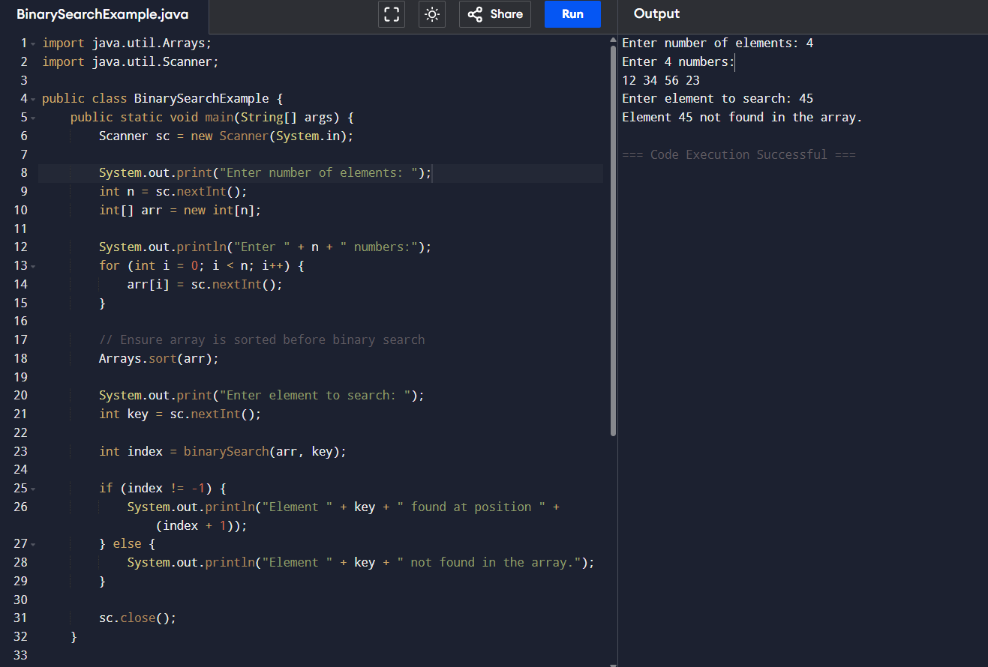

Q15] Write a Java program to perform matrix addition using for loop.

Input -
import java.util.Scanner;

public class MatrixAddition {
public static void main(String[] args) {
Scanner sc = new Scanner(System.in);

// Get dimensions of the matrices
System.out.print("Enter number of rows: ");
int rows = sc.nextInt();
System.out.print("Enter number of columns: ");
int cols = sc.nextInt();

int[][] a = new int[rows][cols];
int[][] b = new int[rows][cols];
int[][] sum = new int[rows][cols];

// Input first matrix
System.out.println("Enter elements of first matrix:");
for (int i = 0; i < rows; i++) {
for (int j = 0; j < cols; j++) {
a[i][j] = sc.nextInt();
}
}

// Input second matrix
System.out.println("Enter elements of second matrix:");
for (int i = 0; i < rows; i++) {
for (int j = 0; j < cols; j++) {
b[i][j] = sc.nextInt();
}
}

// Add the matrices
for (int i = 0; i < rows; i++) {
for (int j = 0; j < cols; j++) {
sum[i][j] = a[i][j] + b[i][j];
}
}

// Display result
System.out.println("Sum of the two matrices:");
for (int i = 0; i < rows; i++) {
for (int j = 0; j < cols; j++) {
System.out.print(sum[i][j] + "\t");
}
System.out.println();
}

sc.close();
}
}

Output -
Enter number of rows: 2
Enter number of columns: 2
Enter elements of first matrix:
12 34
56 16

Enter elements of second matrix:
45 67 89 32
Sum of the two matrices:
57 101
145 48

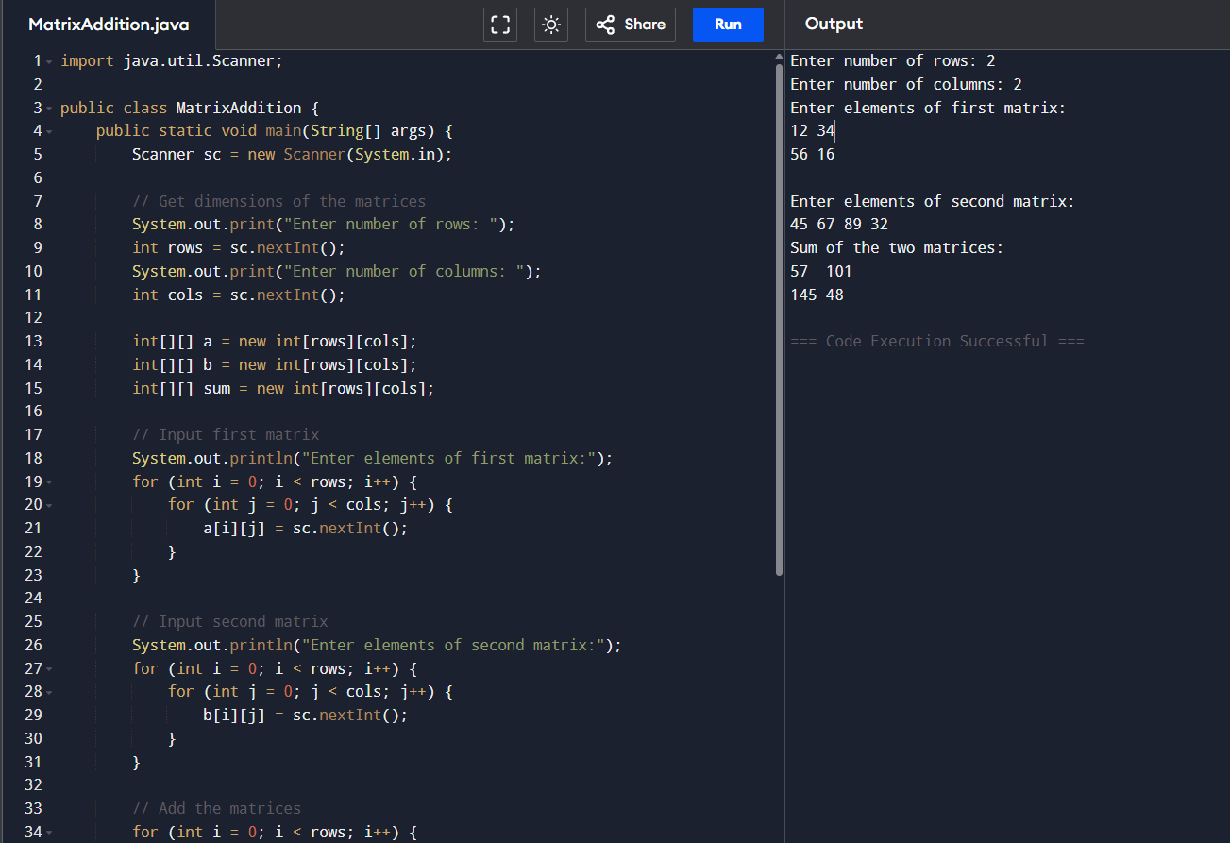

Q16] Write a java program to find the sum of diagonal elements in an array.

Input -
import java.util.Scanner;

public class DiagonalSum {
public static void main(String[] args) {
Scanner sc = new Scanner(System.in);

System.out.print("Enter size of square matrix (n x n): ");
int n = sc.nextInt();

int[][] matrix = new int[n][n];

// Input matrix
System.out.println("Enter the elements of the matrix:");
for (int i = 0; i < n; i++) {
for (int j = 0; j < n; j++) {
matrix[i][j] = sc.nextInt();
}
}

int primarySum = 0;
int secondarySum = 0;

// Calculate sums of diagonals
for (int i = 0; i < n; i++) {
primarySum += matrix[i][i]; // Primary diagonal (top-left to bottom-right)
secondarySum += matrix[i][n - i - 1]; // Secondary diagonal (top-right to bottom-left)
}

System.out.println("Sum of primary diagonal elements = " + primarySum);
System.out.println("Sum of secondary diagonal elements = " + secondarySum);

sc.close();
}
}

Output -
Enter size of square matrix (n x n): 2 2
Enter the elements of the matrix:
23 45 67 89
Sum of primary diagonal elements = 69
Sum of secondary diagonal elements = 68

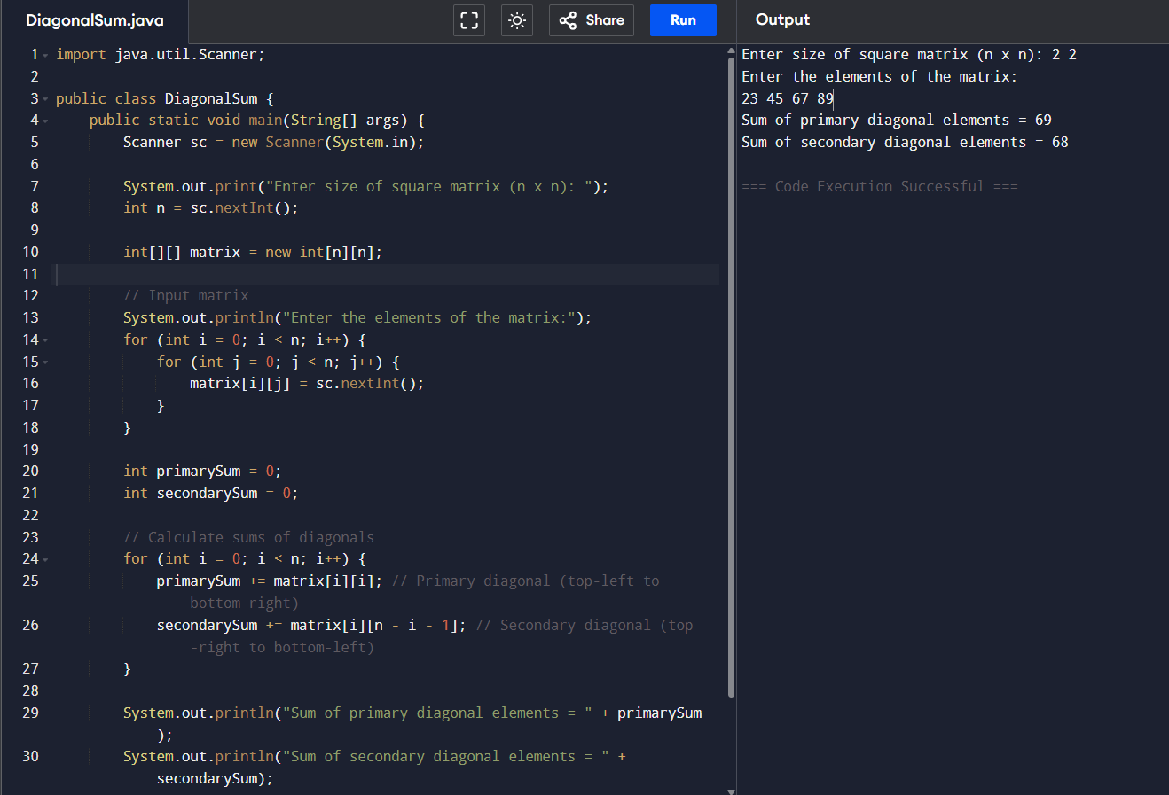

Q17] Check whether a given string is a palindrome.
Input -
import java.util.Scanner;

public class PalindromeString {
public static void main(String[] args) {
Scanner sc = new Scanner(System.in);

System.out.print("Enter a string: ");
String str = sc.nextLine();

// Normalize: remove spaces and make lower case (optional)
str = str.replaceAll("\\s+", "").toLowerCase();

if (isPalindrome(str)) {
System.out.println("The string is a palindrome.");
} else {
System.out.println("The string is not a palindrome.");
}

sc.close();
}

static boolean isPalindrome(String str) {
int left = 0;
int right = str.length() - 1;

while (left < right) {
if (str.charAt(left) != str.charAt(right)) {
return false; // mismatch
}
left++;
right--;
}
return true; // all characters matched
}
}

Output -
Enter a string: chandrika
The string is not a palindrome.

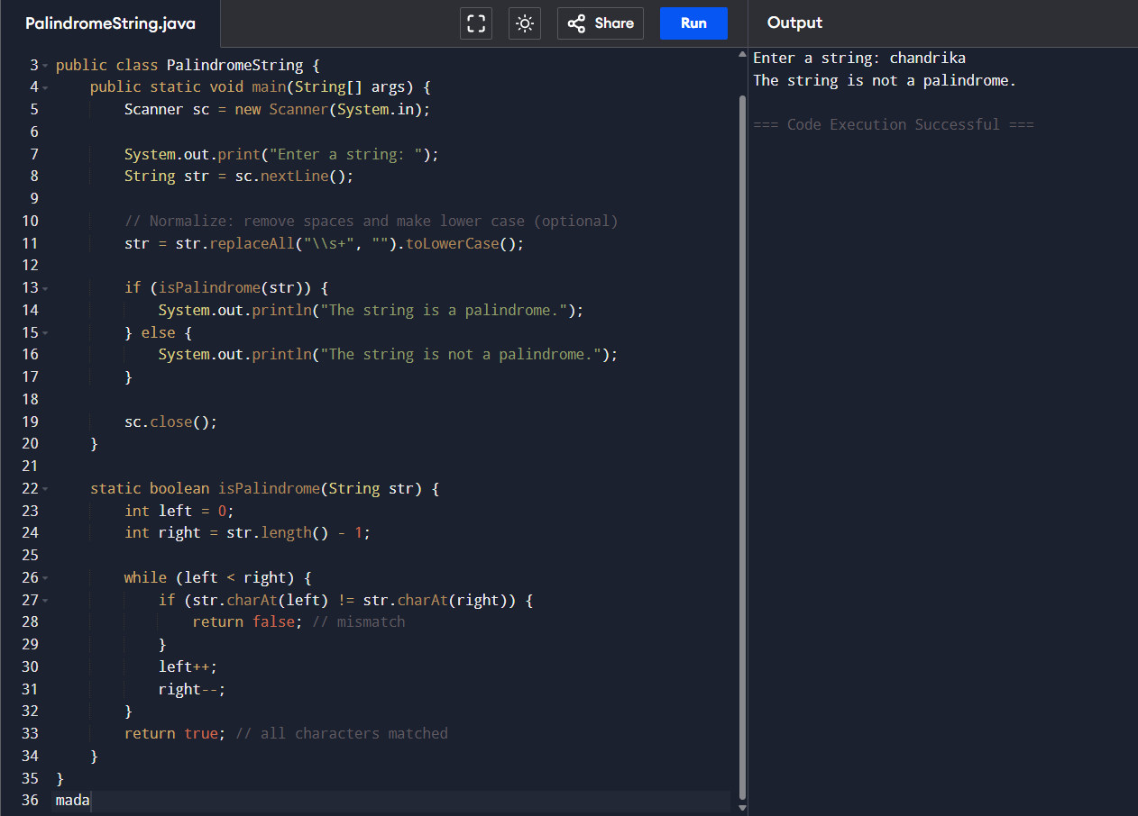

Q18] Count the number of vowels, consonants, digits, and special characters in a string.

Input -
import java.util.Scanner;

public class StringCharacterCounter {
public static void main(String[] args) {
Scanner sc = new Scanner(System.in);

System.out.print("Enter a string: ");
String str = sc.nextLine();

// Initialize counters
int vowels = 0, consonants = 0, digits = 0, specialChars = 0;

str = str.toLowerCase(); // for easier comparison

for (int i = 0; i < str.length(); i++) {
char ch = str.charAt(i);

if (ch >= 'a' && ch <= 'z') { // letter
if (ch == 'a' || ch == 'e' || ch == 'i' || ch == 'o' || ch == 'u') {
vowels++;
} else {
consonants++;
}
} else if (ch >= '0' && ch <= '9') { // digit
digits++;
} else if (ch != ' ') { // anything else except space
specialChars++;
}
}

System.out.println("Number of vowels: " + vowels);
System.out.println("Number of consonants: " + consonants);
System.out.println("Number of digits: " + digits);
System.out.println("Number of special characters: " + specialChars);

sc.close();
}
}

Output -
Enter a string: chandrika
Number of vowels: 3
Number of consonants: 6
Number of digits: 0
Number of special characters: 0

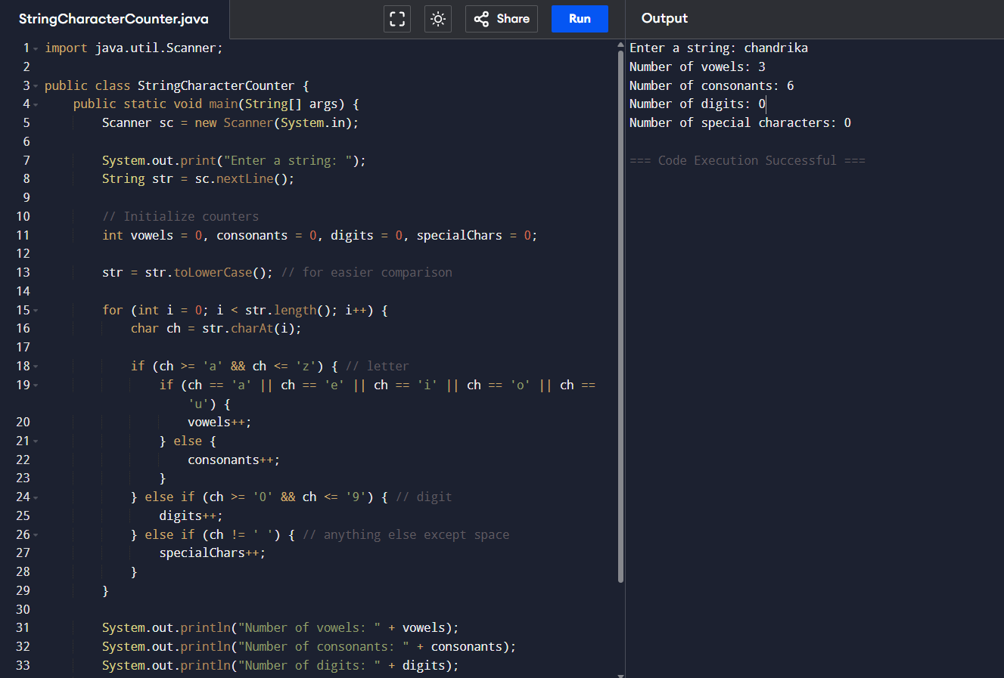

Q19] Program to reverse the string using predefined methods in String class.

Input -
import java.util.Scanner;

public class ReverseString {
public static void main(String[] args) {
Scanner sc = new Scanner(System.in);

System.out.print("Enter a string: ");
String str = sc.nextLine();

// Using StringBuilder’s reverse() method
String reversed = new StringBuilder(str).reverse().toString();

System.out.println("Reversed string: " + reversed);

sc.close();
}
}

Output -
Enter a string: chandrika
Reversed string: akirdnahc

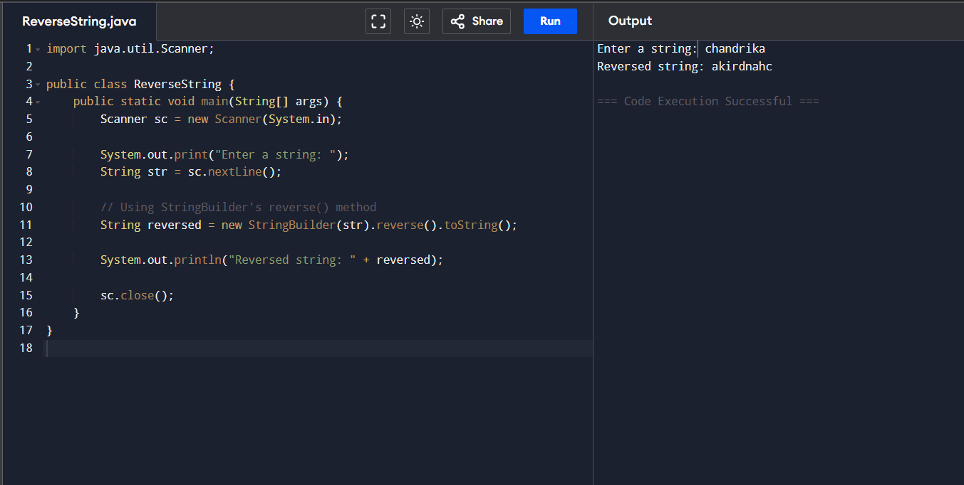

Q 20] Write a program to remove duplicate characters from a string.
Input -
import java.util.Scanner;

public class RemoveDuplicates {
public static void main(String[] args) {
Scanner sc = new Scanner(System.in);

System.out.print("Enter a string: ");
String str = sc.nextLine();

String result = removeDuplicateChars(str);

System.out.println("String after removing duplicates: " + result);

sc.close();
}

static String removeDuplicateChars(String str) {
StringBuilder sb = new StringBuilder();
boolean[] seen = new boolean[256]; // for ASCII characters

for (int i = 0; i < str.length(); i++) {
char ch = str.charAt(i);
if (!seen[ch]) {
seen[ch] = true; // mark as seen
sb.append(ch); // add to result
}
}
return sb.toString();
}
}

Output -
Enter a string: Chandrika
String after removing duplicates: Chandrik

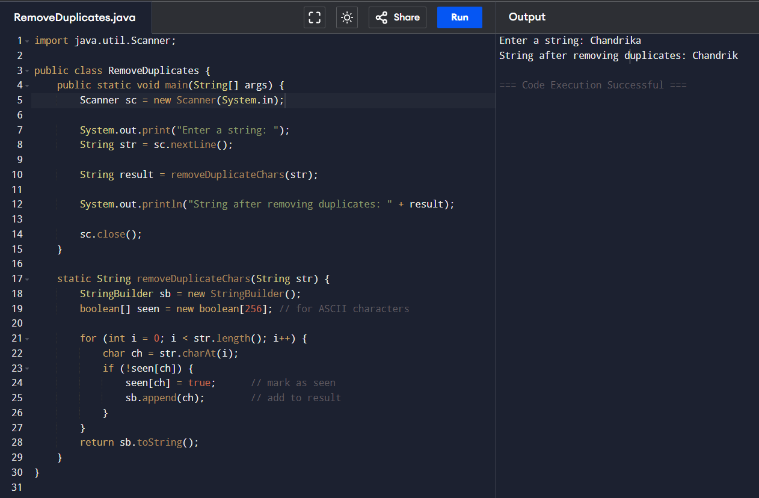

Q21] Develop a Java program to count the frequency of each word in a sentence.
Input -
import java.util.HashMap;
import java.util.Map;
import java.util.Scanner;

public class WordFrequency {
public static void main(String[] args) {
Scanner sc = new Scanner(System.in);

System.out.print("Enter a sentence: ");
String sentence = sc.nextLine();

// Convert to lowercase and split by spaces/punctuation
String[] words = sentence.toLowerCase().split("\\W+");
// \W+ splits on any non-word character (spaces, punctuation)

Map<String, Integer> freq = new HashMap<>();

for (String word : words) {
if (word.isEmpty()) continue; // skip blanks
freq.put(word, freq.getOrDefault(word, 0) + 1);
}

System.out.println("Word frequencies:");
for (Map.Entry<String, Integer> entry : freq.entrySet()) {
System.out.println(entry.getKey() + " : " + entry.getValue());
}

sc.close();
}
}

Output -
Enter a sentence: My name is Budati Vaishnavi Sree Chandrika.
Word frequencies:
chandrika : 1
name : 1
is : 1
sree : 1
my : 1
vaishnavi : 1
budati : 1

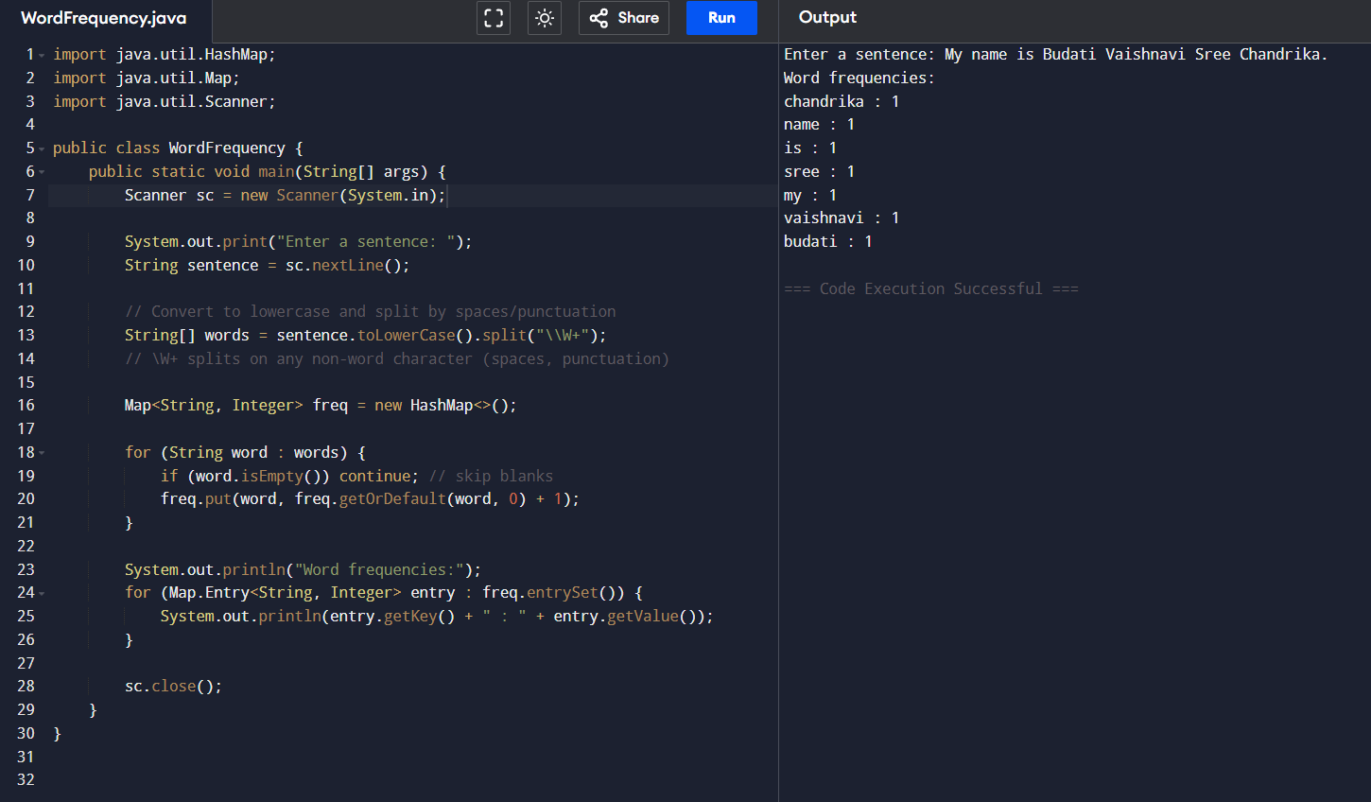

Q22] Design a class BankAccount with methods for deposit, withdraw, and balance inquiry.

Input -
import java.util.Scanner;

class BankAccount {
private String accountNumber;
private String accountHolder;
private double balance;

public BankAccount(String accountNumber, String accountHolder, double initialBalance) {
this.accountNumber = accountNumber;
this.accountHolder = accountHolder;
this.balance = initialBalance;
}

public void deposit(double amount) {
if (amount > 0) {
balance += amount;
System.out.println("Deposited ₹" + amount);
} else {
System.out.println("Deposit amount must be positive.");
}
}

public void withdraw(double amount) {
if (amount > 0 && amount <= balance) {
balance -= amount;
System.out.println("Withdrawn ₹" + amount);
} else if (amount > balance) {
System.out.println("Insufficient balance.");
} else {
System.out.println("Withdrawal amount must be positive.");
}
}

public double getBalance() {
return balance;
}

public void displayAccountInfo() {
System.out.println("\nAccount Number: " + accountNumber);
System.out.println("Account Holder: " + accountHolder);
System.out.println("Current Balance: ₹" + balance + "\n");
}
}

public class Main { // Programiz expects "Main" with main() method
public static void main(String[] args) {
Scanner sc = new Scanner(System.in);

System.out.print("Enter account number: ");
String accNo = sc.nextLine();
System.out.print("Enter account holder name: ");
String holder = sc.nextLine();
System.out.print("Enter initial balance: ");
double initBal = sc.nextDouble();

BankAccount account = new BankAccount(accNo, holder, initBal);

int choice;
do {
System.out.println("\n=== Banking Menu ===");
System.out.println("1. Deposit");
System.out.println("2. Withdraw");
System.out.println("3. Check Balance");
System.out.println("4. Display Account Info");
System.out.println("5. Exit");
System.out.print("Enter your choice: ");
choice = sc.nextInt();

switch (choice) {
case 1:
System.out.print("Enter amount to deposit: ");
double dep = sc.nextDouble();
account.deposit(dep);
break;
case 2:
System.out.print("Enter amount to withdraw: ");
double wd = sc.nextDouble();
account.withdraw(wd);
break;
case 3:
System.out.println("Current Balance: ₹" + account.getBalance());
break;
case 4:
account.displayAccountInfo();
break;
case 5:
System.out.println("Thank you for using our banking system!");
break;
default:
System.out.println("Invalid choice. Please try again.");
}
} while (choice != 5);

sc.close();
}
}

Output -
Enter account number: 23
Enter account holder name: Chandrika
Enter initial balance: 3000

=== Banking Menu ===
1. Deposit
2. Withdraw
3. Check Balance
4. Display Account Info
5. Exit
Enter your choice: 2
Enter amount to withdraw: 34
Withdrawn ?34.0

=== Banking Menu ===
1. Deposit
2. Withdraw
3. Check Balance
4. Display Account Info
5. Exit
Enter your choice:

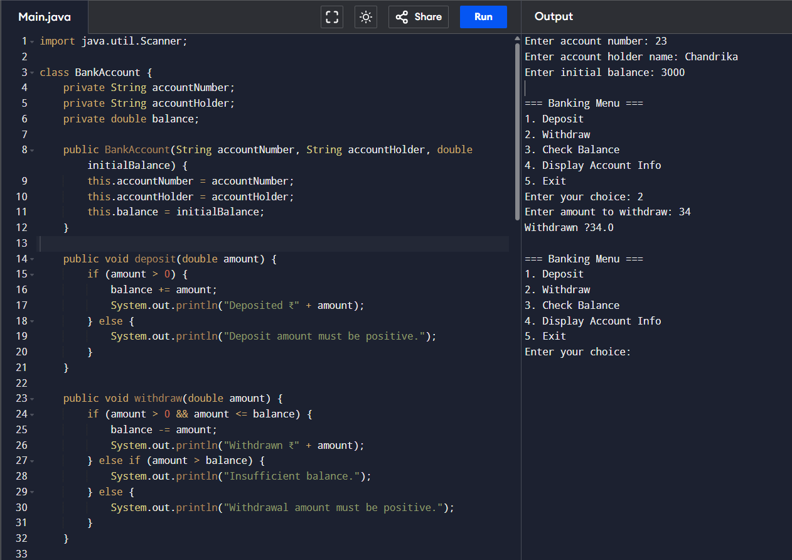

Q23] Design a Java class Employee with the following:A method empDetails() to accept and display employee details.A method salary() to compute basic salary components.A method total() to calculate the total salary (including allowances/deductions).

Input -
import java.util.Scanner;

class Employee {
private String empName;
private String empId;
private double basicSalary;
private double hra; // house rent allowance
private double da; // dearness allowance
private double pf; // provident fund deduction

// Method to accept and display employee details
public void empDetails() {
Scanner sc = new Scanner(System.in);
System.out.print("Enter Employee Name: ");
empName = sc.nextLine();
System.out.print("Enter Employee ID: ");
empId = sc.nextLine();
System.out.print("Enter Basic Salary: ");
basicSalary = sc.nextDouble();

// Display entered details
System.out.println("\nEmployee Details:");
System.out.println("Name: " + empName);
System.out.println("ID: " + empId);
System.out.println("Basic Salary: ₹" + basicSalary);
}

// Method to compute basic salary components
public void salary() {
// simple calculation rules — can be adjusted
hra = 0.20 * basicSalary; // 20% of basic
da = 0.10 * basicSalary; // 10% of basic
pf = 0.05 * basicSalary; // 5% deduction
System.out.println("\nSalary Components:");
System.out.println("HRA (20%): ₹" + hra);
System.out.println("DA (10%): ₹" + da);
System.out.println("PF Deduction (5%): ₹" + pf);
}

// Method to calculate total salary including allowances/deductions
public void total() {
double totalSalary = basicSalary + hra + da - pf;
System.out.println("\nTotal Salary after allowances and deductions: ₹" + totalSalary);
}
}

public class Main {
public static void main(String[] args) {
Employee e = new Employee();
e.empDetails();
e.salary();
e.total();
}
}

Output -
Enter Employee Name: chandrika
Enter Employee ID: 58
Enter Basic Salary: 6000

Employee Details:
Name: chandrika
ID: 58
Basic Salary: ?6000.0

Salary Components:
HRA (20%): ?1200.0
DA (10%): ?600.0
PF Deduction (5%): ?300.0

Total Salary after allowances and deductions: ?7500.0

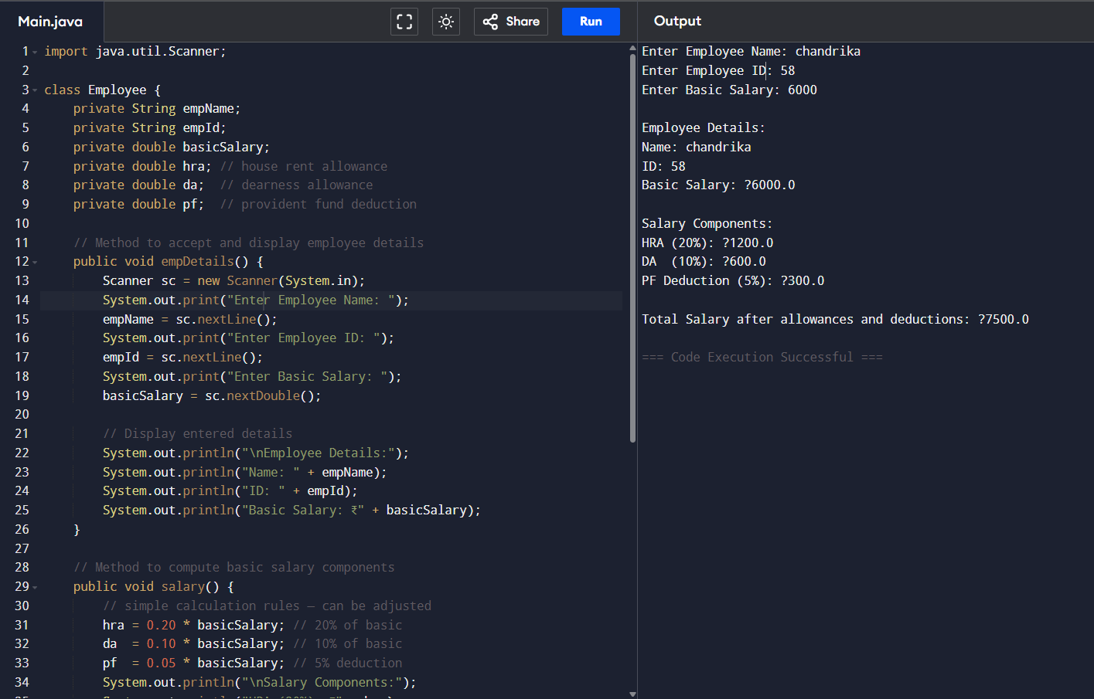

Q24] Create a Student class with marks in 3 subjects and compute the result with percentage.
Input -
import java.util.Scanner;

class Student {
private String name;
private String rollNo;
private int mark1, mark2, mark3;

// Accept student details and marks
public void acceptDetails() {
Scanner sc = new Scanner(System.in);

System.out.print("Enter Student Name: ");
name = sc.nextLine();
System.out.print("Enter Roll Number: ");
rollNo = sc.nextLine();

System.out.print("Enter marks in Subject 1: ");
mark1 = sc.nextInt();
System.out.print("Enter marks in Subject 2: ");
mark2 = sc.nextInt();
System.out.print("Enter marks in Subject 3: ");
mark3 = sc.nextInt();
}

// Compute total and percentage
public void computeResult() {
int total = mark1 + mark2 + mark3;
double percentage = total / 3.0;

System.out.println("\nStudent Details:");
System.out.println("Name: " + name);
System.out.println("Roll Number: " + rollNo);
System.out.println("Marks: " + mark1 + ", " + mark2 + ", " + mark3);
System.out.println("Total Marks: " + total);
System.out.println("Percentage: " + percentage + "%");

if (percentage >= 40)
System.out.println("Result: PASS");
else
System.out.println("Result: FAIL");
}
}

public class Main {
public static void main(String[] args) {
Student s = new Student();
s.acceptDetails();
s.computeResult();
}
}

Output -
Enter Student Name: Chandrika
Enter Roll Number: 58
Enter marks in Subject 1: 34
Enter marks in Subject 2: 67
Enter marks in Subject 3: 89

Student Details:
Name: Chandrika
Roll Number: 58
Marks: 34, 67, 89
Total Marks: 190
Percentage: 63.333333333333336%
Result: PASS

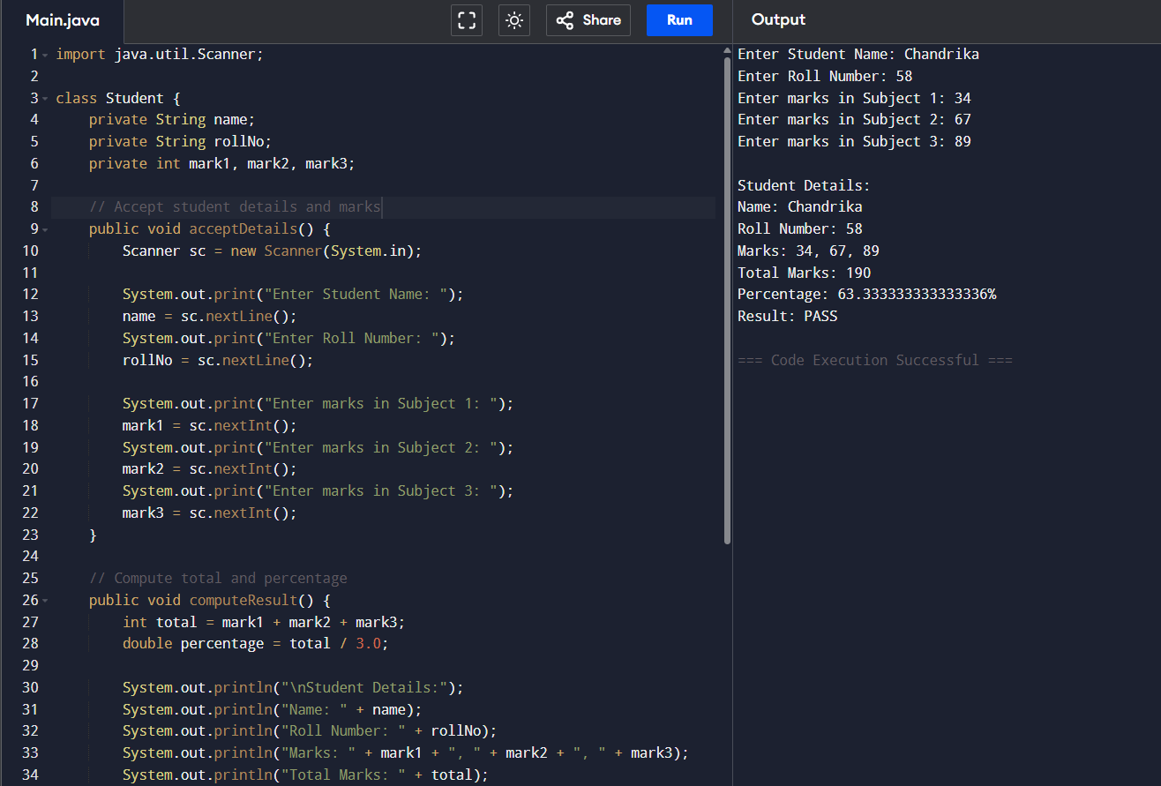

Q25] Create a class Volume and create three constructor with one arg,two arg and three arg with the help of constructor overloading concept.
Input -
class Volume {
private double volume;

// 1-arg constructor (cube)
Volume(double side) {
volume = side * side * side;
System.out.println("Volume of Cube (side " + side + "): " + volume);
}

// 2-arg constructor (cylinder)
Volume(double radius, double height) {
volume = Math.PI * radius * radius * height;
System.out.println("Volume of Cylinder (r " + radius + ", h " + height + "): " + volume);
}

// 3-arg constructor (rectangular box)
Volume(double length, double breadth, double height, boolean box) {
volume = length * breadth * height;
System.out.println("Volume of Box (l " + length + ", b " + breadth + ", h " + height + "): " + volume);
}
}

public class Main {
public static void main(String[] args) {
// cube: only one arg
Volume cube = new Volume(5);

// cylinder: two args
Volume cylinder = new Volume(3, 10);

// box: three args (we pass an extra boolean to differentiate)
Volume box = new Volume(4, 5, 6, true);
}
}

Output -
Volume of Cube (side 5.0): 125.0
Volume of Cylinder (r 3.0, h 10.0): 282.7433388230814
Volume of Box (l 4.0, b 5.0, h 6.0): 120.0

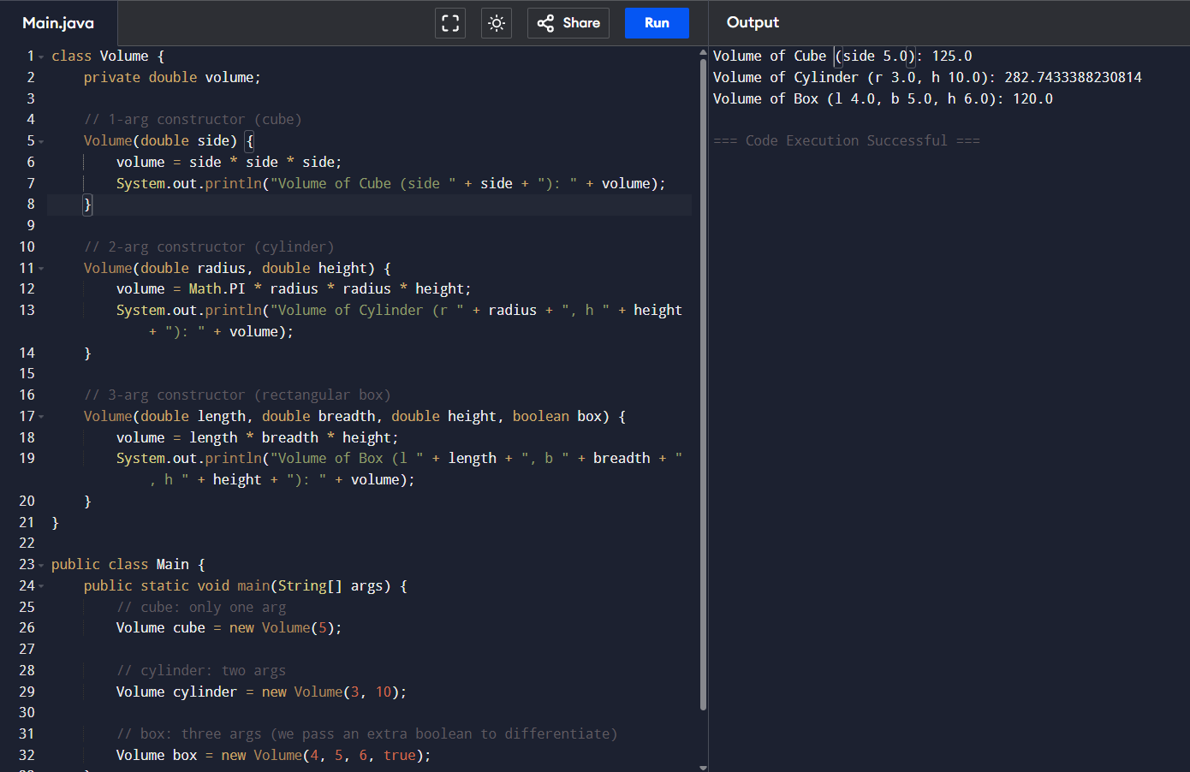
Q26] Write a program to count the number of objects/instances created in a class.
Input -
class Counter {
// static variable shared by all objects
private static int objectCount = 0;

// constructor increments the counter each time a new object is created
public Counter() {
objectCount++;
}

// static method to get the count
public static int getObjectCount() {
return objectCount;
}
}

public class Main {
public static void main(String[] args) {
Counter c1 = new Counter();
Counter c2 = new Counter();
Counter c3 = new Counter();

System.out.println("Number of objects created: " + Counter.getObjectCount());

Counter c4 = new Counter();
System.out.println("After creating one more object: " + Counter.getObjectCount());
}
}

Output -
Number of objects created: 3
After creating one more object: 4

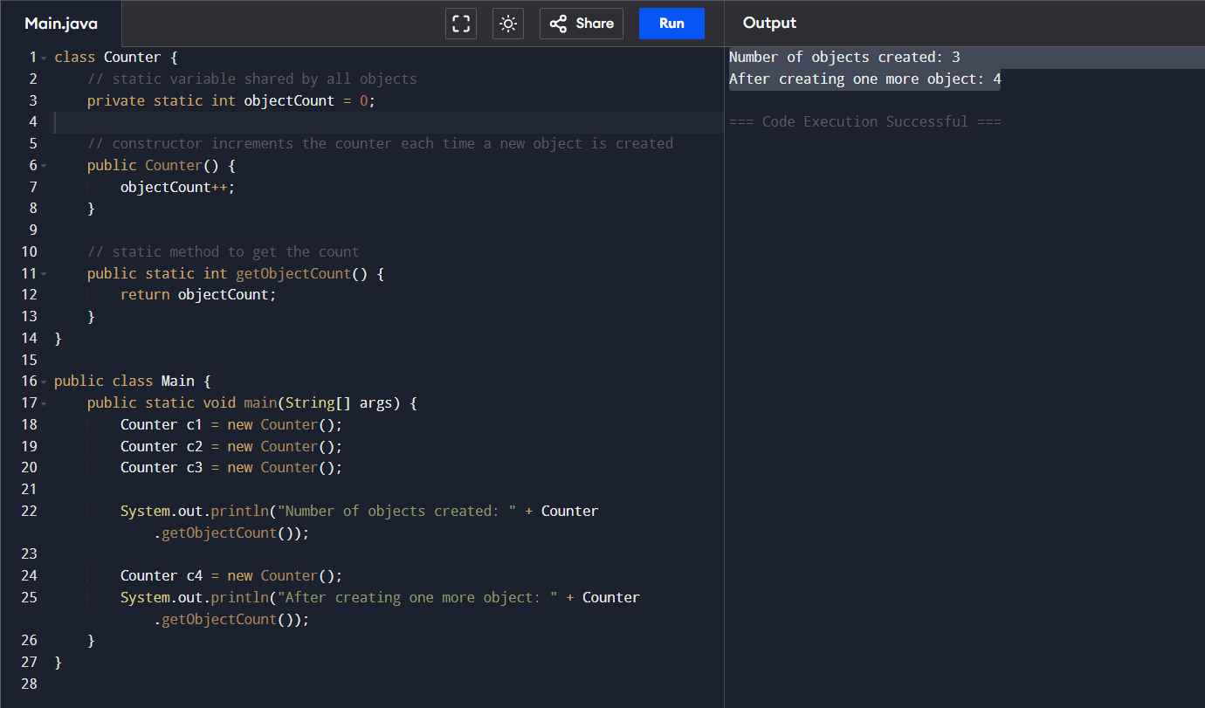

Q27] Design a class hierarchy using inheritance: Person → Employee → Manager.

Input -
// Base class
class Person {
protected String name;
protected int age;

public Person(String name, int age) {
this.name = name;
this.age = age;
}

public void displayPerson() {
System.out.println("Name: " + name);
System.out.println("Age: " + age);
}
}

// Derived class Employee from Person
class Employee extends Person {
protected String employeeId;
protected double salary;

public Employee(String name, int age, String employeeId, double salary) {
super(name, age); // call Person's constructor
this.employeeId = employeeId;
this.salary = salary;
}

public void displayEmployee() {
displayPerson(); // show person info first
System.out.println("Employee ID: " + employeeId);
System.out.println("Salary: ₹" + salary);
}
}

// Derived class Manager from Employee
class Manager extends Employee {
private String department;
private double bonus;

public Manager(String name, int age, String employeeId, double salary,
String department, double bonus) {
super(name, age, employeeId, salary); // call Employee's constructor
this.department = department;
this.bonus = bonus;
}

public void displayManager() {
displayEmployee(); // show employee info first
System.out.println("Department: " + department);
System.out.println("Bonus: ₹" + bonus);
}
}

public class Main {
public static void main(String[] args) {
// create a Manager (inherits all fields)
Manager m = new Manager("Chandrika", 20, "23011058", 75000,
"DS", 15000);
m.displayManager();
}
}

Output -
Name: Chandrika
Age: 20
Employee ID: 23011058
Salary: ?75000.0
Department: DS
Bonus: ?15000.0

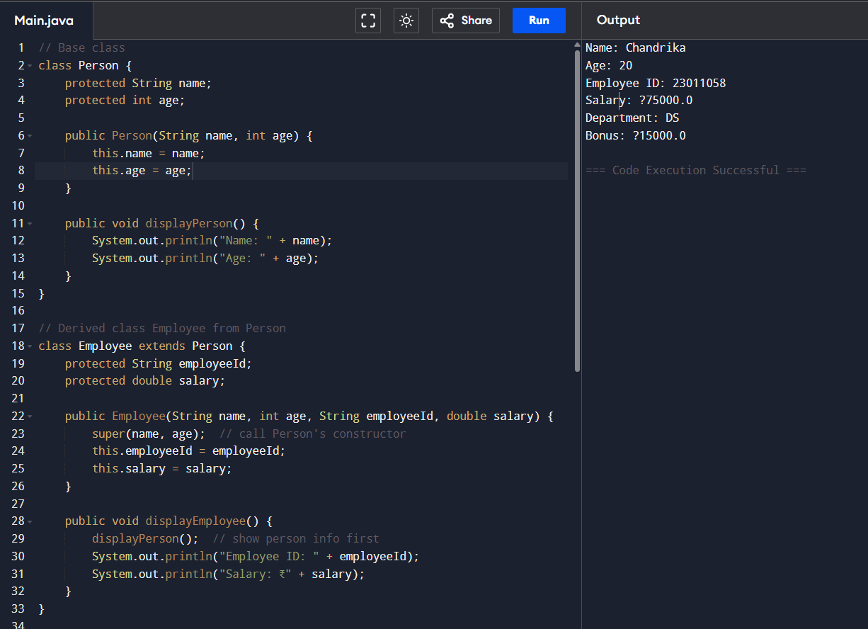

Q28] Implement polymorphism by creating a method area() in multiple shape classes.
Input -
// Base class
abstract class Shape {
// abstract method to be overridden in subclasses
public abstract double area();
}

// Circle subclass
class Circle extends Shape {
private double radius;

public Circle(double radius) {
this.radius = radius;
}

@Override
public double area() {
return Math.PI * radius * radius;
}
}

// Rectangle subclass
class Rectangle extends Shape {
private double length;
private double width;

public Rectangle(double length, double width) {
this.length = length;
this.width = width;
}

@Override
public double area() {
return length * width;
}
}

// Triangle subclass
class Triangle extends Shape {
private double base;
private double height;

public Triangle(double base, double height) {
this.base = base;
this.height = height;
}

@Override
public double area() {
return 0.5 * base * height;
}
}

public class Main {
public static void main(String[] args) {
// Create different shapes but refer by Shape type (polymorphism)
Shape s1 = new Circle(5);
Shape s2 = new Rectangle(4, 6);
Shape s3 = new Triangle(3, 8);

System.out.println("Area of Circle: " + s1.area());
System.out.println("Area of Rectangle: " + s2.area());
System.out.println("Area of Triangle: " + s3.area());
}
}

Output -
Area of Circle: 78.53981633974483
Area of Rectangle: 24.0
Area of Triangle: 12.0

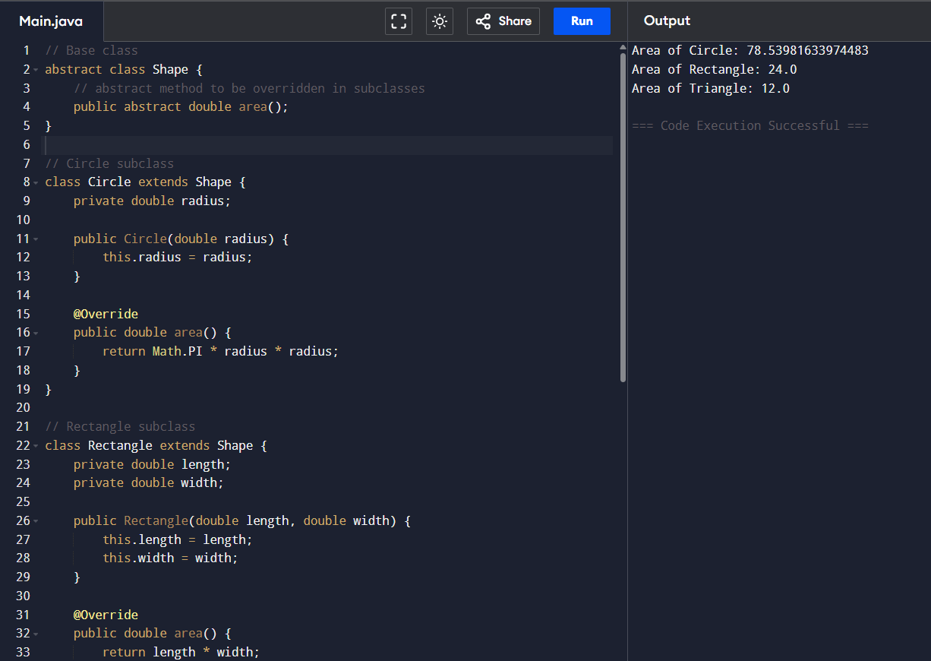

Q29] Use abstract classes to design a Vehicle class with car and bike subclasses.

Input -
// Abstract base class
abstract class Vehicle {
protected String brand;
protected int speed;

public Vehicle(String brand, int speed) {
this.brand = brand;
this.speed = speed;
}

// abstract method to be implemented by subclasses
public abstract void displayDetails();
}

// Car subclass
class Car extends Vehicle {
private int numberOfDoors;

public Car(String brand, int speed, int numberOfDoors) {
super(brand, speed);
this.numberOfDoors = numberOfDoors;
}

@Override
public void displayDetails() {
System.out.println("Car Brand: " + brand);
System.out.println("Speed: " + speed + " km/h");
System.out.println("Number of Doors: " + numberOfDoors);
}
}

// Bike subclass
class Bike extends Vehicle {
private boolean hasCarrier;

public Bike(String brand, int speed, boolean hasCarrier) {
super(brand, speed);
this.hasCarrier = hasCarrier;
}

@Override
public void displayDetails() {
System.out.println("Bike Brand: " + brand);
System.out.println("Speed: " + speed + " km/h");
System.out.println("Has Carrier: " + (hasCarrier ? "Yes" : "No"));
}
}

public class Main {
public static void main(String[] args) {
Vehicle car = new Car("Toyota", 180, 4);
Vehicle bike = new Bike("Honda", 120, true);

System.out.println("=== Car Details ===");
car.displayDetails();

System.out.println("\n=== Bike Details ===");
bike.displayDetails();
}
}

Output -
=== Car Details ===
Car Brand: Toyota
Speed: 180 km/h
Number of Doors: 4

=== Bike Details ===
Bike Brand: Honda
Speed: 120 km/h
Has Carrier: Yes

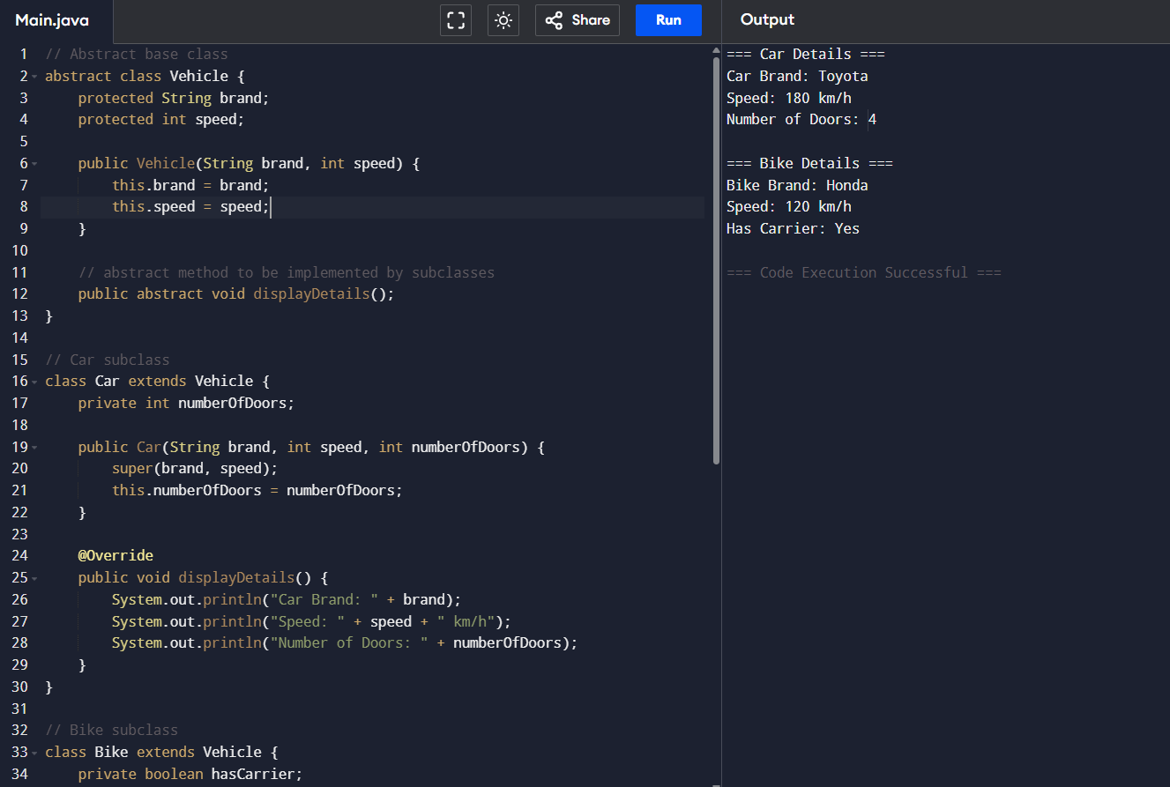

Q30] Implement a stack using an array with push, pop, and display operations.
Input -
import java.util.Scanner;

class StackArray {
private int maxSize; // maximum size of stack
private int[] stack; // array for stack
private int top; // index of top element

public StackArray(int size) {
maxSize = size;
stack = new int[maxSize];
top = -1; // empty stack
}

// Push operation
public void push(int item) {
if (top == maxSize - 1) {
System.out.println("Stack Overflow! Cannot push " + item);
} else {
stack[++top] = item;
System.out.println(item + " pushed onto stack.");
}
}

// Pop operation
public void pop() {
if (top == -1) {
System.out.println("Stack Underflow! Nothing to pop.");
} else {
int item = stack[top--];
System.out.println(item + " popped from stack.");
}
}

// Display stack contents
public void display() {
if (top == -1) {
System.out.println("Stack is empty.");
} else {
System.out.print("Stack elements: ");
for (int i = top; i >= 0; i--) {
System.out.print(stack[i] + " ");
}
System.out.println();
}
}
}

public class Main {
public static void main(String[] args) {
Scanner sc = new Scanner(System.in);

System.out.print("Enter size of stack: ");
int size = sc.nextInt();
StackArray s = new StackArray(size);

int choice;
do {
System.out.println("\n--- Stack Menu ---");
System.out.println("1. Push");
System.out.println("2. Pop");
System.out.println("3. Display");
System.out.println("4. Exit");
System.out.print("Enter your choice: ");
choice = sc.nextInt();

switch (choice) {
case 1:
System.out.print("Enter element to push: ");
int item = sc.nextInt();
s.push(item);
break;
case 2:
s.pop();
break;
case 3:
s.display();
break;
case 4:
System.out.println("Exiting...");
break;
default:
System.out.println("Invalid choice! Try again.");
}
} while (choice != 4);

sc.close();
}
}

Output -
Enter size of stack: 3

--- Stack Menu ---
1. Push
2. Pop
3. Display
4. Exit
Enter your choice: 1
Enter element to push: 23
23 pushed onto stack.

--- Stack Menu ---
1. Push
2. Pop
3. Display
4. Exit
Enter your choice: 3
Stack elements: 23

--- Stack Menu ---
1. Push
2. Pop
3. Display
4. Exit
Enter your choice:

