NOTE: This document is WIP. Will be updating the conclusions and the training and testing scores.

output_extraTreesRegressor

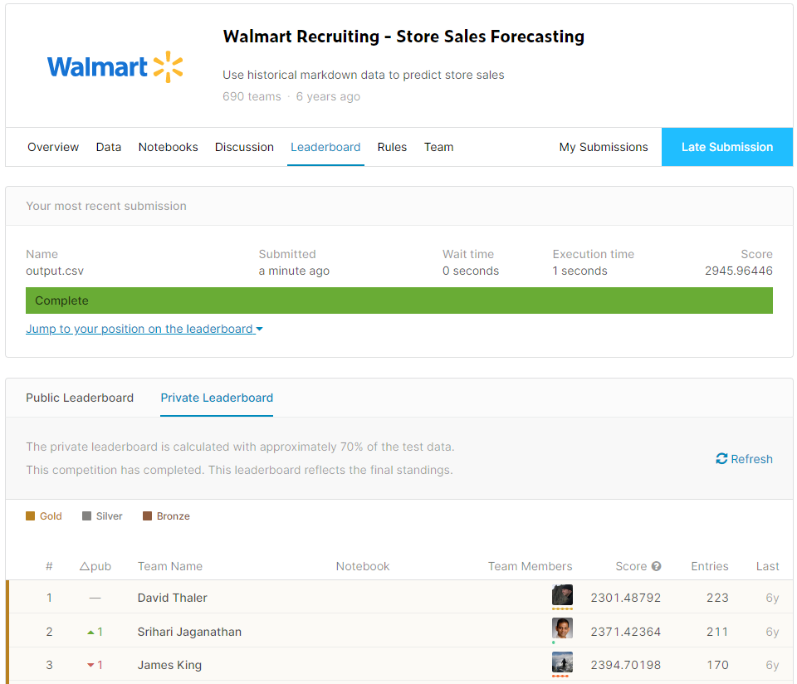

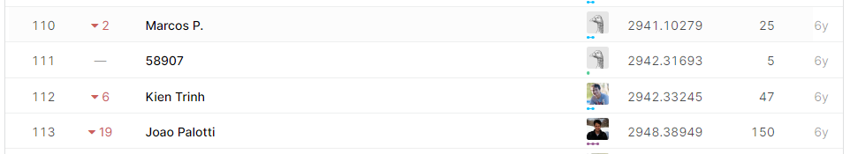

output_decTreeRegressor

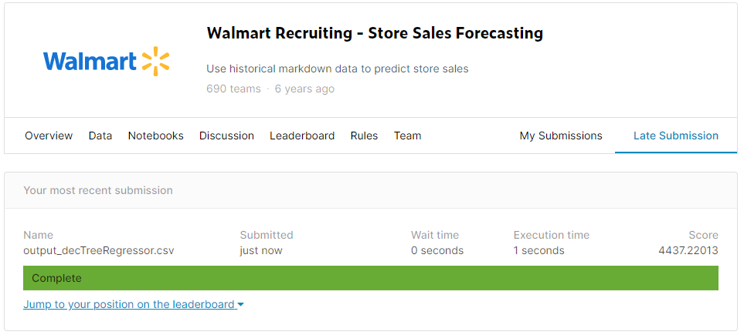

output_ randomForestRegressor

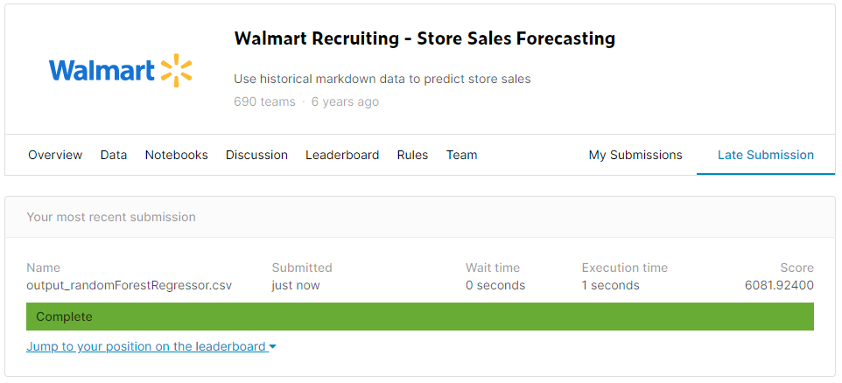

output_xgbRegressor

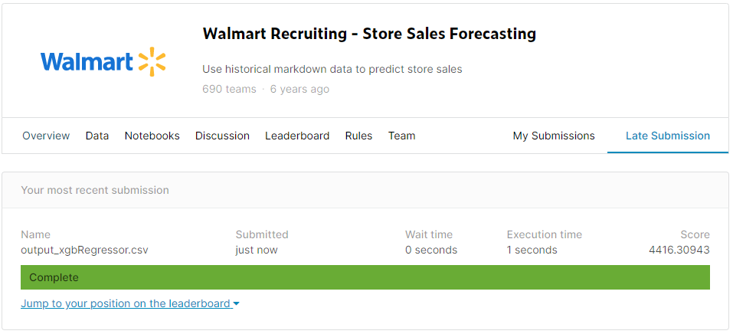

output_SVR