# SQUID

**INTRODUCTION**

The explosive development of the concept of Internet of Things (IoT) is accompanied by an unprecedented revolution in the physical and cyber world. Smart, always- connected devices provide real-time contextual information with low overhead to optimize processes and improve how companies and individuals interact, work, and live. An increased number of businesses, homes and public areas are now starting to use these devices. The number of interconnected devices in use worldwide now exceeds 17 billion, number that is expected to grow to 10 billion by 2020 and 22 billion by 2025, according to a recent report [1].

On one side, the IoT devices offer extended features and functionality; on the other side, their security level is still low, with well-known weaknesses and vulnerabilities, such as easily guessable passwords and insecure default settings [2]. This gives cybercriminals the opportunity to easily exploit these vulnerabilities and create backdoors into a typical organisation infrastructure. To ensure their protection against potential vulnerabilities, these devices need to be updated and patched regularly; however, given they are not perceived as critical IT infrastructure, it is likely that they are less likely to be upgraded. Further, given their hardware, some IoT devices may not be patchable, and the only option is to replace them entirely when they become vulnerable [3]. Beyond the convenience or simplicity of patching, insecure Internet- connected IoT devices represent a security risk. According to a recent report of

Symantec, IoT devices will increasingly represent an exploitation target; Symantec already found a 600% increase in overall IoT attacks in 2017 [4].

Botnets are the most common type of malware when an IoT device is compromised [5], either standalone or aggregated to become part of a botnet, capable of launching devastating DDOS (Distributed Denial of service) attacks. Given its uncommon architecture, once a botnet infects an IoT device, it can be very hard to detect the malware. Most conventional antimalware tools rely on a syntactic signature for their detection methods [6], where the signature of a ﬁle is compared to a list of known malicious ones. Thus, these systems all require a database with every known malware signature contained within it.

This is a very time-consuming process and requires already analysing the malware or its instruction sequence [7]. Moreover, the signature generation involves manual intervention and requires strict code analysis [6, 7], this pushes for enhanced, automated analysis. In this paper, we present a novel IoT malware trafﬁc analysis method that addresses this issue by using a TensorFlow convolutional neural network paired with a binary visualization technique. The main contribution of this proposal is an automated malware trafﬁc analysis method that combines binary visualisation of IoT trafﬁc with the TensorFlow learning model. The combination is ideal for faster analysis of real-time trafﬁc data compared to other approaches and makes it more appropriate to detect and analyse unknown zero-day malware. The proposal utilizes sockets to monitor devices network trafﬁc, the Binvis binary data visualisation technique

to convert the binary content of packets into 2D images, and the TensorFlow machine learning method to analyse the produced images. The objective of this analysis is to identify malware in the recent packets, based on the assumption that malware trafﬁc tends to have a more clustered appearance of its patterns on the produced images whereas classic trafﬁc presents more consistent and static. Obviously, both sides had anomalies and expectations.

The overall structure of the paper is organised as follows: Sect. 2 describes the prior works done in malware trafﬁc analysis and classiﬁcation. In Sect. 3, we present the methodology of the proposed method using neural network TensorFlow and binary visualization. Section 4 presents experiment results and analysis as well as a com- parison with other methods. Finally, Sect. 5 provides concluding remarks and future work.

1. **RELATED WORKS**

Detection of malware and its associated trafﬁc is still a persistent challenge for the security community. Research in this area is always needed to keep one step ahead of the hackers. However, IoT devices are upcoming new technology, especially inside a home environment, so anti-malware tools and associated research have been minimal compared to normal technologies [2]. Most attempts to detect or prevent malware trafﬁc are performed by ﬁrewalls and intrusion prevention systems, for those in a home environment there is not much security other than the regular patches [8].

Several approaches have been proposed in the literature to detect or mitigate malware trafﬁc. Signature-based detection techniques are the most used, however, they are unable to detect unknown malware trafﬁc for which there exists no signature and involve manual interventions [6–8]. Machine learning is one of the most efﬁcient techniques that have been employed to overcome this issue. Over the years, many machines learning approaches have been proposed for malware trafﬁc analysis and classiﬁcation. In [9], authors introduced the deep learning method of DBN (Deep Belief Networks) to the intrusion detection domain. In the proposed approach, authors used the DBN for malware trafﬁc classiﬁcation. Following the same direction, recent work in [10] proposed a malware trafﬁc identiﬁcation method using a sparse autoencoder. In this work, authors proposed a novel classiﬁer model by combining the power of the Non-symmetric Deep Auto-Encoder (NDAE) (deep-learning), and the accuracy and speed of Random Forest (RF) (shallow learning), leading to high accuracy in malware detection. However, they both used a hand-designed flow features dataset as input data. On the other hand, Convolutional Neural Networks (CNN) and recurrent

neural networks (RNN) are also used in many studies to perform malware trafﬁc classiﬁcation tasks based on spatial and temporal features. For example, authors in [11] transformed the network trafﬁc features into a sequence of characters and then used RNNs to learn their temporal features. The RNN was then applied to detect malware trafﬁc. While in this study the RNNs are used alone and learned a single type of trafﬁc feature, authors in [12], authors used CNN to learn the spatial features of network trafﬁc and achieved malware trafﬁc classiﬁcation using an image classiﬁcation method. The proposed method needed no hand-designed features but directly took raw trafﬁc as input data of the classiﬁer, and the classiﬁer then can learn features automatically. The CNN is then used to perform image classiﬁcation of the images that were created from trafﬁc sample PCAP ﬁles. This method has proven the efﬁciency of malware trafﬁc classiﬁcation using representation learning approach, being very successful in identifying classic trafﬁc and even malware. However, it does not focus on unknown malware trafﬁc. Thus, if the neural network is not already trained on the type of attack trafﬁc, it will not be able to classify the trafﬁc, or it will falsely categories it. Moreover, potentially missing Zero-day exploits trafﬁc of viruses lets the work down as such threats are possibly the most serious ones to a network.

The study in [13] that also covered IoT intrusion detection used a different detection factor to help with the trafﬁc analysis, more speciﬁcally the data associated with the CPU and memory usage of the IoT device. This is based on the observation that the CPU and memory usage tend to increase when a malware component is detected on the device. Although the CPU and memory features were effective, they require a lot of set up time and reconstruction of a testing network, making the method rather difﬁcult to implement. In [14], the authors built a similar malware detection tool that focused on malware executables as opposed to trafﬁc. This work also had analysis of binary visualisations through a neural network. The proposed approach uses binary visualisation to convert a binary ﬁle data into an image, and self-organizing incremental neural networks (SOINN) for the analysis and detection of malicious payloads. The limitations of this work stemmed from the limited availability of samples, leading to restricting neural network training options.

1. **THE PROPOSED METHOD**

The proposed IoT malware trafﬁc analysis method consists of three main steps, as shown in Fig. 1. The ﬁrst step is the network trafﬁc collection, through either directly snifﬁng the network or using ﬁles containing pre-captured network trafﬁc that can be replayed through TCPreplay for the sniffer to collect

again. The second step is the binary visualisation phase, which takes the collected trafﬁc stored in ASCII (American Standard Code for Information Interchange) and convert it into a 2D image. In the ﬁnal step, the binary image is then processed by the TensorFlow module, which analyses it against its training modules.

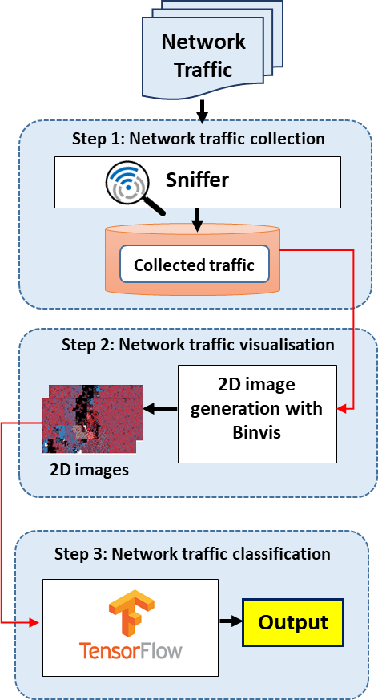

**Fig. 1**. Overview of the proposed method.

* 1. **NETWORK TRAFFIC COLLECTION**

Packet capturing is the most used scheme to accomplish the goal of network data collection [15]. Typically, packet-based collection mechanisms use sniffers to implement network data collection through centralized management such as Wireshark, nmap, Airodump, and TCPdump. A sniffer is regarded as a convenient and efﬁcient tool to detect trafﬁc and capture packets [15]. In our approach, we proposed a network trafﬁc collection method using a Python- based tool [16] which ensures two major tasks are accomplished: collection and storage.

1. **Traffic collection**: When the sniffer is loaded into memory, it can collect all packets that are either traversing the network or are replayed. The used Sniffer utilizes Python sockets at a low-level networking interface to collect packets. It is worth noting that the proposed approach is also applicable for the case of very sporadic IoT trafﬁc as it creates proﬁle of what is normal trafﬁc and compare it with abnormal.
2. **Traffic storage**: Received data is passed out to

a ﬁle that contains the data from the payload in the packet, this data is turned to hexadecimal so that Binvis can plot it into a 2D image in the second step.

The dataset is created by using two main collection methods, one that the sniffer collected of both normal trafﬁc and malware trafﬁc and that used trafﬁc from pcap ﬁles. All the collected ﬁles came from real-world network environments rather than be artiﬁcially generated data. If trafﬁc samples have a large size, only parts of the PCAP ﬁle is used. Similarly, trafﬁc samples that are too small will only be used on a slower TCPreplay speed. The collected pcap-based ﬁles are added to the dataset and replayed through the module TCPreplay using various speeds.

* 1. **TRAFFIC VISUALISATION**

In this work, we use a visual representation algorithm of the trafﬁc collected that is based on Binvis [17]. This binary data visualization tool converts the contents of a binary ﬁle to another domain that can be visually represented (typically a two- dimensional space) [14]. Binvis represents the different ASCII values by using red, green and blue colour classes as shown in Table 1, while black (0x00) and white (0xFF) classes are used to represent null and (non-breaking) spaces.

Table 1. Binvis colour divisions

|  |  |
| --- | --- |
| Colour | Division |
| Blue | if the ASCII character is printable |
| Green | if the character is control |
| Red | if the character is extended ASCII |
| Black | 0x00 |
| White | 0xFF |

To convert a binary ﬁle into a 2D image, its data are seen as a byte string, where each byte value is compared against the ASCII table and is attributed to a colour according to the division it belongs, as outlined in Table 1. In our approach, the binary ﬁle is made from network packets collected by the sniffer, these are then converted into a string of hexadecimal characters which is later used to create the image of the trafﬁc, using a clustering algorithm. The ﬁnal output of Binvis is an image that represents the features of network trafﬁc. The Hilbert space-ﬁlling curve clustering algorithm is used in Figs. 3 and 4. This algorithm surmounts other curves in preserving the locality between objects in multi-dimensional spaces [14, 18], thus creating a much more appropriate imprint of the image. This helps the machine learning neural network analysis the image for anomalies in normal trafﬁc.

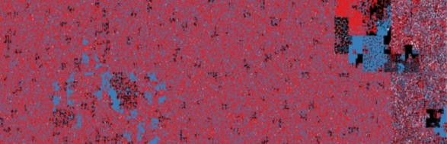

**Fig. 3**. Binary visualisation of Botnet pcap file

Accuracy (A), precision (P), recall (R) and f1 value (F1) metrics were used to evaluate the overall performance of the proposed malware trafﬁc classiﬁcation approach.

𝑇𝑃 + 𝑇𝑁

𝐴 = (1)

𝑇𝑃 + 𝐹𝑃 + 𝑇𝑁 + 𝐹𝑁

**Fig. 4**. Binary visualisation of normal pcap file

𝑃 =

𝑅 =

𝑇𝑃

𝑇𝑃 + 𝐹𝑃

𝑇𝑃

𝑇𝑃 + 𝐹𝑁

2 × 𝑃 × 𝑅

(2)

(3)

* 1. **MALWARE TRAFFIC ANALYSIS**

In this step, TensorFlow is used to analyse the produced images against its in-depth training.

𝐹1 =

(4)

𝑃 + 𝑅

TensorFlow is a machine learning system that operates at large scale and in heterogeneous environments [19], providing full flexibility for implementing any type of model architecture [20]. Moreover, TensorFlow is an effective machine learning algorithm to analyse images and classify them; accordingly, it is easy to retrain and learns quickly from updates to the neural network [19]. Its outstanding artiﬁcial intelligence feature is its excellent image recognition ability, which is speciﬁcally why it is being utilised within this application. The TensorFlow AI could easily detect differences between the images, including differences that the human eye could not detect [20].

The TensorFlow module utilizes a CNN which works like a classic neural network but has an extra layer at the beginning called the convolution. The binary output from Binvis is broken up into a number of tiles and, while the machine learning aims to predict what each tile is, the AI then aims to determine the combination of tiles that the picture is based on. This allows TensorFlow to parallelize operations and detect the object regardless of where it is located in the image [21].

The machine learning process is separated into two stages. The ﬁrst stage is the training phase, where the MobileNet module is employed for the retraining element [21]. MobileNet is a neural network that is very small and efﬁcient, chosen for its lightweight element. It is designed speciﬁcally to be mindful of the resources it takes up on a device or application [21]. In the second stage, the image ﬁles are tested against the samples of the database to perform classiﬁcation.

1. **EXPERIMENTAL RESULT**

In this section, we present the performance analysis results of the prototype that was implemented based on the methodology presented in the previous section.

Where TP is the number of instances correctly

classiﬁed as good trafﬁc, TN is the number of instances correctly classiﬁed as bad trafﬁc, FP is the number of instances incorrectly classiﬁed as good trafﬁc, and FN is the number of instances incorrectly classiﬁed as bad trafﬁc.

* 1. **EXPERIMENT SETUP**

The simulation experiments were performed on a virtual machine built on VM workstation, running Ubuntu 18.0.4. The ISO was not updated during this time to keep prevent technology incompatibility. The dataset that was used in testing, contained a set of 100 pcap samples, collected from external repositories. It is composed of a mixture of 30 normal and 70 malware trafﬁc samples. Samples were classiﬁed into the unknown section if the pcap collected was unnamed or Wireshark testing came back inclusive. Table 2 summarizes the percentage of malicious trafﬁc samples of the whole data set.

Table 2. Malicious trafﬁc sample percentage according to type of malware

|  |  |
| --- | --- |
| Malware type | Percentage |
| Trojans | 25% |
| DDoS | 16% |
| Botnets | 19% |
| OS scan | 8% |
| Keylogger | 6% |
| Backdoors | 10% |

In the training stage, the TensorFlow algorithm was trained by 500 iterations of the data set in a static environment. Knowing that the more training, the better the accuracy of trafﬁc analysis and classiﬁcation, however incorrect training samples will result in a flawed neural network that can only

produce inaccurate results. The minimum training requirements are 30 images for each section, which was 30 images for normal trafﬁc and 30 for malware trafﬁc. Since the TensorFlow was unable to detect whether trafﬁc was good or bad at this stage, the samples used in this stage had to be labelled as being good or malware trafﬁc. For the testing process, the set up was a home scenario, with the thermometer was chosen for the malware host because it is one of the most common home IoT devices and in recent years has been responsible for some of the most devastating attacks [23]. Therefore, it was ﬁtting to use it as the testing scenario. Collected sample ﬁles were replayed using TCPreplay on the same network interface card to homogenize the network behavior exhibited by the datasets.

* 1. **EXPERIMENTS RESULTS AND ANALYSIS**

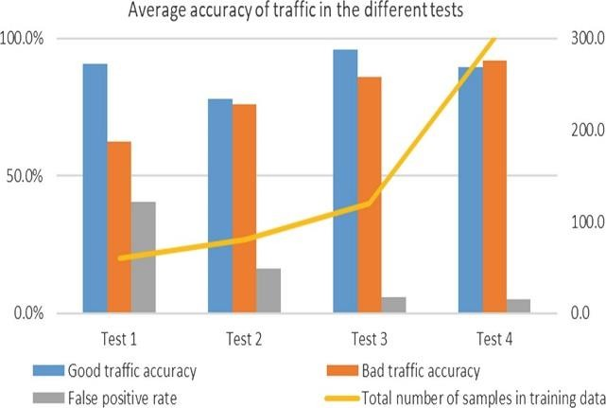Several tests were carried out to determine the accuracy of the proposed classiﬁer after the addition of more samples, in each test more samples were added to the training data for the machine learning to be retrained on. Figure 5 shows the average accuracy of trafﬁc in the different tests. Four set tests were completed, where the fourth test is the ﬁnal test with the most training samples that were collected being used. It is apparent from the four tests that the overall accuracy rate of normal trafﬁc stayed consistent throughout, only varying from 78% to 90% because most normal trafﬁc was found to have very similar characteristics throughout the data stream. This makes the classiﬁcation of this trafﬁc very easy since the training data would almost always be able to match the sample pcap ﬁles against the current trafﬁc being tested. However, even from the start of testing the good trafﬁc had a high accuracy rate, which was surprising given the number of samples in the training at that point. This is the result of test 1 which has a high false positive rate. Knowing that, during early testing, if the algorithm did not recognise a binary visualisation, then it would classify it as good trafﬁc, leading to the 60% - 40% split for malware trafﬁc (*see* Fig. 5).

**Fig. 5**. Average accuracy of malware and good trafﬁc throughout the 4 sets of tests with comparison to number of training data used.

As shown in Fig. 6, the issue with the high false positive rate was slowly being phased out, with the addition of more samples to the neural network throughout the tests, dropping from 40% to 5% by the ﬁnal set of tests. The addition of more training data mainly contained more speciﬁc types of malware samples, in the ﬁrst and second tests, one pcap of a Trojan was used to train the neural network, while no backdoor attacks were used. This made it near impossible for the algorithm to detect more of these types of trafﬁc without more in-depth training. Malware trafﬁc accuracy varied massively across all the tests, starting at a low accuracy (60%) but by the ﬁnal test ended up reaching a good accuracy of 91%. Figure 6 shows the ﬁnal stage of testing results.

The stage has been broken down to show the accuracy of the individual types of trafﬁc, DDOS trafﬁc had clearly the best accuracy rate by the end test which even though it made up only 16% of the overall trafﬁc it had a clear pattern where its malware samples were mainly covered in green pixels. This indicates the use of the control character being used over the staple amount, which the machine learning has clearly learned this malicious trait over four sets of tests and uses it to classify DDOS attacks. The algorithm had a much higher probability of showing false positives than false negatives, thus false negative data was not added to the graph results. In summary, the amount of training was the variable that had the most effect on the accuracy of the neural networks.

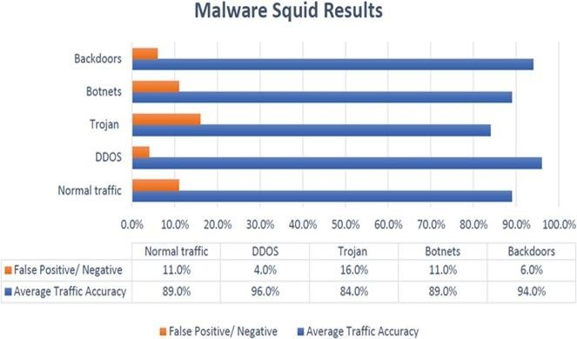

**Fig. 6**. Final test individual average accuracy for each malware type.

Table 3 shows that the proposed approach achieved an accuracy of 91.32%, which meets accuracy of practical use. It has got a high precision 91.67% and recall (91.03%), which shows the ability of our approach in classifying bad and good trafﬁc.

Table 3. Results for the last test

|  |  |  |  |  |
| --- | --- | --- | --- | --- |
|  | (A) | (P) | (R) | (F1) |
| Test 4 | 91.32% | 91.67% | 91.03% | 91.35% |

* 1. **ASCII CHARACTERS FREQUENCY THROUGHOUT TRAFﬁC RESULTS AND ANALYSIS**

As can be seen in Fig. 7, the different types of malwares have distinctive features to differentiate them. Whereas normal trafﬁc can be spotted by their more even distribution of ASCII characters or colours across an image, most of the malware samples follow the same pattern of having more predominance of black (Null Bytes) or white areas (Spaces) in their samples, however, the DDOS is an exception with its extremely high frequency of Control characters. Malware samples do not follow the same pattern as normal trafﬁc, the large volume of null and white spaces might indicate that code was present in the trafﬁc stream. Null bytes which are normally used in coding to mark the end of the string or its termination point [24], could indicate the use of trafﬁc containing a back-door attack or similar.

Null bytes are also the main factor in injection exploitation techniques used to bypass security ﬁlters, the null bytes are added to user- supplied data to manipulate application behaviour that called a null byte injection attack [25]. Null bytes are also commonly not contained within the default ASCII web request [26], an indication of potential botnet usage that is targeting web servers with no intention to establish a legit connection. DDOS attacks also had an interesting pattern that did not match up with the rest of the other malware, as displayed in Fig. 7, the images had a very high frequency of green pixels, more than any type of trafﬁc recorded. High levels of green pixels represent an abuse of the use in control characters [14], attacks commonly use control characters to hide data in packets that are malicious in nature [25].

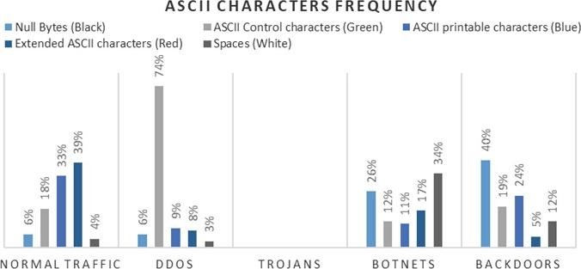

**Fig. 7**. Average ASCII character frequency between malware and normal trafﬁc PCAPS.

* 1. **COMPARISON**

It is not easy to conduct a fair comparison among various malware classiﬁcation approaches due to the differences between the datasets of trafﬁc used, image visitation tools used and target environments. Thus, our comparison will be based on some signiﬁcant features. Table 4 overviews a general comparison between our approach and the well- known IDS (Intrusion Detection System) Snort [28] and Suricata [29].

Table 4. Comparison with other methods

|  |  |  |  |
| --- | --- | --- | --- |
| Features | Malware squid | Snort | Suricata |
| Low false alarm rate | Yes | No | Yes |
| Lightweight | Yes | Yes | No |
| Protocol independent | Yes | No | No |
| Raw trafﬁc input | Yes | Yes | Yes |

The results from the experiments show that malware squid has a low false alarm rate, only beaten by Suricata due to its more modern nature and detection methods. Whereas snort has a high false alarm rate due to problems with extracting malware footprints from trafﬁc, the means of which its Snort rule set runs off [12]. Malware squid is also a lightweight program for one that utilises an AI, this is due to the MobileNet algorithm being as minimalistic as possible, which is also similar to the older Snort [29], however Suricata Is not lightweight due to its increased memory consumption used in multithreading [30]. Both methods use a set rule set to detect malicious trafﬁc, if trafﬁc matches these sets it will trigger an alarm [12], Malware squid uses image classiﬁcation so has no knowledge of rule sets making it protocol independent. Finally, all three approaches can take raw trafﬁc input into their datasets [27], this seems to be a staple in IDS detection technologies.

1. **CONCLUSION**

This paper proposed a novel IoT malware trafﬁc analysis method, leveraging multi- level artiﬁcial intelligence that uses a combination of neural network paired with a binary visualization. The method can be used to protect IoT devices on gateway level bypassing the limitations associated with the IoT environment. From our initial experimental results, the method seems promising and being able to detect unknown malware. Moreover, the method learns from the misclassiﬁcations and improve its efﬁciency. Future work would involve the use of more samples for training and testing and utilising GPU for binary visualization and CNN classiﬁcation and testing the proposed approach for encrypted trafﬁc as well.