Smart Co-Working Space Management Using Real-Time Monitoring

Author: Chandrashekar C S
Email: chandrushekar4567@gmail.com

Internship Organization: Unified Mentor Pvt Ltd

Institution: Presidency University

Abstract— The rapid growth of flexible work environments has increased the demand for efficient co-working space management systems. However, users often face challenges in identifying suitable workspaces based on team size, budget, amenities, and real-time availability. This paper presents a web-based Smart Co-Working Space Management System that enables users to discover, evaluate, and book workspaces through a centralized platform. The system incorporates real-time monitoring, smart filtering, and role-based access for users, space owners, and administrators.

1. Introduction
The rapid growth of remote work, freelancing, and startup culture has significantly increased the demand for co-working spaces. These shared work environments provide flexible, affordable, and collaborative facilities for individuals, startups, and organizations. Unlike traditional office setups, co-working spaces allow users to rent workstations, meeting rooms, or private offices according to their needs and budget. As a result, they have become an important part of the modern business ecosystem.
However, many existing platforms do not provide properly organized information, real-time availability updates, or intelligent matching features. Users often face difficulties in finding suitable workspaces based on location, pricing, seating capacity, and required amenities. Manual communication between users and providers also creates delays and confusion during the booking process.

2. Objectives
The primary objective of the system is to develop a centralized web-based platform for discovering and booking co-working spaces. The platform is designed to simplify workspace management by providing detailed information about available spaces, including pricing, seating capacity, and facilities. Another important objective is to implement a smart matching mechanism that helps users find suitable workspaces based on their requirements such as budget, team size, and location.
The system also focuses on improving the overall user experience by offering a simple and user-friendly interface. Features like personalized recommendations, secure login, and real-time booking updates help users interact with the platform more efficiently.
Additionally, the project aims to improve workspace utilization for providers by increasing visibility and reducing vacant spaces. Automation of booking management and availability tracking minimizes manual coordination efforts and increases operational efficiency.

Key Objectives
- Centralized platform for workspace discovery and booking
- Smart matching based on user requirements
- Real-time availability and transparent pricing
- Improved workspace utilization and automation

3. System Architecture
The Smart Co-Working Space Management System follows a three-tier architecture commonly used in modern web applications. This architecture separates the system into different layers, making it scalable, maintainable, and efficient.
The frontend layer is developed using React.js or Next.js, which provides an interactive and responsive user interface. Users can browse workspaces, apply filters, and make bookings through a visually appealing dashboard. Responsive design ensures that the platform works smoothly across desktops, tablets, and mobile devices.
The backend layer is built using Node.js and Express.js. It handles the core business logic of the application, including user authentication, booking management, API handling, and communication between the frontend and database. JWT authentication is used to ensure secure access to the system.
The database layer uses MongoDB or PostgreSQL for storing user information, workspace details, booking records, and availability data. The database is designed to support fast data retrieval and efficient storage management.

Architecture Layers
- Frontend Layer – React.js / Next.js
- Backend Layer – Node.js and Express.js
- Database Layer – MongoDB / PostgreSQL
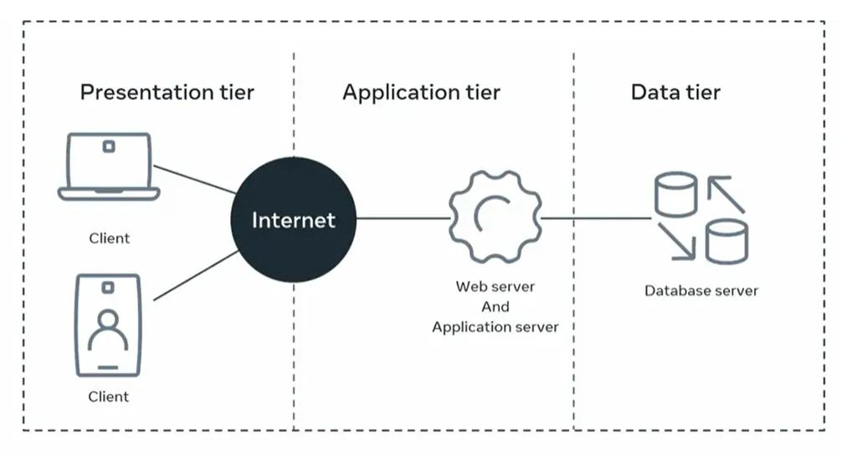

4. Modules

The system is divided into several functional modules to ensure smooth operation and better management of platform activities.

The User Module manages user registration, login, and profile management. It allows users to securely access the platform and maintain their personal information. Authentication and authorization mechanisms ensure data privacy and security.

The Workspace Module displays complete information about available workspaces, such as seating capacity, workspace type, area size, and pricing details. This helps users compare multiple options before making a booking decision.

The Search and Matching Module enables users to filter workspaces based on different criteria like team size, budget, location, and amenities. This intelligent filtering mechanism improves search efficiency and enhances user satisfaction.

The Amenities Module manages details related to facilities provided by workspace owners. These facilities may include Wi-Fi connectivity, parking space, meeting rooms, cafeteria services, and power backup systems.

The Booking Module handles booking requests, approvals, cancellations, and booking history. Real-time availability tracking helps prevent double bookings and ensures accurate reservation management.

The Admin Module manages overall platform operations, including user management, workspace verification, and monitoring of booking activities. Administrators can also remove invalid listings and maintain system performance.

Main Modules
- User Module
- Workspace Module
- Search & Matching Module
- Amenities Module
- Booking Module

5. Database Design (ER Model)

The database design of the Smart Co-Working Space Management System is based on an Entity Relationship (ER) Model. The ER model defines the relationships between different entities such as users, workspaces, bookings, and amenities. Proper database design helps maintain data consistency, reduce redundancy, and improve system performance.

The User entity stores information related to registered users, including user ID, name, email, password, and contact details. The Workspace entity contains information about available co-working spaces, such as workspace ID, location, pricing, capacity, and workspace type.
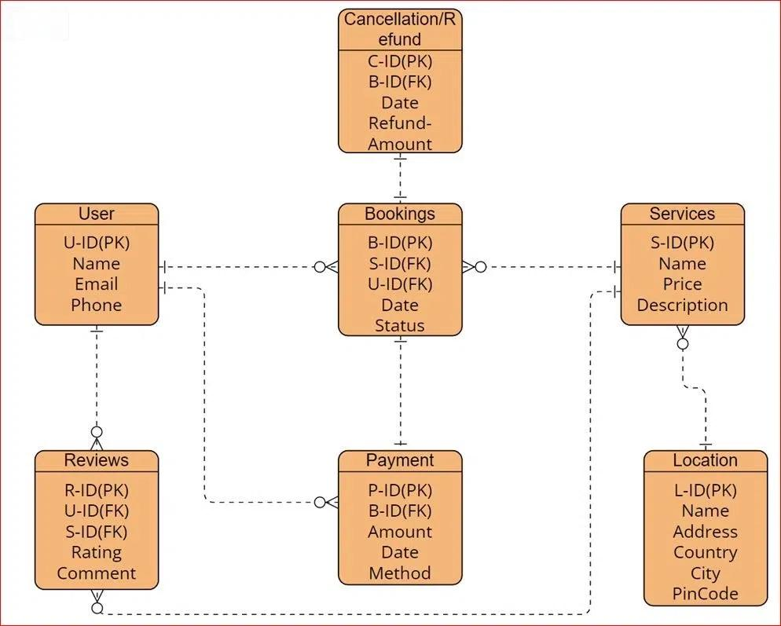

6. Methodology
The development of the Smart Co-Working Space Management System follows a systematic software development methodology to ensure proper planning, implementation, and testing.
The first stage is Requirement Analysis, where user needs and system requirements are identified. This includes understanding features such as workspace filtering, booking management, real-time availability tracking, and secure authentication.
In the System Design stage, the overall architecture, database schema, and user interface wireframes are designed. This stage helps define how different modules interact with each other and ensures smooth system functionality.
Frontend development is carried out using React.js to create responsive and interactive UI components. Backend development is implemented using Node.js and Express.js, where REST APIs are created for communication between the frontend and database. JWT authentication is used to secure user access.
Database integration is performed using MongoDB to manage flexible and scalable data storage. Finally, different testing methods such as functional testing, integration testing, and performance testing are conducted to verify system reliability and efficiency.

Development Stages
- Requirement Analysis
- System Design
- Frontend Development
- Backend Development
- Database Integration
- Testing

7. Results and Discussion
The Smart Co-Working Space Management System successfully provides a centralized solution for workspace discovery and booking. The platform allows users to search and compare workspaces efficiently based on their preferences such as location, pricing, seating capacity, and amenities.
The implementation of real-time availability tracking improves booking accuracy and reduces conflicts caused by duplicate reservations. Role-based dashboards enhance usability by providing separate functionalities for users, workspace providers, and administrators.
The system demonstrates good scalability and performance, making it suitable for deployment in multiple cities and business environments. By automating booking management and workspace monitoring, the platform reduces manual coordination and improves operational efficiency.

8. Advantages
The Smart Co-Working Space Management System offers several advantages for both users and workspace providers. The centralized platform simplifies workspace discovery and reduces the time required to find suitable office spaces.
Real-time availability tracking ensures accurate booking information and minimizes reservation conflicts. Smart filtering and matching features improve user convenience by providing personalized workspace recommendations based on user preferences.
The system also provides secure authentication and role-based access control, ensuring user data privacy and protection. Its scalable architecture allows the platform to handle increasing numbers of users and workspaces efficiently.
Another major advantage of the Smart Co-Working Space Management System is its ability to improve collaboration and networking opportunities among professionals, freelancers, and startups. By bringing users from different industries into a shared digital and physical workspace environment, the platform encourages communication, knowledge sharing, and business growth. The system also helps workspace providers increase occupancy rates and revenue by reaching a larger audience through an online platform. Furthermore, automated management features reduce administrative workload, save time, and improve overall operational efficiency.

Advantages
- Centralized workspace management
- Real-time booking updates
- Smart filtering and matching
- Secure authentication system
- Scalable and flexible architecture

9. Future Enhancements
- AI-based Recommendation System

An AI-based recommendation system can analyze user preferences, booking history, workspace ratings, and search patterns to suggest the most suitable co-working spaces. This feature improves user experience by providing personalized recommendations and reducing the time required to search for workspaces manually. It also helps workspace providers attract the right customers based on their services and facilities.
- Dynamic Pricing Models

Dynamic pricing models allow workspace prices to change automatically depending on factors such as demand, availability, peak working hours, and seasonal trends.
- Mobile Application Development

Developing a mobile application for Android and iOS platforms will increase accessibility and convenience for users. Through the mobile app, users can search for workspaces, check real-time availability, make bookings, receive notifications, and manage reservations from anywhere. A mobile application also improves user engagement and platform usability.
- Payment Gateway Integration

Payment gateway integration enables users to make secure online payments directly through the platform. It supports multiple payment methods such as debit cards, credit cards, UPI, net banking, and digital wallets. This feature simplifies the booking process, improves transaction security, and reduces manual payment handling.
- Advanced Analytics Dashboard

An advanced analytics dashboard provides detailed insights into workspace performance, booking trends, occupancy rates, customer preferences, and revenue generation. Workspace providers and administrators can use these analytics to make better business decisions, improve services, and optimize resource management. The dashboard also helps monitor platform growth and user activity effectively.

10. Conclusion
The Smart Co-Working Space Management System provides an efficient and modern solution for managing co-working spaces and workspace bookings. The system simplifies the process of discovering, comparing, and reserving workspaces by integrating real-time availability tracking, smart filtering, and secure authentication mechanisms.
By using modern web technologies and scalable architecture, the platform improves workspace utilization and enhances user satisfaction. It also reduces manual coordination efforts for workspace providers through automation and centralized management.
The project demonstrates the importance of digital transformation in optimizing resource management within the co-working industry. With future enhancements such as AI recommendations, mobile applications, and dynamic pricing systems, the platform can evolve into a complete and intelligent workspace ecosystem.

References
- MongoDB Documentation - https://www.mongodb.com/docs/
- React.js Official Documentation - https://react.dev/
- Node.js Official Documentation - https://nodejs.org/en/docs
- Express.js Official Documentation - https://expressjs.com/
- PostgreSQL Documentation - https://www.postgresql.org/docs/
- JWT Authentication Documentation - https://jwt.io/introduction
- MDN Web Docs – Web Development Resources - https://developer.mozilla.org/

MERN Stack Tutorials – GeeksforGeeks

