 | A highly motivated and enthusiastic graduate with a passion for web development, seeking a MERN stack developer role to contribute my technical skills and creativity to build innovative and user-friendly web applications.  Education  Technologies  Frontend:  - Html, CSS, Java Script  - Framework/library: Bootstrap, ReactJS  Backend:  - Nodejs  - Express JS  Database:  - MongoDB  - My SQL(Basics)  Projects  - Designed a user-friendly fully responsive Social Media blog app with CRUD operation using MERN stack  - A Full Stack online learning application with course registration and form handling  - A user management system using MERN stack with CRUD operation  - A bulk Email App using MERN stack  - Weather forecast Application using weather API and 10+ mini projects  Experience or internship:  Design engineer at DEWDAS technology private limited Bangalore. Experience in CATIA part design, drafting and part assembly (Experience-10months)  Projects:  - Design and development of AUTOMATIC INCENSE burner  - Design and development of aircraft cockpit lightning panel for Aero India 2023  Certifications  Hobbies  - Listening to music  - Playing Cricket |  |  | 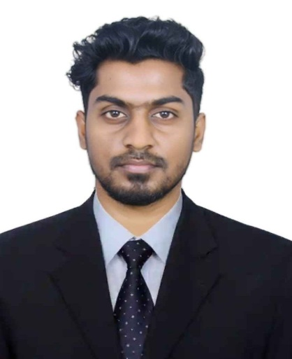  Contact  Address  Salem, India 636453  Phone  +91 6382203297  E-mail  chandruinfo455@gmail  .com  git-hub  https://github.com/Chandru-Ghub  Skills  Flexible and Adaptable  Active Listening  Teamwork and Collaboration  Languages  English  Tamil  Programming Skill  - Java Script  - Python
  Chandru M
  Entry Level Full Stack Developer
  2019-08 - 2022-07 |  | Bachelor of Engineering: Mechanical Engineering  Coimbatore Institute of Technology – Coimbatore, Tamil Nadu  Completed with 7.6 CGPA
  2019-11  2022-7 |  | AutoCAD 2D and 3D course completion from VRET CIT campus  Catia V5 from scratch to professional level course from UDEMY
.

