**Introduction**

Dark Samurai Within

I am making a “simple memory and response test “game. The game request the user’s name as an input.

For example, let the user enter the name "chan". Then the game would start and he will be presented with 3 blocks in which one will contain the first character of his name. And the user should press 1 or 2 or 3 according the location in which the character is present. If he pressed the correct location number, he will be put up with next 3 blocks in which one will contain the next character in his name provided.

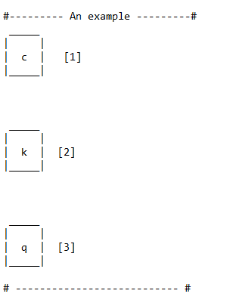

And the same thing will continue with till all the characters in his name is

completed.

In the future:

0) A story board will be made which will be featuring this proverb

"If there is no enemy within, the enemy outside can do us no harm " and involves

a samurai.

1) We will make this game more tough by introducing our own random characters

, that the user has to remember correctly with the correct order and has to play

this game.

2) Adding a score card - The user will be tested on the responsiveness of his input. We will try to

measure in milli seconds the time he takes to respond.

**Research**

<https://steamcommunity.com/discussions/forum/12/541906348046503348/>

<https://www.theatlantic.com/technology/archive/2017/04/video-games-stories/524148/>

See the African proverb

See the kung fu panda scroll

Samurai

What is a samurai

Shadow fight story

Once upon a time, a king was there, he was told by astrologers that 4 witches have been born, they have to be finished.

The best samurai was summoned to kill them, but later the samurai realized that the power’s they had will launch only when they get the light sword.

The curse that witch had was they cannot kill a samurai or a king with the spell.

After the samurai did not kill the witch, the king’s son took over as the next king. The new king wanted the samurai to give the light sword to him and so that he can summon the witch and kill whom ever he wanted.

His mother was a witch, and his father was a samurai. He was born.

He was taught samurai techniques but he did not learn.

He always used the witch techniques that his mother taught him, when he spells his enemy name and write it onto wooden blocks and strike it fully, the enemy would die.

The king liked him very much and made him into high ranks easily but he was not a good samurai.

His mother married his father not out of love but to get the light sword, which is required for that technique, it doesn’t matter how big that enemy is when the technique is performed the enemy would die.

His mother was slowly turning from a witch to a normal human being.

His father was ageing, and her mother too, his father was in the bed before being dead.

He promised to his father that he will stop using the witch techniques. His father told the whole story that, the king is killing everybody without mercy as it is one of the qualities that gets to the wielder of the sword. Even the king’s father was like that but he did not changed, he was killed by the the samurai so that kingdom can be guarded.

But the mother’s sisters did not forget the mission, so they burned the whole village at night while the hero was in the king’s place to tell him that he will turn good.

While telling the king about his feeling and want to quit even though knowing that if he tells no to the king he would be dead.

He saw that king summoned the witch to burn the whole village down to get his hands on the sword.

He was missioned to kill the witches with the same technique and went on to kill the king but he would not be able to. He thought that he can’t remain forever like this he has to end this witch thing and killed himself.

**Cost and Features**

Here the cost refers to the hours (time) that each feature takes for developing it.

We are going to see

**Defining the system**

The system is a simple command line game.

That is the user will enter his name, and will press at most 3 keys during the game play

**SWOT analysis**

Opportunity

* Everybody can run this game

Strength

* Working with characters is easy
* Just taking simple inputs from the user
* The game play is simple

Threats

* The user might not like the simple gameplay
* The user would not feel that much challenged

Weakness

* The game lacks colors

**4 W’s and H’s**

**High level req**

**Low level req**

For every high requirement u need to have a swot analysis and 4w’s and H analysis