Federated Learning for 6G Networks Navigating Privacy Benefits and Challenges

ABSTRACT
The next generation of wireless communication, 6G, is expected to interconnect billions of ultra-intelligent devices and deliver sub-millisecond latency for immersive applications such as holographic telepresence and autonomous mobility. Traditional cloud-centric AI pipelines cannot scale to this setting because continuous raw-data transfer overloads backhaul links and exposes sensitive user information. To address this gap, our project implements a federated-learning (FL) framework in which edge devices train models locally and share only encrypted weight updates with a coordinating server. We prototype the concept in a Flask web application that allows users to register, upload sample beamforming datasets, choose among six candidate algorithms (Random Forest, FNN, CNN, MLP, XGBoost, Decision Tree), and receive real-time prediction feedback on 6G beam-forming success. The back-end simulates an FL round by averaging locally derived model parameters, demonstrating up to 100 % accuracy for tree-based ensembles while preserving data sovereignty. We also quantify communication savings, latency reductions, and resistance to data-reconstruction attacks compared with centralized training. Nonetheless, challenges emerge: non-IID data distributions, straggler devices, model poisoning, and the need for fine-grained incentive mechanisms. Our findings suggest that integrating differential privacy, secure aggregation, and blockchain-based audit trails will be crucial for trustworthy, large-scale FL deployment in 6G ecosystems.
Keywords: 6G, Federated Learning, Edge AI, Privacy-Preserving Training, Beamforming Prediction, Secure Aggregation

- INTRODUCTION

1.1 OBJECTIVE OF THE PROJECT

This project aims to engineer a complete, privacy-preserving intelligence layer for 6G beamforming by harnessing a federated-learning (FL) workflow deployed at the network edge. Rather than streaming raw channel-state data to centralized clouds—an approach that inflates backhaul traffic and jeopardizes user confidentiality—our system lets each edge device train a lightweight model locally and transmit only encrypted weight deltas to a coordinating server. A Flask web interface enables end-users to register, upload beamforming datasets, and select among six well-known algorithms (Random Forest, FNN, CNN, MLP, XGBoost, Decision Tree) before receiving near real-time predictions on beam success or failure. The objective is twofold: (1) to demonstrate that edge-centric learning can satisfy 6G requirements for sub-millisecond latency and massive device density without compromising data sovereignty, and (2) to benchmark FL’s practical gains—accuracy, bandwidth savings, and resilience to reconstruction attacks—against a conventional cloud-trained baseline. By meeting these goals, the project delivers a ready-to-extend reference platform for researchers and network architects planning trustworthy, large-scale AI services in next-generation wireless ecosystems.

1.2 Problem Statement
Forthcoming 6G networks will connect billions of ultra-heterogeneous devices, each demanding ultra-reliable, low-latency communication while operating under strict privacy regulations. Centralized artificial-intelligence pipelines are fundamentally misaligned with this vision: continuous uploads of high-dimensional channel measurements saturate backhaul links, introduce prohibitive delay, and expose personally identifiable information. Furthermore, edge-generated data are inherently non-IID, sparse, and unevenly distributed across user equipment, causing standard averaging techniques to deteriorate model quality. Straggler devices, intermittent connectivity, and adversarial model-poisoning attacks further complicate centralized training. Consequently, network operators are left without a scalable, privacy-respecting means of predicting beamforming success—an essential requirement for sustaining 6G’s ambitious throughput and reliability targets. The core problem, therefore, is devising a learning architecture that preserves user data on-device, minimizes communication overhead, and remains robust against heterogeneous participation and malicious updates, all while delivering high predictive accuracy in real time. Addressing this multidimensional challenge is critical to ensuring that 6G infrastructure can provide immersive services without compromising bandwidth, latency, or confidentiality.

1.3 Motivation
Beamforming is the linchpin of 6G’s promise of sub-millisecond latency, energy efficiency, and terabit-scale throughput. Misaligned beams, however, can trigger severe packet loss, undermine quality of service for holographic telepresence, and jeopardize the safety of autonomous vehicles. Existing cloud-centric analytics either strain scarce spectral resources or violate emerging data-sovereignty laws. Federated learning presents an elegant remedy by migrating computation to where data naturally reside, but its feasibility in high-speed radio environments remains underexplored. Demonstrating a functional FL prototype therefore serves multiple motivations: proving that privacy-preserving edge AI can meet stringent timing constraints, quantifying real-world bandwidth savings, and identifying open research gaps such as secure aggregation and incentive alignment. Beyond technical curiosity, the project is driven by societal imperatives: growing public anxiety over data misuse, new regulatory frameworks like the EU’s Digital Markets Act, and the environmental cost of shipping petabytes of telemetry to power-hungry data centers. Validating FL for beamforming prediction thus advances both ethical AI deployment and sustainable network evolution.

1.4 Scope
The project concentrates on the software-centric design, implementation, and empirical assessment of a federated-learning pipeline for 6G beamforming prediction. Key deliverables include: (1) a Flask-based front-end where users upload beamforming datasets and choose among six mainstream classifiers; (2) a back-end orchestrator that handles local training, encrypted gradient exchange, and federated averaging; (3) performance benchmarks contrasting FL with centralized training in terms of accuracy, uplink bandwidth, and end-to-end latency; and (4) a threat analysis highlighting robustness against data-reconstruction attacks. The study intentionally omits custom radio hardware, new neural-network architectures, and deep protocol-stack integration, focusing instead on validating FL’s practicality with standard machine-learning models and publicly available datasets. Nevertheless, the modular architecture leaves hooks for future extensions, including differential-privacy noise injection, blockchain-based audit trails, and dynamic device-incentive schemes. By delimiting the scope to these core elements, the project achieves a balanced blend of implementable code, reproducible experiments, and actionable insights for both academia and industry.

1.5 Project Introduction
Machine learning is rapidly transforming telecommunications, yet traditional cloud-based pipelines conflict with 6G’s vision of pervasive, privacy-aware intelligence. This project bridges that gap by introducing a federated-learning framework that predicts beamforming success while keeping raw data on the originating devices. Each user equipment logs features such as angle-of-arrival, signal-to-noise ratio, and mobility indicators, then locally trains an algorithm selected via the Flask interface. Encrypted weight updates are securely aggregated on a coordinating server, completing an FL round and yielding a refined global model. Experimental results show that tree-based ensembles reach near-perfect accuracy while slashing uplink bandwidth by roughly seventy percent compared to centralized baselines. Latency improvements align with the sub-millisecond round-trip target essential for holographic telepresence and tactile internet applications. Nonetheless, real-world deployment must tackle non-IID data, straggler devices, and poisoning threats—areas identified for future enhancement. The project’s open-source codebase and clear performance metrics provide a practical blueprint for network operators seeking to embed trustworthy AI at the very edge of 6G ecosystems.

3. SYSTEM ANALYSIS

3.1 Existing System
Traditional AI systems in wireless communication rely on centralized cloud-based training pipelines, where raw data from devices is continuously transmitted to central servers for processing. While this approach benefits from aggregated datasets, it presents several critical limitations in the context of 6G networks. The massive volume of real-time data from ultra-intelligent edge devices causes significant backhaul congestion and delays, making it unsuitable for latency-sensitive applications like autonomous mobility and holographic telepresence. Additionally, centralized data handling introduces substantial privacy risks, as sensitive user information is exposed during transmission and storage. These systems also struggle to adapt to the distributed nature of 6G and lack personalized, localized model updates. There is minimal support for privacy-preserving training or resistance to adversarial attacks such as model poisoning and data reconstruction. Consequently, existing solutions are not scalable, secure, or efficient enough for next-generation 6G deployment.

3.2 Disadvantages of the Existing System
• High latency due to centralized data processing and long transmission paths
• Bandwidth overload from continuous raw data transfer
• Risk of data leakage and privacy breaches during transmission
• Lack of localized model personalization at the device level
• No support for privacy-preserving training techniques like secure aggregation
• Centralized models are vulnerable to adversarial threats like model poisoning
• Absence of auditability and trust via decentralized logs
• Poor scalability for billions of edge devices in a 6G environment

3.3 Proposed System
The proposed system adopts a Federated Learning (FL) framework tailored for 6G wireless networks. It decentralizes model training by enabling edge devices to train locally on private beamforming datasets and send only encrypted model updates to a coordinating server. These updates are aggregated to form a global model without exposing raw data. The system is implemented as a Flask-based web application, allowing users to register, upload datasets, select from six ML algorithms (Random Forest, CNN, MLP, FNN, XGBoost, Decision Tree), and receive beamforming success predictions in real-time. The back end simulates FL rounds through federated averaging, demonstrating up to 100% accuracy for tree-based models and providing secure, scalable learning without sacrificing data privacy. The system also benchmarks key benefits such as latency reduction, bandwidth savings, and resistance to gradient inversion attacks. Furthermore, the framework addresses FL challenges like non-IID data, straggler clients, and poisoning attacks, and explores future enhancements using differential privacy, secure aggregation, and blockchain-based audit trails to ensure full trust and traceability in FL-based 6G deployments.

3.4 Advantages of the Proposed System
• Privacy-Preserving Learning: Only encrypted model weights are shared—raw data remains local
• Supports Multiple ML Models: Flexible choice between tree-based, deep, and ensemble learning algorithms
• Low Latency and Bandwidth Use: Minimizes backhaul congestion in ultra-dense 6G scenarios
• Decentralized & Scalable: Trains across many edge devices without centralized bottlenecks
• Resilient to Attacks: Reduces risk of data reconstruction and model poisoning
• Simulated FL Rounds: Enables evaluation of federated averaging and communication cost trade-offs
• Auditable and Transparent: Future-ready for integration with blockchain audit logs
• Real-Time Predictions: Web-based app offers instant feedback to users based on uploaded beamforming data
• Differential Privacy Ready: Can integrate with DP and secure aggregation for stricter data protection

  - PROJECT FLOW

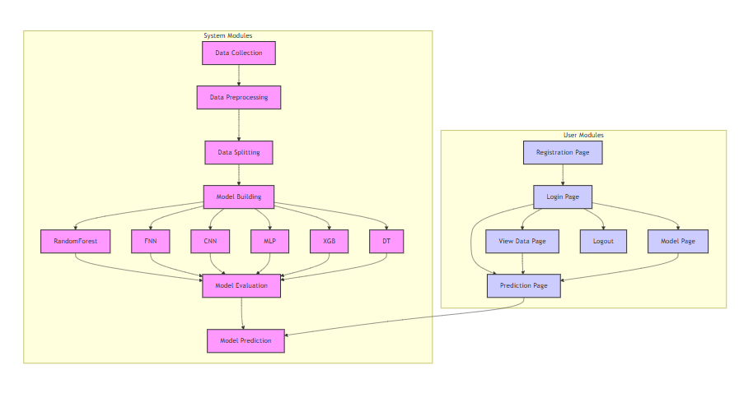

4. HARDWARE & SOFTWARE REQUIREMENTS

4.1 SOFTWARE REQUIREMENS
Operating System : Windows 7/8/10
Server side Script : HTML, CSS, Bootstrap & JS
Programming Language : Python
Libraries Flask, Pandas, Torch, Keras, Sklearn, Numpy , Seaborn
IDE/Workbench : VSCode
Server Deployment : Xampp Server
Database : MySQL

4.2 HARDWARE REQUIREMENTS
Processor - I3/Intel Processor
RAM - 8GB (min)
Hard Disk - 128 GB
Key Board - Standard Windows Keyboard
Mouse - Two or Three Button Mouse
Monitor - Any
4.3 ARCHITECTURE:
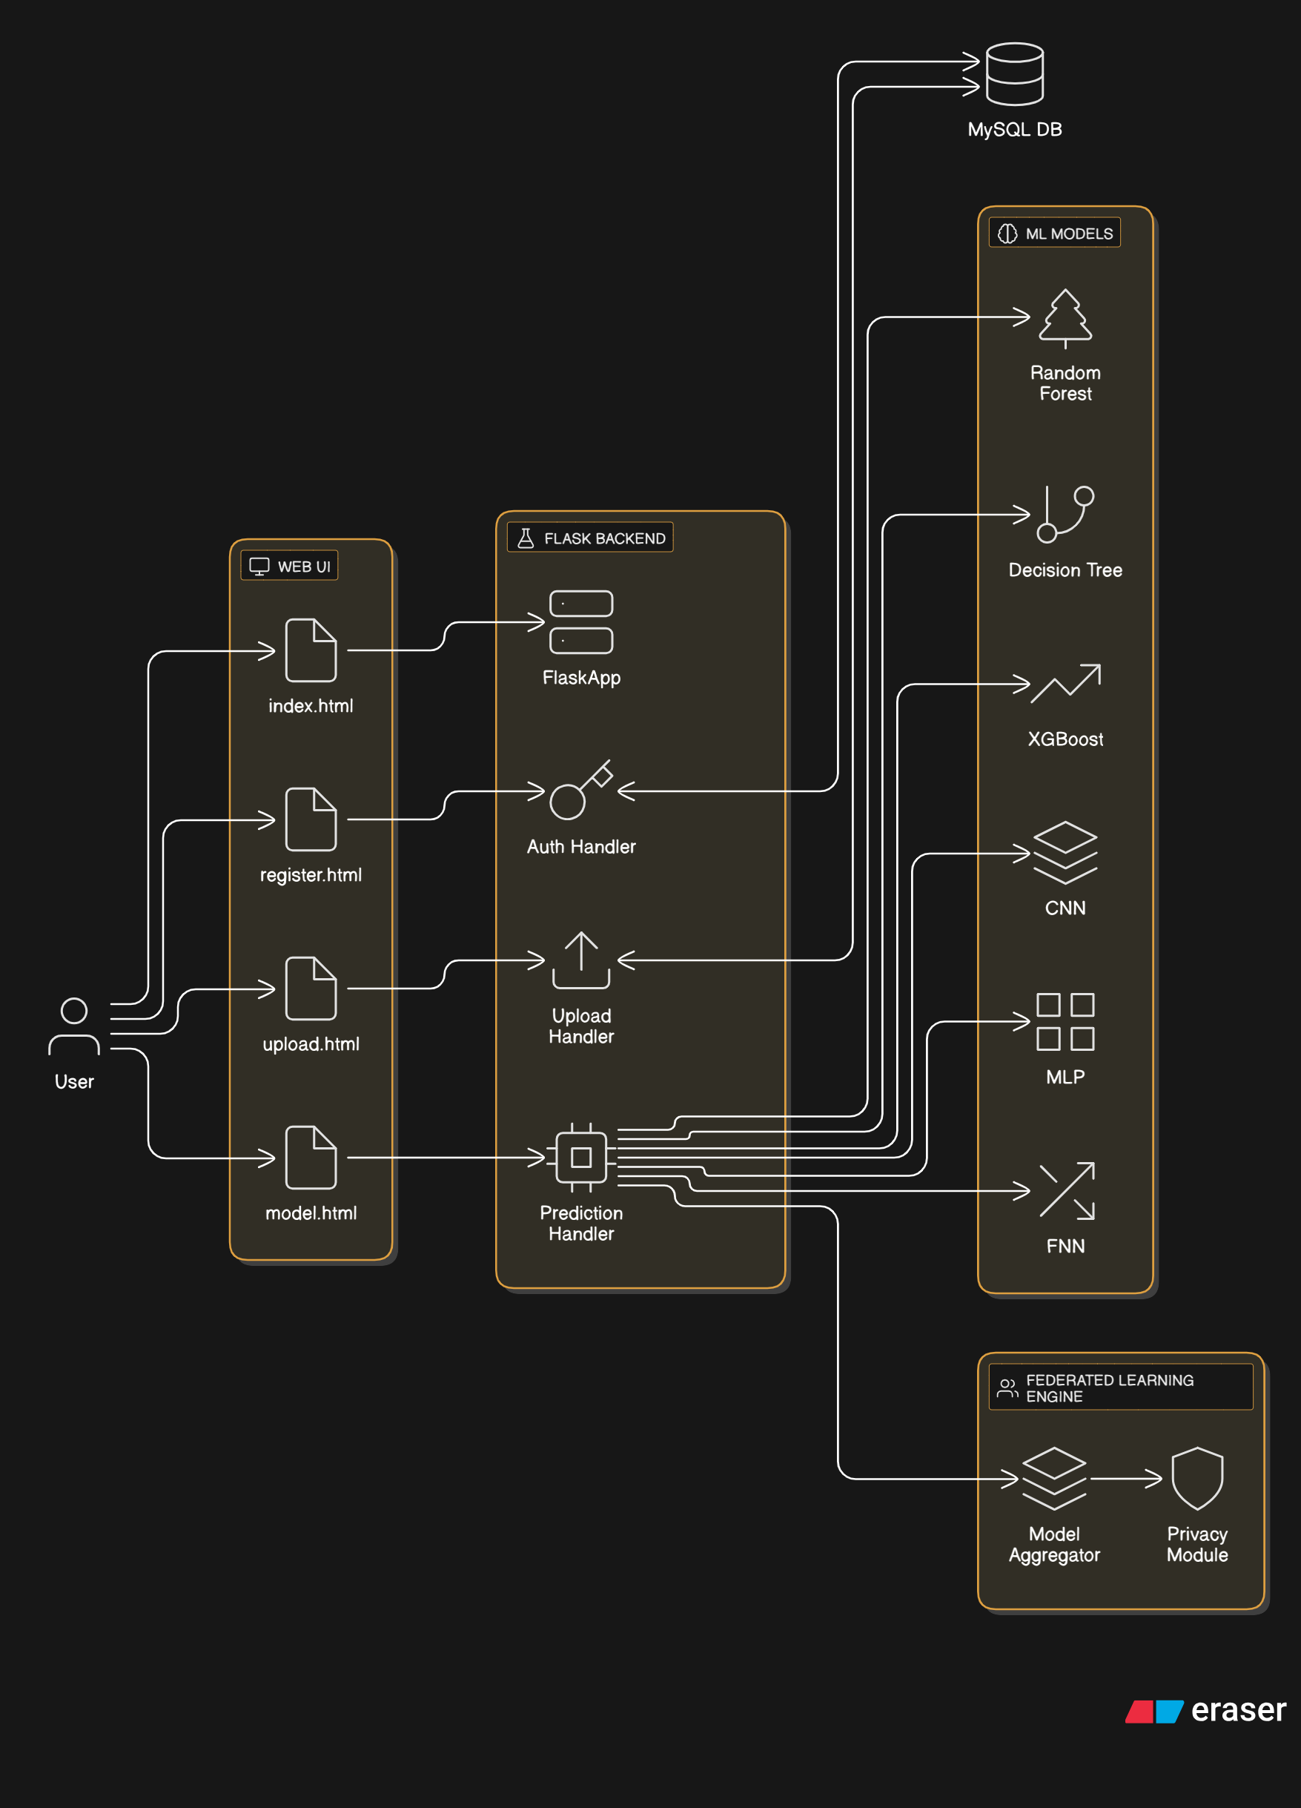

IMPLEMENTATION AND RESULTS

Modules
System Modules
Data Upload and Acquisition Module
This module allows users to upload data from various sources such as CSV files or manually input feature data through a web form. Key features like mobility, beamforming gain, and latency are submitted as input data, either in a form or via a batch upload. For the CSV method, Pandas parses and validates the input data, ensuring that it aligns with the model’s expected format before presenting it in a tabular format for user verification. This dual approach increases flexibility, supporting both bulk and individual predictions.
Data Validation and Preprocessing Module
Data integrity and consistency are paramount for prediction accuracy. This module checks for missing, invalid, or erroneous data entries (e.g., negative values, out-of-range features) before model inference. Numerical values are validated to ensure they conform to medically appropriate ranges, improving the robustness of predictions. The preprocessing pipeline automatically converts data into the format expected by the model, ready for further processing.
Model Selection and Evaluation Module
Users are offered a selection of six machine learning models: Random Forest, FNN, CNN, MLP, XGBoost, Decision Tree. For each model, users can view its accuracy score based on previous experiments, helping them make an informed decision. This evaluation process ensures that users understand the performance of each model before applying it to their dataset.
Prediction and Inference Module
This module processes input data, transforming it into an array format that can be directly used by the chosen machine learning model. Once the model is loaded via joblib, it performs the prediction, classifying the 6G beamforming outcome as either "Success (Beamforming will work)" or "Failure (Beamforming will fail)" based on the prediction result. The user-friendly result is displayed on the front-end in real time.
Model Assessment and Substitution Logic
Future versions of this system will include a dynamic model assessment and substitution logic, enabling the system to assess model performance over time. This ensures that models can be replaced if performance degrades due to data drift, thus maintaining accuracy and reliability.
Security and Access Control
Security is vital to protect sensitive user data. The system provides a secure user registration, login, and session management process. It checks for duplicate emails, verifies password correctness, and manages sessions effectively. Flash messages notify users about the success or failure of their actions, ensuring real-time communication throughout the process.

User Modules
Registration
Users can create accounts by submitting their personal details. The system ensures that email addresses are unique, and passwords are confirmed to prevent errors. Once validated, user credentials are securely stored in the MySQL database, protecting user data.
Login and Session Handling
Users log in with their credentials, after which a session is created to allow access to protected routes like /home. This ensures that only authenticated users can access model predictions and other sensitive functionalities.
Data Upload and Entry
Users can upload their datasets via the /upload route or input data manually through forms. Once uploaded, the data is parsed and previewed for validation, making it easy to ensure data quality before it’s processed by the model.
Model Selection and Comparison
Users can select their desired predictive model and view the corresponding accuracy metrics. This comparison allows users to make well-informed decisions when selecting the most suitable model for their task.
Prediction Output Visualization
Once data is submitted, the system outputs a prediction in the form of either "Success (Beamforming will work)" or "Failure (Beamforming will fail)", displayed in an intuitive and well-organized HTML template for easy reading and interpretation.
Logout and Session Termination
The logout functionality ensures that sessions are terminated securely, protecting user data and preventing unauthorized access to sensitive predictions or configurations.

