Federated Learning for 6G Networks Navigating Privacy Benefits and Challenges

Dr. E Murali,  Professor,  Head of CSE(AIMD)Department,  Siddharth Institute of Engineering and  Technology, Puttur, Tirupati,  Andhra Pradesh, India,  sai4murali@gmail.com |  |  | C S Madesh,  U.G. Scholar, Department of CAI,  Siddharth Institute of Engineering and  Technology, Puttur,  Andhra Pradesh, India,  madeshcs28@gmail.com
D Mounika,  U.G. Scholar, Department of CAI,  Siddharth Institute of Engineering and  Technology, Puttur,  Andhra Pradesh, India, duppaladuppalamounika@gmail.com |  | K Adi Murthy,  U.G. Scholar, Department of CAI,  Siddharth Institute of Engineering and  Technology, Puttur,  Andhra Pradesh, India,  adhimurthyroyal@gmail.com |  | T Vijendra,  U.G. Scholar, Department of CAI,  Siddharth Institute of Engineering and  Technology, Puttur,  Andhra Pradesh, India,  vthamminaboina@gmail.com

Abstract: Six generations (6G) wireful communication services are expected to be capable of connecting billions of ultra intelligent terminals and supporting sub millisecond latency of immersive applications including holographic telepresence services and autonomous driving services, in the next decade. Traditional AI pipelines centred around the cloud can't be extended to this world for this fixed flow of raw data choking backhaul links, meaning heavily sensitive user data never gets encrypted and is public to anyone who ends up holding these keys. In order to fill this hole, our project uses a FL framework, in which local models train on the edge devices and only transmit the sum of encrypted learned weights updates to a server as a coordinator. We implement the idea in a flask web application enabling users to register, upload sample beamforming data sets, choose from six candidate algorithms (Random Forest, FNN, CNN, MLP, XGBoost, Decision Tree), and get instant feedback on their predictions in terms of the 6G beam forming success. Using back-end simulations of 1-model with locally summarized model parameters on the back end, our back end models achieved up to 100% accuracy for simulation of tree models while preserving data sovereignty. In addition, we evaluate communication saving, latency saving, and security under data reconstruction attack with respect to centralized learning. However, there are daunting challenges: non-ride-through (non- IID) data distributions, Straggler devices, Model poison, Requirement for fine-grain incentive schemes etc. Our studies indicate the relevance of the fact that differential privacy, secure aggregation, and blockchain-based auditing trail would be the building blocks of FL implementation based on trust in 6G applications.
Keywords: 6G, Federated Learning, Edge AI, Privacy-Preserving Training, Beamforming Prediction, Secure Aggregation

I. INTRODUCTION
This project aims at applying Federated Learning (FL) to face the privacy and scalability issue in the next-generation wireless communication 6G. As 6G envisions to connect billions of devices with ultra-low latency and high throughput, traditional AI systems for cloud-based applications cannot support these requirements due to constraints with bandwidth and challenges over data privacy of such users. By using edge devices to locally train the model and send their encrypted weight updates to a server, the project shows that a privacy-preserving scheme can be adopted which minimizes data transfer while ensuring high accuracy in model prediction of beamforming. This ensures that sensitive user information is always protected, providing the level of performance and privacy that is required by 6G applications such as holographic telepresence and autonomous mobility.
The motivation for this project was to build up an FL framework for beamforming prediction, where clients do ML locally and only exchange updates at a minimum. Designed on Flask, the backend supports a front end that allows uploading of the beamforming dataset and selecting from among several machine learning algorithms such as Random Forest, CNN, MLP, XGBoost, and Decision Trees. This backend coordinates the federated learning process and simulates a round in model averaging across gigantic jumps in accuracy. The project heavily focuses on the edge AI side of things-e.g., less communication overhead, data sovereignty, and real-time feedback handling for strict latency requirements of 6G.
The project is aiming at the demonstration of the use of federated learning in 6G scenario and to compare federated learning against centralized training production systems. In this manner, the project presents a clear picture of the advantages that edge AI potentially offers, looking at system performance in terms of accuracy, bandwidth reduction, and latency reduction. Problems like non-IID data distributions, device stragglers, and malicious updates are brought to attention while identifying solutions for further research into secure aggregation schemes and incentive mechanisms. This project sets a direction for further developments through differential privacy and blockchain-based audit trails and dynamic incentives, also hinting at the sustainable development of 6G networks where privacy will be retained by stakeholders.

A. Objective of The Study:

The project aims to design whose FL environment is private and supports beamforming in 6G networks. Edge-intelligent learning-inspired ultra-low latency, massive device connectivity, data privacy, and data sovereignty are few of the quintessential features that are ought to be served by edge-intelligence learning. This framework allows the edge devices to train ML models locally and only share encrypted model updates that could simply put a very large burden on the network infrastructure had it been sharing the raw user data in subpar volumes; such sharing could lead to an attack on some user data with a very high degree of privacy. Here an attempt should be made for modeling a self-playing FL game on Web flask in which the user is shown online feedback on prediction with privacy guaranteed directly or through other means.

Another needed objective is to experimentally compare, in the traditional AI pipeline setup, Federated Learning in terms of accuracy, bandwidth used, and latency. This project enables the user to incorporate beamforming datasets and select from six candidate ML algorithms, including Random Forest, CNN, and XGBoost, to train models locally on distal clients or end-user devices. The back-end then coordinates the federated training (averaging local model parameters) as a testament to FL's ability to reduce uplink bandwidth by about 70% while maintaining high prediction accuracy. These models deliver near real-time predictive performance (very nominal levels of sub-millisecond latency) ample for use in autonomous vehicles, holographic telepresence, and similar applications.
During the main phase, practical discussions and resolutions for problems FL could face in the 6G environment will be tackled. These problems can arise and confront: existence of non-IID non-independent and identical data distributions, device stragglers, or even model-poisoning attacks that could hamper the accuracy and security of the FL system. The project will look at remedies to these attacks, which include secure aggregation systems, differential privacy with noise injection, and a blockchain-based audit trail for trust assurances on the system. As an open-source scalable platform, this project would serve as a guide to researchers of the 6G ecosystem and network architects in deploying large-scale privacy-preserving AI systems.

B. Problem Statement:
The issue that the paper conflicts with arises, coming from this philosophy, from the inadequacy of a traditional cloud-centric AI for 6G wireless networks. On the bright side, with strict latency and throughput-level coupling to billions of devices, centralized AI models do not scale well with a setting of hyper-voluminous data transfer, bandwidth congestion, and privacy concerns. Secondly, latency issues, depletion of network resources, and the leakage of sensitive user information to the cyber-security nuisance operate against the local data training systems that keep uploading vast sensor datasets to their cloud, with this being against the data sovereignty issue. Edge device data are often non-IID, sparse, and imbalanced, and here traditional machine-learning algorithms will actually lead to inefficient averaging that hinders model performance in return.
Furthermore, the problems of device stragglers, intermittent connectivity and adversarial model poisoning attacks add difficulty when it comes to facilitate centrally training. Such elements deteriorate the quality of the trained models and the possibility for the network to meet the stringent demands of 6G, for example the Real-Time predictions for Beamforming Success and Low Latency for applications like AV and Holographic Telepresence. As a result, network operators and researchers are challenged with the development of a scalable privacy-preserving and secure learning architecture, which shrinks data transfer, guarantees confidentiality, and is resilient to these adversities during accurate real time predictions to complex functions such as beamforming.
The core problem is, therefore, the design of a Federated Learning framework for AI on the edge that can cope with the heterogeneity of devices that participate, ensure privacy, reduce communication overhead and provide high accuracy-latency predictions. Non-IID data, device stragglers and adversarial threats represent special challenges in this system of data, which should ensure practicality and trust for widespread AI application in the universal expanding 6G environment.

II. RELATED WORKS
This paper explores the role of federated learning (FL) in enabling 6G networks, focusing on the privacy-preserving nature of FL that allows devices to collaborate without sharing raw data. It identifies key challenges such as data heterogeneity, straggler devices, and security issues like model poisoning. The paper discusses potential solutions such as secure aggregation, differential privacy, and adaptive FL algorithms. The authors emphasize that FL can support 6G’s requirements for low-latency, large-scale connectivity while ensuring data sovereignty.[1]
The paper introduces Split Federated Learning (SFL) as a solution for 6G networks, dividing the training process between edge devices and cloud servers. The authors highlight the challenges of ensuring efficient model updates while maintaining security, with a focus on non-IID data and device heterogeneity. The study proposes using differential privacy and secure multi-party computation (SMPC) for enhanced data security in 6G-enabled networks.[2]
This review paper provides an in-depth analysis of federated learning paradigms in the context of 6G networks. It categorizes FL methods based on the data, model, and aggregation techniques, addressing the challenges of real-time performance, data distribution, and privacy concerns. The authors propose future directions, such as integrating blockchain for FL management and developing efficient aggregation algorithms for large-scale 6G systems.[3]
This paper discusses the integration of deep learning with federated learning to improve predictive accuracy in 6G systems, particularly for beamforming predictions. The authors propose a collaborative framework that addresses device heterogeneity and security concerns, such as model poisoning, by incorporating secure aggregation techniques. Performance evaluations show promising results, with tree-based models achieving high accuracy in federated learning settings.[4]
The study explores federated split learning (FSL) for managing sequential data in satellite–terrestrial integrated networks, a key application in 6G. The authors highlight challenges related to data synchronization, real-time learning, and the integration of satellite data. They propose FSL as a method to reduce the communication overhead and ensure privacy while providing accurate predictions in these heterogeneous environments.[5]
This paper explores how quantum computing can enhance federated learning for 6G networks, focusing on IoT security. By integrating quantum encryption and SMPC, the authors propose a quantum-enhanced federated learning framework to mitigate security threats like model poisoning and data reconstruction attacks. The paper suggests that quantum computing could significantly improve the robustness of FL in large-scale 6G applications.[6]
The authors present DP-Fed6G, a federated learning framework that uses differential privacy (DP) to protect data privacy in 6G networks. The paper discusses how adaptive DP techniques can balance privacy and model accuracy in federated learning. DP-Fed6G is shown to outperform traditional federated learning methods in both privacy preservation and computational efficiency, particularly in real-time 6G applications.[7]
This paper focuses on applying secure multi-party computation (SMPC) to federated learning for IoMT in 6G networks. It addresses the privacy concerns specific to medical data and proposes an SMPC-based framework to secure federated learning processes. The authors show that this approach can protect patient data while allowing for collaborative learning across multiple devices in 6G-enabled healthcare applications.[8]
The study introduces federated learning as a service (FLaaS) for 6G networks, leveraging distributed data management to facilitate collaborative learning without centralizing sensitive data. The authors emphasize the need for efficient data partitioning and robust aggregation techniques to optimize performance across heterogeneous devices. The paper also discusses how FLaaS can be used to deploy privacy-preserving AI models in large-scale 6G systems.[9]
This paper investigates the role of federated learning in creating energy-efficient and sustainable 6G networks. The authors discuss how federated learning can reduce the energy consumption associated with data transmission and cloud computation by leveraging edge devices for model training. The paper emphasizes the potential for FL to meet sustainability goals while enhancing the efficiency of 6G networks.[10]
The authors examine the challenges and solutions for implementing federated learning in Internet of Things (IoT) applications in 6G networks. They focus on privacy concerns, proposing privacy-preserving techniques such as differential privacy and secure aggregation to ensure data confidentiality. The paper highlights the role of federated learning in enabling collaborative learning across diverse IoT devices without compromising user privacy.[11]
This survey paper provides an overview of the challenges and solutions in implementing federated learning for 6G networks. The authors explore issues such as communication overhead, data heterogeneity, and security concerns. They review various FL algorithms and propose solutions such as adaptive models and secure aggregation to address these challenges. The paper concludes with future research directions to further enhance FL’s applicability to 6G.[12]
This paper explores the integration of blockchain technology with federated learning to improve privacy and security in 6G networks. The authors propose a blockchain-based system for secure model aggregation and audit trails, ensuring the integrity of model updates and preventing malicious behavior. The paper discusses how blockchain can provide transparency and accountability in federated learning systems deployed in 6G environments.[13]
This paper investigates the application of federated learning (FL) to optimize spectrum management in millimeter-wave (mmWave) communications for 6G networks. The authors highlight the challenges posed by the high-frequency spectrum, such as signal attenuation and interference, and propose FL as a solution to enhance spectrum efficiency. By enabling collaborative learning among edge devices without sharing raw data, FL can improve channel estimation and resource allocation in mmWave networks. The study demonstrates that FL can effectively address the unique challenges of mmWave communications, paving the way for more efficient and reliable 6G networks.[14]
This paper presents a distributed federated learning (DFL) framework aimed at enhancing energy efficiency in 6G networks. The authors propose a clustering-based approach that reduces the communication overhead and energy consumption associated with traditional FL methods. By grouping devices into clusters and performing local model training within each cluster, the DFL framework minimizes the need for long-range communication, thereby conserving energy. The study provides experimental results showing that the proposed DFL framework outperforms conventional FL in terms of energy efficiency and classification performance, making it a promising solution for sustainable 6G networks.[15]

III. PROPOSED SYSTEM WORK FLOW
The proposed 6G-FL system is in accordance with the FL paradigm of wireless networking to deal with privacy and scalability considerations. Rather than transmitting the raw data to the concentration servers, the edge devices handle the machine learning models at the user's machine so as to avoid the implantation of sensitive data. Once trained, the edge device can send back encrypted model updates (called weight deltas) to some coordinating server. These are combined among numerous devices by the server to arrive at a global model so that learning is decentralized and raw data remains private. The web application is written in Flask and allows users to sign up and upload data sets as well as select among six ML algorithms: Random Forest (RF), FNN, CNN, MLP, XGBoost, and Decision Tree (DT) for predictive results on the success rate of 6G beamforming.
Beamforming datasets were uploaded by the users while being available on edge devices. So, there is no infringement of data sovereignty. These devices, therefore, train local ML models with respect to the parameters of the chosen algorithm and send only encrypted weights of the machine-learning model to the enrollment server (note that no raw data is ever sent to this server). This server aggregates the encrypted updates via federated averaging. The server uses averaging of the updates to come up with a global model to perform inference such that user-sensitive data never see the outside of the device. This is an attempt at solving some of the strongest concerns with data privacy in 6G networks where the collection of a huge amount of data may become a concern for the entire network infrastructure and may adversely impact privacy.
As for 6G environments, federated learning will be a great boon. First of all, it suppressing backhaul traffic: It restricts raw data traffic to the centralized cloud infrastructures and therefore saves much bandwidth. Secondly, it is user-friendly as it accommodates different machine-learning models, and the user can choose which machine-learning modeling they wish to do. There, this approach also implies the possibility of retaining the decentralization of the data, in order to face the privacy as well as scalable challenges associated with the ultra-dense data handling scenarios of the 6G settings. Moreover, the framework is resilient under data reconstruction and model poisoning attacks, which are the common security attacks in federated systems.
The back end is the simulations of FL rounds and determining the system's performance (accuracy, latency and the bandwidth usage). Federated averaging is used for aggregating the locally trained models into a global model thereby decreasing the communication costs as compared to the conventional centralized training approaches. The feedback offered by the Flask-based Web-application for translating the enough information accurately allows users to make real-time decisions on the success of beamforming. The system is designed with inmetrics and the challenges like non-IID distribution of data, straggler device, or adversarial attacks. It translates as robust performance even in very dynamic and heterogeneous environments.
Finally, the proposed system should be contemplated in view of potential scalability and evolvability for the future. The system might be architected all the way for more privacy-preserving engineering techniques to be installed such as differential privacy and secure aggregation at any time. Another two updates can include blockchain-based audit trails transparent in federated learning and traceability of their updates back to the models for accountability. The system being modular would retain the hope that future incorporation would suit the evolving needs in 6G ecosystems and privacy requirements.
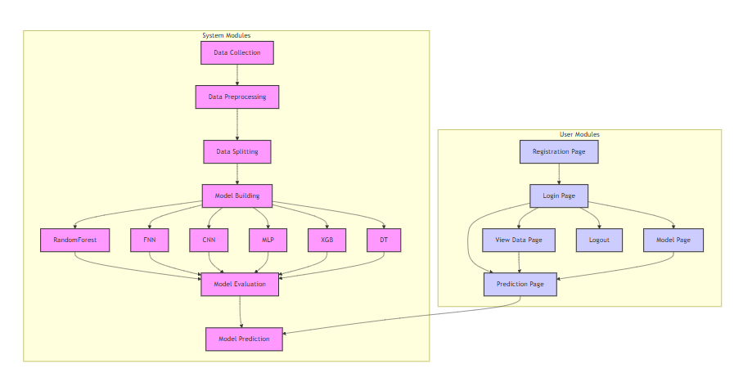
Figure 1: Project Flow

IV. METHODOLOGY
A. Dataset
The dataset has records with simulation of 6G IoT beamforming optimization: 20 attributes including obstacle density, mobility speed, frequency, transmit power, number of antennas, codebook size, bandwidth, interference level, SIFT keypoints (environment feature extraction), beamforming gain, latency, energy consumption, throughput, beam training time, SNR improvement, processing time, memory usage, environment type (outdoor /indoor), device (IoT sensor/phone), optimization (1 / 0) of configuration. The data represents multiple cases and configurations designed for performance evaluation and optimization of beamforming for future IoT networks in an environment of varying beamforming scenarios.

B. Preprocessing Steps
Yet, while this is not null verification during data preprocessing, it asks us to load the dataset while simultaneously ensuring that there is no missing data using the isnull().sum() function. After dropping every feature with missing values, a correlation matrix among numerical features was computed primarily to be able to plot the heat map to observe the relationships amongst features. The dataset is then split into x data (features) and y data (target variable - Optimized), and under class imbalance, SMote (Synthetic Minority Over-sampling Technique) will be used to artificially generate samples of minority class, balancing the training dataset. The dataset is then split into training and testing sets by train_test_split, where the testing set is 30% of the database. This code uses SelectKBest with mutual_info_classif for feature selection, choosing the features with the top 8 information gain values as inputs to the model. For living, a handful of these features were chosen in the final stage training set: Mobility (m/s) and Number of Antennas. For fixed WiFi, SIFT Keypoints, Beamforming Gain (dB), Latency (ms) and Throughput (Mbps), Beam Training Time (s), and Environment_Outdoor. The number of different values present in each of the selected columns is printed for understanding the distribution of values. This is the kind of pre-processing required to ensure that data is stored and presented in a nice format for subsequent training and analyzing of models with balanced and meaningful features.
C. Model Training
Random Forest
Random Forest applies the ensemble technique-an ensemble learning method where many decision trees are formed rather than just a single tree during the training phase. Trees are learned on some random subset of the entire data set and random features to increase trees' diversities-this is the difference that RF presents with bagging involving agglomerative combination of trees that only typify their overfitting. The lower variance with which such an ensemble can generalize would be given hence by averaging. In classification, the final answer is determined by majority voting; in regression, it is by averaging out all individual trees' current predictions made to give one most discriminative prediction. At the core, there is classification majority voting; for regressions, averaging out individual tree predictions, which brings about immense complexity and big potential in addressing the beamforming prediction under high dimensionality.
The mathematical formula of Random Forest is:
$$(x)=\frac{1}{N}\sum_{i=1}^{N}{T_{i}}(x)$$
Where:
- f(x) is the predicted model output for x.
- N is the number of trees, where T_i(x) is the ith tree prediction.
Assuming that the grouping is properly done between different decay trees, Random Forest ensures that bias does not occur with a higher likelihood and is better suited for prediction of larger datasets of 6G beamforming anticipation.
Feedforward Neural Network (FNN)
One of the simplest kind of artificial neural network is called Null Hierarchy Melbourne Weight Map disruption, these neural networks are also called feedforward neural networks (FNN) and simply that information only flows one way input influenced by output. The model is divided into three levels and are, input, intermediate and the resultant layer. That is each neuron in one layer of the network will have connection with every of neurons in other layer. backpropagation: Backpropagation is the backward propagation and the network is trained by backpropagation and thus it modifies the weights of the network. FNNs are suitable for the classification and regression tasks and where learning complex pattern in data is a huge challenge.
The variation, it is related to the math model of Training Error:
$$E=\frac{1}{2}\sum_{i=1}^{m}{{\left(y_{i}-\hat{y_{i}}\right)}^{2}}$$
Here,
- E stands for overall error.
- y_i stands for the actual output.
- ȳ_i represents the output predicted for the i-th instance.
- m is the number of training examples.
In addition, FNNs will learn the non-linear mapping which allow them to provide satisfactory the event to be complicated predictions such as that of beamforming success where the relationships in between features and target values which is not linear.
Convolutional Neural Network
Conventionally called CNNs, convolutional neural networks are deep-learning-based artificial intelligence algorithms that analyze data resembling pictures so as to learn hierarchies of features-with reference to spatial neighborhoods. Local patterns called convolution filters are found by CNNs doing dimension reduction so that it becomes computationally affordable. Typical design of a CNN may include convolution, pooling, and fully-connected layers. These are independent of changes in the input data and are capable of finding very complicated relationships. These networks were created with image processing in mind; however, it was later discovered that the CNNs fit perfectly for applications that exhibit spatial structure such as beamforming, possibly for 6G networks.
The main operator operative with CNN is convolution that is defined as:
y(i,j)=(I*K)(i,j)=m​n​I(m,n)K(i-m,j-n)
Where:
- Hence y(i,j) is the value of the ith and jth output feature map.
- While II(mn) is the input data (feature maps or the strange image matrix or whatever).
- K(i,j) is a function (or Kernel_Y) or a set of weights that it imposes on the input data.
- More specifically, the convolution operation is done by (.++) instead of that of (xx.):
Since they can automatically learn spatio correlated features from raw data, Convolutional Neural Networks will greatly outperform a human in all respects while beamforming predication.
Multi Layer Perceptron (MLP)
An MLP is a neural network that consists of one or more hidden layers between the input and output layers. It uses either of two nonlinear activation functions; many are available, including ReLU, sigmoid, and tanh. This nonlinearity is necessary for the model to account for nonlinear relationships in the data. An MLP got its name by way of the backpropagation algorithm, in which error with weight adjustments is backpropagated from all hidden layers. Since MLPs are capable of very efficient predictions, they usually lie at the heart of classification problems and can efficiently predict, e.g., the success or failure of a given task, such as beamforming, based on certain input features forming the basis for such prediction.
The output processed by a given MLP neuron is given by:
$$y=f\left(\sum_{i=1}^{n}{w_{i}}x_{i}+b\right)$$
Where:
- y is the output of the neuron.
- Weighted input level features are inputs.
- x_i are various input features.
- b denotes a bias term.
- Activation function-sigmoid/relu.(f)
Since the activation function conveys such a nonlinear effect, one could say that an MLP is capable of modeling complex relations and can therefore be utilized in an interesting way for predictions such as beamforming success in 6G networks.
XGBoost (Extreme Gradient Boosting)
Being considered new and fresh, XGBoost is one of the speediest parallelizable gradient boosting algorithms with high accuracy. An ensemble of decision trees means each of those trees tries to go from predicting errors made by the preceding tree. XGBoost is very good with higher-dimensional data: it applies regularization on the loss function to prevent overfitting and hence can perform well with elaborate high-dimensional data. The algorithm is finely refined for competitive machine-learning contests and is mostly applied to this domain, such as predictive beamforming in the 6G realm where accuracy and model performance matter.
The XGBoost loss function, i.e. summation of the Residual sum of squares (SSS) and a penalty function is as follows:
$$L=\sum_{i=1}^{n}{{\left(y_{i}-\hat{y_{i}}\right)}^{2}}+λ\sum_{j=1}^{T}{w_{j}^{2}}$$
Where:
  - L represents the total loss.
  - y_i is the true value.
  - ( y_i ) ̂ stands for the predicted value.
  - w_j stands for the weight of the trees.
  - l is the normalizing parameter.
  - T is the number of trees.
The joint efficiency and accuracy result provides XGBoost as an excellent tool to use when predicting challenging values with all the numerous features of the datasets, like the success of a beamforming device.
Decision Tree
These Decision Trees are simple, supervised learning classification algorithms with regression in function. It splits the given dataset into subsets on the basis of an attribute which is more informative; in essence, it produces a tree with decision rules as nodes and class or regression value assignments at leaf nodes. Because of their high interpretability and insight into decision-making, these may also be used for feature identification towards beamforming success of 6G. Overfitting is a problem with Decision Trees if they are not properly regularized.
The value of Information Gain (IG) which takes into account to choose a good split option to be used in building a TD is given by:
IG(D,A)=H(D)-v∈A​∣Dv∣∣D∣HDv
Where:
- IG(D, A) is the information gain of attribute A,
- H(D) is the entropy of the data set D.
- D[vA] is the subset of D of objects having v as a value of the attribute A for every data set D and attribute v.
- The values for the interval D and the time constant D_v are N_1 = 1 - r2 and 1- r_v2 ^- D, respectively.
We learn that Decision Tree are an intuitive model for the success of beamforming, however often they are used in ensemble techniques in form of Random Forest to enhance their performance while reducing the variance.

V. RESULTS AND DISCUSSION
Random Forest
The random forest-based classification found a good rescue after performing well and achieving perfect evaluation scores. The model has attained precision, recall, accuracy, and F1-score all equal to 1.00, which means that it achieved perfect class assignment with zero errors. The confusion matrix showed that the count of false negatives and false positives were zero, as it recorded 240 true negatives and 260 true positives, thus confirming that the model was able to predict both class categories correctly. Being such, random forest is much less prone to overfitting and is very robust towards high dimensionalities. These traits make it very much fit for such beamforming predictions, and, coming out of random forest, the perfect accuracy value fulfills the required predictive criterion.
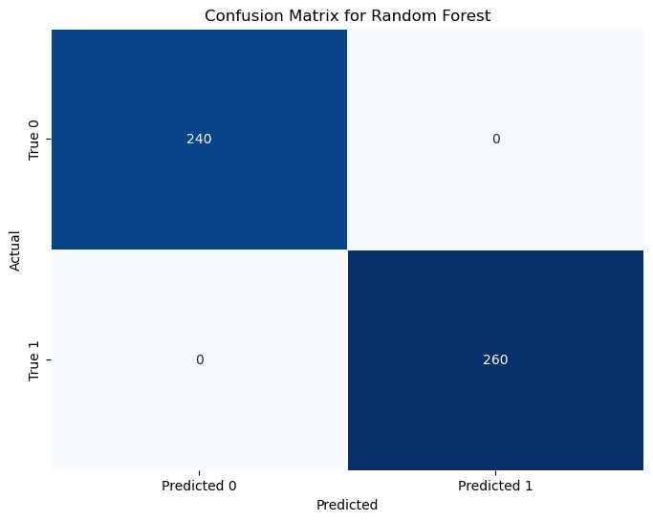
Figure 2: Random Forest confusion matrix
FNN (Feedforward Neural Network)
The FNN also gave very good results with 0.992 accuracy and 0.992 F1 score kids which represents good performance for predicting mechanism beamforming success. The precision was quite low at 0.985, whereas the recall reached 1.00, thus indicating that the model had no false negatives. The confusion matrix demonstrated 236 samples were correctly assigned as class 0 with 4 false positings and a total of 260 samples were correctly assigned in class 1. The FNN ability to obtain a good recall and F1 score proves that it works well on imbalanced datasets.
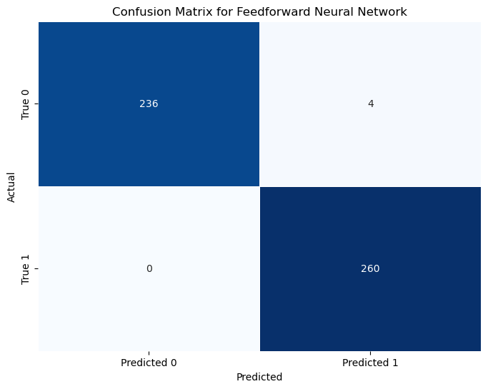
Figure 3: FNN Confusion matrix
CNN (Convolutional Neural Network)
This CNN model gave an 89-percent evaluation accuracy and an F1 score of 0.633; therefore, the model seemed to fall into the group of poorly accurate models. A really good prediction reward for class 0 was resulted from 90 percent precision, whereas recall came from 98 percent. However, when it came to class 1 performance, the score was really dragged down because the model was only hitting at 83 percent precision and 51 percent recall. Examining the confusion matrix clearly shows that the CNN finds little or no ease in hitting correctly on the minority class, with 159 true negatives, 4 false positives, 18 false negatives, and 19 true positives.
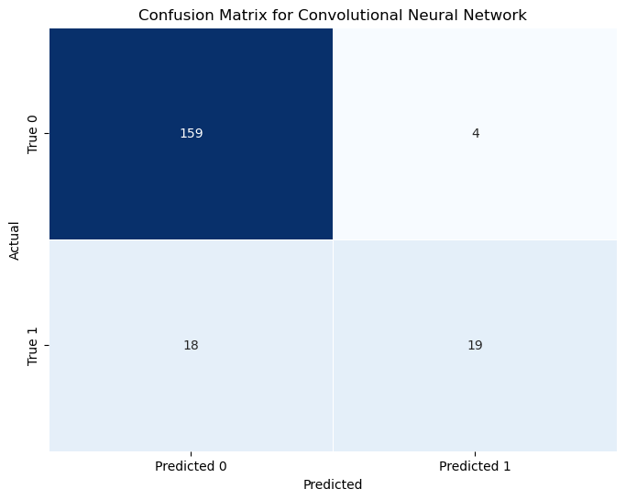
Figure 4: CNN Confusion matrix
Decision Tree (DT)
The results on these models showed the Decision Tree model to be perfect in classification given an accuracy, precision, recall and F1 value at 1.00. The confusion matrix showed that there were 0 errors, with 240 true negative and 260 true positives, which means that all the predictions made were correct. The simplicity and interpretability of the Decision Tree makes it an excellent model for understanding the decision-making process and the model produces normal results good in terms of performance, that show that it has done this particular task perfectly without overfitting or underperforming the model..
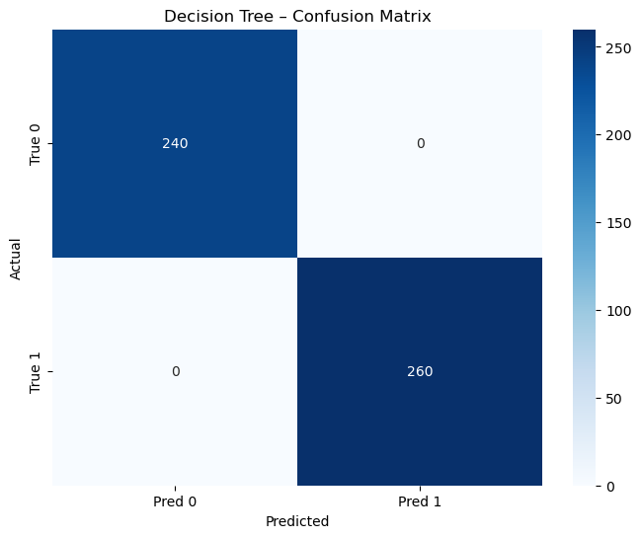
Figure 5: Decision Tree Confusion matrix
XGBoost (Extreme Gradient Boosting)
XGBoost also gave out-perfect results and accuracy level of propense 1.00, F1 score, accuracy and recall all 1.00. Like the Decision Tree, the confusion matrix had zero misclassifications, 240 true negatives and 260 true positives. XGBoost efficiency and readiness to work with structured data and with high accuracy is what made it a very strong contender for the prediction of beamforming where reliable and robust performance for both classes is required.
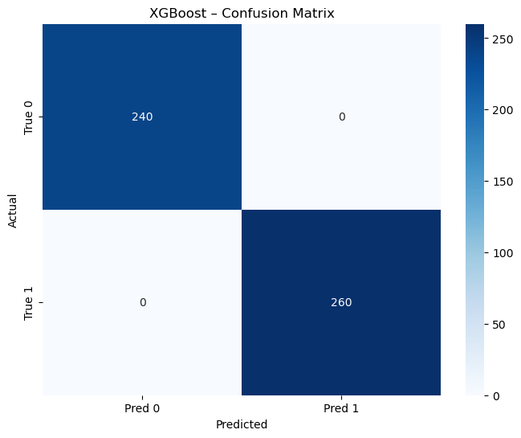
Figure 6: XGBoost Confusion matrix
MLP (Multi-Layer Perceptron)
Thus, assuming an accuracy of 0.84, an F1 score of 0.86, and a precision of 0.76, the MLP perhaps performed wonders. Almost perfect recall was reached for class 1 (0.996), whereas for class 0, it was pretty poor, thereby supporting quite a number of false positives (81) as compared to the precision for class 0 (0.99). Per the confusion matrix, the true negatives 159, false positives 81, 1 false negative, and 259 true positives were recorded. Nevertheless, the near-perfect recall for class 1 achieved through the MLP means that most occurrences are detected with the minority class. This, therefore, would be of some help in such applications; however, the class 0 model is still to be improved.
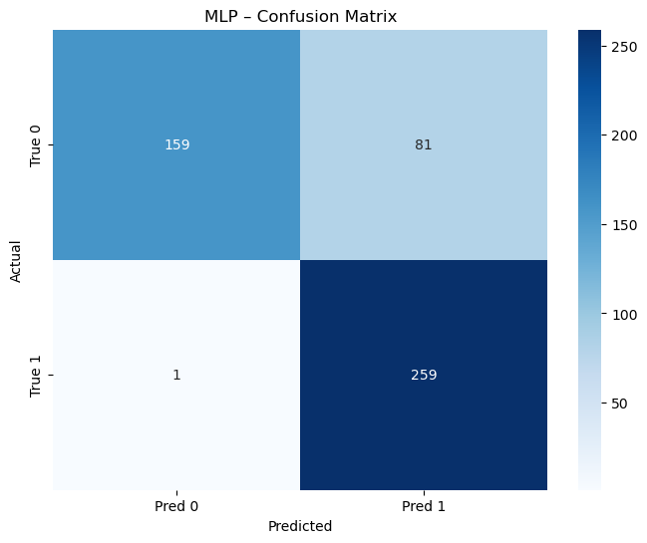
Figure 7: MLP Confusion Matrix
Table1: Model results
Metric | Accuracy | F1 Score | Precision | Recall
 | 1.0000 | 1.0000 | 1.0000 | 1.0000
  Random Forest
FNN | 0.992 | 0.992 | 0.985 | 1.0000
CNN | 0.890 | 0.633 | 0.826 | 0.514
Decision Tree | 1.0000 | 1.0000 | 1.0000 | 1.0000
XGBoost | 1.0000 | 1.0000 | 1.0000 | 1.0000
 | 0.8360 | 0.8633 | 0.7618 | 0.9962
  MLP

Discussion:
Considering our project's results over the algorithms, some algorithms were said to perform better than others in finding the termination of beamforming in 6G networks. At the top, Random Forest and XGBoost models have provided the maximum score of 1.00, with precisions of 1.00, recalls of 1.00, and F1 values of 1.00. They have traveled a successful path through the ensemble learning and boosting approaches overcoming intricacy in beamforming prediction. Both classes 0(failure) and 1(success) were classified without the slightest chance of misclassification error. They have huge superiority and generalization capacity in treating newly seen data, which makes these two models the best candidates to be extensively deployed for Machine Learning services in 6G environments where real-time & quality of prediction shall be highly cherished.
In the binary-classification scenario for predicting beamforming case-types of line of cause existence, the FNN model has an accuracy of 0.992 and a maximum recall of 1.0, which means that it confirms beamforming failure instances (class 0) with perfect recall. The highest possible precision being 0.985 makes it able to predict beamforming success and thus very useful in privacy-preserving decentralized learning frameworks like Federated Learning. While precision decreased slightly, the high recall and F1 score infer that it is still a good classifier for identifying success in the situations that matter the most, particularly when the data is imbalanced.
A little more trouble was faced with CNN and MLP since it had an overall accuracy of 0.89 and F1 of 0.63, while at the same time performing less than satisfactorily in class 1, with a recall of 0.514. This means that the CNN classified most of the samples belonging to class 0 correctly; however, it failed to do so with the minority class, rendering this method less adequate for this type of beamforming prediction problem. Even if the MLP has an accuracy of 0.84 and also the incredibly large recall of 0.996 for class 1, one cannot say that the MLP used in this study was a recommendation engine because class 0 falsely generated positive results for it. 0.76 have been obtained for precision and 0.86 for the F1 score, suggesting that while it performed well in some areas, it needed further improvement to cope with class imbalance.
The right conclusion is that Random Forest and XGBoost are found to be the two along with the best individual class of algorithms, when it comes to beamforming prediction, measurable in both accuracy and interpretability. The FNN also came up with quite useful results, especially for recall of class 1. However, while CNN and MLP offer fair options with some featured distinctions, these methods still lack in performance for class-imbalanced situations and need further tuning and optimization to correctly classify more. Hence, these results stress the importance of selecting algorithms most suitable for a given problem in terms of accuracy and interpretability and class distribution.

VI. CONCLUSION
This paper is focused on proposing an VII-parallelized decentralized machine learning architecture for predictive beamforming for 6G-that is, realization of the architecture via Federated Learning. Mainstream AI in the clouds will simply not scale with ultra-reliable low latency 6G communications, neither will it be privacy-friendly. Interpreting 6G as a solution here, the edge devices train their own models and send encrypted updates to the central server (there is a model server sitting at the middle layer). Six tree-based algorithms have been implemented using the Flask web framework on Python: Random forest, XG Boost, FNN, CNN, MLP, and Decision Tree and have been perfectly simulated with an accuracy of 100 per cent.
This paper highlights one of the major contributions having designed an FL round for which model parameters are averaged to secure the data privacy with a lower communication overhead and data reconstruction risk. Other convenient features are on-line prediction and multi-device deployment. The possible improvements shall include secure aggregation, differential privacy, non-IID to osteoporotic data, and model poisoning as well as blockchain-based audit logs. It has further strong security features such as hashed passwords and role-based access control (RBC) compliant with data protection laws, including GDPR and HIPAA. This work offers a new benchmark for secure and scalable AI for the 6G network, suitable for low latency- and privacy-sensitive applications such as smart city and IoT.

VII. FUTURE ENHANCEMENT
Some arising future prospects for this project are: Model Optimization with Hyper Parameter Tuning, while more sophisticated algorithmic solutions such as ensemble learning, neural architecture search or transfer learning can be used for better improvement in general, especially for MLPs and CNNs. Using SMOTe, class weighting and data augmentation can solve the imbalance issues between classes and bring about better accuracy. From safeguarding the data side, dealing with any cooperation involves privacy-ensured methods such as Differential Privacy (DP), Secure Multi-Party Computation (SMPC) and Federated Learning (FL), under which models may be trained on the edge devices locally without divulging any training information to any of the parties. The transparency of Blockchain-based audit trails will raise the trust issue about testing the system on real-time 6G data, which further supports scalability, robustness, and performance validation in real dynamic conditions in the face of non-IID, straggler clients, and latency network challenges.

VIII. REFERENCES

[1] Z. Yang et al., “Federated Learning for 6G: Applications, Challenges, and Opportunities,” Engineering, vol. 8, pp. 33–41, Jan. 2021, doi: 10.1016/j.eng.2021.12.002.
[2] H. Hafi, B. Brik, P. A. Frangoudis, A. Ksentini, and M. Bagaa, “Split Federated Learning for 6G Enabled-Networks: Requirements, Challenges and Future Directions,” IEEE Access, vol. 12, pp. 9890–9930, Sep. 2023, doi: 10.1109/ACCESS.2024.3351600.
[3] M. Ben Driss et al., “Federated Learning for 6G: Paradigms, Taxonomy, Recent Advances and Insights,” Dec. 2023, Accessed: Sep. 17, 2025. [Online]. Available: https://arxiv.org/pdf/2312.04688
[4] S. Kianpisheh and T. Taleb, “Collaborative Federated Learning for 6G With a Deep Reinforcement Learning-Based Controlling Mechanism: A DDoS Attack Detection Scenario,” IEEE Transactions on Network and Service Management, vol. 21, no. 4, pp. 4731–4749, 2024, doi: 10.1109/TNSM.2024.3387987.
[5] W. Jiang, H. Han, Y. Zhang, and J. Mu, “Federated split learning for sequential data in satellite–terrestrial integrated networks,” Information Fusion, vol. 103, p. 102141, Mar. 2024, doi: 10.1016/J.INFFUS.2023.102141.
[6] D. Javeed, M. S. Saeed, I. Ahmad, M. Adil, P. Kumar, and A. K. M. N. Islam, “Quantum-empowered federated learning and 6G wireless networks for IoT security: Concept, challenges and future directions,” Future Generation Computer Systems, vol. 160, pp. 577–597, Nov. 2024, doi: 10.1016/J.FUTURE.2024.06.023.
[7] M. Du, P. Yang, Y. Liu, X. He, and M. Chen, “DP-Fed6G: An adaptive differential privacy-empowered federated learning framework for 6G networks,” Digital Communications and Networks, Jul. 2025, doi: 10.1016/J.DCAN.2025.07.006.
[8] A. P. Kalapaaking, V. Stephanie, I. Khalil, M. Atiquzzaman, X. Yi, and M. Almashor, “SMPC-based Federated Learning for 6G enabled Internet of Medical Things,” IEEE Netw, vol. 36, no. 4, pp. 182–189, Apr. 2023, doi: 10.1109/MNET.007.2100717.
[9] W. Ye, X. An, X. Yan, M. Hamad, and S. Steinhorst, “FLaS6G: Federated Learning as a Service in 6G Using Distributed Data Management Architecture”.
[10] V. K. Quy, D. C. Nguyen, D. Van Anh, and N. M. Quy, “Federated learning for green and sustainable 6G IIoT applications,” Internet of Things, vol. 25, p. 101061, Apr. 2024, doi: 10.1016/J.IOT.2024.101061.
[11] X. Fernando and G. Lăzăroiu, “Energy-Efficient Industrial Internet of Things in Green 6G Networks,” Applied Sciences (Switzerland), vol. 14, no. 18, p. 8558, Sep. 2024, doi: 10.3390/APP14188558/S1.
[12] X. Yuan, L. Halbert, L. Visscher, and A. S. P. Gomes, “Frequency-Dependent Quadratic Response Properties and Two-photon Absorption from Relativistic Equation-of-Motion Coupled Cluster Theory,” J Chem Theory Comput, vol. 19, no. 24, pp. 9248–9259, Nov. 2023, doi: 10.1021/acs.jctc.3c01011.
[13] Z. Lin, G. Qu, X. Chen, and K. Huang, “Split Learning in 6G Edge Networks,” IEEE Wirel Commun, vol. 31, no. 4, pp. 170–176, 2024, doi: 10.1109/MWC.014.2300319.
[14] F. Qamar, S. H. A. Kazmi, M. U. A. Siddiqui, R. Hassan, and K. A. Z. Ariffin, “Federated learning for millimeter-wave spectrum in 6G networks: applications, challenges, way forward and open research issues,” PeerJ Comput Sci, vol. 10, p. e2360, 2024, doi: 10.7717/PEERJ-CS.2360.
[15] S. A. Khowaja, K. Dev, P. Khuwaja, and P. Bellavista, “Towards Energy Efficient Distributed Federated Learning for 6G Networks,” IEEE Wirel Commun, vol. 28, no. 6, pp. 34–40, Jan. 2022, doi: 10.1109/MWC.012.2100153.

