POLICE RECORD MANAGEMENT

**Group Members :** R CHANDRU (312420205021)

R Antony Vincent (312420205011)

**Description :**

Police Record Management is an application which can be used to store information about police officers. This application is used to store the records such as id, name, cop rank and station code. The data used were stored at database. For security purpose, we kept a login authentication in order to enter this application . Using this application one can add, update and delete details which are stored. There is also a search option where you can search data in any field (id, name, rank, station code). Overall, this will be a great application for police department to monitor the details of police officers.

**Tools to be used :**

1. Apache NetBeans

2. Java Development Kid

3. Mysql Database

**Role of individuals in the Group:**

Chandru R : Code for Police Record Management and Established Database Connectivity.

Antony Vincent R : Code for User Interface and Login page.

**Deliverables :**

1.Login authentication in order to enter this application.

2.You can store data like id, name, station code, cop rank in database using GUI.

3.Data stored in database are shown in the form of table in GUI.

4.Data can be accessed and modified using GUI.

**Code :**

**File Name: login.java**

package Police_Record;

import Police_Record.reg;

import com.sun.jdi.connect.spi.Connection;

import javax.swing.JOptionPane;

import java.lang.System.Logger;

import java.lang.System.Logger.Level;

import java.sql.*;

import java.util.*;

import javax.swing.JComboBox;

import javax.swing.JFrame;

import javax.swing.JOptionPane;

import javax.swing.table.DefaultTableModel;

/**

*

* @author tonyv

*/

public class login extends javax.swing.JFrame {

public login() {

initComponents();

}

@SuppressWarnings("unchecked")

// <editor-fold defaultstate="collapsed" desc="Generated Code">//GEN-BEGIN:initComponents

private void initComponents() {

setTitle("Police Record Management");

jPanel1 = new javax.swing.JPanel();

jLabel4 = new javax.swing.JLabel();

jLabel5 = new javax.swing.JLabel();

jLabel6 = new javax.swing.JLabel();

jLabel7 = new javax.swing.JLabel();

tfusername = new javax.swing.JTextField();

tfpassword = new javax.swing.JPasswordField();

jButton1 = new javax.swing.JButton();

setDefaultCloseOperation(javax.swing.WindowConstants.EXIT_ON_CLOSE);

jPanel1.setBackground(new java.awt.Color(0, 0, 0));

jPanel1.setForeground(new java.awt.Color(204, 255, 255));

jPanel1.setName(""); // NOI18N

jLabel4.setFont(new java.awt.Font("Wide Latin", 1, 24)); // NOI18N

jLabel4.setForeground(new java.awt.Color(255, 204, 0));

jLabel4.setText("POLICE RECORD MANAGEMENT");

jLabel4.setHorizontalTextPosition(javax.swing.SwingConstants.CENTER);

jLabel5.setFont(new java.awt.Font("Tw Cen MT Condensed Extra Bold", 1, 24)); // NOI18N

jLabel5.setForeground(new java.awt.Color(255, 204, 0));

jLabel6.setFont(new java.awt.Font("STFangsong", 0, 18)); // NOI18N

jLabel6.setForeground(new java.awt.Color(255, 204, 0));

jLabel6.setText("USER NAME :");

jLabel7.setFont(new java.awt.Font("STFangsong", 0, 18)); // NOI18N

jLabel7.setForeground(new java.awt.Color(255, 204, 0));

jLabel7.setText("PASSWORD:");

tfusername.setBackground(new java.awt.Color(255, 255, 0));

tfpassword.setBackground(new java.awt.Color(255, 255, 51));

jButton1.setBackground(new java.awt.Color(255, 255, 51));

jButton1.setFont(new java.awt.Font("Wide Latin", 1, 11)); // NOI18N

jButton1.setText("LOGIN");

jButton1.addActionListener(new java.awt.event.ActionListener() {

public void actionPerformed(java.awt.event.ActionEvent evt) {

jButton1ActionPerformed(evt);

}

});

javax.swing.GroupLayout jPanel1Layout = new javax.swing.GroupLayout(jPanel1);

jPanel1.setLayout(jPanel1Layout);

jPanel1Layout.setHorizontalGroup(

jPanel1Layout.createParallelGroup(javax.swing.GroupLayout.Alignment.LEADING)

.addGroup(jPanel1Layout.createSequentialGroup()

.addContainerGap(javax.swing.GroupLayout.DEFAULT_SIZE, Short.MAX_VALUE)

.addGroup(jPanel1Layout.createParallelGroup(javax.swing.GroupLayout.Alignment.LEADING)

.addGroup(jPanel1Layout.createSequentialGroup()

.addGap(99, 99, 99)

.addComponent(jLabel5))

.addGroup(jPanel1Layout.createSequentialGroup()

.addGroup(jPanel1Layout.createParallelGroup(javax.swing.GroupLayout.Alignment.TRAILING)

.addComponent(jLabel7)

.addComponent(jLabel6))

.addGap(18, 18, 18)

.addGroup(jPanel1Layout.createParallelGroup(javax.swing.GroupLayout.Alignment.LEADING)

.addComponent(tfusername, javax.swing.GroupLayout.PREFERRED_SIZE, 259, javax.swing.GroupLayout.PREFERRED_SIZE)

.addComponent(tfpassword, javax.swing.GroupLayout.PREFERRED_SIZE, 259, javax.swing.GroupLayout.PREFERRED_SIZE))))

.addContainerGap(javax.swing.GroupLayout.DEFAULT_SIZE, Short.MAX_VALUE))

.addGroup(jPanel1Layout.createSequentialGroup()

.addGap(441, 441, 441)

.addComponent(jButton1, javax.swing.GroupLayout.PREFERRED_SIZE, 125, javax.swing.GroupLayout.PREFERRED_SIZE)

.addContainerGap(473, Short.MAX_VALUE))

.addGroup(javax.swing.GroupLayout.Alignment.TRAILING, jPanel1Layout.createSequentialGroup()

.addContainerGap(javax.swing.GroupLayout.DEFAULT_SIZE, Short.MAX_VALUE)

.addComponent(jLabel4)

.addGap(131, 131, 131))

);

jPanel1Layout.setVerticalGroup(

jPanel1Layout.createParallelGroup(javax.swing.GroupLayout.Alignment.LEADING)

.addGroup(jPanel1Layout.createSequentialGroup()

.addGap(93, 93, 93)

.addComponent(jLabel4, javax.swing.GroupLayout.PREFERRED_SIZE, 40, javax.swing.GroupLayout.PREFERRED_SIZE)

.addGap(79, 79, 79)

.addGroup(jPanel1Layout.createParallelGroup(javax.swing.GroupLayout.Alignment.BASELINE)

.addComponent(jLabel6, javax.swing.GroupLayout.PREFERRED_SIZE, 28, javax.swing.GroupLayout.PREFERRED_SIZE)

.addComponent(tfusername, javax.swing.GroupLayout.PREFERRED_SIZE, javax.swing.GroupLayout.DEFAULT_SIZE, javax.swing.GroupLayout.PREFERRED_SIZE))

.addPreferredGap(javax.swing.LayoutStyle.ComponentPlacement.RELATED)

.addComponent(jLabel5, javax.swing.GroupLayout.PREFERRED_SIZE, 28, javax.swing.GroupLayout.PREFERRED_SIZE)

.addGap(18, 18, 18)

.addGroup(jPanel1Layout.createParallelGroup(javax.swing.GroupLayout.Alignment.BASELINE)

.addComponent(jLabel7, javax.swing.GroupLayout.PREFERRED_SIZE, 33, javax.swing.GroupLayout.PREFERRED_SIZE)

.addComponent(tfpassword, javax.swing.GroupLayout.PREFERRED_SIZE, javax.swing.GroupLayout.DEFAULT_SIZE, javax.swing.GroupLayout.PREFERRED_SIZE))

.addGap(59, 59, 59)

.addComponent(jButton1, javax.swing.GroupLayout.PREFERRED_SIZE, 33, javax.swing.GroupLayout.PREFERRED_SIZE)

.addContainerGap(229, Short.MAX_VALUE))

);

javax.swing.GroupLayout layout = new javax.swing.GroupLayout(getContentPane());

getContentPane().setLayout(layout);

layout.setHorizontalGroup(

layout.createParallelGroup(javax.swing.GroupLayout.Alignment.LEADING)

.addGroup(layout.createSequentialGroup()

.addContainerGap()

.addComponent(jPanel1, javax.swing.GroupLayout.DEFAULT_SIZE, javax.swing.GroupLayout.DEFAULT_SIZE, Short.MAX_VALUE)

.addGap(24, 24, 24))

);

layout.setVerticalGroup(

layout.createParallelGroup(javax.swing.GroupLayout.Alignment.LEADING)

.addGroup(layout.createSequentialGroup()

.addGap(23, 23, 23)

.addComponent(jPanel1, javax.swing.GroupLayout.DEFAULT_SIZE, javax.swing.GroupLayout.DEFAULT_SIZE, Short.MAX_VALUE)

.addContainerGap())

);

pack();

}// </editor-fold>//GEN-END:initComponents

private void jButton1ActionPerformed(java.awt.event.ActionEvent evt) {//GEN-FIRST:event_jButton1ActionPerformed

String username = tfusername.getText();

String password = tfpassword.getText();

if(username.isEmpty() || password.isEmpty()){

JOptionPane.showMessageDialog(this,"USERNAME/PASSWORD should not be Empty","Error",JOptionPane.ERROR_MESSAGE);

}else if(username.equals("admin")&&password.equals("123")){

dispose();

reg d = new reg();

d.setVisible(true);

}

else{

JOptionPane.showMessageDialog(this,"The entered password/username is wrong");

}

}//GEN-LAST:event_jButton1ActionPerformed

public static void main(String args[]) {

java.awt.EventQueue.invokeLater(new Runnable() {

public void run() {

new login().setVisible(true);

}

});

}

// Variables declaration - do not modify//GEN-BEGIN:variables

private javax.swing.JButton jButton1;

private javax.swing.JLabel jLabel4;

private javax.swing.JLabel jLabel5;

private javax.swing.JLabel jLabel6;

private javax.swing.JLabel jLabel7;

private javax.swing.JPanel jPanel1;

private javax.swing.JPasswordField tfpassword;

private javax.swing.JTextField tfusername;

// End of variables declaration//GEN-END:variables

private void userLogin(String username,String password) {

}}

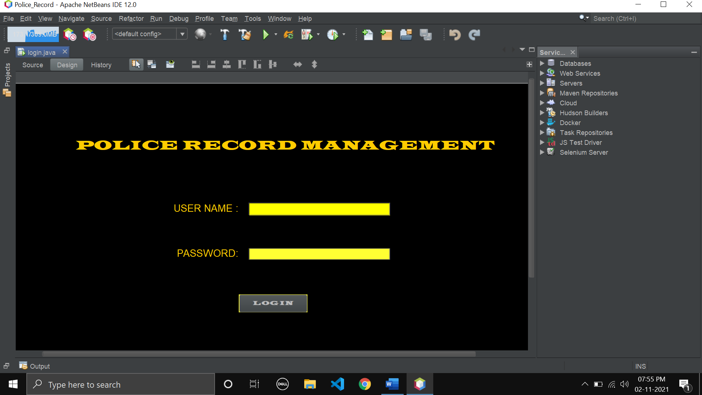

**File Name: reg.java**

package Police_Record;

import java.sql.*;

import java.util.*;

import javax.swing.JOptionPane;

import javax.swing.table.DefaultTableModel;

import net.proteanit.sql.DbUtils;

public class reg extends javax.swing.JFrame {

public reg() {

initComponents();

table_update();

setTitle("Police Record Management");

}

@SuppressWarnings("unchecked")

private void initComponents() {

jPanel2 = new javax.swing.JPanel();

jPanel3 = new javax.swing.JPanel();

jInternalFrame1 = new javax.swing.JInternalFrame();

jButton4 = new javax.swing.JButton();

jScrollBar1 = new javax.swing.JScrollBar();

jLabel1 = new javax.swing.JLabel();

jPanel1 = new javax.swing.JPanel();

jLabel2 = new javax.swing.JLabel();

jLabel3 = new javax.swing.JLabel();

jLabel4 = new javax.swing.JLabel();

txtname = new javax.swing.JTextField();

txtstationcode = new javax.swing.JTextField();

txtrank = new javax.swing.JTextField();

jButton1 = new javax.swing.JButton();

jButton2 = new javax.swing.JButton();

jButton3 = new javax.swing.JButton();

jLabel7 = new javax.swing.JLabel();

jScrollPane1 = new javax.swing.JScrollPane();

jTable1 = new javax.swing.JTable();

textFieldSearch = new javax.swing.JTextField();

jLabel5 = new javax.swing.JLabel();

ComboBoxSelect = new javax.swing.JComboBox<>();

jLabel6 = new javax.swing.JLabel();

javax.swing.GroupLayout jPanel2Layout = new javax.swing.GroupLayout(jPanel2);

jPanel2.setLayout(jPanel2Layout);

jPanel2Layout.setHorizontalGroup(jPanel2Layout.createParallelGroup(javax.swing.GroupLayout.Alignment.LEADING)

.addGap(0, 100, Short.MAX_VALUE));

jPanel2Layout.setVerticalGroup(jPanel2Layout.createParallelGroup(javax.swing.GroupLayout.Alignment.LEADING)

.addGap(0, 100, Short.MAX_VALUE));

javax.swing.GroupLayout jPanel3Layout = new javax.swing.GroupLayout(jPanel3);

jPanel3.setLayout(jPanel3Layout);

jPanel3Layout.setHorizontalGroup(jPanel3Layout.createParallelGroup(javax.swing.GroupLayout.Alignment.LEADING)

.addGap(0, 100, Short.MAX_VALUE));

jPanel3Layout.setVerticalGroup(jPanel3Layout.createParallelGroup(javax.swing.GroupLayout.Alignment.LEADING)

.addGap(0, 100, Short.MAX_VALUE));

jInternalFrame1.setVisible(true);

javax.swing.GroupLayout jInternalFrame1Layout = new javax.swing.GroupLayout(jInternalFrame1.getContentPane());

jInternalFrame1.getContentPane().setLayout(jInternalFrame1Layout);

jInternalFrame1Layout.setHorizontalGroup(jInternalFrame1Layout

.createParallelGroup(javax.swing.GroupLayout.Alignment.LEADING).addGap(0, 0, Short.MAX_VALUE));

jInternalFrame1Layout.setVerticalGroup(jInternalFrame1Layout

.createParallelGroup(javax.swing.GroupLayout.Alignment.LEADING).addGap(0, 0, Short.MAX_VALUE));

jButton4.setText("jButton4");

setDefaultCloseOperation(javax.swing.WindowConstants.EXIT_ON_CLOSE);

jLabel1.setFont(new java.awt.Font("SansSerif", 1, 36)); // NOI18N

jLabel1.setText("POLICE RECORD MANAGEMENT");

jLabel2.setText("COP NAME");

jLabel3.setText("STATION CODE");

jLabel4.setText("COP RANK");

txtname.addActionListener(new java.awt.event.ActionListener() {

public void actionPerformed(java.awt.event.ActionEvent evt) {

txtnameActionPerformed(evt);

}

});

txtstationcode.addActionListener(new java.awt.event.ActionListener() {

public void actionPerformed(java.awt.event.ActionEvent evt) {

txtstationcodeActionPerformed(evt);

}

});

jButton1.setText("INSERT");

jButton1.addActionListener(new java.awt.event.ActionListener() {

public void actionPerformed(java.awt.event.ActionEvent evt) {

jButton1ActionPerformed(evt);

}

});

jButton2.setText("UPDATE");

jButton2.addActionListener(new java.awt.event.ActionListener() {

public void actionPerformed(java.awt.event.ActionEvent evt) {

jButton2ActionPerformed(evt);

}

});

jButton3.setText("DELETE");

jButton3.addActionListener(new java.awt.event.ActionListener() {

public void actionPerformed(java.awt.event.ActionEvent evt) {

jButton3ActionPerformed(evt);

}

});

jLabel7.setFont(new java.awt.Font("Dialog", 1, 16)); // NOI18N

jLabel7.setText("ENTER DATA");

javax.swing.GroupLayout jPanel1Layout = new javax.swing.GroupLayout(jPanel1);

jPanel1.setLayout(jPanel1Layout);

jPanel1Layout.setHorizontalGroup(jPanel1Layout.createParallelGroup(javax.swing.GroupLayout.Alignment.LEADING)

.addGroup(javax.swing.GroupLayout.Alignment.TRAILING, jPanel1Layout.createSequentialGroup()

.addGroup(jPanel1Layout.createParallelGroup(javax.swing.GroupLayout.Alignment.LEADING)

.addGroup(jPanel1Layout.createSequentialGroup().addContainerGap()

.addGroup(jPanel1Layout

.createParallelGroup(javax.swing.GroupLayout.Alignment.LEADING)

.addGroup(jPanel1Layout.createSequentialGroup()

.addComponent(jLabel2, javax.swing.GroupLayout.PREFERRED_SIZE,

77, javax.swing.GroupLayout.PREFERRED_SIZE)

.addGap(0, 0, Short.MAX_VALUE))

.addGroup(jPanel1Layout.createSequentialGroup().addGroup(jPanel1Layout

.createParallelGroup(javax.swing.GroupLayout.Alignment.LEADING)

.addComponent(jLabel3).addComponent(jLabel4)).addPreferredGap(

javax.swing.LayoutStyle.ComponentPlacement.RELATED,

javax.swing.GroupLayout.DEFAULT_SIZE,

Short.MAX_VALUE))))

.addGroup(javax.swing.GroupLayout.Alignment.TRAILING,

jPanel1Layout.createSequentialGroup()

.addContainerGap(javax.swing.GroupLayout.DEFAULT_SIZE, Short.MAX_VALUE)

.addComponent(jButton1, javax.swing.GroupLayout.PREFERRED_SIZE, 80,

javax.swing.GroupLayout.PREFERRED_SIZE)

.addGap(18, 18, 18)))

.addGroup(

jPanel1Layout.createParallelGroup(javax.swing.GroupLayout.Alignment.LEADING)

.addGroup(javax.swing.GroupLayout.Alignment.TRAILING,

jPanel1Layout.createSequentialGroup()

.addComponent(jButton2, javax.swing.GroupLayout.PREFERRED_SIZE,

80, javax.swing.GroupLayout.PREFERRED_SIZE)

.addGap(18, 18, 18)

.addComponent(jButton3, javax.swing.GroupLayout.PREFERRED_SIZE,

80, javax.swing.GroupLayout.PREFERRED_SIZE)

.addGap(21, 21, 21))

.addGroup(jPanel1Layout.createSequentialGroup().addGroup(jPanel1Layout

.createParallelGroup(javax.swing.GroupLayout.Alignment.TRAILING)

.addComponent(txtname, javax.swing.GroupLayout.PREFERRED_SIZE, 144,

javax.swing.GroupLayout.PREFERRED_SIZE)

.addComponent(txtrank, javax.swing.GroupLayout.PREFERRED_SIZE, 143,

javax.swing.GroupLayout.PREFERRED_SIZE)

.addComponent(txtstationcode, javax.swing.GroupLayout.PREFERRED_SIZE,

143, javax.swing.GroupLayout.PREFERRED_SIZE))

.addContainerGap())))

.addGroup(jPanel1Layout.createSequentialGroup().addGap(87, 87, 87).addComponent(jLabel7)

.addContainerGap(javax.swing.GroupLayout.DEFAULT_SIZE, Short.MAX_VALUE)));

jPanel1Layout.setVerticalGroup(jPanel1Layout.createParallelGroup(javax.swing.GroupLayout.Alignment.LEADING)

.addGroup(jPanel1Layout.createSequentialGroup().addContainerGap().addComponent(jLabel7)

.addGap(18, 18, 18)

.addGroup(jPanel1Layout.createParallelGroup(javax.swing.GroupLayout.Alignment.BASELINE)

.addComponent(jLabel2).addComponent(txtname, javax.swing.GroupLayout.PREFERRED_SIZE,

javax.swing.GroupLayout.DEFAULT_SIZE, javax.swing.GroupLayout.PREFERRED_SIZE))

.addGap(39, 39, 39)

.addGroup(jPanel1Layout.createParallelGroup(javax.swing.GroupLayout.Alignment.BASELINE)

.addComponent(jLabel3)

.addComponent(txtstationcode, javax.swing.GroupLayout.PREFERRED_SIZE,

javax.swing.GroupLayout.DEFAULT_SIZE, javax.swing.GroupLayout.PREFERRED_SIZE))

.addGap(18, 39, Short.MAX_VALUE)

.addGroup(jPanel1Layout.createParallelGroup(javax.swing.GroupLayout.Alignment.BASELINE)

.addComponent(jLabel4).addComponent(txtrank, javax.swing.GroupLayout.PREFERRED_SIZE,

javax.swing.GroupLayout.DEFAULT_SIZE, javax.swing.GroupLayout.PREFERRED_SIZE))

.addGap(39, 39, 39)

.addGroup(jPanel1Layout.createParallelGroup(javax.swing.GroupLayout.Alignment.BASELINE)

.addComponent(jButton1).addComponent(jButton2).addComponent(jButton3))

.addGap(18, 18, 18)));

jTable1.setBorder(javax.swing.BorderFactory.createEtchedBorder());

jTable1.setModel(new javax.swing.table.DefaultTableModel(new Object[][] {

}, new String[] { "ID", "NAME", "RANK", "STATION CODE" }) {

Class[] types = new Class[] { java.lang.Integer.class, java.lang.String.class, java.lang.String.class,

java.lang.Integer.class };

public Class getColumnClass(int columnIndex) {

return types[columnIndex];

}

});

jTable1.addMouseListener(new java.awt.event.MouseAdapter() {

public void mouseClicked(java.awt.event.MouseEvent evt) {

jTable1MouseClicked(evt);

}

});

jScrollPane1.setViewportView(jTable1);

textFieldSearch.addActionListener(new java.awt.event.ActionListener() {

public void actionPerformed(java.awt.event.ActionEvent evt) {

textFieldSearchActionPerformed(evt);

}

});

textFieldSearch.addKeyListener(new java.awt.event.KeyAdapter() {

public void keyReleased(java.awt.event.KeyEvent evt) {

textFieldSearchKeyReleased(evt);

}

});

ComboBoxSelect

.setModel(new javax.swing.DefaultComboBoxModel<>(new String[] { "ID", "NAME", "RANK", "SATION CODE" }));

jLabel6.setFont(new java.awt.Font("Dialog", 1, 16)); // NOI18N

jLabel6.setText("SEARCH DATA");

javax.swing.GroupLayout layout = new javax.swing.GroupLayout(getContentPane());

getContentPane().setLayout(layout);

layout.setHorizontalGroup(layout.createParallelGroup(javax.swing.GroupLayout.Alignment.LEADING).addGroup(layout

.createSequentialGroup().addGap(17, 17, 17)

.addGroup(layout.createParallelGroup(javax.swing.GroupLayout.Alignment.TRAILING, false)

.addGroup(layout.createSequentialGroup()

.addComponent(ComboBoxSelect, 0, javax.swing.GroupLayout.DEFAULT_SIZE, Short.MAX_VALUE)

.addPreferredGap(javax.swing.LayoutStyle.ComponentPlacement.UNRELATED)

.addComponent(textFieldSearch, javax.swing.GroupLayout.PREFERRED_SIZE, 144,

javax.swing.GroupLayout.PREFERRED_SIZE)

.addGap(31, 31, 31))

.addGroup(layout.createParallelGroup(javax.swing.GroupLayout.Alignment.TRAILING)

.addGroup(javax.swing.GroupLayout.Alignment.LEADING,

layout.createSequentialGroup()

.addComponent(jPanel1, javax.swing.GroupLayout.PREFERRED_SIZE,

javax.swing.GroupLayout.DEFAULT_SIZE,

javax.swing.GroupLayout.PREFERRED_SIZE)

.addPreferredGap(javax.swing.LayoutStyle.ComponentPlacement.RELATED))

.addGroup(layout.createSequentialGroup()

.addGroup(layout.createParallelGroup(javax.swing.GroupLayout.Alignment.LEADING)

.addComponent(jLabel6).addComponent(jLabel5,

javax.swing.GroupLayout.PREFERRED_SIZE, 41,

javax.swing.GroupLayout.PREFERRED_SIZE))

.addGap(115, 115, 115))))

.addComponent(jScrollPane1, javax.swing.GroupLayout.PREFERRED_SIZE, 537,

javax.swing.GroupLayout.PREFERRED_SIZE)

.addContainerGap(javax.swing.GroupLayout.DEFAULT_SIZE, Short.MAX_VALUE))

.addGroup(javax.swing.GroupLayout.Alignment.TRAILING, layout.createSequentialGroup()

.addContainerGap(javax.swing.GroupLayout.DEFAULT_SIZE, Short.MAX_VALUE).addComponent(jLabel1)

.addContainerGap(javax.swing.GroupLayout.DEFAULT_SIZE, Short.MAX_VALUE)));

layout.setVerticalGroup(

layout.createParallelGroup(javax.swing.GroupLayout.Alignment.LEADING)

.addGroup(layout.createSequentialGroup().addGap(22, 22, 22).addComponent(jLabel1)

.addGap(18, 18, 18)

.addGroup(layout.createParallelGroup(javax.swing.GroupLayout.Alignment.LEADING)

.addGroup(layout.createSequentialGroup()

.addComponent(

jScrollPane1, javax.swing.GroupLayout.PREFERRED_SIZE, 357,

javax.swing.GroupLayout.PREFERRED_SIZE)

.addContainerGap(javax.swing.GroupLayout.DEFAULT_SIZE, Short.MAX_VALUE))

.addGroup(layout.createSequentialGroup()

.addComponent(jPanel1, javax.swing.GroupLayout.PREFERRED_SIZE,

javax.swing.GroupLayout.DEFAULT_SIZE,

javax.swing.GroupLayout.PREFERRED_SIZE)

.addPreferredGap(javax.swing.LayoutStyle.ComponentPlacement.RELATED)

.addComponent(jLabel6)

.addPreferredGap(javax.swing.LayoutStyle.ComponentPlacement.UNRELATED)

.addComponent(jLabel5)

.addPreferredGap(javax.swing.LayoutStyle.ComponentPlacement.RELATED,

javax.swing.GroupLayout.DEFAULT_SIZE, Short.MAX_VALUE)

.addGroup(layout

.createParallelGroup(javax.swing.GroupLayout.Alignment.BASELINE)

.addComponent(textFieldSearch,

javax.swing.GroupLayout.PREFERRED_SIZE,

javax.swing.GroupLayout.DEFAULT_SIZE,

javax.swing.GroupLayout.PREFERRED_SIZE)

.addComponent(ComboBoxSelect,

javax.swing.GroupLayout.PREFERRED_SIZE,

javax.swing.GroupLayout.DEFAULT_SIZE,

javax.swing.GroupLayout.PREFERRED_SIZE))

.addGap(29, 29, 29)))));

pack();

setLocationRelativeTo(null);

}

Connection con1;

PreparedStatement insert;

private void table_update() {

int c;

try {

Class.forName("com.mysql.jdbc.Driver");

con1 = DriverManager.getConnection("jdbc:mysql://localhost/police_records", "root", "");

} catch (Exception ex) {

}

try {

insert = con1.prepareStatement("select * from record");

ResultSet rs = insert.executeQuery();

ResultSetMetaData Rss = rs.getMetaData();

c = Rss.getColumnCount();

DefaultTableModel Df = (DefaultTableModel) jTable1.getModel();

Df.setRowCount(0);

while (rs.next()) {

Vector v2 = new Vector();

for (int a = 1; a <= c; a++) {

v2.add(rs.getString("ID"));

v2.add(rs.getString("Name"));

v2.add(rs.getString("Station_Code"));

v2.add(rs.getString("Rank"));

}

Df.addRow(v2);

}

txtname.setText("");

txtstationcode.setText("");

txtrank.setText("");

txtname.requestFocus();

} catch (Exception ex) {

}

}

private void txtstationcodeActionPerformed(java.awt.event.ActionEvent evt) {

}

private void jButton1ActionPerformed(java.awt.event.ActionEvent evt) {

String name = txtname.getText();

String mobile = txtstationcode.getText();

String rank = txtrank.getText();

try {

Class.forName("com.mysql.jdbc.Driver");

con1 = DriverManager.getConnection("jdbc:mysql://localhost/police_records", "root", "");

} catch (Exception ex) {

}

try {

insert = con1.prepareStatement("insert into record(Name,Station_Code,Rank)values(?,?,?)");

insert.setString(1, name);

insert.setString(2, mobile);

insert.setString(3, rank);

insert.executeUpdate();

table_update();

txtname.setText("");

txtstationcode.setText("");

txtrank.setText("");

txtname.requestFocus();

} catch (Exception ex) {

}

}

private void txtnameActionPerformed(java.awt.event.ActionEvent evt) {

}

private void jButton2ActionPerformed(java.awt.event.ActionEvent evt) {

DefaultTableModel Df = (DefaultTableModel) jTable1.getModel();

int selectedIndex = jTable1.getSelectedRow();

try {

Class.forName("com.mysql.jdbc.Driver");

con1 = DriverManager.getConnection("jdbc:mysql://localhost/police_records", "root", "");

} catch (Exception ex) {

}

try {

int id = Integer.parseInt(Df.getValueAt(selectedIndex, 0).toString());

String name = txtname.getText();

String mobile = txtstationcode.getText();

String rank = txtrank.getText();

Class.forName("com.mysql.jdbc.Driver");

insert = con1.prepareStatement("update record set Name=?,Station_Code=?,Rank=? where id=?");

insert.setString(1, name);

insert.setString(2, mobile);

insert.setString(3, rank);

insert.setInt(4, id);

insert.executeUpdate();

table_update();

txtname.setText("");

txtstationcode.setText("");

txtrank.setText("");

txtname.requestFocus();

} catch (Exception ex) {

}

}

private void jButton3ActionPerformed(java.awt.event.ActionEvent evt) {

DefaultTableModel Df = (DefaultTableModel) jTable1.getModel();

int selectedIndex = jTable1.getSelectedRow();

try {

int id = Integer.parseInt(Df.getValueAt(selectedIndex, 0).toString());

int dialogResult = JOptionPane.showConfirmDialog(null, "Do you want to Delete the Record", "Warning",

JOptionPane.YES_NO_OPTION);

if (dialogResult == JOptionPane.YES_OPTION) {

Class.forName("com.mysql.jdbc.Driver");

insert = con1.prepareStatement("delete from record where id=? ");

insert.setInt(1, id);

insert.executeUpdate();

table_update();

txtname.setText("");

txtstationcode.setText("");

txtrank.setText("");

txtname.requestFocus();

}

} catch (Exception ex) {

}

}

private void jTable1MouseClicked(java.awt.event.MouseEvent evt) {

DefaultTableModel Df = (DefaultTableModel) jTable1.getModel();

int selectedIndex = jTable1.getSelectedRow();

txtname.setText(Df.getValueAt(selectedIndex, 1).toString());

txtstationcode.setText(Df.getValueAt(selectedIndex, 2).toString());

txtrank.setText(Df.getValueAt(selectedIndex, 3).toString());

}

private void textFieldSearchActionPerformed(java.awt.event.ActionEvent evt) {

}

private void textFieldSearchKeyReleased(java.awt.event.KeyEvent evt) {

try {

String selection = (String) ComboBoxSelect.getSelectedItem();

String query = "select ID,Name,Station_Code,Rank from record where " + selection + "=?";

PreparedStatement pst = con1.prepareStatement(query);

pst.setString(1, textFieldSearch.getText());

ResultSet rs = pst.executeQuery();

jTable1.setModel(DbUtils.resultSetToTableModel(rs));

pst.close();

} catch (Exception ex) {

ex.printStackTrace();

}

}

public static void main(String args[]) {

try {

for (javax.swing.UIManager.LookAndFeelInfo info : javax.swing.UIManager.getInstalledLookAndFeels()) {

if ("Nimbus".equals(info.getName())) {

javax.swing.UIManager.setLookAndFeel(info.getClassName());

break;

}

}

} catch (ClassNotFoundException ex) {

java.util.logging.Logger.getLogger(reg.class.getName()).log(java.util.logging.Level.SEVERE, null, ex);

} catch (InstantiationException ex) {

java.util.logging.Logger.getLogger(reg.class.getName()).log(java.util.logging.Level.SEVERE, null, ex);

} catch (IllegalAccessException ex) {

java.util.logging.Logger.getLogger(reg.class.getName()).log(java.util.logging.Level.SEVERE, null, ex);

} catch (javax.swing.UnsupportedLookAndFeelException ex) {

java.util.logging.Logger.getLogger(reg.class.getName()).log(java.util.logging.Level.SEVERE, null, ex);

}

java.awt.EventQueue.invokeLater(new Runnable() {

@Override

public void run() {

new reg().setVisible(true);

}

});

}

private javax.swing.JComboBox<String> ComboBoxSelect;

private javax.swing.JButton jButton1;

private javax.swing.JButton jButton2;

private javax.swing.JButton jButton3;

private javax.swing.JButton jButton4;

private javax.swing.JInternalFrame jInternalFrame1;

private javax.swing.JLabel jLabel1;

private javax.swing.JLabel jLabel2;

private javax.swing.JLabel jLabel3;

private javax.swing.JLabel jLabel4;

private javax.swing.JLabel jLabel5;

private javax.swing.JLabel jLabel6;

private javax.swing.JLabel jLabel7;

private javax.swing.JPanel jPanel1;

private javax.swing.JPanel jPanel2;

private javax.swing.JPanel jPanel3;

private javax.swing.JScrollBar jScrollBar1;

private javax.swing.JScrollPane jScrollPane1;

private javax.swing.JTable jTable1;

private javax.swing.JTextField textFieldSearch;

private javax.swing.JTextField txtname;

private javax.swing.JTextField txtrank;

private javax.swing.JTextField txtstationcode;

}

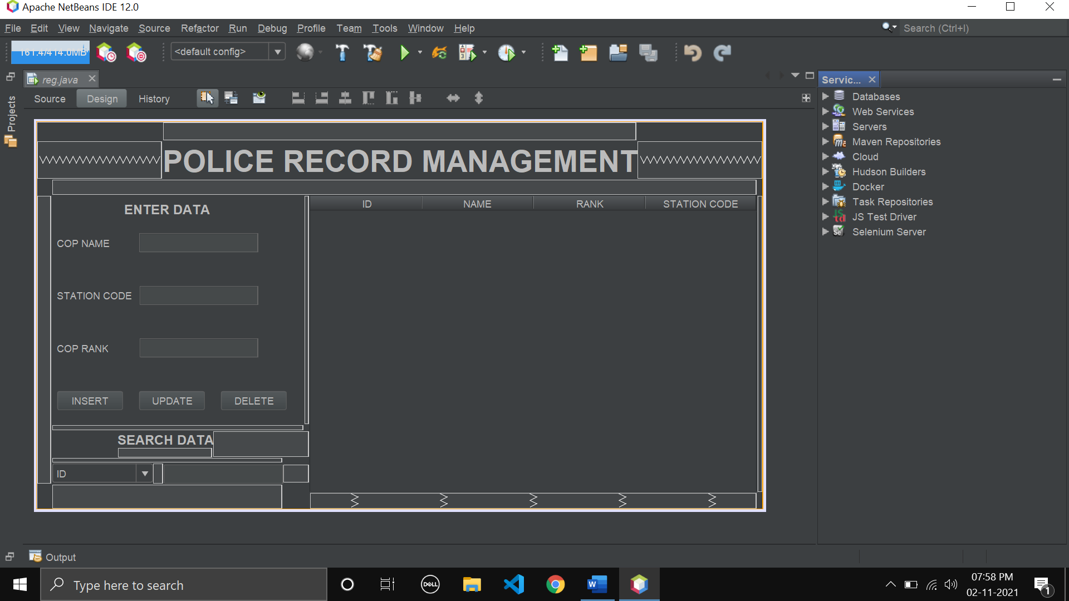

**Output:**

