INTERNSHIP REPORT

Allison Transmission India Pvt. Ltd.

Duration: 1 Month Internship

Submitted by
Chandru V

Department: Fabrication Department
Supervisor: Mr. Gowri Shankar
Guide: Mr. Rajan Sankaran

Acknowledgements

I express my sincere gratitude to the Almighty for granting me the strength, wisdom, and perseverance to successfully complete this internship.
I would like to extend my heartfelt thanks to Allison Transmission Pvt. Ltd. for providing me with the valuable opportunity to undertake my internship in such a reputed organization. The experience has been highly enriching and transformative.
I am especially grateful to Mr. John Vasanth for offering me this opportunity and for his continuous guidance and support throughout the internship.
I would also like to express my deep appreciation to my supervisor, Mr. Gowri Shankar, and my guide, Mr. Rajan Sankaran, for their constant mentorship, encouragement, and insightful feedback. Their guidance played a vital role in enhancing my learning experience and professional development.
I extend my sincere thanks to the entire team of the Fabrication Department for their warm support, cooperation, and for sharing their valuable knowledge and expertise. Their professionalism significantly contributed to my understanding of real-world industrial practices.
I am also deeply thankful to my family and friends for their unwavering encouragement and motivation throughout this journey.
This internship at Allison Transmission Pvt. Ltd. has provided me with practical exposure to real-world engineering applications and has further strengthened my interest in automotive engineering and powertrain systems.

Chandru V

About the Company

Allison Transmission is a global leader in propulsion technology, widely recognized for its innovation, engineering excellence, and significant contributions to commercial and defence vehicle mobility. With decades of industry experience, the company specializes in designing, manufacturing, and distributing advanced propulsion solutions that cater to the evolving demands of modern transportation and industrial sectors.
Allison’s propulsion systems are utilized across a wide range of applications, including on-highway commercial vehicles such as distribution trucks, construction vehicles, and fire and emergency response units. The company also plays a vital role in public transportation, providing solutions for school buses, transit buses, and long-distance coaches.
In addition, Allison serves off-highway industries such as energy, mining, and construction, where durable and high-performance transmission systems are essential for efficient operations. The company is also a trusted provider for defence applications, supplying propulsion systems for tactical wheeled and tracked vehicles designed for reliability in rugged environments.
Allison Transmission products are well known for their durability, reliability, and low total cost of ownership. These systems are engineered to enhance vehicle performance, particularly under demanding operating conditions. With a strong global presence, Allison operates manufacturing facilities and service networks across key markets, ensuring consistent product availability and customer support worldwide.
Mission:
To provide the most reliable and valued propulsion solutions in the world, enabling customers to operate more efficiently.
Vision:
To be the global leader in commercial-duty propulsion solutions that improve the way the world works.
Core Values:
- Quality: Commitment to excellence in all operations and deliverables.
- Customer Focus: Delivering solutions tailored to unique customer needs.
- Integrity: Upholding the highest ethical standards.
- Innovation: Continuously improving products and processes to create value.
- Teamwork: Collaborating effectively to achieve common goals.

Internship Objectives
- To gain practical exposure to industrial working environments, processes, and operational standards.
- To work on real-world engineering problems and develop effective, optimized solutions.
- To enhance technical skills, problem-solving ability, and understanding of industrial practices.
- To apply theoretical knowledge acquired during academic studies to practical manufacturing and industrial scenarios.
- To develop professional competencies such as teamwork, communication, and adaptability in a corporate environment.

Abstract
This internship report presents my one-month training experience at Allison Transmission India Pvt. Ltd., a subsidiary of a global leader in the manufacturing of fully automatic transmissions for medium- and heavy-duty commercial vehicles, serving both on-highway and off-highway applications.

During the internship, I was assigned to the Fabrication Department, where key components of planetary gear systems—such as Ring gears, Pinion gears, and Sun gears—are manufactured. I gained exposure to various production lines, including the Ring Line, Green Line, Heat Treatment Line, and Hard Line, each playing a critical role in the overall manufacturing process.

My work was primarily aligned with Value Stream Mapping (VSM), with a focus on analysing and improving process flow and operational efficiency. This involved understanding existing workflows, identifying inefficiencies, and contributing to process improvement initiatives.

This report details the activities I performed, the manufacturing technologies I was exposed to, and the practical skills I developed during the internship. Overall, the experience significantly enhanced my understanding of production systems, lean manufacturing principles, and real-world industrial engineering practices.
Internship Overview

The following table summarizes the key learning activities carried out during each week of the one-month internship at Allison Transmission India Pvt. Ltd.:

Week | Focus Areas & Activities
Week 1 | Introduction to Total Productive Maintenance (TPM), 8 Pillars of TPM, OEE concepts, and overview of the Fabrication Department layout, production lines, and safety protocols.
Week 2 | In-depth study of Fabrication of Planetary Gears — Ring Gear (1000, 2000, 3000, 4000 series) and Sun & Pinion Gear manufacturing processes, machines, and process flows.
Week 3 | Study and application of Lean Manufacturing Tools including VSM, SMED, Six Sigma (DMAIC), 5S, Poka Yoke, Andon, FIFO, Gemba, and Cause & Effect Analysis.
Week 4 | Study of the Housing & Assembly Line — machines used (VTL, HMC, Keyway Milling, Radial Drilling, CMM), and comprehensive learning of CNC programming through G-codes (motion, canned cycles, compensation) and M-codes (spindle, coolant, tool change, pallet control).
Week 1: Introduction to TPM & Fabrication Department

The first week of the internship was dedicated to orientation, understanding the company's manufacturing philosophy, and gaining a foundational understanding of Total Productive Maintenance (TPM) — a core operational framework at Allison Transmission India Pvt. Ltd.

1.1 Orientation & Safety Induction
The week began with a comprehensive plant orientation. I was introduced to the different departments, safety protocols, personal protective equipment (PPE) requirements, and the overall layout of the Fabrication Department. I familiarised myself with the production lines: Green Line, Ring Line, Heat Treatment Line, and Hard Line.

1.2 Total Productive Maintenance (TPM)
TPM is an approach to maintenance that empowers operators with the expanded responsibility of integrating equipment maintenance into the manufacturing process. Its core objectives are:
- Avoid waste in a quickly changing economic environment.
- Produce goods without reducing product quality.
- Reduce operational costs.
- Produce low batch quantities at the earliest possible time.
- Send only non-defective parts to customers.

TPM offers several key benefits:
- Reduced Maintenance Costs: Preventive maintenance helps avoid costly repairs by addressing issues before breakdowns occur.
- Higher Equipment Availability: TPM minimizes downtime and defects, boosting output and reducing waste.
- Enhanced Employee Engagement: Involving workers in maintenance fosters teamwork and motivates them to improve overall productivity.

1.3 The 8 Pillars of TPM
These are the core areas aimed at achieving zero breakdowns, zero defects, and zero accidents through proactive and preventive practices:

Pillar | Description
Autonomous Maintenance | Operators trained to perform basic maintenance (cleaning, inspecting, lubricating), increasing ownership and early detection of issues.
Planned Maintenance | Maintenance activities scheduled based on predicted failures or equipment history to minimize unexpected breakdowns.
Quality Maintenance | Identifies and eliminates causes of defects in processes and equipment to ensure zero quality defects.
Focused Improvement (Kaizen) | Small teams work on continuous improvement projects to eliminate losses and inefficiencies in specific areas.
Early Equipment Management | Maintenance and production staff involved in new equipment design to ensure reliability from the start.
Training and Education | Skill development for all employees to improve equipment handling, maintenance, and problem-solving abilities.
Safety, Health & Environment | Ensures equipment and work practices support a safe, healthy, and environmentally friendly workplace.
Administrative TPM | Applies TPM principles to support departments to improve efficiency and reduce process waste.

1.4 Autonomous Maintenance (AM):
Autonomous Maintenance (AM) is a key pillar of Total Productive Maintenance (TPM) in which machine operators are empowered and trained to take responsibility for routine maintenance activities such as cleaning, inspection, lubrication, and minor adjustments. The primary objective of Autonomous Maintenance is to improve machine reliability, reduce unexpected breakdowns, and enhance overall equipment effectiveness (OEE). Since operators work closely with machines on a daily basis, they are in the best position to detect early signs of abnormalities such as unusual noise, vibration, leakage, or wear. By identifying and addressing these issues at an early stage, major failures can be prevented, leading to improved productivity and reduced maintenance costs.

The implementation of Autonomous Maintenance follows a structured approach consisting of seven steps. It begins with initial cleaning, where machines are thoroughly cleaned to expose hidden defects such as oil leaks, loose components, and contamination. This is followed by eliminating sources of contamination and improving accessibility, ensuring that the root causes of dirt, dust, and debris are addressed. The next step involves establishing cleaning and lubrication standards, where clear guidelines are defined regarding what, when, and how maintenance activities should be performed. Operators are then trained to conduct general inspections, enabling them to understand machine components and identify potential issues. As they gain proficiency, they move to autonomous inspection, where they independently perform routine checks using standardized procedures and checklists. The sixth step focuses on standardization, which includes implementing visual controls, standard operating procedures (SOPs), and tagging systems to maintain consistency. Finally, continuous improvement is encouraged through Kaizen activities, where operators actively participate in enhancing machine performance and efficiency.

Autonomous Maintenance offers several benefits, including reduced downtime, improved product quality, enhanced safety, and increased machine life. It also fosters a sense of ownership among operators and promotes teamwork between production and maintenance departments. In an industrial environment such as gear manufacturing, Autonomous Maintenance ensures that machines like hobbing, broaching, and grinding units are kept in optimal condition through regular cleaning, lubrication, and inspection. This not only improves process stability but also ensures consistent product quality and efficient production operations.
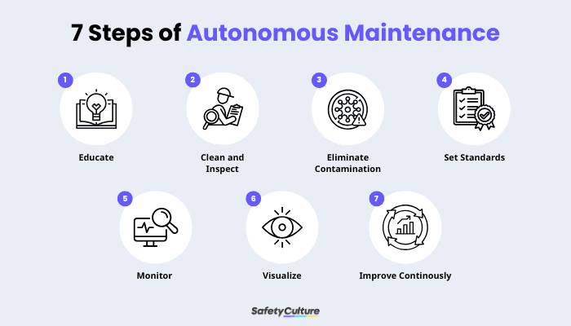

1.5 Overall Equipment Effectiveness (OEE)
OEE is a key performance indicator in manufacturing that measures how effectively equipment is being used. It helps identify losses and improve productivity by focusing on three key factors:

- Availability: Measures the percentage of scheduled time the equipment is actually running.
  - Availability = Operating Time / Planned Production Time
- Performance: Assesses whether the machine is running at its ideal speed.
  - Performance = (Ideal Cycle Time × Total Pieces) / Operating Time
- Quality: Indicates the proportion of good units produced without defects.
  - Quality = Good Pieces / Total Pieces

OEE = Availability × Performance × Quality

An OEE score of 85% or above is considered excellent. The major equipment losses addressed by OEE include: Startup Loss, Setup/Adjustment Loss, Cycle Time Loss, Breakdown Loss, and Defect Loss.

Week 2: Fabrication of Planetary Gears

The second week was devoted to an in-depth study of the Fabrication Department. Allison India fabricates planetary gears for 4 transmission series: 1000, 2000, 3000, and 4000 series. The planetary gear set consists of Ring Gears, Sun Gears, and Pinion Gears.

2.1 Ring Gear Manufacturing

4000 Series Ring Gear
- The process begins with cleaning the gear blanks using a JENFAB washer. This step ensures that the components are free from contaminants such as oil, dust, and metal particles.
- After cleaning, the gear blanks are transferred to the hobbing station, where external teeth are machined using the GLEASON GP300 hobbing machine. This operation is critical for generating accurate gear tooth profiles.
- The gears are then moved to the shaving station, where internal teeth are finely machined using the MITSUBISHI ST40 CNC shaving machine to achieve high precision and improved surface finish.
- Following machining, burrs formed during the cutting processes are removed using a REDIN deburring machine. The components are then washed again to eliminate any remaining residues before heat treatment.
- The next stage involves surface hardening through a nitriding process carried out in a NITREX furnace. This enhances surface hardness, wear resistance, and overall durability of the gears.
- After heat treatment, the components undergo rigorous quality inspection to ensure they meet dimensional and performance specifications.
- Finally, once approved, the finished gears are carefully packaged and prepared for dispatch.

3000 Series Ring Gear
- The process begins with washing the gear blanks using a JENFAB washer to remove contaminants and ensure a clean surface for machining.
- The cleaned components are sent to the broaching station, where internal teeth are machined using the FEDERAL BROACH machine with high precision.
- Next, the gears are transferred to the hobbing station, where external teeth are generated using the GLEASON GP 200 hobbing machine.
- After machining, burrs are removed using a REDIN deburring machine, followed by a secondary washing process to eliminate any residual particles.
- The components then undergo surface hardening through a nitriding process in a NITREX furnace, improving wear resistance and durability.
- Finally, the gears are subjected to quality inspection to ensure they meet required specifications, after which they are packaged for dispatch.

1000 & 2000 Series Ring Gear
- The process begins with cleaning the gear blanks using a JENFAB washer to remove contaminants and prepare the surface for machining.
- The cleaned components are transferred to the broaching station, where internal teeth are precisely machined using the FROST BROACH machine.
- After broaching, burrs formed during machining are removed using a REDIN deburring machine, followed by a secondary washing process to ensure cleanliness.
- The components then undergo surface hardening through a nitriding process in a NITREX furnace, which enhances surface hardness and wear resistance.
- Once hardened, the gears are subjected to hard turning using an EMAG lathe, where the external surfaces are precision-machined to achieve the required dimensions and finish.
- The gears are then moved to the hobbing station, where external teeth are generated using the GP200 hobbing machine.
- Finally, the components undergo final deburring, quality inspection to verify specifications, and are then packaged for dispatch.

2.2 Sun & Pinion Gear Manufacturing
The Sun and Pinion gears follow a more refined manufacturing process due to their precision requirements:

- The process begins with washing the gear blanks using a JENFAB washer to remove contaminants and prepare them for machining operations.
- The cleaned components are transferred to the hobbing station, where external teeth are generated using the GLEASON 130H hobbing machine.
- The gears then move to the GLEASON 130SVC machine, where chamfering and deburring are performed, followed by the shaving process to refine the external tooth geometry and improve surface finish.
- After machining, the components undergo carburizing heat treatment, which includes hardening and tempering to enhance surface hardness, strength, and durability.
- The hardened gears are then subjected to surface grinding, where one face of the gear is finished to achieve the required flatness and smoothness.
- This is followed by honing of the internal bore using a NAGEL honing machine, ensuring high precision, dimensional accuracy, and superior surface finish.
- The components are then washed again using the JENFAB washer and inspected using the Intra Roll Check machine to verify critical parameters such as runout, tooth thickness, and backlash.
- Finally, the gears undergo Firewall Inspection stages 1 and 2 to ensure complete compliance with quality standards before being approved for packaging and dispatch.

2.3 Machining of Housings
Allison Transmission India Pvt. Ltd. also performs precision machining of housing components for various transmission series, including the 4000, 5000, 6000, 7000, and 8000 series. The housing serves as the outer casing of the transmission system, playing a critical role in protecting internal components, maintaining proper alignment, sealing internal mechanisms, and withstanding operational loads and vibrations.
The primary housing components manufactured include the Rear Cover, Main Housing, and Converter Housing. These components are machined with high precision to ensure dimensional accuracy, structural integrity, and reliable performance under demanding operating conditions.

Manufacturing Processes — Housing Department
- Vertical Turret Lathe (VTL):
This machine is used for machining large and heavy cylindrical components. It performs operations such as facing, turning, and boring with high stability and precision, making it ideal for housing parts.
- Horizontal Machining Centre (HMC):
The HMC is used for complex multi-face machining operations, including drilling, tapping, and facing. It is equipped with an automatic tool changer, enabling efficient and continuous production with high accuracy.
- Keyway Milling Machine:
This machine is utilized to cut keyways or slots in cylindrical components, which are essential for transmitting torque between mating parts.
- Radial Drilling Machine:
The radial drilling machine is used to drill accurately positioned holes on large and heavy components. It is suitable for creating mounting holes, tapped holes, and internal fluid channels.

Inspection Processes — Housing Department
- Coordinate Measuring Machine (CMM):
The CMM is used to verify the dimensional accuracy and geometric tolerances of components after major machining operations. It ensures that the part conforms to the specified design requirements.
- Leak Test:
This test is conducted using air or fluid pressure to identify any leakage paths or micro-defects in the component, ensuring proper sealing and functional integrity.
- Final Inspection:
A comprehensive inspection is performed to confirm that all critical dimensions, tolerances, and quality standards are met before the components are approved for packaging and dispatch.

Week 3: Lean Manufacturing Tools & Techniques

The third week focused on understanding and studying the Lean Manufacturing tools used at Allison Transmission India. Lean Manufacturing tools are techniques used to make production processes more efficient, reduce waste, and increase quality, helping companies deliver more value using fewer resources.

3.1 Value Stream Mapping (VSM)
VSM is a lean visualization tool used to map the current and future states of a production process. Its purpose is to identify and eliminate waste by analyzing every step from raw material to finished product.

Key components of a VSM:
- Process Flow: Shows all operations in sequence.
- Material Flow: Traces the physical flow of parts.
- Information Flow: Documents how decisions are made and communicated.

Metrics captured in VSM include Cycle Time, Takt Time, Lead Time, Inventory Levels, Uptime, and Rejection Rate. The primary goal of VSM is to maximize value-adding (VA) time and minimize non-value-adding (NVA) time.

3.2 SMED (Single Minute Exchange of Dies)
SMED is a method introduced by Shigeo Shingo to drastically reduce the time required for equipment changeovers. It is especially useful in high-mix, low-volume production settings where flexibility is key.

- Internal Setup: Tasks performed while the machine is stopped.
- External Setup: Tasks performed while the machine is operating.

SMED is implemented using the ECRS principle:
- Eliminate: Remove unnecessary steps such as redundant tool adjustments.
- Combine: Execute multiple steps simultaneously.
- Reduce: Shorten the time needed for each step.
- Simplify: Design equipment for easier setup.

3.3 Six Sigma
Six Sigma is a methodology to make products better by reducing mistakes and problems. It aims to achieve near-perfection by reducing the defect rate to just 3.4 defects per million opportunities.

Six Sigma follows two primary methods:
- DMAIC: For fixing existing processes — Define, Measure, Analyse, Improve, Control.
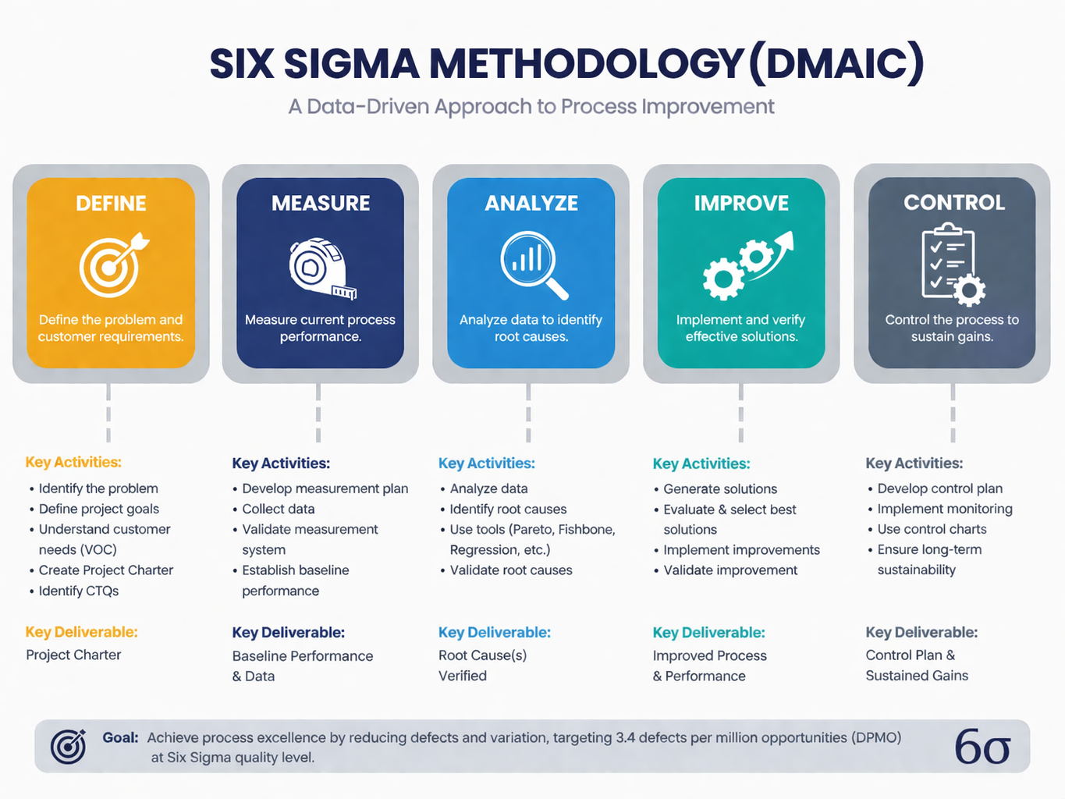
- DMADV: For creating new products or processes — Define, Measure, Analyse, Design, Verify.

3.4 5S Methodology
5S is a five-step methodology that helps create a more organized and efficient workspace. It originated as part of the Toyota Production System (TPS).

Japanese Term | English Term | Description
Seiri | Sort | Sort through and eliminate that which is not truly needed.
Seiton | Straighten | Organize what remains after sorting.
Seisou | Shine | Clean and inspect the work area.
Seiketsu | Standardize | Create standards that support a repeatable process.
Shitsuke | Sustain | Consistently apply these standards across work areas.
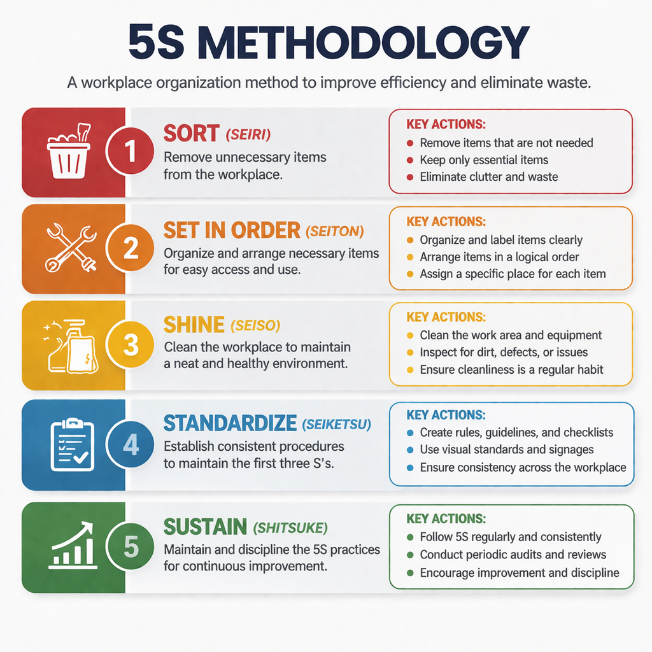

3.5 Poka Yoke (Error Proofing)
Poka Yoke is a Japanese term meaning 'Error Proofing.' It involves implementing mechanisms to eliminate the possibility of mistakes, make errors immediately obvious, or prevent a process from continuing until the error is corrected.
- Error Prevention: Stop errors from happening by designing processes that make errors impossible or highly unlikely.
- Error Detection: Detect errors as they occur or immediately afterward (e.g., use of sensors in lines).
- Error Correction: Quick and easy correction mechanisms for detected errors.

3.6 Andon System
An Andon is a mechanism for ensuring that problems occurring during production are immediately recognized and resolved. It empowers operators to halt their line of work if any problem occurs. At Allison, the Andon system uses Andon Light Alert systems:
- Red: Critical problem — line is stopped, immediate attention needed.
- Yellow: Non-critical issue — line can run but the issue should be addressed soon.
- Green: No problem — line is running normally.

3.7 Other Lean Tools
- FIFO (First-In, First-Out): Oldest items in stock are used first, minimizing waste and ensuring product quality.
- Gemba: Field experts walk production lines to closely observe process flow and ensure standards are followed.
- Kaizen: Continuous improvement philosophy involving all employees to incrementally improve processes.
- Cause & Effect Analysis (Fishbone Diagram): Categorizes possible causes under Man, Machine, Method, Material, Measurement, and Environment.

Week 4: Housing & Assembly Line — Machines, G-Code & M-Code

The fourth and final week was spent in the Housing and Assembly Line section of the Fabrication Department. This week provided deep exposure to CNC machining operations used in manufacturing transmission housings, along with a practical understanding of CNC programming through G-codes and M-codes.

4.1 Housing & Assembly Line Overview
Allison India performs precision machining of housing parts for the 4000, 5000, 6000, 7000, and 8000 series transmissions. The housing is the structural backbone of the transmission system, serving the following critical functions:
- Protects internal components such as gears, shafts, and bearings from external damage.
- Supports the alignment and precise positioning of all moving components.
- Seals internal systems to prevent leakage of fluids such as oil and coolant.
- Withstands mechanical loads, vibrations, and environmental factors during operation.

The primary housing parts machined at Allison India include:
- Rear Cover
- Main Housing
- Converter Housing

4.2 Machines Used in the Housing & Assembly Line

4.2.1 Vertical Turret Lathe (VTL)
The Vertical Turret Lathe is primarily used to machine large cylindrical components such as housing parts. The workpiece is mounted horizontally on a rotating table, and the cutting tool is positioned vertically. Operations performed include:
- Facing: Machining the flat end surfaces of large cylindrical housings.
- Turning: Reducing the outer diameter of the housing to the required dimensions.
- Boring: Enlarging the internal diameter of the housing bores with high precision.
VTLs are preferred for heavy, large-diameter components that would be difficult to hold and rotate on a conventional horizontal lathe.

4.2.2 Horizontal Machining Center (HMC)
The Horizontal Machining Center is a CNC machine tool used for complex multi-face machining operations. The spindle axis is oriented horizontally, and the workpiece is held on a pallet that can rotate to expose multiple faces in a single setup. Key capabilities include:
- Drilling: Creating precise holes for fasteners, fluid passages, and bearing seats.
- Tapping: Cutting internal threads inside drilled holes for bolted connections.
- Milling: Removing material to create flat surfaces, slots, and contoured profiles.
- Boring: Precision finishing of large internal diameters.
Equipped with automatic tool changers (ATC) and pallet systems, the HMC allows uninterrupted machining of multiple features in a single setup, significantly improving efficiency and dimensional accuracy.

4.2.3 Keyway Milling Machine
This machine is specifically designed to cut keyways — rectangular slots — into cylindrical components such as shafts and housing bores. Keyways are critical for:
- Torque transmission between rotating shafts and mating gears.
- Ensuring secure and non-slip mechanical connections between components.
- Maintaining precise angular positioning of gears and couplings on shafts.

4.2.4 Radial Drilling Machine
The Radial Drilling Machine is used for drilling accurately located holes on large or uneven housing surfaces. Its radial arm can swing and extend outward, allowing the spindle to be positioned precisely over any point on the workpiece without repositioning the component. It is ideal for:
- Creating mounting holes and through-holes on large housing surfaces.
- Tapping holes at precise angles and positions on complex housing geometries.
- Drilling fluid channels and coolant passages within the housing.

4.2.5 Coordinate Measuring Machine (CMM)
After machining, all housing components are inspected using a CMM — a highly precise measurement instrument that uses a probe to detect the surface geometry of a part in 3D space. At Allison, CMM is used to:
- Verify bore diameters, flatness, perpendicularity, and positional tolerances.
- Confirm dimensional accuracy after each major machining operation.
- Generate inspection reports for quality documentation and traceability.

4.3 Introduction to CNC Programming
Modern CNC (Computer Numerical Control) machines in the Housing Line are programmed using a standardized language consisting of G-codes and M-codes. These codes form the backbone of all CNC machining instructions and define both the motion of the cutting tool and the auxiliary functions of the machine.

A typical CNC program structure looks like this:
O0001 ; (Program Number)
N10 G21 G17 G90 ; (Setup: Metric, XY Plane, Absolute)
N20 G28 G91 Z0 ; (Return Z to home)
N30 T01 M06 ; (Tool Change to Tool 1)
N40 G00 X50 Y50 S1200 M03 ; (Rapid move, Spindle ON)
N50 G43 H01 Z5 ; (Tool Length Compensation)
N60 G01 Z-10 F150 ; (Linear Feed Down)
N70 G01 X100 F200 ; (Linear Cut in X)
N80 G00 Z5 ; (Rapid Retract)
N90 M05 ; (Spindle OFF)
N100 M30 ; (Program End & Rewind)

4.4 G-Codes (Preparatory Codes)
G-codes are preparatory or geometric codes that control the movement and path of the cutting tool. They define how the machine physically moves, including the type of motion (rapid, linear, circular), the plane of operation, and coordinate settings.

4.4.1 Motion G-Codes
Code | Name | Description
G00 | Rapid Positioning | Moves the tool to a specified position at maximum speed without cutting. Used for non-cutting movements to save time.
G01 | Linear Interpolation | Moves the tool in a straight line at a programmed feed rate. Used for all straight cutting operations.
G02 | Circular Interpolation CW | Moves the tool in a clockwise circular arc. Requires center point (I, J) or radius (R) values.
G03 | Circular Interpolation CCW | Moves the tool in a counter-clockwise circular arc. Used for CCW profiling operations.

4.4.2 Plane Selection G-Codes
Code | Name | Description
G17 | XY Plane Selection | Selects the XY plane for circular interpolation and cutter compensation. Default for vertical machining.
G18 | XZ Plane Selection | Selects the XZ plane for circular interpolation. Common in lathe turning operations.
G19 | YZ Plane Selection | Selects the YZ plane for circular interpolation in side-machining operations.

4.4.3 Dimensional Mode G-Codes
Code | Name | Description
G20 | Inch Input | Sets the machine to interpret all positional values in inches.
G21 | Metric Input | Sets the machine to interpret all positional values in millimetres. Standard at Allison India.
G90 | Absolute Positioning | All coordinates are measured from a fixed origin (work zero point).
G91 | Incremental Positioning | All coordinates are measured relative to the current tool position.

4.4.4 Reference & Compensation G-Codes
Code | Name | Description
G28 | Return to Machine Home | Moves the tool to the machine's reference (home) position. Used at start and end of programs.
G40 | Cancel Cutter Comp. | Cancels any active cutter radius compensation (G41 or G42).
G41 | Cutter Comp. Left | Offsets the tool path to the left of the programmed path by the tool's radius value.
G42 | Cutter Comp. Right | Offsets the tool path to the right of the programmed path by the tool's radius value.
G43 | Tool Length Comp. + | Applies positive tool length offset to compensate for tool length variation.
G49 | Cancel Tool Length Comp. | Cancels any active tool length compensation.

4.4.5 Canned Cycle G-Codes
Canned cycles are predefined, repetitive machining operations stored as a single G-code command, widely used in the Housing Line for drilling and tapping multiple holes efficiently.
Code | Name | Description
G73 | Peck Drilling Cycle | High-speed peck drilling with partial retract. Used for deep holes with chip breaking.
G74 | Left-Hand Tapping | Performs counter-clockwise (left-hand) tapping cycle with spindle reversal.
G76 | Fine Boring Cycle | Precision boring with spindle orientation at the bottom for clean retract without scratching the bore.
G80 | Cancel Canned Cycle | Cancels any active canned cycle (G73–G89).
G81 | Drilling Cycle | Standard drilling cycle: drill to depth, retract rapidly. Used for shallow holes.
G82 | Drilling Cycle w/ Dwell | Drilling with a dwell (pause) at the bottom for improved finish at hole bottom.
G83 | Deep Hole Peck Drilling | Full retract peck drilling for deep holes; clears chips completely between pecks.
G84 | Tapping Cycle | Performs clockwise tapping with automatic spindle reversal on retract.
G85 | Boring Cycle | Boring with feed-in and feed-out — used where bore surface finish is critical.

4.5 M-Codes (Miscellaneous / Machine Functions)
M-codes control the auxiliary or miscellaneous functions of the CNC machine — actions that are not related to tool movement but are essential for a complete machining cycle. These include spindle control, coolant, tool changes, and program control.

4.5.1 Program Control M-Codes
Code | Name | Description
M00 | Program Stop | Unconditional stop — pauses the program. Operator must press cycle start to resume.
M01 | Optional Stop | Conditional stop — pauses the program only if the Optional Stop switch is ON on the control panel.
M02 | Program End | Signals the end of the main program. Resets the machine but does not rewind to the start.
M30 | Program End & Rewind | Ends the program and rewinds back to the start. Most commonly used end-of-program code.
M99 | Subprogram Return | Returns control from a subprogram back to the main program after execution.
M98 | Subprogram Call | Calls a subprogram by its program number. Used to repeat standard machining sequences.

4.5.2 Spindle Control M-Codes
Code | Name | Description
M03 | Spindle ON — CW | Starts the spindle rotating in the clockwise direction at the programmed speed (S value).
M04 | Spindle ON — CCW | Starts the spindle rotating counter-clockwise. Used for left-hand threading and special operations.
M05 | Spindle OFF | Stops the spindle rotation. Always commanded before tool changes or program end.
M19 | Spindle Orientation | Rotates and stops the spindle at a specific angular position. Used in boring and tool change sequences.

4.5.3 Tool Change M-Codes
Code | Name | Description
M06 | Tool Change | Commands the Automatic Tool Changer (ATC) to replace the current tool with the tool specified by the T-word (e.g., T02 M06).
M61 | Select Tool | Pre-selects the next tool in the magazine without performing the physical change. Reduces changeover time.

4.5.4 Coolant Control M-Codes
Code | Name | Description
M07 | Mist Coolant ON | Activates mist coolant — a fine spray of air and coolant. Used for light cuts and sensitive materials.
M08 | Flood Coolant ON | Activates flood coolant — high-volume coolant flow for chip evacuation and temperature control during heavy cuts.
M09 | Coolant OFF | Turns off all active coolant (mist or flood).
M50 | Coolant Through Spindle ON | Activates high-pressure coolant directed through the spindle and tool for deep-hole drilling on HMC.

4.5.5 Pallet & Rotary M-Codes (HMC Specific)
Code | Name | Description
M10 | Pallet Clamp | Clamps the pallet securely in position on the HMC table before machining begins.
M11 | Pallet Unclamp | Unclamps the pallet to allow rotation or exchange with another pallet.
M60 | Automatic Pallet Change | Commands the Automatic Pallet Changer (APC) to swap the current pallet with the next loaded pallet.

4.6 Key Learnings from Week 4
This week provided a holistic view of the Housing and Assembly Line operations at Allison Transmission India. The key takeaways from this week include:
- Understanding of how housing components fit into the broader transmission assembly and why dimensional accuracy is critical.
- Practical knowledge of the machines used — VTL, HMC, Keyway Milling, and Radial Drilling — and their specific roles in the housing manufacturing sequence.
- Comprehensive understanding of G-codes and M-codes, and how they work together to define a complete CNC machining program.
- Appreciation for canned cycles (G73–G85) as powerful tools that simplify repetitive hole-making and threading operations on housing components.
- Insight into how HMC-specific M-codes (pallet clamping, APC, through-spindle coolant) enable highly efficient, unattended multi-face machining.

Conclusion

This one-month internship at Allison Transmission India Pvt. Ltd. has been an exceptionally rewarding and transformative experience. Throughout the four weeks, I progressed from understanding foundational maintenance philosophies to actively participating in a live process improvement project.

In Week 1, I gained a strong understanding of Total Productive Maintenance (TPM) and Overall Equipment Effectiveness (OEE) — frameworks that are deeply ingrained in Allison's manufacturing culture. In Week 2, I explored the detailed fabrication processes for planetary gears across multiple series, gaining hands-on knowledge of specialized machines such as GLEASON hobbing machines, NITREX furnaces, and NAGEL honing machines.

Week 3 broadened my perspective on lean manufacturing, introducing me to tools like VSM, SMED, Six Sigma, 5S, Andon, and Poka Yoke. Finally, Week 4 took me into the Housing and Assembly Line, where I studied the key CNC machines used — Vertical Turret Lathe, Horizontal Machining Center, Keyway Milling Machine, and Radial Drilling Machine — and developed a solid understanding of CNC programming through G-codes and M-codes covering motion control, canned cycles, spindle operation, coolant management, and pallet control.

This internship has significantly enhanced my understanding of production systems, lean manufacturing, and real-world industrial engineering. The experience has deepened my passion for automotive engineering and powertrain systems, and I am confident that the skills and insights gained here will serve as a strong foundation for my future career.

Chandru V
Fabrication Department, Allison Transmission India Pvt. Ltd.

