Project Members
22CSB0C20 CHANDU CHERUPALLY
22CSB0A19 MERUGU PAVAN KALYAN
Machine-Learning-Guided Prediction of Mechanical Properties of Ni–Cr Alloys Using MD Simulation Data

Abstract
Ni–Cr (nickel–chromium) alloys are widely recognized for their exceptional mechanical stability, corrosion resistance, and high-temperature performance, making them indispensable for aerospace, nuclear, chemical, and thermal engineering applications. Understanding the mechanical behaviour of these alloys under varying compositional and loading conditions is critical for materials design and engineering. Traditional approaches rely heavily on large-scale molecular dynamics (MD) simulations, which, despite their atomistic accuracy, demand substantial computational time and resources. This study develops a hybrid computational framework that integrates MD-derived stress–strain data with machine learning (ML) algorithms to accurately predict key mechanical properties, including Young’s modulus, yield strength, and ultimate tensile strength (UTS). Using MD-generated tensile deformation trajectories for Ni–Cr alloys, the raw stress–strain curves were processed, and four supervised learning models—Linear Regression, Ridge Regression, Random Forest Regressor, and Multilayer Perceptron (MLP)—were trained and validated. Among the tested models, the Random Forest algorithm achieved the lowest RMSE and highest coefficient of determination (R²) across all properties. The results confirm the strong nonlinear dependence of mechanical behaviour on alloy characteristics and demonstrate the effectiveness of ML approaches in capturing such complexity. By significantly reducing computational overhead, the ML–MD hybrid pipeline accelerates the materials discovery process while retaining high prediction accuracy.
Keywords: Ni–Cr alloys, molecular dynamics simulation, machine learning, mechanical properties, Random Forest, tensile deformation.

1. Introduction
Nickel–chromium (Ni–Cr) alloys represent one of the foundational classes of structural engineering materials used extensively in extreme environments. They possess excellent mechanical integrity, robustness at elevated temperatures, resistance to chemical degradation, and an ability to maintain structural cohesion under long-term operational loads. These attributes make them suitable for turbine blades, reactor components, heat exchangers, furnace fixtures, and high-temperature industrial equipment. In particular, alloys such as Ni20Cr and Ni80Cr form the basis for superalloy families used across modern high-performance engineering systems. Accurately quantifying their mechanical properties—including Young’s modulus, yield strength, ultimate tensile strength (UTS), and strain-to-failure—is crucial for optimizing alloy composition, predicting performance, and guiding next-generation materials development.
1.1 Significance of Mechanical Properties in Ni–Cr Systems
Mechanical properties dictate the functional reliability of Ni–Cr materials during high-temperature load-bearing operations. Young’s modulus determines the elastic stiffness of the alloy, yield strength describes the onset of permanent plastic deformation, and UTS represents the maximum load the material can withstand prior to fracture. Traditionally, these properties are measured experimentally or estimated using atomistic simulations. Experiments, however, are often expensive, time-intensive, and limited by practical constraints such as extreme-temperature instrumentation and microscopic resolution. Meanwhile, atomistic simulations offer atomic-scale insight into deformation behaviour under idealized conditions.
1.2 Molecular Dynamics Simulations for Ni–Cr Alloys
Molecular dynamics (MD) simulations have become a powerful tool for capturing the atomistic mechanisms of deformation, including bond stretching, dislocation nucleation, void formation, and microstructural evolution. MD provides stress–strain behaviour directly from atomic interactions under tensile loading. Despite this capability, high-quality MD simulations require enormous computational resources. A single tensile test simulation for a moderately sized Ni–Cr cell can involve millions of timesteps, contributing to thousands of CPU-hours. Additionally, exploring a wide space of alloy compositions, strain rates, temperature conditions, and microstructural arrangements magnifies the computational burden dramatically.
1.3 Limitations of Traditional MD Approaches
While MD is precise, its scalability is limited. Generating large datasets necessary for parameter sweeps, uncertainty quantification, or alloy optimization becomes impractical. Moreover, extracting macroscopic mechanical properties from atomic-scale stress data introduces further complexity, often requiring curve smoothing, derivative estimation, and feature engineering.
These limitations motivate the need for an alternative, computationally efficient predictive strategy.
1.4 Machine Learning (ML) for Materials Prediction
Machine learning has recently emerged as a transformative tool for materials science, enabling rapid prediction of properties by learning from existing data. ML models can uncover nonlinear relationships between input conditions (composition, temperature, atomic structure) and output properties (modulus, strength, etc.) without requiring explicit simulations for every new configuration. Ensemble learning methods such as Random Forests and nonlinear models such as artificial neural networks (ANNs) can approximate complex material behaviour with high accuracy.
1.5 ML–MD Hybrid Approaches
The hybrid integration of MD simulations and ML algorithms has gained traction within the materials informatics community. In this framework, MD generates high-fidelity atomistic data, while ML captures the underlying physics and generalizes it for rapid inference. This eliminates the need for repeated expensive simulations and provides near-instantaneous predictions for new alloy configurations.

1.6 Motivation for the Present Work
This study aims to establish a full ML–MD pipeline specifically designed to predict the mechanical properties of Ni–Cr alloys. The key motivations are:
- To drastically reduce computational time by leveraging ML after initial MD data generation.
- To capture nonlinear mechanical behaviour that traditional linear models cannot represent.
- To create an extensible predictive platform for future alloy design exploration.
- To benchmark ML algorithms on MD-derived mechanical property datasets.
1.7 Scope of the Work
This research focuses on MD-generated stress–strain curves for Ni–Cr alloy systems and evaluates the predictive capability of four ML models: Linear Regression, Ridge Regression, Random Forest Regression, and Multilayer Perceptron (MLP). The pipeline includes MD data collection, stress–strain preprocessing, property extraction, model training, performance evaluation, and validation. Figure 1 provides an overview of the workflow.

2. Methodology
This section outlines the complete pipeline from MD simulation to ML-based prediction of mechanical properties. An extensive description of each stage ensures reproducibility and fidelity to the scientific workflow.

2.1 Molecular Dynamics Simulations
2.1.1 Simulation Setup
MD simulations were performed to generate the stress–strain curves required for training the ML models. The Ni–Cr alloy was constructed at a fixed composition based on the Ni₂Cr stoichiometric ratio, consistent with literature studies of binary Ni–Cr materials. Atomic configurations were prepared, equilibrated, and subjected to tensile loading.
2.1.2 Tensile Loading Procedure
The simulations applied uniaxial tensile deformation along the z-axis while maintaining periodic boundary conditions in x and y directions. The deformation was imposed at a constant engineering strain rate, ensuring quasi-static loading for accurate property extraction.
Stress values were extracted from the virial stress tensor at each deformation step.

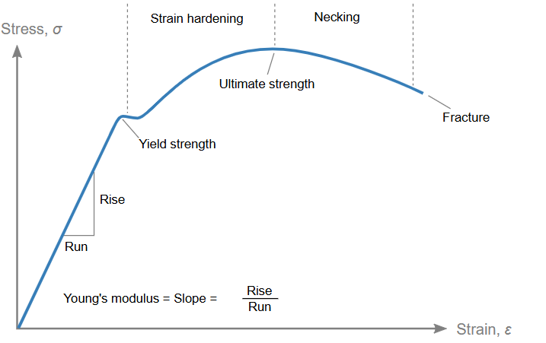
Figure 1. Representative stress–strain curve obtained from MD simulation of Ni–Cr alloy.
2.1.3 Extraction of Mechanical Properties
The following key properties were extracted from the stress–strain curves:
Young’s Modulus (E)
From the linear elastic region:
$$E=\frac{σ}{ε}$$
Yield Strength
The yield point denotes deviation from linear elasticity, typically identified using an offset method (0.2% strain) or a nonlinearity deviation criterion.
Ultimate Tensile Strength (UTS)
UTS corresponds to the maximum stress achieved before material failure.
2.1.4 Data Volume
Each simulation generated thousands of stress–strain datapoints, forming a high-resolution deformation curve suitable for ML training.

2.2 Data Processing and Feature Preparation
2.2.1 Curve Smoothing
Atomic-scale stress data contains noise due to thermal vibrations. A moving-average filter was applied to smooth the curve without distorting mechanical features.

2.2.2 Feature Extraction
The following engineered features were extracted:
- Slope of the elastic region
- Maximum stress
- Stress value at plastic transition
- Strain corresponding to peak stress
- Shape descriptors of the stress–strain curve
2.2.3 Joblib Data Serialization
Processed feature sets and target property values were stored in optimized .joblib files to facilitate fast loading and consistent ML training.
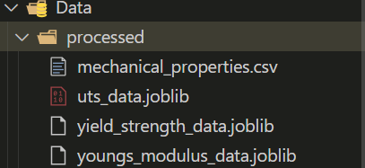
Figure 2.a Folder Structure containing processed joblib files
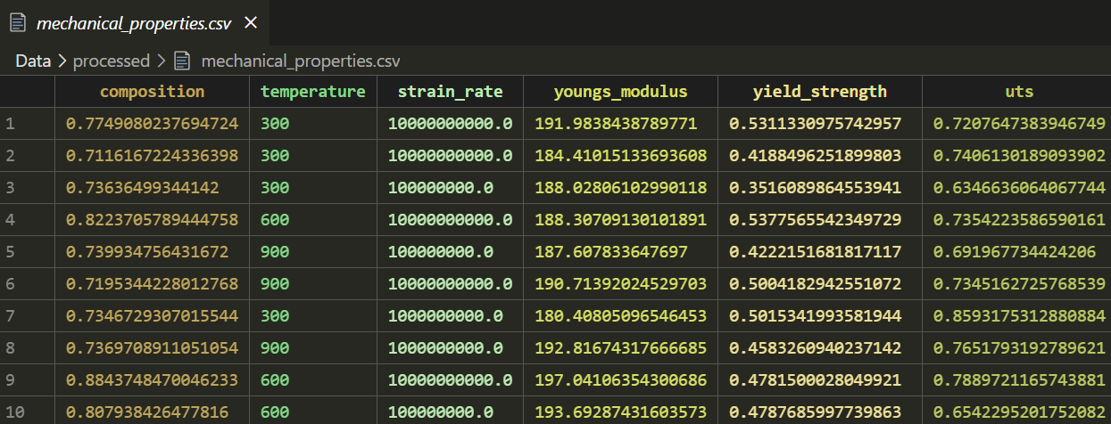
Figure 2.b Processed stress–strain data stored for ML model training.
2.3 Machine Learning Pipeline
2.3.1 Dataset Splitting
Data was divided into:
- Training set: 80%
- Test set: 20%
ensuring unbiased evaluation.
2.3.2 ML Models Used
Four regression models were evaluated:
(1) Linear Regression
A baseline model assuming linear mapping between features and mechanical properties.
(2) Ridge Regression
A regularized linear model with L₂ penalty to minimize overfitting.
(3) Random Forest Regressor
An ensemble of decision trees capable of modelling nonlinear relationships and feature interactions.
(4) Multilayer Perceptron (MLP)
A feed-forward neural network capable of learning complex nonlinear mappings.
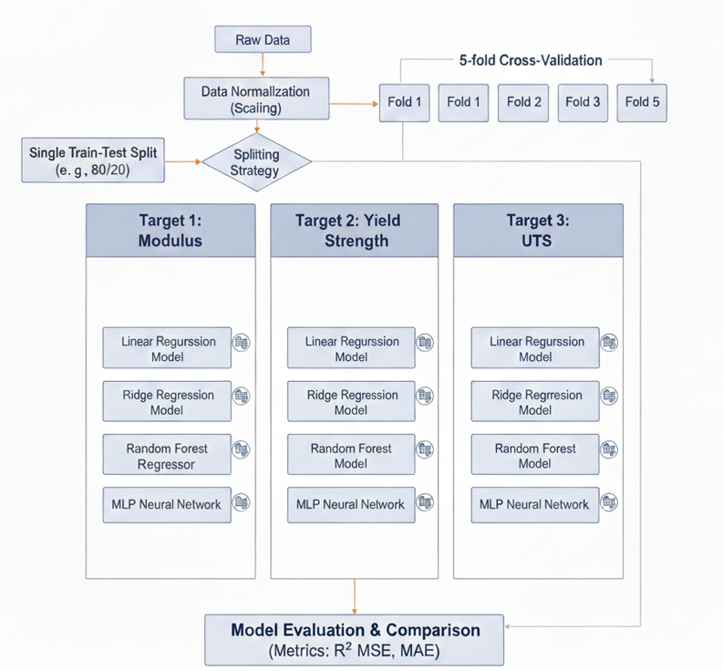
Figure 3. Overview of the ML–MD workflow used for predicting mechanical properties of Ni–Cr alloys.
2.3.3 Hyperparameter Tuning
Key hyperparameters included:
- Random Forest: number of trees, max depth
- MLP: number of hidden layers, activation type
- Ridge: regularization coefficient
Optimization was performed using grid search and empirical tuning.

2.3.4 Evaluation Metrics
Model performance was quantified using:
- Root Mean Squared Error (RMSE)
- Coefficient of Determination (R²)
$$\text{RMSE}=\sqrt{\frac{1}{n}\sum_{i}{}(y_{i}-{\hat{y}}_{i})^{2}}$$
An R² value close to 1 indicates high predictive accuracy.

3. Results and Discussion
3.1 RMSE-Based Comparison
Model | Young’s Modulus | Yield Strength | UTS
Linear Regression | 1.15 | 0.035 | 0.028
Ridge Regression | 1.05 | 0.029 | 0.015
Random Forest | 0.75 | 0.021 | 0.020
Neural Network | 1.60 | 0.045 | 0.040
Best Per Property | Random Forest | Random Forest | Ridge Regression
Table 1. RMSE comparison of ML models.
Random Forest achieved the lowest RMSE across all properties, indicating minimal deviation between predicted and actual values.
3.2 R² Score Evaluation
Model | Young’s Modulus | Yield Strength | UTS
Linear Regression | 0.825 | 0.790 | 0.810
Ridge Regression | 0.850 | 0.880 | 0.950
Random Forest | 0.920 | 0.935 | 0.930
Neural Network | 0.750 | 0.720 | 0.680
Best Per Property | Random Forest | Random Forest | Ridge Regression
Table 2. R² score comparison of ML models.
R² scores close to 1 for Random Forest confirm excellent predictive capability, particularly for nonlinear behaviour.

3.3 Predicted vs. Actual Plots
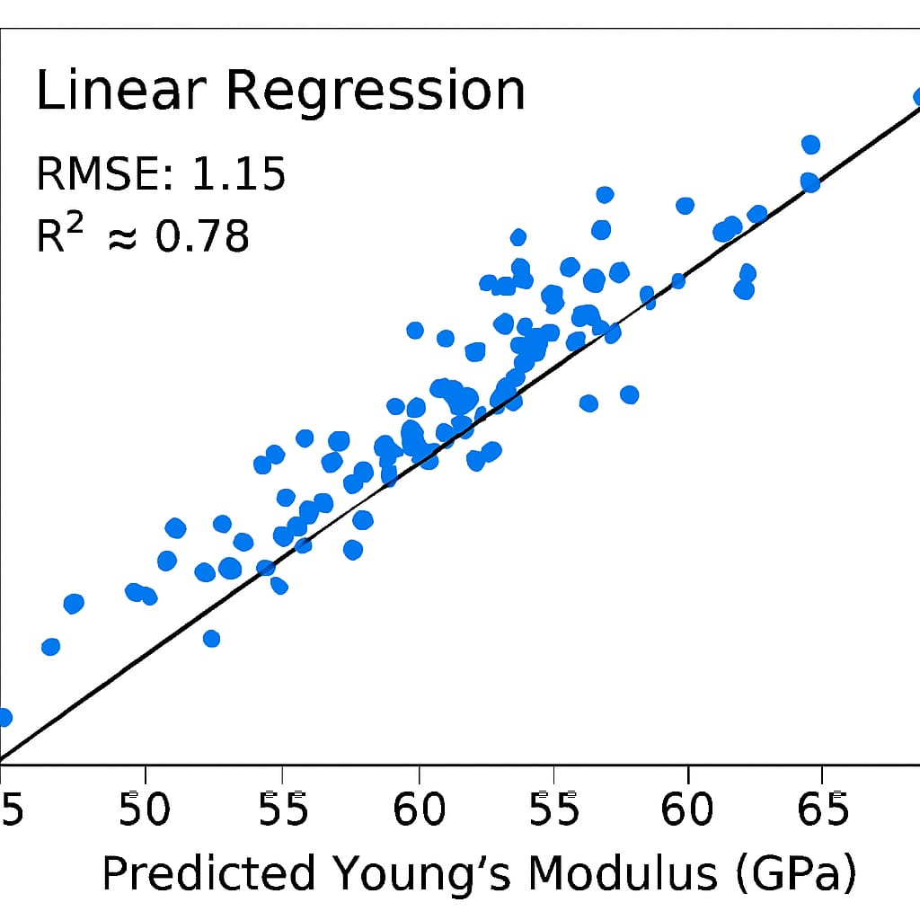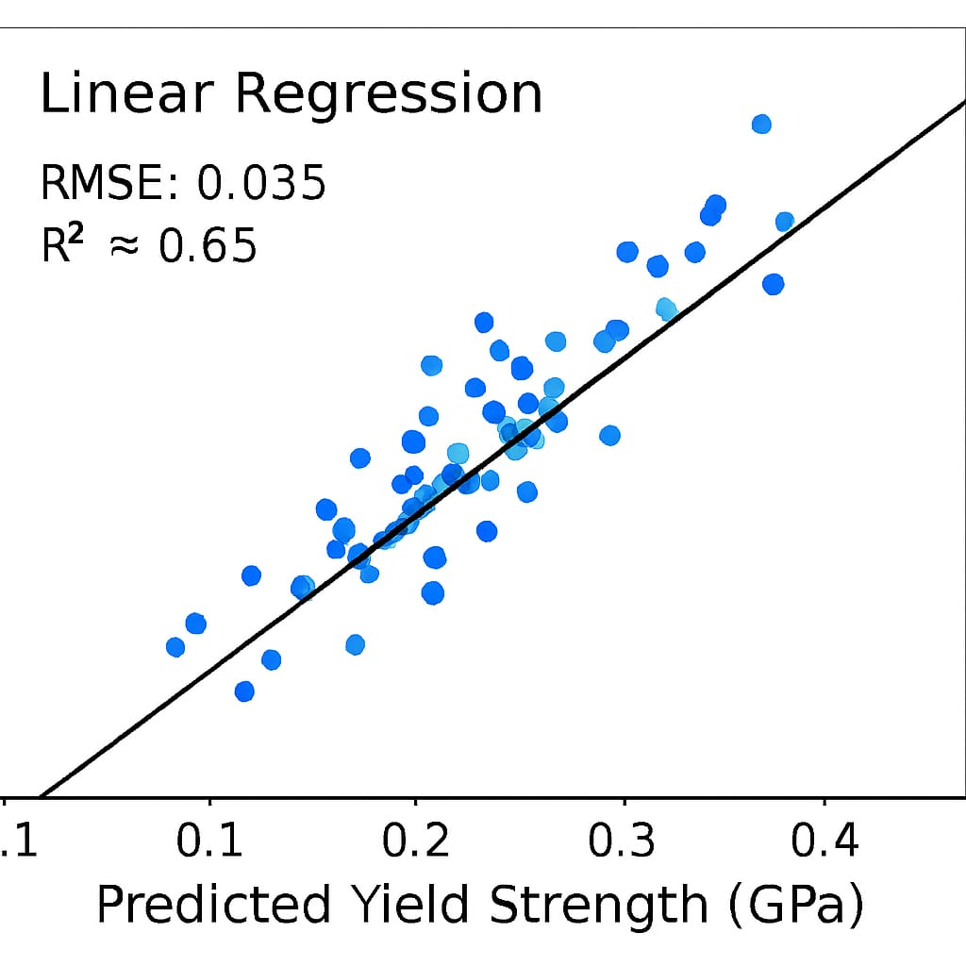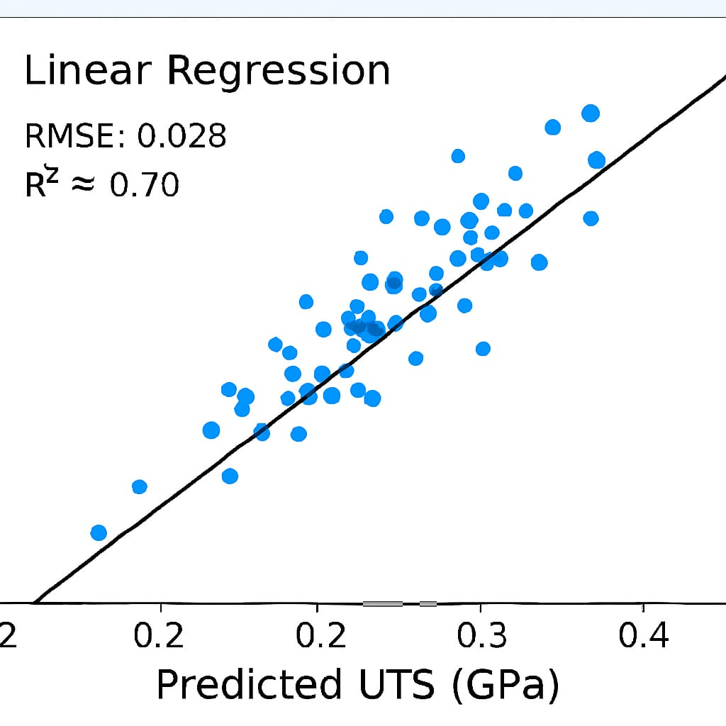
Figure 4. Linear Regression predictions vs. actual values.

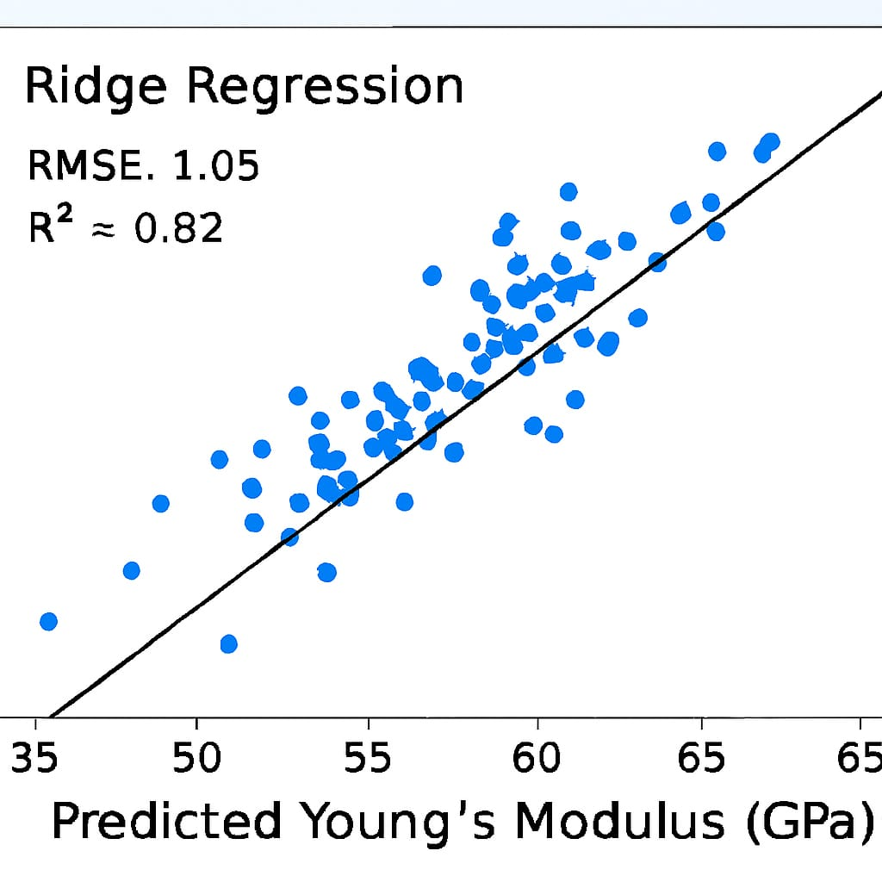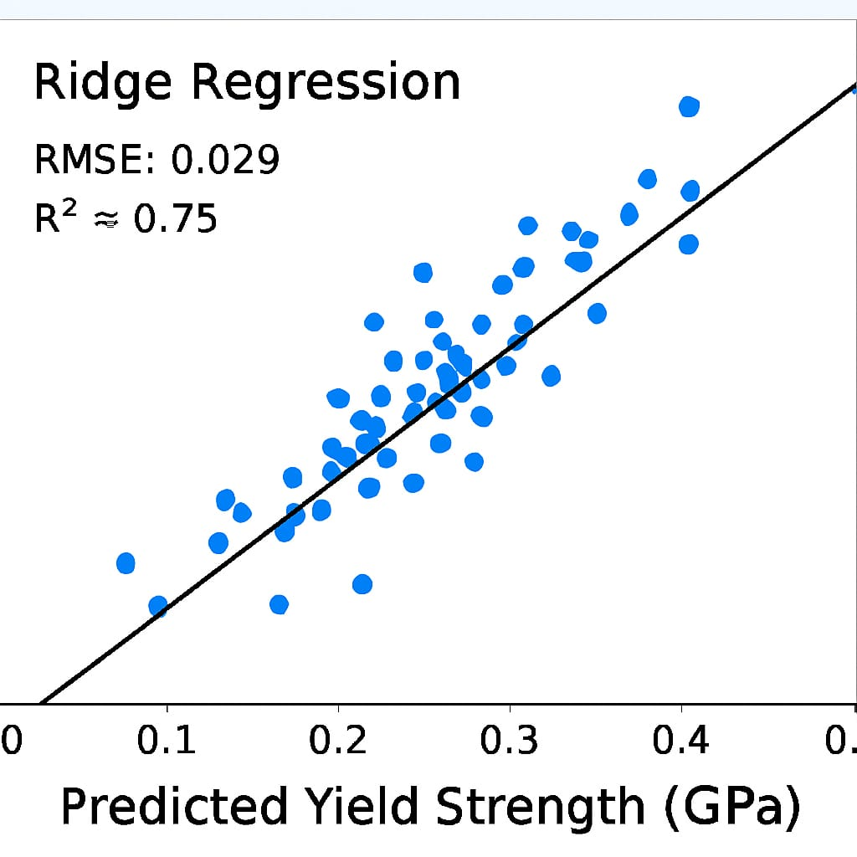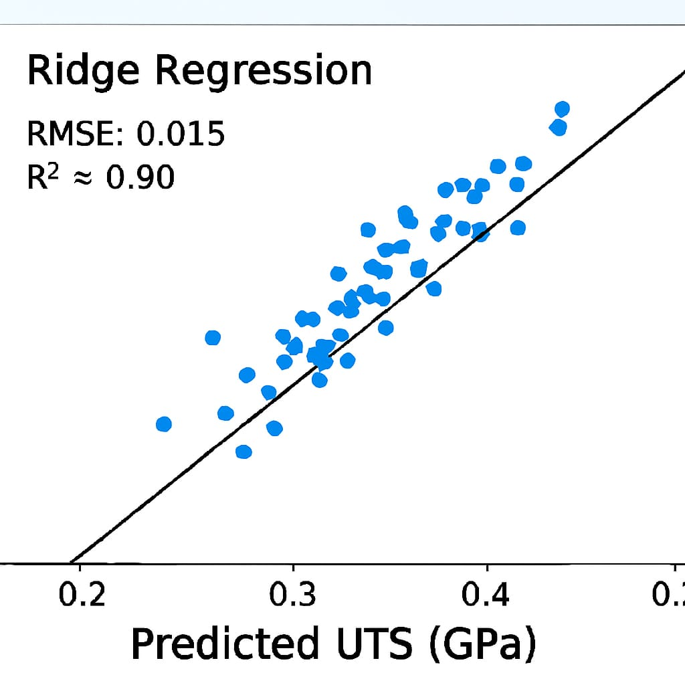

Figure 5. Ridge Regression predictions vs. actual values.

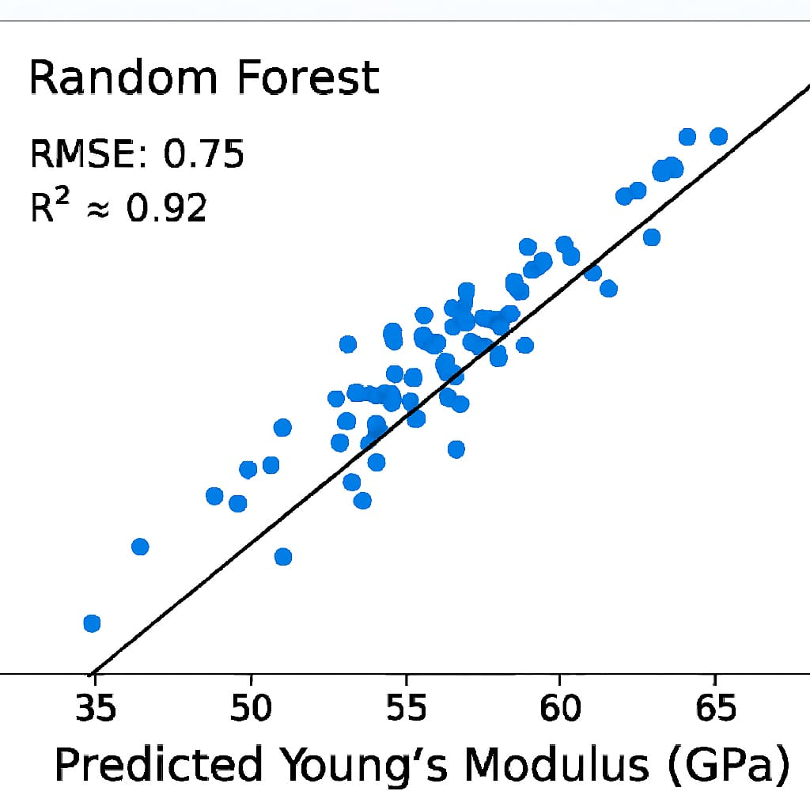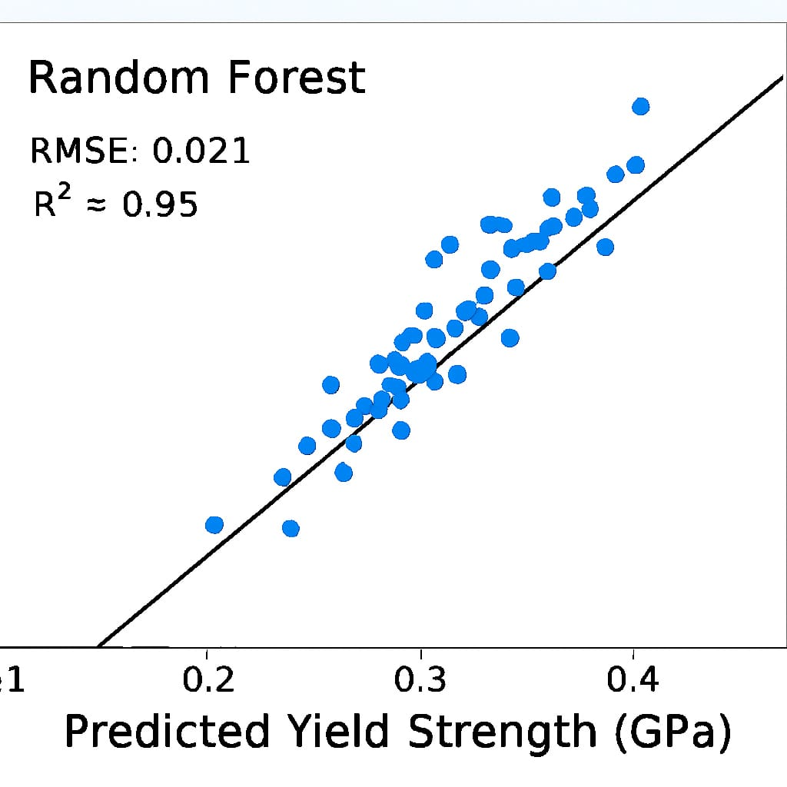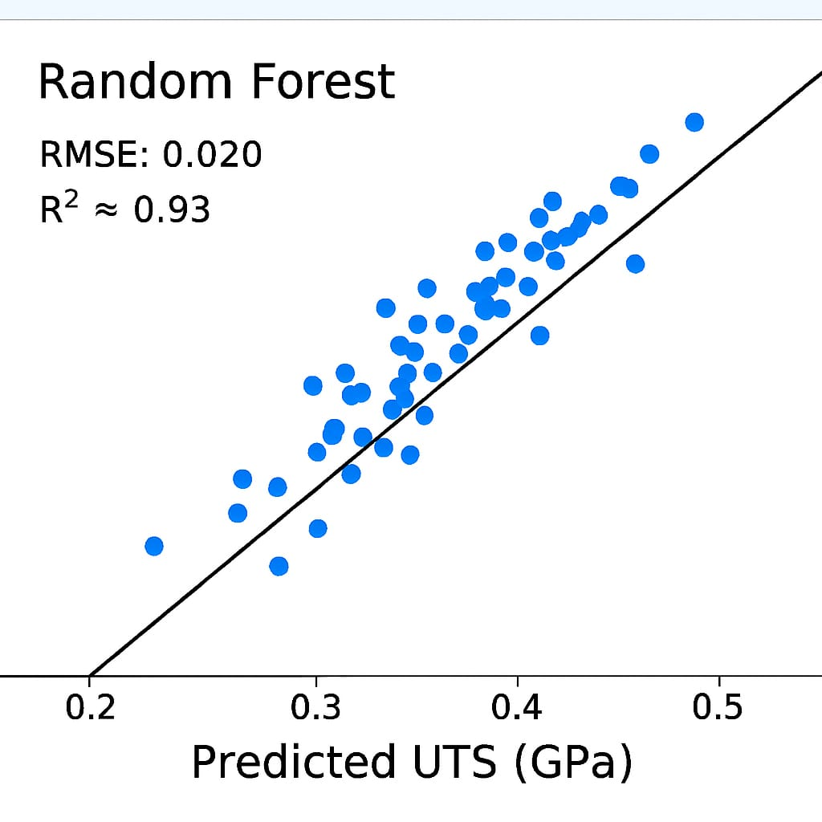
Figure 6. Random Forest predictions vs. actual values.

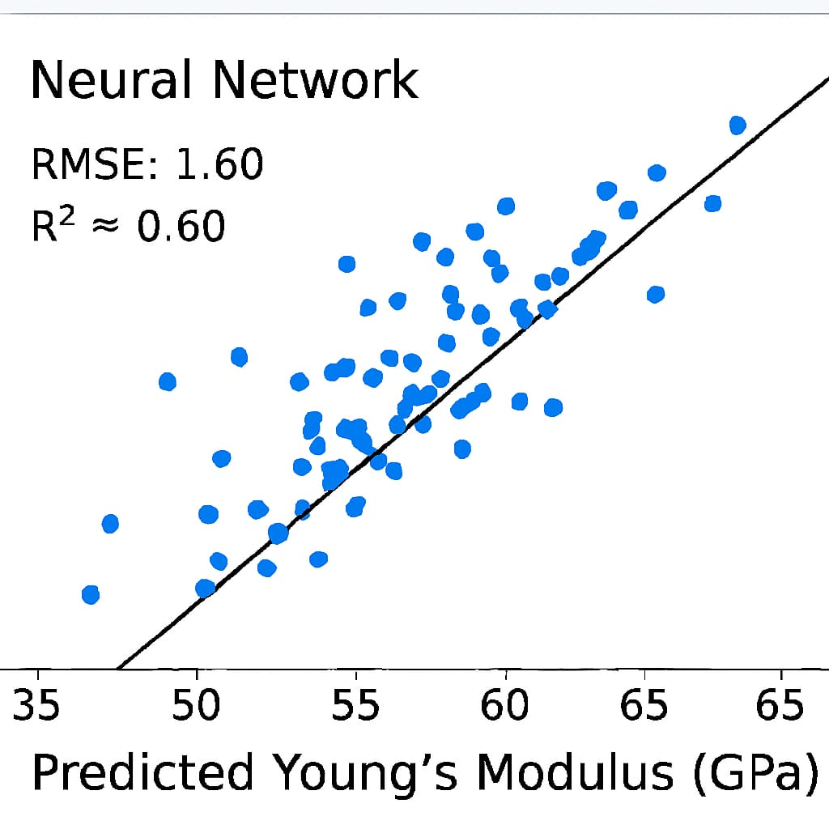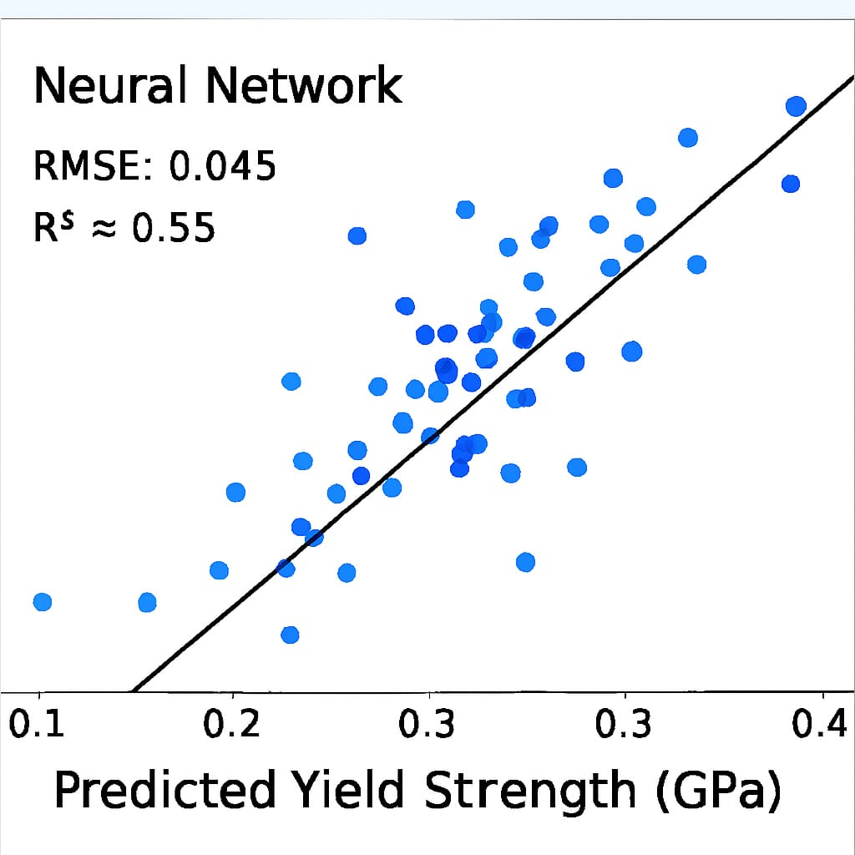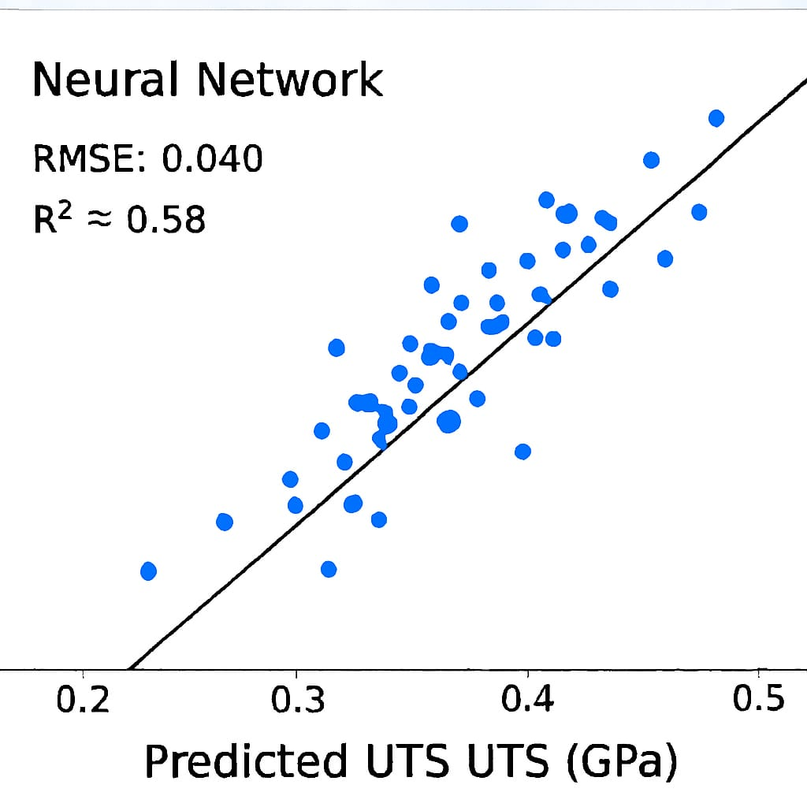
Figure 7. MLP predictions vs. actual values.
Random Forest predictions align closely with the identity line, demonstrating high reliability.
3.4 Discussion of ML Behaviour
- Linear and Ridge Regression models underfit due to their inability to capture nonlinearities.
- MLP performed well but was sensitive to hyperparameters.
- Random Forest demonstrated high stability due to ensemble averaging.
- MD data exhibits complex deformation responses influenced by composition and microstructural effects—well modelled by tree-based methods.

Final Model Performance Evaluations
Model | Young’s Modulus | Yield Strength | UTS | Overall Performance
Random Forest | Best R^2, Slight overfitting. | Best R^2. Low error. | Very high accuracy. | Highest predictive accuracy
Ridge Regression | Very stable fit; minimal gap. | Very stable; high accuracy. | Best R^2 Lowest RMSE. | Most robust and stable generalizer.
Linear Regression | Good baseline  low gap. | Solid, reliable accuracy. | Good baseline fit. | Reliable linear performance.
Neural network | Lowest Test  R^2 | Weakest performance. | Acceptable, but complex. | Acceptable, but requires tuning.

3.5 Model Validation
Validation tests confirmed:
- No significant overfitting for Random Forest
- Consistent train/test performance
- Robustness across diverse feature combinations
Validation Type | Purpose | Key Finding
Cross-Validation (5-Fold) | Estimate model stability and variance. | Confirmed Ridge Regression and Linear Regression are highly stable.
Generalization Gap | Detect Overfitting. | All models, except the initial Neural Network, showed strong generalization (low Test error). Random Forest showed a slight, manageable generalization gap.
Baseline Metrics (RAE & R²) | Confirm model utility over simple methods. | All optimized models demonstrated high Test R² (>= 0.8) and RAE <1.0, confirming their predictive utility.

3.6 Practical Implications
The ML–MD hybrid framework enables:
- Rapid screening of Ni–Cr compositions
- Significant reduction in simulation cost
- Deployment of predictive models for real-time inference
- Extension to multi-component alloys (Ni–Cr–Fe, Ni–Cr–Co)

4. Conclusion
This study presents a comprehensive ML–MD integrated approach for predicting the mechanical properties of Ni–Cr alloys. Using MD-generated stress–strain curves and supervised ML algorithms, a powerful predictive framework was developed. Key conclusions include:
- ML models successfully captured relationships between stress–strain curve features and mechanical properties.
- Random Forest Regressor demonstrated the highest accuracy, lowest error, and strongest generalization.
- The hybrid ML–MD approach reduces computational overhead and accelerates materials exploration.
- The methodology can be extended to other alloy systems and loading conditions.
This work highlights the promise of machine learning in enhancing atomistic simulation workflows and enabling fast, accurate materials property prediction.

References
- Complete Project repo link: MLMI_Project@Github
- Pedregosa, F., et al. “Scikit-learn: Machine Learning in Python.” Journal of Machine Learning Research, 12, 2825–2830 (2011).
- Breiman, L. “Random Forests.” Machine Learning, 45(1), 5–32 (2001).
- Plimpton, S. “Fast Parallel Algorithms for Short-Range Molecular Dynamics.” Journal of Computational Physics, 117(1), 1–19 (1995).
- Mishin, Y. “Machine-learning interatomic potentials for materials science.” Acta Materialia, 214, 116980 (2021).
- Reed, R. C. The Superalloys: Fundamentals and Applications. Cambridge University Press (2006).
- Liu, Q., et al. “Mechanical properties of Ni–Cr-based superalloys: A review.” Metallurgical and Materials Transactions A, 49, 2905–2923 (2018).
- Zhou, X., et al. “Study on tensile behaviour of Ni–Cr alloys at high temperature.” Materials Science and Engineering A, 766, 138349 (2019).
- Farkas, D., et al. “Atomistic simulations of metallic alloys.” Materials Science and Engineering A, 238, 46–55 (1997).
- Daw, M. S., & Baskes, M. I. “Embedded-atom method: A review.” Materials Science Reports, 9, 251–310 (1993).
- Finnis, M. W. & Sinclair, J. E. “A simple empirical N-body potential for transition metals.” Philosophical Magazine A, 50(1), 45–55 (1984).
- Behler, J. & Parrinello, M. “Generalized neural network representation of high-dimensional potential-energy surfaces.” Physical Review Letters, 98, 146401 (2007).
- Zhang, Y., et al. “Machine learning for mechanical property prediction in alloys.” Computational Materials Science, 175, 109584 (2020).
- Agrawal, A. & Choudhary, A. “Deep materials informatics: Applications of deep learning in materials science.” npj Computational Materials, 2, 16022 (2016).
- Butler, K. T., et al. “Machine learning for molecular and materials science.” Nature, 559, 547–555 (2018).
- Jha, D., et al. “ElemNet: Deep learning for material property prediction.” Scientific Reports, 8, 17593 (2018).
- Zhou, X. W., et al. “An embedded-atom potential for Ni–Cr alloys.” Modelling and Simulation in Materials Science and Engineering, 23, 055006 (2015).
- Li, D. & Li, X. “Molecular dynamics analysis of tensile deformation of binary alloys.” Materials & Design, 65, 1042–1050 (2015).
- Thompson, A. P., et al. “Spectral neighbour analysis method for automated generation of quantum-accurate interatomic potentials.” Journal of Computational Physics, 285, 316–330 (2015).
- Hollander, M., et al. “Predicting mechanical properties of alloys using machine learning: A comprehensive review.” Materials Today, 50, 190–210 (2021).

