Question 3: Municipal Waste Collection Optimizer
3a) Data Types:

Write a Java program to store and display the following details of a waste collection vehicle:

Vehicle number – integer
Waste collected in kilograms – decimal value
Number of collection points – integer
Vehicle status – character
Use appropriate Java data types for each value and display all the details.

Ans) public class MunicipalA{
public static void main(String[] args){

int vechileno = 4326;
double wastecollected = 130.5;
int collectionpoints = 10;
char vechilestatus = 'C';
System.out.println("===Welcome to our services===");
System.out.println("Vechile number:" +vechileno);
System.out.println("Waste collected:" +wastecollected);
System.out.println("Collection points:" +collectionpoints);
System.out.println("Vechile Status:" +vechilestatus);
System.out.println("***Thank you for choosing us***");
}
}
Output:- 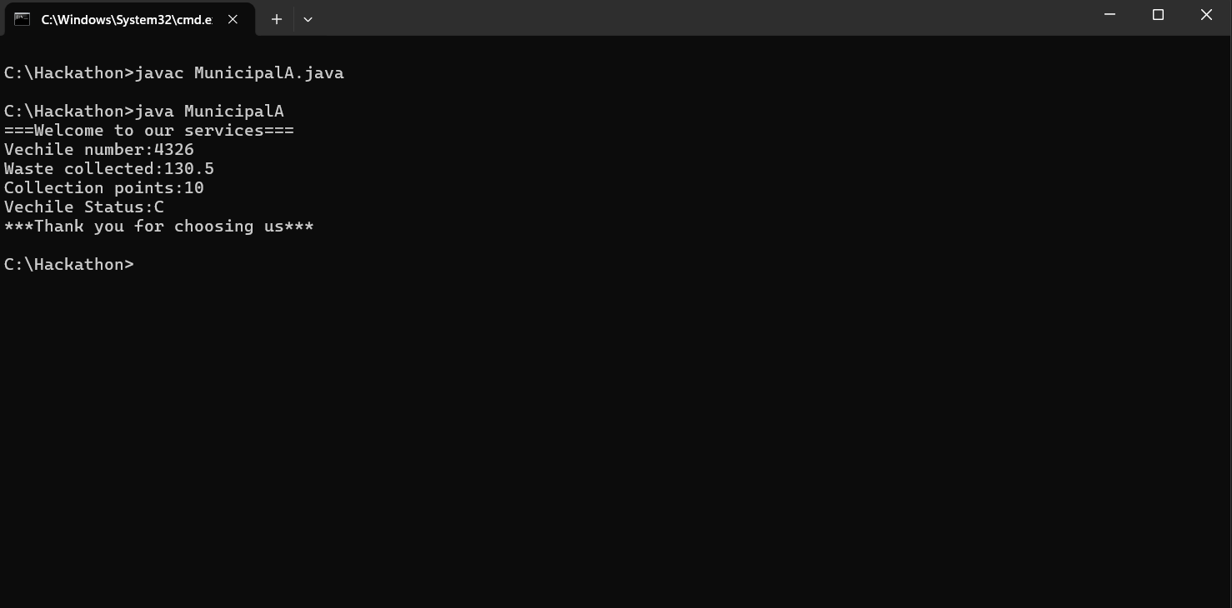

3b) If-Else Condition:

Write a Java program to check the waste collection status based on the amount of waste collected. Read the waste collected in kilograms.

If the waste collected is 100 kg or more, display "Collection Target Achieved".
Otherwise, display "More Waste Collection Required".
Use an if-else statement.

Ans) import java.util.Scanner;
class WasteCollection{
public static void main(String[] args){
Scanner in = new Scanner(System.in);
System.out.println("please enter the waste collected (in kg's):");
double waste = in.nextDouble();

if(waste >= 100){
System.out.println("Collection Target Achieved");
}
else{
System.out.println("More Waste Collection Required");
}
}
}
Output:- 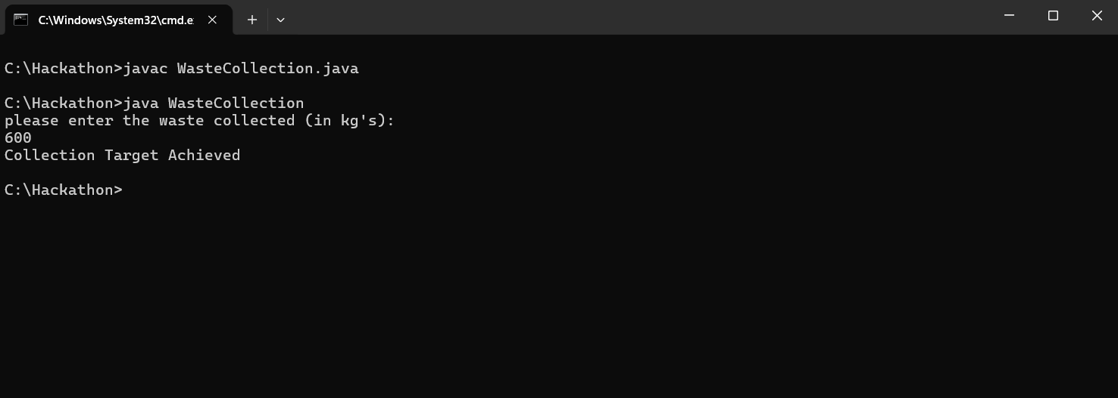
3c) Methods:

Write a Java program to calculate the total waste collected from two collection points using a method.

Create the following method:

calculateTotalWaste(double point1Waste, double point2Waste)
The method should return the total waste collected. Read the waste collected at the two collection points from the user, call the method, and display the total waste collected.
Ans) import java.util.Scanner;

class HackathonMethod {
static double calculateTotalWaste(double point1Waste, double point2Waste) {
return point1Waste + point2Waste;
}

public static void main(String[] args) {
Scanner sc = new Scanner(System.in);
System.out.println("===please enter the the waste collected at point1 & point2 respectfully===");

System.out.print("Enter waste at point 1: ");
double a = sc.nextDouble();

System.out.print("Enter waste at point 2: ");
double b = sc.nextDouble();

double total = calculateTotalWaste(a, b);

System.out.println("Total waste collected: " + total);
}
}
Output:- 