# Website Traffic Analysis Importing required libraries

**import** pandas **as** pd

**import** numpy **as** np

**import** matplotlib.pyplot **as** plt

**import** seaborn **as** sns

In [1]:

In [2]:

**!**pip install wordcloud

Requirement already satisfied: wordcloud in c:\users\sanjay pk\anaconda3\lib\site- packages (1.9.2)

Requirement already satisfied: pillow in c:\users\sanjay pk\anaconda3\lib\site-pac

kages (from wordcloud) (9.2.0)

Requirement already satisfied: matplotlib in c:\users\sanjay pk\anaconda3\lib\site

-packages (from wordcloud) (3.5.2)

Requirement already satisfied: numpy>=1.6.1 in c:\users\sanjay pk\anaconda3\lib\si te-packages (from wordcloud) (1.21.5)

Requirement already satisfied: python-dateutil>=2.7 in c:\users\sanjay pk\anaconda 3\lib\site-packages (from matplotlib->wordcloud) (2.8.2)

Requirement already satisfied: cycler>=0.10 in c:\users\sanjay pk\anaconda3\lib\si

te-packages (from matplotlib->wordcloud) (0.11.0)

Requirement already satisfied: fonttools>=4.22.0 in c:\users\sanjay pk\anaconda3\l ib\site-packages (from matplotlib->wordcloud) (4.25.0)

Requirement already satisfied: kiwisolver>=1.0.1 in c:\users\sanjay pk\anaconda3\l

ib\site-packages (from matplotlib->wordcloud) (1.4.2)

Requirement already satisfied: pyparsing>=2.2.1 in c:\users\sanjay pk\anaconda3\li b\site-packages (from matplotlib->wordcloud) (3.0.9)

Requirement already satisfied: packaging>=20.0 in c:\users\sanjay pk\anaconda3\lib

\site-packages (from matplotlib->wordcloud) (21.3)

Requirement already satisfied: six>=1.5 in c:\users\sanjay pk\anaconda3\lib\site-p ackages (from python-dateutil>=2.7->matplotlib->wordcloud) (1.16.0)

In [3]:

**import** os

**from** wordcloud **import** WordCloud

**%matplotlib** inline

**import** warnings

warnings**.**filterwarnings("ignore")

# Importing the Dataset

In [4]:

data **=** pd**.**read_csv('Documents/daily-website-visitors.csv') data

|  |  |  |  |  |  |  |  |  |
| --- | --- | --- | --- | --- | --- | --- | --- | --- |
| Out[4]: | **Row** | **Day** | **Day.Of.Week** | **Date** | **Page.Loads** | **Unique.Visits** | **First.Time.Visits** | **Retu** |
|  | **0** 1 | Sunday | 1 | 9/14/2014 | 2,146 | 1,582 | 1,430 |  |
|  | **1** 2 | Monday | 2 | 9/15/2014 | 3,621 | 2,528 | 2,297 |  |
|  | **2** 3 | Tuesday | 3 | 9/16/2014 | 3,698 | 2,630 | 2,352 |  |
|  | **3** 4 | Wednesday | 4 | 9/17/2014 | 3,667 | 2,614 | 2,327 |  |
|  | **4** 5 | Thursday | 5 | 9/18/2014 | 3,316 | 2,366 | 2,130 |  |
|  | **...** ... | ... | ... | ... | ... | ... | ... |  |
|  | **2162** 2163 | Saturday | 7 | 8/15/2020 | 2,221 | 1,696 | 1,373 |  |
|  | **2163** 2164 | Sunday | 1 | 8/16/2020 | 2,724 | 2,037 | 1,686 |  |
|  | **2164** 2165 | Monday | 2 | 8/17/2020 | 3,456 | 2,638 | 2,181 |  |
|  | **2165** 2166 | Tuesday | 3 | 8/18/2020 | 3,581 | 2,683 | 2,184 |  |
|  | **2166** 2167 | Wednesday | 4 | 8/19/2020 | 2,064 | 1,564 | 1,297 |  |

2167 rows × 8 columns

Droping the columns

In [7]:

data **=** data**.**drop(columns**=**['Date']) data

|  |  |  |  |  |  |  |  |
| --- | --- | --- | --- | --- | --- | --- | --- |
| Out[7]: | **Row** | **Day** | **Day.Of.Week** | **Page.Loads** | **Unique.Visits** | **First.Time.Visits** | **Returning.Visits** |
|  | **0** 1 | Sunday | 1 | 2,146 | 1,582 | 1,430 | 152 |
|  | **1** 2 | Monday | 2 | 3,621 | 2,528 | 2,297 | 231 |
|  | **2** 3 | Tuesday | 3 | 3,698 | 2,630 | 2,352 | 278 |
|  | **3** 4 | Wednesday | 4 | 3,667 | 2,614 | 2,327 | 287 |
|  | **4** 5 | Thursday | 5 | 3,316 | 2,366 | 2,130 | 236 |
|  | **...** ... | ... | ... | ... | ... | ... | ... |
|  | **2162** 2163 | Saturday | 7 | 2,221 | 1,696 | 1,373 | 323 |
|  | **2163** 2164 | Sunday | 1 | 2,724 | 2,037 | 1,686 | 351 |
|  | **2164** 2165 | Monday | 2 | 3,456 | 2,638 | 2,181 | 457 |
|  | **2165** 2166 | Tuesday | 3 | 3,581 | 2,683 | 2,184 | 499 |
|  | **2166** 2167 | Wednesday | 4 | 2,064 | 1,564 | 1,297 | 267 |

2167 rows × 7 columns

# Checking the dataset

In [8]:

data**.**info()

<class 'pandas.core.frame.DataFrame'> RangeIndex: 2167 entries, 0 to 2166

Data columns (total 7 columns):

# Column Non-Null Count Dtype

1. Row 2167 non-null int64
2. Day 2167 non-null object
3. Day.Of.Week 2167 non-null int64
4. Page.Loads 2167 non-null object
5. Unique.Visits 2167 non-null object
6. First.Time.Visits 2167 non-null object
7. Returning.Visits 2167 non-null object dtypes: int64(2), object(5)

memory usage: 118.6+ KB

# Checking the missing values

In [9]:

Out[9]:

In [13]:

Row 0

data**.**isnull()**.**sum()

Day 0

Day.Of.Week 0

Page.Loads 0

Unique.Visits 0

First.Time.Visits 0

Returning.Visits 0

dtype: int64

data['Day.Of.Week'] **=** data['Page.Loads']**.**apply(**lambda** x: x**.**split('-')[0]) data

|  |  |  |  |  |  |  |  |
| --- | --- | --- | --- | --- | --- | --- | --- |
| Out[13]: | **Row** | **Day** | **Day.Of.Week** | **Page.Loads** | **Unique.Visits** | **First.Time.Visits** | **Returning.Visits** |
|  | **0** 1 | Sunday | 2,146 | 2,146 | 1,582 | 1,430 | 152 |
|  | **1** 2 | Monday | 3,621 | 3,621 | 2,528 | 2,297 | 231 |
|  | **2** 3 | Tuesday | 3,698 | 3,698 | 2,630 | 2,352 | 278 |
|  | **3** 4 | Wednesday | 3,667 | 3,667 | 2,614 | 2,327 | 287 |
|  | **4** 5 | Thursday | 3,316 | 3,316 | 2,366 | 2,130 | 236 |
|  | **...** ... | ... | ... | ... | ... | ... | ... |
|  | **2162** 2163 | Saturday | 2,221 | 2,221 | 1,696 | 1,373 | 323 |
|  | **2163** 2164 | Sunday | 2,724 | 2,724 | 2,037 | 1,686 | 351 |
|  | **2164** 2165 | Monday | 3,456 | 3,456 | 2,638 | 2,181 | 457 |
|  | **2165** 2166 | Tuesday | 3,581 | 3,581 | 2,683 | 2,184 | 499 |
|  | **2166** 2167 | Wednesday | 2,064 | 2,064 | 1,564 | 1,297 | 267 |

2167 rows × 7 columns

# Visualizing the Datasets using various Graphs

In [14]:

plt**.**figure(figsize**=**(10,10))

sns**.**heatmap(data**.**corr(),annot**=True**)

Out[14]:

In [15]:

data**.**corr()**.**T

<AxesSubplot:>

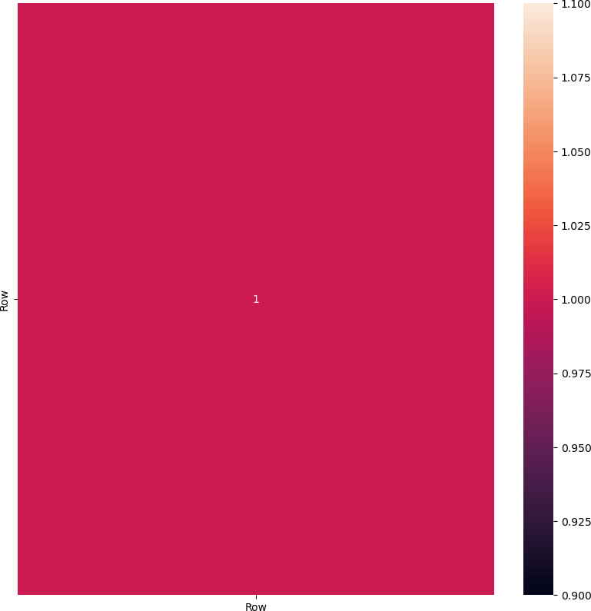

Out[15]:

In [16]:

**for** i **in** data**.**columns:

print(i," ",data[i]**.**unique())

**Row**

**Row** 1.0

Row --------- [ 1 2 3 ... 2165 2166 2167]

Day --------- ['Sunday' 'Monday' 'Tuesday' 'Wednesday' 'Thursday' 'Friday' 'Saturd ay']

Day.Of.Week --------- ['2,146' '3,621' '3,698' ... '2,623' '3,581' '2,064']

Page.Loads --------- ['2,146' '3,621' '3,698' ... '2,623' '3,581' '2,064']

Unique.Visits --------- ['1,582' '2,528' '2,630' ... '2,638' '2,683' '1,564']

First.Time.Visits --------- ['1,430' '2,297' '2,352' ... '1,686' '2,184' '1,297']

Returning.Visits --------- ['152' '231' '278' '287' '236' '241' '133' '175' '274'

'268' '284' '286'

'216' '140' '193' '296' '312' '308' '250' '162' '200' '328' '359' '351'

'319' '282' '177' '233' '366' '387' '421' '376' '329' '203' '409' '434'

'244' '290' '451' '423' '416' '384' '279' '226' '264' '428' '402' '403'

'407' '343' '191' '292' '440' '410' '454' '436' '362' '208' '289' '490'

'437' '488' '458' '389' '253' '469' '415' '406' '314' '337' '281' '560'

'574' '561' '535' '377' '310' '546' '552' '594' '554' '442' '300' '391'

'478' '477' '447' '320' '178' '321' '145' '197' '160' '183' '252' '182'

'161' '258' '150' '223' '356' '385' '393' '350' '174' '220' '382' '427'

'388' '288' '185' '221' '394' '429' '368' '270' '375' '411' '418' '464'

'214' '297' '499' '501' '417' '242' '335' '494' '521' '509' '342' '471'

'495' '500' '496' '380' '254' '361' '542' '570' '587' '483' '283' '556'

'603' '533' '448' '325' '364' '578' '576' '596' '580' '486' '313' '424'

'579' '581' '585' '551' '398' '618' '605' '571' '360' '408' '599' '604'

'591' '504' '295' '371' '559' '648' '614' '633' '516' '318' '456' '698'

'693' '686' '689' '566' '397' '475' '765' '715' '696' '754' '780' '760'

'636' '502' '445' '709' '702' '679' '479' '695' '670' '668' '597' '345'

'632' '506' '299' '354' '564' '651' '622' '466' '583' '455' '355' '589'

'607' '639' '628' '255' '544' '545' '569' '468' '317' '553' '573' '541'

'520' '432' '293' '522' '538' '363' '204' '229' '484' '523' '528' '467'

'201' '276' '505' '548' '266' '525' '422' '213' '562' '503' '239' '285'

'531' '511' '489' '401' '245' '473' '532' '524' '260' '515' '498' '470'

'481' '536' '206' '259' '404' '235' '537' '482' '238' '311' '519' '563'

'251' '333' '567' '584' '577' '256' '353' '547' '623' '645' '649' '661'

'616' '331' '656' '652' '324' '657' '674' '646' '348' '419' '716' '660'

'650' '678' '708' '704' '665' '621' '491' '461' '322' '753' '790' '749'

'620' '833' '798' '800' '748' '617' '724' '658' '640' '598' '232' '309'

'138' '176' '367' '326' '228' '457' '512' '426' '339' '624' '465' '301'

'358' '575' '412' '588' '572' '392' '568' '609' '507' '613' '687' '555'

'746' '810' '558' '370' '517' '731' '743' '736' '772' '346' '480' '737'

'783' '744' '510' '792' '775' '694' '735' '634' '727' '681' '543' '782'

'771' '725' '610' '400' '534' '836' '857' '837' '758' '662' '849' '877'

'898' '830' '676' '625' '987' '924' '926' '832' '631' '907' '730' '606'

'794' '755' '747' '680' '378' '444' '685' '787' '819' '856' '734' '803'

'769' '675' '414' '796' '728' '673' '565' '707' '413' '677' '692' '667'

'257' '365' '225' '269' '334' '647' '608' '611' '600' '529' '271' '381'

'682' '672' '627' '653' '298' '476' '643' '699' '595' '275' '659' '513'

'425' '729' '697' '294' '430' '776' '330' '742' '774' '349' '703' '714'

'797' '841' '405' '899' '914' '815' '761' '872' '890' '897' '669' '853'

'825' '845' '915' '814' '644' '946' '903' '919' '902' '690' '905' '918'

'822' '487' '880' '969' '1,036' '961' '806' '784' '979' '998' '993' '957'

'985' '895' '842' '369' '190' '439' '207' '396' '557' '590' '526' '373'

'635' '341' '420' '684' '801' '763' '671' '705' '691' '344' '745' '717'

'720' '700' '460' '664' '340' '721' '722' '443' '683' '719' '831' '710'

'723' '602' '654' '452' '642' '374' '638' '463' '441' '323' '230' '527'

'263' '492' '383' '234' '493' '518' '395' '198' '261' '435' '249' '497'

'453' '450' '219' '265' '332' '438' '184' '291' '433' '472' '474' '446'

'459' '305' '248' '327' '593' '372' '615' '592' '205' '199' '390' '302'

'315' '462' '316' '399' '386' '619' '530' '641' '809' '586' '739' '767'

'485' '706' '701' '629' '688' '711' '805' '881' '777' '663' '908' '913'

'925' '866' '852' '848' '773' '751' '666' '612' '307' '549' '601' '306'

'539' '626' '379' '582' '759' '732' '811' '752' '802' '630' '859' '838'

'947' '850' '956' '937' '973' '243' '277' '550' '514' '766' '770' '823'

'785' '778' '789' '791' '821' '817' '762' '824' '304' '181' '540' '202'

'508' '637' '712' '157' '210' '188' '187' '246' '267' '303' '655' '834'

'431' '280' '338']

In [18]:

plt**.**figure(figsize**=**(10, 6))

plt**.**hist(data['Unique.Visits'], bins**=**20, edgecolor**=**'k') *# You can adjust the numbe*

plt**.**xlabel('Daily Web Traffic') plt**.**ylabel('Frequency')

plt**.**title('Web Traffic Histogram')

plt**.**show()

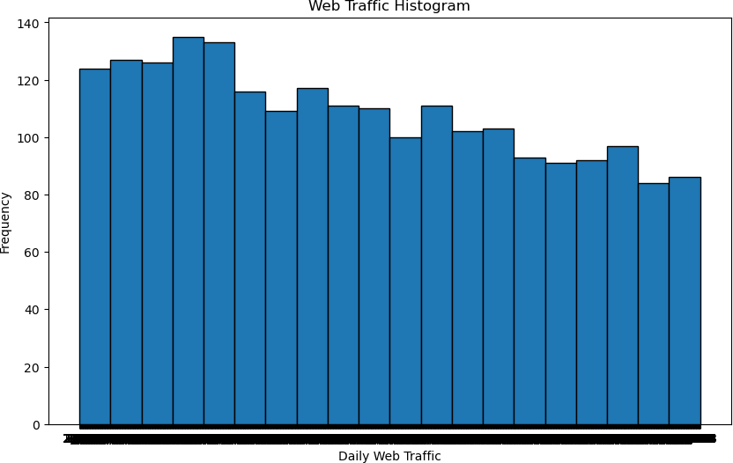

In [21]:

plt**.**figure(figsize**=**(15,15),dpi**=**100) plt**.**subplot(2,2,1)

sns**.**barplot(x**=**"Row",y**=**"Unique.Visits",data**=**data,edgecolor**=**"black",estimator**=**sum) plt**.**xticks(rotation**=**90);

plt**.**subplot(2,2,2)

sns**.**barplot(x**=**"Row",y**=**"First.Time.Visits",data**=**data,edgecolor**=**"black",estimator**=**su

Out[21]:

<AxesSubplot:xlabel='Row', ylabel='First.Time.Visits'>

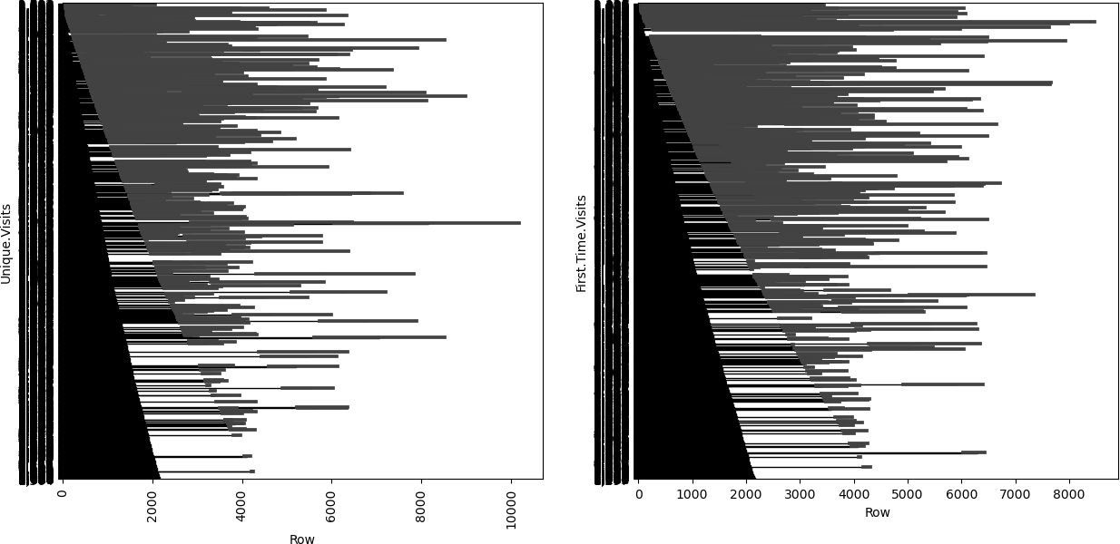

In [23]:

plt**.**figure(figsize**=**(15,15),dpi**=**100) plt**.**subplot(2,2,1)

sns**.**barplot(x**=**"Row",y**=**"First.Time.Visits",data**=**data,edgecolor**=**"black",estimator**=**su plt**.**xticks(rotation**=**90);

plt**.**subplot(2,2,2)

sns**.**barplot(x**=**"Row",y**=**"Returning.Visits",data**=**data,edgecolor**=**"black",estimator**=**sum

Out[23]:

In [29]:

plt**.**figure(figsize**=**(10, 6))

plt**.**scatter(data['Day'], data['First.Time.Visits'], s**=**20, alpha**=**0.5) plt**.**xlabel('Day')

plt**.**ylabel('First.Time.Visits')

plt**.**title('Website Traffic Scatter Plot') plt**.**show()

<AxesSubplot:xlabel='Row', ylabel='Returning.Visits'>

