Data Cleaning & Visualization Project
Dataset: Titanic Passenger Records (public dataset)

1. Project Overview
This project takes a raw, messy passenger dataset (the classic Titanic dataset, with duplicate rows intentionally reintroduced to simulate a real-world "raw export") and walks through the full data-cleaning and exploratory-visualization pipeline: auditing and handling missing values, detecting and treating outliers, removing duplicates, and producing visual insights that tell a story about who survived the disaster and why.

2. Raw Data Snapshot
Metric | Value
Rows (raw) | 899
Columns | 15
Duplicate rows found | 115
Total missing cells | 879
Columns with missing data | deck (77.4%), age (19.9%), embarked (0.2%), embark_town (0.2%)

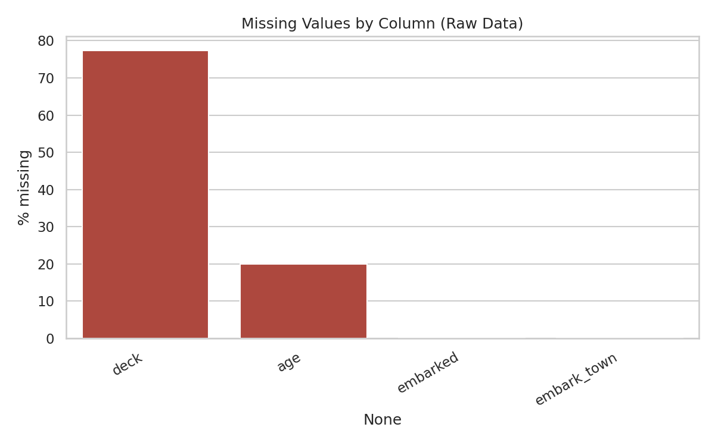
Figure 1 — Missing values by column, raw data

3. Cleaning Steps Applied

3.1 Duplicates
- Detected 115 fully duplicate rows (including 8 injected to simulate raw-export noise).
- Removed all duplicates, keeping the first occurrence — final row count: 784.

3.2 Missing Values
- deck: dropped — over 77% missing, not reliably imputable.
- embark_town: dropped — redundant with the 'embarked' port-code column.
- age: imputed using the median age within each (sex, passenger class) group, which is far more accurate than a single flat median.
- embarked: filled the 2 missing values with the most common port (mode).
- fare: any missing values filled with the median fare for that passenger class (none were actually missing here, but the pipeline handles it defensively).

3.3 Outliers
- Applied the IQR rule to 'fare': values above Q3 + 1.5×IQR (~$73.20) flagged as outliers — 102 rows.
- Rather than deleting these (they are real ticket prices for 1st-class suites, not data errors), the values were capped ('winsorized') at the upper bound in a new 'fare_capped' column, preserving every passenger record while reducing skew for analysis.
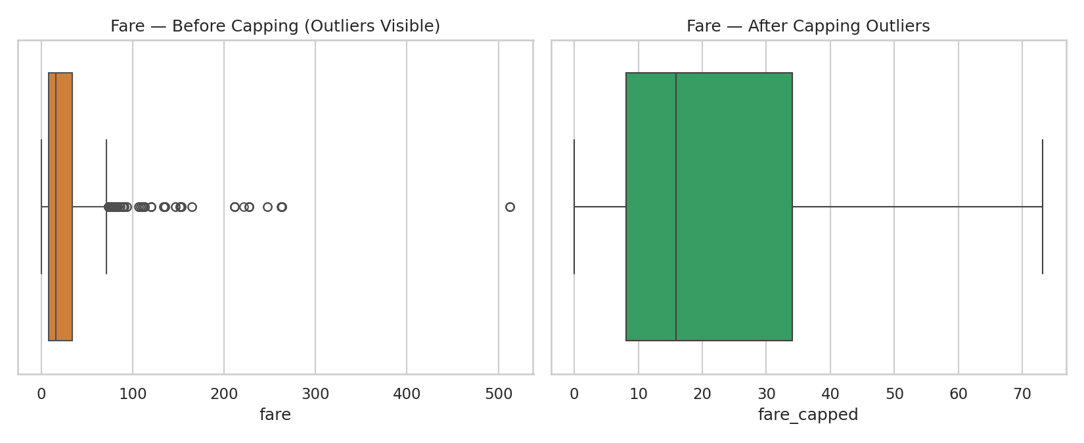
Figure 2 — Fare distribution before and after outlier capping

4. Key Visual Insights

4.1 Survival by Class and Sex
Survival was overwhelmingly determined by sex and class. Women survived at far higher rates than men in every class, and 1st-class passengers of both sexes fared better than those in steerage.
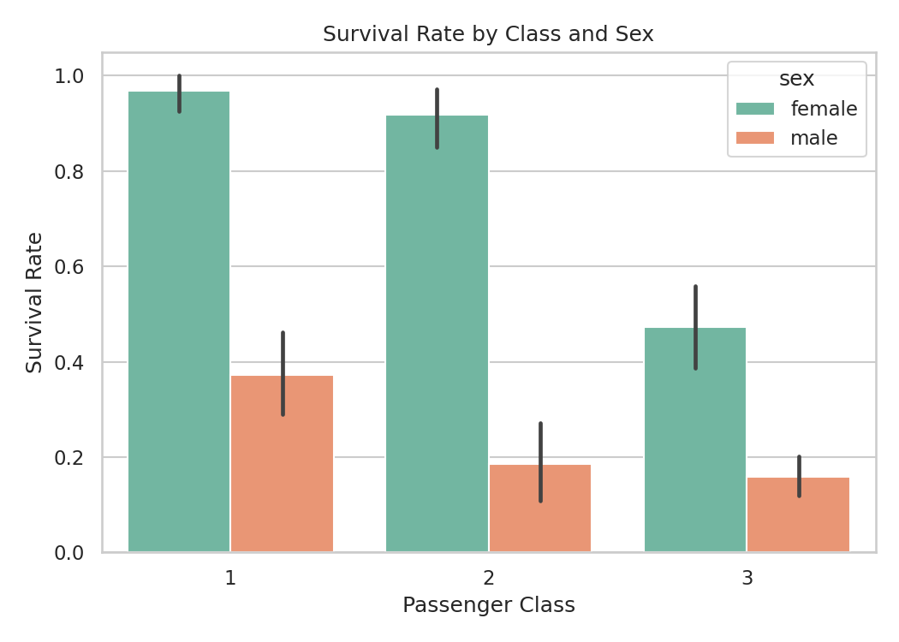
Figure 3 — Survival rate by passenger class and sex

4.2 Age Distribution
Most passengers were young adults (20s–30s). Very young children show a noticeably higher survival share, consistent with a "women and children first" evacuation pattern.
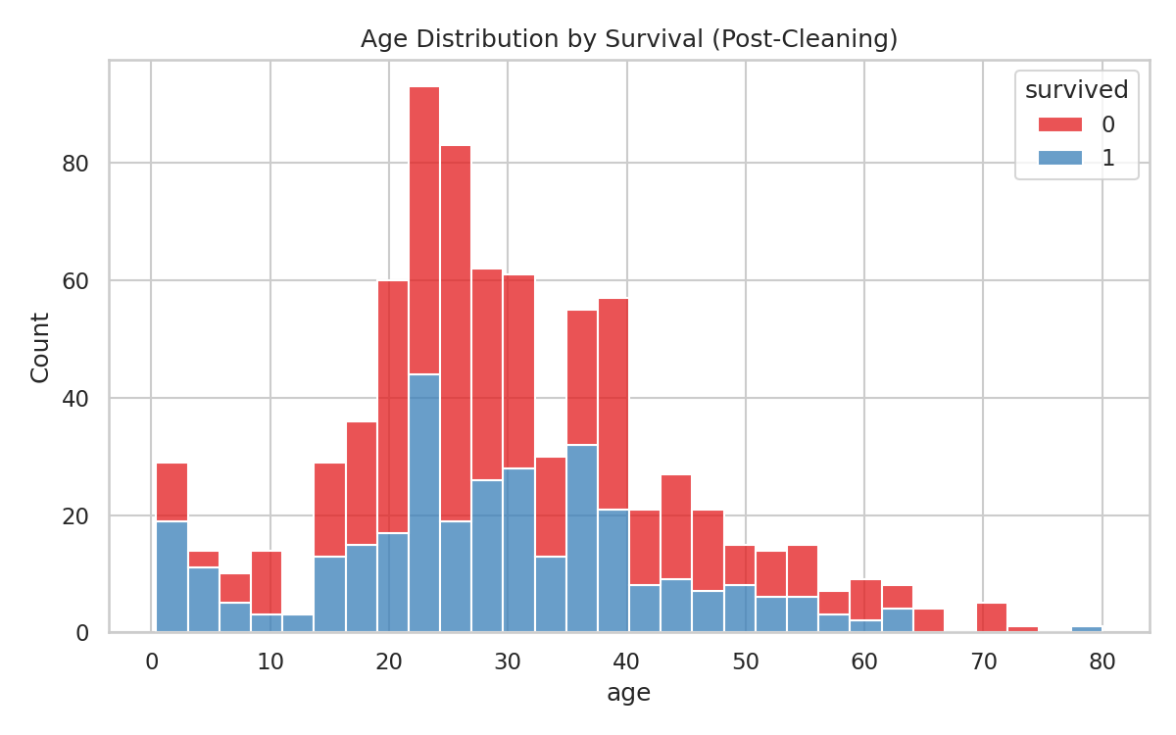
Figure 4 — Age distribution split by survival outcome

4.3 Correlation Between Numeric Features
Fare (a proxy for class/wealth) has the strongest positive correlation with survival among numeric features, while passenger class shows a negative correlation (lower class number = better survival odds). Age shows only a weak relationship.
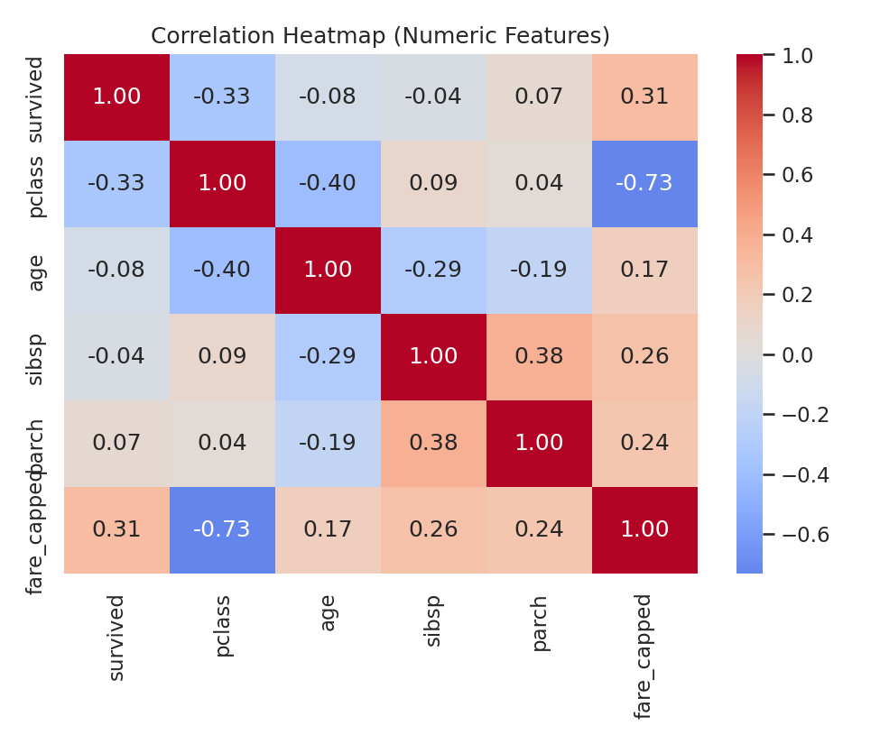
Figure 5 — Correlation heatmap of numeric features

4.4 Port of Embarkation
Passengers who boarded at Cherbourg (C) had a notably higher survival rate than those from Southampton (S) or Queenstown (Q) — largely because Cherbourg boarders skewed wealthier and more often traveled 1st class.
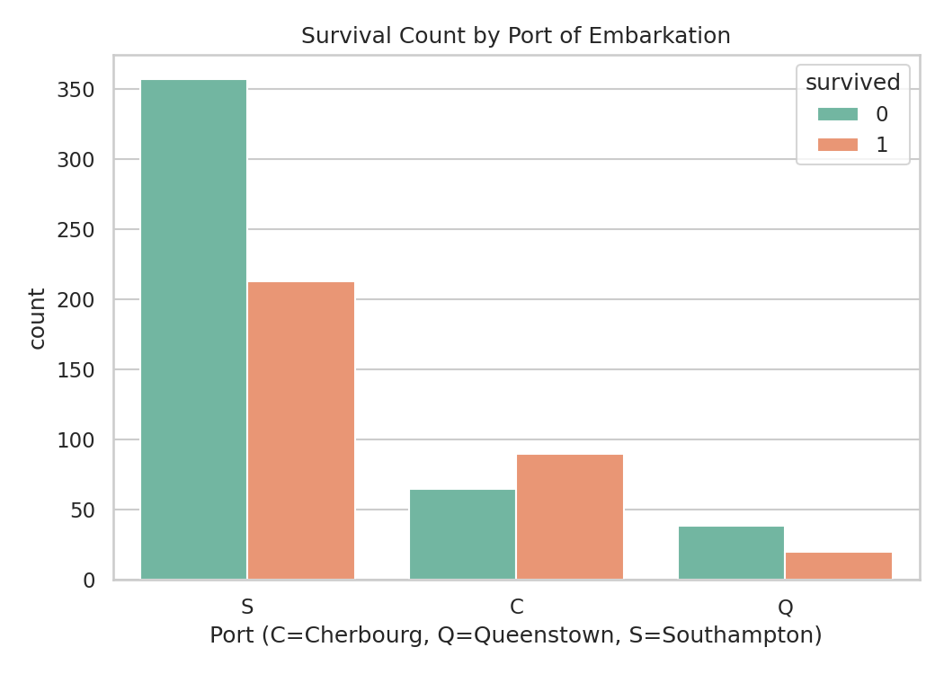
Figure 6 — Survival counts by port of embarkation

5. Summary of Findings
Metric | Value
Overall survival rate | 41.2%
Female survival rate | 74.1%
Male survival rate | 21.6%
1st class survival rate | 63.1%
3rd class survival rate | 25.7%
Fare ↔ survival correlation | +0.31
Age ↔ survival correlation | -0.08

6. Conclusion
After removing duplicate records, imputing missing values with group-aware statistics, and taming extreme fare outliers, the cleaned dataset reveals a clear story: survival on the Titanic was driven primarily by sex and socio-economic class (proxied by fare and passenger class), with only a weak relationship to age. This mirrors well-documented historical accounts of the disaster's evacuation priorities.
Deliverables accompanying this report: the cleaned dataset (titanic_cleaned.csv), the full Python cleaning/visualization script (data_cleaning_pipeline.py), and an interactive HTML dashboard summarizing all findings in one view.

